Design Principles:  
Assignment 1 Writeup

Mark Joshwel, SXXXXXXXX (IM02/P12)

# 50-word Writeup

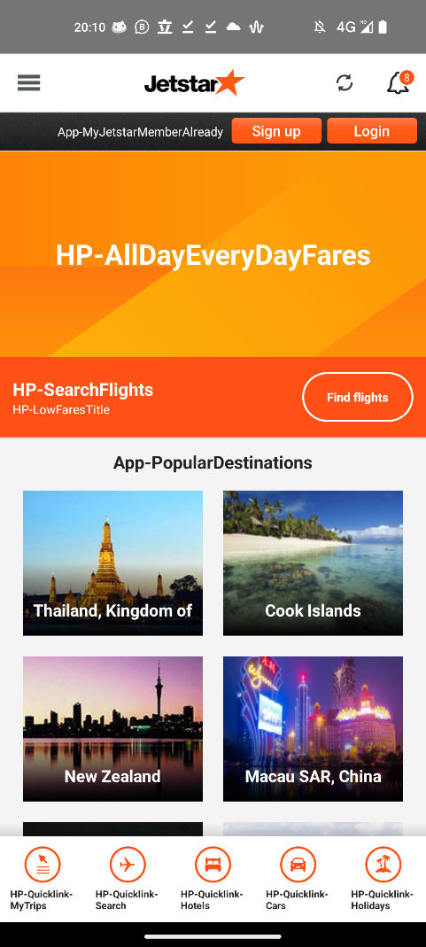“Old Design”  
Screenshots of the Jetstar app accessed May 28 2023, showcased on the right.

“New Design”  
Screenshot of the Jetstar website accessed May 28, 2023, showcased on the right.

Considering the dated design of the Jetstar mobile app, this poster highlights a fresh new redesign. The redesign follows the new Jetstar brand guidelines, using a vibrantly coloured zig-zagged shape to visually guide flow throughout the document and towards the QR code, enticing onlookers to download the app, making them potential future travellers.

# References, Credits and Sources

* QR Code: Generated with **Adobe Express QR Code Generator Tool**  
  <https://express.adobe.com/tools/qr-code-generator>
* Phone Mock-up: **Authgear MockuPhone** - Google Pixel 5 (Just Black)   
  <https://mockuphone.com/device/google-pixel5-justblack>
* Application Demonstration Screens: Self-made in Adobe Illustrator  
  <https://github.com/markjoshwel/school/tree/main/np/1.1/dp/as1>
* Link Shortener: Custom-made **HTML Link Shortener**  
  <https://links.joshwel.co/>

<https://github.com/markjoshwel/links/>

* Typefaces:  
  **TASA Orbiter Display  
  TASA Orbiter Text**  
  <https://fontesk.com/tasa-orbiter-typeface/>
* Brand Guidelines:  
  <https://andylachlansmith.com/Jetstar-brand-refresh>
* Brand Elements:  
  **Logo**: <https://1000logos.net/jetstar-logo/>  
  **Gradient Shapes**: Self-made in Adobe Illustrator (<https://github.com/markjoshwel/school/tree/main/np/1.1/dp/as1>)
* Photos:
  + **Singapore Photo**: Photo by Coleen Rivas on Unsplash  
    <https://unsplash.com/photos/OZ2rS2zCjNo>
  + **Australia Photo**: Photo by Photoholgic on Unsplash  
    <https://unsplash.com/photos/1GFUOji-yck>
  + **Japan Photo**: Photo by Yoav Aziz on Unsplash  
    <https://unsplash.com/photos/tKCd-IWc4gI>