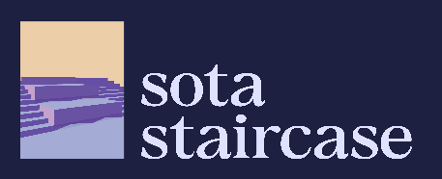

Integrated Studio Project 3
Checkpoint 1
Project Idea

Another Looking Glass
(name still work in progress)

Our Game Idea: Another Looking Glass is a VR empathy experience that lets players inhabit different disabled perspectives as they navigate everyday Singapore, revealing how “normal” environments become hostile once viewed through another lens.

Core Concept
- “Looking Glass” – Players put on the headset, the experiencing (hopefully) shifting how they perceive and move through familiar Singaporean spaces.
- Each disability mode changes both mechanics and perception, forcing players to relearn simple tasks like crossing a road or navigation locations with a disability.

Key Experiences
- Blindness: Using one of the VR controllers to move a virtual walking stick, they get to map out a blacked-out environment, and slowly move towards places like lifts, and other end goals without much vision. On the floor, a the environment is mapped out as they move the controller, requiring them to identify blind tiles as a way to navigate.
- Wheelchair-boundness: Movement is driven by making pushing motions using the two VR controllers. Players quickly discover missing ramps, steep slopes, and tight corridors, highlighting how many “accessible” paths are inconvenient or unsafe in a Singaporean streetscape.
- Colour-blindness: A post-processing filter simulates common colour vision deficiencies (e.g., protanopia, deuteranopia), altering signage, traffic lights, and UI feedback. Can be layered onto wheelchair mode to show how even well-designed spaces can fail when visual cues depend heavily on colour. (also so I can do my 3DE -mark)

Team Branding
Name: sota staircase 32
Members: Mark, Arwen
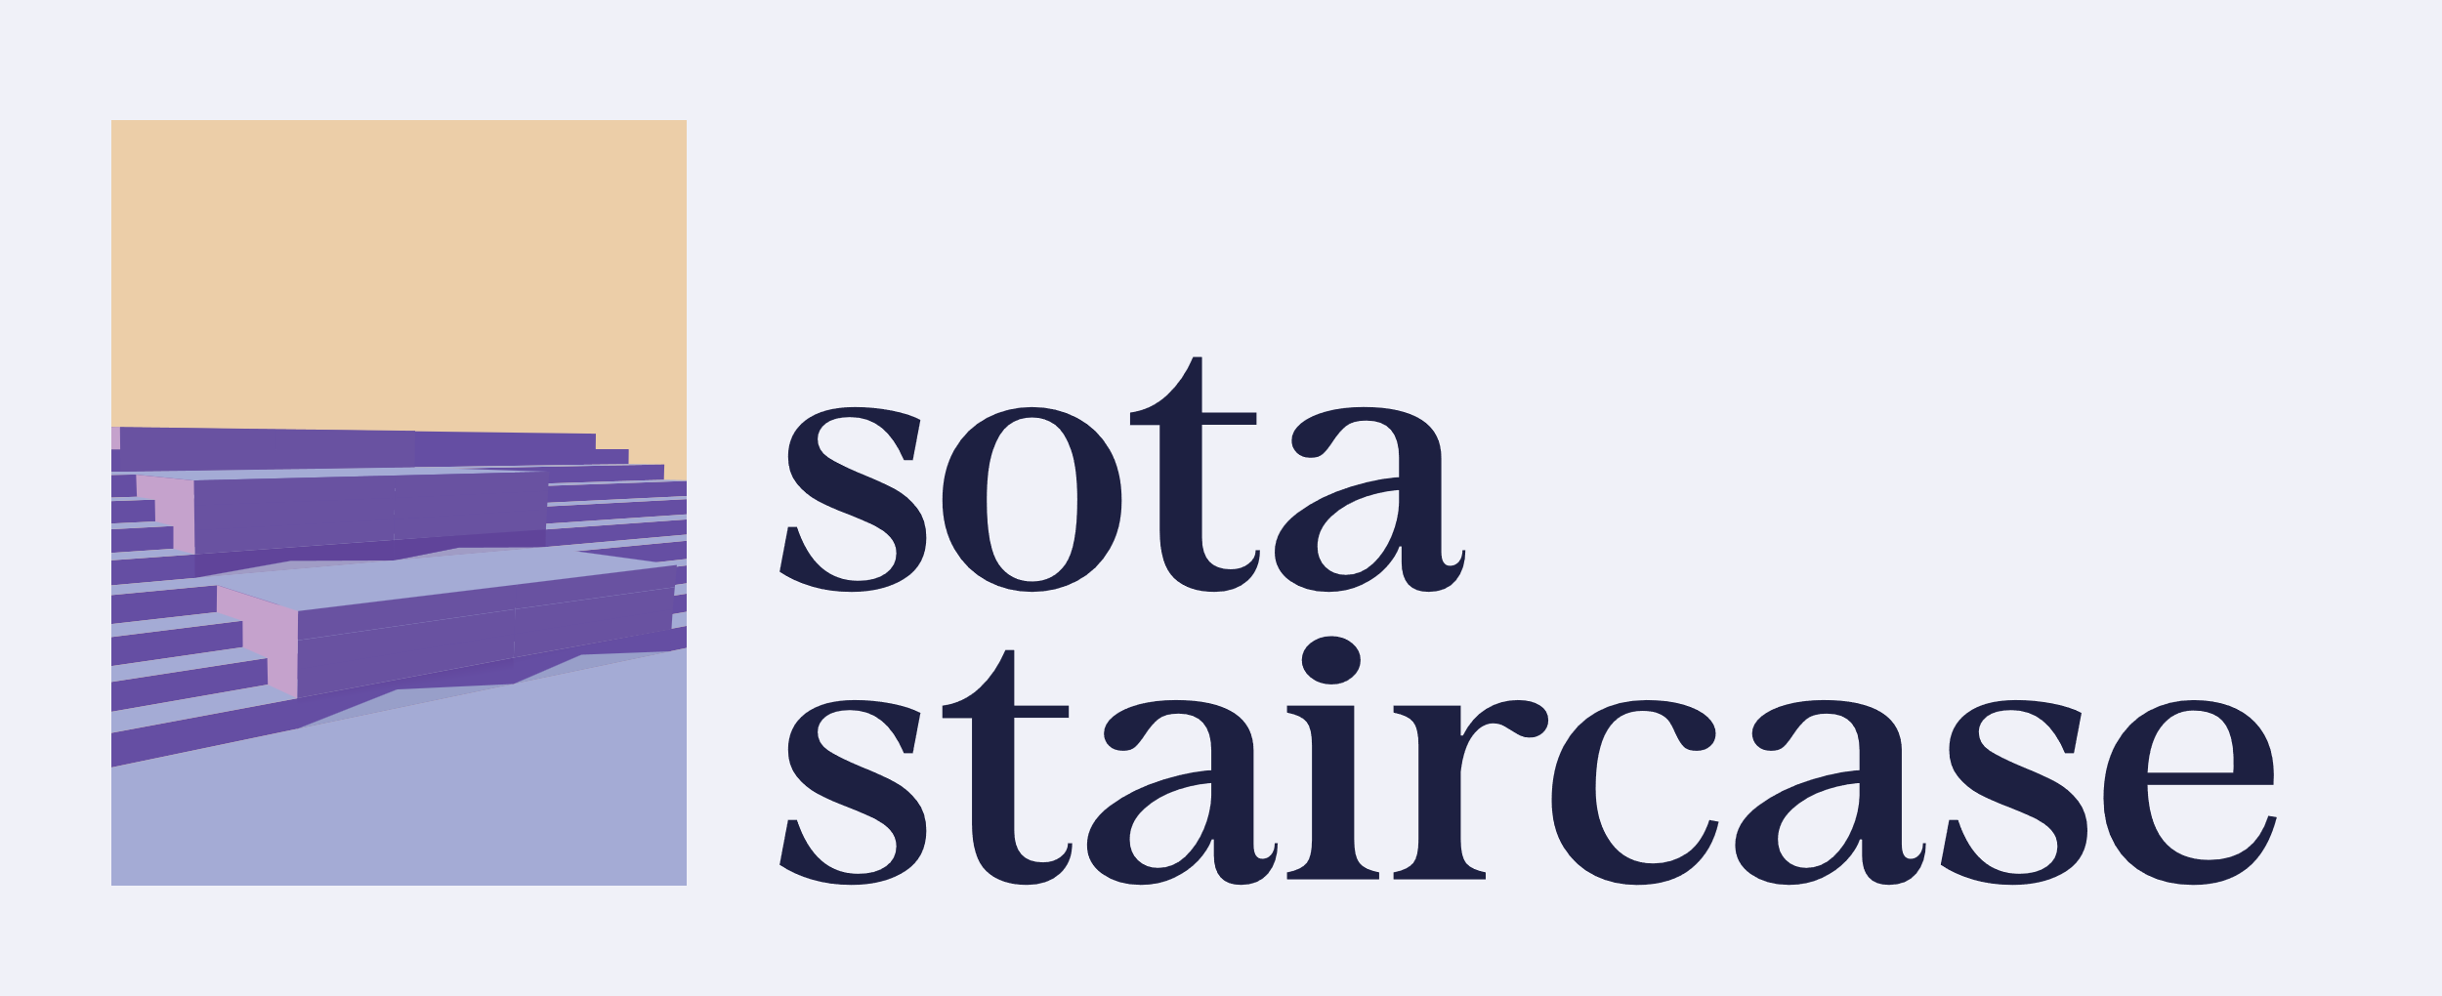
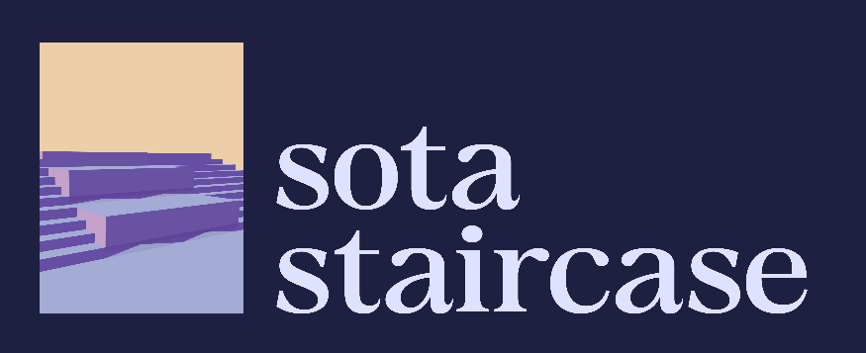
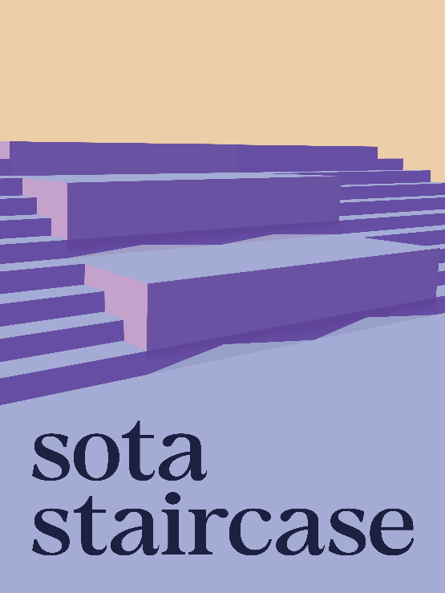
Branding Examples:


