Vowel 1
a | 684.6265 | 82.04408 | 1701833
e | 467.2935 | 35.84834 | 2279013
i | 378.2714 | 38.95234 | 2420520
o | 507.5776 | 48.14584 | 1404892
u | 423.1694 | 64.93884 | 1403106

Scatterplot
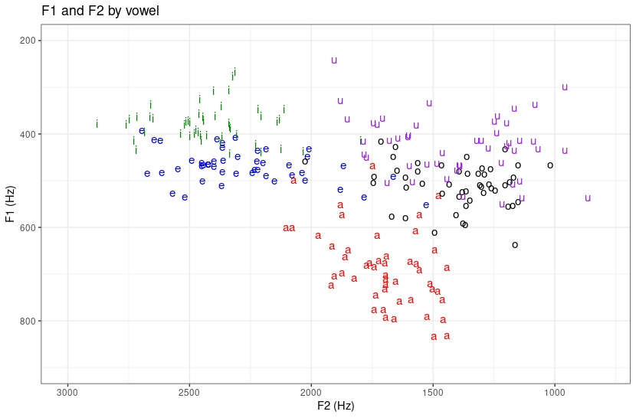

Scatterplot means

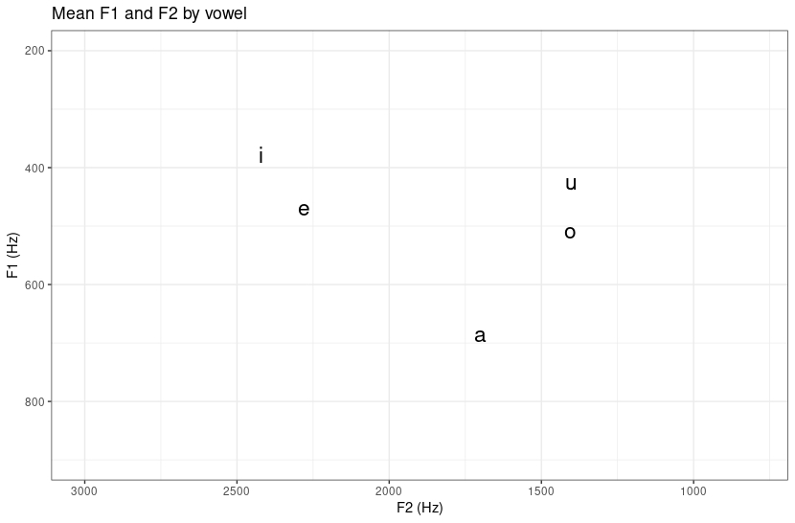

1. /i/ and /e/ have high F2 values, mostly of 2kHz. /a/ has a lower F2 between 2kHz and 1.5kHz. /o/ and /u/ have low F2 values ranging from about 1.75kHz to 1kHz.

/i/ and /u/ have low F1 values, /i/ being mostly between 300 Hz and 400 Hz and /u/ between about 350 Hz and 500 Hz. /e/ and /o/ are lower, with /e/ averaging around 400-500 Hz and /o/ from 400-600. /a/ has the greatest dispersion in F1, ranging from less than 600 to over 800.

2. The means scatterplot lacks information pertaining to intra-vowel dispersion of F1 and F2 values as well as overlap between different vowel clusters. These are only visible in the full scatterplot.

