****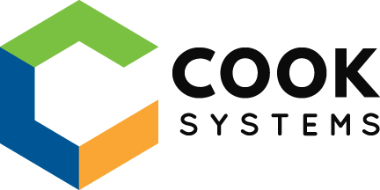

**BLANK BLANKSKI**

**PROFESSIONAL SUMMARY**

~~Blank Blankski is a skilled associate software developer whose strong work ethic, attention to detail, and adaptability makes him a valuable addition to any project. He is a graduate of the FastTrack Java Developer program with a bachelor’s degree in computer science and a background in management. Blank has displayed skills in developing, deploying, troubleshooting and maintaining Java applications. He has achieved a productive level of knowledge and skill in numerous Java frameworks such as Spring Framework and Spring MVC, Hibernate, JDBC, and Angular. Blank brings a positive outlook and a knack for problem solving to any team of which he is a member.~~

**TECHNICAL SKILLS**

**Programming:** Java, JavaScript, Angular, TypeScript, HTML5, CSS3, SQL, Spring, Spring Boot, JDBC, Jackson, JPA, jQuery, Node, webpack, Babel, Maven, npm,

**Software:** Eclipse, VS Code, Git, GitHub, cmder, pgAdmin

**Databases:**PostgreSQL

**Operating Systems:** Windows

**PROFESSIONAL EXPERIENCE**

**COOK SYSTEMS – Memphis, TN                                          09/23 – Present**

***FastTrack Developer***

*Assessment #1*

* A
* B
* C
* D

*Environment:*

*Assessment #2*

* A
* B
* C
* D

*Environment:*

*Assessment #3*

* A
* B
* C
* D

*Environment:*

**ACME Vacuum Equipment – Nashville, TN 01/19 – 10/22**

*Training and Engineering Manager*

* Tested VOC exposure of production laborers to ensure OSHA compliance
* Designed improved ventilation system for heated press to reduce exposure to toxins
* Developed production methods to improve output without increasing number of laborers
* Wrote SOP's for vane production processes to accelerate operator training

**All-Star Watersports – Gulf Shores, AL 05/16 – 10/18**

*Beach Manager*

* Organized day to day financials and rental contracts
* Managed rental schedule for 20+ pieces of equipment over two locations
* Coordinated with ownership for employee scheduling and major equipment repairs
* Maintained mechanical operation of rental fleet

**PERSONAL PROJECTS**

**EDUCATION**

**Cook Systems FastTrack Java Program – Memphis, TN           09/23 – Present**

*Concentrated Java Frameworks and developer tools training*

**Middle Tennessee State University – Murfreesboro, TN          08/17 – 05/21**

*Bachelor of Science: Computer Science*