#JulMar TAPI Service Provider Wizard
This App Wizard will help you to generate the basic shell for a 32-bit TAPI Service Provider for Windows. The generated service provider requires the JulMar Technology, Inc. TSP++ class library.

What do you want more information about?

Step 1: Welcome
Step 2: Company Information
Step 3: Basic device information
Step 4: Device configuration
Step 5: Line features
Step 6: Phone features
Step 7: Generated class names

#K$ Welcome to the TSP++ Service Provider Wizard
This App Wizard will help you to generate the basic shell for a 32-bit TAPI Service Provider for Windows. Before you begin, you should familiarize yourself with features and restrictions of the telephony hardware this TSP will control.

Project Name
The value entered in this field will be used to generate the project directory and name of the primary source files.

Path
This value, in combination with the project name, will be used as the main project directory.

My Build Environment
The TSP Wizard will automatically generate a project solution file that is compatible with Microsoft Visual Studio 6.0, Visual Studio.NET 2002, and Visual Studio.NET 2003. When using the newer versions of Visual Studio, you may need to open the project as a “legacy” project and allow VS.NET to convert it to a newer format.

#K$ Company Information
This page will allow entry of overall company information and will determine the steps taken by the TSP Wizard.

Company Name
The value entered in this field will be used to fill out the comments in the header blocks generated by the wizard in the form of: Copyright © 200n, xxxx

I plan to use SPLUI for my user-interface
This indicates that you will be generating a user-interface for your TSP and plan to use the accompanying TSP++ user-interface library to build it. This option will determine what type of initialization code is used within the TAPI service provider. If you select this option, the wizard will create a secondary project that will build your user-interface DLL. It will be stored into a sub-directory off the main project directory.

I want to manage trace events
This indicates that you want to monitor all debugging trace events that are generated by TSP++ and your source code while the TSP runs under Windows. If you would like to generate logs of the TSP operation then you should check this box.

This service provider is for Windows NT only
This indicates that the service provider will only be used under Windows NT, Windows 2000 or Windows XP. This will cause the wizard to optimize the generated code specifically for Windows NT. The generated provider will be marked for Unicode and will not load under any version of Windows 9x.

I want to use this service provider with..
This allows you to choose which version of TAPI (2.0, 2.1, 3.0) that the TSP will negotiate to. This determines the highest version of TAPI that the TSP will be able to communicate with. TSP++ will automatically negotiate down to TAPI 2.0 as its lowest version.

TAPI Version | Operating System
TAPI 2.0 | Windows NT 4.0, Windows 95
TAPI 2.1 | Windows NT 4.0, Windows 95, Windows 98
TAPI 3.x | Windows 2000, Windows XP/2003

Would you like to generate source file comments?
This determines whether the AppWizard generates comment blocks and suggestions on implementation while generating the code for your TSP.
#K$Basic Device Information
This page allows you to define basic information about the hardware this TAPI Service Provider is going to manage.

Uses Windows Sockets to communicate
This option causes the App Wizard to add support and basic initialization code for Windows Sockets™.

Uses a Serial Communications interface
This option causes the App Wizard to add support and basic initialization code for Win32 communications port management.

Uses some other form of communication

This option tells the wizard to not add any code for connecting to a serial port or windows socket.

Please enter the Provider Information for your device
This required field is used to report textual information about the TAPI Service Provider software to TAPI. Specifically, it fills in the LINEDEVCAPS and PHONEDEVCAPS dwProviderInfo fields.

Please enter the Switch Information for your device
This required field is used to report textual information about the telephony device to TAPI. Specifically, it fills in the LINEDEVCAPS and PHONEDEVCAPS dwSwitchInfo fields.

Please type the name of the structure or object
This field is used to name the structure or object that is passed to each line and phone handler in the generated TAPI Service Provider. If this is filled in, the App Wizard will assume that each event received from the telephony hardware will fill in a structure or object. It is used in all places where the object is received by code in the service provider.

Warning: Do not use a pointer or reference – type in only the name you wish to identify the objects with.

I would like TSP++ to manage my worker threads
This option tells the wizard to add code into the generated service provider to utilize the TSP++ template class CThreadPoolMgr that will manage incoming events from the telephony hardware and use groups of threads to process the requests.

#K$ Line Features
This dialog allows you to decide which line features your TAPI Service Provider is going to support. The following features are available (note that some features may be disabled based on whether the device supports incoming/outgoing call traffic).

Line Features

Called party's phone can be forced off-hook automatically
This indicates that in some cases, the destination (receiver) of a call can be automatically connected to an incoming call with no user-interaction. This happens on many ACD systems with agents receiving ACD-related calls.

Calling party's phone goes offhook automatically
This indicates that when a call is placed, no hardware interaction is required to take the phone off-hook. This is normally the case and should be selected for most hardware. Some key-systems require that the user physically pick up the handset before the software can place a call.

Can answer incoming calls
This indicates that incoming calls may be answered.

Can complete unconnected calls automatically
This indicates that outgoing calls that could not be connected may be completed in some fashion by the hardware switch. The methods might include barge-in, camp-on, call-back, etc.

Can detect digits entered by far-end party
This indicates that the device can detect pulse and/or DTMF digits dialed on an active call.

Can detect DTMF tones entered by far-end party
This indicates that the device can detect tones entered by the far-end party. Tones can include things such as billing tones for calling card access, different styles of busy tones, etc.

Can forward line/address to other destinations
This indicates that the device supports forwarding of calls received at a station.

Can generate pulse/DTMF digits on connected calls
This indicates that the device can generate pulse or DTMF information on a connected call.

Can generate tones on connected calls
This indicates that the device can generate tones on a connected call. Tones can include things such as billing tones for calling card access, different styles of busy tones, etc.

Device has incoming/outgoing trunk lines

This indicates that the device has one or more trunk connections and that the link software sends events concerning the trunk usage and seizure. If the device supports route points, then this should only be selected if there is a difference between a trunk and a route point on the target hardware.

Device has queues for incoming calls
This indicates that the device has one or more area where calls may be queued waiting for agents. This normally is available on ACD or larger PBX systems.

Stations can accept incoming calls before answer
This indicates that the device allows alerting associated with incoming calls to be separated from the initial offering of the call. This is available in environments such as Integrated Services Digital Network (ISDN).

Supports agents on stations
This indicates that the device supports agent features such as group assignment, agent state changes, etc. This is normally available on ACD systems.

Supports blind transfers
This indicates that the device supports single-step transfers.

Supports call treatments
This indicates that the device supports setting the sounds a party on a call that is unanswered or on hold hears.

Supports caller-id
This indicates that the device supports incoming caller-id.

Supports changing the dialing timeouts/delays
This indicates that the device supports changing outgoing dialing parameters such as the inter-digit timeouts, DTMF tone duration, etc.

Supports conferences
This indicates that the device supports conferencing of multiple parties together.

Supports consultation transfers
This indicates that the device supports multi-step transfers.

Supports device specific features
This indicates that you wish to support features outside the range of TAPI. This will cause the App Wizard to generate code that will override the lineDevSpecificFeature and lineDevSpecific functions of the TSP.

Supports dynamic creation of line devices
This indicates that the TSP can dynamically determine the device’s configuration and create line devices while the service provider is running.

Supports Hold/Unhold ability
This indicates that the device supports hard hold of connected calls (and returning a call in the held state to the connected state).

Supports incoming call route points
This indicates that the device has one or more incoming trunk lines which are used specifically to route calls to agents or ACD queues. This is normally used in an ACD environment.

Supports inverse multiplexing

This indicates that the device can accept multiple dialing destinations in a single dial string. If this is selected, then lineMakeCall and/or lineDial are able to deal with multiple addresses at once.

Supports manipulation/control of the media stream
This indicates that the device can perform media control actions on the connected media stream for a call. These actions can include pausing, stopping or restarting the media stream, speeding it up or down, changing the volume, etc.

Supports multiple dialtones (internal/external)
This indicates that the device generates more than one type of dial tone. This is common in PBX environments where internal calls have a different dial tone than external calls.

Supports park of calls to other extensions
This indicates that the device supports parking connected calls to specific addresses or switch-defined areas.

Supports partial dialing of numbers
This indicates that the device can handle partially-dialed input strings. This is common for modem-style devices.

Supports pickup of calls from other extensions
This indicates that the device can pickup ringing calls from other extensions.

Supports predictive dialing
This indicates that the device supports automated dialing with some form of answer-detection.

Supports Quality of Service
This indicates that the quality-of-service for media carried by this device can be selected. This is used for IP-Telephony.

Supports redirecting of incoming calls w/o answer
This indicates that incoming calls can be transferred to another destination without answering the call. Normally a one-step transfer requires answering the call first.

Supports securing the media stream from interruption
This indicates that the device can stop the media stream from being cut off prematurely, barged into, or monitored.

Supports special dialing characters

This indicates that the device supports waiting for different styles of events while dialing. An example of this would be waiting for a dial-tone before proceeding with the dial event.

Supports terminals (headset/handset/speaker)
This indicates that hardware terminal devices such as a handset, headset or speaker can be controlled by the service provider.

Supports user-to-user (UUI) information
This indicates that information may be sent between connected parties at different times during the call. This information is normally textual in nature.

Supports voice-response units (IVRs)
This indicates that the device has one or more automated voice response units which may be monitored or controlled by the service provider.

Want to support query/set of device configuration
This indicates that the device supports saving device configuration (such as QOS, data speed, etc.) and can restore it at a later point. This functionality is required for programs such as HyperTerminal.

Number of addresses per line device
This determines how many address objects are available on each line device. Each address is normally considered a dialable number on the station.

Max # of active calls per address
This determines how many calls TSP++ will allow to be in the Connected (active) state simultaneously. On most telephony hardware, only one call may be connected (although other calls may be held or waiting for a conference/transfer event).
#K$ Phone Features
This dialog allows you to decide which phone features your TAPI Service Provider is going to support. The following features are available.

Phone Features
Has buttons and/or lamps
This indicates that the phone device has one or more buttons and/or lamps that perform various functions on the switch or local unit.
Has a display device
This indicates that the phone device has a display panel which displays textual information to the user of the phone unit.
Has one or more download buffers
This indicates that the phone device has one or memory buffers where applications can store information into.
Has one or more upload buffers
This indicates that the phone device has one or memory buffers where applications can read information from.
Supports a handset, headset, or speaker
This indicates that the phone device has an I/O device that allows the user to interact with the media stream.

Supports device specific features
This indicates that you wish to support features outside the range of TAPI. This will cause the App Wizard to generate code that will override the phoneDevSpecific function of the TSP.

Supports dynamic creation of phone devices
This indicates that the TSP can dynamically determine the device’s configuration and create phone devices while the service provider is running.
Supports multiple ringer styles
This indicates that the phone unit has more than one ringer style. Some hardware uses different ring styles to indicate different types of calls (internal vs. external), and some allow the user to select the ring style they prefer.

#K$ Generated Class Names
This dialog allows you to change the names of each class created by the TSP App Wizard. The following classes might be available:

Base TSP++ Class | Description
CServiceProvider | Main object override (required)
CTSPIDevice | Hardware device management object (required)
CTSPILineConnection | Line management object (line features)
CTSPIPhoneConnection | Phone management object (phone features)
CTSPIAddressInfo | Address object (one per dialable number on a line)
CTSPICallAppearance | Call object
CTSPIConferenceCall | Conference call object

#K$Device Features
This dialog allows you to adjust the device features that are available on your telephony hardware.

Device Characteristics

Can control display, button, lamp or hook-switch elements

This indicates that the device has phone features that can be controlled by the TAPI Service Provider. This will cause a CTSPIPhoneConnection object to be generated for this project.

Can perform call-control functions on the device

This indicates that the device has line features that can be controlled by the TAPI Service Provider. This will cause a CTSPILineConnection object to be generated for this project.

Closing a line using TAPI will drop any active calls

This indicates that you want the TAPI Service Provider to disconnect any calls owned by a line when the line is closed by all TAPI applications. This is not recommended for server-based TAPI service providers.

Dropping a consultation call reconnects to original

This indicates that the device reconnects the original call when a consultation call (created for transfer or conference) is disconnected without performing the transfer or conference event. Most switches leave the original call in the consultation hold state.

Supports Incoming Call traffic

This indicates that the hardware supports incoming calls.

Supports Outgoing Call traffic

This indicates that the hardware supports outgoing calls.

Supports TAPI 3.x Media Service Provider

This indicates that the TSP will use an accompanying media service provider (MSP) for media control. This feature is only available under TAPI 3.0 or above and should only be selected if the TSP will run on a server.

Supports TAPI 3.x Call Hubs

This indicates that the TSP will support call hub tracking internally and allow TAPI to modify the call hub tracking notifications. Call hub tracking refers to the management of half-calls. This feature is only available under TAPI 3.0 or above and should only be selected if the TSP will run on a server.

Media Types

Select the different types of media that can be managed by the telephony hardware. Note that some older TAPI applications require DataModem support – even if the device is not capable of data transfers.

Overridable TSP++ objects
Base TSP++ Class | Description
CTSPIAddressInfo | Address object (one per dialable number on a line)
CTSPICallAppearance | Call object
CTSPIConferenceCall | Conference call object

#K$Accept Incoming calls dialog
This dialog allows you to select features that are available when the device supports accepting incoming calls before answering them.

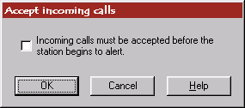

Incoming calls must be accepted before the station begins to alert.

This indicates that the station, which is the target of the incoming call, will not ring (sound an alert tone) until the station accepts the call.

Related TAPI structures:

This sets the LINEADDRESSCAPS.dwAddrCapFlags field.

See TAPI functions: lineAccept
#K$Agent properties dialog
This dialog allows you to select the agent features that are available for this device.

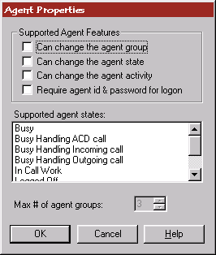

Can change the agent group

This tells the wizard that the device supports agent groups and that the agent may log into one or more of these groups to process calls. This causes the lineSetAgentGroup to be added to the service provider.

Can change the agent state

This tells the wizard that the service provider may adjust the agent state. This causes the lineSetAgentState feature to be added to the service provider.

Can change the agent activity

This tells the wizard that the service provider can change the current agent activity. Many ACDs don’t support agent activities so this will normally not be checked. This causes the lineSetAgentActivity feature to be added to the service provider.

Require agent id & password for logon

This should be checked if the device requires some kind of logon to occur before the agent is allowed to sit at a station. Most ACDs require this. TAPI 2.x has no provision for this feature so the wizard will code a work-around in the lineSetAgentGroup function in order to process agent id and password.

Supported agent states

Select the different agent states that the device can report. Note this is enabled even if you do not allow the state to be changed by the generated TSP (i.e. the Can change the agent state feature is not selected).

Max # of agent groups

This determines the total number of agent groups that may be passed in during an agent logon or a request to change the current group association. It should be set to the total number allowed by the hardware (+2 if the hardware requires agent id & password and the target platform is TAPI 2.1).

Related TAPI structures:

This dialog fills in the LINEAGENTCAPS structure reported by each line with agent abilities.

See TAPI functions: lineSetAgentGroup lineSetAgentState lineSetAgentActivity
#K$Answer properties dialog
This dialog allows you to select the behavior of the hardware when it answers an incoming call.

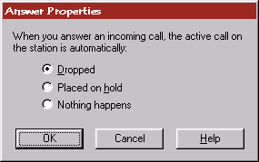

Dropped

Select this if active calls are dropped when an incoming call on the same line is answered.

Placed on hold

Select this if active calls are automatically placed on hold by the switch when an incoming call on the same line is answered.

Nothing happens

Select this if the switch performs no default action for this request or does not allow incoming calls to be answered by the station without first doing something to the active call.

Related TAPI Structures:

This sets the LINEDEVCAPS.dwAnswerMode field.

See TAPI functions: lineAnswer
#K$Call completion properties dialog
This dialog allows you to select the call completion features of your hardware device.

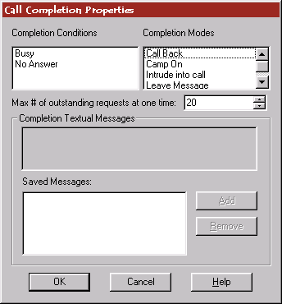

Completion Conditions

Select the different conditions where the hardware may complete non-connected calls.

Completion Modes

Select the different ways the hardware may complete non-connected calls

Max # of outstanding requests at one time

Enter the number of call completion requests that may be pending against a single line simultaneously.

Completion Textual Messages

This allows you to add switch-defined messages that the user may choose from for the completion mode Leave a Message. Type the text into the edit control and press Add to add it to the list. If you want to remove an entry, select it in the Saved Messages list and press Remove.

Related TAPI Structures:

This sets the call completion fields in the LINEADDRESSCAPS structure.

See TAPI functions: lineCompleteCall lineUncompleteCall

#K$Digit detection properties dialog
This dialog allows you to select the types of digits that may be detected by the hardware device.

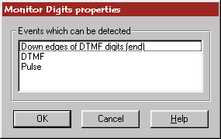

Down edges of DTMF digits

Select this if the device can detect provide application notification of DTMF down edges.

DTMF

Select this if the device can detect digits as DTMF tones.

Pulse

Select this if the device can detect digits as audible clicks from part of a rotary sequence.

Related TAPI Structures:

This sets the LINEDEVCAPS.dwMonitorDigitModes field.

See TAPI functions: lineMonitorDigits

#K$Tone detection properties dialog
This dialog allows you to identify the tone detection properties for the device to the wizard.

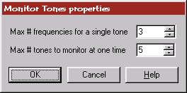

Max # frequencies for a single tone

Input the maximum number of frequencies that may be specified together as a single tone. This value should be the maximum that the service provider would ever consider monitoring for.

Max # tones to monitor at one time

Input the maximum number of tones that the service provider will monitor for on the device at one time. Depending on the other system-related activities that compete for system resources, the number of tones that can be detected can vary over time. This value should be the maximum.

Related TAPI Structures:

This sets the tone monitor fields in the LINEADDRESSCAPS structure.

See TAPI functions: lineMonitorTones

#K$Forwarding support dialog
This dialog allows you to supply the different forwarding features that are available on the telephony device.

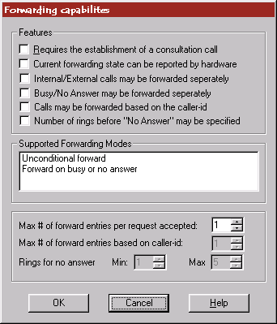

Requires the establishment of a consultation call

This indicates that forwarding on this device requires the establishment of a consultation call.

Current forwarding state can be reported by hardware

This indicates that the hardware supports querying the forwarding state and therefore the service provider will always be in synch with the hardware – even if no forwarding command has been issued by TAPI.

Internal/External calls may be forwarded separately

This indicates that internal and external calls can be forwarded to different forwarding addresses. This is meaningful only if forwarding of internal and external calls can be controlled separately.

Busy/No Answer may be forwarded separately

This indicates that call forwarding for busy and no answer can use different forwarding addresses. This is meaningful only if forwarding for busy and no answer can be controlled separately.

Calls may be forwarded based on the caller-id

This indicates that forwarding addresses can be determined by the caller and that different callers can be forwarded to different forwarding addresses.

Number of rings before “No Answer” may be specified

This indicates that the No Answer forwarding condition can specify the number of rings on the station before the call is actually forwarded.

Supported forwarding modes

Select the different conditions that can be forwarded on this device.

Max # of forward entries per request accepted

Specify the maximum number of forwarding instructions that can be sent in one request for an address. This will limit the number of TAPI forwarding structures passed on a single call to the lineForward API.

Max # of forward entries based on caller-id

This is only used if the Calls may be forwarded based on the caller-id field is checked. Specify the maximum number of forwarding instructions that contain specific caller information

Related TAPI Structures:

This sets the forwarding fields in the LINEADDRESSCAPS structure.

See TAPI functions: lineForward

#K$Generate digits properties dialog
This dialog allows you to indicate the type of digits that may be generated by the hardware device.

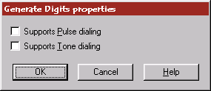

Supports Pulse dialing

This indicates that the device can generate audible to be used on a rotary dialing system.

Supports Tone dialing

This indicates that the device can generate DTMF tones.

Related TAPI Structures:

This sets the digit generation fields in the LINEDEVCAPS structure.

See TAPI functions: lineGenerateDigits

#K$Generate tones properties dialog
This dialog allows you to indicate the type of tones that may be generated by the hardware device. In each case, the tone is specific to the device and the service provider (i.e. the service provider can choose a tone which may be generated by the device and call it any of these pre-defined tones).

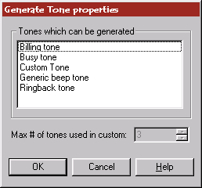

Billing tone

The device supports a billing information tone such as a credit card prompt tone.

Busy tone

The device supports a standard station busy tone.

Custom

The device supports custom tones, made up of one or more frequencies.

Generic beep tone
The device supports a beep, as used to announce the beginning of a recording.

Ringback tone

The device supports a ring tone.

Related TAPI Structures:

This sets the tone generation fields in the LINEDEVCAPS structure.

See TAPI functions: lineGenerateTone

#K$Blind Transfer properties dialog
This dialog allows you to specify restrictions placed on the single-step transfer feature of the service provider. If neither of these restrictions applies, then simply dismiss the dialog.

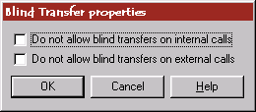

Do not allow blind transfers on internal calls
This should be checked if the device does not allow single-step transfers on a call between two internal addresses on the hardware.

Do not allow blind transfers on external calls

This should be checked if the device does not allow single-step transfers on a call connected to a trunk device.

See TAPI functions: lineBlindTransfer

#K$Call treatment properties dialog
This dialog allows you to specify the types of call treatments that the hardware supports (or that the service provider will implement for the hardware).

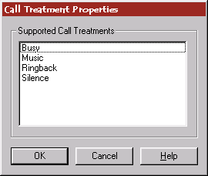

Busy
A busy signal tone.

Music

Some form of music or automated (repeated) announcement.

Ringback

A ring-back tone.

Silence

Silence.

Related TAPI Structures:

This sets the call completion fields in the LINEADDRESSCAPS structure.

See TAPI functions: lineSetCallTreatment

#K$Caller ID properties dialog
This dialog allows you to specify the types of caller-id information the hardware device is capable of reporting.

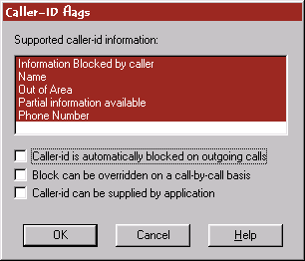

Information Blocked by Caller
The device can report when caller id information for the call has been blocked by the caller but would otherwise have been available.

Name

The device can sometimes report the name of the caller.

Out of Area

The device can report when the caller id information for the call is not available because it is not propagated all the way by the network

Partial information available

The device sometimes receives only parts of the caller-id information.

Phone Number

The device can sometimes report the number of the caller.

Caller-id is automatically blocked on outgoing calls

Specifies that the network blocks caller id information when making a call on this address.

Block can be overridden on a call-by-call basis

Specifies whether the default setting for sending or blocking of caller id information can be overridden on a per call basis.

Caller-id can be supplied by an application

Specifies that the service provider wants to allow TAPI applications to identify the caller (if they are so enabled) and will propagate this information to other requesting applications through the caller-id fields.

Related TAPI Structures:

This sets the caller-id, called-id, connected-id, redirecting-id, and redirection-id fields in the LINEADDRESSCAPS structure.

#K$Dialing properties dialog
This dialog allows you to specify the dialing time-out values which the service provider for the hardware may alter. The default values for all four entries should be filled in with the number that most closely matches the hardware behavior even if the value is not adjustable.

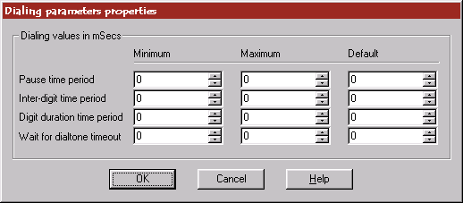

Pause time period

This is the duration in milliseconds of a comma in the dialable address. If this is not settable, then input 0 for the minimum and maximum.

Inter-digit time period

The inter-digit time period in milliseconds between successive digits while dialing a number. If this is not settable, then input 0 for the minimum and maximum.

Digit duration time period

This is the duration in milliseconds of a digit. If this is not settable, then input 0 for the minimum and maximum.

Wait for dialtone timeout

This is the maximum amount of time in milliseconds that should be waited for dialtone when a 'W' is used in the dialable address. If this is not settable, then input 0 for the minimum and maximum.

Related TAPI Structures:

This sets the LINEDIALPARAMS structures in the LINEDEVCAPS structure. The default values are used for all calls placed with the TAPI lineMakeCall API.

#K$Conference properties dialog
This dialog allows you to specify the conference features that are available on the telephony hardware.

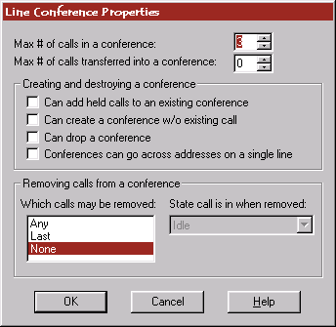

Max # of calls in a conference

Enter the maximum number of calls that may be conferenced together on a single station. This value should be the maximum that the hardware supports through any mechanism of creation (i.e. not just through the software link).

Max # of calls transferred into a conference

Enter the maximum number of calls that may be conferenced together through a transfer condition. Normally this value is 1 if this is supported. If the hardware does not support transfer to a conference, set this value to 0.

Can add held calls to an existing conference

This flag specifies whether a hard held call can be added to a conference call. Often, only calls on consultation hold may be able to be added to a conference call

Can create a conference w/o existing call

This flag specifies whether setting up a conference call starts out with an initial call.

Can drop a conference

This flag specifies whether the entire conference is dropped when the conference call itself is dropped. If the parties continue to talk together when the conference owner drops the conference then do not select this feature.

Conferences can go across addresses on a single line

This flag specifies whether conferences can be created with calls on different addresses on a single line device. In many switch environments, only calls on the same address may be conferenced together.

Removing calls from a conference – Which calls may be removed

Select which calls may be individually removed from the conference. If this is not a supported feature, select None.

State call is in when removed

Select the state the call will be in when it is removed from the conference. If a call enters this state when involved in a conference, TSP++ will automatically remove it from the conference for you. If you do not wish this behavior, select Idle.

Related TAPI Structures:

This sets the conference features in the LINEADDRESSCAPS structure.

See TAPI functions: lineSetupConference linePrepareAddToConference
lineAddToConference lineRemoveFromConference

#K$Consultation transfer properties dialog
This dialog allows you to specify the multi-step transfer features that are available on the telephony hardware.

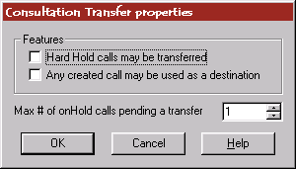

Hard Hold calls may be transferred

This flag specifies whether a hard held call can be transferred. Often, only calls on consultation hold may be able to be transferred

Any created call may be used as a destination

This flag specifies whether an entirely new call can be established for use as a consultation call on transfer.

Max # of onHold calls pending a transfer

Enter the maximum number of calls that may be in the consultation hold state simultaneously. Normally this will be 1.

Related TAPI Structures:

This sets the conference features in the LINEADDRESSCAPS structure.

See TAPI functions: lineSetupConference linePrepareAddToConference
lineAddToConference lineRemoveFromConference

#K$Hold/Unhold properties dialog
This dialog allows you to specify the hold features that are available on the telephony hardware.

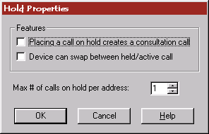

Placing a call on hold creates a consultation call
When a call on this address is placed on hold, a new call is automatically created (most likely in the dialtone state).

Device can swap between held/active call

This flag specifies that the user can alternate between a held call and a consultation call. Note that if this is not directly supported by the hardware, the service provider can support this by placing both calls on hold and retrieving the originally held call if it supports holding a consultation call. This determines whether the lineSwapHold API is available.

Max # of calls on hold per address

Enter the maximum number of calls that may be hard-held simultaneously on a single address.

Related TAPI Structures:

This sets the holding features in the LINEADDRESSCAPS structure.

See TAPI functions: lineHold lineUnhold lineSwapHold

#K$Media Control properties dialog
This dialog allows you to specify the media control features of the hardware. In TAPI, media control actions can be triggered by the detection of specified digits, media modes, custom tones, and call states.

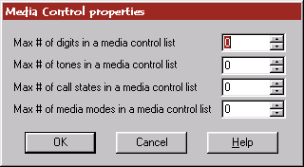

Max # of digits in a media control list

Enter the maximum number of digits that can be specified to trigger media control actions. Each time a digit in the digit list is detected, a specified media control action is carried out on the call's media stream. If digit detection is not available, enter 0.

Max # of tones in a media control list

Enter the maximum number of tones that can be specified to trigger media control actions. Each tone includes a description of the tone to be monitored, duration of the tone, and a media-control field. If a tone in the list is detected, the corresponding media control action is performed on the call's media stream. If tone detection is not available, enter 0.

Max # of call states in a media control list

Enter the maximum number of call states to monitor for which will trigger media control events. Each entry will include a call state and a media control action. Whenever the given call transitions into one of the call states in the list, the corresponding media control action is invoked. If this is not supported, enter 0.

Max # of media modes in a media control list

Enter the maximum number of media modes to monitor for which will trigger media control events. Each entry will contain a media mode to be monitored, media-type specific information (such as duration), and a media control field. If a media mode in the list is detected, the corresponding media control action is performed on the call's media stream. If the device supports only one media mode, enter 0.

Related TAPI Structures:

This sets the media control features in the LINEDEVCAPS structure.

See TAPI functions: lineSetMediaControl

#K$Dial tone properties dialog
This dialog allows you to specify the different styles of dial tones that are available on the device.

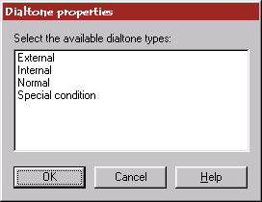

External

This is an external (public network) dial tone.

Internal

This is an internal (PBX) generated dial tone.

Normal

This is a normal dial tone, which is typically a continuous tone.

Special condition

This is a special dial tone indicating that a certain condition (known by the switch or network) is currently in effect. Special dial tones typically use an interrupted tone. An example of this is the messages waiting dial tone used by some telephone companies. Note: this indicates that the switch is ready to receive the number to be dialed

Related TAPI Structures:

This sets the available dial tone modes in the LINEADDRESSCAPS structure.

#K$Park properties dialog
This dialog allows you to specify the features available with parking calls on the hardware. On most telephony systems, only one of the two provided parking models is available.

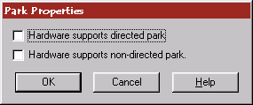

Hardware supports directed park

This indicates that the address where the call is to be parked can or must be supplied to the switch.

Hardware supports non-directed park

This indicates that the address where the call is parked can be selected by the switch and provided back to the application.

Related TAPI Structures:

This sets the available park modes in the LINEADDRESSCAPS structure.

See TAPI functions: linePark lineUnpark

#K$Pickup properties dialog
This dialog allows you to specify the features available with pickup up calls on the hardware.

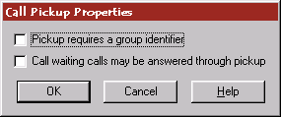

Pickup requires a group identifier

This flag specifies whether a group identifier is required for call pickup.

Call waiting calls may be answered through pickup

This flag specifies that the TAPI function linePickup can be used to pick up a call for which the user has audibly detected the call-waiting signal but for which the provider is unable to perform the detection.

Related TAPI Structures:

This sets the pickup features in the LINEADDRESSCAPS structure.

See TAPI functions: linePickup

#K$Predictive dialer properties dialog
This dialog allows you to specify the features available for the predictive dialer on the hardware.

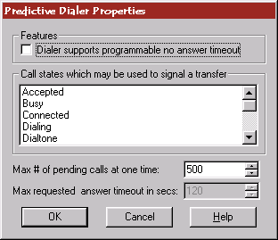

Dialer supports programmable no answer timeout

This flag specifies that the time interval the predictive dialer waits for an answer from a dialed call can be specified. This enables the Max requested answer timeout field.

Call states which may be used to signal a transfer

Select each of the call states that cause the predictive dialer to transfer the call. If the dialer does not support automatically transferring a call, do not select any entries.

Max # of pending calls at one time

Enter the maximum number of simultaneous predictive calls that the predictive dialer hardware can place at one time. If this is not a constant (i.e. dependant on system resources or some other unavailable value) then pick a reasonably high number.

Max requested answer timeout in secs

Enter the maximum time interval the predictive dialer waits for an answer from a dialed call in seconds.

Related TAPI Structures:

This sets the predictive dialer features in the LINEADDRESSCAPS structure.

See TAPI functions: lineMakeCall

#K$Secure media stream properties dialog
This dialog allows you to specify the properties of the secure data stream features of the hardware.

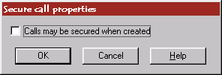

Calls may be secured when created

This flag specifies whether or not calls on this address can be made secure at call-setup time.

Related TAPI Structures:

This sets the secure media stream features in the LINEADDRESSCAPS structure.

See TAPI functions: lineSecureCall

#K$Terminal properties dialog
This dialog allows you to enter information about each available hardware terminal on the device.

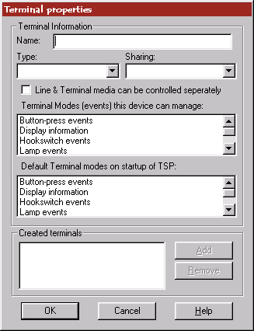

Name

Enter a textual name to represent this terminal; an example might be Phone handset.

Type

Select the type of terminal from the list
- Phone
- Headset
- Speaker

Sharing

Select how the terminal device is shared between line devices.
- Private – private to a single line
- Shared exclusive – the terminal device can be used by multiple lines, one at a time.
- Shared merged – the terminal device can be used by multiple lines, all merged.

Line & Terminal media can be controlled separately

This flag specifies whether the media stream between the line and the terminal device can be controlled independently of each other. If the routing of both unidirectional channels of a call's media stream can be controlled independently, select this option.

Terminal modes

Select each of the events that the device can process or manage.

Default terminal modes

Select each of the events that are passed to/from the line and terminal when no specific command has been sent to the hardware (i.e. on startup).

Created Terminals

This is the list of created terminals. To create a new terminal, enter all the above information and press Add. To remove a created terminal, select the terminal from the list and press Remove.

Related TAPI Structures:

This sets the terminal information in the LINEDEVCAPS structure.

See TAPI functions: lineSetTerminal

#K$User-to-User information properties dialog
This dialog allows you to enter information about the types of user-to-user information that is supported on the hardware.

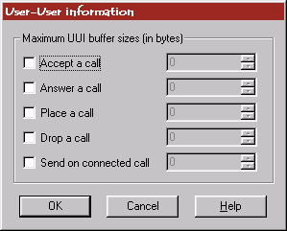

Accept a call

Select this if the device can send UUI during the accepting of an incoming call. Enter the maximum number of bytes that can be sent in the edit control.

Answer a call

Select this if the device can send UUI during the answering of an incoming call. Enter the maximum number of bytes that can be sent in the edit control.

Place a call

Select this if the device can send UUI during the creation of an outgoing call. Enter the maximum number of bytes that can be sent in the edit control.

Drop a call

Select this if the device can send UUI when an active call is dropped. Enter the maximum number of bytes that can be sent in the edit control.

Send on connected call

Select this if the device can send UUI at some point on an active call. Enter the maximum number of bytes that can be sent in the edit control.

Related TAPI Structures:

This sets the UUI information in the LINEDEVCAPS structure.

See TAPI functions: lineSendUserUserInfo

#K$Dialing character properties dialog
This dialog allows you to specify which events the hardware can wait on when dialing a number.

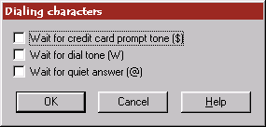

Wait for credit card prompt tone

Select this if the device can detect and wait for credit card prompt tones while dialing a number.

Wait for dial tone

Select this if the device can wait for a dial tone while dialing a number.

Wait for quiet answer

Select this if the device can wait for quiet answer before dialing the remainder of the dialable address. This means to wait for at least one ringback tone followed by several seconds of silence.

Related TAPI Structures:

This sets the available dialing properties in the LINEDEVCAPS structure.

See TAPI functions: lineMakeCall lineDial

#K$Phone display properties dialog
This dialog allows you to specify the features associated with the phone display for the hardware device. The display is an alphanumeric area with rows and columns.

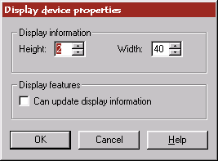

Height

Enter the height in characters of the display unit.

Width

Enter the width in characters of the display unit.

Can update display information

Select this if the link software allows you to change the display adding your own information or comments.

Related TAPI Structures:

This sets the available display properties in the PHONECAPS structure.

See TAPI functions: phoneSetDisplay

#K$Phone buffer properties dialog
This dialog allows you to specify the number and sizes of the upload/download buffers associated with the phone. TSP++ doesn’t require that the buffers are the same (although on many devices they will be).

You must enter each set of buffers separately – the download and upload buffers are separate dialogs but they are identical in functionality to each other.

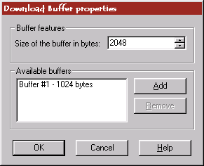

Size of the buffer in bytes

Enter the size of the buffer to add in bytes.

Available buffers

This lists the buffers that have been added to the phone unit.

Add

This adds a buffer of the size listed in the top edit control.

Remove

This removes the selected buffer from the available list.

Related TAPI Structures:

This sets the upload/download buffer sizes in the PHONECAPS structure.

See TAPI functions: phoneSetData phoneGetData

#K$Phone buttons and lamps properties dialog
This dialog allows you to identify the buttons and lamps available on the hardware device.

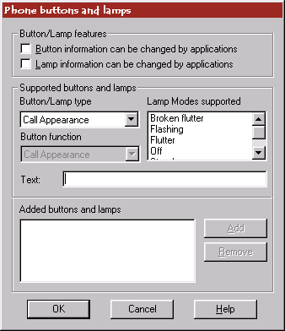

Button information can be changed by applications

Check this if the link software allows updates of soft buttons directly through software.

Lamp information can be changed by applications

Check this if the link software allows the lamp states to be changed through software.

Button/Lamp type

Select the type of button or lamp this is
- Call Appearance – The button represents a call button.
- Display Button – The button requests information for the display.
- Lamp only – The entry has no associated button.
- Local Station Feature – The button invokes a feature on the station, such as muting the microphone or changing the volume level.
- Switch Feature – The button invokes a switch feature, such as placing a call on hold or transferring a call.

Lamp Modes supported

Select each of the lamp styles that are supported by the button/lamp.
- Broken Flutter – This is the superposition of flash and flutter.
- Flashing – slow on and off.
- Flutter – fast on and off.
- Off – The lamp is dark.
- Steady – The lamp is on
- Winking – The lamp is winking.

Button Function

Select the function of the button. In some cases, this is selected for you based on the button mode. The list of functions is specific to the mode supplied for the button and some entries listed below may not be available for a given button mode
- Bridged Appearance – Selects a particular appearance of a bridged address.
- Call Appearance – Selects a particular call appearance.
- Caller ID – Requests display of caller ID on the phone's display.
- Camp On – Camps-on an extension that returns a busy indication. When the remote station returns to idle, the phone will be rung with a distinctive pattern. Picking up the local phone reinitiates the call.
- Conference – The button invokes a conference
- Cover – Forwards all calls destined for this phone to another phone used for coverage.
- Data Off – Indicates that the next call is not a data call.
- Data On – Indicates that the next call is a data call
- Date/Time – Requests the current date and time from the switch to be displayed.
- Directory – Pulls up a switch directory
- Disconnect – Disconnects a call, such as after initiating a transfer.
- Do not disturb – Places the phone in "do not disturb" mode; incoming calls receive a busy signal or are forwarded to an operator or voice mail system.
- Drop call – Disconnect an active or held call.
- Flash – Flash over to another call – invokes a flash hook event.
- Forward – The button invokes the forwarding feature of the switch.
- Hold – Places the active call on hold.
- Intercom – Connects the phone to the intercom system.
- Make Busy –
- MsgWait On/Off – Controls the message-waiting lamp.
- MsgWaitOff – Turns the message waiting lamp off
- MsgWaitOn – Turns the message waiting lamp on
- Mute – Mutes the hook-switch device.
Night Service – Places the phone in the mode it is configured for during night hours.
- None – The button has no function.
- Not listed – The button has a function but it is not defined by TAPI.
- Park – Parks the active call on the switch.
- Pickup – Allows the station to pickup a call ringing on another extension.
- Program Speed Dial – Speed dial button.
- Queue Call – Queues the active call to the ACD.
- Recall – Recall a call from hold.
- Reconnect – Reconnect to a call during a consultation event – if the consultation is canceled for example.
- Redial last number – Redial the last number dialed.
- Redirect – Redirect a ringing call to another station.
- Reject call – Reject an incoming call.
- Repetory Dialing – Repertory dialing—the number to be dialed is provided as a shorthand following pressing of this button.
- Ring Again – Initiates a request to be notified if a call cannot be completed normally because of a busy signal or no answer.
Save Repeat – When pressed while a call or call attempt is active, it will remember that call's number or command. When pressed while no call is active (such as during dial tone), it repeats the most saved command.
- Select Ring – Select the ring style for the station.
- Send Calls – Sends all calls to another phone used for coverage.
- Set RepDial – Programs the shorthand-to-phone number mappings accessible by means of repertory dialing (the "REPDIAL" button).
- Speaker Off – Turn the speakerphone off.
- Speaker On – Turn the speakerphone on.
- Speed Dial – The number to be dialed is provided as a shorthand following pressing of this button. The mappings for station speed dialing are specific to this station (phone).
- Transfer – The button invokes a transfer
- Volume Dn – Adjust the volume of the station up.
- Volume Up – Adjust the volume of the station down.

Text

Enter the text printed on or next to the button to identify it to applications by name.

Button List

This lists all the buttons added to the system.

Add

This adds a button in the list.

Remove

This removes the selected button from the list.

Related TAPI Structures:

This sets the button properties in the PHONECAPS structure.

See TAPI functions: phoneSetButtonInfo phoneSetLampInfo

#K$Phone hook switch properties dialog
This dialog allows you to identify the hook switch devices available on the hardware device.

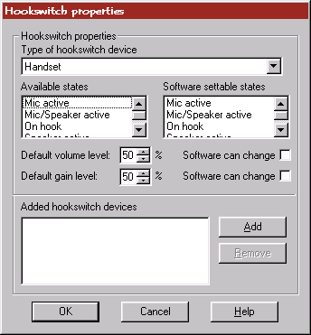

Type of hook-switch device

Select the type of hook-switch device.

Available states

Select each of the states that can be reported by the hardware for this hook-switch device.

Software settable states

Select each of the states that can be set by the software for this hook-switch device. If the hook-switch is read-only (i.e. only changeable by the hardware) then clear all selections from this box.

Default volume level

Enter the default volume level in percentage. This is the level for the unit when the TSP first initializes.

Software can change

Check this if the volume/gain can be changed through software.

Default gain level

Enter the default gain level in percentage. This is the level for the unit when the TSP first initializes.

Hookswitch list

This lists all the added hook-switch devices.

Add

This adds the given hook-switch device to the list.

Remove

This removes the selected button from the list.

Related TAPI Structures:

This sets the hook-switch properties in the PHONECAPS structure.

See TAPI functions: phoneSetHookswitch phoneSetVolume phoneSetGain

#K$Phone ringer properties dialog
This dialog allows you to specify the number of ringer styles available on the device.

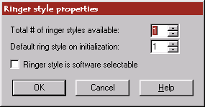

Total # of ringer styles available

Enter the total number of ringer styles that are available on the device.

Default ring style on initialization

Enter the default ring style used by the device.

Ringer style is software selectable

Check this if the software can change the ringer style.

Related TAPI Structures:

This sets the ringer properties in the PHONECAPS structure.

See TAPI functions: phoneRing

contents
HIDD_CUSTOM0
Introduction
Welcome
HIDD_CUSTOM1
Collecting company Information
Company Information
HIDD_CUSTOM2
Collecting device information
Basic device information
HIDD_CUSTOM3
Determining supported line features
Line Features
HIDD_CUSTOM4
Determining supported phone features
Phone features
HIDD_CUSTOM5
Changing the generated class names
Generated class names
HIDD_CUSTOM2_3
Determining device features
Primary device features
HIDD_ACCEPT
Supporting accepting of alerting calls
TAPI lineAccept support
HIDD_AGENTPROP
Agent support and management
Agent support
HIDD_ANSWER
Answer support
Answering calls
HIDD_CALLCOMPL
Call Completion support
Completing non-connected calls
HIDD_MONITORD
Digit monitoring support
Monitoring digits on a connected call
HIDD_MONITORTONE
Tone monitoring support
Monitoring tones on a connected call
HIDD_FORWARD
Forwarding support
Forwarding lines and addresses
HIDD_GENERATEDIGITS
Digit generation support
Generating digits on a connected call
HIDD_GENERATET
Tone generation support
Generating tones on a connected call
HIDD_BLINDXFER
Blind transfer support
Managing single-step (blind) transfers
HIDD_CALLTREATMENT
Call treatment support
Handling call treatments
HIDD_CALLERID
Caller-id support
Handling caller-id
HIDD_DIALPARAMS
Dialing parameters
Adjusting the dialing limits and timeout values
HIDD_CONFERENCE
Conference parameters
Supporting conferences
HIDD_TRANSFER
Transfer parameters
Supporting multi-step (consultation) transfers
HIDD_HOLD
Hold/Unhold parameters
Supporting held calls
HIDD_MEDIACONTROL
Media control parameters
Triggering media control events
HIDD_DIALTONES
Dial tone types
Managing different dial tones
HIDD_PARK
Park mode types
Parking calls on the system
HIDD_PICKUP
Pickup features
Picking up calls on the system
HIDD_PREDDIALER
Predictive dialer features
Managing predictive dialing
HIDD_SECURE
Secure media stream features
Securing calls on the system
HIDD_TERMINALS
Terminal device features
Creating terminal devices
HIDD_UUIPROP
User-to-User features
Specifying types of user-to-user information (UUI)
HIDD_DIALCHARS
Special dialing characters
Special dialing characters
HIDD_DISPLAY
Phone display properties
Phone display properties
HIDD_UPDOWNBUFF
Phone buffer properties
Phone buffer properties
HIDD_BUTTONS
Phone button and lamp properties
Phone button and lamp properties
HIDD_HSWITCH
Phone hook-switch properties
Phone hook-switch properties
HIDD_RINGERS
Phone ringer properties
Phone ringer properties

