This revision keeps 48 full-precision fine-tunes — 18 mental-health, 20 medical, and 10 safety — each with one full-precision instruction-tuned parent (27 parents) and a stated training dataset, weight-update method, and training objective.
The benchmarks add Reddit C-SSRS and MHB-Safety, the suicide and self-harm conversations from MentalHealthBench, and drop the screens for an inappropriate therapy request and for the model delivering therapy.
The regression is now a linear mixed model with a random intercept for each instruction-tuned parent and its fine-tunes.

Figure 1
Available models by family, parameter weight, and training type.
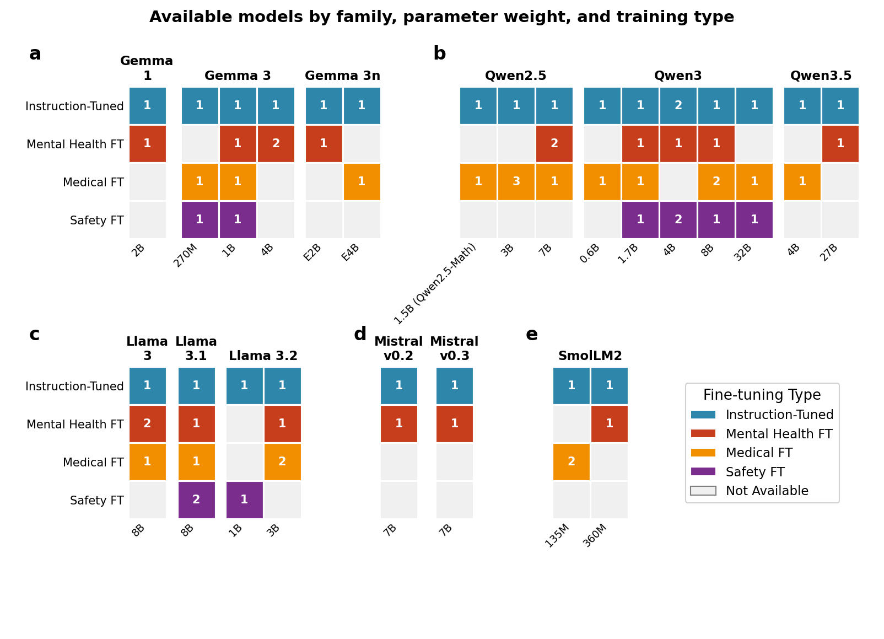
main-figures/figure-1.png

Figure 2
Score versus parameter count for each task.
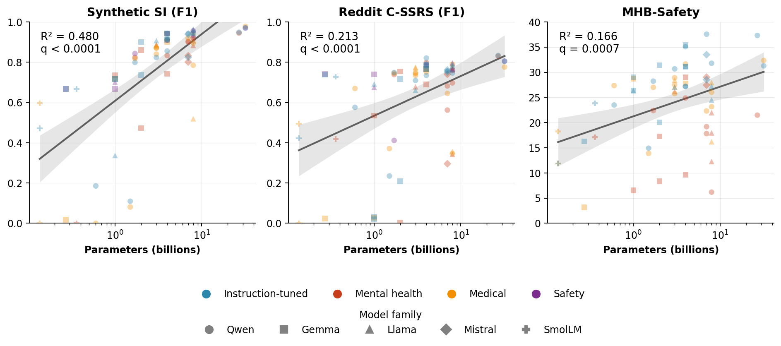
main-figures/figure-2.png

ALTERNATIVE Figure 2 (to discuss with John)
Score against parameter count, one row per training type. A solid line is a fit with Benjamini–Hochberg q below 0.05. A dotted line is a fit with q of 0.05 or higher.
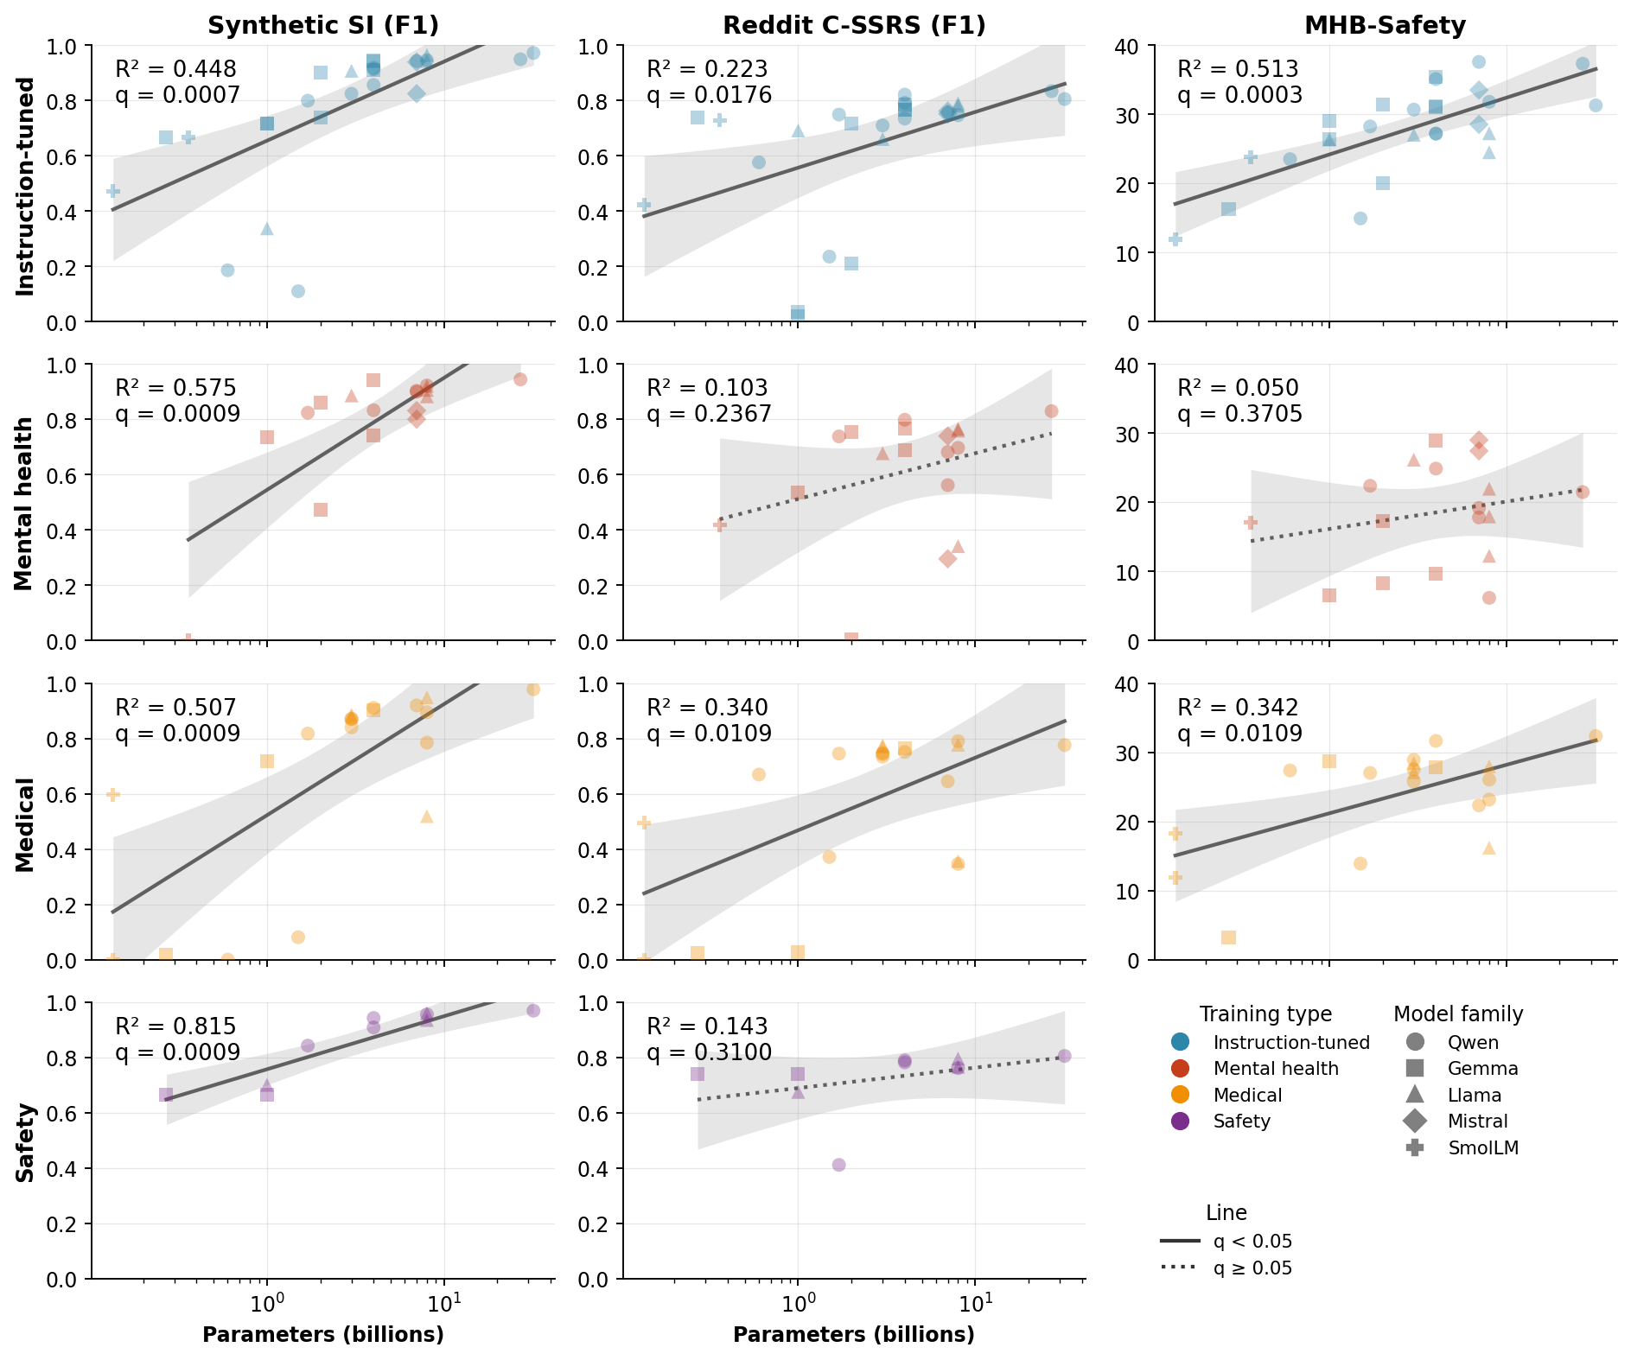
main-figures/figure-2-by-type.png

Figure 3
Fine-tune score and the instruction-parent score.
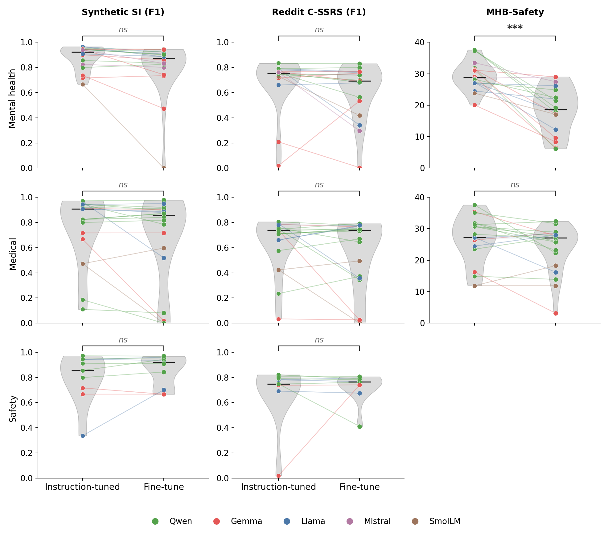
main-figures/figure-3.png

Table 1. Score by size, version, family, and fine-tune type
Term | Suicidal-ideation yes/no F1 |  | C-SSRS yes/no F1 |  | MHB-Safety
 | β (95% Wald CI) | q | β (95% Wald CI) | q | β (95% Wald CI) | q
Parameter count, per doubling | 0.122 (0.066 to 0.178) | <0.001*** | 0.038 (−0.003 to 0.079) | 0.168 | 0.019 (0.005 to 0.033) | 0.040*
Version rank, per step | 0.049 (−0.074 to 0.173) | 0.547 | 0.105 (0.016 to 0.193) | 0.084 | 0.032 (0.004 to 0.061) | 0.088
Mental-health fine-tune | −0.073 (−0.167 to 0.021) | 0.250 | −0.050 (−0.167 to 0.068) | 0.533 | −0.094 (−0.128 to −0.059) | <0.001***
Medical fine-tune | −0.106 (−0.198 to −0.013) | 0.088 | −0.101 (−0.215 to 0.012) | 0.180 | −0.025 (−0.058 to 0.008) | 0.250
Safety fine-tune | 0.036 (−0.077 to 0.150) | 0.605 | 0.038 (−0.101 to 0.177) | 0.638 | — | —
Llama vs Gemma | −0.090 (−0.370 to 0.189) | 0.605 | 0.149 (−0.046 to 0.345) | 0.250 | 0.011 (−0.055 to 0.077) | 0.772
Mistral vs Gemma | −0.110 (−0.466 to 0.245) | 0.605 | 0.134 (−0.130 to 0.399) | 0.440 | 0.087 (0.002 to 0.172) | 0.116
Qwen vs Gemma | −0.134 (−0.375 to 0.107) | 0.401 | 0.189 (0.016 to 0.363) | 0.094 | 0.033 (−0.024 to 0.091) | 0.389
SmolLM vs Gemma | 0.042 (−0.319 to 0.403) | 0.819 | 0.188 (−0.075 to 0.450) | 0.274 | 0.054 (−0.032 to 0.140) | 0.355
Intercept | 0.628 (0.416 to 0.840) | <0.001*** | 0.369 (0.209 to 0.528) | <0.001*** | 0.187 (0.135 to 0.239) | <0.001***

Figure S1
Mental-health funnel.
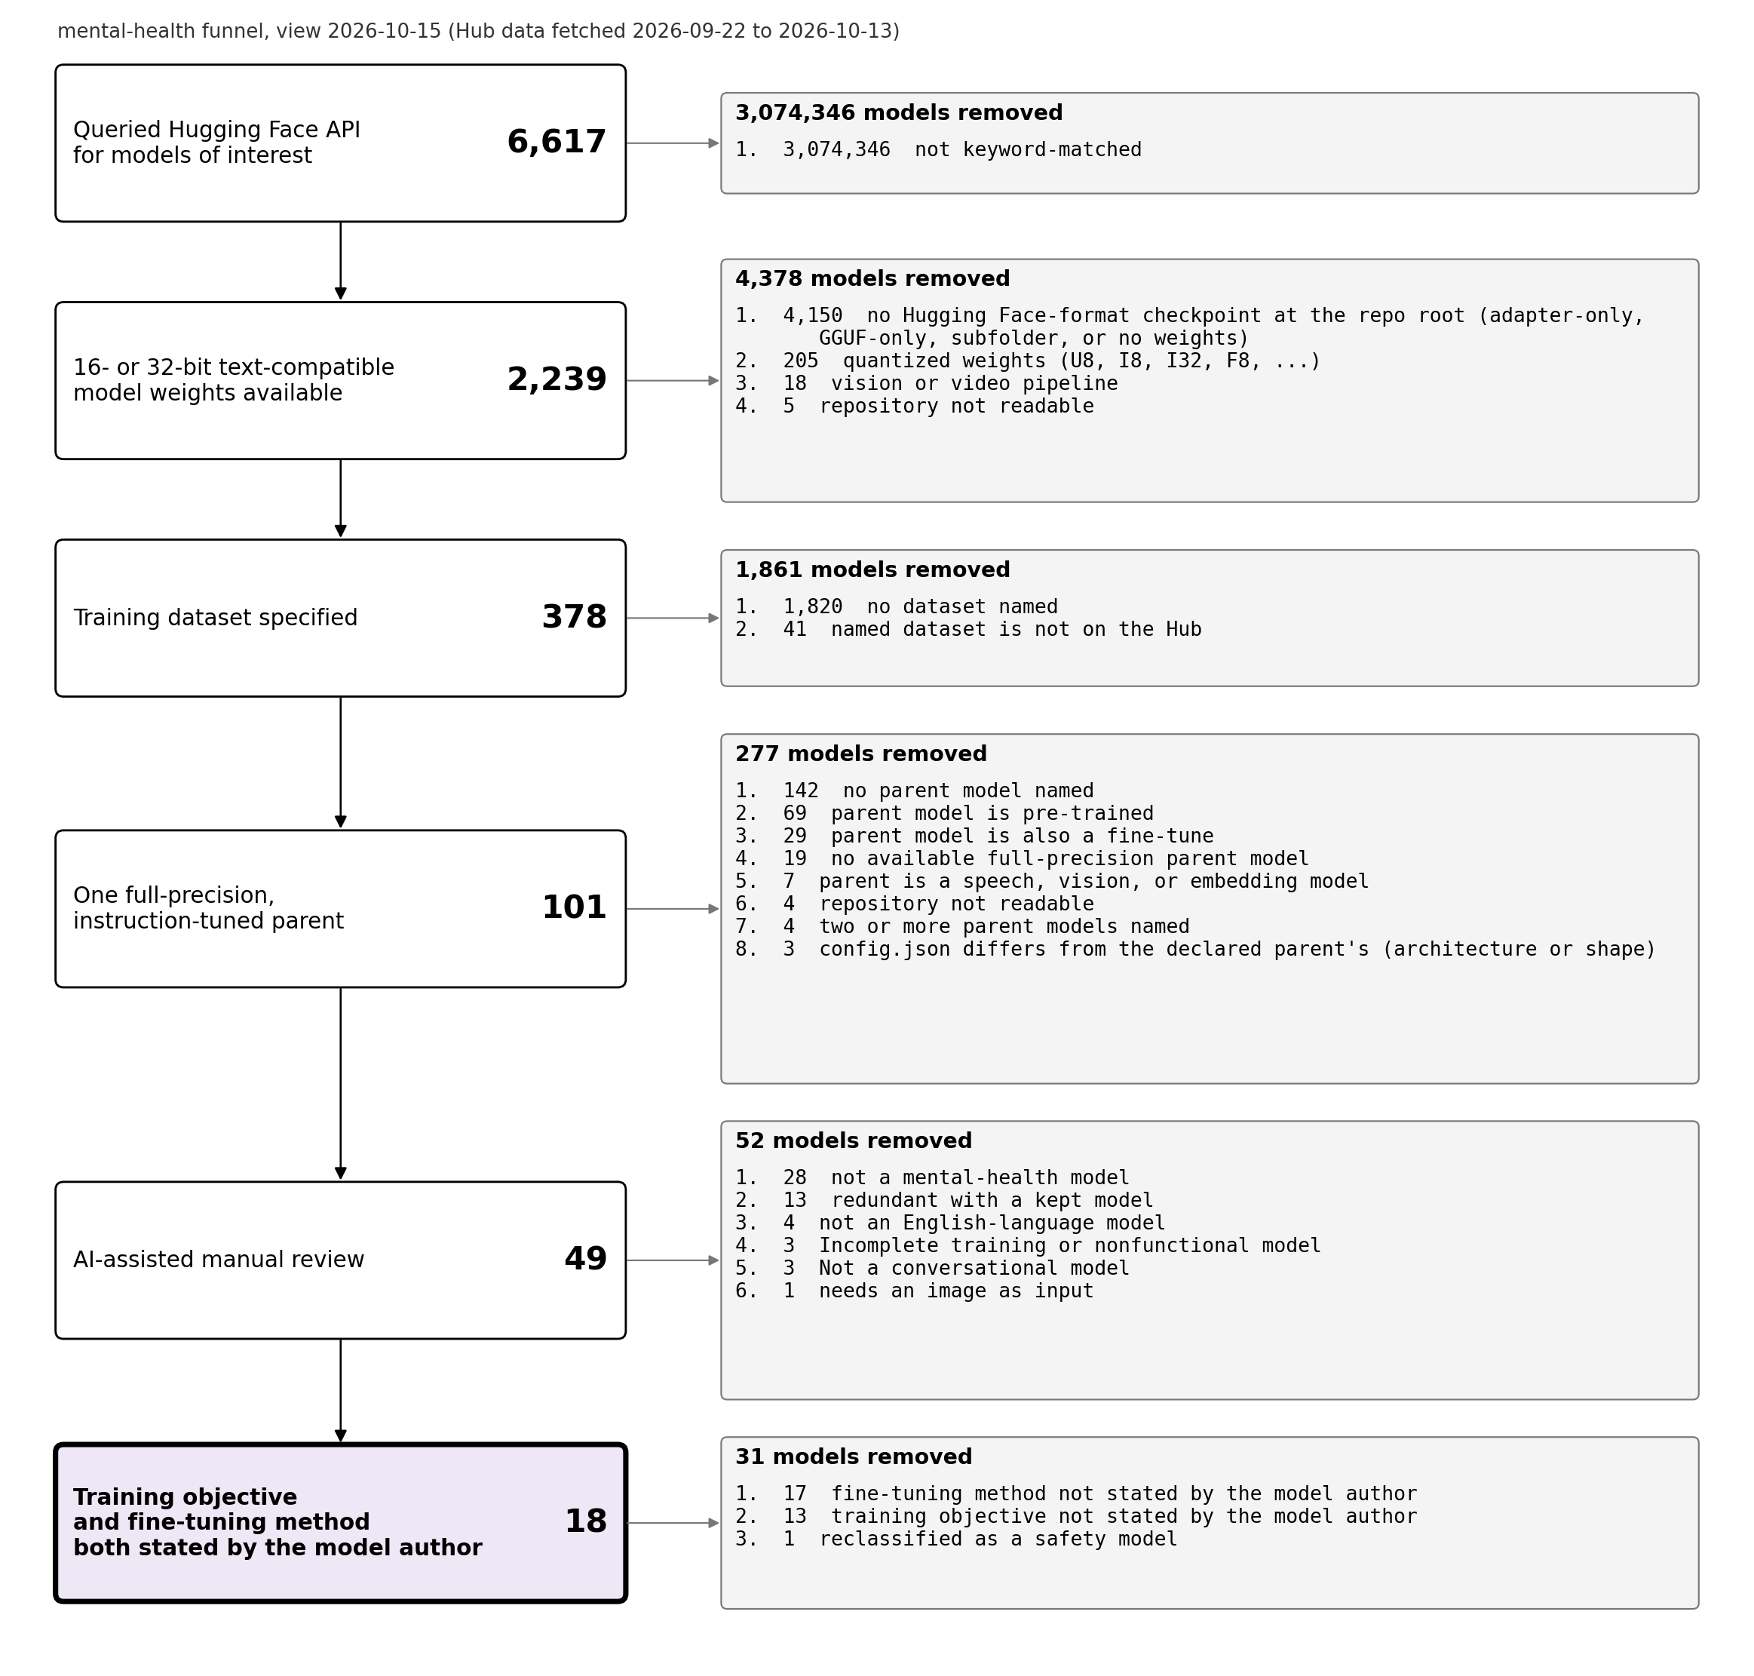
supp-figures/figure-s1.png

Figure S2
Medical funnel.
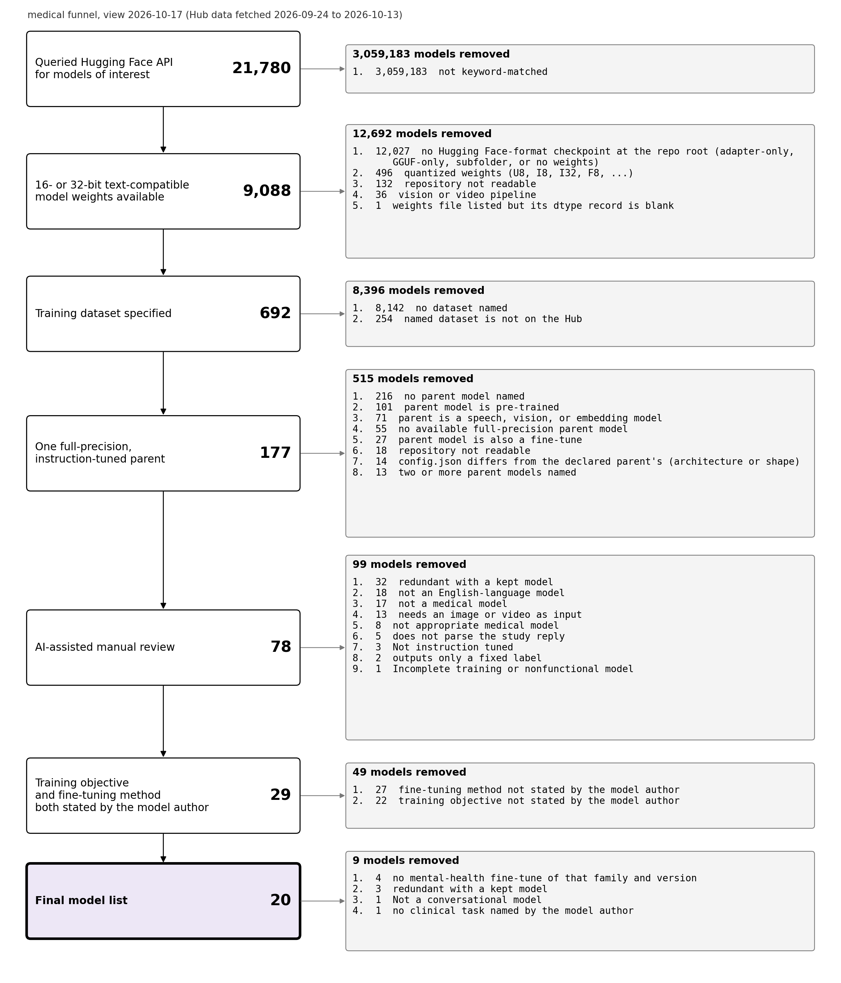
supp-figures/figure-s2.png

Figure S3
Safety funnel.
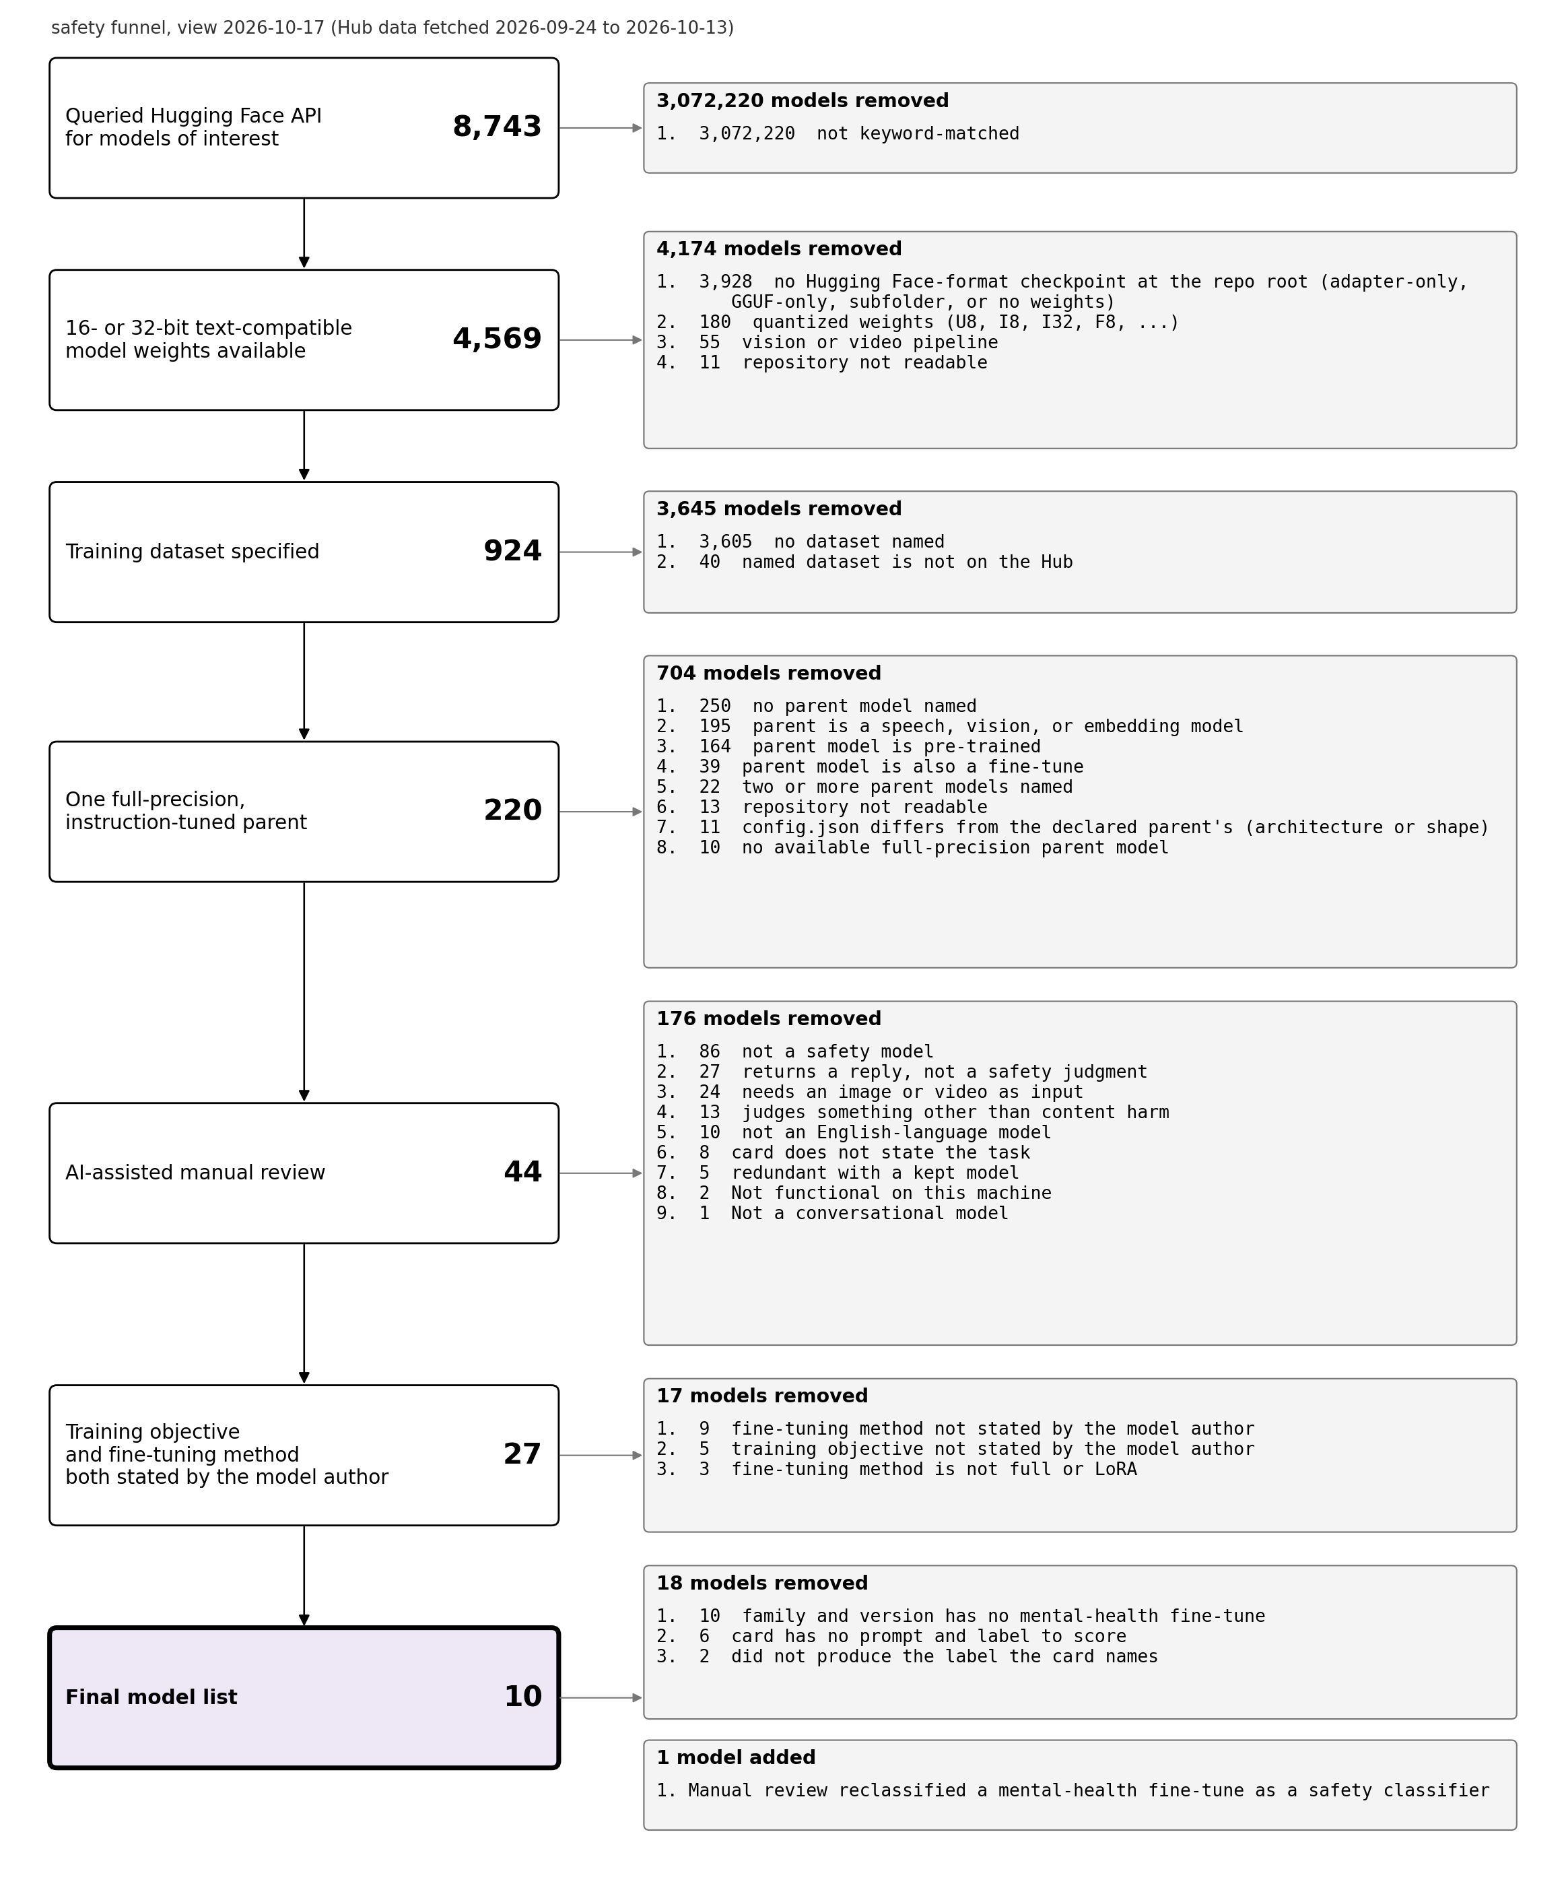
supp-figures/figure-s3.png

Figure S4
Yes/no replies recovered by the stored labels.
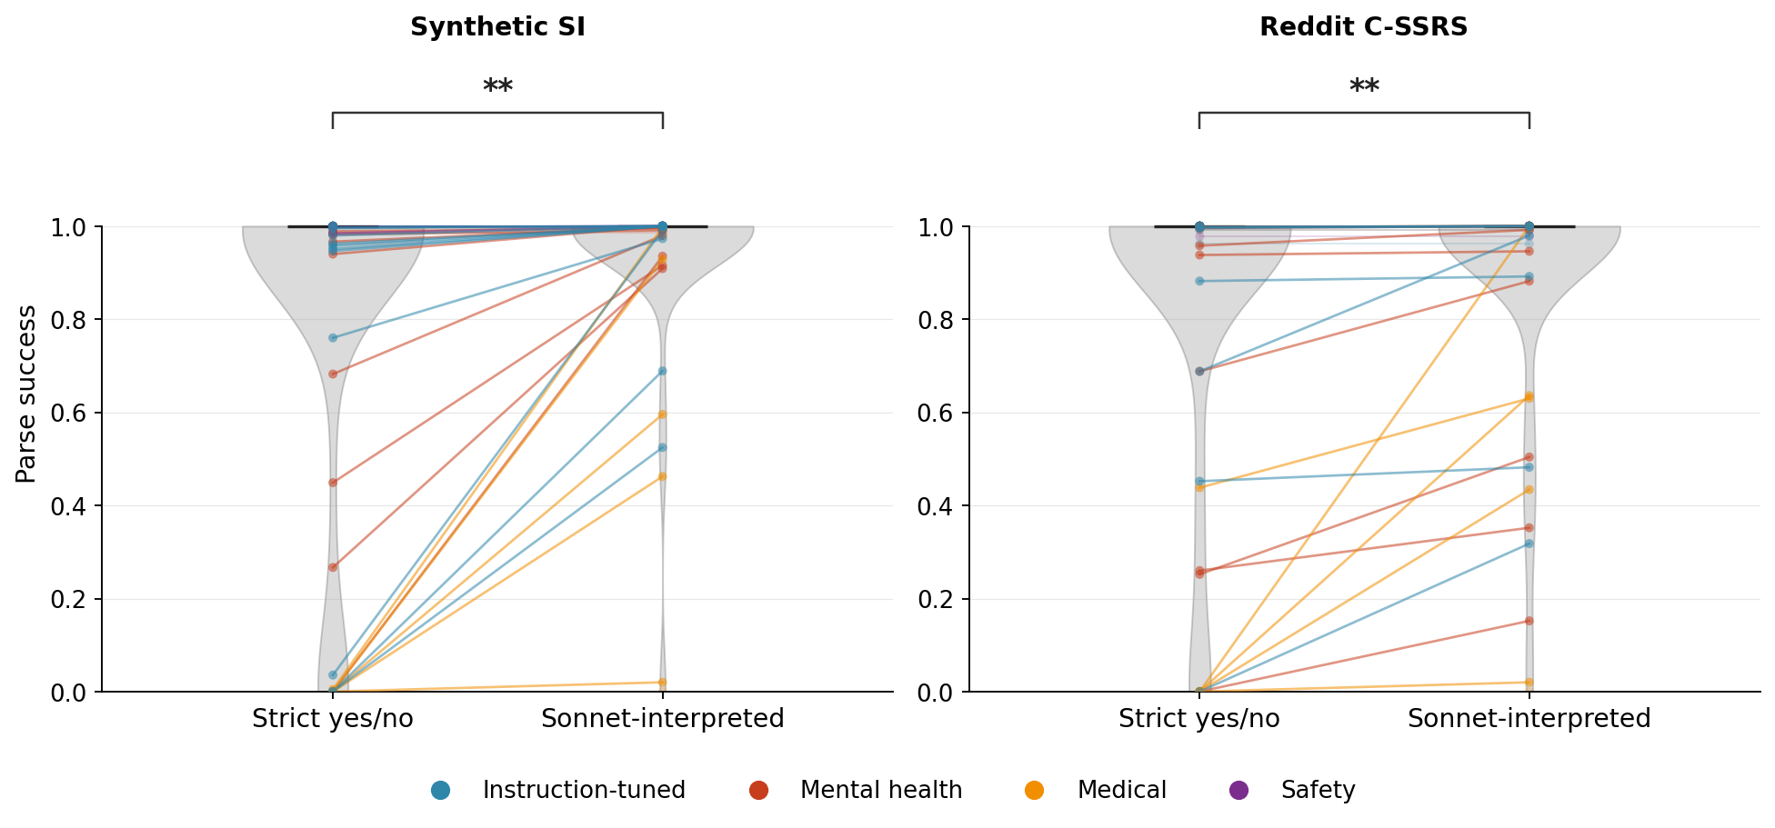
supp-figures/figure-s4.png

Figure S5
Qwen scores.
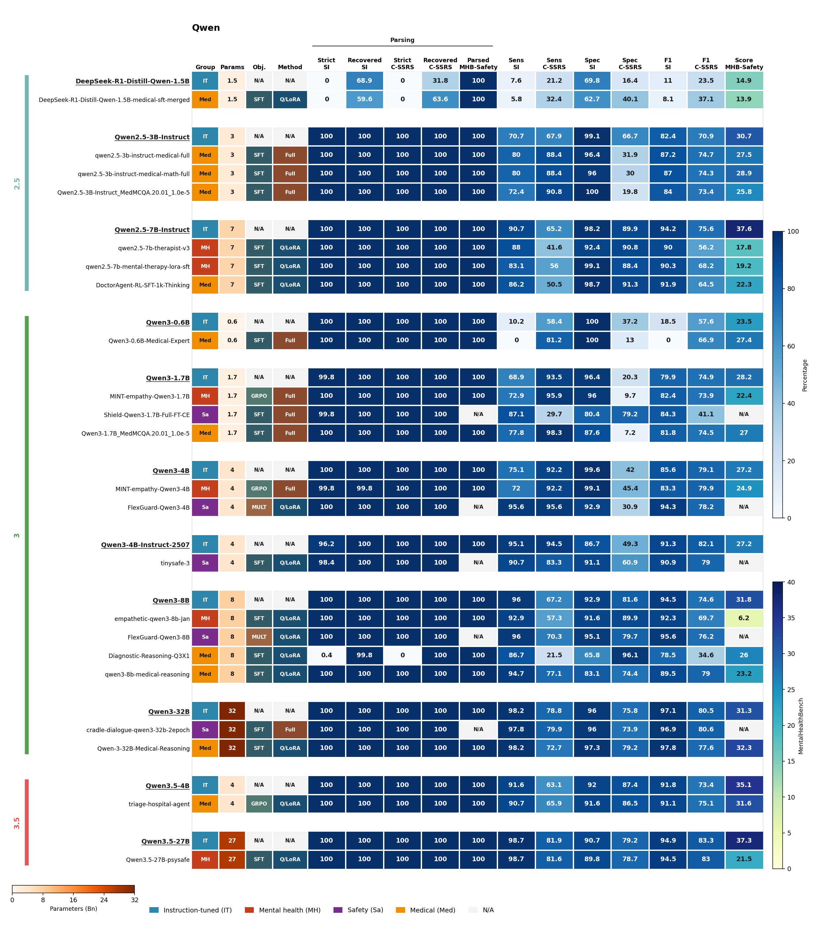
supp-figures/figure-s5.png

Figure S6
Gemma scores.
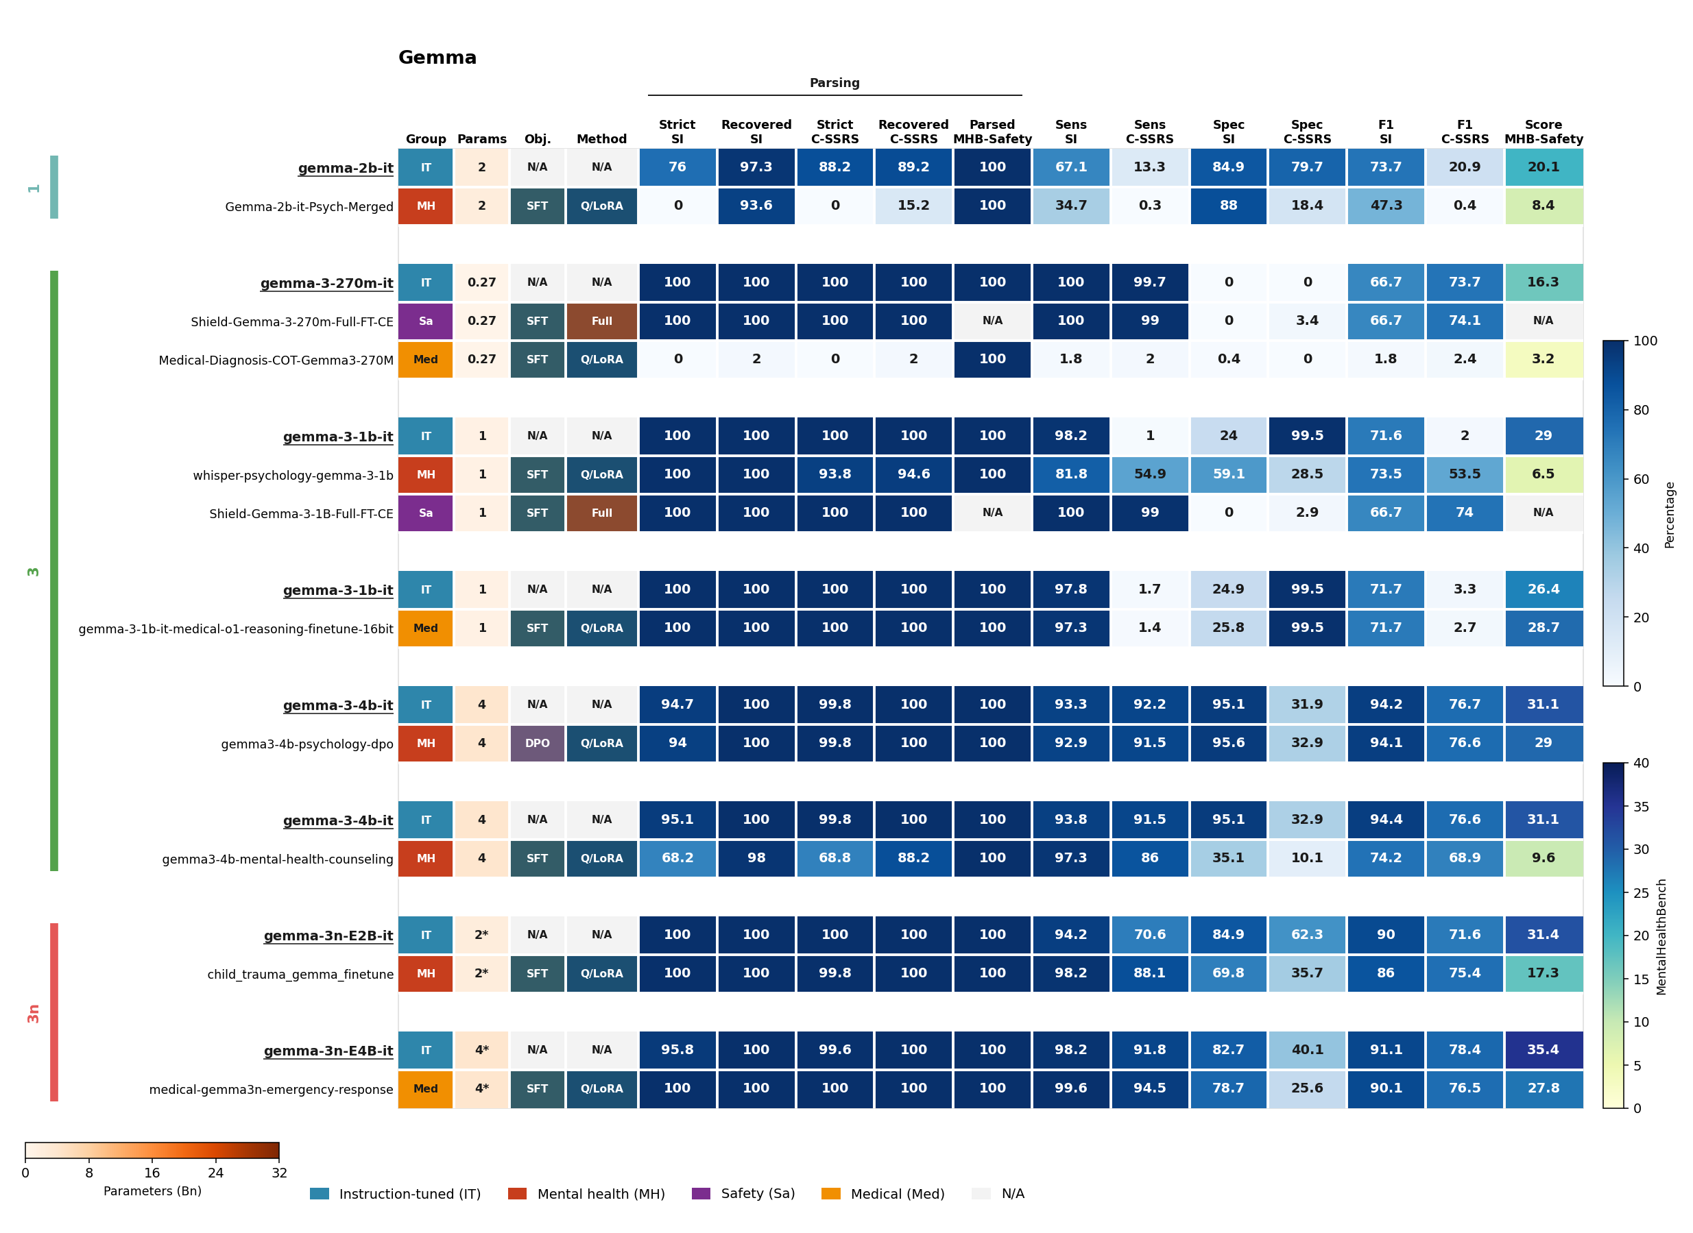
supp-figures/figure-s6.png

Figure S7
Llama scores.
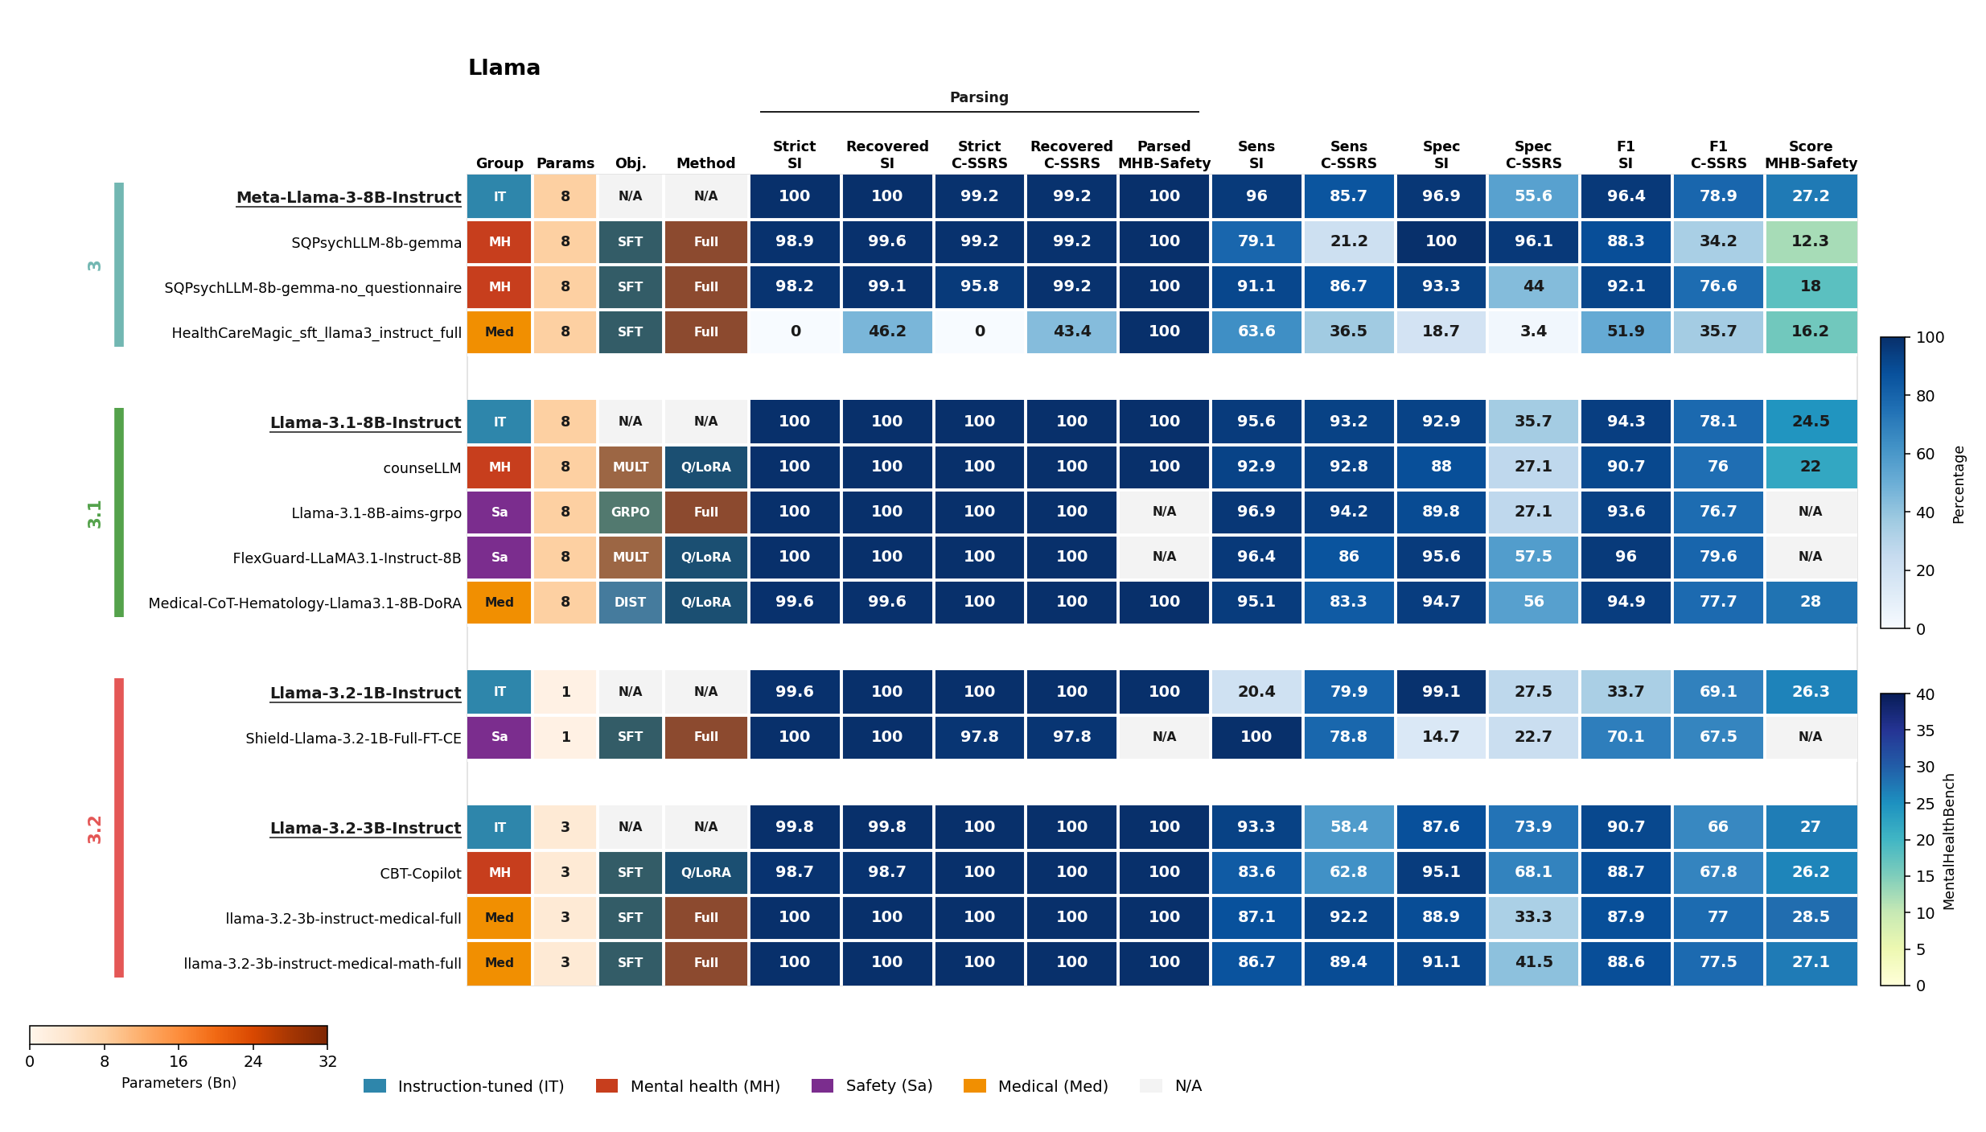
supp-figures/figure-s7.png

Figure S8
Mistral and SmolLM scores.
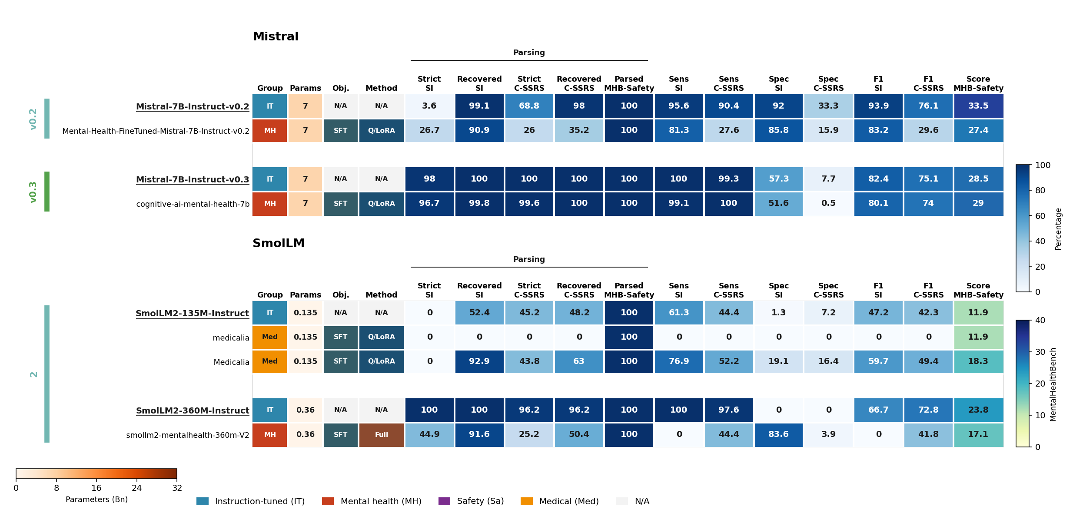
supp-figures/figure-s8.png

Figure S9
Fine-tune minus parent, split by weight-update method.
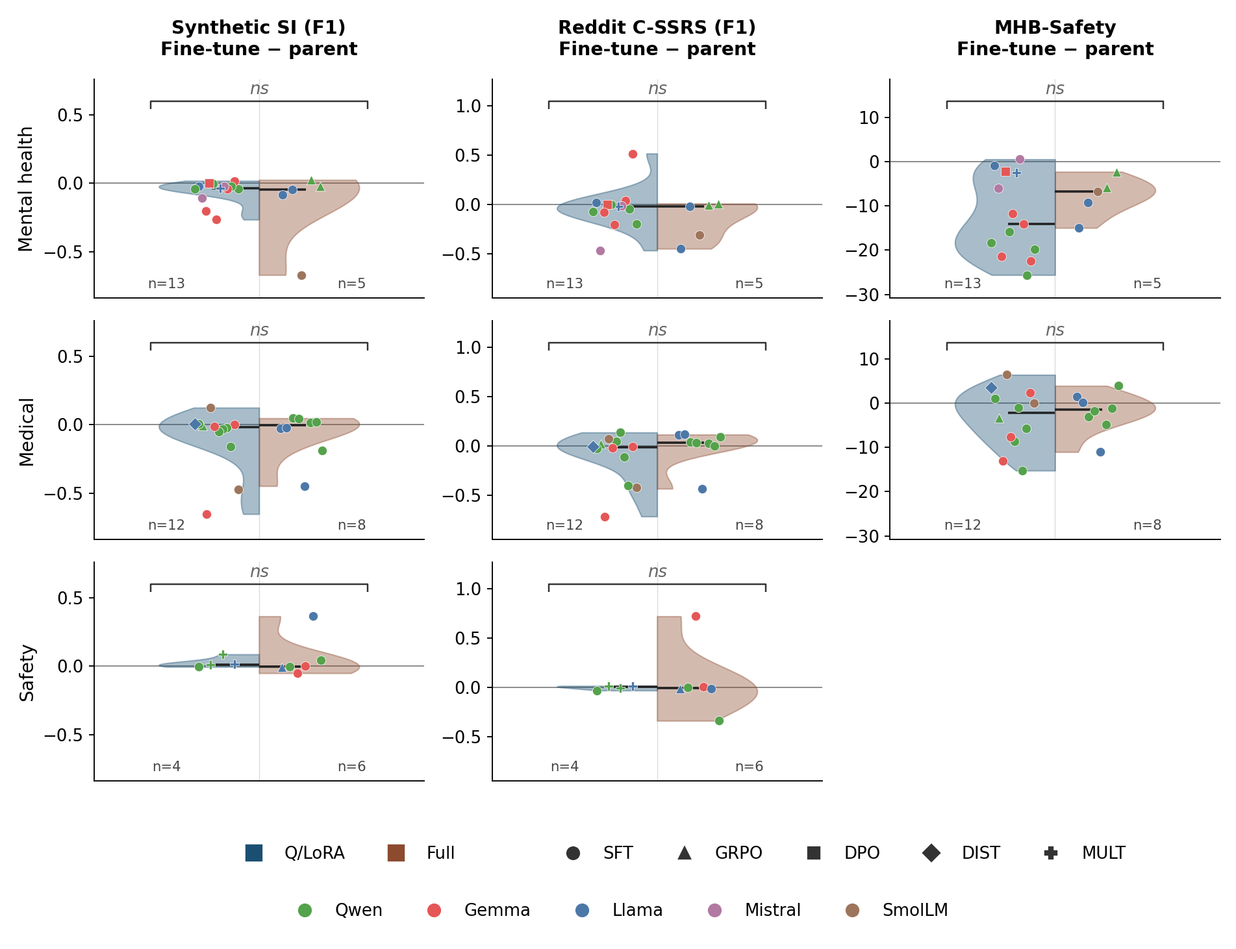
supp-figures/figure-s9.png

Figure S10
Fine-tune minus parent, split by training objective.
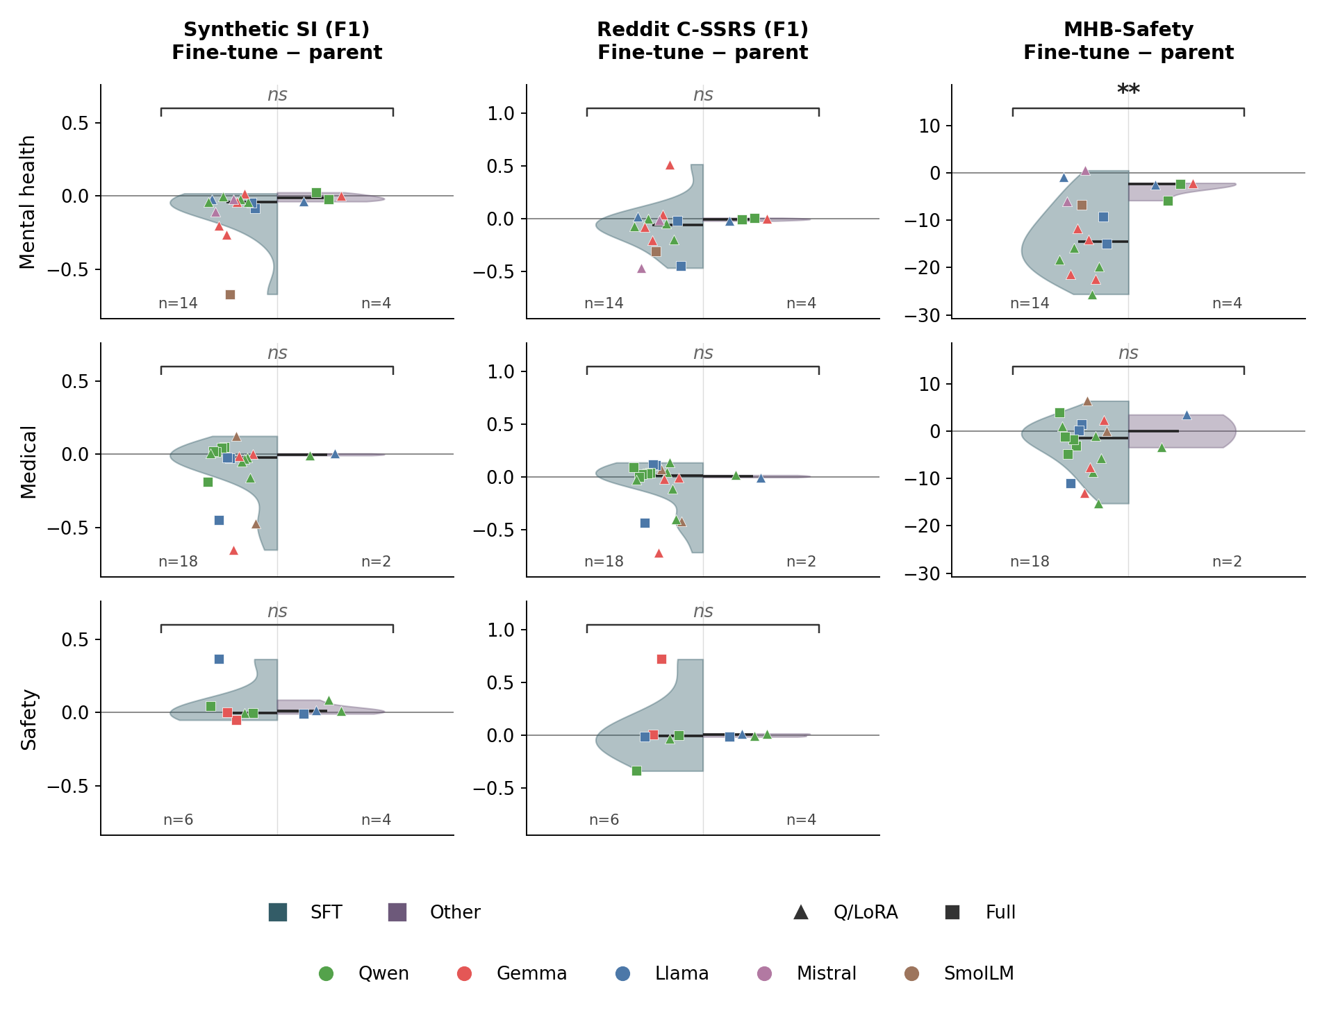
supp-figures/figure-s10.png

Table S1
Grouping | Hugging Face ID | Supporting text (Quote source) | Model details | Parent model | Links
mental-health | AIMH/SQPsychLLM-8b-gemma | chat model fine-tuned to roleplay a therapist in synthetic, Cognitive Behavioral Therapy (CBT)-informed counseling conversations. (Model card) | Llama 3; 8B; sft; full; F32 | meta-llama/Meta-Llama-3-8B-Instruct | Dataset: AIMH/SQPsychConv_gemma (https://huggingface.co/datasets/AIMH/SQPsychConv_gemma); HuggingFace: https://huggingface.co/AIMH/SQPsychLLM-8b-gemma
mental-health | AIMH/SQPsychLLM-8b-gemma-no_questionnaire | chat model fine-tuned to roleplay a therapist in synthetic, Cognitive Behavioral Therapy (CBT)-informed counseling conversations. (Model card) | Llama 3; 8B; sft; full; BF16 | meta-llama/Meta-Llama-3-8B-Instruct | Dataset: AIMH/SQPsychConv_gemma_no_questionnaire_finetune (https://huggingface.co/datasets/AIMH/SQPsychConv_gemma_no_questionnaire_finetune); HuggingFace: https://huggingface.co/AIMH/SQPsychLLM-8b-gemma-no_questionnaire
mental-health | ArkMaster123/qwen2.5-7b-therapist-v3 | A therapist-oriented model based on Qwen/Qwen2.5-7B-Instruct, fine-tuned with LoRA on a curated counseling mixture and merged for direct inference. (Model card) | Qwen2.5; 7B; sft; lora; BF16 | Qwen/Qwen2.5-7B-Instruct | Dataset: Amod/mental_health_counseling_conversations|nbertagnolli/counsel-chat|IINOVAII/therapy-conversations-combined (https://huggingface.co/datasets/Amod/mental_health_counseling_conversations|nbertagnolli/counsel-chat|IINOVAII/therapy-conversations-combined); HuggingFace: https://huggingface.co/ArkMaster123/qwen2.5-7b-therapist-v3
mental-health | KNipun/whisper-psychology-gemma-3-1b | Whisper is a mental health chatbot fine-tuned on the Gemma-3-1B-IT model using psychology-focused conversational data. The model is designed to provide supportive and empathetic responses for mental health conversations. / The model introduces itself as: I'm Whisper, your mental health chatbot, developed by DeepFinders - an innovative student team at SLTC Research University. (Model card) | Gemma 3; 1B; sft; qlora; F16 | google/gemma-3-1b-it | Dataset: jkhedri/psychology-dataset (https://huggingface.co/datasets/jkhedri/psychology-dataset); HuggingFace: https://huggingface.co/KNipun/whisper-psychology-gemma-3-1b
mental-health | Someet24/empathetic-qwen3-8b-Jan | An empathetic conversational AI fine-tuned for supportive, understanding responses. Use cases: Emotional support conversations / Mental wellness chatbots / Empathetic dialogue systems (Model card) | Qwen3; 8B; sft; qlora; BF16 | Qwen/Qwen3-8B | Dataset: facebook/empathetic_dialogues;thu-coai/esconv;google-research-datasets/go_emotions (https://huggingface.co/datasets/facebook/empathetic_dialogues;https://huggingface.co/datasets/thu-coai/esconv;https://huggingface.co/datasets/google-research-datasets/go_emotions); HuggingFace: https://huggingface.co/Someet24/empathetic-qwen3-8b-Jan
mental-health | SoufianeDahimi/child_trauma_gemma_finetune | This is a fine-tuned version of Gemma 3N specifically optimized for conducting trauma assessments with children from conflict zones. The model is designed to facilitate empathetic, culturally-sensitive conversations and generate professional psychological reports. (Model card) | Gemma 3n; E2B; sft; qlora; BF16; F16 | google/gemma-3n-E2B-it | Dataset: trauma_assessment_training.jsonl; HuggingFace: https://huggingface.co/SoufianeDahimi/child_trauma_gemma_finetune
mental-health | SpaceXerror/cognitive-ai-mental-health-7b | Cognitive AI - Mental Health Assistant / The assistant is designed to: Validate user feelings with empathy / Provide evidence-based coping strategies / Offer psychoeducation on mental health topics (Model card) | Mistral 7B v0.3; 7B; sft; qlora; F16 | mistralai/Mistral-7B-Instruct-v0.3 | Dataset: nbertagnolli/counsel-chat;vibhorag101/phr_mental_therapy_dataset (https://huggingface.co/datasets/nbertagnolli/counsel-chat;https://huggingface.co/datasets/vibhorag101/phr_mental_therapy_dataset); HuggingFace: https://huggingface.co/SpaceXerror/cognitive-ai-mental-health-7b
mental-health | Wothmag07/counseLLM | An empathy-aligned conversational support model fine-tuned from Llama 3.1 8B Instruct using a two-stage alignment pipeline: Supervised Fine-Tuning (SFT) on 36K counseling examples followed by Direct Preference Optimization (DPO) on ~2K preference-filtered pairs. (Model card) | Llama 3.1; 8B; sft; dpo; qlora; BF16 | meta-llama/Llama-3.1-8B-Instruct | Dataset: MentalChat16K; empathetic_dialogues; Psych8k; counsel-chat; ESConv; PsychoCounsel-Preference; HuggingFace: https://huggingface.co/Wothmag07/counseLLM
mental-health | dzur658/smollm2-mentalhealth-360m-V2 | The model has decent knowledge of common mental health topics, ie explaining to the user what anxiety, depression, PTSD, etc are. ... and can provide high level advice to the user on how to better their mental health. Uses: User mental health learning: Can teach the user symptoms, and definitions regarding standard mental health issues and provide examples / Advice: Model can give broad (albiet sometimes not great) advice to a user presenting with mental health conditions (Model card) | SmolLM2; 360M; sft; full; F32 | HuggingFaceTB/SmolLM2-360M-Instruct | Dataset: Amod/mental_health_counseling_conversations (https://huggingface.co/datasets/Amod/mental_health_counseling_conversations); HuggingFace: https://huggingface.co/dzur658/smollm2-mentalhealth-360m-V2
mental-health | ecorbari/Gemma-2b-it-Psych-Merged | The model is optimized to generate empathetic, supportive, and professionally aligned psychological responses. Intended for: Proof-of-concept psychological support tools. (Model card) | Gemma 1; 2B; sft; qlora; F16 | google/gemma-2b-it | Dataset: jkhedri/psychology-dataset (https://huggingface.co/datasets/jkhedri/psychology-dataset); HuggingFace: https://huggingface.co/ecorbari/Gemma-2b-it-Psych-Merged
mental-health | giannor/Qwen3.5-27B-psysafe | Rather than producing blunt non-compliance, this model is trained to acknowledge the person behind the request, apply domain-appropriate psychological intervention strategies, refer users to professional resources, and offer a hopeful, personalized closing - all while declining to provide harmful information. / Intended use: Mental health support platforms; Crisis-intervention or safeguarding tools. (Model card) | Qwen3.5; 27B; sft; lora; BF16 | Qwen/Qwen3.5-27B | Dataset: PSYCHOSAFE dataset; HuggingFace: https://huggingface.co/giannor/Qwen3.5-27B-psysafe
mental-health | hongli-zhan/MINT-empathy-Qwen3-1.7B | This model is intended for research on empathic dialogue, discourse diversity, and supportive response generation. (Model card) | Qwen3; 1.7B; grpo; full; BF16 | Qwen/Qwen3-1.7B | Dataset: 322 multi-turn emotional-support conversations from WildChat and SENSE-7; HuggingFace: https://huggingface.co/hongli-zhan/MINT-empathy-Qwen3-1.7B
mental-health | hongli-zhan/MINT-empathy-Qwen3-4B | This model is intended for research on empathic dialogue, discourse diversity, and supportive response generation. (Model card) | Qwen3; 4B; grpo; full; BF16 | Qwen/Qwen3-4B | Dataset: WildChat and SENSE-7; HuggingFace: https://huggingface.co/hongli-zhan/MINT-empathy-Qwen3-4B
mental-health | i5-8300h/gemma3-4b-psychology-dpo | DPO and LoRA PeFT finetuned version of Gemma 3 4B for response tone adjustment. (Model card) | Gemma 3; 4B; dpo; qlora; F16 | google/gemma-3-4b-it | Dataset: entfane/psychotherapy-dpo (https://huggingface.co/datasets/entfane/psychotherapy-dpo); HuggingFace: https://huggingface.co/i5-8300h/gemma3-4b-psychology-dpo
mental-health | naazimsnh02/gemma3-4b-mental-health-counseling | Gemma 3 (4B) Fine-tuned for Mental Health Counseling / This model has been fine-tuned to provide empathetic and helpful responses to mental health-related queries. It's designed to offer supportive guidance while maintaining professional boundaries appropriate for AI-assisted mental health support. (Model card) | Gemma 3; 4B; sft; qlora; BF16 | unsloth/gemma-3-4b-it | Dataset: Amod/mental_health_counseling_conversations (https://huggingface.co/datasets/Amod/mental_health_counseling_conversations); HuggingFace: https://huggingface.co/naazimsnh02/gemma3-4b-mental-health-counseling
mental-health | prabureddy/Mental-Health-FineTuned-Mistral-7B-Instruct-v0.2 | This model is a fine-tuned version of mistralai/Mistral-7B-Instruct-v0.2 on the mental_health_counseling_conversations dataset. (Model card) | Mistral 7B v0.2; 7B; sft; qlora; F16 | mistralai/Mistral-7B-Instruct-v0.2 | Dataset: Amod/mental_health_counseling_conversations (https://huggingface.co/datasets/Amod/mental_health_counseling_conversations); HuggingFace: https://huggingface.co/prabureddy/Mental-Health-FineTuned-Mistral-7B-Instruct-v0.2
mental-health | thillaic/CBT-Copilot | designed to simulate compassionate and supportive dialogues in the style of Cognitive Behavioral Therapy (CBT). (Model card) | Llama 3.2; 3B; sft; qlora; F32 | meta-llama/Llama-3.2-3B-Instruct | Dataset: Lumiiree/therapod-dpo (https://huggingface.co/datasets/Lumiiree/therapod-dpo); HuggingFace: https://huggingface.co/thillaic/CBT-Copilot
mental-health | zbt566666/qwen2.5-7b-mental-therapy-lora-sft | Trained on fadodr/mental_health_therapy. (Dataset name on the model card) | Qwen2.5; 7B; sft; not stated; BF16 | Qwen/Qwen2.5-7B-Instruct | Dataset: fadodr/mental_health_therapy (https://huggingface.co/datasets/fadodr/mental_health_therapy); HuggingFace: https://huggingface.co/zbt566666/qwen2.5-7b-mental-therapy-lora-sft
medical | Alexossss/medicalia | This model is a fine-tuned version of HuggingFaceTB/SmolLM2-135M-Instruct on the QuyenAnhDE/Diseases_Symptoms dataset. It has been trained using TRL. (Model card) | SmolLM2; 135M; sft; lora; BF16 | HuggingFaceTB/SmolLM2-135M-Instruct | Dataset: QuyenAnhDE/Diseases_Symptoms (https://huggingface.co/datasets/QuyenAnhDE/Diseases_Symptoms); HuggingFace: https://huggingface.co/Alexossss/medicalia
medical | ArindamSingh/gemma-3-1b-it-medical-o1-reasoning-finetune-16bit | Medical education, PubMed triage, coding suggestions (ICD, SNOMED), research ideation (Intended use on the model card) | Gemma 3; 1B; sft; lora; BF16; F16 | unsloth/gemma-3-1b-it | Dataset: FreedomIntelligence/medical-o1-reasoning-SFT (https://huggingface.co/datasets/FreedomIntelligence/medical-o1-reasoning-SFT); HuggingFace: https://huggingface.co/ArindamSingh/gemma-3-1b-it-medical-o1-reasoning-finetune-16bit
medical | Clinical-Reasoning-Hub/Diagnostic-Reasoning-Q3X1 | A QLoRA fine-tune of Qwen3-8B for medical question answering, released as the evaluated artifact for a study of training-corpus overlap in medical language model benchmarks. (Model card) | Qwen3; 8B; sft; qlora; F16 | Qwen/Qwen3-8B | Dataset: MedQA (USMLE); PubMedQA; MedMCQA train split; HuggingFace: https://huggingface.co/Clinical-Reasoning-Hub/Diagnostic-Reasoning-Q3X1
medical | Jarvis1111/DoctorAgent-RL-SFT-1k-Thinking | DoctorAgent-RL is a novel reinforcement learning (RL)-based multi-agent collaborative framework that models medical consultations as a dynamic decision-making process under uncertainty. It addresses core challenges faced by LLMs in real-world clinical consultations, such as vague diagnoses from single-round systems and the inflexibility of traditional multi-turn dialogue models constrained by static supervised learning. (Model card) | Qwen2.5; 7B; sft; lora; F32 | Qwen/Qwen2.5-7B-Instruct | Dataset: MTMedDialog_sft_train; HuggingFace: https://huggingface.co/Jarvis1111/DoctorAgent-RL-SFT-1k-Thinking
medical | MilyaShams/DeepSeek-R1-Distill-Qwen-1.5B-medical-sft-merged | This is notebook for adapting LLM to medical domain by fine-tuning it (SFT) on medical dataset of triples of question-CoT-answer. This notebook produces final SFT model for the project. (Training notebook (MedAdapt-LLM/sft_training.ipynb)) | Qwen2.5; 1.5B (Qwen2.5-Math); sft; qlora; BF16 | unsloth/DeepSeek-R1-Distill-Qwen-1.5B | Dataset: FreedomIntelligence/medical-o1-reasoning-SFT (https://huggingface.co/datasets/FreedomIntelligence/medical-o1-reasoning-SFT); HuggingFace: https://huggingface.co/MilyaShams/DeepSeek-R1-Distill-Qwen-1.5B-medical-sft-merged
medical | Satyam810/qwen3-8b-medical-reasoning | A LoRA fine-tune of unsloth/Qwen3-8B-unsloth-bnb-4bit on medical reasoning and doctor-patient conversational data. Trained using the Unsloth library. (Model card) | Qwen3; 8B; sft; qlora; BF16 | Qwen/Qwen3-8B | Dataset: FreedomIntelligence/medical-o1-reasoning-SFT | lavita/ChatDoctor-HealthCareMagic-100k; HuggingFace: https://huggingface.co/Satyam810/qwen3-8b-medical-reasoning
medical | Slyracoon23/medical-gemma3n-emergency-response | A fine-tuned version of Gemma 3N designed for emergency response scenarios. Powers the Citizen2Responder app with dual-mode capabilities: natural guidance for bystanders and structured tool outputs for EMTs - all with a privacy-first, local deployment focus. (Model card) | Gemma 3n; E4B; sft; qlora; F32 | unsloth/gemma-3n-E4B-it | Dataset: medical_emergency_dataset.json | forced_tool_calls_dataset.json; HuggingFace: https://huggingface.co/Slyracoon23/medical-gemma3n-emergency-response
medical | ThxZ3US/Medicalia | This model is a fine-tuned version of HuggingFaceTB/SmolLM2-135M-Instruct on the QuyenAnhDE/Diseases_Symptoms dataset. It has been trained using TRL. (Model card) | SmolLM2; 135M; sft; lora; BF16 | HuggingFaceTB/SmolLM2-135M-Instruct | Dataset: QuyenAnhDE/Diseases_Symptoms (https://huggingface.co/datasets/QuyenAnhDE/Diseases_Symptoms); HuggingFace: https://huggingface.co/ThxZ3US/Medicalia
medical | alpha-ai/Medical-Diagnosis-COT-Gemma3-270M | Alpha AI (www.alphaai.biz) fine-tuned Gemma-3 270M for medical question answering with explicit chain-of-thought (CoT). (Model card) | Gemma 3; 270M; sft; lora; BF16; F16 | google/gemma-3-270m-it | Dataset: FreedomIntelligence/medical-o1-reasoning-SFT (https://huggingface.co/datasets/FreedomIntelligence/medical-o1-reasoning-SFT); HuggingFace: https://huggingface.co/alpha-ai/Medical-Diagnosis-COT-Gemma3-270M
medical | balarajr/triage-hospital-agent | A GRPO fine-tuned version of Qwen3.5-4B specialized for hospital crisis management and clinical triage decision-making, trained as part of the TRIAGE multi-agent system. This model serves as the backbone for a 6-agent hospital crisis simulation that coordinates: ER Triage Agent - Patient severity classification (START protocol); ICU Management Agent - Bed allocation and overflow protocols; Pharmacy Agent - Drug order validation and contraindication detection; HR Rostering Agent - Emergency staff deployment; IT Systems Agent - EHR integrity and system failure response; CMO Oversight Agent - Override decisions and crisis governance. (Model card) | Qwen3.5; 4B; grpo; qlora; BF16 | Qwen/Qwen3.5-4B | Dataset: openlifescienceai/medmcqa;bigbio/med_qa (https://huggingface.co/datasets/openlifescienceai/medmcqa;https://huggingface.co/datasets/bigbio/med_qa); HuggingFace: https://huggingface.co/balarajr/triage-hospital-agent
medical | calebking/llama-3.2-3b-instruct-medical-full | Full fine-tuned LLaMA-3.2-3B-Instruct on medical instruction datasets to improve medical quantitative reasoning. (Model card) | Llama 3.2; 3B; sft; full; BF16 | meta-llama/Llama-3.2-3B-Instruct | Dataset: MedInstruct; HuggingFace: https://huggingface.co/calebking/llama-3.2-3b-instruct-medical-full
medical | calebking/llama-3.2-3b-instruct-medical-math-full | Full fine-tuned LLaMA-3.2-3B-Instruct on medical instruction datasets plus 15% MQR data from MedCalc-Bench-v1.0 to improve medical quantitative reasoning. (Model card) | Llama 3.2; 3B; sft; full; BF16 | meta-llama/Llama-3.2-3B-Instruct | Dataset: Med-MathInstruct; HuggingFace: https://huggingface.co/calebking/llama-3.2-3b-instruct-medical-math-full
medical | calebking/qwen2.5-3b-instruct-medical-full | Full fine-tuned Qwen2.5-3B-Instruct on medical instruction datasets to improve medical quantitative reasoning. (Model card) | Qwen2.5; 3B; sft; full; BF16 | Qwen/Qwen2.5-3B-Instruct | Dataset: MedInstruct; HuggingFace: https://huggingface.co/calebking/qwen2.5-3b-instruct-medical-full
medical | calebking/qwen2.5-3b-instruct-medical-math-full | Full fine-tuned Qwen2.5-3B-Instruct on medical instruction datasets plus 15% MQR data from MedCalc-Bench-v1.0 to improve medical quantitative reasoning. (Model card) | Qwen2.5; 3B; sft; full; BF16 | Qwen/Qwen2.5-3B-Instruct | Dataset: Med-MathInstruct; HuggingFace: https://huggingface.co/calebking/qwen2.5-3b-instruct-medical-math-full
medical | geshijoker/HealthCareMagic_sft_llama3_instruct_full | This model is a fine-tuned version of meta-llama/Meta-Llama-3-8B-Instruct on the healthcaremagic dataset. The training rows tell the model: If you are a doctor, please answer the medical questions based on the patient's description. (Model card and training rows of the healthcaremagic corpus) | Llama 3; 8B; sft; full; BF16 | meta-llama/Meta-Llama-3-8B-Instruct | Dataset: healthcaremagic; HuggingFace: https://huggingface.co/geshijoker/HealthCareMagic_sft_llama3_instruct_full
medical | graliuce/Qwen2.5-3B-Instruct_MedMCQA.20.01_1.0e-5 | You are a Medical Triage Assistant. Reason about the conversation to determine if there is sufficient information to provide a diagnosis. (Training rows of graliuce/MedMCQA.20.01) | Qwen2.5; 3B; sft; full; BF16 | Qwen/Qwen2.5-3B-Instruct | Dataset: graliuce/MedMCQA.20.01 (https://huggingface.co/datasets/graliuce/MedMCQA.20.01); HuggingFace: https://huggingface.co/graliuce/Qwen2.5-3B-Instruct_MedMCQA.20.01_1.0e-5
medical | graliuce/Qwen3-1.7B_MedMCQA.20.01_1.0e-5 | You are a Medical Triage Assistant. Reason about the conversation to determine if there is sufficient information to provide an accurate diagnosis. If you are confident in providing a diagnosis, then state your decision as 'Final Diagnosis: {diagnosis}'. Otherwise, state your decision as 'Need More Information'. (Training rows of graliuce/MedMCQA.20.01) | Qwen3; 1.7B; sft; full; BF16 | Qwen/Qwen3-1.7B | Dataset: graliuce/MedMCQA.20.01 (https://huggingface.co/datasets/graliuce/MedMCQA.20.01); HuggingFace: https://huggingface.co/graliuce/Qwen3-1.7B_MedMCQA.20.01_1.0e-5
medical | nicoboss/Qwen-3-32B-Medical-Reasoning | This project fine-tunes the Qwen/Qwen3-32B model using a medical reasoning dataset (FreedomIntelligence/medical-o1-reasoning-SFT) with 4-bit quantization for memory-efficient training. (Model card) | Qwen3; 32B; sft; qlora; BF16 | Qwen/Qwen3-32B | Dataset: FreedomIntelligence/medical-o1-reasoning-SFT (https://huggingface.co/datasets/FreedomIntelligence/medical-o1-reasoning-SFT); HuggingFace: https://huggingface.co/nicoboss/Qwen-3-32B-Medical-Reasoning
medical | suayptalha/Qwen3-0.6B-Medical-Expert | This project performs full fine-tuning on the Qwen3-0.6B language model to enhance its medical reasoning and clinical understanding capabilities. Training was conducted on the FreedomIntelligence/medical-o1-reasoning-SFT dataset using bfloat16 (bf16) precision for efficient optimization. (Model card) | Qwen3; 0.6B; sft; full; BF16 | Qwen/Qwen3-0.6B | Dataset: FreedomIntelligence/medical-o1-reasoning-SFT (https://huggingface.co/datasets/FreedomIntelligence/medical-o1-reasoning-SFT); HuggingFace: https://huggingface.co/suayptalha/Qwen3-0.6B-Medical-Expert
medical | taksa1990/Medical-CoT-Hematology-Llama3.1-8B-DoRA | A DoRA (Weight-Decomposed Low-Rank Adaptation) adapter that teaches Llama-3.1-8B-Instruct to perform step-by-step clinical reasoning in hematology and blood transfusion medicine, distilled from a larger teacher model. (Model card) | Llama 3.1; 8B; distillation; qlora; BF16 | meta-llama/Llama-3.1-8B-Instruct | Dataset: GBaker/MedQA-USMLE-4-options;qiaojin/PubMedQA (https://huggingface.co/datasets/GBaker/MedQA-USMLE-4-options;https://huggingface.co/datasets/qiaojin/PubMedQA); HuggingFace: https://huggingface.co/taksa1990/Medical-CoT-Hematology-Llama3.1-8B-DoRA
safety | Jazhyc/Llama-3.1-8B-aims-grpo | Built with Llama, this is a full fine-tuned model derived from meta-llama/Llama-3.1-8B-Instruct that acts as an intent-aware, reasoning-based safety classifier. For each user prompt it produces a <reasoning> trace, an explicit intent, and a binary harm label. It is trained with GRPO (Group Relative Policy Optimization), using a reward that explicitly verifies intent faithfulness against the AIMS human annotations. (Model card) | Llama 3.1; 8B; grpo; full; BF16 | meta-llama/Llama-3.1-8B-Instruct | Dataset: Jazhyc/aims-safety-intents (https://huggingface.co/datasets/Jazhyc/aims-safety-intents); HuggingFace: https://huggingface.co/Jazhyc/Llama-3.1-8B-aims-grpo
safety | Tommy-DING/FlexGuard-LLaMA3.1-Instruct-8B | FlexGuard-LLaMA3.1-Instruct-8B is a strictness-adaptive LLM content moderation model that outputs a continuous risk score (0-100) and one or more safety categories. It supports strictness-specific decisions via thresholding (e.g., strict / moderate / loose) without retraining. (Model card) | Llama 3.1; 8B; sft; grpo; lora; BF16 | meta-llama/Llama-3.1-8B-Instruct | Dataset: Aegis 2.0 | WildGuardMix; HuggingFace: https://huggingface.co/Tommy-DING/FlexGuard-LLaMA3.1-Instruct-8B
safety | Tommy-DING/FlexGuard-Qwen3-4B | FlexGuard-Qwen3-4B is a strictness-adaptive LLM content moderation model that outputs a continuous risk score (0-100) and one or more safety categories. It supports strictness-specific decisions via thresholding (e.g., strict / moderate / loose) without retraining. (Model card) | Qwen3; 4B; sft; grpo; lora; BF16 | Qwen/Qwen3-4B | Dataset: Aegis 2.0 | WildGuardMix; HuggingFace: https://huggingface.co/Tommy-DING/FlexGuard-Qwen3-4B
safety | Tommy-DING/FlexGuard-Qwen3-8B | FlexGuard-Qwen3-8B is a strictness-adaptive LLM content moderation model that outputs a continuous risk score (0-100) and one or more safety categories. It supports strictness-specific decisions via thresholding (e.g., strict / moderate / loose) without retraining. (Model card) | Qwen3; 8B; sft; grpo; lora; BF16 | Qwen/Qwen3-8B | Dataset: Aegis 2.0 | WildGuardMix; HuggingFace: https://huggingface.co/Tommy-DING/FlexGuard-Qwen3-8B
safety | jdleo1/tinysafe-3 | 4B parameter safety classifier built on Qwen3-4B-Instruct. Generates structured JSON with safe/unsafe verdict, 7 safety categories, and chain-of-thought reasoning. (Model card) | Qwen3; 4B; sft; qlora; BF16 | Qwen/Qwen3-4B-Instruct-2507 | Dataset: lmsys/toxic-chat;allenai/wildguardmix;PKU-Alignment/BeaverTails;google/civil_comments (https://huggingface.co/datasets/lmsys/toxic-chat;https://huggingface.co/datasets/allenai/wildguardmix;https://huggingface.co/datasets/PKU-Alignment/BeaverTails;https://huggingface.co/datasets/google/civil_comments); HuggingFace: https://huggingface.co/jdleo1/tinysafe-3
safety | jsl5710/Shield-Gemma-3-1B-Full-FT-CE | This model is part of the Shield project - a collection of safety-classifier models fine-tuned on the DIA-GUARD dataset (48 English dialects, ~836K records of safe/unsafe prompts) to robustly classify harmful content across diverse dialects. (Model card) | Gemma 3; 1B; sft; full; BF16 | google/gemma-3-1b-it | Dataset: DIA-GUARD; HuggingFace: https://huggingface.co/jsl5710/Shield-Gemma-3-1B-Full-FT-CE
safety | jsl5710/Shield-Gemma-3-270m-Full-FT-CE | This model is part of the Shield project - a collection of safety-classifier models fine-tuned on the DIA-GUARD dataset (48 English dialects, ~836K records of safe/unsafe prompts) to robustly classify harmful content across diverse dialects. (Model card) | Gemma 3; 270M; sft; full; BF16 | google/gemma-3-270m-it | Dataset: DIA-GUARD; HuggingFace: https://huggingface.co/jsl5710/Shield-Gemma-3-270m-Full-FT-CE
safety | jsl5710/Shield-Llama-3.2-1B-Full-FT-CE | This model is part of the Shield project - a collection of safety-classifier models fine-tuned on the DIA-GUARD dataset (48 English dialects, ~836K records of safe/unsafe prompts) to robustly classify harmful content across diverse dialects. (Model card) | Llama 3.2; 1B; sft; full; BF16 | meta-llama/Llama-3.2-1B-Instruct | Dataset: DIA-GUARD; HuggingFace: https://huggingface.co/jsl5710/Shield-Llama-3.2-1B-Full-FT-CE
safety | jsl5710/Shield-Qwen3-1.7B-Full-FT-CE | This model is part of the Shield project - a collection of safety-classifier models fine-tuned on the DIA-GUARD dataset (48 English dialects, ~836K records of safe/unsafe prompts) to robustly classify harmful content across diverse dialects. (Model card) | Qwen3; 1.7B; sft; full; BF16 | Qwen/Qwen3-1.7B | Dataset: DIA-GUARD; HuggingFace: https://huggingface.co/jsl5710/Shield-Qwen3-1.7B-Full-FT-CE
safety | SungJoo/cradle-dialogue-qwen3-32b-2epoch | A Qwen3-32B model fine-tuned for turn-level mental health crisis detection in multi-turn conversations. / the model assigns a crisis label to the current user turn only. (Model card) | Qwen3; 32B; sft; full; BF16 | Qwen/Qwen3-32B | Dataset: SungJoo/Cradle-Dialogue (https://huggingface.co/datasets/SungJoo/Cradle-Dialogue); HuggingFace: https://huggingface.co/SungJoo/cradle-dialogue-qwen3-32b-2epoch

Table S2
Grouping | Hugging Face ID | Template or message modifications | Parsing modifications
mental-health | AIMH/SQPsychLLM-8b-gemma | No tokenizer files in the repository, and no chat template. Served with the tokenizer from meta-llama/Meta-Llama-3-8B-Instruct, whose tokenizer config holds the chat template.
mental-health | AIMH/SQPsychLLM-8b-gemma-no_questionnaire | No tokenizer files in the repository, and no chat template. Served with the tokenizer from meta-llama/Meta-Llama-3-8B-Instruct, whose tokenizer config holds the chat template.
mental-health | ArkMaster123/qwen2.5-7b-therapist-v3
mental-health | KNipun/whisper-psychology-gemma-3-1b
mental-health | Someet24/empathetic-qwen3-8b-Jan
mental-health | SoufianeDahimi/child_trauma_gemma_finetune
mental-health | SpaceXerror/cognitive-ai-mental-health-7b
mental-health | Wothmag07/counseLLM
mental-health | dzur658/smollm2-mentalhealth-360m-V2
mental-health | ecorbari/Gemma-2b-it-Psych-Merged | The template accepts user and model turns, and the first turn has to be the user. We sent one user message: the instruction, a blank line, then the sentence.
mental-health | giannor/Qwen3.5-27B-psysafe
mental-health | hongli-zhan/MINT-empathy-Qwen3-1.7B
mental-health | hongli-zhan/MINT-empathy-Qwen3-4B
mental-health | i5-8300h/gemma3-4b-psychology-dpo
mental-health | naazimsnh02/gemma3-4b-mental-health-counseling
mental-health | prabureddy/Mental-Health-FineTuned-Mistral-7B-Instruct-v0.2 | The template accepts alternating user and assistant turns, and the first turn has to be the user. We sent one user message: the instruction, a blank line, then the sentence.
mental-health | thillaic/CBT-Copilot
mental-health | zbt566666/qwen2.5-7b-mental-therapy-lora-sft
medical | Alexossss/medicalia
medical | ArindamSingh/gemma-3-1b-it-medical-o1-reasoning-finetune-16bit
medical | Clinical-Reasoning-Hub/Diagnostic-Reasoning-Q3X1
medical | Jarvis1111/DoctorAgent-RL-SFT-1k-Thinking
medical | MilyaShams/DeepSeek-R1-Distill-Qwen-1.5B-medical-sft-merged
medical | Satyam810/qwen3-8b-medical-reasoning
medical | Slyracoon23/medical-gemma3n-emergency-response
medical | ThxZ3US/Medicalia
medical | alpha-ai/Medical-Diagnosis-COT-Gemma3-270M
medical | balarajr/triage-hospital-agent
medical | calebking/llama-3.2-3b-instruct-medical-full
medical | calebking/llama-3.2-3b-instruct-medical-math-full
medical | calebking/qwen2.5-3b-instruct-medical-full
medical | calebking/qwen2.5-3b-instruct-medical-math-full
medical | geshijoker/HealthCareMagic_sft_llama3_instruct_full
medical | graliuce/Qwen2.5-3B-Instruct_MedMCQA.20.01_1.0e-5
medical | graliuce/Qwen3-1.7B_MedMCQA.20.01_1.0e-5
medical | nicoboss/Qwen-3-32B-Medical-Reasoning
medical | suayptalha/Qwen3-0.6B-Medical-Expert
medical | taksa1990/Medical-CoT-Hematology-Llama3.1-8B-DoRA
safety | Jazhyc/Llama-3.1-8B-aims-grpo |  | A reply with one Harm: harmful or Harm: safe line counts as parsed. harmful is scored as yes.
safety | Tommy-DING/FlexGuard-LLaMA3.1-Instruct-8B |  | After a think block is removed, a category line and a risk score from 0 to 100 count as parsed. A category other than SAFE is scored as yes.
safety | Tommy-DING/FlexGuard-Qwen3-4B |  | After a think block is removed, a category line and a risk score from 0 to 100 count as parsed. A category other than SAFE is scored as yes.
safety | Tommy-DING/FlexGuard-Qwen3-8B |  | After a think block is removed, a category line and a risk score from 0 to 100 count as parsed. A category other than SAFE is scored as yes.
safety | jdleo1/tinysafe-3 |  | A JSON object with safe, categories, and reasoning counts as parsed. safe false is scored as yes.
safety | jsl5710/Shield-Gemma-3-1B-Full-FT-CE |  | A reply that is exactly safe or unsafe counts as parsed. unsafe is scored as yes.
safety | jsl5710/Shield-Gemma-3-270m-Full-FT-CE |  | A reply that is exactly safe or unsafe counts as parsed. unsafe is scored as yes.
safety | jsl5710/Shield-Llama-3.2-1B-Full-FT-CE |  | A reply that is exactly safe or unsafe counts as parsed. unsafe is scored as yes.
safety | jsl5710/Shield-Qwen3-1.7B-Full-FT-CE |  | A reply that is exactly safe or unsafe counts as parsed. unsafe is scored as yes. Thinking is turned off so those tokens are the label.
safety | SungJoo/cradle-dialogue-qwen3-32b-2epoch

Table S3
Group | Model count | Strict SI 100% | Strict SI >90% | Strict SI >75% | Strict SI >50% | Sonnet SI 100% | Sonnet SI >90% | Sonnet SI >75% | Sonnet SI >50% | Strict C-SSRS 100% | Strict C-SSRS >90% | Strict C-SSRS >75% | Strict C-SSRS >50% | Sonnet C-SSRS 100% | Sonnet C-SSRS >90% | Sonnet C-SSRS >75% | Sonnet C-SSRS >50%
Instruction-tuned | 27 | 55.6% (15/27) | 85.2% (23/27) | 88.9% (24/27) | 88.9% (24/27) | 81.5% (22/27) | 92.6% (25/27) | 92.6% (25/27) | 100.0% (27/27) | 66.7% (18/27) | 85.2% (23/27) | 88.9% (24/27) | 92.6% (25/27) | 77.8% (21/27) | 88.9% (24/27) | 92.6% (25/27) | 92.6% (25/27)
Mental health | 18 | 44.4% (8/18) | 77.8% (14/18) | 77.8% (14/18) | 83.3% (15/18) | 50.0% (9/18) | 100.0% (18/18) | 100.0% (18/18) | 100.0% (18/18) | 44.4% (8/18) | 77.8% (14/18) | 77.8% (14/18) | 83.3% (15/18) | 61.1% (11/18) | 77.8% (14/18) | 83.3% (15/18) | 88.9% (16/18)
Medical | 20 | 65.0% (13/20) | 70.0% (14/20) | 70.0% (14/20) | 70.0% (14/20) | 65.0% (13/20) | 80.0% (16/20) | 80.0% (16/20) | 85.0% (17/20) | 70.0% (14/20) | 70.0% (14/20) | 70.0% (14/20) | 70.0% (14/20) | 75.0% (15/20) | 75.0% (15/20) | 75.0% (15/20) | 85.0% (17/20)
Safety | 10 | 80.0% (8/10) | 100.0% (10/10) | 100.0% (10/10) | 100.0% (10/10) | 100.0% (10/10) | 100.0% (10/10) | 100.0% (10/10) | 100.0% (10/10) | 90.0% (9/10) | 100.0% (10/10) | 100.0% (10/10) | 100.0% (10/10) | 90.0% (9/10) | 100.0% (10/10) | 100.0% (10/10) | 100.0% (10/10)

Table S4
 | Mental health |  |  |  |  | Medical |  |  |  |  | Safety
Objective | LoRA | QLoRA | Full | Total |  | LoRA | QLoRA | Full | Total |  | LoRA | QLoRA | Full | Total
SFT | 3 | 8 | 3 | 14 |  | 5 | 5 | 8 | 18 |  | 0 | 1 | 5 | 6
GRPO | 0 | 0 | 2 | 2 |  | 0 | 1 | 0 | 1 |  | 0 | 0 | 1 | 1
DPO | 0 | 1 | 0 | 1 |  | 0 | 0 | 0 | 0 |  | 0 | 0 | 0 | 0
Distillation | 0 | 0 | 0 | 0 |  | 0 | 1 | 0 | 1 |  | 0 | 0 | 0 | 0
More than one stage | 0 | 1 | 0 | 1 |  | 0 | 0 | 0 | 0 |  | 3 | 0 | 0 | 3
Total | 3 | 10 | 5 | 18 |  | 5 | 7 | 8 | 20 |  | 3 | 1 | 6 | 10

Table S5. Fine-tune minus its instruction-tuned parent, clustered by parent
Fine-tune type | Suicidal-ideation delta F1 |  | C-SSRS delta F1 |  | MHB-Safety delta
 | Mean delta (95% CI) | q | Mean delta (95% CI) | q | Mean delta (95% CI) | q
Mental-health fine-tunes | −0.087 (−0.173 to −0.001) | 0.147 | −0.073 (−0.187 to 0.041) | 0.278 | −0.111 (−0.155 to −0.067) | <0.001***
Medical fine-tunes | −0.091 (−0.191 to 0.010) | 0.147 | −0.072 (−0.190 to 0.045) | 0.278 | −0.030 (−0.063 to 0.002) | 0.147
Safety fine-tunes | 0.046 (−0.052 to 0.143) | 0.353 | 0.035 (−0.180 to 0.249) | 0.719 | — | —

