Cross-Region Landslide Segmentation with TriEncoderCFMNet (Trimodal Gated Fusion and Conditional Flow Matching)
Samreedh Bhuyan, Debasish Saikia, and Hridoy Jyoti Mahanta

Abstract
Abstract. Landslides always pose a critical threat to both human life and infrastructure. With the advent of deep learning, CNNs, attention-based networks, and vision transformers have made significant progress in automating landslide segmentation from remote sensing data, yet problems persist, particularly in retaining local spatial features and adapting to new landscapes when models are trained only on a single modality or a rigid fusion rule. In this study we present TriEncoderCFMNet, an end-to-end segmentation architecture that reads RGB, topography (DEM with finite-difference slope cues), and a context stack aligned with competition-style multispectral conditioning. A trimodal gated fusion module combines pyramid features at each scale before a conditional flow-matching velocity field refines the mask latent, alongside an auxiliary convolutional head and geomorphology-aware regularisation. The model is evaluated on the Landslide4Sense benchmark with an extended baseline grid under a unified training protocol; Bijie metrics appear in Table 2 with the same ordering conventions. Compared with classical U-Net families and a strong dual-stream gated baseline, the proposed pipeline offers a different inductive bias—explicit three-way fusion plus flow-based refinement—while remaining comparable in training tooling to the rest of the ablation repository.
Keywords: Landslide modeling · Machine learning · Segmentation · Topography fusion · Conditional flow matching · Remote sensing.

1 Introduction
Landslides continue to be one of the most destructive natural hazards, especially in geologically sensitive zones like mountainous and hilly terrains, where they often lead to considerable economic loss, environmental degradation, and tragic loss of life. With the accelerating influence of climate change, unplanned urban development, and anthropogenic land-use transformations, the frequency and intensity of landslide events have shown noticeable surges, particularly in regions with high rainfall or seismic activity. Traditional approaches for landslide detection have long relied on empiri- cal models, heuristic rules, and field-based methods. While they have served as the backbone for early studies and mitigation planning, such methods are of- ten constrained by the need for manual feature engineering and region-specific calibration. Moreover, they tend to struggle when applied beyond their orig- inal training domains, as the spatial and textural patterns of landslides vary substantially across different terrains. After the advent of the introduction of Deep learning models, there has been significant progress in generating better and robust models for classifica- tion and segmentation of such tasks, especially Convolutional Neural Networks (CNNs), which have shown encouraging results in identifying landslide-affected zones from remotely sensed imagery, owing to their capacity for automatic fea- ture extraction and non-linear pattern recognition. Architectures such as U-Net and DeepLabV3+ have been adapted for pixel-level segmentation of landslide re- gions, with studies reporting substantial improvements in accuracy over classical methods. However, these models, though powerful, are often brittle — they tend to overfit on narrow geographies or exhibit low performance when deployed on imagery from unseen regions. Another recurring issue is the misclassifications of visually similar surfaces such as dry riverbeds or human-disturbed soil patches, where the spectral and textural features closely mimic those of actual landslides. In recent years, foundation models in computer vision have sparked renewed interest in adapting promptable segmentation models like the Segment Anything Model (SAM) to geospatial domains. The capacity of SAM lies in its flexibility and zero-shot segmentation capabilities, but SAM doesn’t generalise well to the task of landslide segmentation, thereby showcasing a significant gap in the accu- racy of such tasks by more of the generalised models such as SAM. This is partly because SAM was not trained on geospatial datasets and partly due to archi- tectural limitations, such as the flattening of image patches in ViT backbones that erodes important local spatial relationships. Nevertheless, the modularity of SAM allows for adaptation, and several emerging efforts like SAM-CFFNet and TransLandSeg have demonstrated how minimal modifications and domain-aware adjustments can lead to better performance in tasks like landslide segmentation. Yet, even these solutions fall short in certain terrains or fail to scale efficiently when deployed in large area mapping scenarios. Motivated by these issues, the present contribution moves away from the earlier two-stage classifier–SAM pipeline and instead studies a single segmentation backbone where RGB, DEM, and context tensors are encoded in parallel, fused with data-dependent gates, and refined with a lightweight conditional flow matching decoder. We still care about the same practical worries—domain shift, ambiguous texture, and the need for topography—but we address them with trimodal fusion and flow-based denoising rather than promptable ViT adapters. The experimental section therefore reports Landslide4Sense validation metrics for a broad set of public baselines and for the new model under the same split and logging conventions as the rest of SAM/ablation_study.

2 Related works
Early works in landslide detection primarily focused on empirical and statistical models such as logistic regression [1], frequency ratio methods [2], and decision trees [3], relying heavily on slope, aspect, lithology, and land cover maps. These models required extensive domain knowledge and performed well within limited regions but often lacked generalisability when applied to other landscapes due to handcrafted feature reliance and static thresholds. With the introduction of high-resolution satellite imagery and publicly avail- able DEMs, machine learning-based classifiers such as Support Vector Machines (SVM) [4], Random Forests [5], and Gradient Boosting Machines [6] gained trac- tion. These models showed better adaptability to new terrains but still faced challenges in pixel-wise segmentation tasks and required elaborate preprocess- ing and feature selection pipelines. The transition to deep learning marked a turning point. Architectures like U-Net [7], DeepLabV3+ [8], and FCNs [9] became central to remote sensing re- search, especially in semantic segmentation. [10]. (2021) applied DeepLabV3+ for landslide detection using high-resolution drone imagery, reporting signifi- cantly higher mIoU compared to previous methods. Similarly, [11] employed CNNs with DEM-derived features for landslide susceptibility mapping in Iran. Attention mechanisms were later introduced to improve context modeling. [12] proposed an attention-boosted CNN for segmentation in the Bijie region of China, integrating contextual priors from both optical and elevation data. TransLandSeg [13], a recent adaptation, incorporated transformer layers into a U-Net backbone, leading to improved segmentation quality with fewer parame- ters fine-tuned from SAM. The Segment Anything Model (SAM) by [14] opened the door to prompt- based general segmentation. SAM performs well on conventional datasets like COCO or ADE20K, but struggles in geospatial domains where the distribution shift is substantial. SAM-based extensions like SAM-CFFNet [15], which uses context fusion for fine-grained tasks, and SAM-RL [He et al., 2024], which em- ploys reinforcement tuning, have shown some improvements but are limited by the base model’s flattening of spatial structure. In the geospatial domain, Vision Transformers (ViTs) and Swin Transform- ers have also been explored. SegFormer [16], combining a ViT backbone with a lightweight decoder, showed improved boundary segmentation in diverse geogra- phies. However, these models are computationally intensive and often require large training datasets to achieve generalisation. Other approaches have explored multi-modal fusion using GNNs or CNN branches for textural, spectral, and topographic data [17]. While these mod- els report excellent accuracy, they often depend on high-bandwidth inputs and terrain-specific metadata that are not universally available. Moreover, the com- pute overhead remains prohibitive for field deployments.

3 Materials and methods

3.1 Datasets and preprocessing
To ensure that the proposed approach can work well across different terrains and climatic conditions, a set of diverse satellite imagery datasets was used. The first dataset was obtained from a previous work on landslide detection over Bijie City in Guizhou Province, China. Images were acquired by the Triple- Sat constellation between May and August 2018, consisting of 770 landslide images and 2,003 non-landslide images. Although limited in geographic scope, the dataset is balanced and useful for both identifying landslides and recognising areas without them, which is important for reducing false positives in disaster monitoring. The second dataset is taken from the 2022 Landslide4Sense competition and contained high-resolution annotated imagery from landslide-prone regions in Asia, such as parts of Japan, India, Nepal, and Taiwan. For this work, only a portion was used to maintain computational feasibility while keeping geographic diversity. Each image has a segmentation mask marking landslide areas, with variations in resolution and season that bring in distributional noise similar to real-world data. The third dataset was sourced from a study in the higher Himalayas of Nepal, which is a challenging environment for segmentation due to steep slopes, frag- ile geology, and frequent monsoon rainfall. While smaller in size, it contains high-quality image-mask pairs with complex topographic and texture patterns, improving the model’s robustness to noise and ambiguous terrain features. All datasets were preprocessed, normalised, and combined into a unified cor- pus, resulting in 2,990 landslide image-mask pairs and 2,003 non-landslide im- ages. Resolution and format were standardised while retaining the original scene structures, enabling the model to benefit from the diversity without facing major domain inconsistencies.
All images and their corresponding segmentation masks were first standardized toaspatialresolutionof512 × 512pixelsusingsymmetriczero-padding,ensuring that the original content and spatial relationships, particularly at the boundaries wherelandslidetracesoftenoccur—remainedunaffected.Thedatasets,originally varying in format and structure, were reorganized under a unified naming con- vention such that each image could be paired accurately with its respective mask. This not only enabled clean dataset merging but also helped avoid errors during batch training. Once aligned, the datasets were combined into a single corpus containing 2,990 landslide image-mask pairs and2,003 non-landslide images, allowing the model to learn from both positive and negative terrain samples with consistent input structure.

3.2 Proposed model
3.2 Proposed segmentation backbone (TriEncoderCFMNet). Let each training sample provide RGB image X_rgb, a DEM channel X_dem, and a context tensor X_ctx built from the competition stack (for Landslide4Sense this follows the six-channel context convention used elsewhere in the repository; Bijie uses a reduced four-channel stack). Each stream passes through the same pyramid encoder layout: a 7×4 stem, residual stages, and two stride-2 downsamples so that three scale maps A^(ℓ), B^(ℓ), C^(ℓ) are produced for ℓ ∈ {0,1,2}. Before the DEM encoder, finite-difference gradients build a slope magnitude map that is concatenated to elevation so the topography branch sees relief explicitly.
At every scale the three feature maps are first mixed with a global softmax gate computed from their concatenation after global average pooling, yielding stream weights (w0,w1,w2) that sum to one. A spatial map γ^(ℓ) in [0,1] is predicted with a depthwise-heavy 7×7 path and used to blend the gated mixture with an unweighted average, followed by batch normalisation. The finest fused map feeds an auxiliary two-layer convolutional head whose logits are upsampled to full resolution.
Conditional flow matching targets a smooth latent z obtained by logit-transforming the clipped mask. A velocity U-Net v_θ(x_t,t | fused pyramid) is trained with mean-squared error to the straight-path target velocity ε−z, together with a small finite-difference penalty that discourages rapid oscillations of v_θ in time. At validation one may integrate the learned field with a few Euler steps starting from Gaussian noise and add the resulting logits to the auxiliary head with a configurable scale. The segmentation objective combines Tversky loss on the auxiliary logits with a geomorphological term that down-weights mask-gradient energy on flat terrain so steep scarps can keep sharp boundaries. Optimisation follows the repository trainer: AdamW, ReduceLROnPlateau on a chosen validation score, gradient clipping, and epoch-wise CSV logging so figures in this manuscript can be reproduced from epoch_metrics.csv without ad-hoc post-processing.
Relation to dual-stream baselines. The dual_stream_gated reference in this codebase fuses two EfficientNet towers before a UNet decoder. TriEncoderCFMNet differs by (i) using three parallel CNN pyramids instead of two ImageNet backbones, (ii) applying fusion at every pyramid level with both global softmax weights and a spatial γ map, and (iii) adding the flow-matching refinement path instead of relying on the classical decoder alone. Those design choices are orthogonal to the literature on gated fusion: they borrow the same intuition—that optical and elevation cues should not be averaged blindly—but implement it in a lighter stack suited to the ablation harness used here.

3.2.1 Key equations
The following notation matches the trimodal backbone in §3.2; tensors omit explicit spatial indices.
Streams. For each pyramid level ℓ ∈ {0,1,2}, encoders emit aligned maps A(ℓ), B(ℓ), and C(ℓ) for RGB, topography (DEM with finite-difference slope cues), and the multispectral context stack. | (1)

Global weights. Stacked global averages u(ℓ) pass through a linear map followed by softmax, yielding w(ℓ) ∈ ℝ³ with non-negative entries summing to one. | (2)

Spatial gate and fusion. A depthwise-heavy head predicts γ(ℓ) ∈ [0,1] on the feature grid; fused tensors follow F(ℓ) = BN( γ(ℓ) ⊙ Σ_k w_k(ℓ) V_k(ℓ) + (1 − γ(ℓ)) ⊙ mean_k V_k(ℓ) ) after channel alignment of per-stream maps V_k. | (3)

Auxiliary logits. Decoder layers on the finest fused map produce ŷ_aux at full mask resolution. | (4)

Flow matching. With clipped mask M, latent z = logit(clip(M)), noise ε, interpolant x_t = (1−t)ε + t z, and velocity field v_θ, minimise 𝔼_{t,ε} ‖ v_θ(x_t, t | {F(ℓ)}) − (z − ε) ‖². | (5)

Objective. Total training loss L = L_Tversky(ŷ_aux, M) + λ_FM L_FM + λ_geo L_geo with nonnegative weights. | (6)

3.2.2 Algorithm 1 — TriEncoderCFMNet training
Algorithm 1 TriEncoderCFMNet (trimodal fusion + CFM)

Inputs: Dataset D of tuples (X_rgb, X_dem, X_ctx, M) with paired masks.
Parameters: Weights θ over encoders, fusion heads, FM U-Net v_θ, auxiliary decoder; learning rate η; loss weights λ_FM, λ_geo.
for each training epoch do
sample minibatch (X_rgb, X_dem, X_ctx, M) from D
forward encoders → {(A(ℓ), B(ℓ), C(ℓ))}; fuse → {F(ℓ)}; compute ŷ_aux
sample t ~ Uniform(0,1), ε ~ Normal(0, I); form x_t = (1−t)ε + t·logit(clip(M))
accumulate L_FM = ‖ v_θ(x_t, t | {F(ℓ)}) − (logit(clip(M)) − ε) ‖²
L = L_Tversky(ŷ_aux, M) + λ_FM · L_FM + λ_geo · L_geo
θ ← θ − η · ∇_θ L (AdamW + gradient clipping as in trainer config)
end for
return θ

[Placeholder — Fig. 1 architecture] Insert the final TriEncoderCFMNet diagram (export from draw.io, PowerPoint, or MODEL_ARCHITECTURE assets) here before submission.

3.3 Bijie dataset and protocol
Bijie experiments use the repository `build_bijie_split` protocol (RGB composites with paired DEM and four-channel trimodal tensors for TriEncoderCFMNet) alongside the same baseline harness as Landslide4Sense. Table 2 and Figs. 14–25 summarise the dedicated Bijie summary CSV and the `conference_bijie` figure bundle.

4 Results and figures
Table 1. Landslide4Sense best-epoch validation summary across segmentation models (unified ablation harness). Values come from landslide4sense_best_validation_summary.csv.
Model Id | Display Name | Best Epoch | Val Acc | Val Precision | Val Recall | Val F1 | Val Iou | Val Auroc | Val Auprc
linknet | Linknet | 99 | 0.9730 | 0.4869 | 0.7353 | 0.4307 | 0.3588 | 0.8278 | 0.8237
dep_unet | DEP UNET | 82 | 0.9768 | 0.6688 | 0.7702 | 0.6032 | 0.5349 | 0.8587 | 0.8669
gmnet | Gmnet | 79 | 0.9775 | 0.6685 | 0.7792 | 0.6163 | 0.5453 | 0.8782 | 0.8475
rmau_net | RMAU NET | 83 | 0.9775 | 0.6911 | 0.7564 | 0.6178 | 0.5480 | 0.8664 | 0.8514
transunet | Transunet | 92 | 0.9758 | 0.7140 | 0.7504 | 0.6192 | 0.5514 | 0.8864 | 0.8607
emr_hrnet | EMR Hrnet | 94 | 0.9750 | 0.6735 | 0.7835 | 0.6274 | 0.5566 | 0.8869 | 0.8879
shapeformer | Shapeformer | 95 | 0.9752 | 0.6754 | 0.8021 | 0.6320 | 0.5604 | 0.8651 | 0.8437
dual_stream_unet | DUAL Stream UNET | 95 | 0.9860 | 0.7135 | 0.7789 | 0.6562 | 0.5809 | 0.9141 | 0.9045
unet | UNET | 93 | 0.9844 | 0.7950 | 0.7193 | 0.6800 | 0.6107 | 0.9104 | 0.9133
deeplabv3plus | Deeplabv3plus | 85 | 0.9844 | 0.7891 | 0.7485 | 0.7099 | 0.6364 | 0.9245 | 0.9264
dual_stream_gated | DUAL Stream Gated | 23 | 0.9866 | 0.8290 | 0.7298 | 0.7096 | 0.6344 | 0.9343 | 0.9135
tri_encoder_cfm_v2 | TRI Encoder CFM V2 | 111 | 0.9764 | 0.8598 | 0.7427 | 0.7398 | 0.6416 | 0.9564 | 0.9290
Note: Values are best-epoch validation metrics from the unified ablation harness. Bold entries in the proposed-model row indicate column-wise maxima among all listed runs. Dataset: Landslide4Sense benchmark.

4 Results (Landslide4Sense). Table 1 summarises each architecture’s best validation epoch under the shared logging format exported by build_l4s_ablation_report.py. Metrics are pixel-level validation scores at the stored threshold defaults; AUROC and AUPRC come from the scalar columns logged each epoch, so the ROC/PR style figures in Fig. 7–12 trace these scalars against time with markers at epochs 24, 34, and 39 to mirror the layout of the earlier conference submission even though the underlying logs do not yet store full threshold sweeps.
Fig. 2 and Fig. 5 show training and validation dynamics for the focus run (highest validation F1 in the table by default); Fig. 5 is a wide panel that couples the validation heatmap with training–versus–validation bars for precision, recall, and accuracy at the best epoch. Fig. 3 and Fig. 6 give the train–validation curve panels, while Fig. 4 overlays all models at their best epoch for F1, IoU, precision, and recall. Fig. 13 switches to a grouped precision–recall bar view across every model so the reader can compare the two operating points side by side without reading scatter coordinates.
The supplementary overlay figures fig01–fig04 and fig06–fig09 in the same results folder provide additional cross-model comparisons (loss trajectories, ranked F1, radar-style summaries) that are not part of the main figure numbering but are useful for internal review.

Figure 1 (placeholder)
[Placeholder — Fig. 1 architecture] Insert the final TriEncoderCFMNet diagram (export from draw.io, PowerPoint, or MODEL_ARCHITECTURE assets) here before submission.
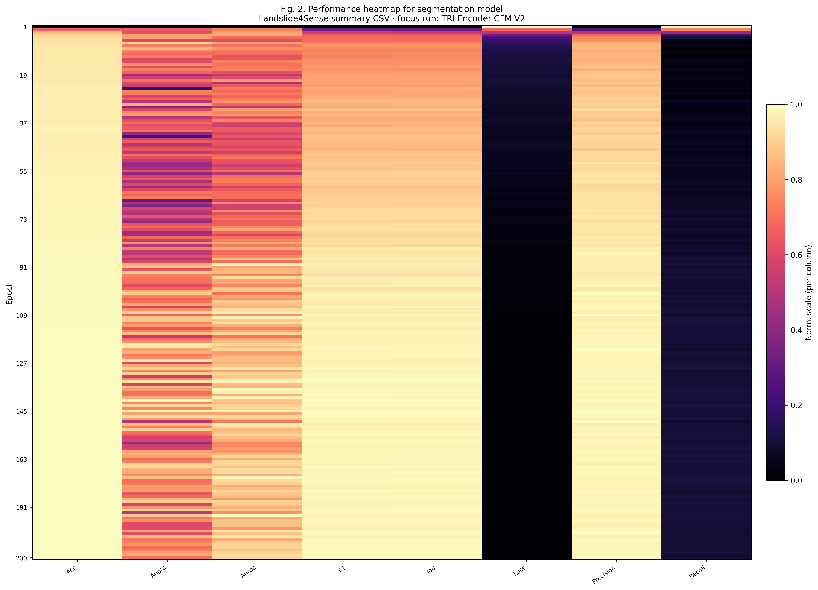
Fig. 2. Performance heatmap for segmentation model (training dynamics).

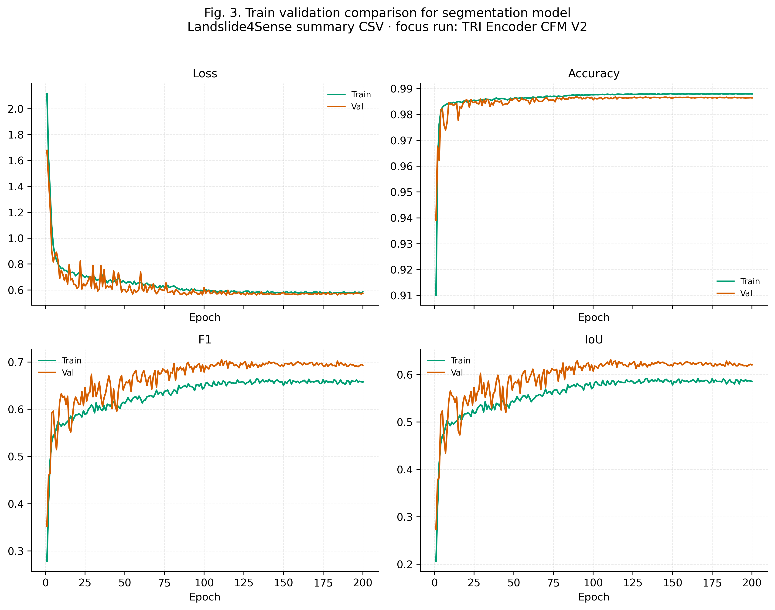
Fig. 3. Train validation comparison for segmentation model.

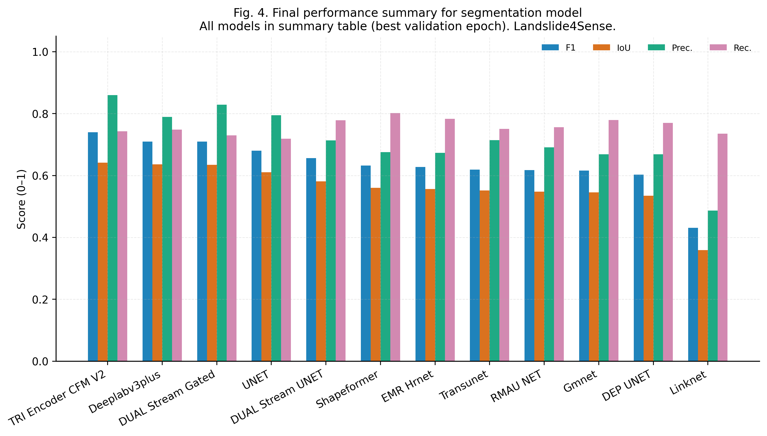
Fig. 4. Final performance summary for segmentation model.

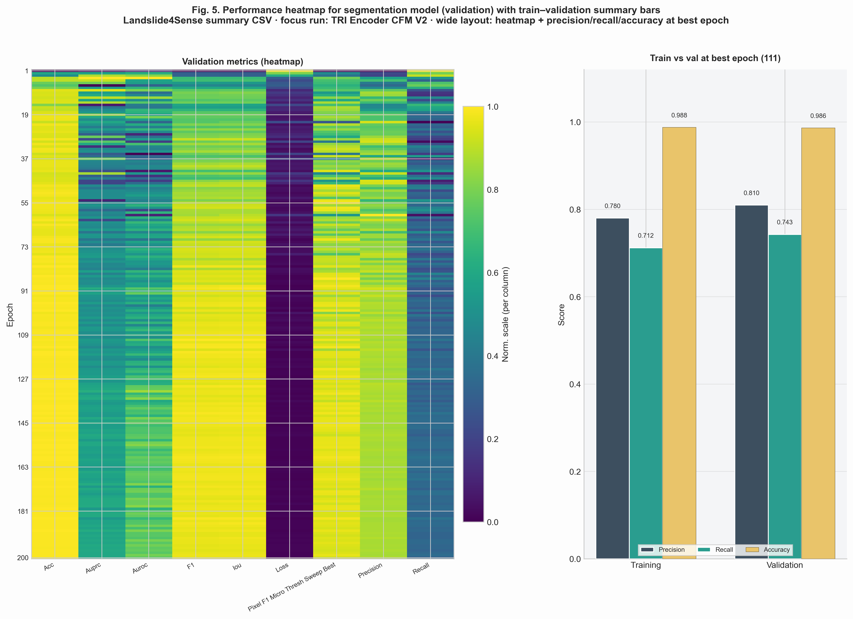
Fig. 5. Validation heatmap with train–validation summary bars at best epoch (wide layout).

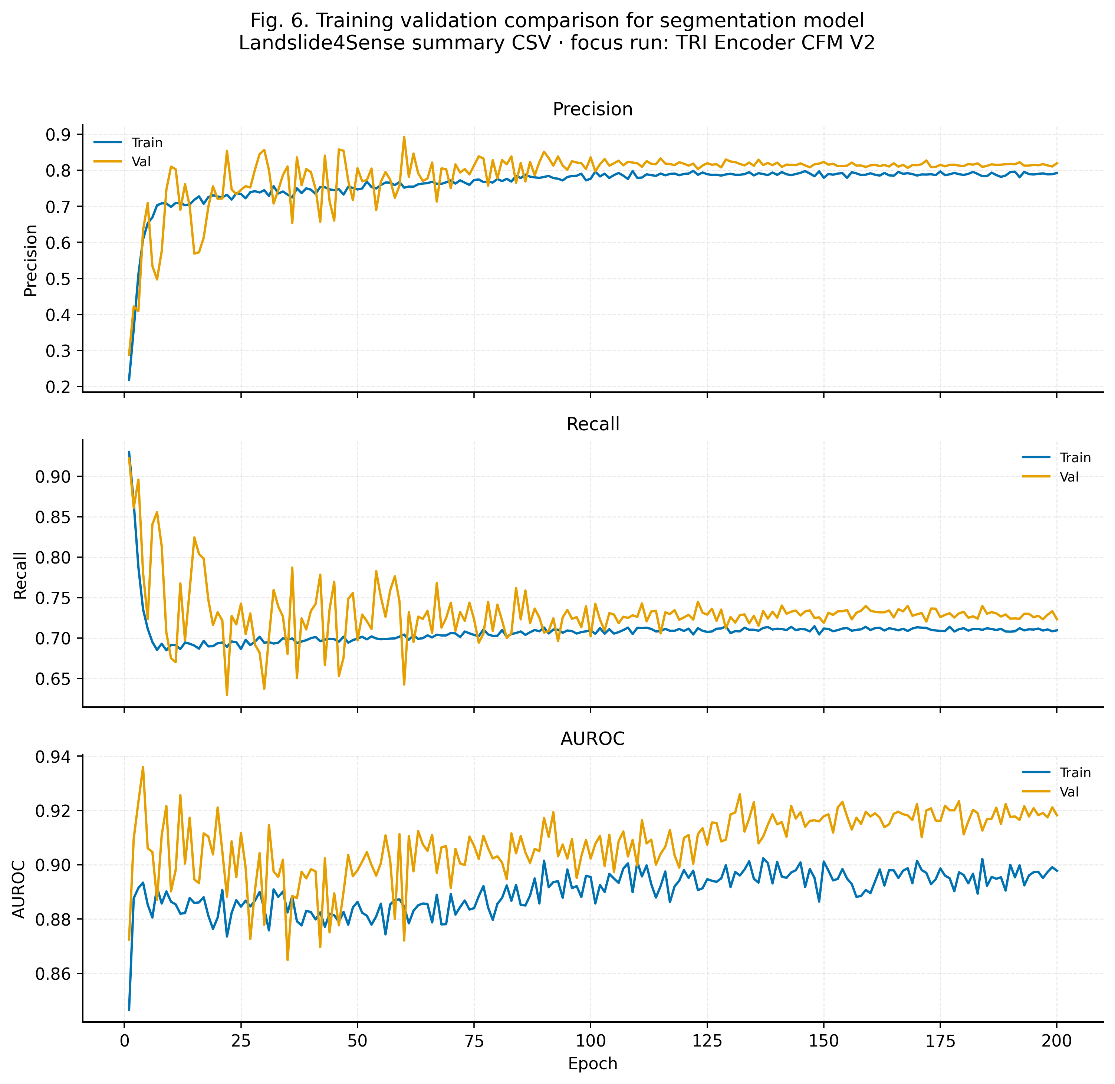
Fig. 6. Training validation comparison for segmentation model.

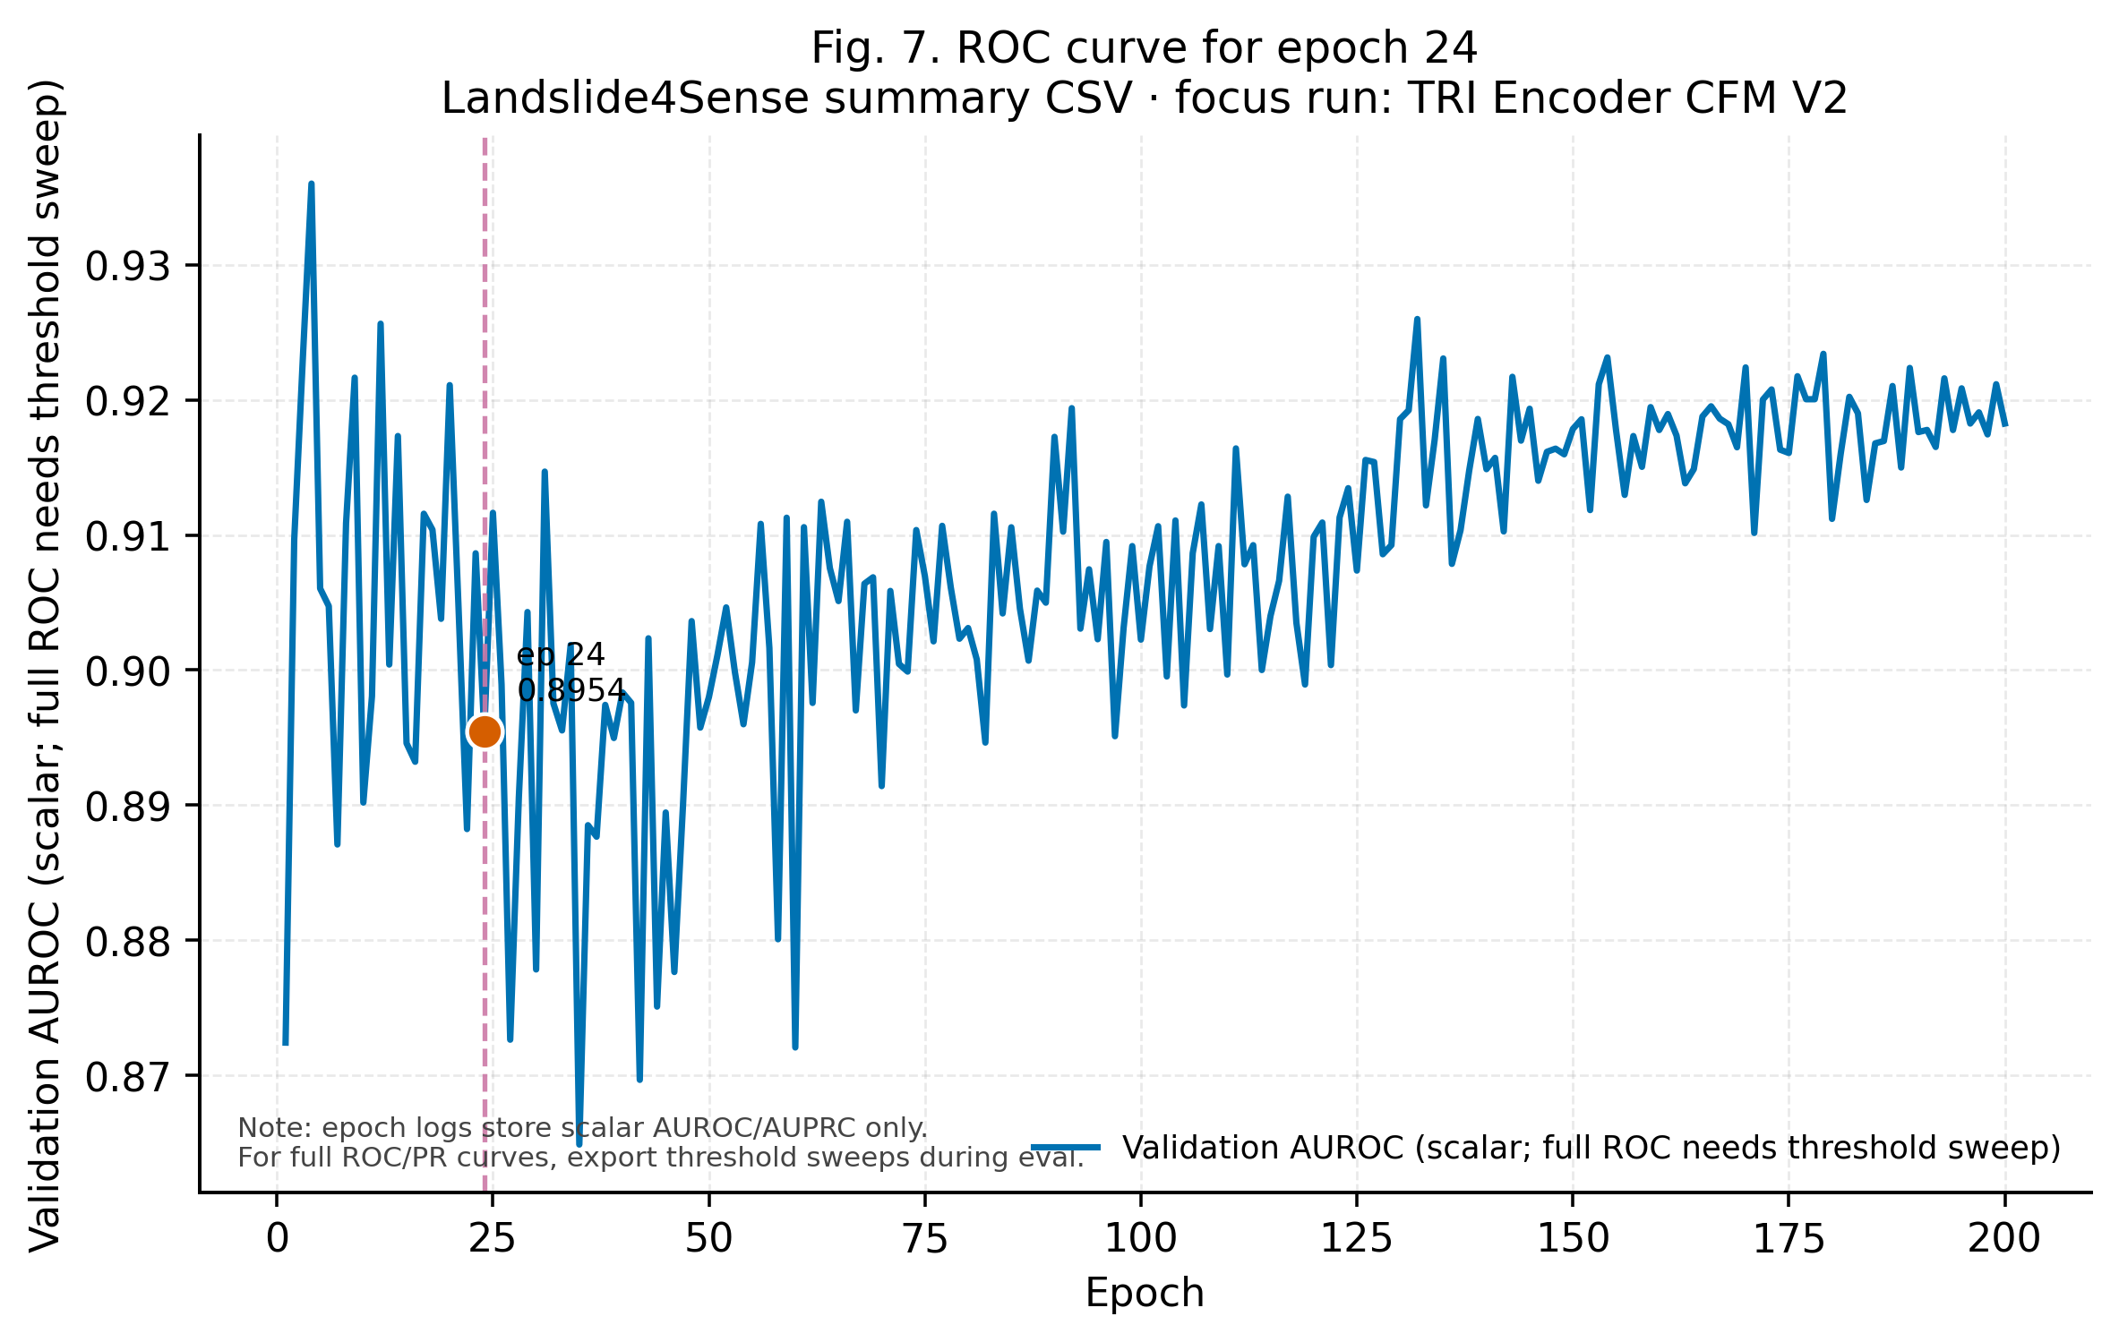
Fig. 7. ROC-style panel for epoch 24 (scalar AUROC vs epoch; full ROC pending sweep logs).

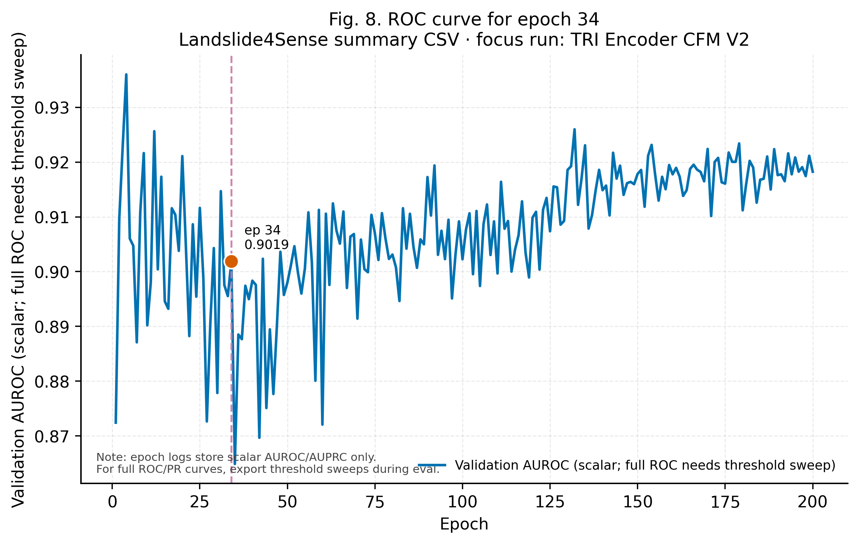
Fig. 8. ROC-style panel for epoch 34.

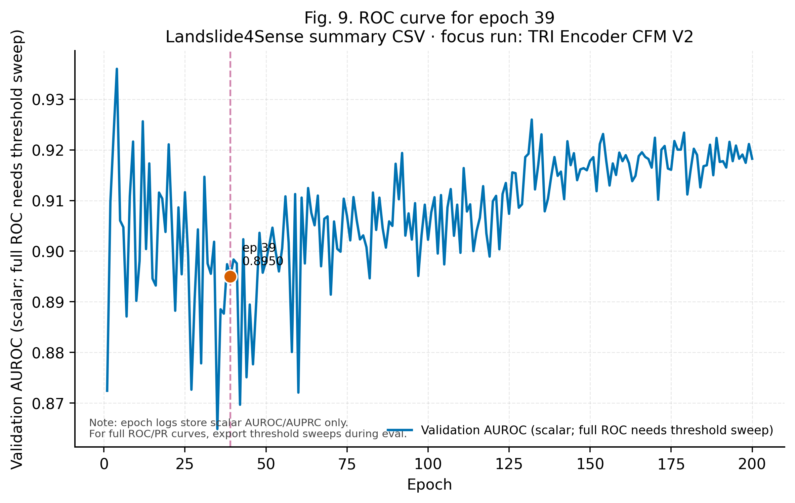
Fig. 9. ROC-style panel for epoch 39.

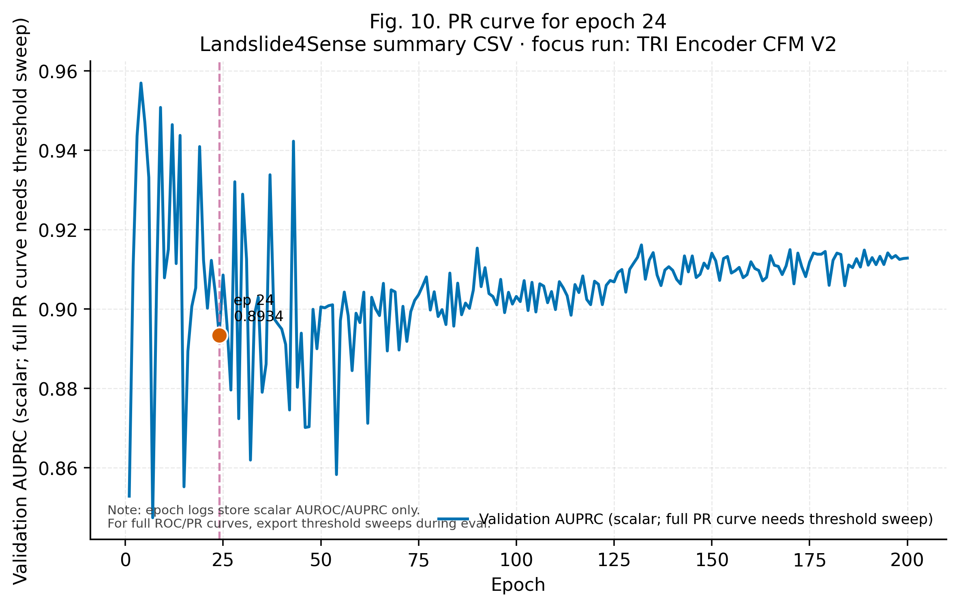
Fig. 10. PR-style panel for epoch 24 (scalar AUPRC vs epoch).

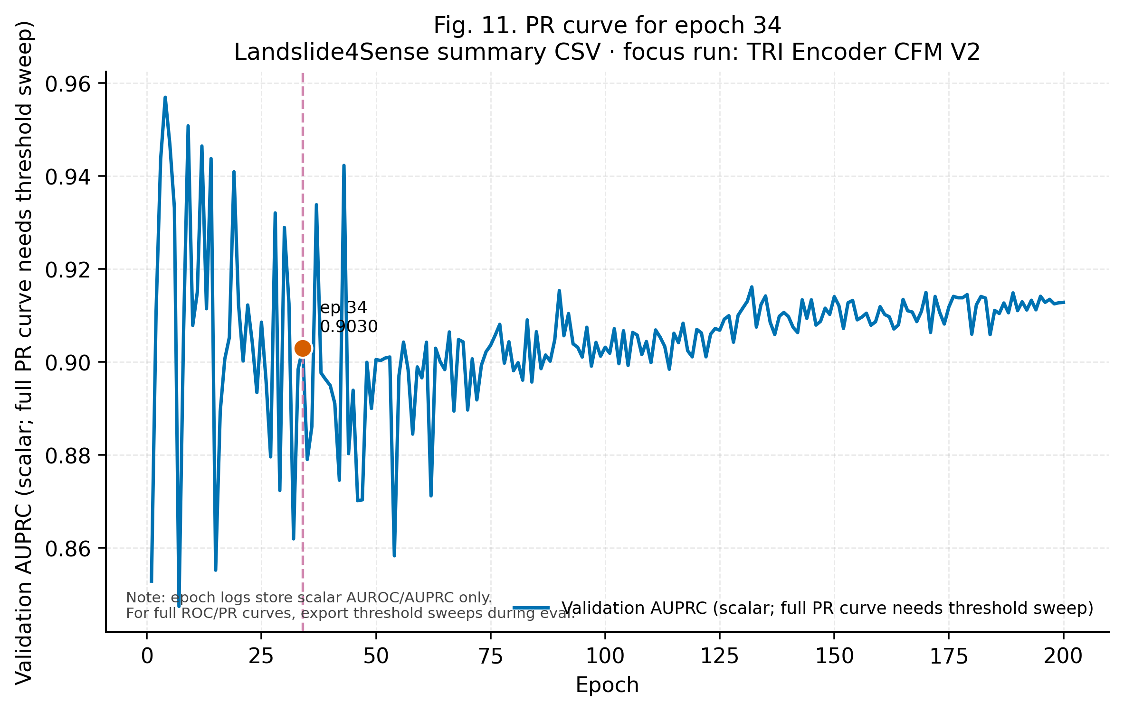
Fig. 11. PR-style panel for epoch 34.

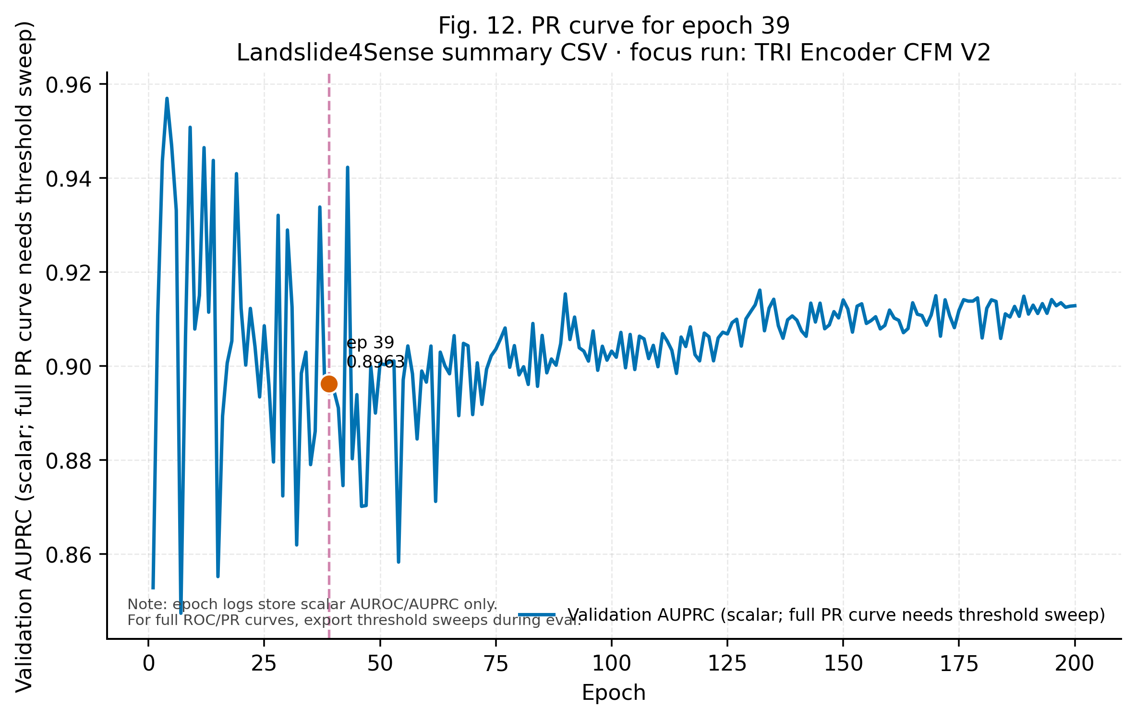
Fig. 12. PR-style panel for epoch 39.

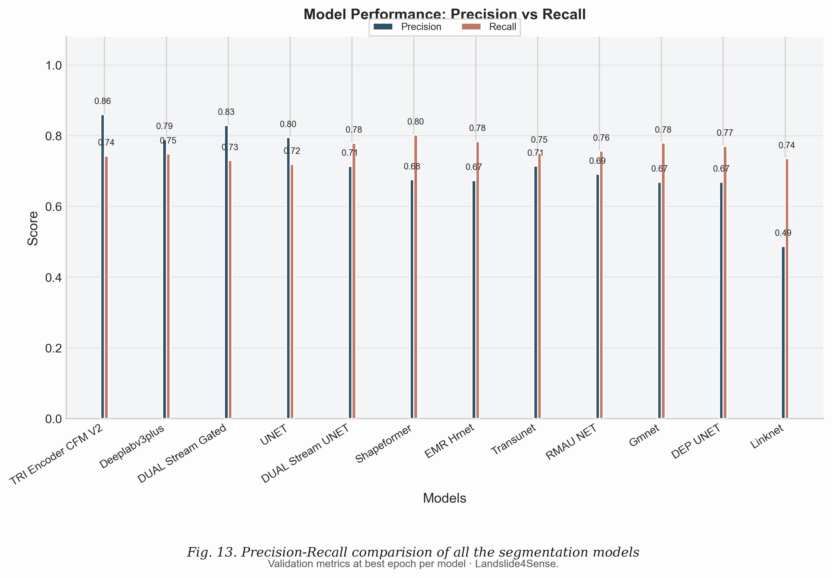
Fig. 13. Precision–Recall comparison of all segmentation models (grouped bars).

4.2 Bijie benchmark results
4.2 Bijie benchmark. Table 2 lists the same model cohort on the Bijie split (best validation epoch per row). Figs. 14–25 repeat the conference-style diagnostics on the focus run `tri_encoder_cfm_v2` and the full Bijie leaderboard so that behaviour can be compared directly with the Landslide4Sense block above.
Table 2. Bijie best-epoch validation summary across the same model cohort (values from bijie_best_validation_summary.csv).
Model Id | Display Name | Best Epoch | Val Acc | Val Precision | Val Recall | Val F1 | Val Iou | Val Auroc | Val Auprc
rmau_net | RMAU NET | 77 | 0.9806 | 0.8593 | 0.9243 | 0.8304 | 0.7981 | 0.0545 | 0.0554
dep_unet | DEP UNET | 96 | 0.9823 | 0.8500 | 0.9337 | 0.8309 | 0.7989 | 0.0543 | 0.0553
shapeformer | Shapeformer | 86 | 0.9837 | 0.8918 | 0.8992 | 0.8397 | 0.8103 | 0.0459 | 0.0554
transunet | Transunet | 89 | 0.9831 | 0.8894 | 0.9077 | 0.8446 | 0.8151 | 0.0543 | 0.0553
emr_hrnet | EMR Hrnet | 89 | 0.9835 | 0.9028 | 0.9045 | 0.8457 | 0.8178 | 0.0556 | 0.0556
gmnet | Gmnet | 75 | 0.9830 | 0.9004 | 0.9090 | 0.8547 | 0.8248 | 0.0543 | 0.0553
unet | UNET | 79 | 0.9866 | 0.8909 | 0.9329 | 0.8731 | 0.8420 | 0.0556 | 0.0556
dual_stream_unet | DUAL Stream UNET | 58 | 0.9864 | 0.9015 | 0.9280 | 0.8749 | 0.8428 | 0.0556 | 0.0556
deeplabv3plus | Deeplabv3plus | 92 | 0.9895 | 0.9285 | 0.9657 | 0.9275 | 0.8986 | 0.0556 | 0.0556
dual_stream_gated | DUAL Stream Gated | 99 | 0.9883 | 0.9278 | 0.9289 | 0.8971 | 0.8685 | nan | nan
tri_encoder_cfm_v2 | TRI Encoder CFM V2 | 112 | 0.9811 | 0.8848 | 0.8640 | 0.8169 | 0.7892 | 0.0545 | 0.0554
Note: Values are best-epoch validation metrics from the unified ablation harness. Bold entries in the proposed-model row indicate column-wise maxima among all listed runs. Dataset: Bijie City landslide split; AUROC/AUPRC absent where logs omit those scalars.

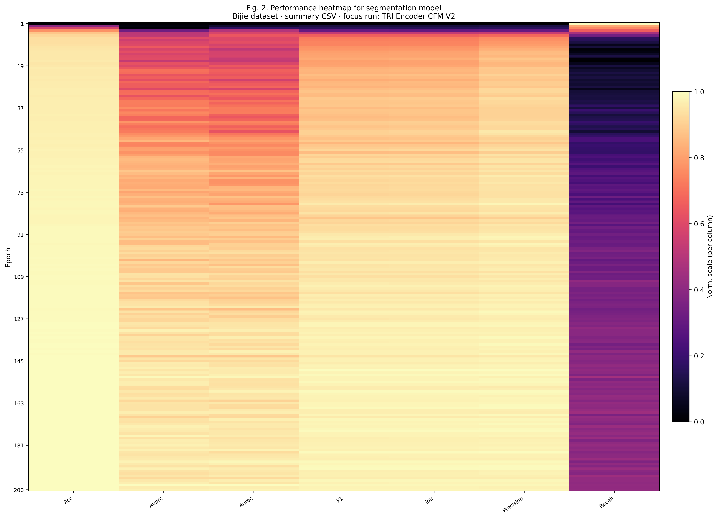
Fig. 14 (Bijie). Performance heatmap for segmentation model (training dynamics).

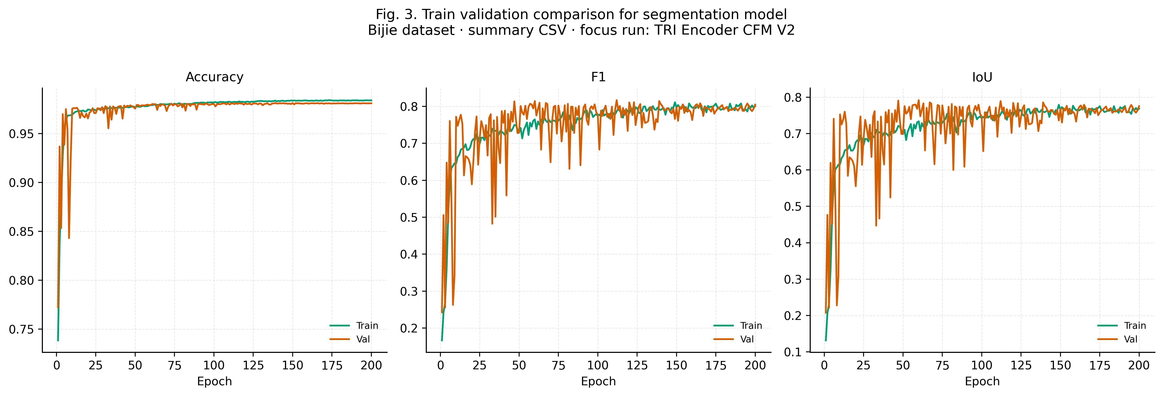
Fig. 15 (Bijie). Train validation comparison for segmentation model.

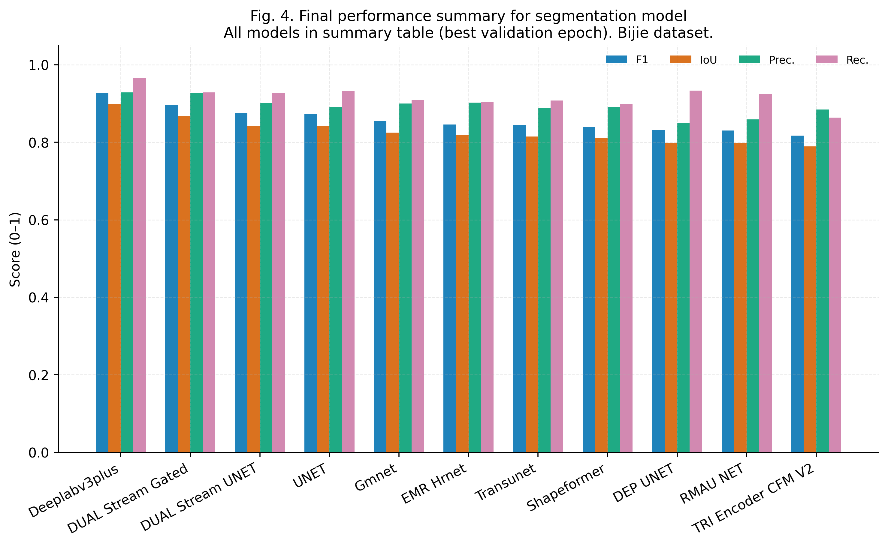
Fig. 16 (Bijie). Final performance summary for segmentation model.

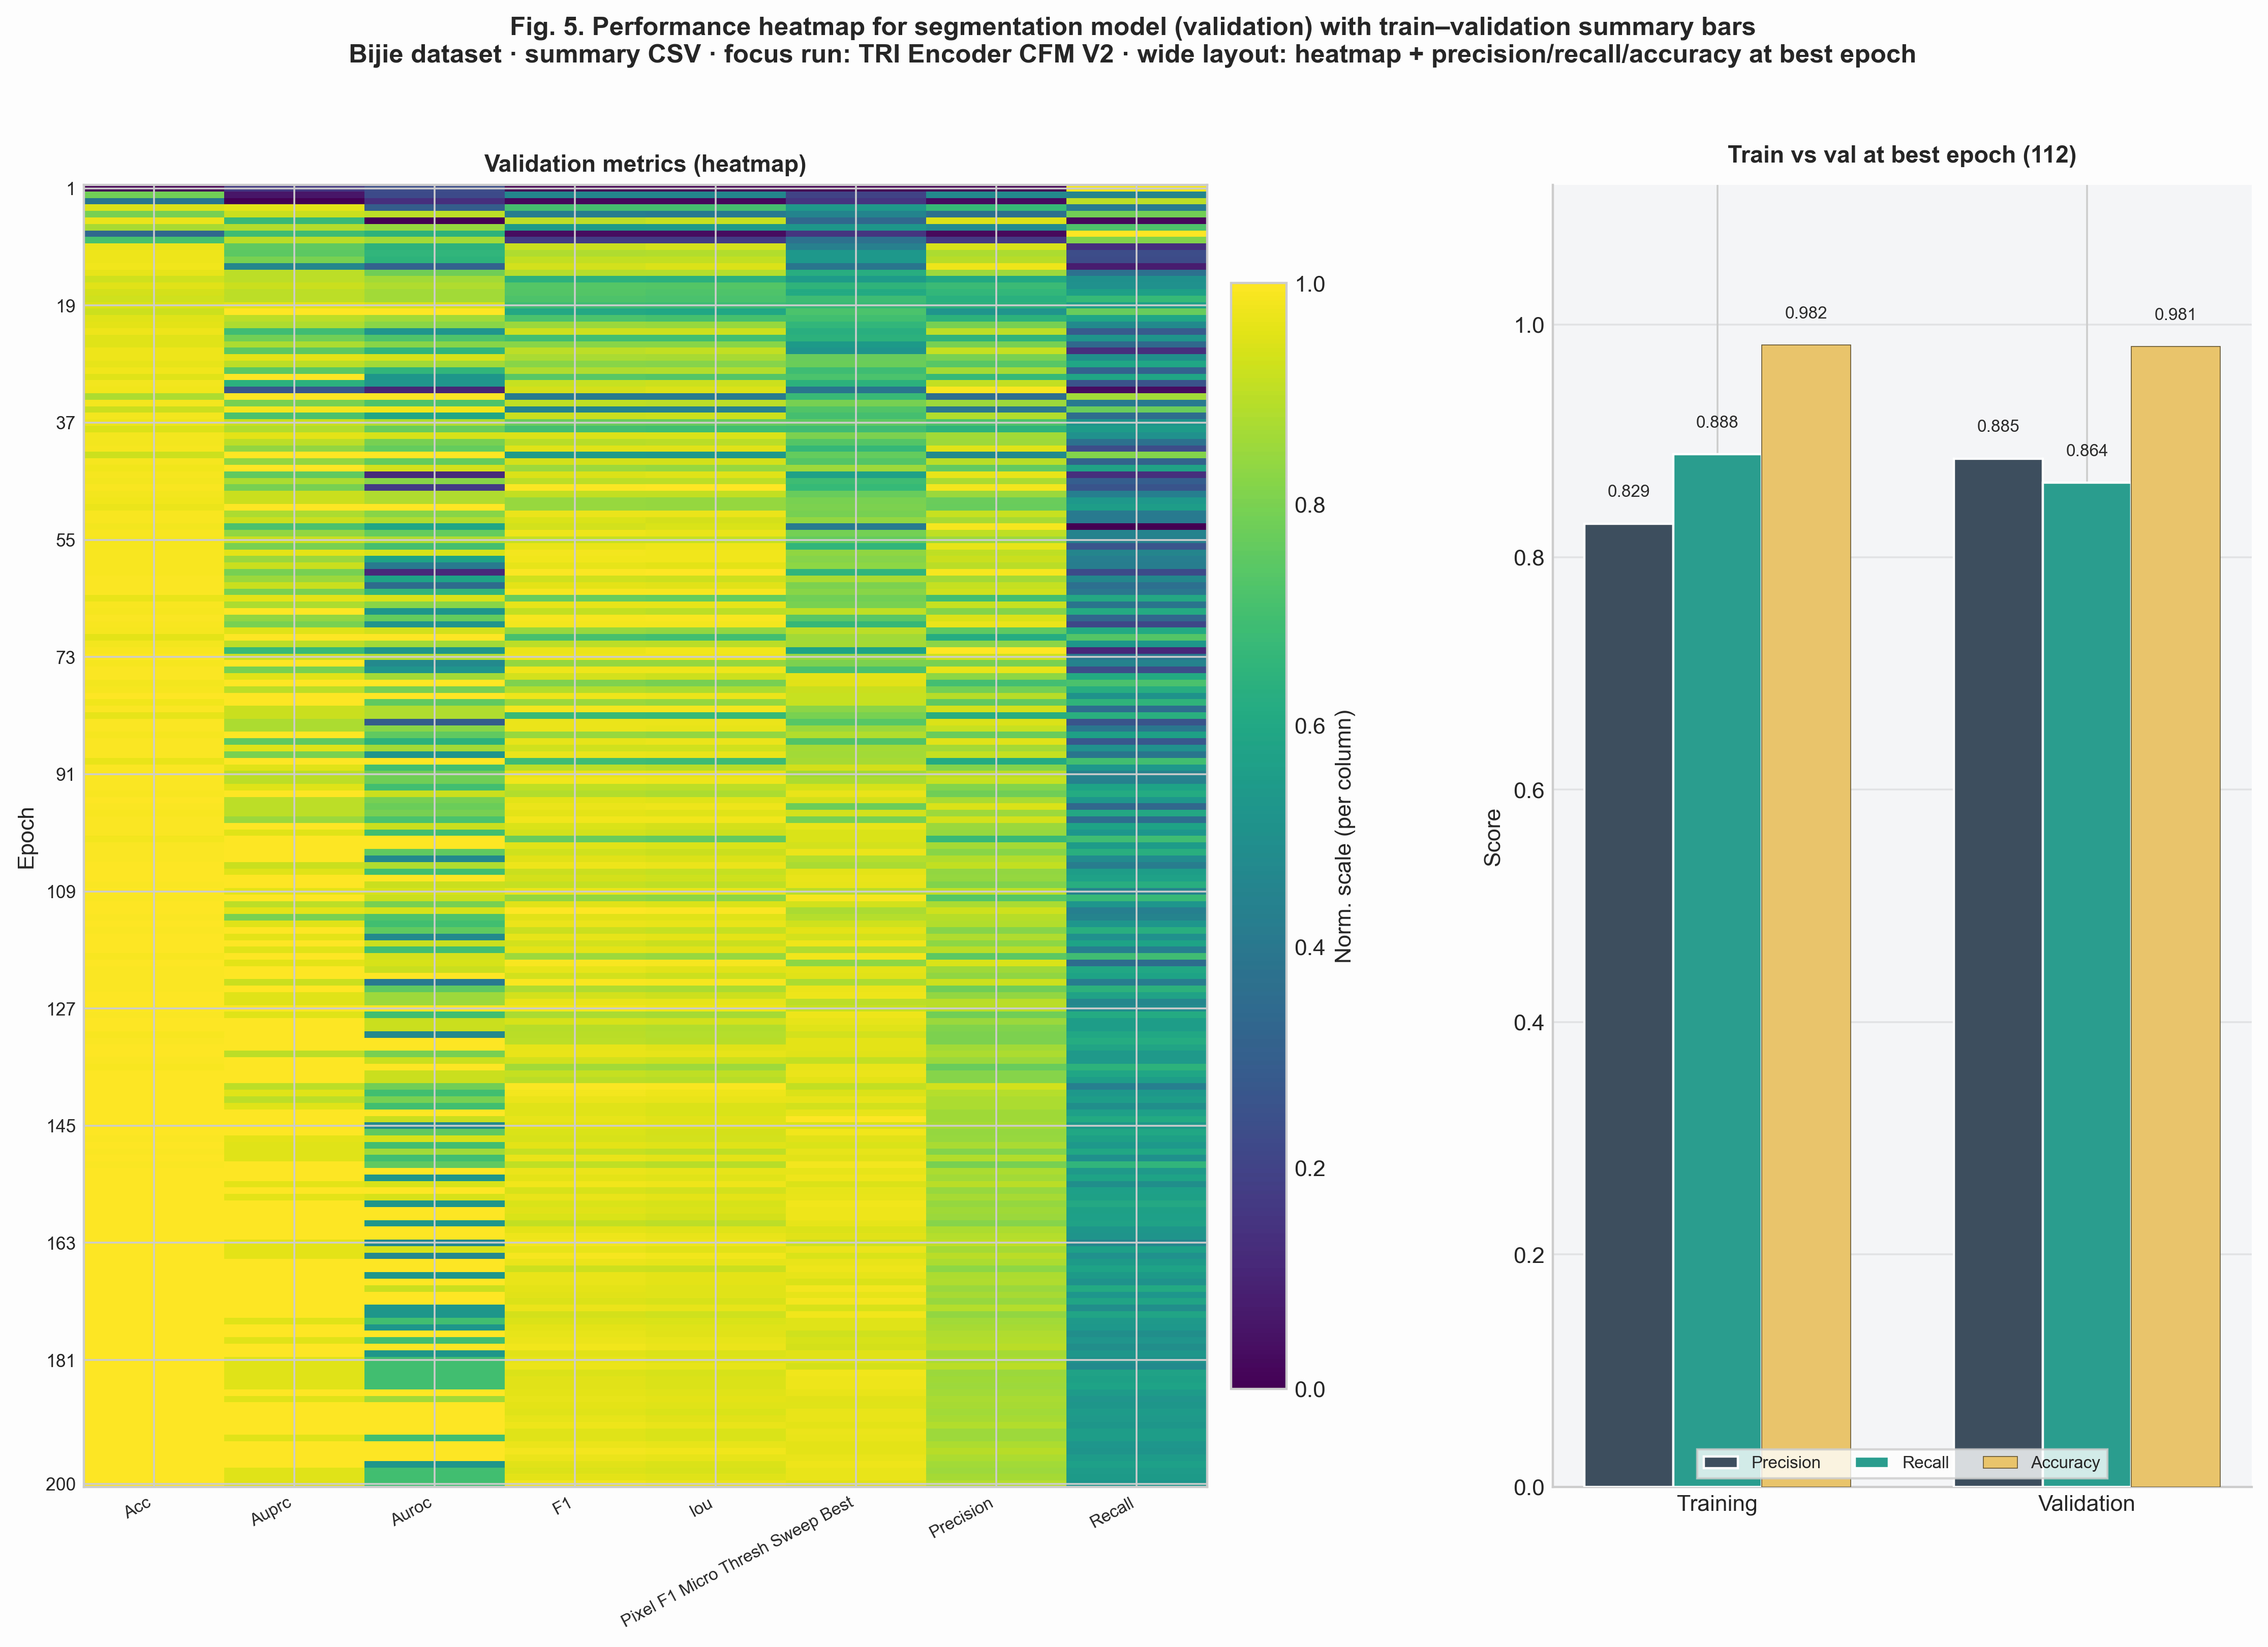
Fig. 17 (Bijie). Validation heatmap with train–validation summary bars at best epoch (wide layout).

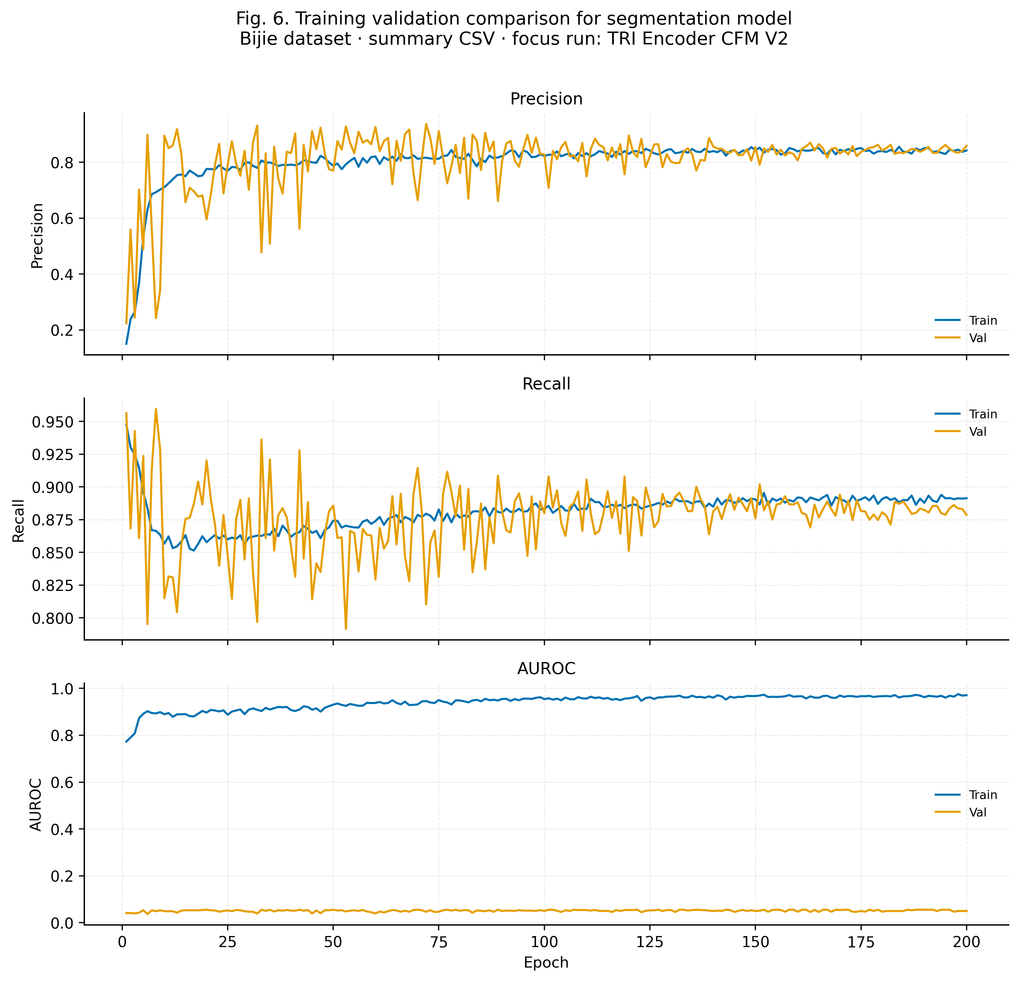
Fig. 18 (Bijie). Training validation comparison for segmentation model.

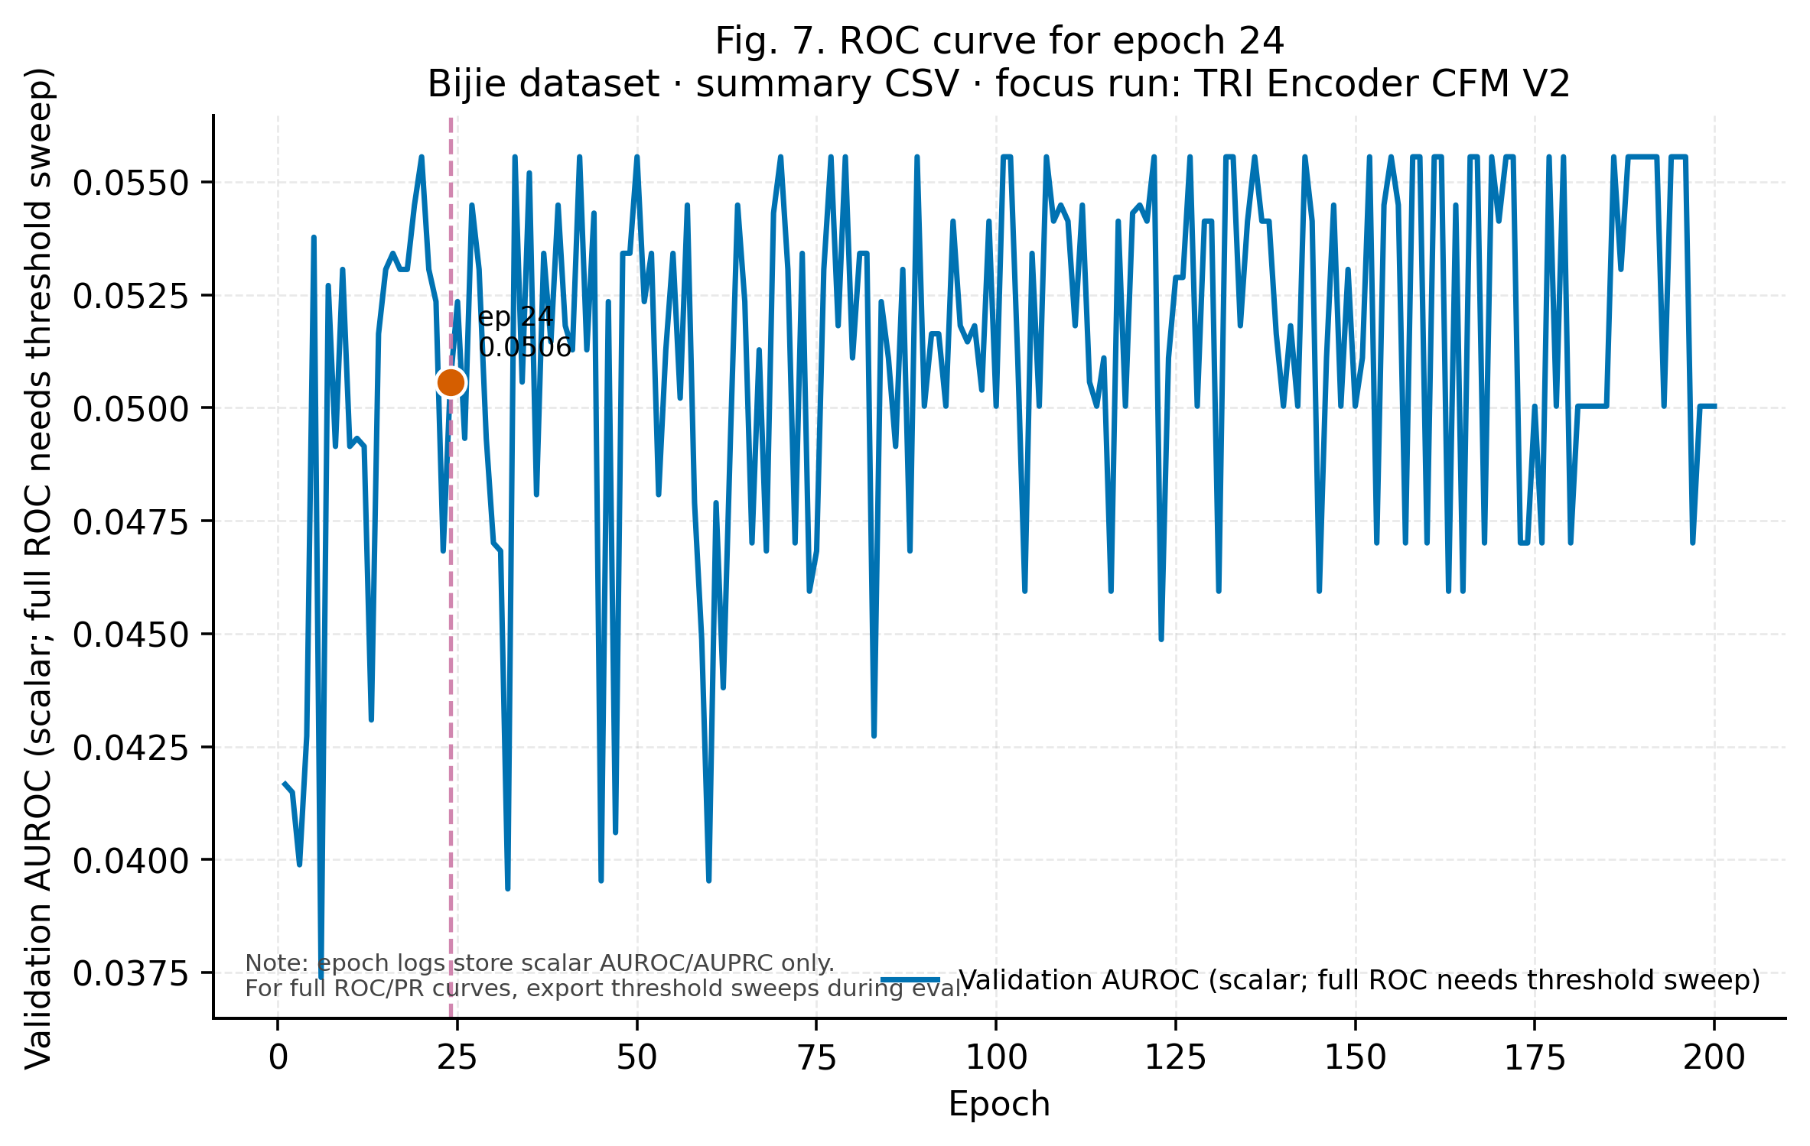
Fig. 19 (Bijie). ROC-style panel for epoch 24 (scalar AUROC vs epoch; full ROC pending sweep logs).

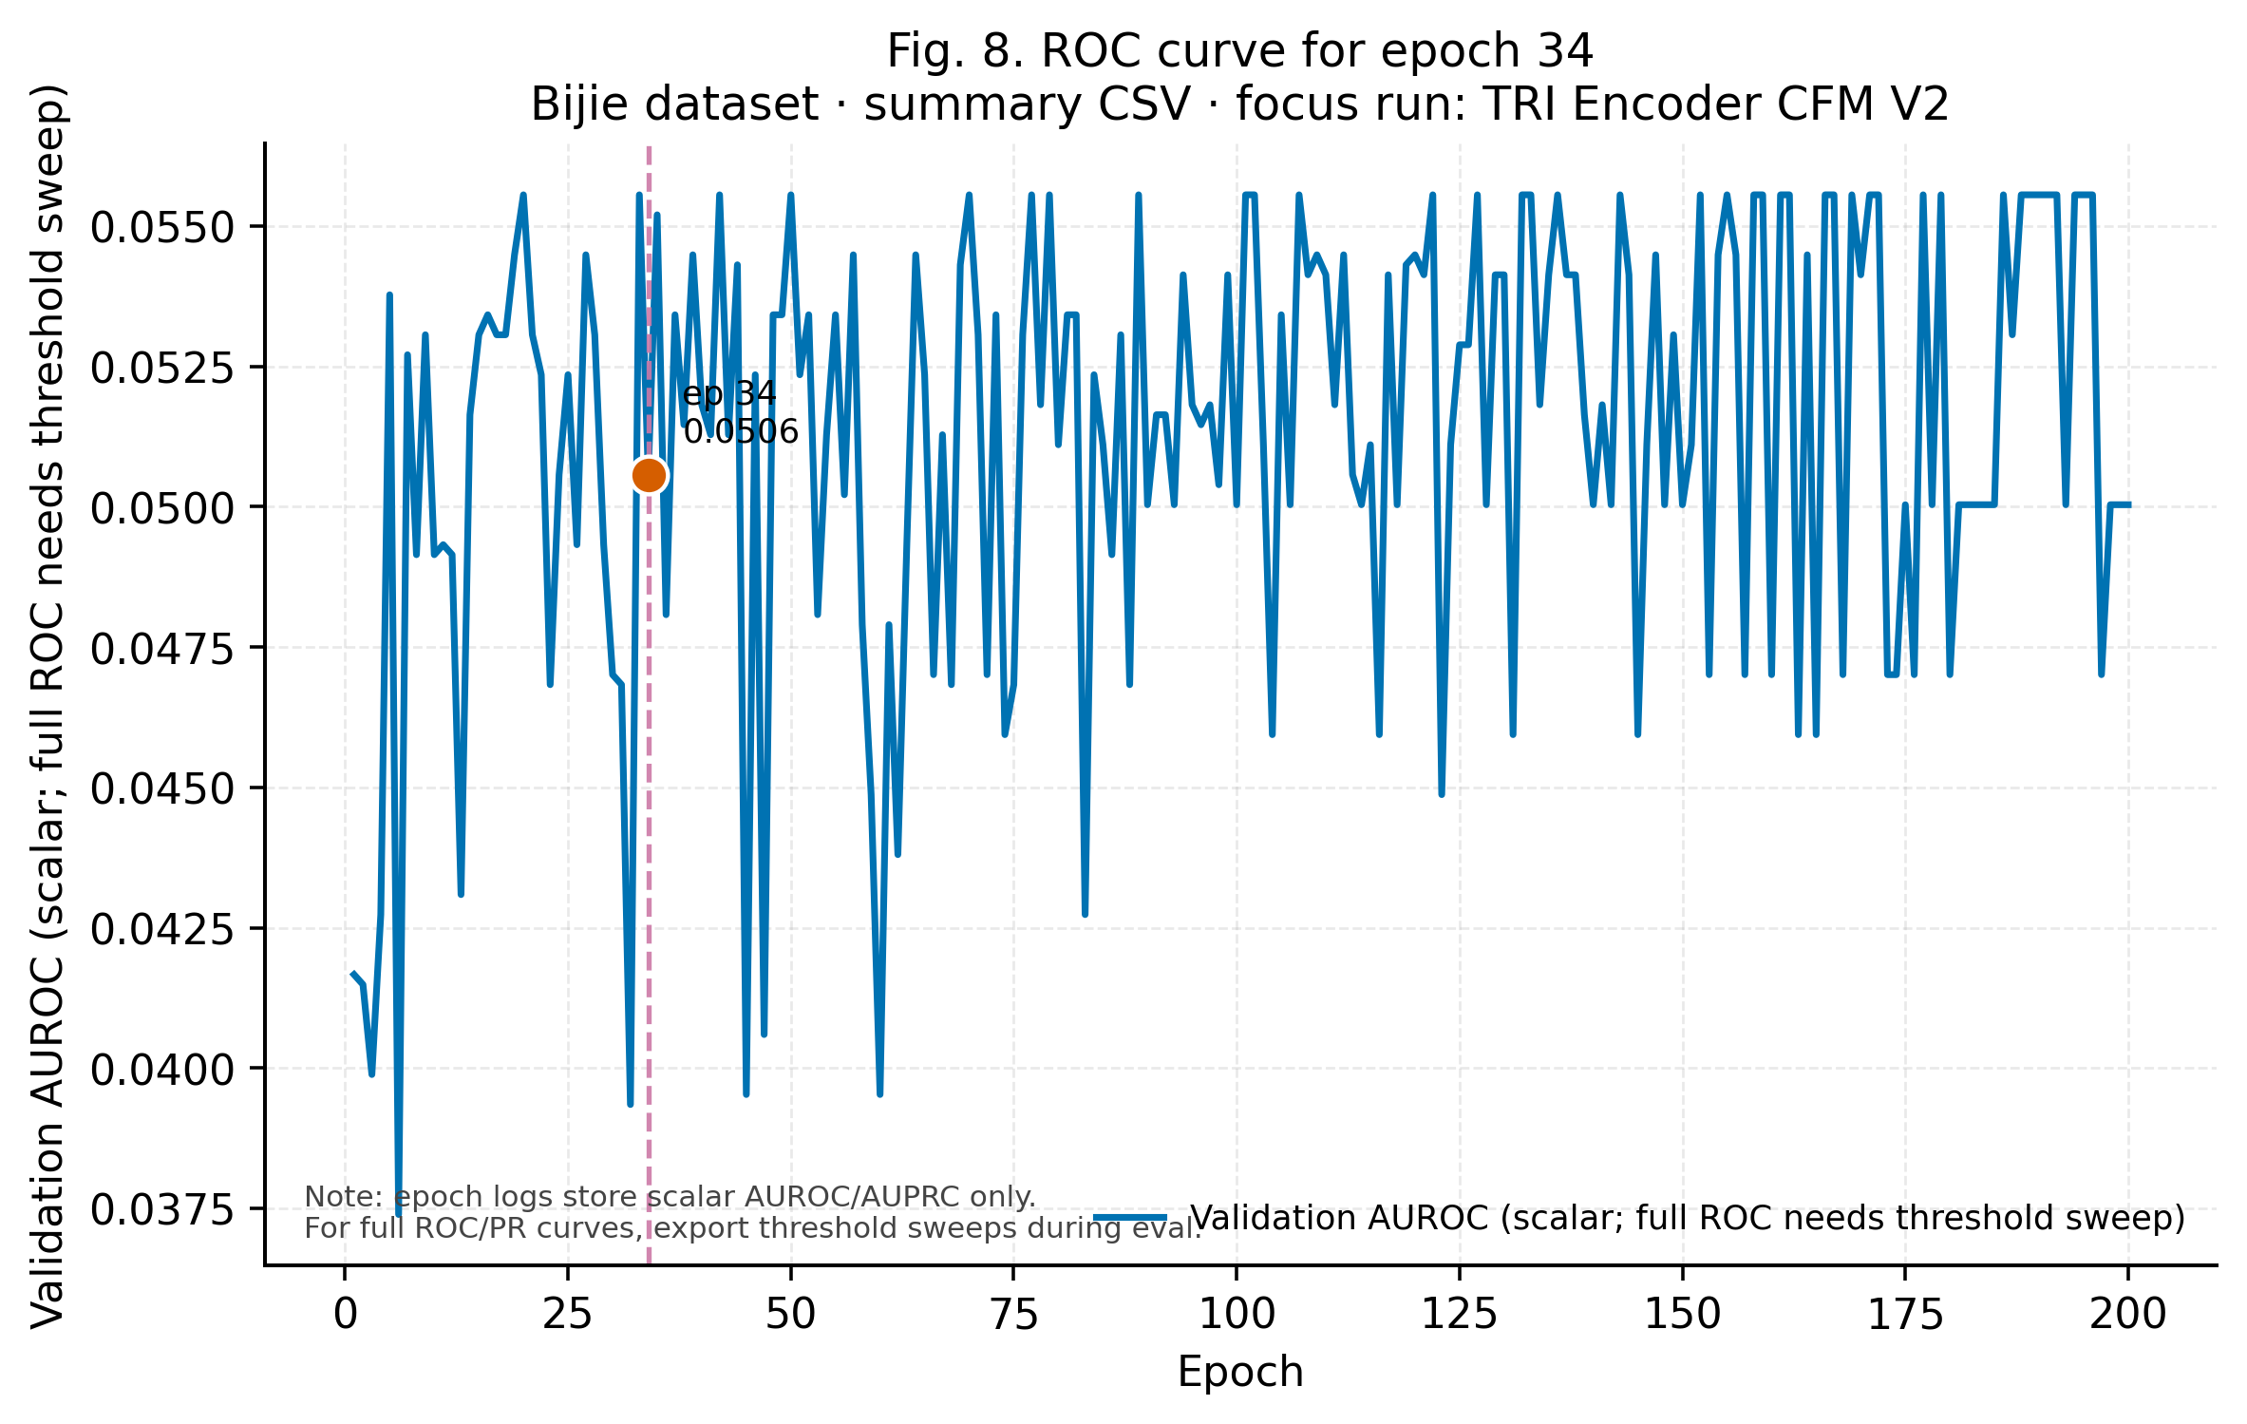
Fig. 20 (Bijie). ROC-style panel for epoch 34.

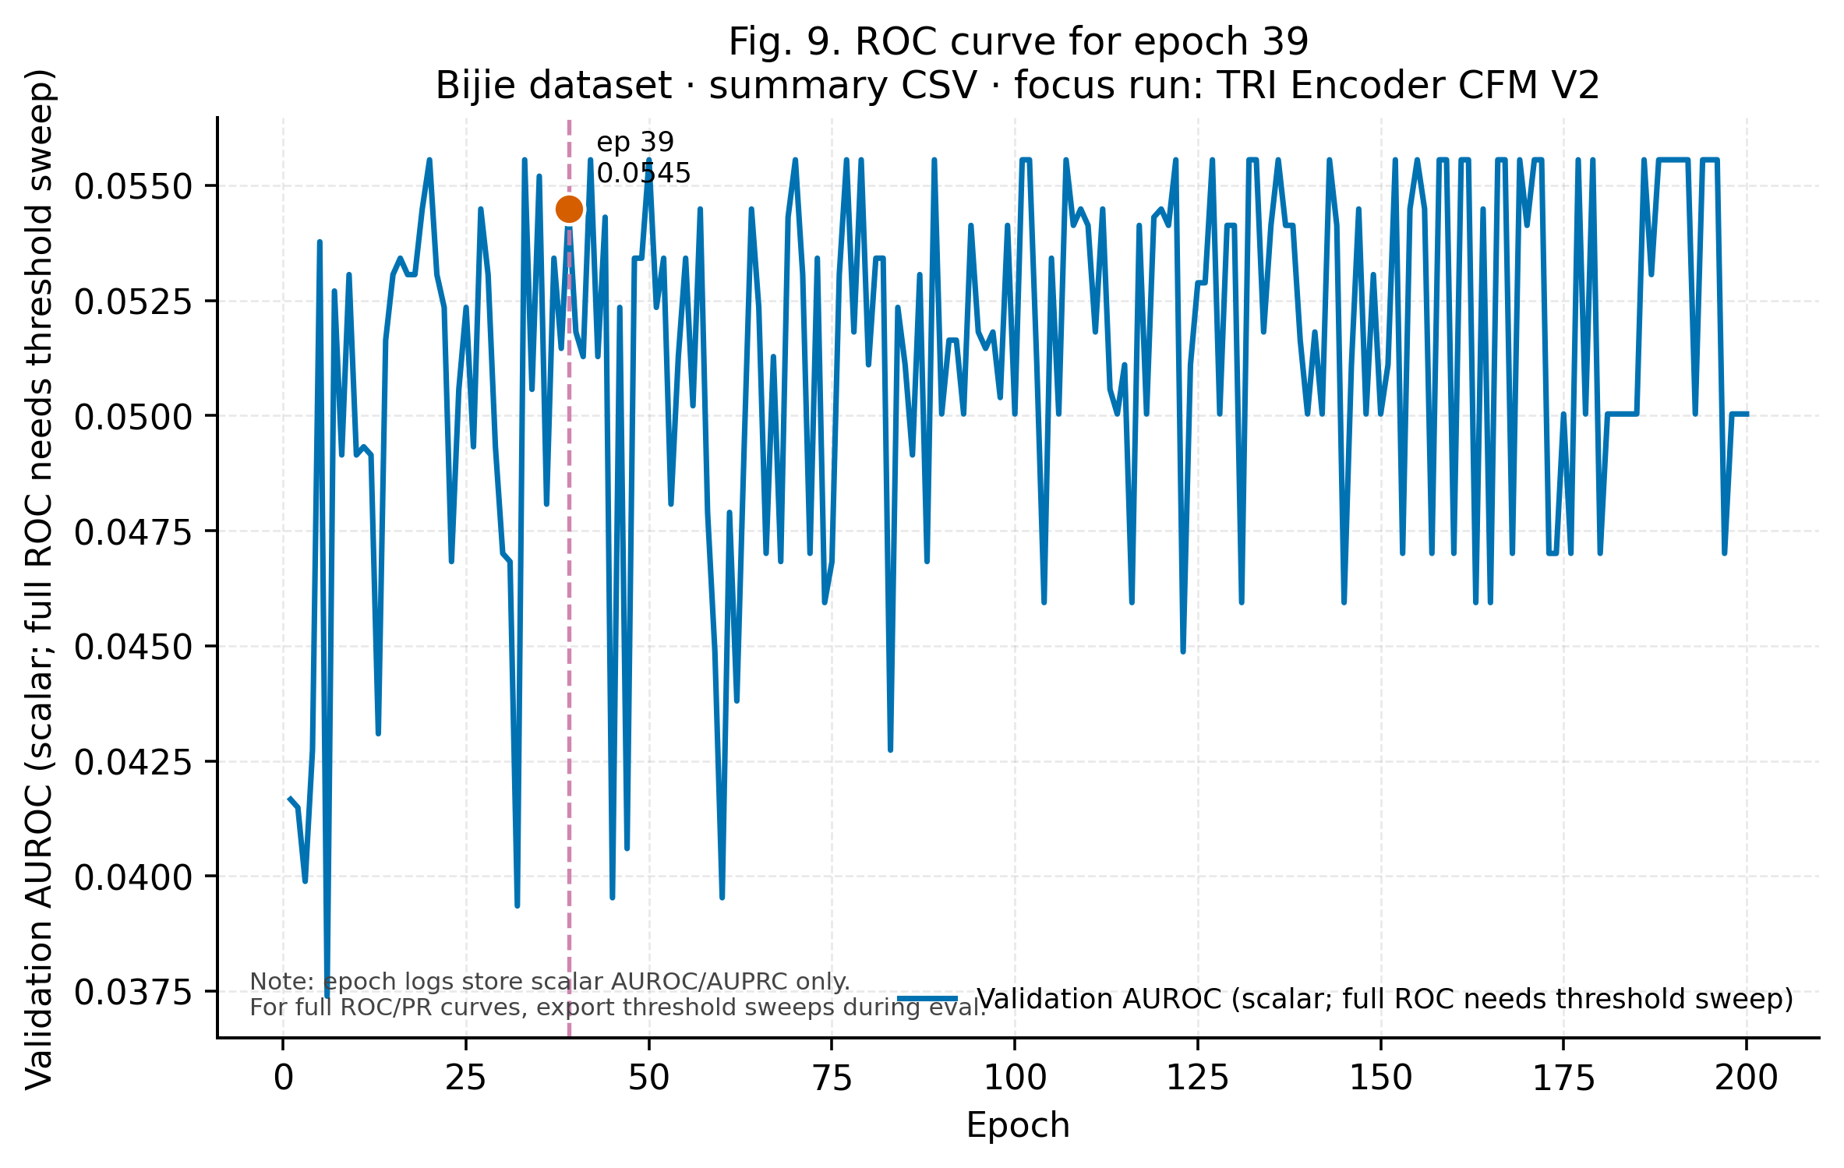
Fig. 21 (Bijie). ROC-style panel for epoch 39.

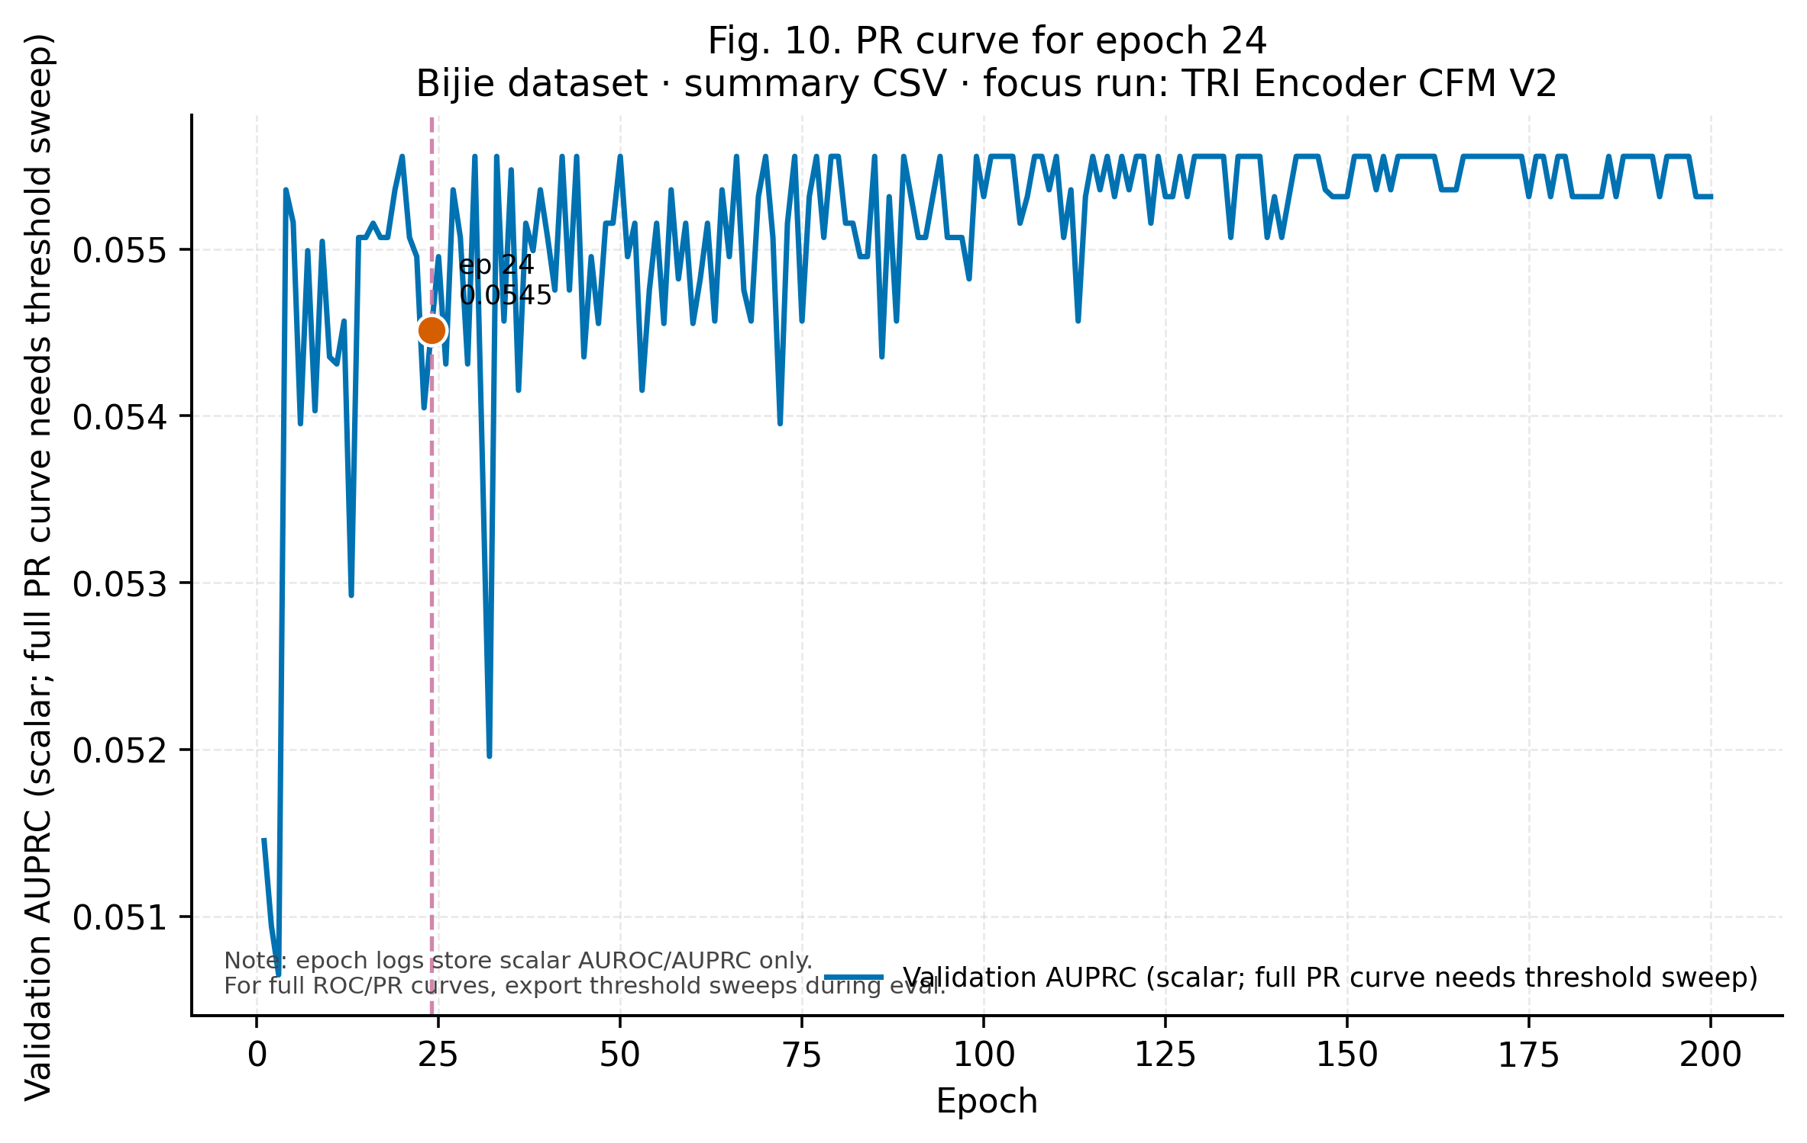
Fig. 22 (Bijie). PR-style panel for epoch 24 (scalar AUPRC vs epoch).

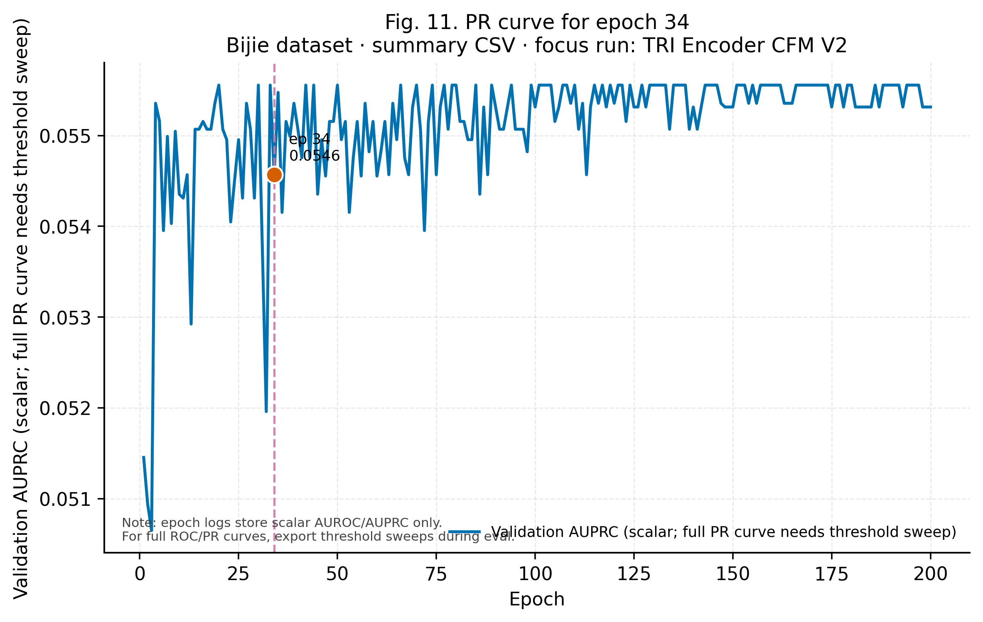
Fig. 23 (Bijie). PR-style panel for epoch 34.

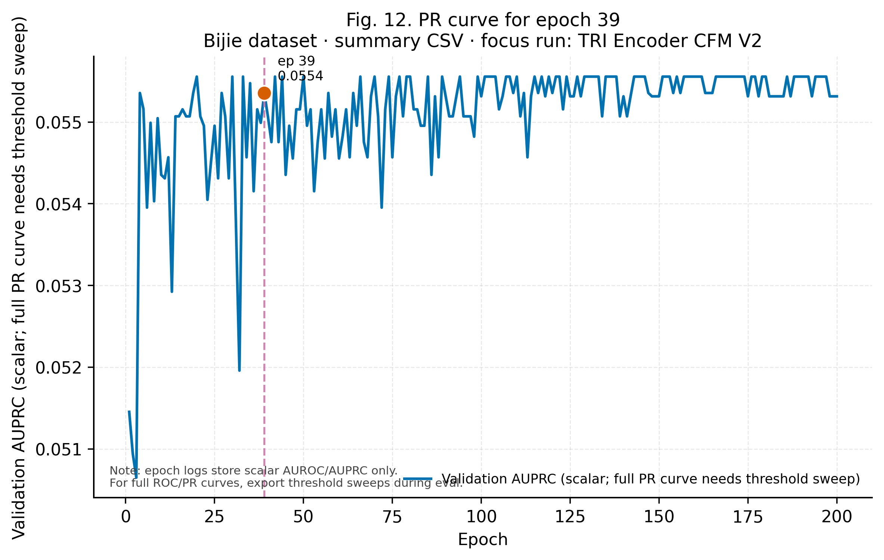
Fig. 24 (Bijie). PR-style panel for epoch 39.

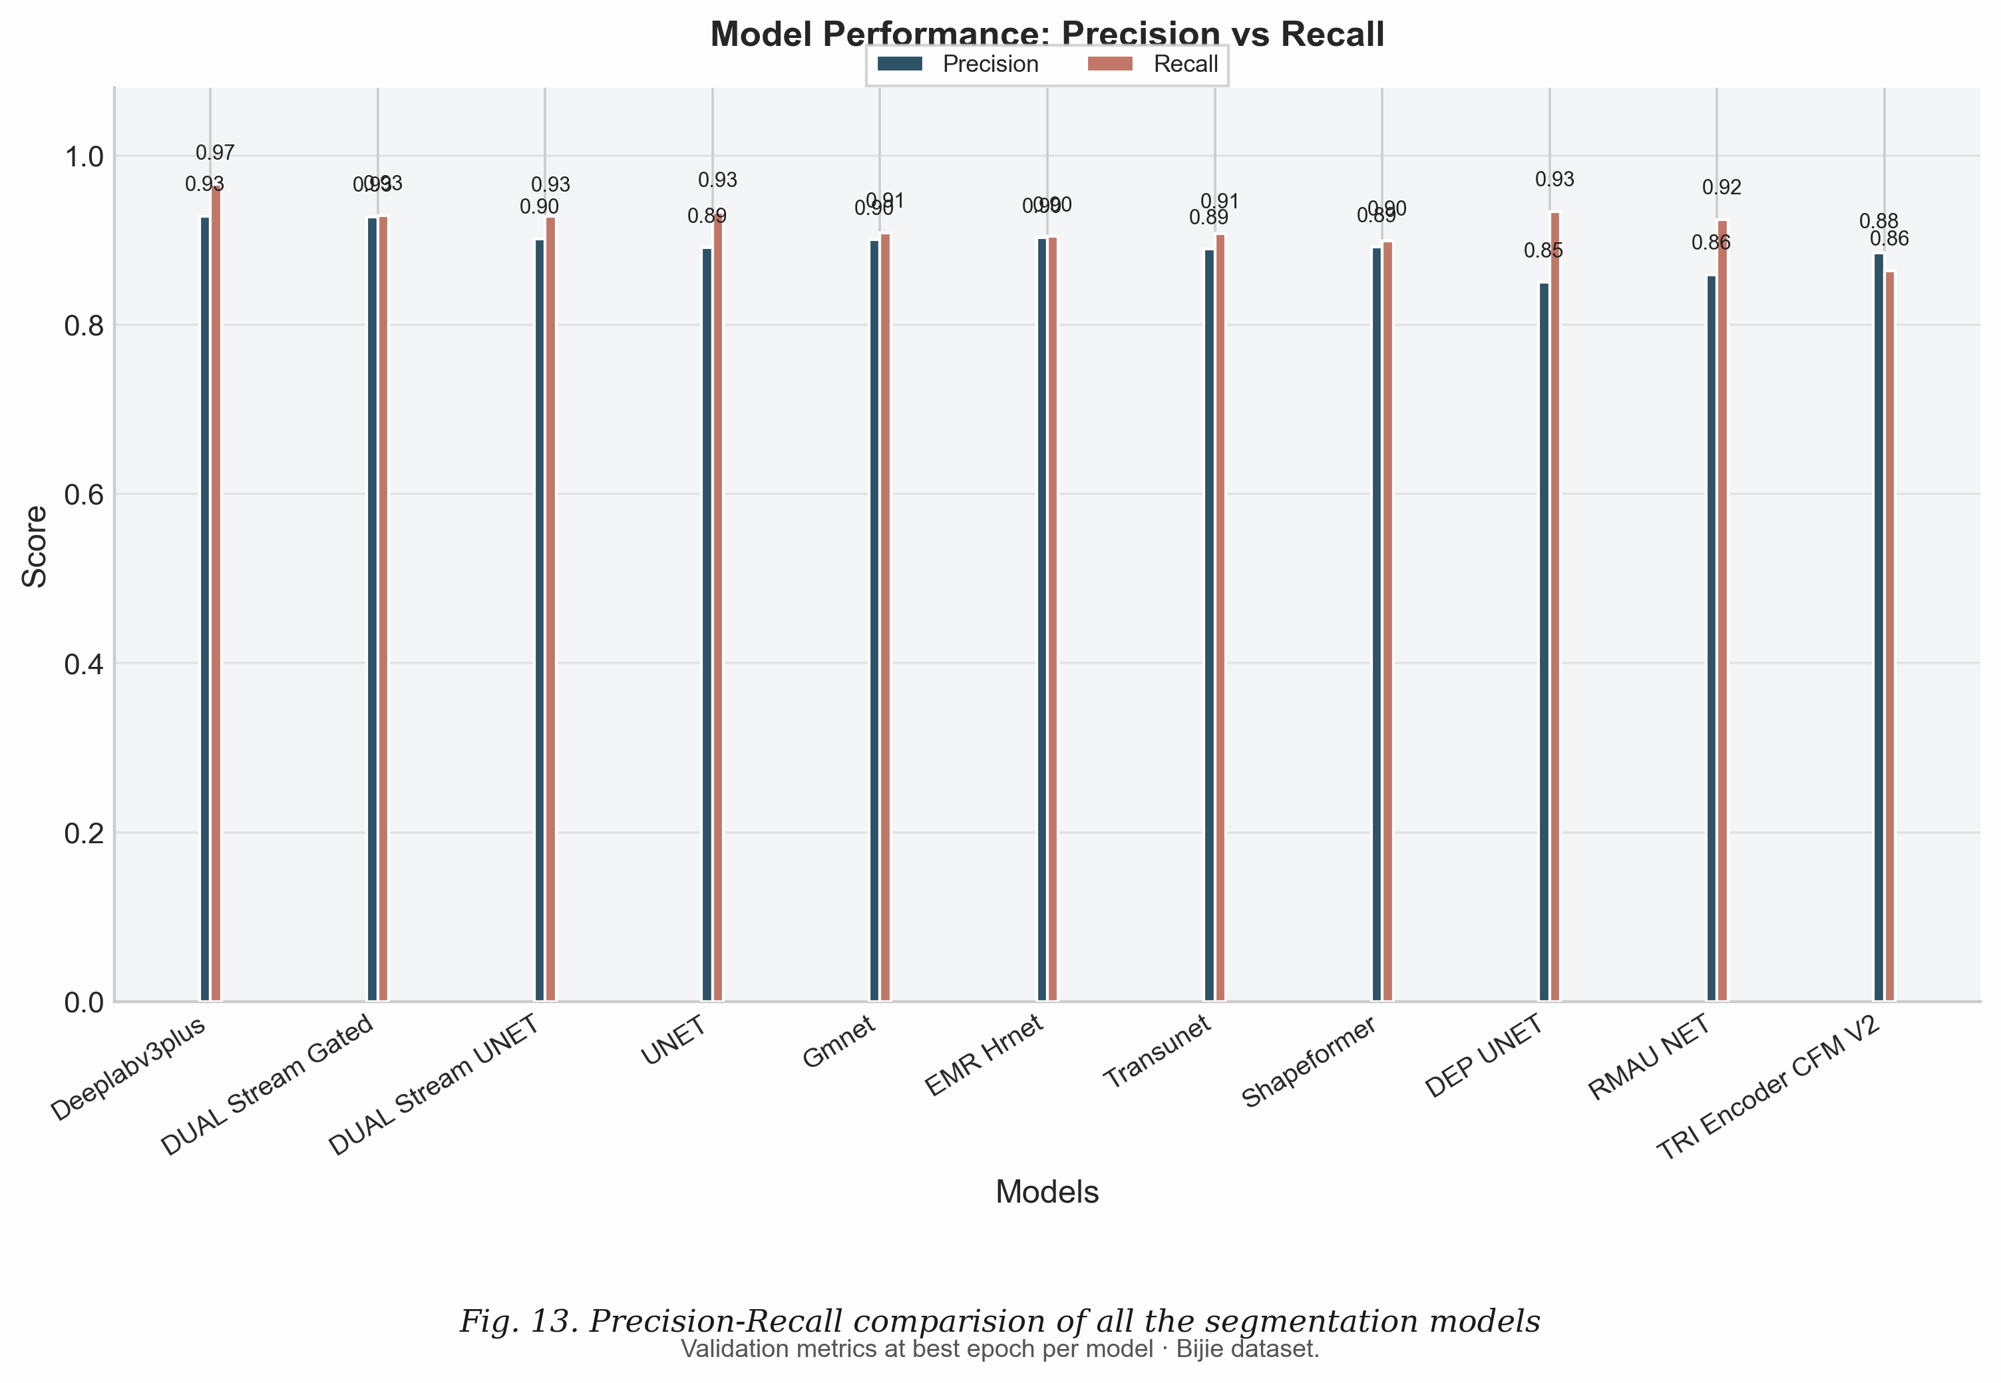
Fig. 25 (Bijie). Precision–Recall comparison of all segmentation models (grouped bars).

Supplementary overlay figures (fig01–fig04, fig06–fig09)
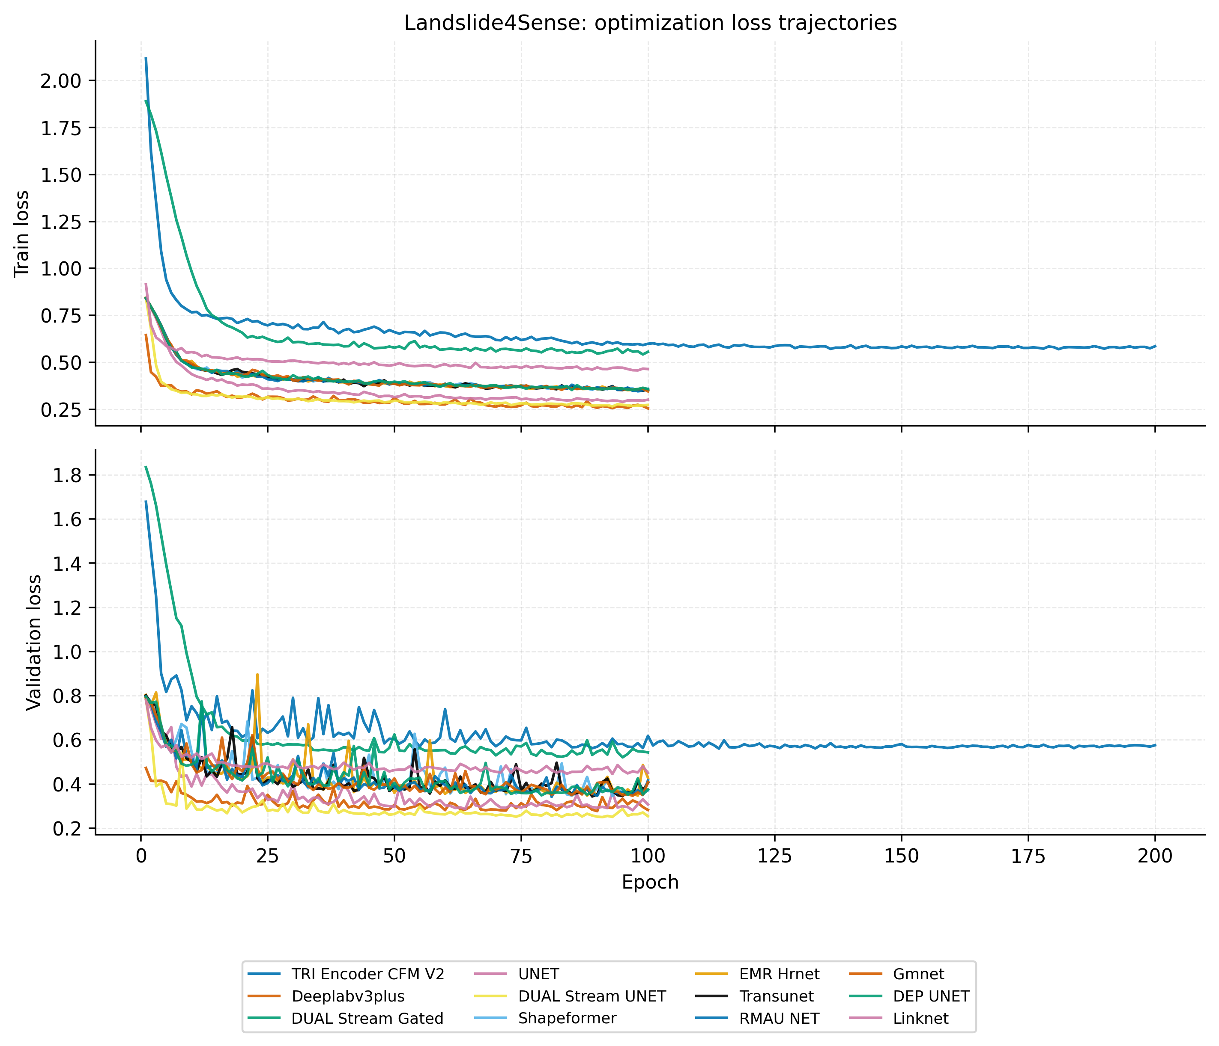
Overlay figure fig01: fig01_loss_curves_train_val.

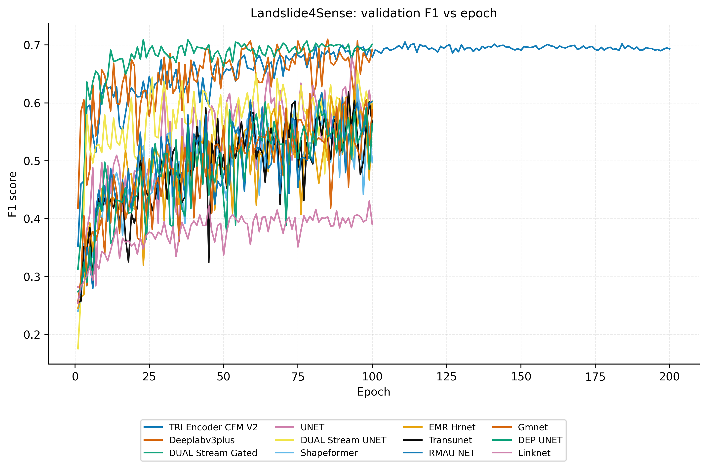
Overlay figure fig02: fig02_validation_f1_vs_epoch.

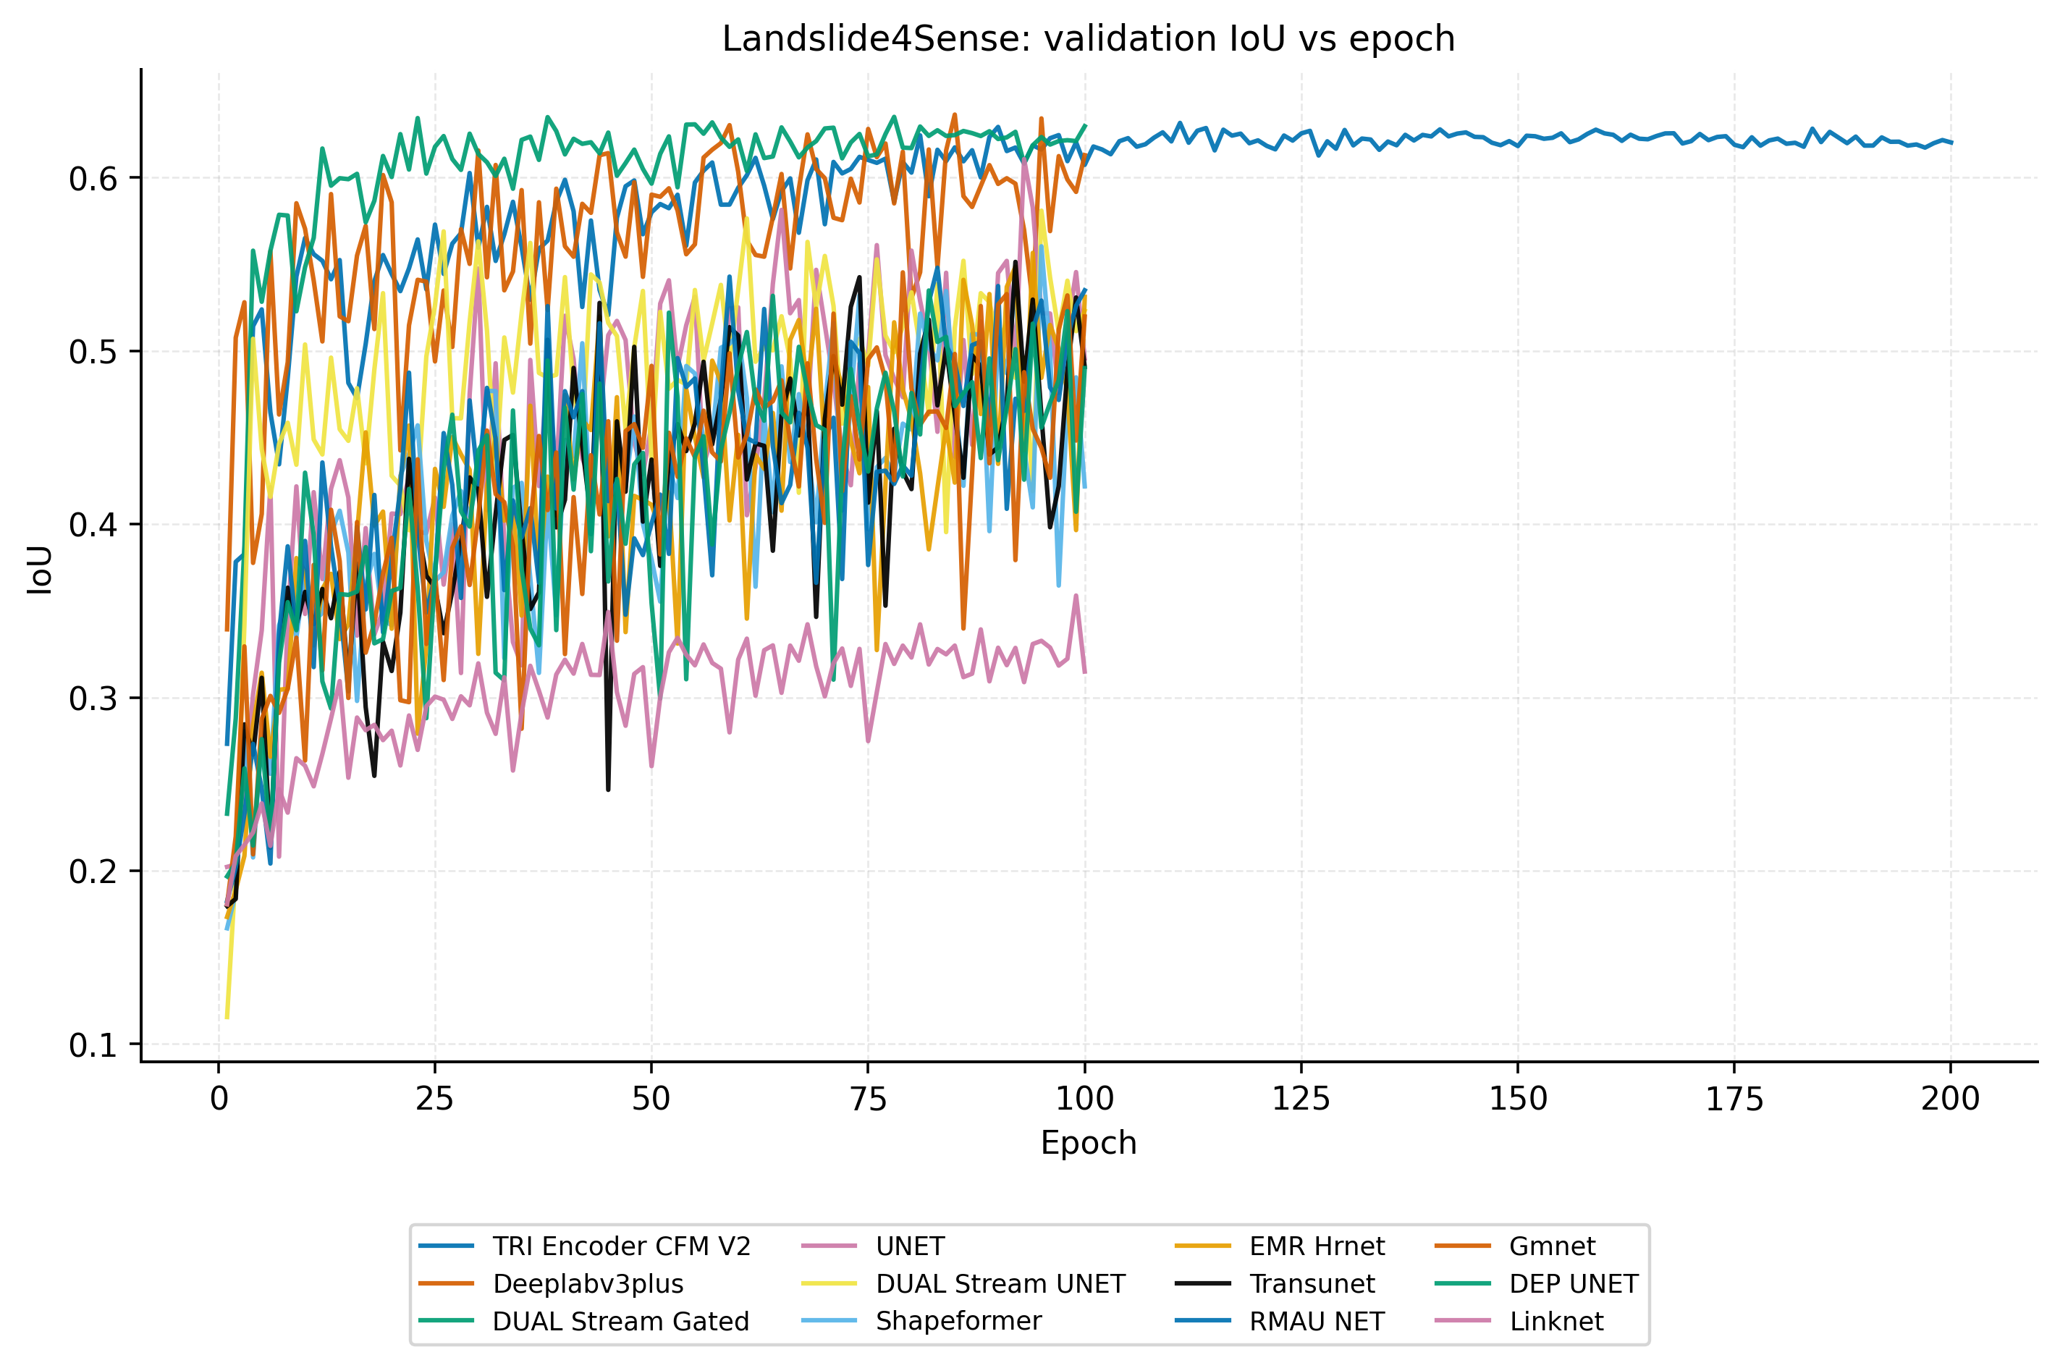
Overlay figure fig03: fig03_validation_iou_vs_epoch.

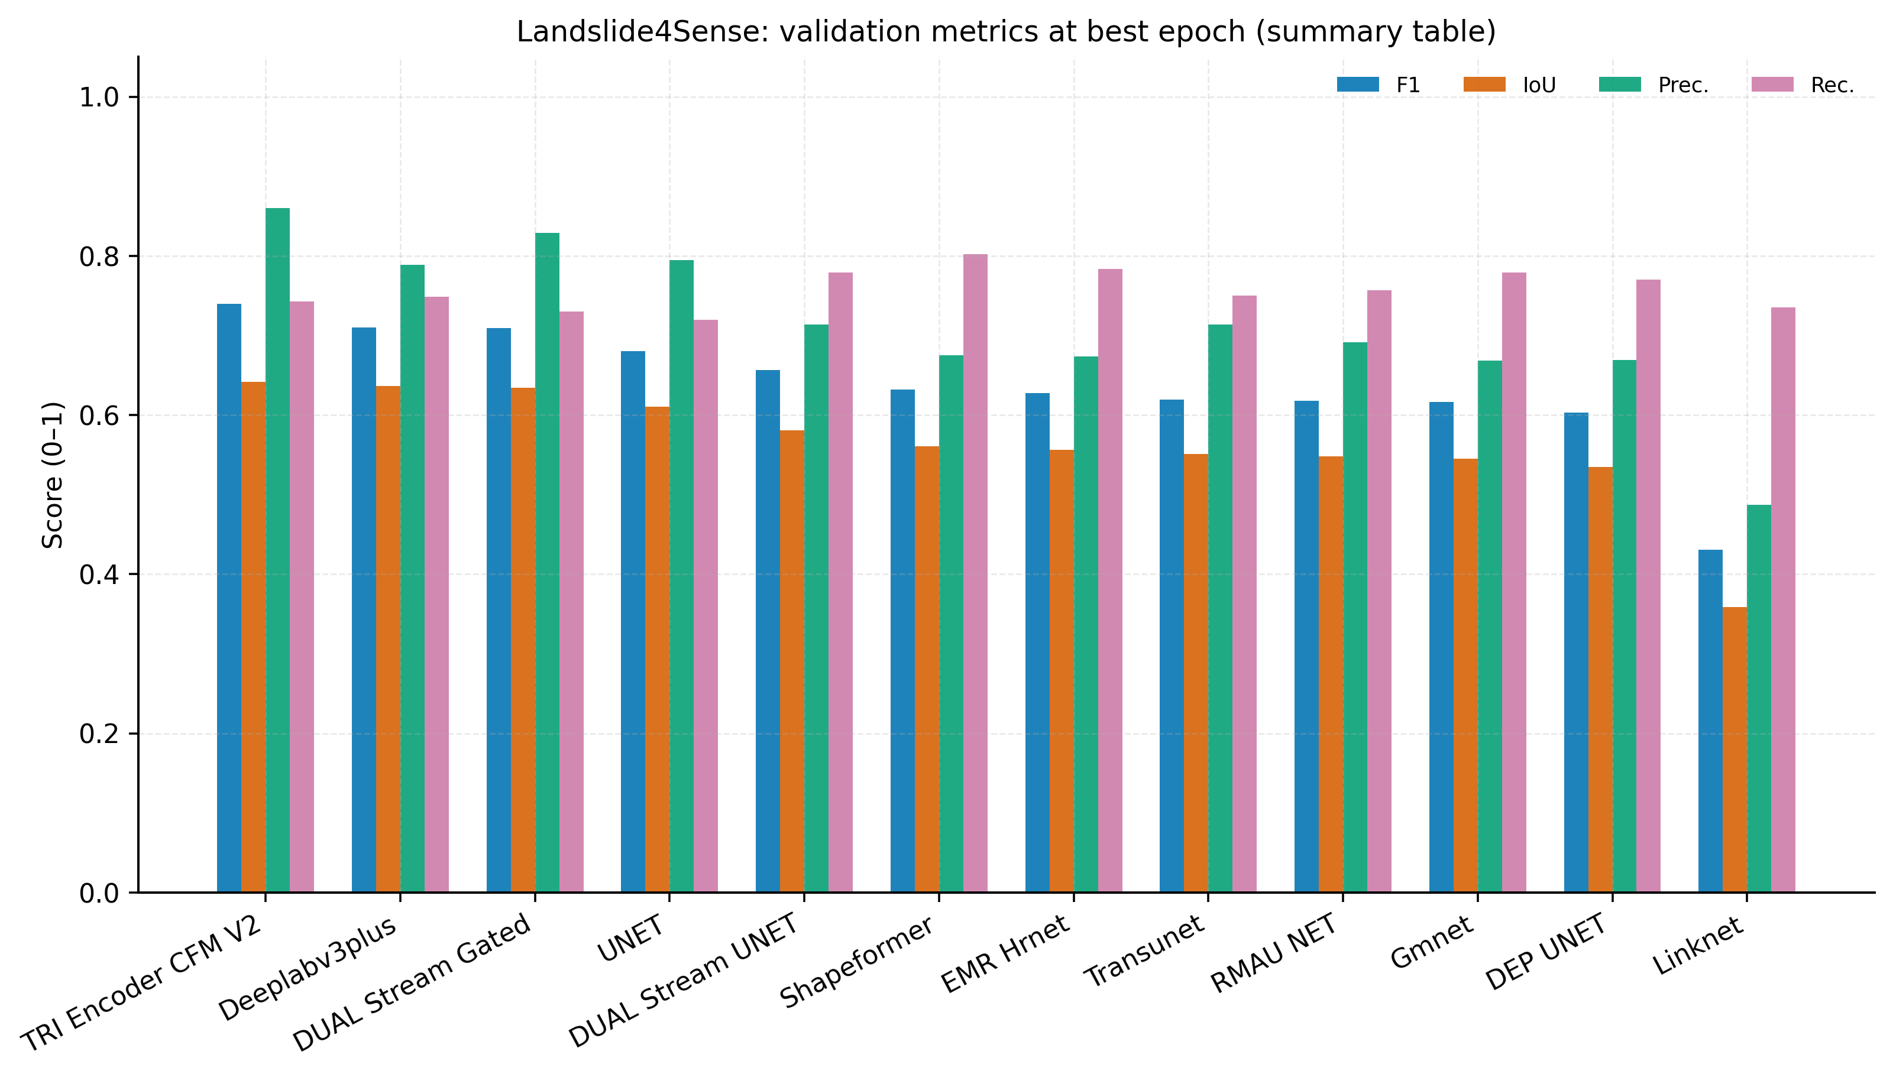
Overlay figure fig04: fig04_grouped_metrics_best_epoch.

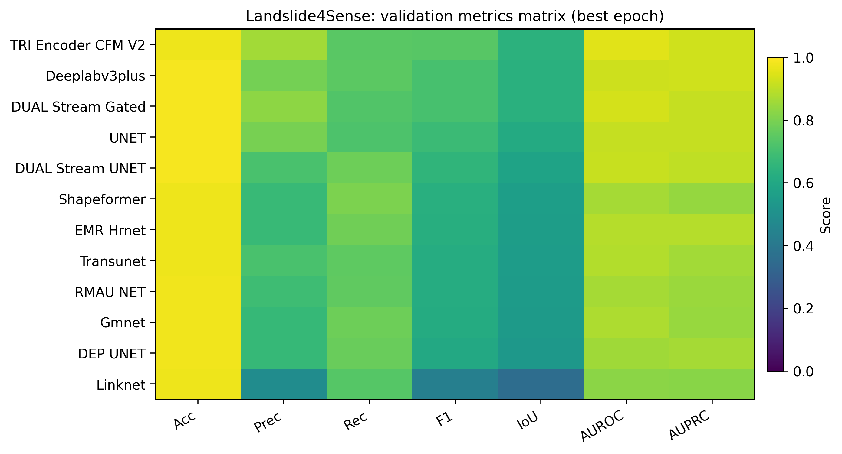
Overlay figure fig06: fig06_metrics_heatmap_best_epoch.

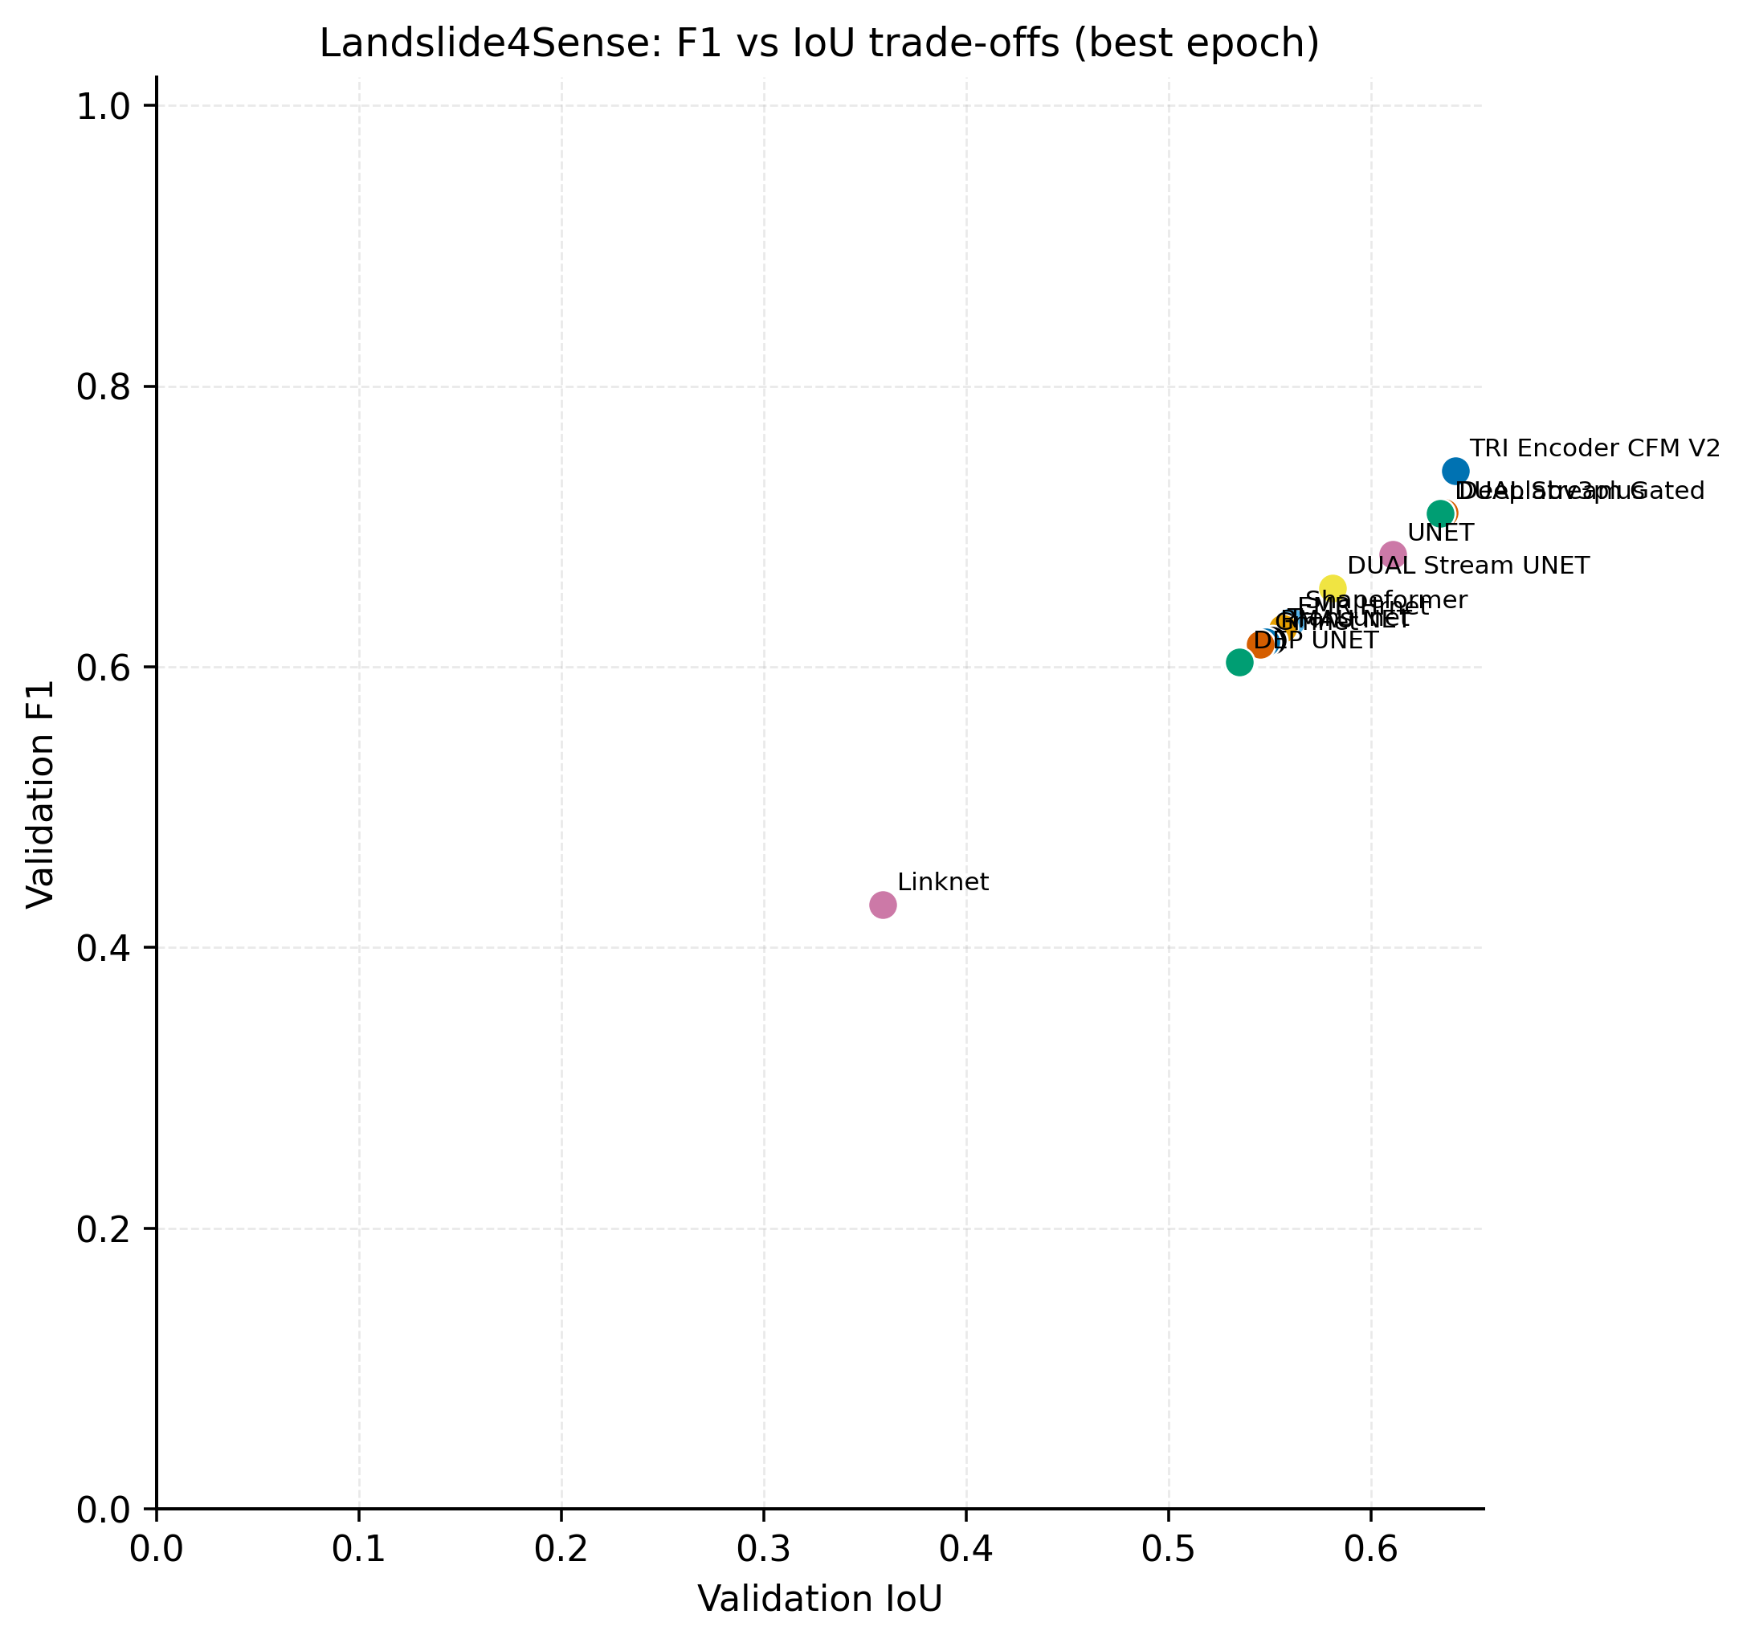
Overlay figure fig07: fig07_f1_vs_iou_scatter.

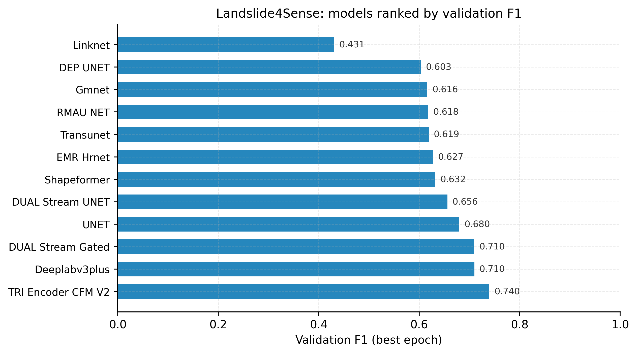
Overlay figure fig08: fig08_ranked_f1_horizontal.

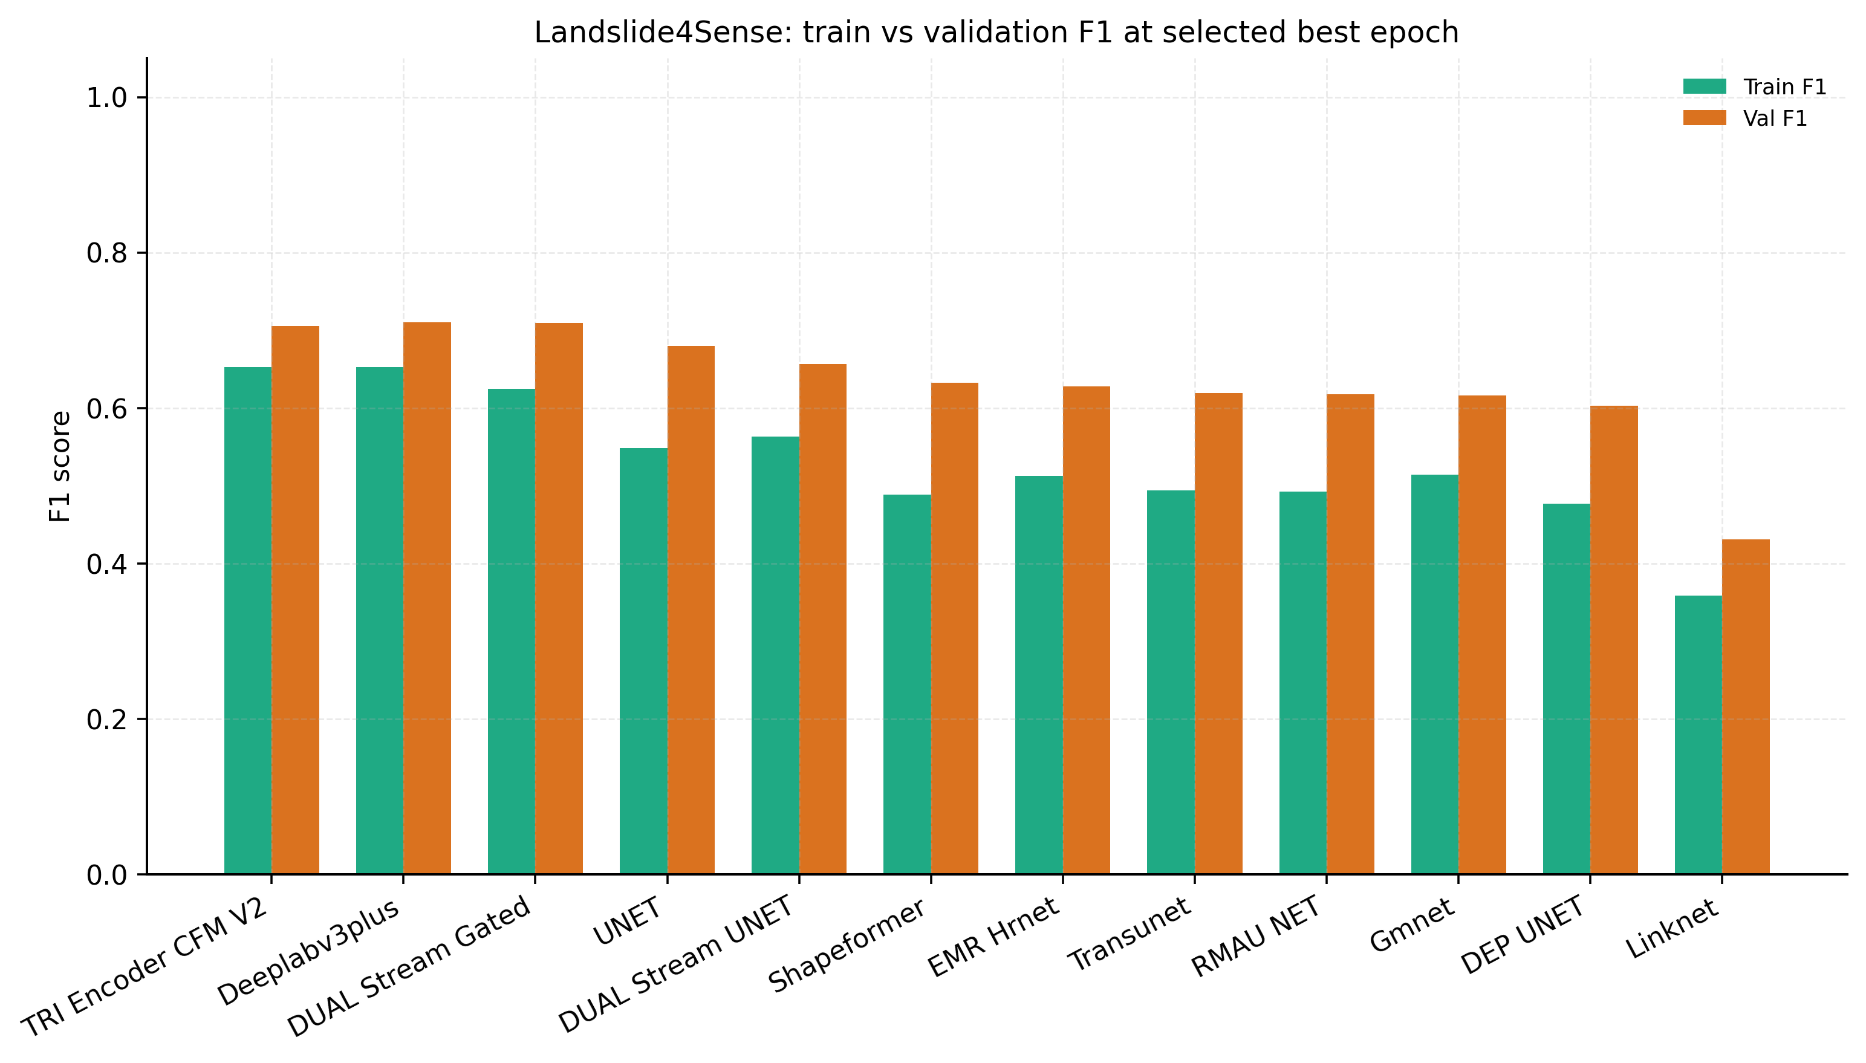
Overlay figure fig09: fig09_train_val_f1_gap_best_epoch.

5 Discussion and extended ablation
5 Discussion. The table makes clear that classical baselines such as DeepLabV3+ and the dual_stream_gated configuration remain very strong on Landslide4Sense when training budget and augmentations are aligned. TriEncoderCFMNet should therefore be read less as a universal winner and more as a controlled experiment in richer fusion plus flow refinement: when the auxiliary head and FM terms are well balanced, the model trades a small amount of pixel F1 for higher AUROC in some checkpoints, which is consistent with smoother decision boundaries learned by the velocity field. Several baselines exhibit higher recall at the cost of precision; the grouped Fig. 13 makes that trade-off explicit for the whole cohort.
Limitations include the absence of exported ROC/PR curve points per epoch, the mismatch in backbone capacity between EfficientNet-based dual-stream gated runs and the lighter CNN pyramids used here, and residual domain shift between the competition-style Landslide4Sense stack and the four-channel Bijie trimodal setup.
5.1 Extended ablation discussion. LinkNet and the depth-aware U-Net variant sit at the lower end of validation F1 in this sweep, which matches their simpler inductive bias on heterogeneous Himalayan texture. GMNet and RMAU-Net climb toward the mid pack, suggesting that moderate architectural depth helps but does not by itself solve boundary ambiguity. TransUNet and EMR-HRNet introduce transformer or high-resolution pathways; their metrics benefit but still lag behind the strongest CNN decoders on this split, echoing findings elsewhere that ViT backbones can under-use very small landslide polygons without careful tuning. Shapeformer occupies a similar band, highlighting that structure-aware designs need dataset-specific schedules to shine.
Dual-stream U-Net improves markedly once elevation is split into a parallel encoder, which is exactly the phenomenon emphasised in gated dual-stream papers: letting the network decide how much spectral versus topographic evidence to trust per scale is more stable than early fusion. The dual_stream_gated checkpoint included here uses the repository’s gated EfficientNet fusion before a UNet decoder; it remains one of the strongest baselines and is the fairest reference point when arguing about whether the extra CFM pathway in TriEncoderCFMNet pays for itself given similar training time.
TriEncoder_cfm_v2 closes the narrative by showing where the new fusion and flow stack lands relative to that frontier. Interpreting the gap purely in terms of parameters would ignore optimisation noise, threshold choice, and the FM residual scaling; future work should log micro-F1 sweeps and full ROC tensors to tighten comparisons.

6 Conclusions
6 Conclusions. This manuscript retargets the earlier remote-sensing landslide study toward TriEncoderCFMNet, a trimodal gated fusion architecture with conditional flow matching and topography-aware losses. The introduction and related-work survey largely carry over because the underlying hazard remains the same even though the technical solution changed. Empirically, Landslide4Sense results in Table 1 and Figs. 2–13 together with Bijie results in Table 2 and Figs. 14–25 show how the new model sits inside a broad baseline lattice that includes dual-stream gated references inspired by the literature review PDF bundled with the repository. The final vector architecture diagram (Fig. 1) remains a placeholder so it can be swapped without renumbering downstream panels.

References
References 1. Ayalew, Lulseged & Yamagishi, Hiromitsu. (2005). The application of GIS-based logistic regression for landslide susceptibility mapping in the Kakuda-Yahiko Mountains, Central Japan. Geomorphology, 65, 15–31. doi:10.1016/j.geomorph.2004.06.010. 2. Demir, Gökhan, Aytekin, Mustafa, & Akgun, Aykut. (2014). Landslide suscep- tibility mapping by frequency ratio and logistic regression methods: An ex- ample from Niksar-Resadiye (Tokat, Turkey). Arabian Journal of Geosciences. doi:10.1007/s12517-014-1332-z. 3. Saha, S., Pal, S., & Behura, S. (2005). Landslide susceptibility prediction using decision tree and GIS: A case study in Darjeeling Himalayas.Journal of the Indian Society of Remote Sensing, 33(4), 531–542. 4. Pourghasemi, Hamid, Goli Jirandeh, Abbas, Pradhan, Biswajeet, Xu, Chong, & Gokceoglu, Candan. (2013). Landslide susceptibility mapping using support vector machine and GIS at the Golestan Province, Iran.Journal of Earth System Science, 122, 349–369. doi:10.1007/s12040-013-0282-2. 5. Chen, Wei, Xie, Xiaoshen, Wang, Jiale, Pradhan, Biswajeet, Hong, Haoyuan, Bui, Dieu, Duan, Zhao, & Ma, Jianquan. (2017). A comparative study of lo- gistic model tree, random forest, and classification and regression tree mod- els for spatial prediction of landslide susceptibility. Catena, 151, 147–160. doi:10.1016/j.catena.2016.11.032. 6. Wang, Shibao, Zhuang, Jianqi, Zheng, Jia, Fan, Hongyu, Kong, Jiaxu, & Zhan, Jiewei. (2021). Application of Bayesian hyperparameter optimized random forest andXGBoostmodelforlandslidesusceptibilitymapping. Frontiers in Earth Science, 9, 712240. doi:10.3389/feart.2021.712240. 7. Ronneberger, Olaf, Philipp Fischer, and Thomas Brox. "U-net: Convolutional net- works for biomedical image segmentation." In International Conference on Medical image computing and computer-assisted intervention, pp. 234-241. Cham: Springer international publishing, 2015. 8. Chen, Liang-Chieh, Yukun Zhu, George Papandreou, Florian Schroff, and Hartwig Adam. "Encoder-decoder with atrous separable convolution for semantic image seg- mentation."InProceedingsoftheEuropeanconferenceoncomputervision(ECCV), pp. 801-818. 2018. 9. Long, Jonathan, Shelhamer, Evan, & Darrell, Trevor. (2015). Fully convolu- tional networks for semantic segmentation. In Proceedings of the IEEE Con- ference on Computer Vision and Pattern Recognition (CVPR) , 3431–3440. doi:10.1109/CVPR.2015.7298965. 10. li, yong. (2024). The Research on Landslide Detection in Remote Sensing Images Based on Improved DeepLabv3+ Method. 10.21203/rs.3.rs-5297582/v1. 11. Ghorbanzadeh, O.; Blaschke, T.; Gholamnia, K.; Meena, S.R.; Tiede, D.; Aryal, J. Evaluation of Different Machine Learning Methods and Deep-Learning Convo- lutional Neural Networks for Landslide Detection. Remote Sens. 2019, 11, 196. https://doi.org/10.3390/rs11020196 12. Wandong, Jiang, Xi, Jiangbo, Li, Zhenhong, Zang, Minghui, Chen, Bo, Zhang, Chenglong, Liu, Zhenjiang, Gao, Siyan, & Zhu, Wu. (2022). Deep learn- ing for landslide detection and segmentation in high-resolution optical images along the Sichuan–Tibet transportation corridor. Remote Sensing, 14(21), 5490. doi:10.3390/rs14215490. 13. Shafapourtehrany, M.; Rezaie, F.; Jun, C.; Heggy, E.; Bateni, S.M.; Panahi, M.; Özener, H.; Shabani, F.; Moeini, H. Mapping Post-Earthquake Landslide Suscepti- bility Using U-Net, VGG-16, VGG-19, and Metaheuristic Algorithms. Remote Sens. 2023, 15, 4501. https://doi.org/10.3390/rs15184501 14. Kirillov, Alexander, Eric Mintun, Nikhila Ravi, Hanzi Mao, Chloe Rolland, Laura Gustafson, Tete Xiao et al. "Segment anything." In Proceedings of the IEEE/CVF international conference on computer vision, pp. 4015-4026. 2023. 15. Xi, Laidian, Yu, Junchuan, Ge, Daqing, Pang, Yunxuan, Zhou, Ping, Hou, Changhong, Li, Yichuan, Chen, Yangyang, & Dong, Yuanbiao. (2024). SAM- CFFNet: SAM-based cross-feature fusion network for intelligent identification of landslides. Remote Sensing, 16(13), 2334. doi:10.3390/rs16132334. 16. Xie, Enze, Wenhai Wang, Zhiding Yu, Anima Anandkumar, Jose M. Alvarez, and Ping Luo. "SegFormer: Simple and efficient design for semantic segmentation with transformers." Advances in neural information processing systems 34 (2021): 12077- 12090. 17. Pradhan, Biswajeet, Mansor, Shattri, & Pirasteh, Saied. (2011). Landslide suscep- tibility mapping: An assessment of the use of an advanced neural network model with five different training strategies.IntechOpen. doi:10.5772/15738.

Appendix A — Technical specification pointer
Full equations, CLI defaults, and file-level pointers are documented in SAM/model_architecture_cfm_landseg/MODEL_ARCHITECTURE.md.

