
CSIR Fourth Paradigm Institute
(Council of Scientific & Industrial Research)

NAL Belur Campus, Bangalore - 560 037, India

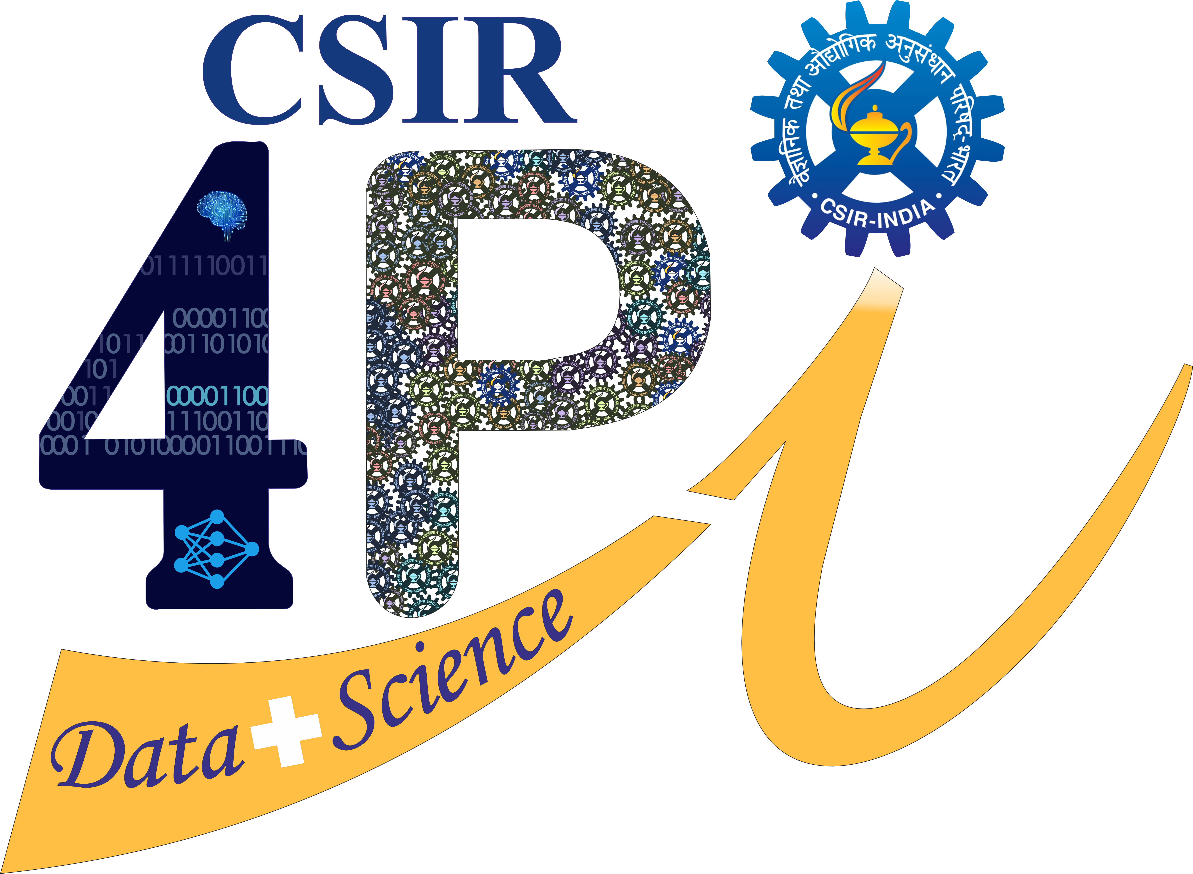

CSIR-Integrated Skill Initiative

CERTIFICATE

This is to certify that the project report entitled “---------------------------------------------------- (title of the project in bold)” submitted by --------------------------------------------------(Name of the Students in bold) in partial fulfillment of the requirements for the award of the degree of ------------------------------------ (Name of the degree in bold) from ---------------------------------------(Name of the College/University in bold), is a bonafide record of the work carried out at the CSIR Fourth Paradigm Institute (CSIR-4PI), NAL Belur Campus, Bangalore-37 from ---------------- to ---------------- under my supervision and guidance.

Signature of the Guide Signature of the Convenor, SPARK
Name of the Guide
Designation

Tel: +91-80-2505 1921, 2522 4667 (Off); Fax: +91-80-2522 0392
E-mail: spark@csir4pi.in; URL: www.csir4pi.in/~spark

