A Project Report on

Title

Submitted in partial fulfilment of requirement for the award of the degree

Bachelor of Technology
Of
Jawaharlal Nehru Technological University

By

Name of Student-1 Reg. No
Name of Student-2 Reg. No
Name of Student-3 Reg. No.
Name of Student -4 Reg. No.

Carried out under
Student Programme for Advancement in Research Knowledge (SPARK) at

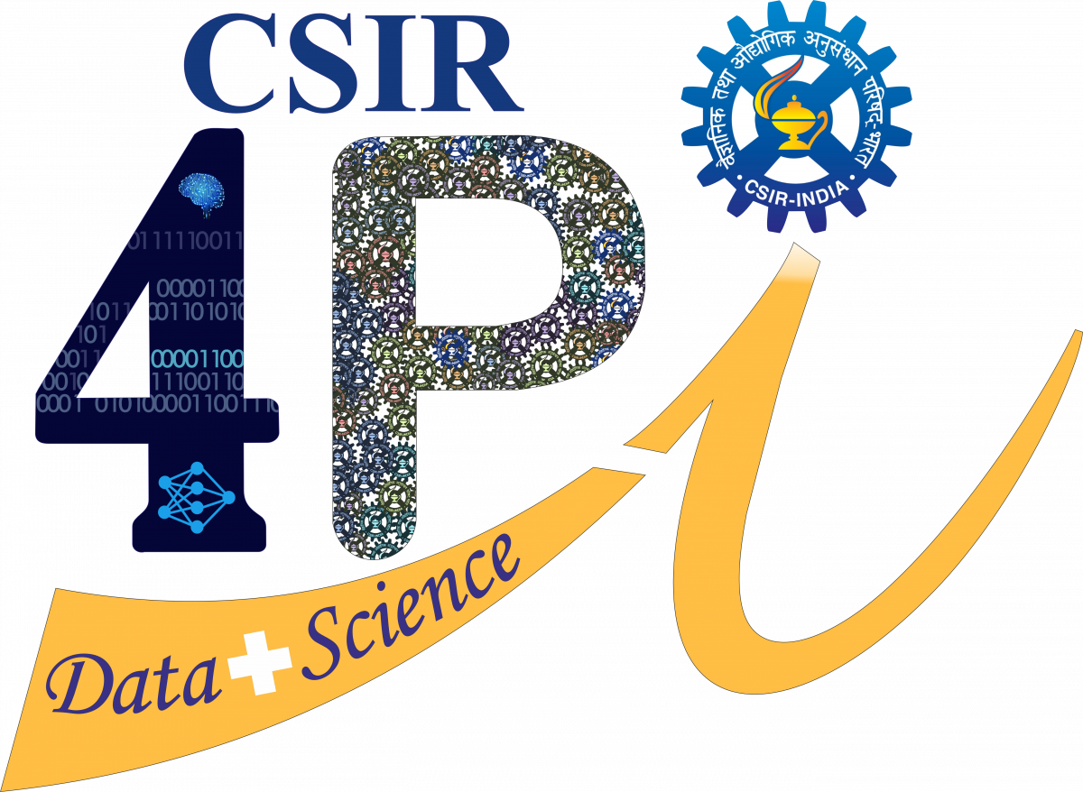

Council of Scientific & Industrial Research
FOURTH PARADIGM INSTITUTE (CSIR-4PI)
NAL BELUR CAMPUS, BANGALORE - 560 037

Under the guidance of

INTERNAL GUIDE EXTERNAL GUIDE Name of Guide from College/University Name of Guide from CSIR-4PI
Designation Designation

DEPARTMENT OF AERONAUTICAL ENGINEERING
MALLA REDDY COLLEGE OF ENGINEERING AND TECHNOLOGY
(Affiliated to JNTU, Hyderabad)
Maisammaguda, Dhulapally, Kompally, Hyderabad-500 014, A.P.

