Software Design Document
BubbleChess v1.0
Steve Calabro, Mark Koh, Alex Mann, and Eric Most

Revision History

Name | Date | Change purpose | Version
Steve Calabro, Mark Koh, Alex Mann, Eric Most | 11/8/26 | Initial version | 1.0

Table of Contents
1. State the purpose of your project/sub-system 3
2. Define the high level entities in your design 3
3. For each entity, define the low level design 4
Usage 4
Configuration 4
Model 4
Interaction 5
4. Benefits, assumptions, risks/issues 5
Writing for a Manager 6
Conclusion 6

1. State the purpose of your project/sub-system
In this section, write a few paragraphs that describe what the project or sub-system does. What is the problem it is trying to solve? Why does it need to exist? Who will use it? By answering these questions, you establish the scope of your design. If you find it hard to write a few paragraphs in this section, then you probably don’t understand the domain as much as you should. If you can’t fit your description within a few paragraphs, then perhaps the scope is too large. Use this section as a tool to verify that the scope of your design is reasonable.

2. Define the high level entities in your design
High level entities are objects, or groups of objects, that constitute major constructs of your design. Good examples of entities are a data access layer, a controller object, a set of business objects, etc…

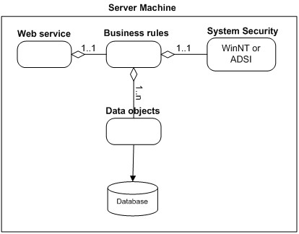
Figure 1

In this section, explain in a few sentences what each entity does. The descriptions don’t have to be verbose, just enough to explain what each block’s purpose is. Be sure to describe your reasoning for defining the entities in your diagram and what their roles are.

3. For each entity, define the low level design
This section is where your objects and object relationships are defined. For each object (or set of objects) define the following:

Usage
Describe in a paragraph how the object is used and what function it serves. If an object will interface with an external object or system, it is a good idea to show the interface for the object. Most importantly, you must again describe your thought process for defining the object as you did. List the benefits and risks. If an object provides an encapsulation, describe in a sentence why the encapsulation adds value. Use your descriptions to give meaning to the diagrams. They don’t have to be verbose, just enough to get the point across.

Configuration
If your object needs any special configuration or initialization, this is a good place to describe it. If not, this section can be left out.

Model
Figure 2 shows an example of a to supplement the System Security entity from figure 1. It is not perfect UML, but has some aspects of UML. Most importantly, it describes the design.
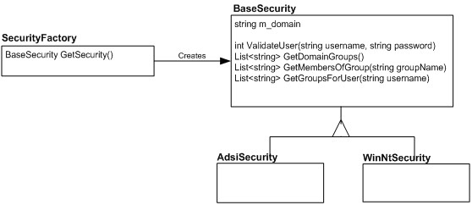
Figure 2

Don’t worry about perfection in your models, but be sure to describe exactly what is going on in the diagram. Here, two concrete security objects derive from a base security object, and a security factory will create one or the other for a client depending on the security model of the system.

Interaction
This is also a good section for interaction diagrams. An interaction diagram shows how a set of objects or entities communicate with each other to perform a complex task. Figure 3 shows an example of an to show how a user might log in. It uses objects from the various entities shown in figure 1.
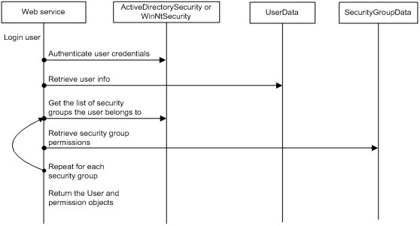
Figure 3

Again, this diagram is not perfect UML, but it explains the communication sequence to accomplish a complex task. Interaction diagrams are most useful when you want to diagram how an object in your system will communicate with an object in another subsystem. This type of diagram will let the other developer verify that the interaction is correct.

4. Benefits, assumptions, risks/issues
In this section, make a list of 5-6 top benefits of the design, a list of ALL known risks/issues and a list of ALL assumptions. Some of this may simply be rehashing what you wrote in a previous section of the document. What’s important is getting all of these items into one section so that the reader doesn’t have to read the whole document to understand what the benefits, risks and assumptions are.

Never remove anything from this section! As risks become non-risks, document that they are now non-risks and why they became non-risks. Never erase them from the document. The same holds true for assumptions. You should be able to look at this section and know instantly what the current risks are to your design.

Writing for a Manager
The goal of a design document for your manager is to make sure that your manager understands what the main entities of the system are, what the benefits are and, most importantly, what the risks are. The document is your chance to show that you understand the requirements and that you have come up with a plan to meet those requirements.

If you have written the peer developer document well, then writing the manager’s document is simple, because it is just made up of sections 1, 2 and 4. By dividing the peer developer document up as described previously, the parts which are typically not meaningful to a manager have been contained in a single section of the document which may be removed.

Conclusion
The hardest part of writing a design document has nothing to do with the writing. The difficult part is working through a logical design before you get to coding. Once you have a vision of how the objects and entities are arranged, writing the details is easy. In addition, it should not require anything more than a word processor and a simple shape painting program. The positive difference that spending a week on this task can make is unbelievably rewarding in the end. As the adage goes, “If you fail to plan, then you plan to fail.”

