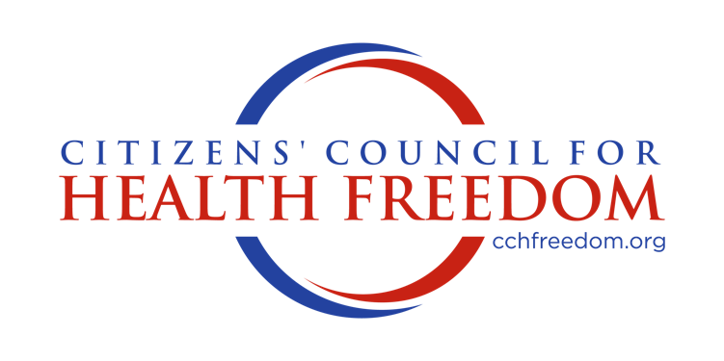

VIA ONLINE PORTAL

February 13, 2026

Michael Lipinski
Office of Policy
Assistant Secretary for Technology Policy
Office of the National Coordinator for Health Information Technology

RE: Health Data, Technology, and Interoperability: ASTP/ONC Deregulatory Actions to Unleash Prosperity

45 CFR Parts 170 and 171
RIN: 0955-AA09

Dear Mr. Lipinski:

Citizens’ Council for Health Freedom (CCHF) submits this comment to the above-referenced proposed rule. CCHF is a 501(c)(3) organization and, for over two decades, has fought to restore the mission of medicine by protecting doctor and patient freedom. CCHF provides valuable resources, policy research, and unique initiatives.

CCHF supports the rule’s decisive shift away from heavy federal micromanagement toward competition-driven innovation in health IT and supports the rule to the extent that the rule accomplishes the following:

- REDUCES REGULATORY COMPLIANCE: Cuts regulatory compliance costs and allows market forces—not federal checklists—to shape technology adoption and acknowledges that health care markets do not require prescriptive regulation to enforce baseline functionality.

- ENHANCES CONSUMER CHOICE: Emphasizes consumer choice and innovation, enabling providers to select tools that best meet their needs rather than those optimized for certification.

- FOSTERS COMPETITION: Recognizes that innovation, AI integration, and efficiency are better driven by consumer-oriented competition than by federal micromanagement.

- PROPERLY ALLOCATES RESOURCES: Shifts resources from regulatory compliance toward patient care, product development, and cost-saving innovation.

- REVERSES CONSOLODATION: Generates substantial long-term savings and expands consumer-driven health care markets, reversing the concerning trend of health market conglomerate consolidation.

Conversely, CCHF is apprehensive regarding the relaxation of health IT regulation in health care, especially novel AI technology, for the following reasons:

- PRIVACY INTRUSIONS: Patient privacy and care must remain a top priority for the health care markets; it remains to be seen how less IT regulation and the use of AI will advance these priorities.

- HIPAA: The HIPAA rule, properly understood, is a data security rule rather than a privacy rule. It permits confidential patient data to be shared broadly without patient consent by “covered entities.” Other laws and rules require interoperability, thus mandating the use of digital networks, frameworks, Trusted Exchange Framework and Common Agreements (TEFCA), electronic health records, clinical data platforms, qualified health information networks (QHINs), and other technologies without patient consent—while requiring that the data be shielded from unauthorized access. AI will have access to this data, also without patient consent, for purposes the patient may not support, and potentially to directly impact the patient’s care in ways that could be harmful, insufficient, or generated through AI hallucinations.

- ALGORITHMS: AI can be exploited in the health care market; several class-action lawsuits are pending against large insurers, alleging the inappropriate use of algorithms to deny Medicare Advantage and other claims.

- HARM TO PATIENTS: The misuse of AI in health care markets will likely deny necessary care, cause patient harm, and increase costs.

- LIMITING ACCESS TO CARE: AI and patient data are used to manipulate and control physician treatment decisions, limit treatments to a pre-set menu of corporate-determined treatment options populated on the EHR system, and standardize treatment in a way that does not meet the needs of unique patients at the biological, physiological, emotional, financial, genetic, and cultural levels.

Critically, this proposed rule omits a proposal to restore medical privacy rights to patients that were eliminated under the federal HIPAA privacy rule (CFR sections 160 and 164). Restoring medical privacy has the added benefits of rebuilding patient trust, fostering frank conversations at the bedside, improving history and physicals, promoting patient-centered care, and reducing physician burnout caused by the current bureaucratic reporting system and the ethical conflict of sharing private information with countless outsiders without patient consent.

Warm Regards,

/s/ Allison R. Lucas
Allison R. Lucas, J.D.
Director of Public Policy
Citizens’ Council for Health Freedom
allison@cchfreedom.org

