
+

Strategic Alliance

RESPONSE TO REQUEST FOR INFORMATION

RIN 0955-AA13
ACCELERATING THE ADOPTION AND USE OF
ARTIFICIAL INTELLIGENCE AS PART OF CLINICAL CARE

Agentic AI Solutions for Healthcare Transformation

A Joint Response from Cyberhill Partners, LLC. & ServiceNow

Submitted to:
Department of Health and Human Services Office of the Assistant Secretary for Technology Policy
Office of the National Coordinator for Health Information Technology

January 2026

Primary Contact: | Corporate Office: | Corporate Address:
Chris Walker | 1900 Reston Metro Plaza | 1985 Riviera Drive
AI Solutions Architect | 6th Floor | Suite 103-1138
chris@cyberhillpartners.com | Reston, Virginia 20190 | Mount Pleasant, SC 29464


Table of Contents

Table of Contents 2
- Executive Summary 4
- Responder Qualifications 4
  - About Cyberhill Partners 4
  - ServiceNow Partnership 4
Partner Contributions: Clear Roles and Responsibilities 5
  - Relevant Experience 5
- Technical Approach: Clinical Care Intelligence Platform 7
  - Solution Overview 7
  - Clinical Knowledge Ontology Architecture 7
Core Ontology Entities 8
  - Agentic AI Architecture 8
- Responses to Specific Questions 9
HIPAA Compliance and PHI Access Control 9
Regulatory Uncertainty 9
Data Interoperability Gaps 9
Trust and Explainability Deficits 9
Reimbursement Misalignment 9
Regulatory Recommendations 9
Payment Policy Recommendations 10
Liability and Accountability 10
Privacy and Security 10
Algorithmic Bias 10
Pre-Deployment Evaluation 10
Post-Deployment Monitoring 11
Standards Development Support 11
Testing Infrastructure 11
Workforce Development 11
Successes 11
Shortfalls 11
High-Potential Novel Applications 11
Key Decision Makers 12
Administrative Hurdles 12
Priority Data Types 12
Priority Standards 12
Benchmarking Tools 13
Patient/Caregiver Challenges AI Could Address 13
Patient/Caregiver Concerns 13
High-Priority Research Areas 13
- Conclusion 14

Executive Summary
Cyberhill, in collaboration with ServiceNow, is pleased to submit this response to the Department of Health and Human Services (HHS) Request for Information regarding the acceleration of AI adoption in clinical care. As an AI solutions firm with deep expertise within the Department of War (DoW) and Intelligence Community (IC), Cyberhill brings a unique perspective on deploying secure, scalable, and governance-compliant AI solutions in highly regulated environments.
Our response addresses the three core pillars identified by HHS—Regulation, Reimbursement, and Research & Development—while providing actionable recommendations derived from our experience deploying agentic AI systems for federal agencies. Our approach emphasizes:
- Security-First Architecture: HIPAA-aligned AI deployments with zero-trust principles
- Knowledge Graph-Powered Intelligence: Ontology-driven clinical decision support
- Agentic AI Workflows: Autonomous clinical task automation with human oversight
- Interoperability by Design: FHIR-native, HL7-compliant data exchange
Our proposed Clinical Care Intelligence Platform (CCIP) leverages the ServiceNow Healthcare and Life Sciences Service Management platform as its enterprise foundation, augmented with Cyberhill's custom ontology engineering and agentic AI. This combination delivers a solution that is both enterprise-grade and clinically intelligent.

Responder Qualifications
  - About Cyberhill
Cyberhill is a professional services firm headquartered in Austin, Texas, specializing in complex software implementations for Fortune 500 companies and the U.S. Government. With over 8 years of experience and 800+ successful enterprise software implementations, Cyberhill has established itself as a trusted partner for organizations navigating digital transformation.
Our core competencies span three interconnected domains:

AI/ML | CYBERSECURITY | CLOUD
- Custom AI Agent Dev  - Ontology Engineering  - Knowledge Graphs  - MLOps & Lifecycle  - Model Security | - Zero Trust Strategy  - PAM & IAM  - SIEM Implementation  - Network Detection  - DLP Solutions | - Hybrid Migration  - Cloud Strategy  - DevOps Automation  - Data Engineering  - Cloud Native Apps

ServiceNow Partnership

Cyberhill maintains a strategic partnership with ServiceNow, the leading digital workflow platform. ServiceNow's Healthcare and Life Sciences Service Management (HLSM) solution provides the enterprise foundation for our proposed clinical AI platform, offering:
    - FedRAMP High Authorization for government deployments
    - HIPAA Business Associate Agreement (BAA) compliance
    - Native FHIR R4 integration capabilities
    - Now Assist AI capabilities with healthcare-specific training

Partner Contributions: Clear Roles and Responsibilities
ServiceNow Provides: Enterprise workflow backbone with FedRAMP High/HIPAA compliance; healthcare-specific service management modules (patient flow, care coordination, provider management); native Now Assist conversational AI; enterprise integration hub with pre-built healthcare connectors; scalable cloud infrastructure with guaranteed uptime SLAs.
Cyberhill Provides: Custom clinical ontology engineering and knowledge graph development; graph-native AI architecture with explainable reasoning paths; agentic AI orchestration with human-in-the-loop controls; domain-specific model fine-tuning and prompt engineering; semantic layer design that grounds AI outputs in authoritative clinical sources, reducing hallucinations; specialized integration with clinical terminologies (ICD-10, SNOMED CT, LOINC, RxNorm). Cyberhill’s unique value lies in transforming ServiceNow’s powerful enterprise platform into a clinically intelligent system that understands healthcare semantics—not just healthcare workflows.

Relevant Experience
Cyberhill has successfully delivered AI-powered document intelligence platforms for federal agencies, including agentic systems that process complex regulatory documents, extract clinical entities, and provide grounded AI assistance. Our experience includes:
    - Defense Innovation Unit (DIU) – Next-Generation Biosurveillance Platform: Delivered alongside ServiceNow as a strategic partner, this platform captures, catalogs, and visualizes health threat data from diverse sources including official reporting agencies (CDC, WHO), social media signals (HomeTree), and open internet monitoring. The system provides near-real-time AI-derived summarization and reporting to the warfighter, demonstrating our ability to integrate highly heterogeneous data sources, deliver timely actionable intelligence, and operate within highly regulated and closed network environments.
    - U.S. Air Force (AETC) – AI-Enabled Training Platform: Building a first-of-its-kind platform that leverages existing approved training materials to dynamically create new learning pathways. The system allows users to train and test knowledge while ensuring all AI-generated content is traceable to approved source documents. Our ontology-first approach ensures every recommendation maps back to validated curricula, dramatically reducing hallucination risk and providing full auditability for training compliance.
    - Enterprise Healthcare (Cerebro Platform) – Healthcare Ecosystem Intelligence: Rather than building another diagnostic tool, Cyberhill developed a platform that connects data across entire healthcare ecosystems, automatically generates domain ontologies, and provides executive-level decision support to improve system effectiveness and efficiency. The philosophy is “treat the patient, not the symptom”—addressing logistics,

systemic patterns, and early warning indicators at the population and operational level. Critically, the platform relies on metadata and aggregations rather than Protected Health Information (PHI), demonstrating that powerful healthcare AI does not require training models on confidential patient data. This approach addresses HIPAA concerns while delivering actionable intelligence for healthcare administrators and executives.

Technical Approach: Clinical Care Intelligence Platform

Solution Overview
Our Clinical Care Intelligence Platform (CCIP) is designed as an agentic AI system that augments clinical decision-making while maintaining strict governance and human oversight. The platform is built on three foundational pillars:
- Clinical Knowledge Ontology: A comprehensive semantic layer encoding healthcare regulations, diagnostic criteria, treatment protocols, and reimbursement rules
- Agentic Workflow Engine: Autonomous AI agents that execute clinical tasks with human-in-the-loop checkpoints
- Enterprise Integration Layer: FHIR-native connectivity with EHR systems, claims processors, and regulatory databases

Clinical Knowledge Ontology Architecture
The foundation of effective clinical AI is a well-structured knowledge representation. Our ontology provides the semantic backbone for all AI reasoning:
CLINICAL CARE ONTOLOGY - ENTITY RELATIONSHIP MODEL
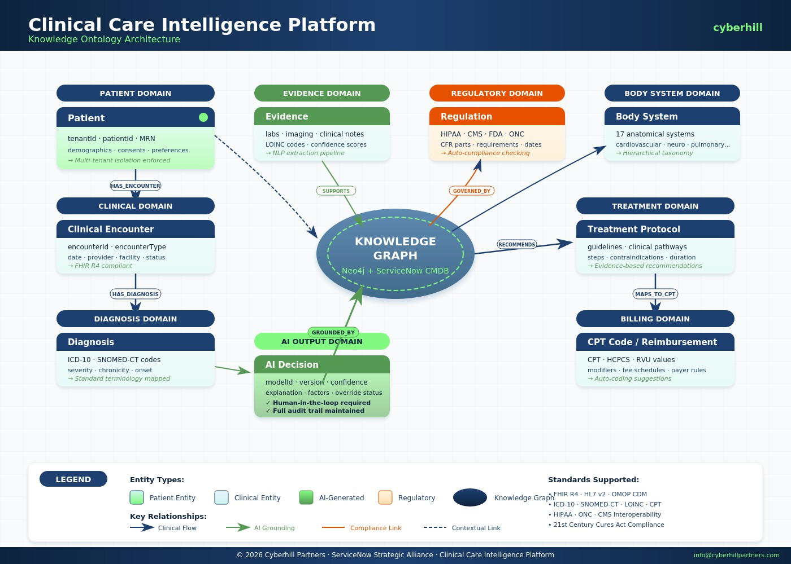

Core Ontology Entities

Entity | Description | Key Properties
Diagnosis | ICD-10/SNOMED coded clinical diagnoses with severity levels | icdCode, snomedCt, severity, chronicity, bodySystem
Evidence | Clinical observations supporting diagnoses (labs, imaging, notes) | evidenceType, loincCode, value, unit, confidence
TreatmentProtocol | Clinical practice guidelines and care pathways | guidelineSource, steps, contraindications, cptMappings
Regulation | Healthcare regulations (HIPAA, CMS rules, FDA guidance) | cfrPart, section, requirements, penalties, effectiveDate
AIDecision | AI-generated recommendations with provenance tracking | modelId, confidence, explanation, evidenceRefs, humanOverride

Agentic AI Architecture
Our agentic architecture enables autonomous clinical task execution with appropriate guardrails:
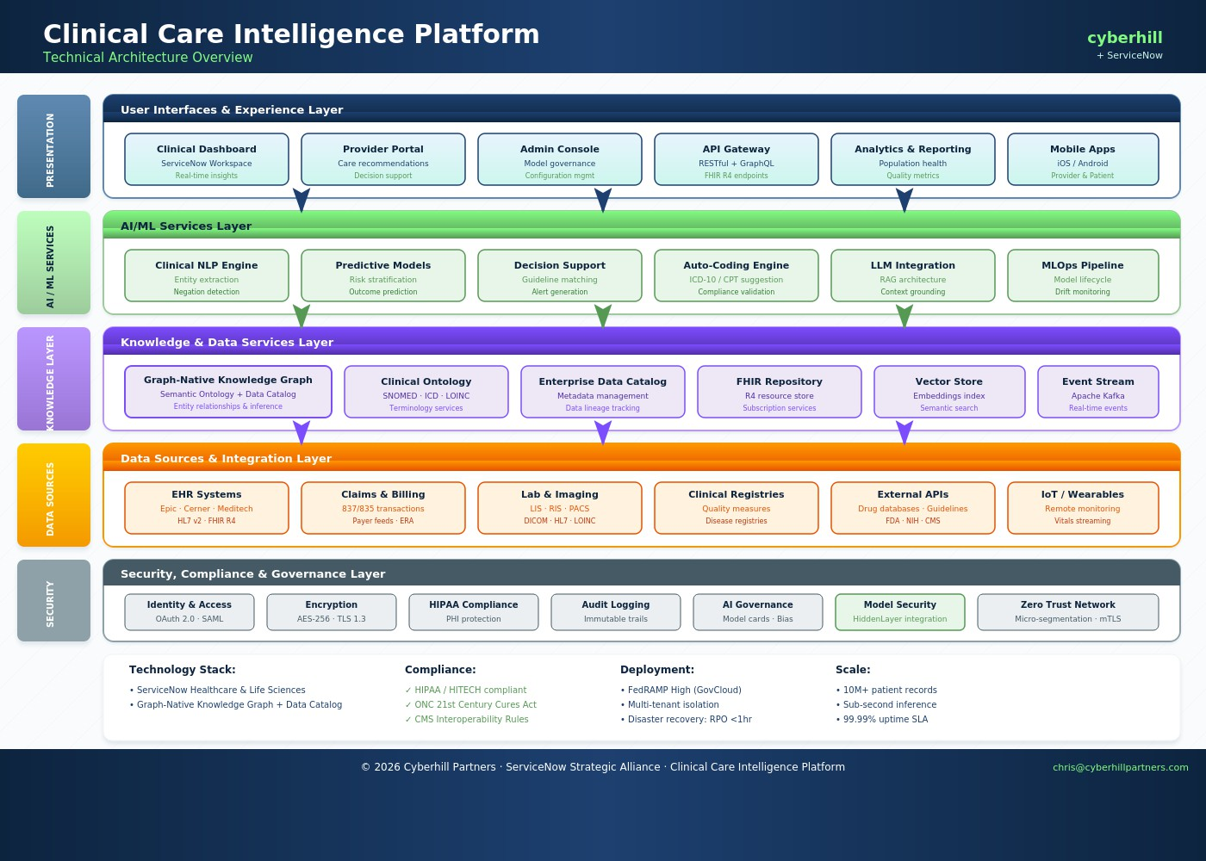

Responses to Specific Questions

Question 1: What are the biggest barriers to private sector innovation in AI for health care and its adoption and use in clinical care?
Based on our experience deploying AI systems in highly regulated federal environments, we identify the following primary barriers:

HIPAA Compliance and PHI Access Control
One of the most significant barriers is ensuring HIPAA compliance when AI systems interact with clinical data. Unlike traditional rule-based systems, AI models that touch patient data present complex access control challenges—particularly because AI can produce Protected Health Information (PHI) in its outputs, even when queried with seemingly innocuous prompts. This creates a fundamental tension: AI systems require data access to function effectively, but existing access control frameworks were not designed for systems that generate, infer, or synthesize PHI. Organizations face uncertainty about minimum necessary standards for AI, audit trail requirements for AI-generated content, and liability when AI inadvertently discloses PHI. HHS should provide specific guidance on AI-PHI boundaries, including technical safeguards for preventing PHI leakage in model outputs and clear standards for AI access control that balance innovation with patient privacy protection.

Regulatory Uncertainty
The absence of clear regulatory frameworks for non-medical device AI creates significant uncertainty. Organizations are hesitant to invest in clinical AI when liability, accountability, and compliance requirements remain undefined. HHS could establish safe harbor provisions for AI systems meeting specified governance criteria.

Data Interoperability Gaps
Despite progress with FHIR adoption, significant barriers remain in accessing comprehensive, standardized clinical data. Proprietary data silos, inconsistent implementations of standards, and limited access to training datasets impede AI development. HHS should accelerate enforcement of interoperability requirements under the 21st Century Cures Act.

Trust and Explainability Deficits
Our data indicates 61% of executives lack trust in AI outputs. Clinical AI requires explainable decision-making that clinicians can understand and verify. Investment in explainable AI (XAI) research and standards for model transparency would address this barrier.

Reimbursement Misalignment
Current fee-for-service models do not incentivize AI adoption. When AI reduces unnecessary procedures or shortens hospital stays, it may decrease revenue under current payment structures. Value-based payment models that reward outcomes would better align incentives.

Question 2: What regulatory, payment policy, or programmatic design changes should HHS prioritize to incentivize the effective use of AI in clinical care?
We recommend the following prioritized changes:

Regulatory Recommendations

- Establish clear distinction between AI as medical devices (FDA jurisdiction) and clinical decision support tools (ONC oversight) per 21st Century Cures Act Section 3060(a)
- Create certification pathways for clinical AI analogous to EHR certification under 45 CFR Part 170, with specific criteria for safety, effectiveness, and interoperability
- Modernize HIPAA Privacy Rule (45 CFR Part 164) to address AI-specific considerations including model training on de-identified data and synthetic data generation

Payment Policy Recommendations
- Create new CPT codes for AI-assisted clinical services, enabling direct reimbursement for AI-enhanced care
- Include AI deployment metrics in Merit-based Incentive Payment System (MIPS) quality measures under 42 CFR Part 414
- Establish shared savings provisions for AI-driven efficiency gains under Medicare Shared Savings Program (42 CFR Part 425)

Question 3: For non-medical devices, what novel legal and implementation issues exist and what role should HHS play?

Liability and Accountability
The most significant legal uncertainty concerns liability allocation when AI contributes to adverse outcomes. Current medical malpractice frameworks assume human decision-making. HHS should work with stakeholders to develop model liability frameworks that appropriately allocate responsibility among AI developers, healthcare organizations, and clinicians based on their respective roles and the degree of AI autonomy.

Privacy and Security
AI systems present novel privacy risks including model inversion attacks, membership inference, and potential for re-identification of de-identified data. HHS should issue guidance on AI-specific security controls, potentially through updates to the HIPAA Security Rule technical safeguards.

Algorithmic Bias
AI systems trained on historical data may perpetuate or amplify existing healthcare disparities. HHS should establish requirements for bias testing and mitigation, building on the Office of Civil Rights' authority under Section 1557 of the Affordable Care Act.

Question 4: What are the most promising AI evaluation methods for clinical care? Should HHS support these processes?
We recommend HHS support the following evaluation approaches through grants, cooperative agreements, and prize competitions:

Pre-Deployment Evaluation
- Prospective clinical validation studies with diverse patient populations
- Robustness testing across demographic subgroups and edge cases
- Red team exercises to identify failure modes and adversarial vulnerabilities
- Human factors evaluation assessing clinician-AI interaction patterns

Post-Deployment Monitoring
- Continuous performance monitoring with automated drift detection
- Real-world outcome tracking linked to AI recommendations
- Sentinel surveillance for adverse events potentially linked to AI
- Feedback loops enabling continuous model improvement
Prize competitions would be particularly effective for developing standardized evaluation benchmarks and testing methodologies, following the successful model of the ONC Health IT Interoperability Standards Challenge.

Question 5: How can HHS best support private sector activities to promote innovative and effective AI use in clinical care?
HHS can most effectively support the private sector through:

Standards Development Support
Fund and participate in standards development organizations (SDOs) working on clinical AI standards. Support ANSI/AAMI work on AI in medical devices, HL7 efforts on AI data exchange standards, and IEEE standards for AI transparency. Provide ONC resources to develop clinical AI certification criteria.

Testing Infrastructure
Establish or fund regional AI testing centers that provide access to synthetic clinical data, standardized evaluation protocols, and expert consultation. These centers could operate similarly to ONC-Authorized Testing Laboratories for EHR certification.

Workforce Development
Support training programs for clinical informaticists who can bridge the gap between AI developers and clinical users. Partner with HRSA on health professions training grants that include AI literacy components.

Question 6: Where have AI tools met or exceeded expectations and where have they fallen short? What novel AI tools would have the greatest potential?

Successes
- Medical imaging analysis (radiology, pathology, dermatology) achieving expert-level accuracy
- Clinical documentation assistance reducing physician administrative burden
- Sepsis and deterioration prediction enabling earlier intervention

Shortfalls
- Alert fatigue from poorly calibrated clinical decision support
- Workflow integration challenges creating additional burden rather than efficiency
- Performance degradation when deployed in populations different from training data

High-Potential Novel Applications

- Agentic AI systems that autonomously execute administrative tasks (prior authorization, care coordination, claims processing) with human oversight
- Knowledge graph-powered diagnostic reasoning that explains its clinical logic
- Multimodal AI integrating clinical notes, imaging, genomics, and social determinants
- Continuous monitoring AI for chronic disease management in home settings

Question 7: Which roles/decision-makers within healthcare organizations have the most influence on AI adoption? What are the primary administrative hurdles?

Key Decision Makers

Role | Influence on AI Adoption
Chief Medical Officer | Highest influence—clinical validation and physician adoption require CMO sponsorship
Chief Information Officer | Critical for infrastructure, security, and EHR integration decisions
Chief Financial Officer | Controls budget allocation and require clear ROI demonstration
Medical Informatics | Technical bridge between clinical and IT teams—drives implementation success

Administrative Hurdles
- Procurement complexity—healthcare purchasing cycles average 12-18 months
- Security and compliance review bottlenecks
- Governance committee approval requirements
- Change management and training resource constraints
- EHR vendor ecosystem limitations and integration costs

Question 8: Where would enhanced interoperability widen market opportunities and accelerate AI development?
Enhanced interoperability would have the greatest impact in the following areas:

Priority Data Types
- Unstructured clinical notes: Standardized clinical document architecture (C-CDA 2.1) with consistent section coding
- Medical imaging: DICOM-SR structured reporting with AI-compatible annotation standards
- Social determinants of health: SDOH FHIR Implementation Guide adoption
- Genomic data: GA4GH standards for variant representation

Priority Standards
- USCDI v4 expansion to include AI-relevant data elements
- FHIR Bulk Data Access for efficient AI training data extraction
- SMART on FHIR for AI application authorization and launch

- CDS Hooks for standardized clinical decision support integration

Benchmarking Tools
HHS should fund development of standardized clinical AI benchmarking datasets that enable apples-to-apples comparison of AI performance. These datasets should include diverse patient populations, annotated ground truth, and defined evaluation metrics.

Question 9: What challenges do patients and caregivers wish to see addressed by AI? What concerns do they have?

Patient/Caregiver Challenges AI Could Address
- Care coordination burden—navigating complex healthcare systems
- Access to specialist expertise in underserved areas
- Understanding diagnosis and treatment options in plain language
- Medication management and adherence support
- Appointment scheduling and administrative tasks

Patient/Caregiver Concerns
- Privacy—fear of health data misuse or breach
- Loss of human connection in healthcare relationships
- AI errors leading to misdiagnosis or inappropriate treatment
- Algorithmic bias resulting in discriminatory care
- Lack of transparency about when AI is being used in their care

Question 10: Are there specific areas of AI research HHS should prioritize?
We recommend HHS prioritize research in the following areas:

High-Priority Research Areas
- Explainable Clinical AI: Methods to make AI reasoning transparent and understandable to clinicians
- Bias Detection and Mitigation: Techniques to identify and correct algorithmic disparities
- Privacy-Preserving AI: Federated learning and differential privacy for model training
- Human-AI Teaming: Optimal interfaces and workflows for clinician-AI collaboration
- AI Safety and Robustness: Methods to ensure reliable AI performance across diverse settings
- Implementation Science: Research on effective strategies for AI deployment and adoption

Conclusion
Cyberhill and ServiceNow appreciate the opportunity to contribute to this important dialogue on accelerating AI adoption in clinical care. Our experience deploying secure, governance-compliant AI systems for federal agencies positions us uniquely to support HHS in achieving its objectives.
The key themes from our response include:
- Regulatory clarity is essential—clear frameworks reduce uncertainty and enable investment
- Payment alignment must incentivize AI adoption—value-based models reward AI-driven efficiency
- Interoperability enables innovation—standardized data access accelerates AI development
- Trust requires transparency—explainable AI and bias mitigation build confidence
- Human oversight remains paramount—agentic AI augments rather than replaces clinical judgment
We stand ready to engage further with HHS as it develops policies and programs to advance AI in clinical care. Our combined expertise in AI solution architecture, healthcare workflow automation, and federal compliance provides a strong foundation for partnership.

For Additional Information

1900 Reston Metro Plaza 6th Floor Reston, Virginia 20190 chris@cyberhillpartners.com | www.cyberhillpartners.com

