International Business Machines (IBM) Corporation

Request for Information (RFI)

February 23, 2026

Department of Health and Human Services (HHS)
Office of the Secretary

Accelerating the Adoption and Use of Artificial Intelligence as Part of Clinical Care

In Response to 90 FR 60108

Submitted by: International Business Machines (IBM) Corporation
6710 Rockledge Drive
Bethesda, MD 20817
Kristine Allen, MPH, PMP
Associate Partner, HHS
770.843.7486
Kristine.Allen@ibm.com

Table of Contents
Section Page
0. Introduction 1
1. Barriers to AI Innovation and Adoption (RFI Question #1) 1
2. HHS Regulatory Priorities (RFI Question #2) 2
3. Governance and Accountability (RFI Question #3) 3
4. Evaluation and Robustness (RFI Question #4) 5
5. Supporting Private Sector Innovation (RFI Question #5) 5
6. Successes, Lessons Learned, and Priority Areas for AI in Clinical Care (RFI Question #6) 6
7. AI Adoption Dynamics in Health Care Organizations (RFI Question #7) 9
8. Interoperability as a Catalyst (RFI Question #8) 9
9. Patient and Caregiver Perspectives (RFI Question #9) 10
10. Research Priorities (RFI Question #10) 11
11. Conclusion 12

List of Figures
Figure 1 - IBM's AI Governance Framework 4
Figure 2 Case Study: From AI Model to Compliant Medical Device 7
Figure 3 IBM Consulting Advantage Platform – Centralized AI Control Tower Enabling Scalable, Federated Governance 8
Figure 4 – Examples of Interoperability Driving AI Innovation 10

Introduction
A report published by the IBM Institute for Business Value (IBV) in August 2025 found that 77% of healthcare executives report AI is delivering clear and measurable competitive advantage, and 69% expect it to contribute significantly to financial performance within the next three years. AI in clinical care has moved beyond proof-of-concept experimentation and now presents an implementation challenge. The central barriers to adoption are no longer model capability, but structural conditions: payment alignment, regulatory clarity, interoperable data infrastructure, and mature governance frameworks. HHS is uniquely positioned to address these systemic constraints. By modernizing reimbursement policy, establishing adaptive regulatory pathways, and enforcing standards-based interoperability, HHS can accelerate safe and scalable AI deployment in clinical care while reinforcing public trust.
IBM Consulting, together with IBM’s Technology and Research divisions, brings decades of experience supporting federal health agencies, academic medical centers, integrated delivery networks, life sciences organizations, and payers in implementing and advancing AI within highly regulated healthcare environments. Drawing on this cross-sector experience, we offer practical insights into how policy, reimbursement, governance, and technology must align to translate strategy into operational impact. We look forward to continued collaboration with HHS to advance a trusted, scalable, and patient-centered AI ecosystem that strengthens clinical care delivery.

Barriers to AI Innovation and Adoption (RFI Question #1)
The most significant barriers to private sector innovation and clinical adoption of AI are structural rather than technical. Regulatory fragmentation remains a persistent obstacle. Developers and health systems must navigate overlapping and occasionally inconsistent requirements across FDA, CMS, NIH, and ASTP/ONC. This ambiguity increases compliance costs, delays commercialization, and creates disproportionate burden for smaller innovators.
Even when AI tools demonstrate measurable clinical value, predictable reimbursement pathways are often absent. Medicare regulations do not consistently recognize or value AI-enabled diagnostic interpretation and decision support services. As a result, providers face financial disincentives to adopt tools that require integration, monitoring, and governance oversight. Adoption therefore remains concentrated in well-capitalized health systems, exacerbating disparities in access to advanced care capabilities.
Data access and interoperability limitations further constrain innovation. Although progress has been made under the 21st Century Cures Act, clinical data remain fragmented across electronic health record platforms and proprietary systems. Variability in FHIR implementation and restrictive data-use practices limit the ability to train, validate, and benchmark AI models at scale. Significant engineering effort is frequently diverted toward data normalization rather than performance validation, bias mitigation, or workflow integration.
Workforce readiness remains a challenge, with gaps in trust and digital literacy among clinicians. Many providers lack formal training in algorithmic performance metrics, bias evaluation, or appropriate-use boundaries, limiting their ability to critically interpret AI-generated outputs. Concerns regarding patient safety, liability exposure, and accountability for AI-influenced decisions further suppress confidence, particularly in environments where governance frameworks and oversight mechanisms are not clearly defined.
Clinical workflow alignment also represents material barriers. AI tools that are not embedded seamlessly into care pathways risk increasing documentation burden or contributing to alert fatigue. Fragmented implementation can also create ambiguity regarding responsibility for acting on recommendations, particularly in team-based care environments. Without tight integration with existing clinical workflow, AI systems risk being treated as optional overlays rather than embedded components of clinical decision-making.

HHS Regulatory Priorities (RFI Question #2)
Based on IBM’s experiences supporting providers, payers, regulators, and industry partners, HHS should prioritize regulatory and payment policy changes that directly address the structural barriers preventing AI from being deployed at scale in routine clinical care.
CMS should urgently modernize reimbursement frameworks to recognize AI-assisted diagnostic interpretation and clinical decision support as covered and appropriately valued services under Medicare Part B. This includes clarifying coverage under 42 CFR Part 410, establishing valuation methodologies under the Physician Fee Schedule (42 CFR Part 414), and updating National Coverage Determinations to address AI tools systematically. AI adoption should also be aligned with value-based care by expanding incentives under the Medicare Shared Savings Program (42 CFR Part 425) and updating Merit-based Incentive Payment System (MIPS) measures (42 CFR Part 414.1305) to recognize measurable improvements in cost, quality, safety, and coordination attributable to validated AI tools.
FDA regulatory modernization is equally critical, particularly for developers seeking to deploy adaptive AI tools responsibly. Current approval pathways under 21 CFR Part 814 and 21 CFR Part 807 are designed for static technologies and do not accommodate continuously learning algorithms without repeated, costly resubmissions. HHS should formalize the use of predetermined change control plans and establish AI-specific Software as a Medical Device guidance under 21 CFR Part 807, enabling algorithm updates within defined boundaries. In parallel, FDA should refine device classification criteria under 21 CFR Part 860.7 to account for clinical impact and the degree of human oversight, while shifting greater emphasis toward post-market, real-world performance monitoring.
Interoperability and data access reforms are foundational to both AI development and deployment. HHS should strengthen ONC Health IT Certification requirements under 45 CFR Part 170 to mandate standardized API access to all clinically relevant data types, including imaging and longitudinal records, and require comprehensive FHIR implementation across EHR-generated data. At the same time, HHS should expand information blocking prohibitions under 45 CFR Part 171.103 to ensure that legitimate data access for AI development and validation is not improperly restricted. Clarifying HIPAA de-identification standards under 45 CFR Part 164.514 would further augment AI development by providing clearer safe harbors for training data, while expedited pathways for minimal-risk validation studies under 45 CFR Part 46 would reduce unnecessary research friction.
Beyond agency-specific reforms, HHS should establish a coordinated, risk-based regulatory framework aligning the roles of FDA, CMS, ONC, and OCR. Oversight should be tiered according to clinical risk, with rigorous standards for high-risk decision support tools and proportionate governance for lower-risk operational applications. Transparency and bias mitigation requirements could be incorporated into hospital Conditions of Participation (42 CFR Part 482), alongside clearer federal guidance on liability and standard-of-care considerations. Finally, workforce development should be advanced through graduate medical education incentives and expanded federal support for AI validation, implementation science, and equity research.
Collectively, these reforms would directly augment providers’ and developers’ ability to deploy effective AI in clinical care while maintaining appropriate safeguards for safety, equity, and accountability.

Governance and Accountability (RFI Question #3)
The integration of AI into clinical care introduces governance and accountability challenges that extend beyond traditional health IT oversight. Unlike static clinical software, AI systems may evolve over time, rely on probabilistic outputs, and depend heavily on the quality and representativeness of training data. These characteristics raise novel questions related to liability, transparency, bias mitigation, lifecycle monitoring, and shared responsibility among developers, providers, and institutions.
HHS should play a central coordinating and standard-setting role in addressing these challenges. Federal leadership is necessary to establish consistent national expectations, ensure risk-proportionate oversight, and safeguard equity across the healthcare ecosystem while avoiding fragmentation across agencies and states.
IBM’s AI Governance framework (Figure 1) provides a useful operational blueprint, demonstrating how policy objectives can be translated into practice through the integration of enterprise-level governance structures with continuous AI technical lifecycle management, aligning institutional accountability with ongoing AI model validation, monitoring, and oversight.
At the organizational level, this framework emphasizes maintaining a comprehensive AI inventory that documents system purpose, risk classification, validation evidence, intended use boundaries, and known limitations. It incorporates structured risk-tiering to differentiate administrative automation tools from clinical decision support systems and higher-risk autonomous or semi-autonomous applications. Clearly defined governance bodies and decision rights guide procurement, validation, deployment, monitoring, and retirement, ensuring accountability across clinical, technical, compliance, and executive leadership.
At the technical level, the framework extends governance across the full AI lifecycle. This includes rigorous pre-deployment validation, ongoing post-deployment performance monitoring, version control, documentation of training data provenance, and formal processes for detecting and addressing model drift, performance degradation, or emerging bias. Ongoing subgroup performance monitoring promotes equitable outcomes across populations. Transparency is operationalized through structured documentation of model assumptions, context-appropriate explainability mechanisms, and auditable records of system behavior, reinforcing both regulatory compliance and public trust.
At IBM, dedicated Safety Officers play a central role in supporting this model by providing independent assurance, overseeing safety cases, monitoring AI‑related risks, and supporting incident management and escalation. Human‑in‑the‑loop oversight remains mandatory for safety‑critical use cases, supported by full auditability and traceability of AI outputs. Governance bodies continuously monitor performance, bias, and unintended impacts, enabling rapid response to emerging risks, new evidence, or policy change while maintaining trust and regulatory confidence.
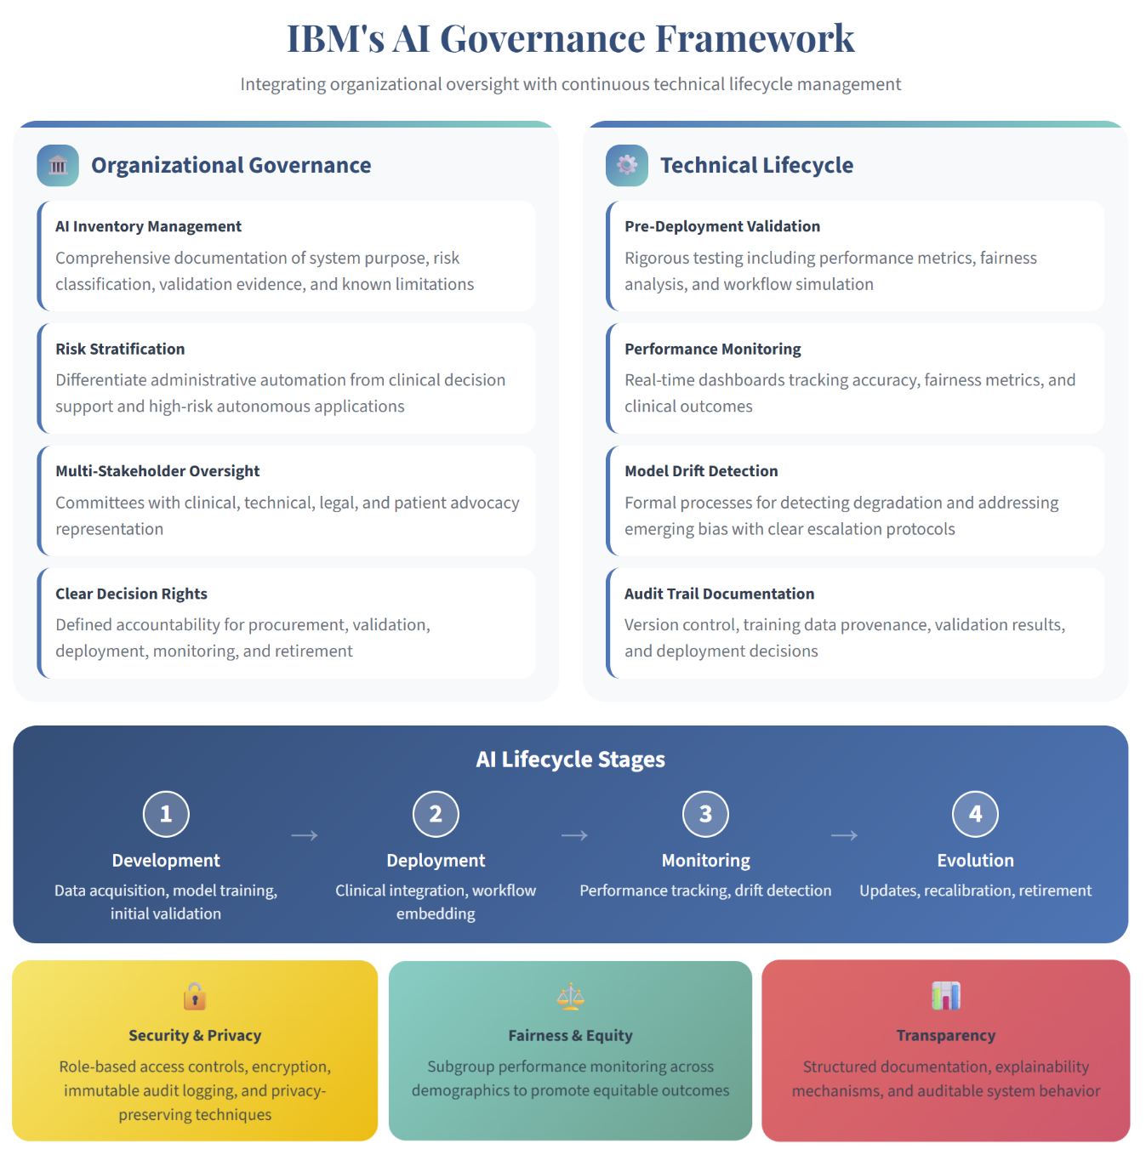
Figure 1 - IBM's AI Governance Framework

HHS has a critical role in promoting consistent governance expectations and best practices across institutions. Robust governance and accountability frameworks are essential to the safe and effective use of AI in healthcare and should be embedded by design rather than applied retrospectively. This includes formal clinical risk assessment, clearly defined accountability across the AI lifecycle, and multidisciplinary oversight spanning clinical, technical, policy, and operational leadership. Clinical governance should be embedded directly within the AI enterprise platform, ensuring that safety, auditability, compliance, and traceability are native architectural and operational capabilities that scale consistently as AI systems evolve.

Evaluation and Robustness (RFI Question #4)
AI systems used in clinical care require rigorous, lifecycle-based evaluation methodologies that extend beyond traditional software testing. Evaluation should be conceptualized as a continuous process rather than a one-time validation event.
Pre-deployment validation must assess clinical performance in realistic conditions. This includes sensitivity, specificity, positive predictive value, and calibration across relevant patient populations. Subgroup equity analysis should be mandatory for systems influencing diagnosis, treatment selection, or care prioritization. Robust testing should evaluate performance under data perturbation, missingness, and potential adversarial inputs. Importantly, validation should include workflow simulation to determine how outputs are interpreted and acted upon in practice, not merely whether predictions are statistically accurate.
Post-deployment monitoring is equally critical. AI performance may degrade over time due to changes in patient populations, clinical practice patterns, data collection methods, or external factors. Continuous monitoring should track drift in input distributions, outcome divergence, override patterns by clinicians, and unexpected error clusters. Monitoring systems should support rapid root-cause analysis and structured remediation pathways. For higher-risk applications, periodic revalidation or recalibration thresholds should be defined in advance.
Human-centered evaluation must complement technical metrics. Clinical AI effectiveness depends on comprehension, trust calibration, and usability. Evaluation should therefore assess clinician understanding of model outputs, alignment with cognitive workflow, and impact on decision confidence. Metrics such as alert fatigue rates, time-to-decision, and override frequency can provide insight into real-world integration quality. Patient-centered measures, including understanding of AI-supported recommendations and satisfaction with transparency, are also important components of trust-building.
HHS can meaningfully advance evaluation standards through a mix of grants, cooperative agreements, prize competitions, and targeted contract vehicles. Grants and cooperative agreements are well suited to academic-led methodological research and the development of standardized benchmarking frameworks. In contrast, contract mechanisms may be more effective for building shared benchmarking infrastructure, reference implementations, and standardized evaluation toolkits that require clearly defined deliverables, timelines, and cross-sector technical coordination.
Longitudinal studies examining clinical outcomes, cost implications, health equity impacts, and workforce effects will be essential to inform reimbursement reform and regulatory modernization. These efforts may benefit from blended funding models that combine academic research rigor with industry implementation expertise. Establishing common evaluation norms through coordinated funding approaches will reduce variability in institutional review processes and support safe, scalable adoption of AI in clinical care.

Supporting Private Sector Innovation (RFI Question #5)
HHS can materially accelerate Clinical Care AI development and adoption by harmonizing governance expectations across agencies and establishing a predictable evaluation environment. A unified cross-agency AI governance framework would reduce duplication and clarify expectations regarding risk classification, transparency requirements, bias evaluation, and post-deployment monitoring. Aligning these expectations across FDA, CMS, NIH, and ASTP/ONC would significantly reduce uncertainty for developers and providers. HHS continues to collaborate and build their AI council with a comprehensive AI governance program to ensure the responsible and ethical use of AI technologies. HHS should focus on effective AI governance which transcends technical solutions, requiring a holistic approach encompassing societal, ethical, and organizational considerations alongside technical aspects.
The creation of a national AI testing and evaluation infrastructure would further lower barriers to innovation. Standardized benchmarking datasets, including synthetic and de-identified real-world data, combined with FHIR-native interoperability testing suites and workflow-based simulation environments, would allow consistent safety and performance validation. Such infrastructure would particularly benefit smaller innovators who lack access to large-scale validation environments.
Accreditation and certification mechanisms can also strengthen trust. HHS could support model certification programs aligned with ONC Health IT certification, vendor accreditation standards focused on responsible AI development practices, and clinician credentialing pathways that improve AI literacy. These mechanisms would help create consistent quality expectations across the ecosystem.
Finally, aligning AI adoption with value-based care objectives is essential. Incorporating AI-enabled outcome improvements into CMS quality programs and expanding reimbursement pathways for validated AI tools would directly link adoption to measurable clinical and financial performance.

Successes, Lessons Learned, and Priority Areas for AI in Clinical Care (RFI Question #6)
Where AI Succeeds in Healthcare
Based on IBM’s experience supporting healthcare providers, payers, and life sciences organizations, AI tools in clinical environments tend to meet or exceed expectations when deployed in well-defined workflows with clear performance metrics and strong human oversight. Administrative and operational applications, such as documentation support, coding assistance, prior authorization analytics, scheduling optimization, and revenue cycle intelligence, have consistently demonstrated measurable improvements in cycle time, throughput, and staff productivity. In these contexts, outputs are verifiable, risk tolerance is manageable, and success metrics are concrete. Similarly, AI applied to bounded clinical tasks, such as imaging triage, signal interpretation, deterioration risk scoring within defined populations, and medication safety surveillance, has shown strong performance when integrated into existing workflows and paired with clinician review. These tools add value by improving prioritization, consistency, and early detection rather than replacing clinical judgment. For instance, IBM has successfully deployed AI-enabled scheduling, workflow optimization, and operational analytics platforms that improved throughput and reduced administrative burden in UK hospitals. These deployments achieved measurable gains because they were embedded within existing workflows, aligned with organizational governance structures, and evaluated against defined operational metrics such as cycle time, staffing efficiency, and quality performance indicators.
Case Study: From AI Model to Compliant Medical Device
IBM collaborated with a Swiss life sciences company to develop an AI-powered medical device for diabetes management that met EU regulatory standards. The project exemplified how AI predictions become regulated, safe user experiences through rigorous engineering Trustworthy AI controls such as robustness testing, explainability, and uncertainty communication to reduce false prediction and improve transparency.
Key Success Factors
Cross-functional operating model: Integrated teams spanning data science, engineering, regulatory affairs, and clinical expertise
Evidence pipeline mindset: Continuous generation of audit-ready artifacts throughout the development lifecycle
Reusable assets: Framework templates, model documentation, V&V test suites, and monitoring dashboards
Outcome
This approach enabled faster iteration under control, delivering innovation without sacrificing safety, demonstrating that regulatory compliance and agility are not mutually exclusive.
Figure 2 Case Study: From AI Model to Compliant Medical Device
AI has also performed well in population health and value-based care settings, where predictive analytics support risk stratification, gap-in-care identification, and targeted outreach. When organizations have operational mechanisms to act on these insights, such as care management programs and closed-loop referral processes, AI-enabled interventions can reduce avoidable utilization and improve quality measure performance.
Where AI Falls Short
Conversely, AI tools have fallen short when introduced into complex, high-stakes clinical decision-making without sufficient integration, explainability, and governance. Systems positioned as standalone diagnostic or treatment engines often struggle with real-world variability in data quality, patient populations, and evolving standards of care. Even technically accurate models underperform if they generate excessive false positives, lack contextual explanation, or disrupt clinical workflow. In addition, organizations sometimes overestimate cost savings by focusing on model development without investing in process redesign, training, monitoring infrastructure, and accountability structures required to operationalize insights. Without clear ownership of downstream actions and ongoing lifecycle oversight, early gains can diminish over time.
Priority Areas for Future Development
Looking forward, the AI tools with the greatest potential to improve outcomes and reduce costs are those that combine predictive intelligence with governed workflow orchestration. Agent-enabled systems that synthesize longitudinal patient data and guideline-based evidence, while preserving clear human oversight, can support more coordinated, proactive care. Evidence-grounded clinical intelligence and personalized treatment sequencing models, particularly in chronic and specialty care, can reduce unwarranted variation, minimize trial-and-error prescribing, and lower avoidable adverse events.
IBM’s national-scale advisory work with NHS England demonstrates that accelerating AI adoption in clinical care requires coordinated strategy, shared governance, and operational alignment across a federated system. Fragmented, use-case pilots frequently fail to scale, leading to duplication, inconsistent assurance, and “pilot fatigue.” Establishing common standards and enterprise-level oversight early enables safe, repeatable deployment while maintaining clinical safety, regulatory confidence, and public trust. This has driven a shift toward enterprise AI platforms with embedded governance and operational controls. Recent large-scale deployments across global enterprises and public-sector organizations such as Scuderia Ferrari, Riyadh Air, demonstrate that centralized operating models, providing visibility, performance monitoring, and policy enforcement, enable scalable and trusted AI. Healthcare organizations are now piloting IBM Consulting Advantage Platform (Figure 3) as a centralized “control tower,” supporting overall governance consistency while preserving local flexibility and enabling AI to scale beyond perpetual pilots.
Ultimately, AI delivers sustained value when deployed within a governed, interoperable, and outcome-oriented ecosystem. Aligning reimbursement, regulatory oversight, interoperability standards, and institutional governance is essential to unlocking the full impact of these capabilities.
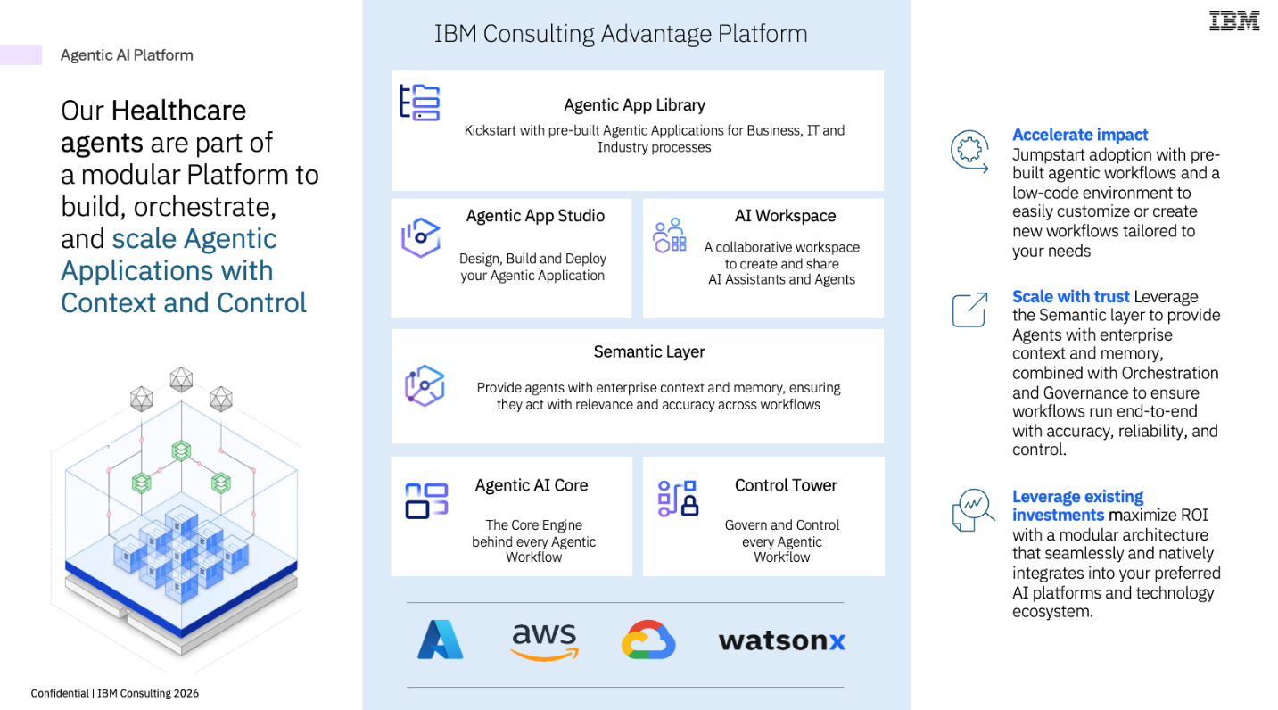
Figure 3 IBM Consulting Advantage Platform – Centralized AI Control Tower Enabling Scalable, Federated Governance

AI Adoption Dynamics in Health Care Organizations (RFI Question #7)
Adoption of AI in clinical care is shaped as much by institutional dynamics as by technical merit. Within healthcare organizations, decision-making authority is distributed across clinical leadership, digital and information technology leadership, data governance bodies, compliance committees, and financial executives. Chief Medical Officers often determine whether AI tools are clinically credible and aligned with standards of care, while Chief Information or Digital Officers assess infrastructure readiness and integration feasibility. Finance committees evaluate return on investment and budget trade-offs, and compliance and privacy officers scrutinize risk exposure. Adoption frequently stalls when these constituencies are not aligned or when accountability boundaries are unclear.
One of the primary administrative hurdles is limited AI literacy across clinical and operational leadership. Without a shared understanding of capabilities, limitations, and governance safeguards, decision-makers may either overestimate risk or place inappropriate trust in system outputs. Structured education initiatives, including executive briefings, clinician training modules, and competency frameworks, can significantly reduce hesitation and improve responsible use.
Another barrier is the absence of standardized internal evaluation pathways. Many institutions apply procurement processes designed for traditional medical devices to AI software that may iterate more rapidly. This can lead to prolonged approval cycles and inconsistent review criteria. Establishing streamlined AI review committees with defined evaluation frameworks, risk-tiering protocols, and clear escalation pathways would improve efficiency while maintaining safety oversight.
Budget constraints also play a significant role. AI deployment requires investment in integration, monitoring infrastructure, cybersecurity controls, and ongoing governance. Without reimbursement alignment or shared savings incentives, these investments may compete unfavorably with other priorities such as staffing, EHR modernization, or cybersecurity upgrades. Linking AI adoption to value-based care metrics and outcome improvements is therefore essential to support internal business justification.
Workflow redesign represents an additional challenge. AI systems can inadvertently reinforce inefficient processes if underlying documentation or care pathways are poorly structured. Successful adoption requires parallel workflow optimization and change management efforts to ensure that AI augments rather than disrupts clinical operations.
Sustained AI adoption in healthcare requires clear, measurable ROI, including revenue improvement, cost reduction, efficiency gains, throughput, quality, and safety outcomes. Standardized KPIs and baseline benchmarking are essential to link deployment to value; without demonstrable impact, initiatives rarely scale beyond pilots.

Interoperability as a Catalyst (RFI Question #8)
Enhanced interoperability, anchored in HL7 FHIR-based APIs and nationally standardized datasets, delivers outsized downstream impact by providing the high-volume, high-variety, and well-labeled data AI requires. Standardized data access enables clinical AI model training (e.g., early disease detection, risk stratification, medication optimization), supports enterprise-scale learning through Bulk FHIR for large cohorts and federated approaches, and significantly reduces data engineering effort, allowing teams to focus on feature development, validation, and deployment rather than ingestion.
Figure 4 includes a few examples that demonstrate how enhanced interoperability translates into concrete datasets, data flows, and actionable AI use cases across clinical care, research, and healthcare operations. Collectively, they show that interoperability is not simply about improving data exchange; it is a foundational enabler that materially accelerates the development, rigorous evaluation, and scalable deployment of AI in clinical care.
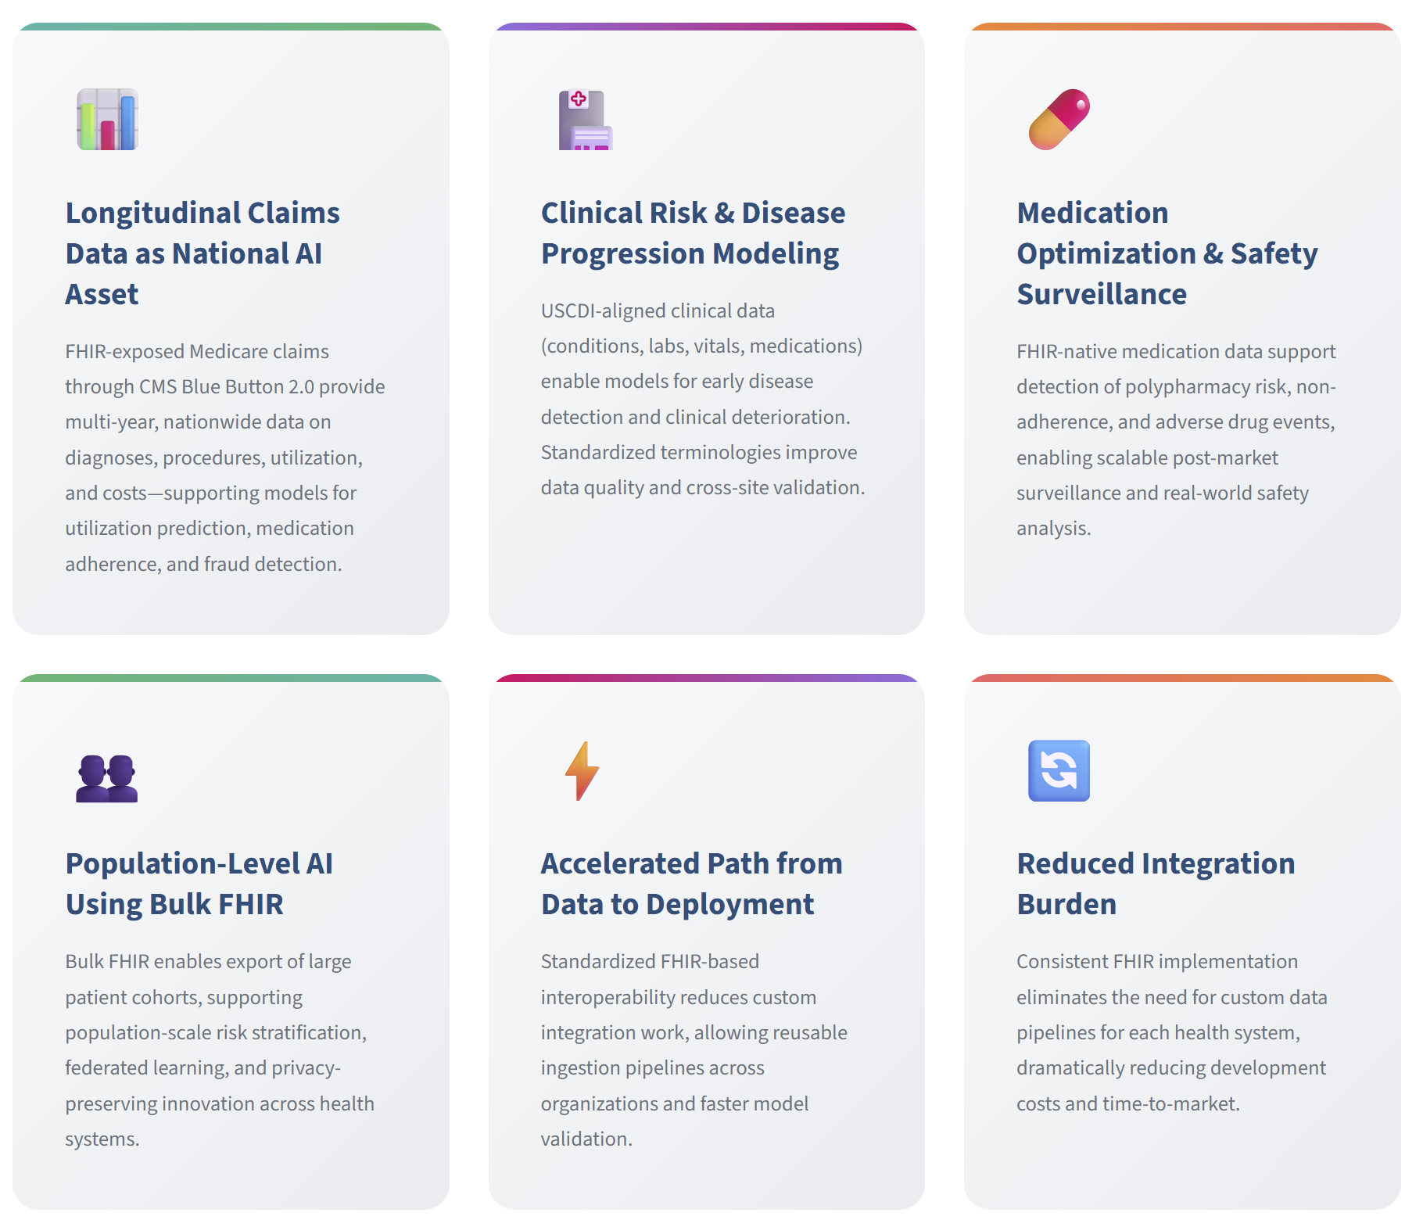
Figure 4 – Examples of Interoperability Driving AI Innovation

Patient and Caregiver Perspectives (RFI Question #9)
Patients and caregivers generally view AI in clinical care through a practical lens: they are less concerned with the technical architecture of models and more concerned with whether AI meaningfully improves access, accuracy, timeliness, and coordination of care. Many patients wish to see AI address persistent systemic challenges, including long wait times for specialty care, delayed diagnoses, fragmented medical records, administrative burden, and inconsistent communication across providers. AI-supported triage tools, early detection systems, and care coordination platforms hold promise in reducing diagnostic delays, preventing avoidable hospitalizations, and improving medication safety. For caregivers managing chronic or complex conditions, AI-enabled monitoring and predictive analytics may provide earlier warning of deterioration, improved treatment personalization, and better alignment across multidisciplinary care teams.
Patients are also interested in more personalized and proactive care. AI has the potential to synthesize longitudinal health records, genomic information, and lifestyle data to support individualized treatment recommendations rather than one-size-fits-all protocols. In addition, AI-driven automation of administrative processes, such as prior authorization, scheduling, and documentation, could reduce delays and free clinicians to spend more time in direct patient interaction. From the patient perspective, the most compelling value proposition is not technological sophistication but improved outcomes, clearer communication, and a more responsive care experience.
At the same time, significant concerns remain. Transparency is paramount: patients want understandable explanations of how AI-informed recommendations are generated and what their limitations are. Equity is another major concern, particularly the risk that models trained on non-representative data could reinforce disparities. Privacy and data use practices must be clearly governed and communicated, especially regarding secondary use of health information.
Patients also emphasize that AI should augment, not replace, clinician judgment. Preserving the human relationship in care and maintaining clear accountability when errors occur are essential to sustaining trust. Ultimately, adoption will depend on whether AI demonstrably improves outcomes and experience while maintaining transparency, fairness, privacy, and meaningful human oversight.

Research Priorities (RFI Question #10)
HHS should prioritize AI research areas that directly strengthen clinical decision-making by connecting upstream biomedical evidence to point-of-care actions. A particularly high-impact area is AI-enabled integration of the full therapeutic lifecycle, from preclinical discovery through regulatory approval and post-market evidence, into clinically usable intelligence. Advances in Large Language Models (LLMs) and Agentic AI make it technically feasible to compress and contextualize vast bodies of heterogeneous data (e.g., molecular mechanisms, New Alternative Methodologies (NAMs), clinical trial outcomes, and regulatory submissions) and surface them at the moment a clinician is selecting among therapeutic options. Prioritizing research that enables traceability and explainability across this lifecycle would help clinicians move beyond trial-and-error prescribing toward more informed decisions, reducing avoidable treatment failures and downstream harm.
HHS should also invest in AI research focused on agentic AI systems with long-term memory, reasoning, and workflow orchestration for clinical care. Unlike static decision support tools, agentic systems can autonomously synthesize patient-specific data with evolving scientific evidence, guidelines, and real-world outcomes. The complexity and scale of data generated by modern drug development, particularly human-relevant NAMs and multi-omic cellular models, exceed what individual clinicians can reasonably internalize. Research into agentic architectures that can reason across these data sources, maintain provenance, and adapt recommendations as new evidence emerges would materially enhance clinical judgment without supplanting it.
Finally, HHS should prioritize AI research that enables personalized therapeutic selection and sequencing, especially in conditions where the order of treatment materially affects outcomes. Prescribing the “wrong” drug first can reduce the effectiveness of subsequent therapies due to physiological effects, even when all prescribing is technically permissible. AI models that combine mechanistic biology, patient-specific characteristics, and historical response patterns could help clinicians identify the most appropriate initial therapy rather than relying on iterative trial-and-error. Targeted federal investment in this area would accelerate adoption by aligning AI capabilities with clinicians’ real decision points, while advancing HHS goals of improved outcomes, reduced waste, and greater trust in AI-supported clinical care.

Conclusion
AI will not scale in clinical care through technical advancement alone. Sustainable adoption requires coordinated reform across reimbursement policy, regulatory oversight, interoperability standards, governance structures, and workforce readiness. When these structural enablers are aligned, AI can improve diagnostic accuracy, personalize treatment selection, reduce administrative burden, and strengthen care coordination, while maintaining safety, equity, and transparency.
IBM is well positioned to support HHS in advancing this effort. Our cross-sector experience working with federal agencies, healthcare delivery organizations, life sciences companies, and payers enables us to translate policy intent into practical, operational implementation. We bring a deep understanding of the technical, regulatory, and organizational complexities involved in embedding AI responsibly into clinical and operational workflows, while balancing innovation with safety, governance, and accountability. We would also welcome the opportunity to partner with HHS through discovery, user-centered design, and proof of value to help shape, test, and scale solutions in a way that is grounded in real-world needs and delivers measurable impact across the system.
We look forward to continued collaboration with HHS to help build a trusted, scalable, and patient-centered AI ecosystem that strengthens clinical care delivery nationwide while upholding the highest standards of safety, equity, and public trust.

