Response to Request for Information
Accelerating the Adoption and Use of Artificial Intelligence as Part of Clinical Care
___________________________
Title:
A Focused AI-Enabled Photobiomodulation Care Model to Reduce the Burden of Traumatic Brain Injury

Responding Organizations
Lead Implementation Entity
Vielight USA, Inc. — U.S.-based entity advancing clinical deployment, partnerships, and regulatory engagement for AI-enabled photobiomodulation (PBM) neuromodulation
Supporting Organizations
Vielight Inc. — technology developer and scientific platform
PBM Foundation (501(c)(3)) — nonprofit research, education, and policy partner
Center of Excellence for Photobiomodulation, Shepherd University — academic research and training hub
Advanced Health Center for Integrative & Functional Medicine — potential clinical implementation partner

1. Executive Summary
This submission provides a focused perspective on how artificial intelligence can enable scalable, non-invasive neurological therapeutics, using traumatic brain injury (TBI) as a high-impact use case.
The responding organizations are committed to developing targeted AI capabilities aligned with a clear mission: maximizing functional recovery and long-term outcomes for individuals affected by TBI. Rather than attempting to address all aspects of AI in healthcare, this initiative concentrates on areas where photobiomodulation-based neuromodulation, physiological monitoring, and longitudinal analytics can have measurable impact.
Photobiomodulation (PBM), a low-risk light-based neuromodulation modality, offers the potential for scalable deployment under risk-proportionate oversight. Through coordinated research, clinical deployment, and real-world evidence generation, the goal is to establish a scalable system for reducing TBI burden at population level and to inform broader neurological care strategies.
Headline Impact Statement
Even modest improvements in recovery outcomes across a subset of individuals living with TBI could translate into tens of billions of dollars in lifetime societal savings. Scalable, AI-enabled PBM interventions therefore represent a potentially high-value strategy for addressing one of the nation’s most persistent neurological health challenges while supporting long-term economic and human capital resilience.

2. Public Health Context
Traumatic brain injury remains a major contributor to disability, mental health conditions, and long-term healthcare utilization. Recovery trajectories are heterogeneous, and many individuals experience persistent symptoms affecting cognitive, emotional, and functional capacity.
Innovative care models leveraging physiological monitoring and data-driven insights have the potential to improve recovery pathways and reduce long-term disability and societal costs.

2.1 National Economic Impact Scenario
Lifetime societal costs associated with TBI range widely, with estimates spanning approximately $85,000 to more than $3 million per individual depending on severity.^{1, 2} For policy modeling purposes, an illustrative average burden of $500,000 per patient demonstrates the scale of opportunity for improved recovery pathways.
Assuming a conservative 10% reduction in long-term costs through improved outcomes, savings could reach approximately $50,000 per individual. Applied to one million individuals — a subset of the population living with TBI-related disability — this represents potential lifetime societal savings exceeding $50 billion.
By comparison, providing a home-based PBM system at approximately $2,400 per patient would total roughly $2.4 billion, illustrating the magnitude of potential net societal benefit even under conservative assumptions.

Illustrative Economic Impact Scenario
Parameter | Assumption | Result
Average lifetime cost | $500,000 | —
Modeled improvement | 10% | $50,000 savings per patient
Population modeled | 1,000,000 | —
Total savings | — | $50B
Intervention cost | $2,400 per patient | $2.4B
Net societal benefit | — | ~$47.6B
Illustrative modeling for policy context.

3. Clinical Use Case: AI-Guided Photobiomodulation Neuromodulation
Photobiomodulation (PBM) is a non-invasive light-based neuromodulation modality being investigated for its ability to influence biological processes relevant to TBI recovery, including neuroinflammation, mitochondrial activity, and cerebral perfusion.³
Vielight USA is advancing an integrated platform combining:
- PBM neuromodulation
- Physiological and symptom monitoring
- Cloud-based analytics
- Machine learning–driven treatment optimization
Artificial intelligence capabilities are already being incorporated into research programs and pilot implementations, enabling adaptive treatment optimization and longitudinal outcome tracking.⁴

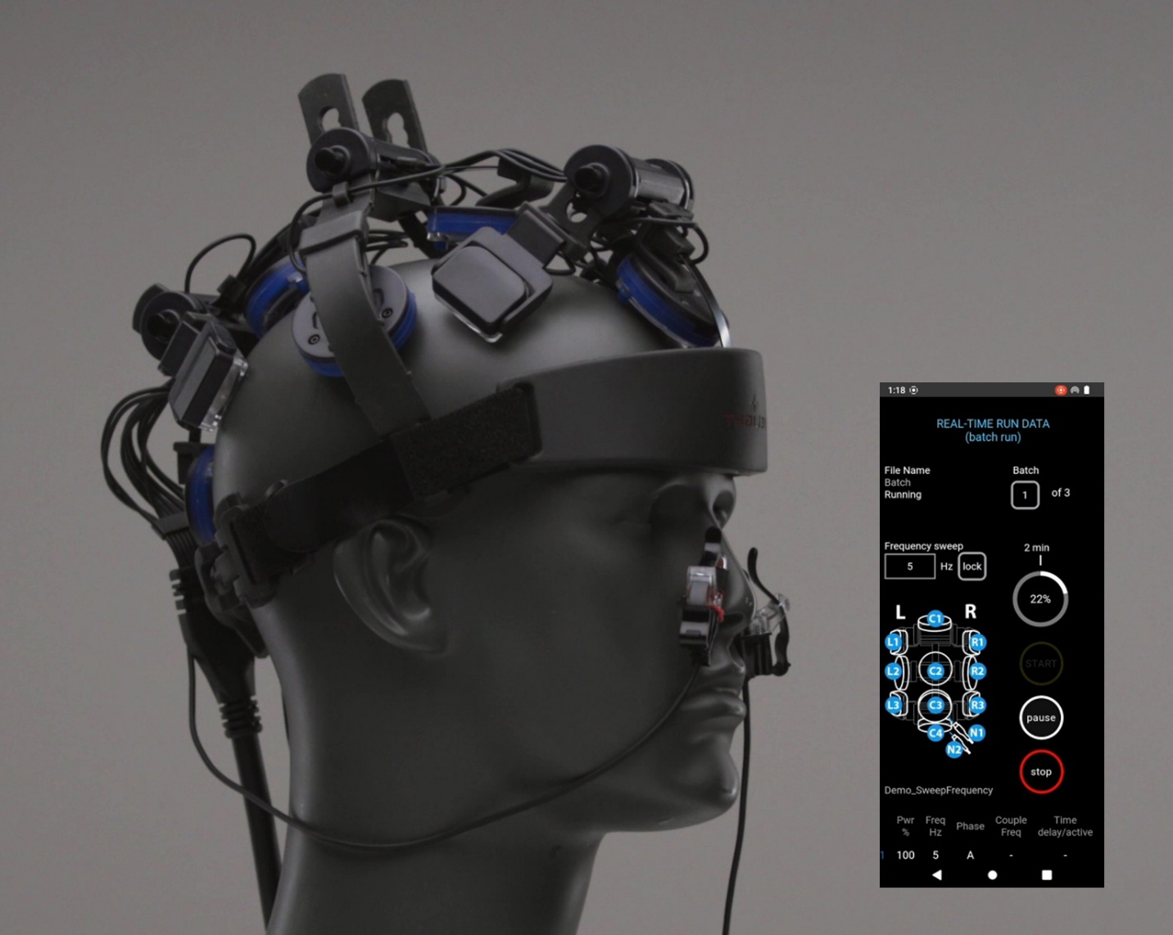
Figure 1. PBM platform with integrated digital interface supporting treatment monitoring and optimization.

4. Translational Ecosystem
The initiative leverages a collaborative ecosystem spanning technology development, academic research, nonprofit advocacy, and clinical implementation, supporting evidence generation and scalable deployment.

5. Implementation Readiness and Credibility
PBM technologies referenced in this submission are supported by peer-reviewed research and clinical studies. Artificial intelligence–driven analytics are being incorporated into research programs to support treatment personalization.
More than 150,000 PBM devices have been deployed globally for home use, demonstrating feasibility of large-scale distribution and patient adherence. This level of real-world deployment provides a foundation for AI-driven optimization and population-level implementation.
The combination of peer-reviewed evidence, active AI development, and large-scale real-world deployment positions Vielight PBM as an implementation-ready platform capable of supporting federal pilot programs and evidence-generation initiatives.

6. Military Readiness and Human Capital Considerations
Beyond healthcare cost savings, improving neurological recovery has implications for military readiness and long-term veteran health. TBI remains a significant challenge affecting service members,⁵ and interventions that support resilience and cognitive function may contribute to preservation of operational capability and human capital.

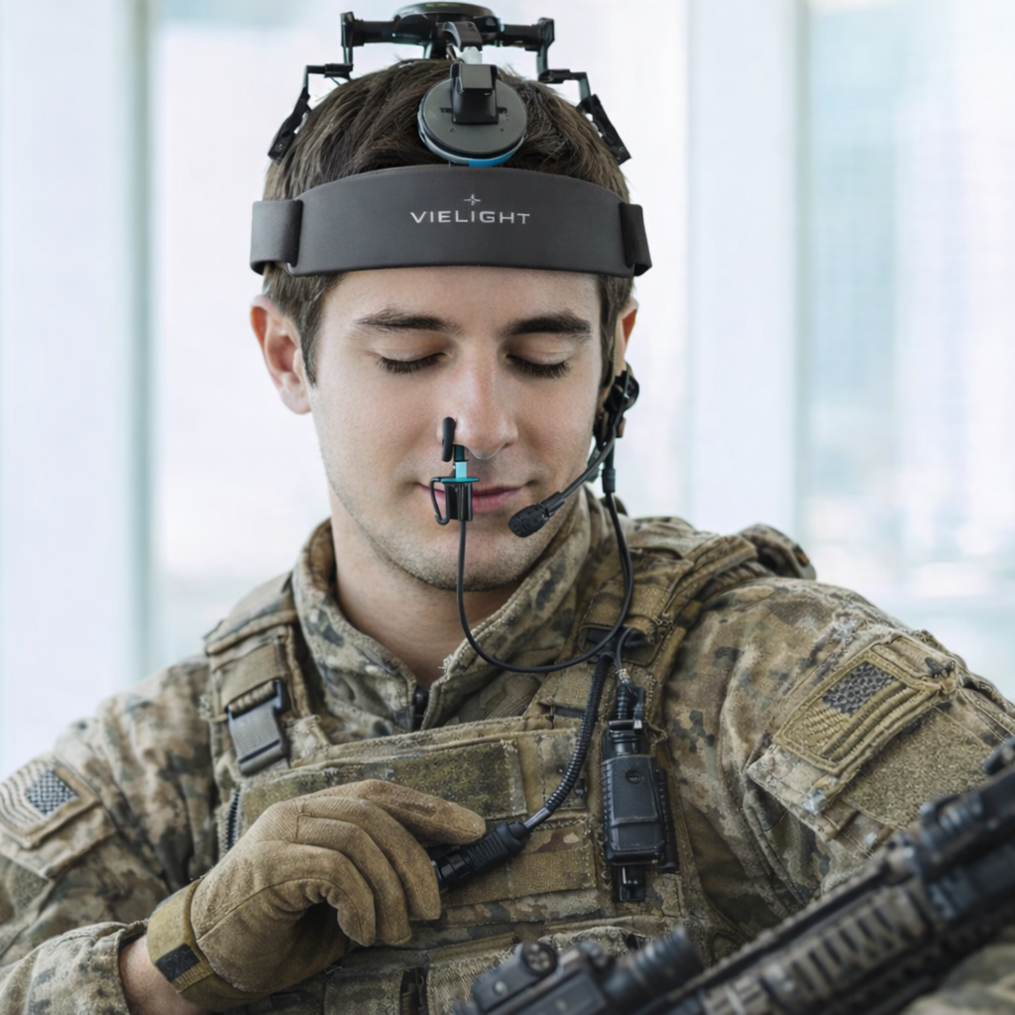
Figure 2. Example of PBM neuromodulation being explored in operational readiness and recovery contexts.

7. Responses to Specific Questions
7.1 Barriers to innovation
A major barrier to AI-enabled neurological therapeutics is the lack of reimbursement pathways recognizing longitudinal outcome improvement. TBI recovery unfolds over extended periods, making traditional episodic payment models poorly aligned with therapeutic impact.
PBM platforms equipped with monitoring and analytics can generate real-world evidence demonstrating functional improvement and cost offsets. Federal demonstration programs enabling coverage with evidence development would accelerate adoption and provide critical data for policymakers.

7.2 Regulatory and payment considerations
Low-risk non-invasive therapies may face lengthy evaluation pathways that delay patient access despite favorable safety profiles. For PBM-based interventions, a risk-proportionate framework allowing provisional access with ongoing safety monitoring could enable earlier deployment while preserving safeguards.
Outcome-based reimbursement pilots could evaluate the value of AI-guided treatment optimization in improving recovery trajectories and reducing long-term costs.

7.3 Legal and governance considerations
AI-enabled therapeutic systems require clear governance structures defining responsibility among developers, clinicians, and healthcare organizations. PBM platforms can incorporate human-in-the-loop oversight, transparent decision support, and version control to ensure accountability.
Federal guidance on governance standards would help ensure safe and consistent implementation.

7.4 Evaluation methods
Traditional clinical trials may not fully capture the impact of therapies whose benefits accrue over months or years. Hybrid evaluation models combining pragmatic trials, digital biomarkers, and real-world evidence are particularly relevant for TBI.
Continuous monitoring enabled by PBM platforms can provide longitudinal data supporting these evaluation frameworks. Federal support for demonstration projects would accelerate validation.

7.5 Supporting private sector activities
Public-private clinical testbeds would allow developers to evaluate AI-enabled therapies in real-world settings. PBM programs could be deployed in academic or federal healthcare systems to study outcomes, workflow integration, and cost impact.
Grants and cooperative agreements would facilitate these collaborations.

7.6 Where AI has met or fallen short
AI has demonstrated strong performance in diagnostics but less impact on directly improving patient outcomes. Therapeutic optimization represents the next frontier.
AI-enabled PBM platforms offer an example of how algorithms can personalize treatment parameters and monitor response over time, potentially translating data insights into improved clinical outcomes.

7.7 Adoption decision makers
Health system leadership evaluates new technologies based on clinical benefit, cost impact, and operational feasibility. Implementation toolkits demonstrating workflow integration and economic value would facilitate adoption.
Pilot programs providing structured outcome reporting could support evidence-based procurement decisions.

7.8 Interoperability
Integration of physiological monitoring with electronic health records is critical for advancing AI-enabled care. Vielight PBM systems capable of collecting remote telemetry could contribute valuable longitudinal data streams.
Expansion of interoperability standards would enable broader research and innovation.

7.9 Patient and caregiver perspectives
Patients prioritize improved recovery, accessibility, and transparency. Home-based PBM interventions supported by remote monitoring may enhance access while maintaining clinician oversight.
Clear communication and privacy protections are essential to building trust.

7.10 Research priorities
AI-guided treatment personalization and longitudinal neurological outcomes should be prioritized research areas. Collaborative programs involving academic centers, developers, and healthcare systems could evaluate PBM and similar modalities.
Emerging literature supports integration of physiological monitoring with adaptive neuromodulation approaches, though further studies are needed to quantify economic impact and long-term benefits.

8. Conclusion
Artificial intelligence offers a meaningful opportunity to transform neurological care when applied to clearly defined high-burden conditions such as traumatic brain injury.
By focusing on photobiomodulation-based neuromodulation and leveraging targeted AI capabilities aligned with demonstrated expertise, this initiative seeks to establish a scalable, evidence-driven model for improving outcomes and reducing societal burden.
Risk-proportionate provisional access pathways combined with real-world evidence generation could accelerate innovation while maintaining safety and accountability.

REFERENCES
- National Academies of Sciences, Engineering, and Medicine. Traumatic Brain Injury: A Roadmap for Accelerating Progress. 2022. https://www.ncbi.nlm.nih.gov/books/NBK580076/
- Corso P., Finkelstein E., Miller T., Fiebelkorn I., Zaloshnja E. Incidence and Lifetime Costs of Injuries in the United States. Injury Prevention. 2006.
- Lim L. Traumatic Brain Injury Recovery with Photobiomodulation: Cellular Mechanisms, Clinical Evidence, and Future Potential. Cells. 2024.
- Topol E. High-performance medicine: the convergence of human and artificial intelligence. Nature Medicine. 2019.
- Defense and Veterans Brain Injury Center (DVBIC). TBI in Military Populations. https://dvbic.dcoe.mil

