OttnoAI
  - A Medical AI Revolution

THE world’s first ai personal health record.
We believe healthcare information should be intuitive, highly personalized, and available to everyone. That's why we've created something extraordinary: an AI that understands medicine at a profound level, speaks 14 languages, and processes knowledge at a scale never before possible. It's not just an evolution in medical technology—it's a revolution in how we access and understand health information. And this is just the beginning.

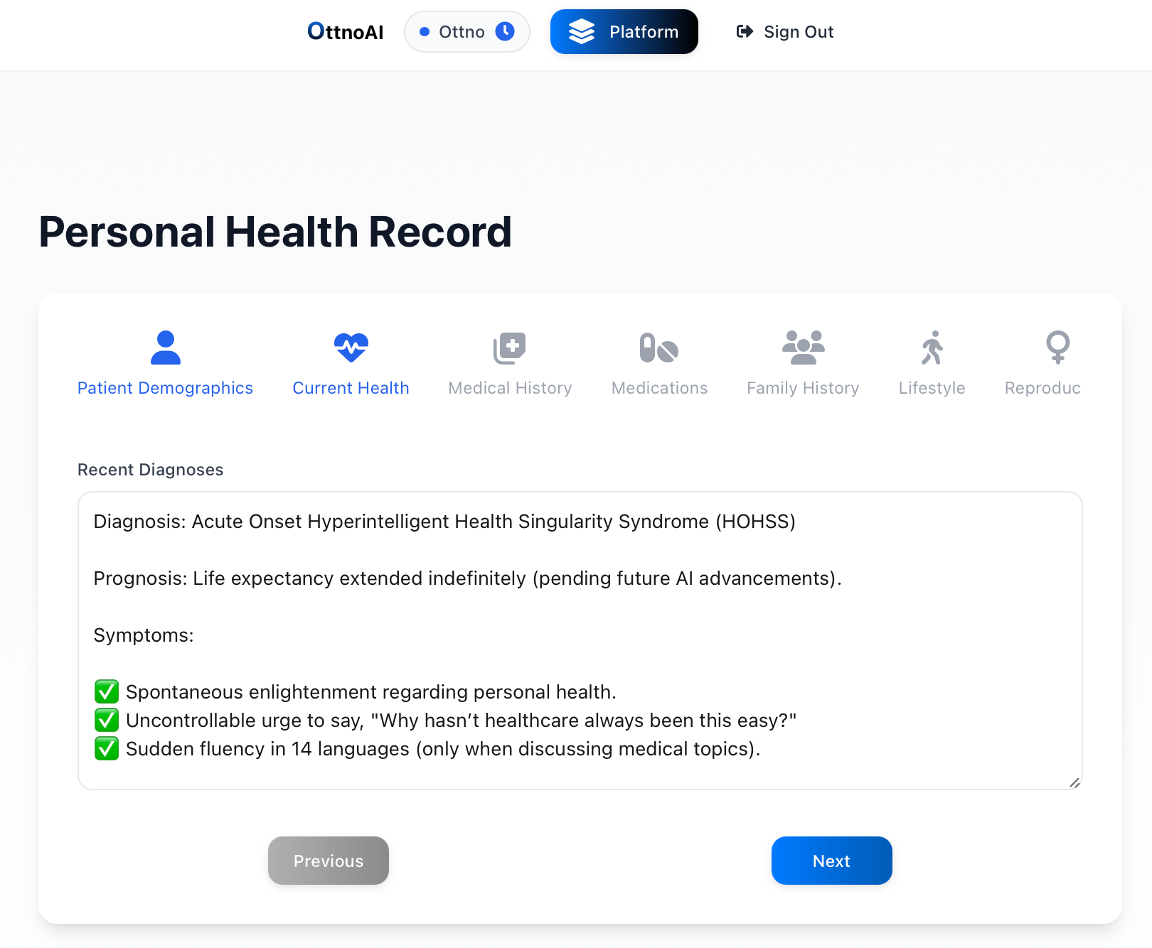

Every conversation matters. Ottno remembers them all.

Your medical history is a story that deserves to be remembered perfectly. We've created an AI system that transforms how your healthcare conversations are preserved and protected. Simple, elegant, and incredibly powerful. This is Ottno.
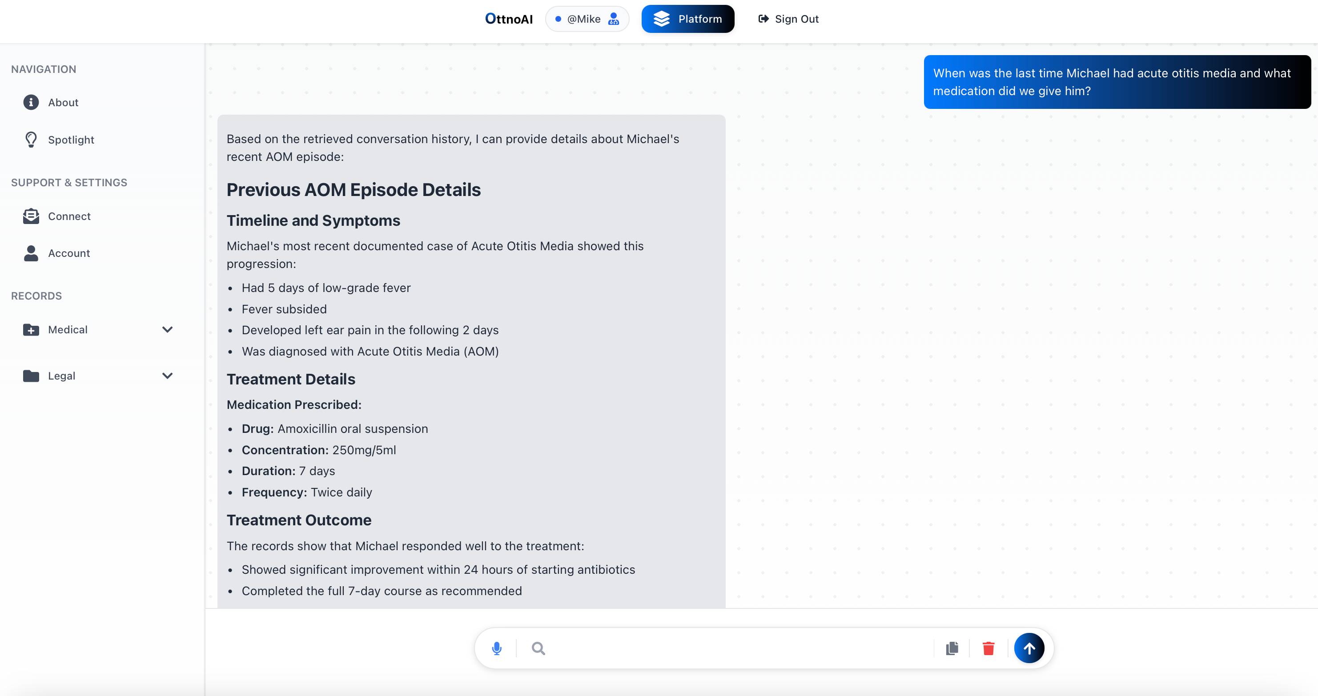

Your data. Your control. Your security.
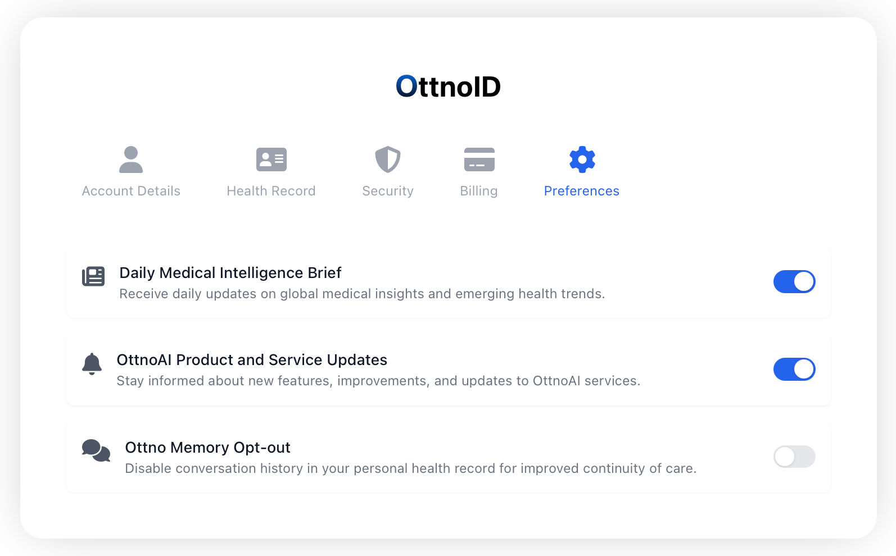

Safety Engineering at the Intersection of AI and Medicine.
Medical AI should help, never harm. That's why we've engineered an Adverse Event Reporting System that's as thoughtful as it is powerful. When something unexpected happens, Ottno doesn't just listen—it responds. Beautifully designed, meticulously engineered, and centered on keeping you safe:
- Immediate detection and prioritization of potential adverse events.
- Real-time connection with our expert team for personalized support.
- Comprehensive data gathering with privacy at its core.
- AI fine-tuning based on your feedback for continuous safety improvement.
- Full transparency through the entire resolution process.
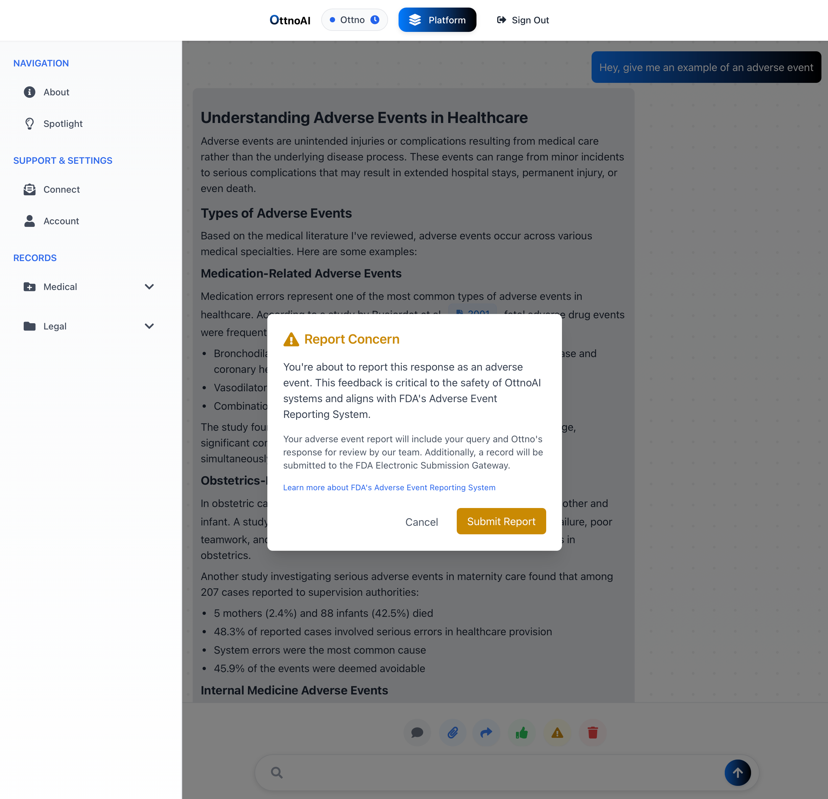

Advanced AI System Administration & Security.
At the intersection of cybersecurity and healthcare, we've engineered an advanced AI system that operates as our collective digital guardian. Our platform leverages sophisticated machine learning algorithms to provide 24/7 system administration, real-time security monitoring, automated threat response, and software debugging. Ottno performs continuous security audits while maintaining HIPAA compliance and ensuring zero-trust architecture implementation. The SHIELD (Secure Health Information Enforcement & Logic Device) gateway provides enterprise-grade protection through:
- Real-time threat detection and automated response.
- End-to-end encryption for data in transit and at rest.
- Dynamic PII redaction and content filtering.
- Automated debugging, vulnerability assessment, and patching.
- Continuous security audit logging and compliance monitoring.
