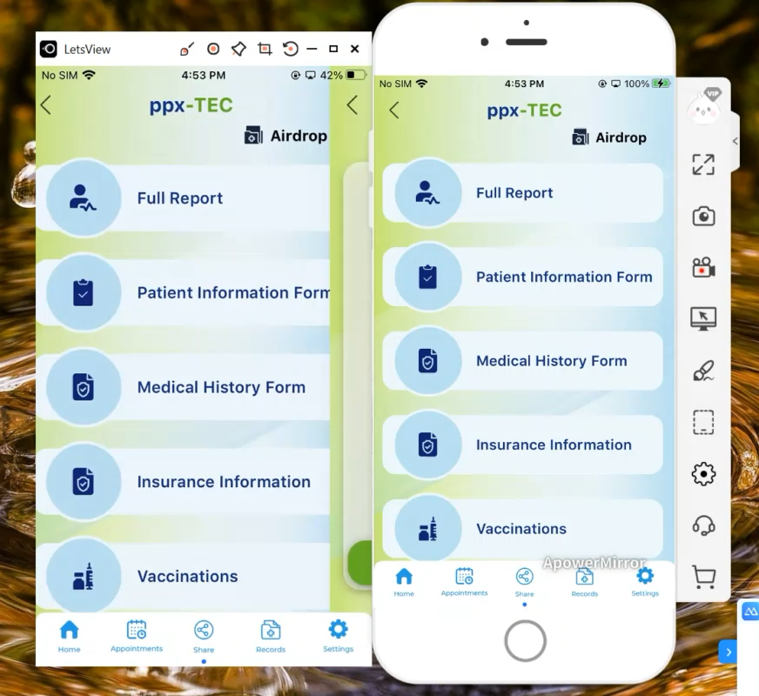
Document # 3

CMS RFI Response2 06032025, RESENDING ALL DOCUMENTS SNAIL MAIL

ppxTEC (PROTOTYPE) Response to CMS RFI: Bridging Technical and Cultural Barriers in Healthcare Interoperability

