Recently evil AHCCCS sent me yet another degenerate flyer:
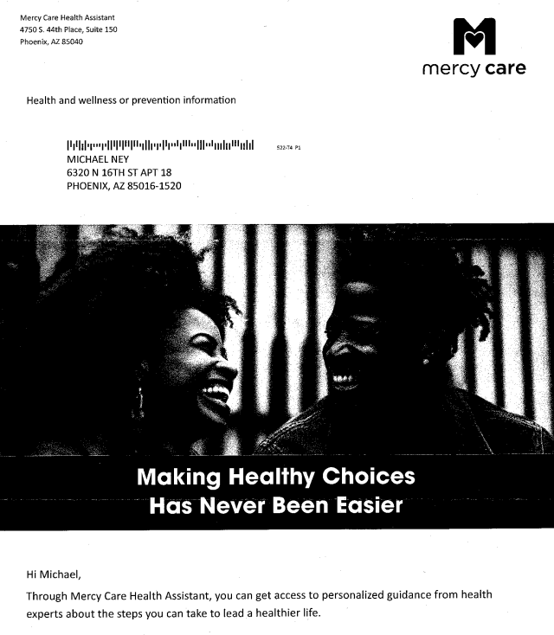
This flyer came in two pages: on ine English and another in Spanish despite I do not speak Spanish. They do it for 20 years.
As seen from this vomit-inducing photo, two models with exellent dental work, which AHCCCS does not pay for, engaged in degenerate smiling for no reason. A man on right wears haircut that no man would conceived in the last 10 million years and also advertises his gayness by wearing an earring. The cretin-inspired slogans like “Making Healthy Choice Has Never Been Easier” is on par with other degenerate statements made by AHCCCS over the years – like “We Want You To Be Healthy” without disclosing how they will make money then.
They call me, a grown man, a senior, a great grandfather on th first name basis as if we were casual pals. They want to “guide” a man disabled since birth to lead a healthier life while my SSI remains non-survivable.
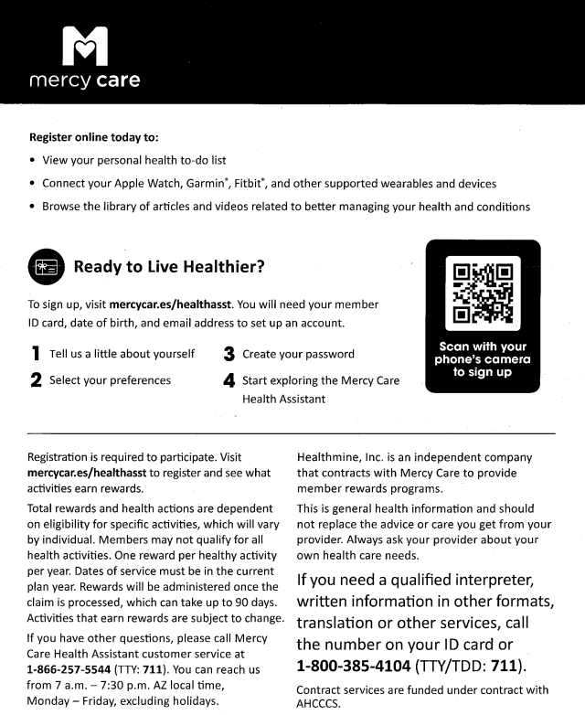
They are sending this garbage to a senior and trying to entice him to Apple Watch, Garmin*, Fitbit* and whatever else no senior ever heard of. (The stars* are not explained). They want a patient to watch videos to “manage” conditions, never to treat them. They want me to tell them “a little” about myself, not the whole picture of severely disabled senior. They want a patient to register first and only then to see what activities earn unspecified “rewards”as if patients were dogs wiggling their tales expecting “rewards.” And then they mentioned Healthmine as a middle man squeezed in between fake “Mercy” non-Care and the patients (to violate HIPAA.)

2025 comment:
You want more electronics, CMS? Then don’t complain on name calling.

