Japanese researchers discovered bacteria from gum infections can travel through the bloodstream to heart tissue, potentially causing dangerous irregular heartbeats.
I am in GRAVE dental pain around the clock for YEARS. Thanks CMS for your hard work. I have severe heartache upon each step. Cannot walk much anymore and there is no way to get a wheelchair. Every conceivable aspect of this government is always the same thing: genocide, not our phony improvements.

***
If AI are so good in replacing humans in Call Centers, then why AI are not trained to write emails? You know the answer: ram satanic technology down everyone’s throat every which way to achieve the ultimate goal – transhumanism.

***
As the breadth, depth, quality, and timeliness of health data available to patients through standards-based APIs increase, evolving digital health products will gain greater functionality and potential for enhancing the healthcare experience, reducing costs, increasing access to care, enabling chronic disease prevention, and improving healthcare outcomes.

You – worthless non-human entities: how about all seniors would have electronics first? My 72-year old neighbor never had a computer and the email, does not know how to use it and does not want to.

***
https://www.hhs.gov/civil-rights/for-providers/compliance-enforcement/agreements/cms/cms-bulletin/index.html
The Centers for Medicare & Medicaid Services Commits to Effective Communication for All Individuals with Disabilities in All of Its Programs
FOR IMMEDIATE RELEASE
Contact HHS Office for Civil Rights
1-800-368-1019
[Correction: that was a joke, stupid! CALL or DIE.]

https://ocrportal.hhs.gov/ocr/smartscreen/main.jsf
Federal Civil Rights Laws help to protect you from unfair treatment or discrimination because of your race, color, national origin, disability, age, or sex.
[Blatant lie. Total, absolute, 100% lie proven many times over. CALL or DIE.]

If you have any questions or need help filing a civil rights, conscience or religious freedom, or health information privacy complaint, you may email OCR at OCRMail@hhs.gov
[I did several times. No response. CALL or DIE.]

***
NOT ONE medical insurance responded to me by email. NOT ONE bank, office, business, police, court, etc. – everyone is hell-bend on telephone. I am on verge of eviction to die on a street because the new band of thieves, a.k.a. management company, wants everything online, everything electronics, through “portal.”

https://ocrportal.hhs.gov/ocr/cp/wizard_cp.jsf
[Started 2023-02-08 at 1:18 PM AZ time]

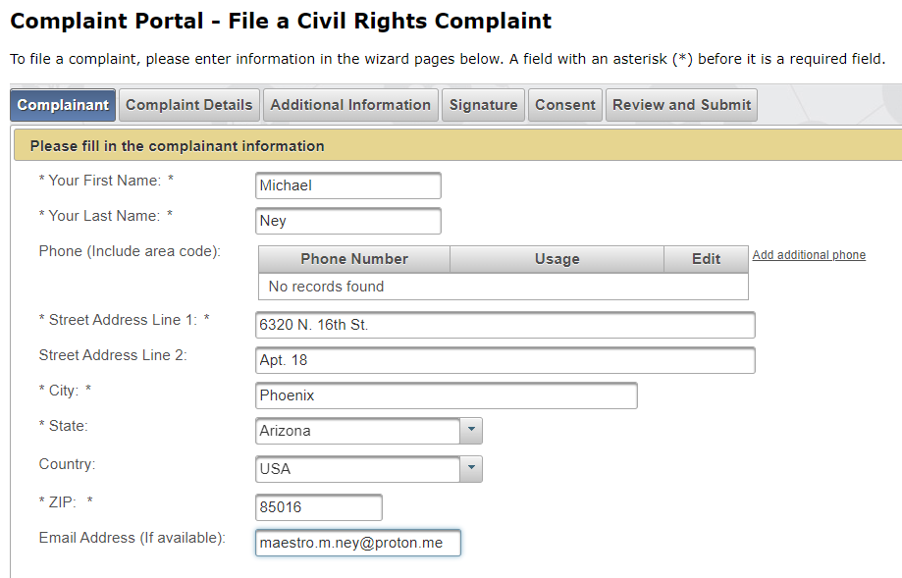

Receipt Number: 28362544

https://www.cms.gov/newsroom/press-releases/dr-mehmet-oz-shares-vision-cms
Press Releases
Apr 10, 2025
Dr. Mehmet Oz Shares Vision for CMS

As Dr. Mehmet Oz completes his first week as the 17th Administrator of the Centers for Medicare & Medicaid Services (CMS), he is sharing his agenda and vision for the agency. A cardiothoracic surgeon and former host of an award-winning TV show, he now leads the largest agency under the Department of Health and Human Services (HHS), with a $1.7 trillion budget, tasked with delivering health outcomes for more than 160 million people.

Say what? CMS wastes $1.7 for nothing?

$1.7T? Twice more than DOD? More than GDP of absolute majority of countries?

CMS: please enjoy google responses as is, nothing photoshopped:
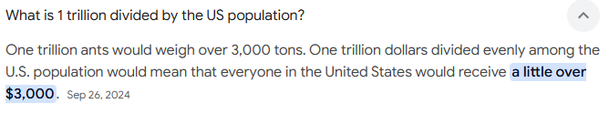
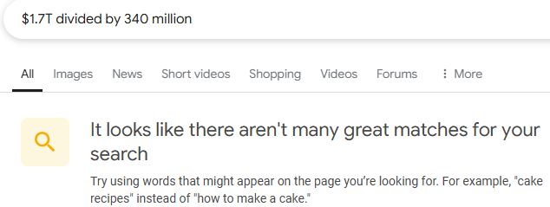



As you see, Google does not know what does it mean 340 million, it prefers 330 million.

CMS: is this how much money Americans get from your services? CMS is serving 160 million people. Therefore, the price people get from CMS is twice more than shown.

***
“Great societies protect their most vulnerable. As stewards of the health of so many Americans – especially disadvantaged youth, those with disabilities, and our seniors, the CMS team is dedicated to delivering superior health outcomes across each program we administer.

Present tense, not the future. Dr. OZ: you are a liar. And what “great societies” have to do with contemporary America?

Together, we are committed to Make America Healthy Again by combating fraud and abuse in Medicare and Medicaid, and ensuring that these programs truly serve the American people.”

The word “together” is despicable. Compare with the insulting USDA slogan of the same sort. There is nothing “together” about. MAHA – ha-ha.

CMS operates many programs that can be used to focused on improving holistic health outcomes.
Dr. Oz: you are a big-time liar.

CMS works in partnership with the entire health ecosystem to improve health quality and outcomes for the patients it serves.

Joke, stupid: CMS works in partnership with the entire health ecosystem to protect criminal sadists at all costs.
X: @DrOzCMS
Instagram: @DrOzCMS
Facebook: CMS Administrator Dr. Oz
Dr. Oz: for what frogging hell you are offering social networks, but not the direct email?

https://www.medicare.gov/my/medicare-complaint/step2b
ENTER A VALID CALL BACK NUMBER.
Medicare/CMS: you are not just fraud, you are outright criminals abusing disabled as a Federal Felony. Tis fraudulent form does not allow any complaints unless one enters the telephone.

https://civilrights.justice.gov/
Enforcement
We sue or prosecute individuals and organizations who violate civil rights laws.
You are ALL liars and fraud. Not one scum medical insurance (and all other imaginable and unimaginable companies) responded to me without the telephone.


YOU ARE LIARS.

This is how UHC improves health:


These photos illustrate health improvements.

28532099 for complaint submitted to Office for Civil Rights
From OCR_Portal@nih.gov
To Maestro.m.ney@proton.me<maestro.m.ney@proton.me>
Thursday, March 16th, 2023 at 14:05

How this fraud helped me?

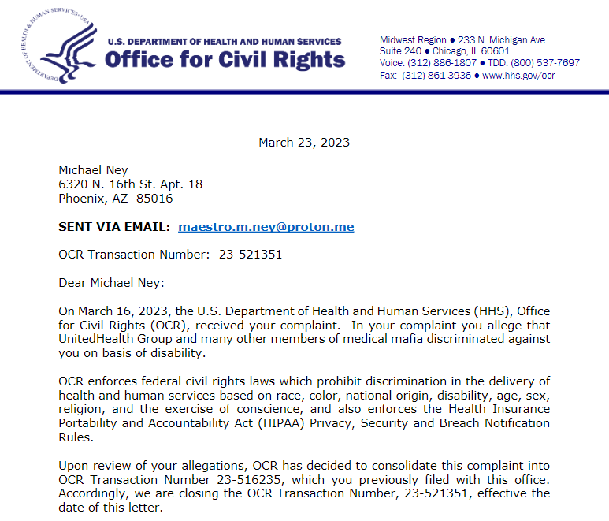
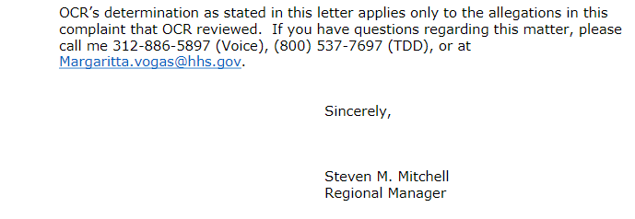

From Le-Yuen, Mai (CMS/CMCS)Mai.Le-Yuen@cms.hhs.gov
To Maestro.m.ney@proton.me<Maestro.M.Ney@proton.me>
CC Le-Yuen, Mai (CMS/CMCS)Mai.Le-Yuen@cms.hhs.gov
Friday, March 8th, 2024 at 10:29

Dear Michael Ney:

Thank you for contacting the Centers for Medicare & Medicaid Services (CMS) regarding a communication issue with your Medicaid health plan. CMS appreciates hearing your view on this issue. Your inquiry was referred to The Center for Medicaid and CHIP and we are pleased to respond.
[What “view”? What “inquiry”? What “pleased”? This disgusting language is intolerable.]

We understand from your email that due to health limitations; you cannot communicate via telephone. Your Medicaid health plan, United Healthcare, has not made communication accessible to you as they have not provided a method of communication that would allow for you to communicate with them. You would like this issue addressed. We asked Arizona Medicaid to address your concerns. Arizona Medicaid informed our office that they will reach out to United Healthcare about your concerns and will have United Healthcare work with you to resolve your concerns. If you do not receive communication from United Healthcare or Arizona Medicaid by the end of next week, please feel free to email me.

If you have other questions, please email me at mai.le-yuen@cms.hhs.gov.

Sincerely,

Mai Le-Yuen

***
support@subscriptions.cms.hhs.gov: host
mx.public.govdelivery.com[209.134.144.241] said: 550 5.1.1
<support@subscriptions.cms.hhs.gov>... User unknown (in reply to RCPT TO command)

I vehemently demand criminal prosecution of evil AHCCCS and evil UHC for refusing me all medical care. Cutie-pie language is not going to make a cut with me. Of course, CMS exits for the sole purpose of protecting medical mafia posing as humans and nothing would come out of it until I get a human lawyer who does not harass me with telephone. Thus, my complaints exist for the purpose of demonstrating consistency of my demand and UHC’ arrogant, criminal ignorance to everything I ever said. Nothing ever solved, not a single question ever answered.

Here is one of many very specific examples: the IRS notified me about ID theft requesting an immediate appointment. I contacted Edi.crd.ra@irs.gov 4 times: arrogant bullies would not schedule me an appointment: call or die. Who can possibly go after the illegal IRS?

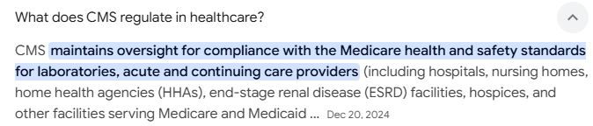

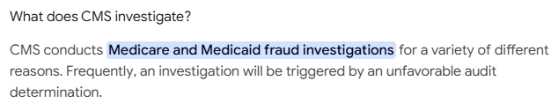
YOU ARE PERPETUAL LIARS.

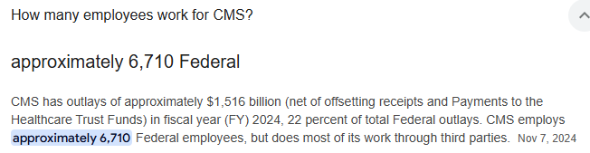

Aha, MAHA: 6,710 federal Employees with a 6-digit paycheck are sitting around doing nothing because they are outsourcing everything to third parties? Which parties – CCP?

https://www.meps.ahrq.gov/data_files/publications/st558/stat558.shtml?_gl=1*nl3ydd*_ga*MTk1NTQ0NDQ2LjE3NDA2ODgzNDQ.*_ga_1NPT56LE7J*MTc0MDY4ODM0NC4xLjEuMTc0MDY5MDA0OS4wLjAuMA..

 I am white non-Hispanic. In 2025, I am 70.

Yes, I saw such a queston and viewed it as insult: what are you going to do about it – donate me a car? I cannot even drive a car anymore: need only SUV – or else I would not be able to get out of it, and need hand control (and likely modified dashboard with bigger numbers and letters).

Same as above: what are you going to do aboit it – prescribe me a guilliotine?
Yu omitted a very principal issue: “diagnosed” means one is having and trusting a dotor vs. not having any doctor at all or absolutely distrusing their fake tests, analises or anyting at all. COVID fraud proved it for alll those who did not know that before.

9.1% if one has at lest 4 conditions. But what if one has 62 self-counted conditions vs. your phony “quality” care and without any doctors (no exaggerations here, I am really all broken apart while don’t look disabled one bit, and all of this is because of CALL or DIE.)

***
This is classical government lie:
https://www.hhs.gov/civil-rights/for-providers/compliance-enforcement/agreements/cms/cms-bulletin/index.html
The Centers for Medicare & Medicaid Services Commits to Effective Communication for All Individuals with Disabilities in All of Its Programs
FOR IMMEDIATE RELEASE
Contact HHS Office for Civil Rights

“ALL INDIVIDUALS” – as long as they talk on the phone. TALK or DIE.

Etc. Etc. Etc. Everything is a lie and fraud and there is no way to survive without talking on the phone. It is our legal obligation to press criminal charges against UHC and return my money back x 100 times. But you will ignore it and continue on ramming electronics.

NAME THE LAW WHICH SAYS THAT IN ORDER TO GET MEDICAL CARE IN THE USA ONE MUST HAVE TELEPHONE AND OTHER DEVICES?

No such law exists. You are all in the business of genocide.

