The criminality and vicious discrimination against disabled by CMS (and everyone else) is mafia level.

https://www.cms.gov/about-cms/agency-information/aboutwebsite/cmsnondiscriminationnotice
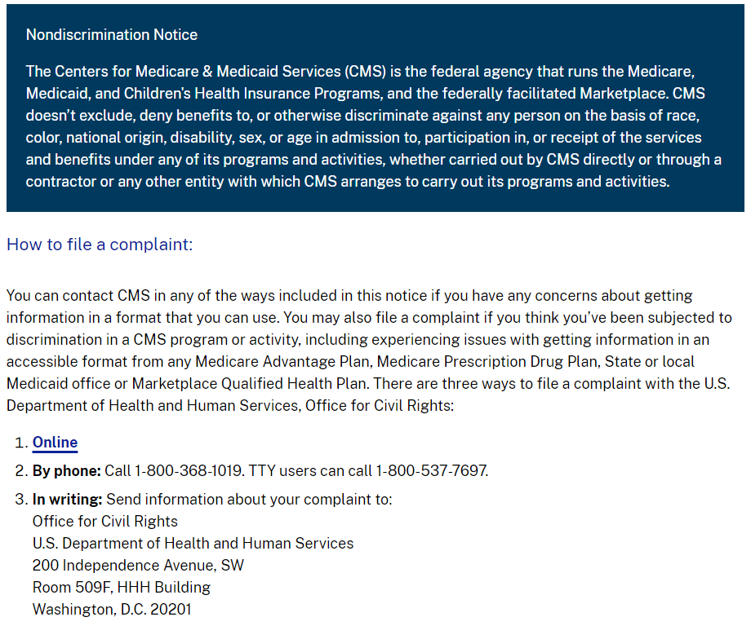

Fraud, fake email. As everywhere else: CALL or DIE.

If you prefer, you may submit a written complaint in your own format by either:

Mail to
Centralized Case Management Operations
U.S. Department of Health and Human Services
200 Independence Avenue, S.W.
Room 509F HHH Bldg.
Washington, D.C. 20201
Email to OCRComplaint@hhs.gov

I am explaining how this brazen fraud of card activation works:
[Written on the go from public library- and I am not a native speaker]

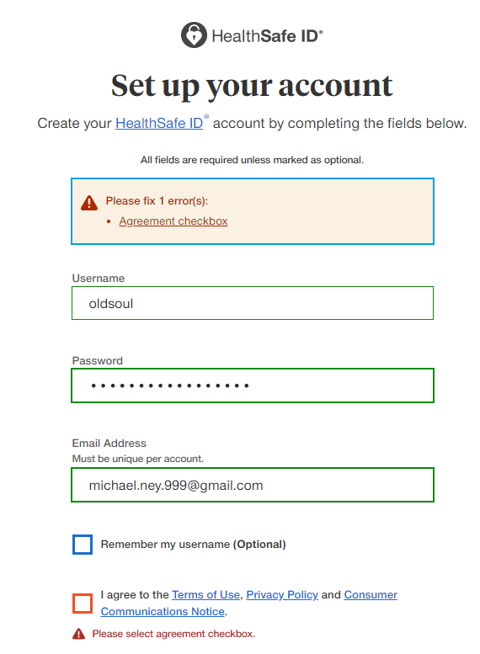
UHC sends a new card without any explanations of changes in the benefits and wants patients to activate it online. It does not work – ever. UHC wants everyone to calmly accept its satanic idea of sitting on hold forever and ever while being terrorized to death with sickening music (it is about ramming the vomit-inducing music from hell down everyone’s throat, to induce zombie-type condition, not because they are too busy.)

The arrogant feministic bullies then either disconnect for fun or talk outrageously fast to aggravate patients. Three years ago, My Dr. of Audiology confirmed my hearing problems (not to be confused with hard of hearing) and assured me that it could only get worse, which it does. I do not expect to talk on the phone for as long as I live (and losing ability to understand others in person), and any sadistic entity posing as a human while preventing me everything imaginable and unimaginable unless I talk on the phone should be treated as enemy combatant. UHC’s own “privacy” states that they must respond by email.

To activate the card, UHC wants patients to enter their personal data and then click on next. By doing so, a patient sees that he allegedly supposed to agree to Terms, Privacy and Communication Notice, but these links were not shown previously. Clicking on any of them removes me from the initial screen and in order to continue on activation I have to start over. Therefore, I had to enter all my data 4 times to copy UHC deplorable, disrespectful Nazi terms, which UHC never expected that anyone would do that. Thus, UHC wants patients to automatically agree to something nobody reads, which is coercion, a part of domestic terrorism. I said that UHC is legally provable band of terrorists.

But it gets worth: the mission is not accomplished, not everyone is a vaccinated cyborg who has home computer and Internet access. I don’t have it for over 20 years and use public computers. It means that I have no place to record this anti-human idea of making screennames and passwords on every website on the Internet – unless I will write it down in a notebook, which is ridiculous. This is why I never register anywhere on the face of earth and not a shred of legitimate info exists on me online.

Note this arrogant mind control: on one hand, it is “SAFE” ID, and on the other, “We may communicate protected health information with you via unencrypted methods.” (See below). No, dear, you may not. How is that UHC may write unprotected health-related email, but couldn’t write about anything else? How is that every corporation and office ramming social networks down everyone’s throats, but refusing direct email?

https://www.healthsafe-id.com/rt/register/ucard/en
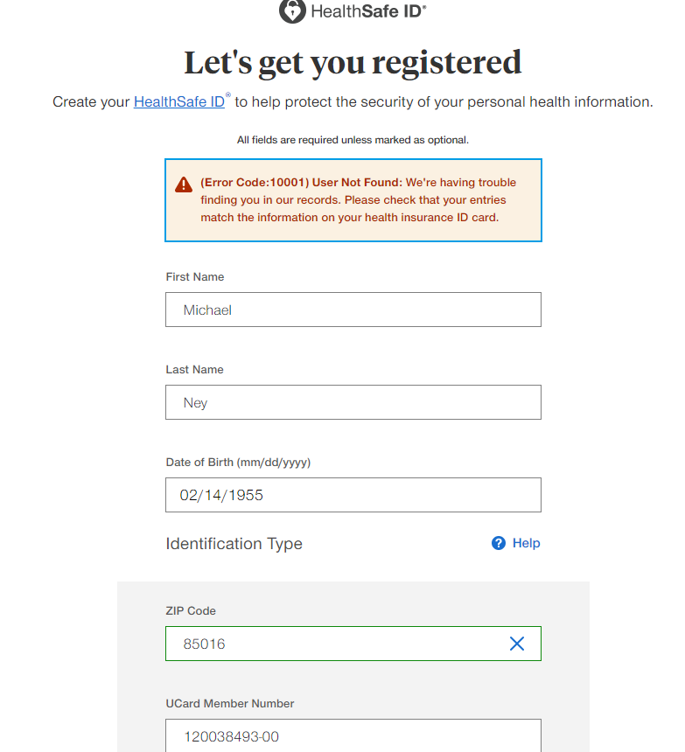

SEE MY CORRECT MEMBER #?
This fraud only intended for CALL or DIE: no other options. And it is not even run by AI yet!

This fraud tells me that I made a mistake: UHC never makes mistakes. And no way around it. In 2022 UHC offered an email in case of such problems, but it was fraud as usual: the email bounced off. Then UHC offered automatic activation over the telephone, which was OK as long as I don’t need to talk to anyone. As it is now obvious, the system did not work claiming that I made a mistake.

Before I filed my legal complaint with CMS marking it as an emergency (because I had to have food money and must visit doctors), I had other communications and stories in this regard, but CMS outdid them all: 6 weeks after filing my complaint, I blasted CMS for not responding. CMS calmly responded that it would combine two of my complaints into one. SEVEN months later, CMS, displaying its mafia-style criminality, sent me a letter saying that CMS does not feel like investigating the case despite there is nothing to investigate: I must communicate by email, that’s all there to it. One just cannot make it up: I can guarantee on record that if the doctor would shot a patient in the head for not being vaccinated (so that the doctor would miss his bloody money), CMS would say exactly the same: we only care to protect medical mafia and terrorize the entire US population with vaccination demand. Still, the complaints posted on the official Federal Agency websites would remain here forever. They are not entirely useless.
Note that UHC does not bother to include the date in the chat and that the chatter never answered to me why I was unable to activate it by myself. [The lengthy chat omitted here]
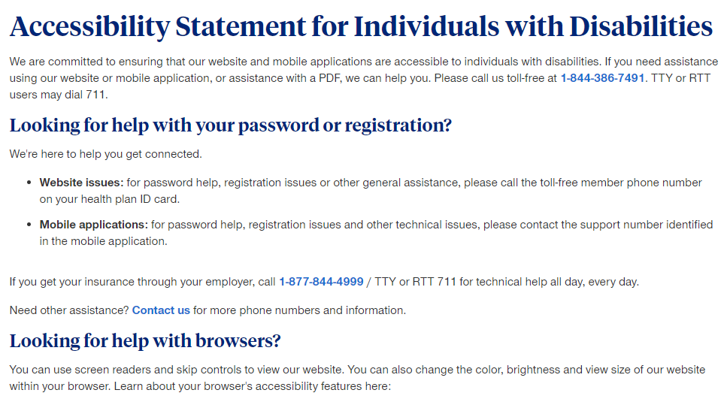
This band of criminal sadists does not allow email communication in this paragraph under mocking masquerade of “accessibility” – as if accommodation for disabled. Any and all disablities are accepted except one: CALL or DIE.

https://www.healthsafe-id.com/rt/register/communityplan/en/credentials
Consumer Communications Notice
I never agreed on it voluntarily. FRAUD VITIATES EVERYTHING. This fake Notice is null and void.

This Notice governs (a) electronic delivery of communications about existing benefits, programs, products, services, or tools and/or general health information via email, websites, and mobile applications (collectively, “Informational Electronic Communications”) and (b) informational calls and text messaging (“Informational Calls and Texts”), regarding the programs, products, or services that we make available to you.
Translation: either accept pathological spam and pay for delivery or die without medical insurance.

We reserve the right to modify this Notice at any time. The modified Notice will be effective immediately upon posting. Your continued receipt of Informational Electronic Communications and Informational Calls and Texts will constitute your acceptance of the modified Notice.
Translation: we are entrapping you in advance and we don’t care that you would not know when this fascist Notice is updated. Does not say anything how to get rid of it. How to stop this “informational” garbage? I reserve the right to curse the daylight out of scoundrels treating patients as unwashed slaves.

We may communicate protected health information with you via unencrypted methods. You acknowledge and accept that communications may be sent unencrypted and there is some risk of disclosure or interception of the contents of these communications.
Translation: I acknowledge that I absolutely do not accept this arrogant and indisputable criminality. Subverting HIPAA is criminal.

Any request to opt-out of receiving Informational Electronic Communications will be effective only after we have a reasonable period of time to process your request.
Translation: Opt-out by what means? How long does it take to press a “delete” button? How come the lawyers for UHC were not disbarred immediately due to this reason alone?
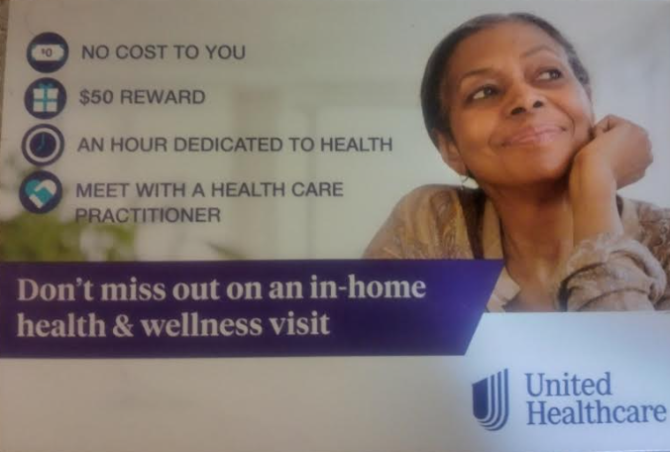

CMS: if you consider yourself humans, then answer this – what this smile represents? What kind of human emotion? I’ll help you out as a former theater director: NONE. All mailings from AHCCCS and UHC addressed to an educated white man sport smiling black women as unbeatable push to get vaccinated. I get “reward” for letting in some whore willing to sell her mother for body parts to brainwash me with vaccination, for which she will get paid.

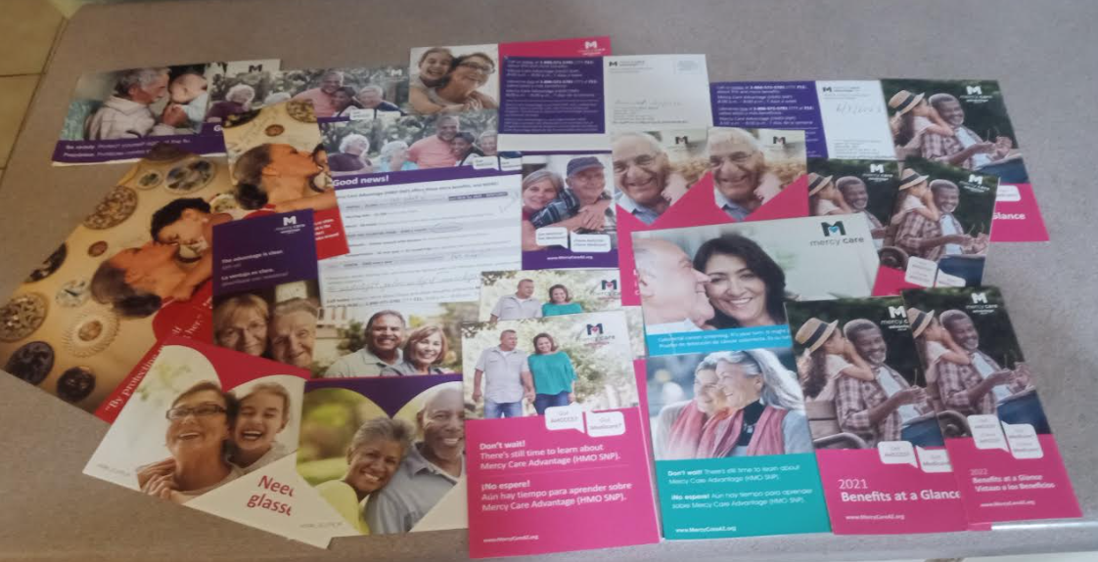

Get vaccinated, get vaccinated, get vaccinated, get vaccinated, get vaccinated, get vaccinated, get vaccinated, get vaccinated, get vaccinated, get vaccinated, get vaccinated, get vaccinated, get vaccinated, get vaccinated, get vaccinated, get vaccinated, get vaccinated, get vaccinated, get vaccinated, get vaccinated, get vaccinated, get vaccinated, get vaccinated, get vaccinated, get vaccinated, get vaccinated, get vaccinated, get vaccinated, get vaccinated, get vaccinated, get vaccinated, get vaccinated, get vaccinated …

I am disabled since birth, have every pulmonary disease you can name, one lung, and extremely vulnerable to respiratory illnesses. Never wore a mask and not vaccinated. Still breathing – how is that possible? [Hint: I don’t watch TV]
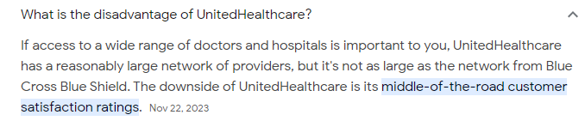
What customer service? Are there somebody even worse?

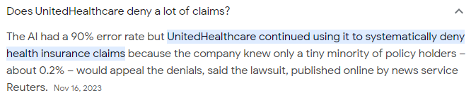
This band of criminal sadists harmed me very severely. I did appeal so I have first hand experience about this dog and pony show.

I asked UHC repatedly to help me get to PCPand doctors. They changed me 4 cards with deferent names of the doctors, but all from the same NOAH facility, which is intrested in two things only: get vaccinated and respect rainbow crowd. It is as if only this medical facility exists in the 5th largest city oin the USA. The list of doctors on UHC website is 100% fraud and I covered it extensively before.

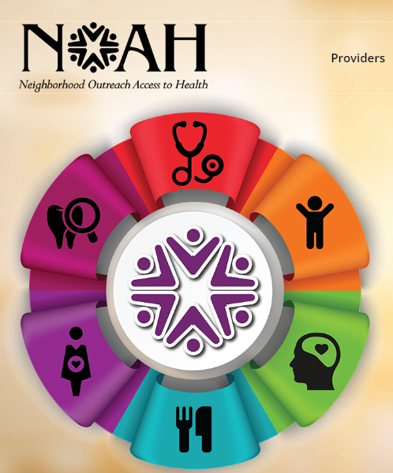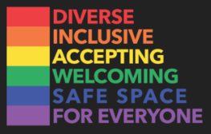
https://noahhelps.org/request-an-appointment/
CALL or DIE.

https://www.hhs.gov/about/agencies/hhs-agencies-and-offices/index.html
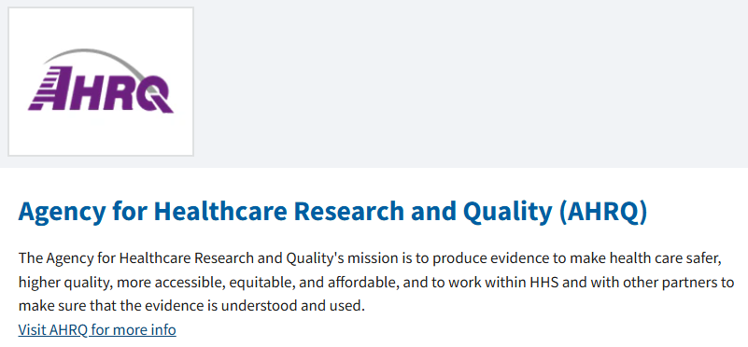

Lying scumbags. I corresponded with them, got absolutely nothing.

On all photos people are shown wearing masks – in February 2025.




To aid understanding of submitted responses, please prioritize clarity and conciseness and annotate your responses with question label(s) (for example, PC-1).

Sorry, I spent 7 hours in the library hungry, thirsty and suffering/embarrassed from going to restroom every so often due to stress (not age). Cannot make it presentable at this time. I am absolutely, categorically against more electronics and don’t have any at home – this is way too difficult for you to understand that 3% of Americans = 10 million people do not have telephones. If I had one, I would not be able to TALK anyway.

