Response to CMS/ASTP/ONC, HHS Request for Information (RFI) Health Technology Ecosystem [CMS-0042-NC] RIN 0938-AV68
This response to the HHS RFI CMS-0042-NC regarding Health Technology Ecosystem is specific to a health management application (defined in this RFI as a digital tool to support patients with health-decision making).
Problem(s) overcome by this health management app:
Deciding whether to use a clinical intervention often requires weighing the expected benefits against the expected harms. Quantifying the expected benefits and harms requires finding and interpreting the evidence specific to the clinical intervention and the patient’s characteristics. Individualizing the determination of balance of effects requires knowing the patient’s relative importance of each benefit and harm. Despite instantaneous decision support for complex decision making in other environments (such as traffic navigation), there is no such common solution for healthcare decisions.

Data inputs for this health management app:
- Data reflecting the condition of interest, either entered manually or imported from patient health data
- Data reflecting the quantitative estimates of effects of clinical interventions on important outcomes in patients with specific conditions, derived from systematic analysis of clinical research
- Data reflecting the relative importance of the outcomes, either entered individually for truly individualized decision support or as default values to reflect population preferences
Data outputs for this health management app:
- Quantified estimation of the net effect of clinical interventions in patients with specific conditions, adding the ‘relative benefits’ and subtracting the ‘relative harms’
- Representation of the net effect as a net benefit or net harm
- Quantification and representation of confidence intervals to reflect the likely range of possible net effect values, given the uncertainty in the evidence regarding effect estimates
- Listing of each outcome with its net effect contribution so users can see how the overall balance of benefits and harms is derived, and can modify inputs to evaluate changes in response to changes in relative importance of outcomes or baseline risk estimates
Response provided by:
Brian S. Alper, MD, MSPH, FAAFP, FAMIA, FGIN
CEO, Computable Publishing LLC
President, Scientific Knowledge Accelerator Foundation
For a brief background, to put this response in perspective, for 25 years (from 1995 to 2020) I followed a mission to provide the most useful support for healthcare decision-making described in detail at https://computablepublishing.com/mission. During that time, I founded, developed, and scaled DynaMed (https://www.dynamed.com/). DynaMed now employs hundreds of professionals to systematically monitor clinical research results and clinical practice guidelines and transform the content into point-of-care decision support used by millions of healthcare professionals.
In 2020, I realized the “most useful support” that I could provide shifted to the “precursor” stages of the evidence ecosystem to accelerate our knowledge development, so I changed my mission to enable standard-based machine-interpretable expression of knowledge, especially related to healthcare and scientific evidence.
I lead an effort within Health Level 7 International (HL7), the standards development organization behind Fast Healthcare Interoperability Resources (FHIR), to extend FHIR (the standard for health data exchange) to provide a standard for science data exchange. As described below, this “EBMonFHIR” project provides a standard that can enable the health management app described above.
PC-1. What health management applications would help you understand and manage your (or your loved ones) health needs, as well as the actions you should take?
As a patient or adviser to my loved ones, a health management application that would be most useful would be one that would present the management options for my situation, a quantifiable estimate of the benefits and harms for each management option, and allow me to specify the relative importance of the benefits and harms to quickly see the “net benefit” or “net harm” for each of the management options. Providing this is an easy-to-view format, understandable by patients with different degrees of numeracy and health literacy, would be ideal.
PC-3. Are you aware of health management applications that would be useful to Medicare beneficiaries and their caregivers?
For the health management application I described in PC-1, I am not aware of it existing today, but I am aware that both the technical standards and the technology are now available to create it and I would be happy to help produce or advise others in producing such an application.
PC-4a. What apps should exist but do not yet? Why do you believe they do not exist yet?
The application feature to provide quantifiable estimates of benefits and harms of health management options has had limited feasibility, reproducibility, and scalability because there has not been a machine-interpretable, interoperable form for the expression of medical evidence (e.g. the likelihood and magnitude of changes in outcomes resulting from interventions).
This problem is now solved within the Fast Healthcare Interoperability Resources (FHIR) standard that is already used by CMS for health data exchange. Since 2018, a Health Level 7 International (HL7, the standards developing organization that maintains FHIR) project to extend FHIR to Evidence-Based Medicine knowledge assets (“EBMonFHIR”) has extended FHIR to be used for science data exchange. For example, a FHIR Evidence Resource provides a standard form to represent:
- what the evidence is about (e.g. the effect on mortality comparing a treatment with a placebo in a specific population),
- the statistical findings for that evidence (e.g. a relative risk reduction of 5% with 95% confidence interval ranging from 10% risk reduction to 2% risk increase, or an absolute risk reduction of 10 fewer deaths per 1,000 people with 95% confidence interval ranging from 20 fewer deaths per 1,000 people to 4 more deaths per 1,000 people), and
- the certainty of the evidence (e.g. low certainty due to limitations in study design and wide confidence intervals).
The Evidence Based Medicine on FHIR Implementation Guide (available at https://build.fhir.org/ig/HL7/ebm) covers many aspects of science data exchange. It starts with:
“Welcome to the EBMonFHIR Implementation Guide!
The FHIR Resources for Evidence Based Medicine Knowledge Assets ('EBMonFHIR') Implementation Guide defines profiles and value sets for the representation of scientific knowledge. This implementation guide is intended for developers of systems using FHIR for data exchange of scientific knowledge and for authors of more specialized implementation guides in this domain.
This implementation guide covers the broad scope of representation of scientific knowledge, including (1) citations to represent identification, location, classification, and attribution for knowledge artifacts; (2) components of research study design including study eligibility criteria (cohort definitions) and endpoint analysis plans; (3) research results including the statistic findings, definition of variables for which those findings apply, and the certainty of these findings; (4) assessments of research results; (5) aggregation and synthesis of research results; (6) judgments regarding evidence syntheses and contextual factors related to recommendations; (7) recommendations; and (8) compositions of combinations of these types of knowledge. The types of interoperability covered include syntactic (Resource StructureDefinitions) and semantic (value sets).”

The application feature to provide an individualized net effect (a net benefit or net harm determined by adjusting the effect estimates across outcomes for the individual’s relative importance of these outcomes) has had limited feasibility, reproducibility, and scalability because there was no peer-reviewed, accepted method to combine the effect estimates and relative importance ratings.
This problem is now solved with the publication of “Defining certainty of net benefit: a GRADE concept paper ” at https://bmjopen.bmj.com/content/9/6/e027445.
The EBMonFHIR Implementation Guide includes multiple structures to support this concept, and an example showing a net benefit for bariatric surgery (https://fevir.net/resources/Composition/104383) has been demonstrated:
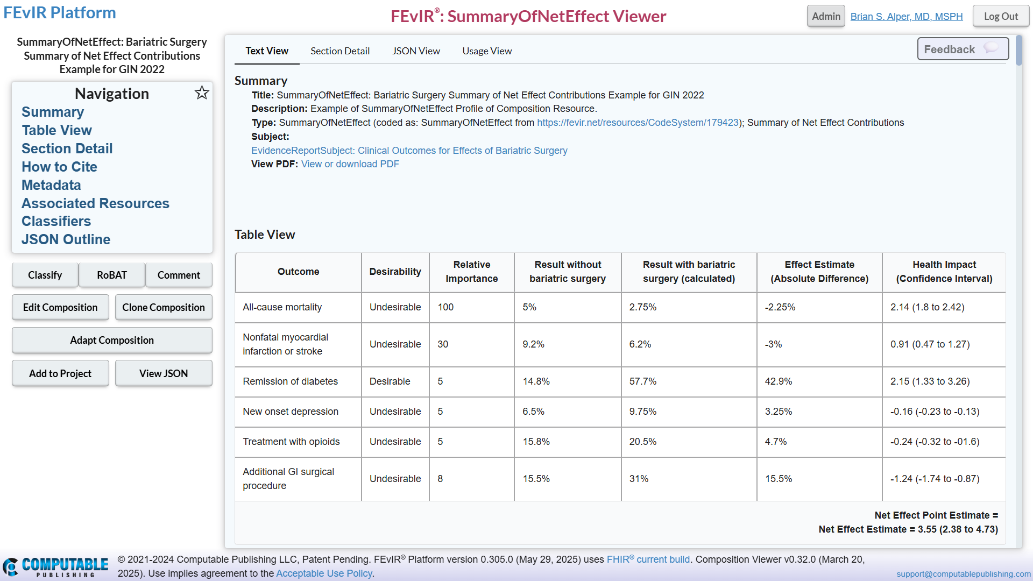

PC-5. What can CMS and its partners do to encourage patient and caregiver interest in these digital health products?
PC-5a. What role, if any, should CMS have in reviewing or approving digital health products on the basis of their efficacy, quality or impact or both on health outcomes (not approving in the sense of a coverage determination)? What criteria should be used if there is a review process?
The application described above could be developed as a commercial activity. I have previously developed and scaled clinical decision support applications, and I would be open to work with others who are interested in such commercial development.
If this were developed as commercial technology and CMS and its partners were anticipating involvement in the review and approval of such technology, then I would encourage CMS and its partners to get involved at the standards development portion of the process (through open HL7 meetings) as the technical standards will have considerable impact on most aspects of review and approval of the technology.
If CMS and its partners anticipate paying for such health care applications, it could be more cost-effective to commission its development. I could be willing to provide such development at cost, through for-profit or non-profit entities, as a means of serving the greater good.

