Public Comment on CMS-2025-0050
Submitted by MedStartr, Inc.
June 16, 2025
We thank CMS and its partners for the opportunity to respond to RFI CMS-2025-0050. This RFI represents an important step toward building a more connected, patient-centered, and innovation-ready healthcare system. MedStartr is pleased to offer our experience and suggestions in the spirit of partnership and shared purpose.

1. Executive Summary
At MedStartr, we believe the path to better care lies not just in new ideas—but in the partners and ecosystems that help them flourish. We respectfully propose a framework that CMS can support and extend to create a sustainable infrastructure for the ideation, validation, integration, and adoption of healthcare innovations. This comment outlines a pragmatic, tested model for CMS to consider, informed by over 17 years of our work iterating and enabling healthcare innovation ecosystems.

2. The Problem:

2.1 A System That Kills Good Ideas
Healthcare innovators consistently face structural barriers that prevent even the most promising solutions from scaling sustainably to produce the promised benefits. In our experience, there exist major barriers not just in the Pilot stage, but also in the growth and scaling stages.

2.2 Inhibition of Investment in Innovations that Solve CMS Problems
The failure of a large proportion of Healthcare innovation inhibits investment due to uncertainty of scale and exits for investors which reduces the influx of private sector capital in solutions that provide intrinsic value to satisfy government goals such as those noted in the RFI.

2.3 A Lack of a National Healthcare Innovation Adoption and Investment Ecosystem
While myriad programs to improve the American healthcare system have been tried, the outcomes and costs have not improved. Programs such as CMMI grants, Blue Button, Regulatory frameworks, thematic initiatives like the Quarduple Aim, NYCEDC’s Health Tech Pilot Program, ONC’s Crowds Care 4 Cancer (2012) and myriad others produced significant impact resulting in an explosion of growth in the healthcare innovation sector, they have failed to drive impactful systemic change. Many of the solutions that would have had the greatest impact did not make it into wide adoption (Mymee), were privatized into incumbent organizations thus reducing their impact (Flatiron Health), were provided contracts that were cost negative resulting in their bankruptcy (Babylon), or forced into a fire sale by the government (Patients Like Me). Without a well supported CMS Innovation Validation, Selection, Acceleration, Contracting and Onboarding framework, the American Healthcare System has not been able to evolve as it has in other countries that are seeing improved outcomes at reduced costs.

3. The Solution: A National Healthcare Innovation Framework to Evolve Healthcare Faster
We propose the development of an infrastructure for an ecosystem that solves the problems above. Such a system would develop a national network of accelerators and local ecosystems to foster innovation. We advise finding local and national organizations to partner with and creating a collaborative infrastructure to validate, accelerate, Coordinate and ultimately integrate hundreds of new ideas into government health programs.
In preparation for this response we fed the RFI responses into our AI Agent and it summarized and prioritized many innovative ideas. There is no lack of innovation, as you can also easily see, but the selection and adoption of the best solutions is challenging, as is assisting the innovators in building solutions that are sustainable and satisfy CMS needs.
In the first crowd challenge we ever ran, in 2012 and ending at Healthdatapalooza in 2013 we ran our Crowds Care for Cancer for ONC/ HHS. The winner was a new idea from a medical resident at UCSF named Michelle Longmire, MD. That $25,000 grant was the first funding for her company that became Medable, which has since been one of the greatest innovations in healthcare. Dozens of other companies have since been validated by the MedStartr Crowd Challenge Model and gone on to transform care, although many that were well-supported by the community failed to be widely adopted due to the aforementioned attributes of the American healthcare system.
In 2015 we ran the stats on the first 2,644 companies that applied to use the MedStartr Crowdfunding and Crowdchallenge platforms and it showed that if we have been investing it would have produced trple digit returns pr year. So in 2017 we began investing in the winners of our crowd challenges. The model proved accurate and we have since become one of the highest performing accelerators as a result. This is not just due to our crowd-validation algorithms and AI agents, but our acceleration and support programs to drive adoption and sustainable growth from ideation to integration. We have created a complete system to Validate, Accelerate (three stages), Coordinate and Integrate new ideas into the healthcare system to help it evolve faster. This would not be possible without the help of one of the largest healthcare innovation ecosystems we built by running over 1,272 events in 42 cities and with over 1,200 MedStartr Mentors and an Aligned Investor Network.
The Composition of the Ecosystem Matters: Patients Come First
While it may seem that such an ecosystem would only include healthcare orgainizations, we have always put Patients first. With Patient activist leaders like Regina Holliday, Christine Von Raesfeld, Grace Cordovano and hundreds more actively engaged in our selection process and brining in millions more, patients far outnumber Providers, hospital leaders, and partners in our voting process. No, they can not offer to do Pilots or Partnerships like leaders at large organizations do, but once patients get behind an idea, usually Providers come next. After a number of care providers (Doctors, Nurses, PT, OT,…) support an idea, usually pilots and partners get on board. Once all stakeholders are aligned, companies are 22 times more likely to be successful in the marketplace in our experience.
Not Just MedStartr
While we are confident we can help create and run such a national program, we believe it will work best by creating a collaborative infrastructure not just for our organization but for many aligned organizations. Programs like Together.Health, Scale Health, CancerX, and so many more can be enabled with a simple framework for selection, investment, acceleration, and preparation for adoption of new ideas that satisfy CMS goals.
In short, we propose a series of programs to adopt solutions that are crowdsourced, crowd validated, ecosystem supported, well contracted and CMS adopted. Funding would come from both private and public sources. Knowing that companies would be supported by CMS and our government to drive systemic change quickly and sustainably would also increase investment in the sector and help Americans live longer, better lives with reduced costs of care.

4. Our Proposal to CMS
We invite CMS to consider supporting a national framework that:
- Uses open challenges and ALL stakeholder engagement to source innovative care models suited to CMS Goals
- Validates them through real-world feedback, partnerships, pilot data, Founder Psychometrics, and predictive AI
- Accelerates Crowd-Validated teams through Acceleration Partners
- Enables Investment in Innovations by Aligned Public and Private Parties
- Integrates validated solutions into payment pathways and CMS delivery systems
- Fosters sustainable adoption with aligned funding, training, and measurement infrastructure
CMS can plug into existing programs like MedStartr has created, co-develop new programs, or launch new collaborative efforts with trusted partners. We welcome the opportunity to help design or support pilots aligned to CMS’s equity, trust, and patient-centered goals.

5. Conclusion
We stand ready to collaborate in building the future of care. Our goal is to ensure that CMS and its stakeholders can continue to discover and deliver the best ideas—faster, safer, and with lasting impact. We thank you again for the opportunity to comment and are happy to offer additional data, case studies, or support upon request.

Thank you for this initiative. We look forward to helping in any way we can.

Additional Information:
- Three Sample MedStartr Crowd Validated Companies: Mymee, Medable, DocGraph
- Case Study: MedStartr CrowdChallenge for the American Medical Association
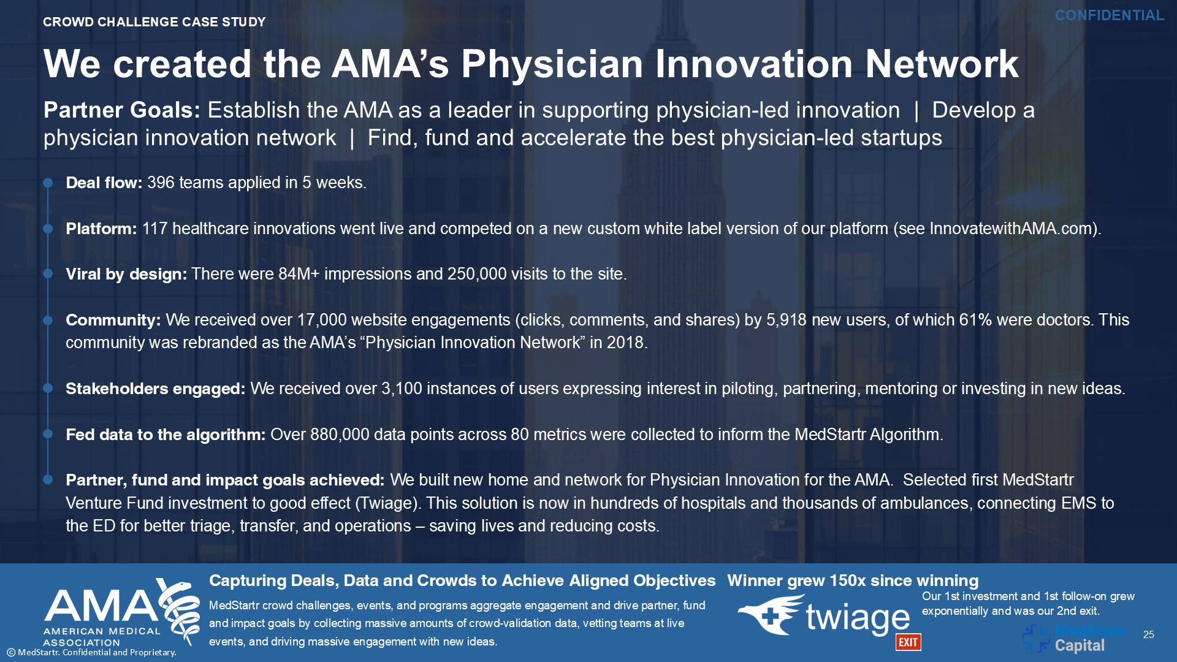

- The MedStartr Crowd
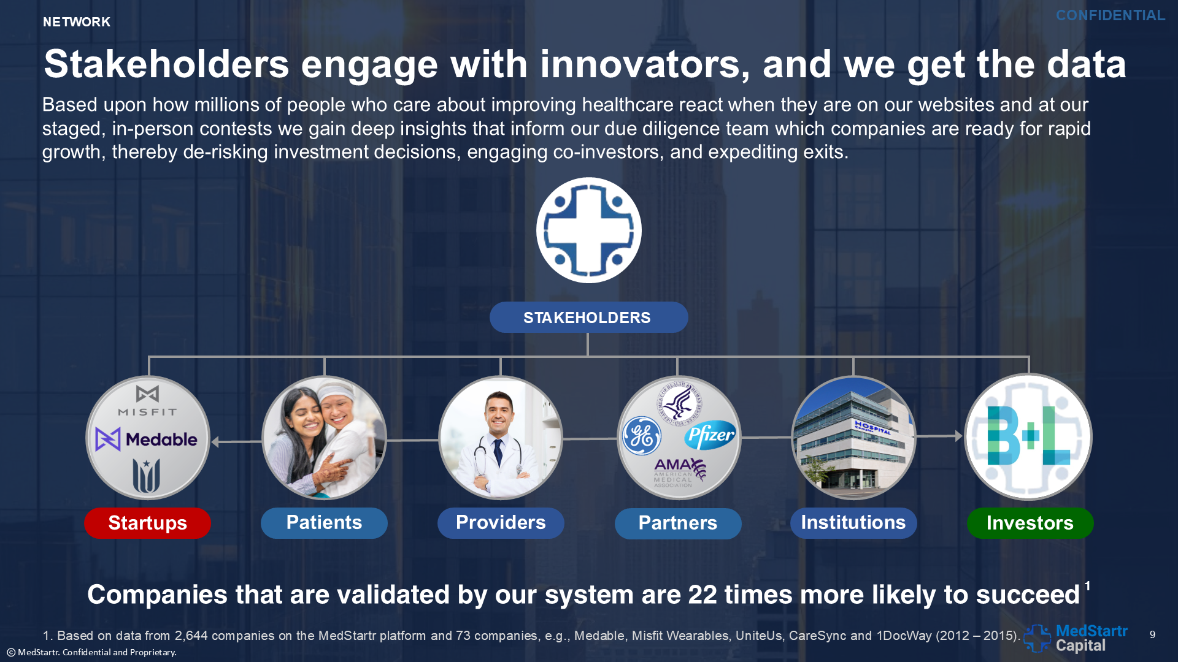
- Sample Grand Challenge: https://medstartr.com/pages/nolahichallenge19
- Next Grand Challenge: National Crowd Challenge 2025: Launching 6/20/2025 at https://medstartr.com/pages/NCC2025

