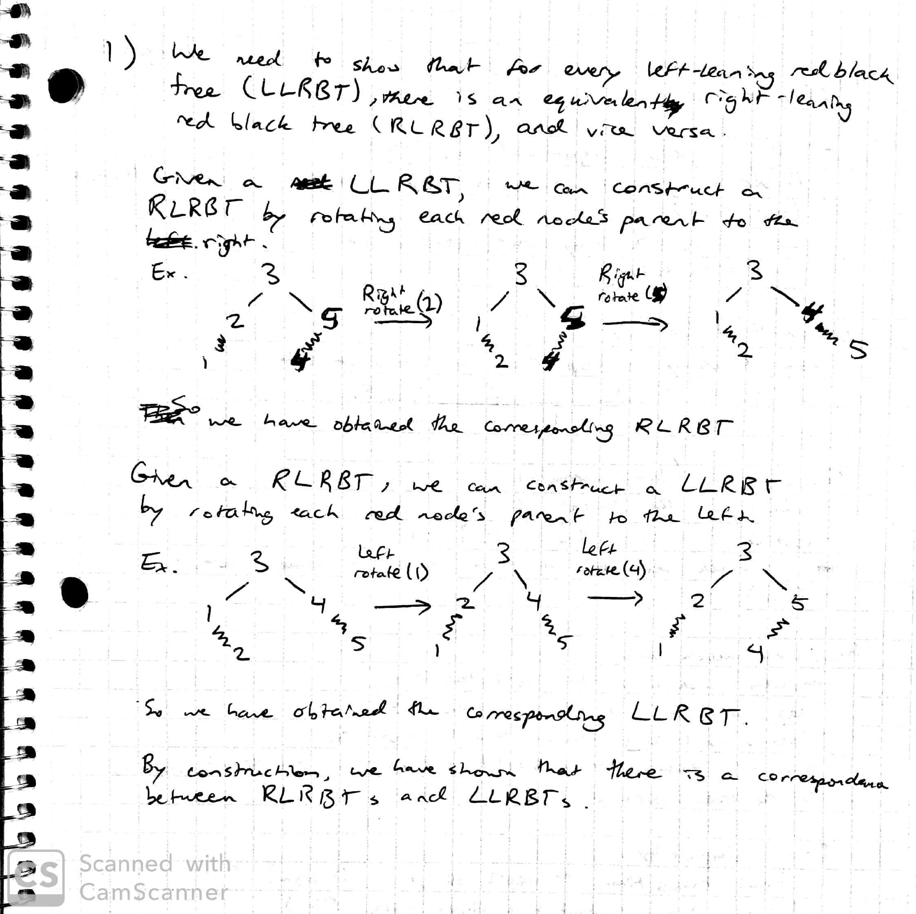

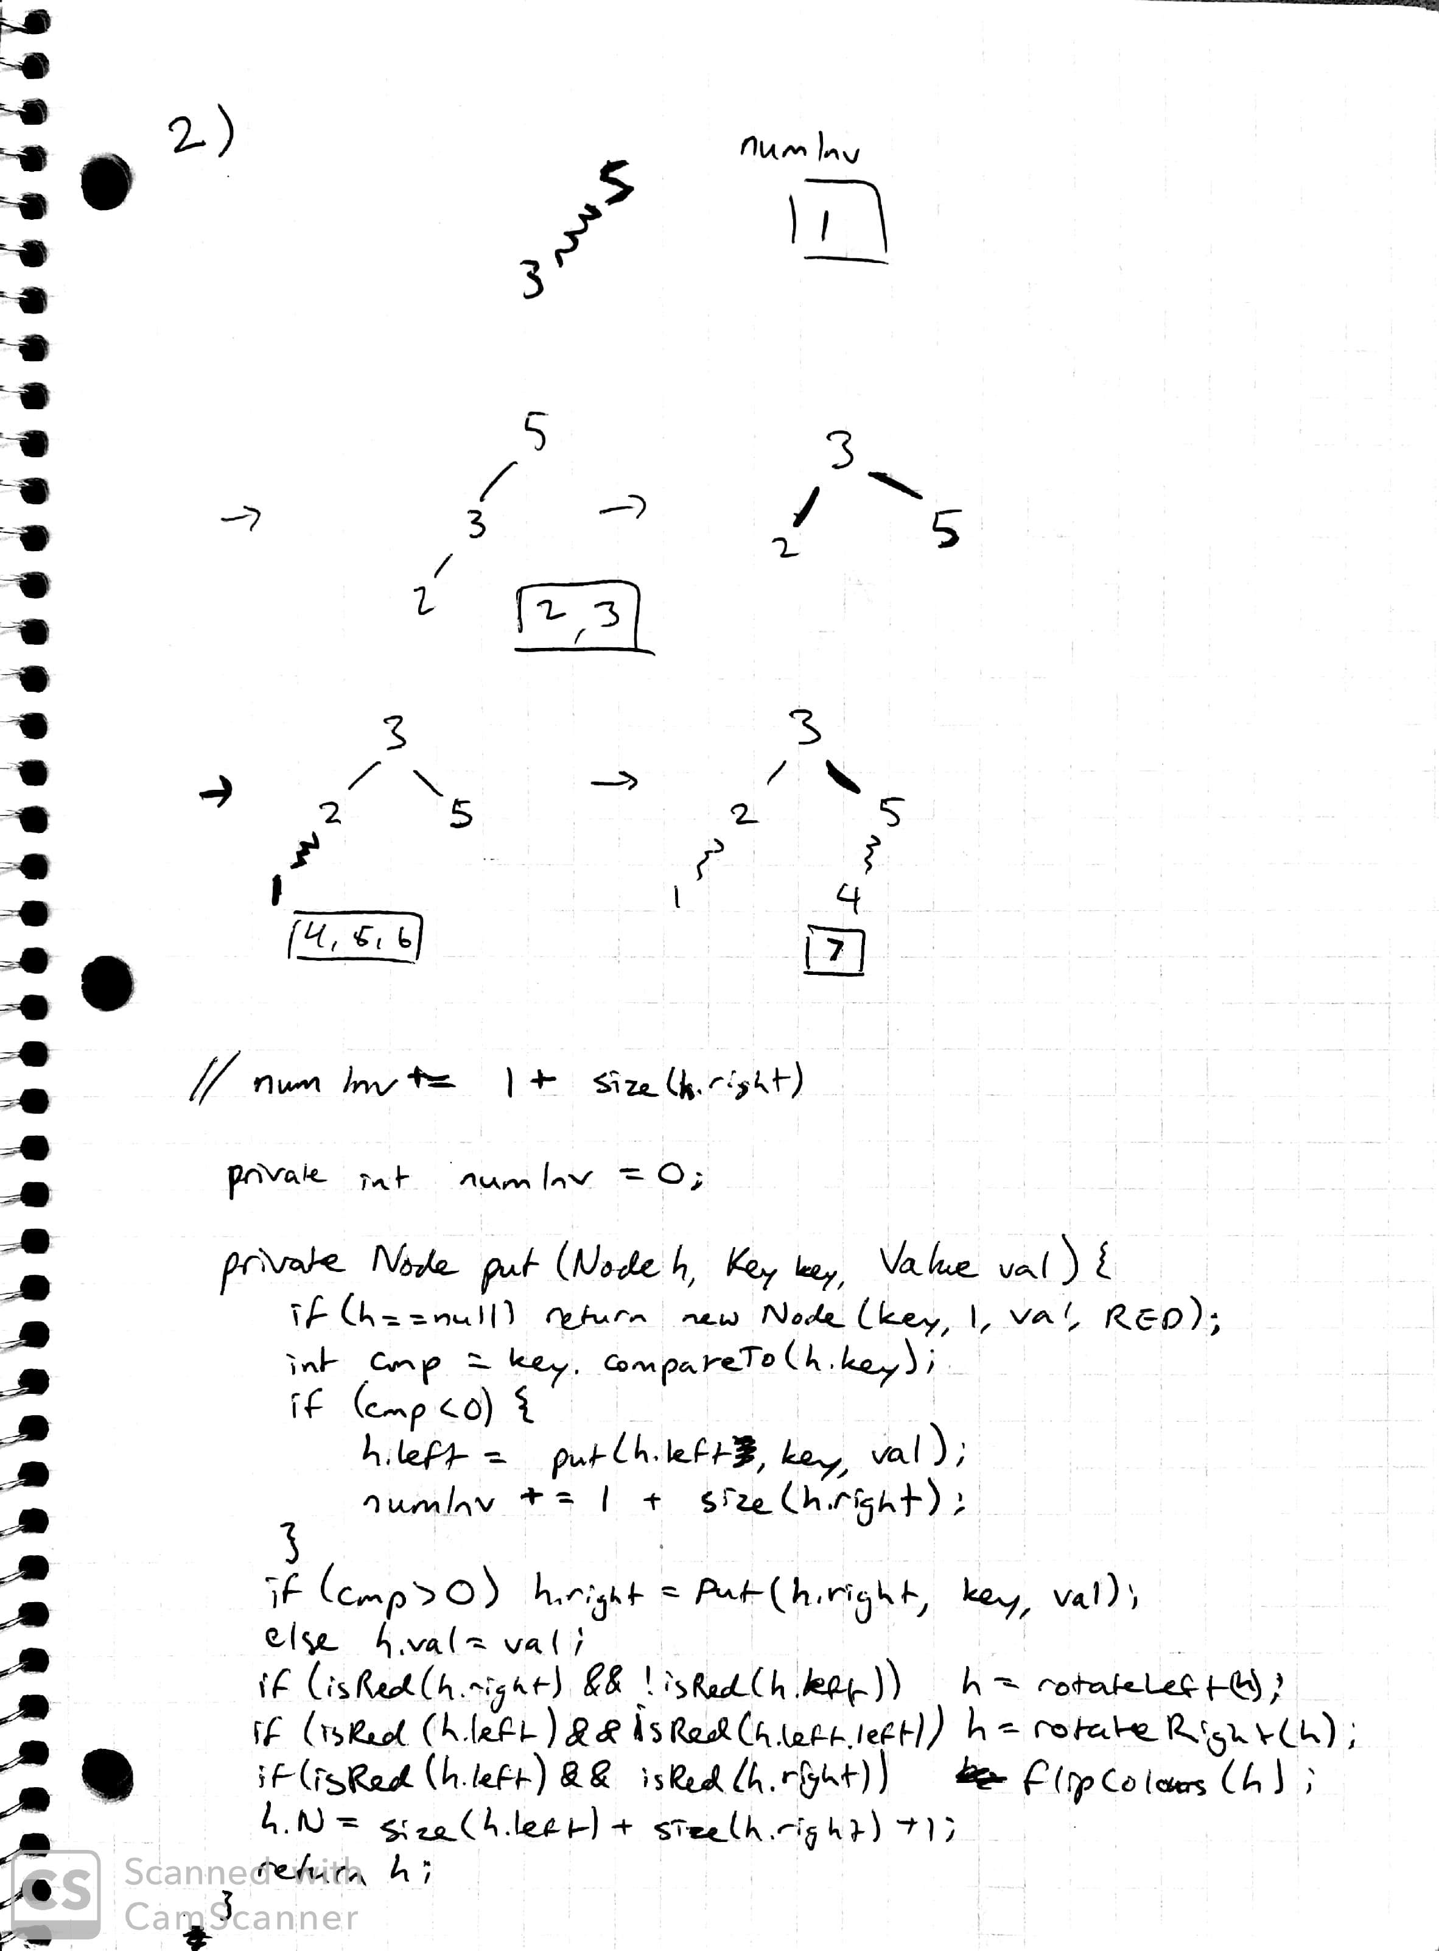

By updating the put method to increment the inverse counter by (1 + size(h.right)), we are able to use left leaning red black trees to count the number of inverses in a set. This works because as we add node x to the tree, we only recurse left if x < h (the comparison node). From this, we see that x comes after h in the set, but x < h. Also, x < h.right. Due to this, we add to the counter: 1 (as x < h) + size(h.right) (as x < h.right).

