Arellano university

Jose abad santos campus

College clinic medical records

**Names :**

**Casiano Dennis**

**Endaya Catherine A.**

**Laroya Mark Lester**

**Add / Save**

**name = txtname.getText();**

**timein = txtin.getText();**

**timeout = txtout.getText();**

**purpose = txtpurpose.getText();**

**course = txtcourse.getText();**

**year = txtyear.getText();**

**medicine= txtmedicine.getText();**

**String data[] = { txtname.getText(),txtin.getText(),txtout.getText(),txtcourse.getText(),txtyear.getText(),txtmedicine.getText(),txtpurpose.getText()};**

**try {**

**Class.forName("com.mysql.jdbc.Driver");**

**con = DriverManager.getConnection("jdbc:mysql://localhost/clinic","root","");**

**pst = con.prepareStatement("Insert into college values(?,?,?,?,?,?,?,?)");**

**pst.setString(1, name);**

**pst.setString(2, timein);**

**pst.setString(3, timeout);**

**pst.setString(4, course);**

**pst.setString(5, year);**

**pst.setString(6, medicine);**

**pst.setString(7, purpose);**

**int Id = Integer.parseInt(ID.getText());**

**pst.setInt(8,Id);**

**pst.executeUpdate();**

**JOptionPane.showMessageDialog(null, "Record Added");**

**DefaultTableModel t1 = (DefaultTableModel) table.getModel();**

**t1.addRow(data);**

**} catch (SQLException ex) {**

**Logger.getLogger(College.class.getName()).log(Level.SEVERE, null, ex);**

**} catch (ClassNotFoundException ex) {**

**Logger.getLogger(College.class.getName()).log(Level.SEVERE, null, ex);**

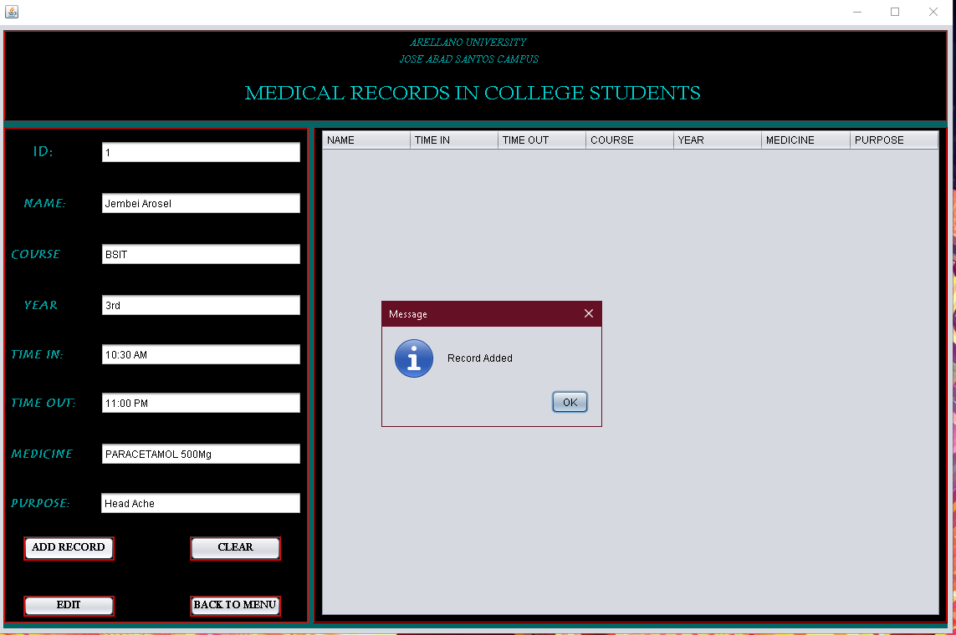

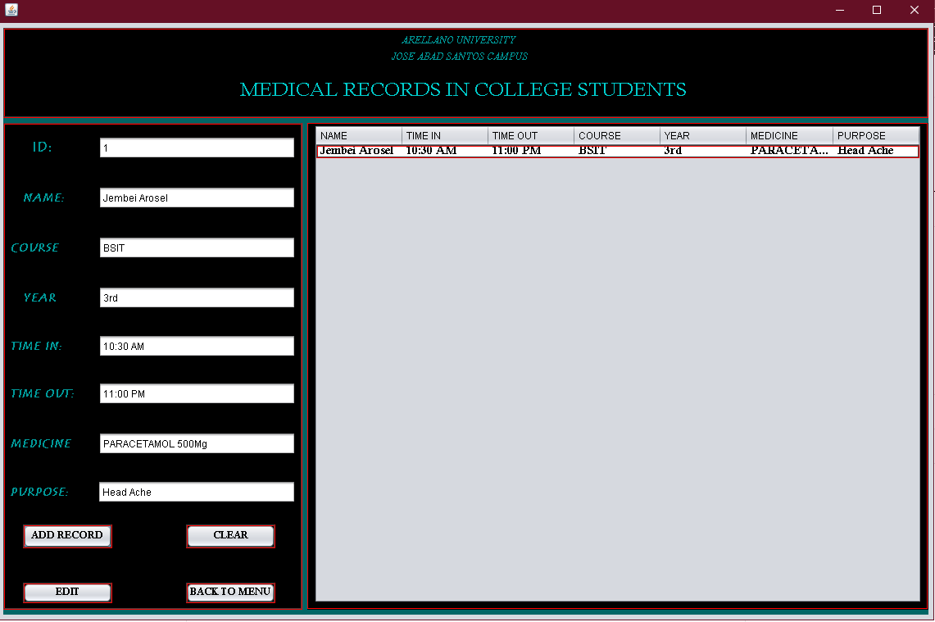

**Update:**

String name,timein,timeout,department,course,year,medicine,purpose;

DefaultTableModel model = (DefaultTableModel) tab.getModel();

int SelectedIndex = tab.getSelectedRow();

int id = Integer.parseInt(model.getValueAt(SelectedIndex, 0).toString());

name = txtname.getText();

timein = txtin.getText();

timeout = txtout.getText();

course = txtcourse.getText();

year = txtyear.getText();

medicine = txtmed.getText();

purpose = txtpurpose.getText();

try {

Class.forName("com.mysql.jdbc.Driver");

con = DriverManager.getConnection("jdbc:mysql://localhost/clinic","root","");

pst = con.prepareStatement("update college set Name=?, Timein=?, Timeout=?, Course=?, Year=?, Medicine=?, Purpose=?where ID=?");

pst.setString(1, name);

pst.setString(2, timein);

pst.setString(3, timeout);

pst.setString(4, course);

pst.setString(5, year);

pst.setString(6, medicine);

pst.setString(7, purpose);

pst.setInt(8, id);

pst.executeUpdate();

JOptionPane.showMessageDialog(null,"Record Updated");

cg();

} catch (SQLException ex) {

Logger.getLogger(college2.class.getName()).log(Level.SEVERE, null, ex);

} catch (ClassNotFoundException ex) {

Logger.getLogger(college2.class.getName()).log(Level.SEVERE, null, ex);

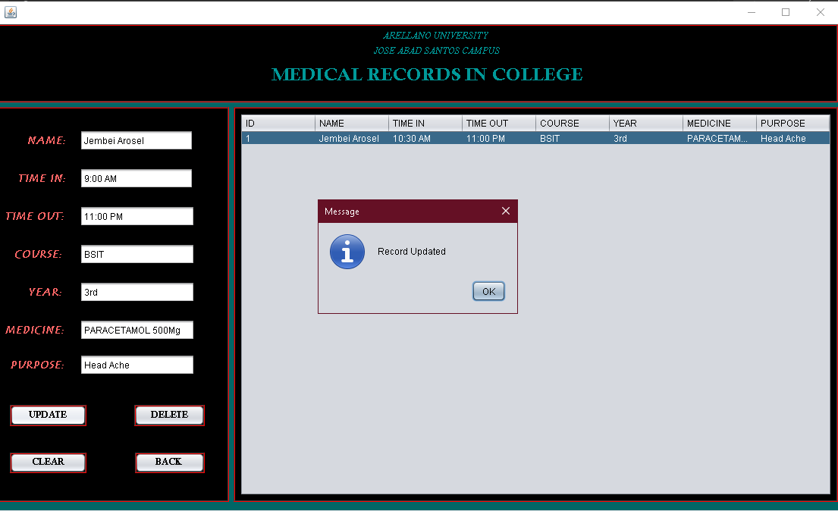 }

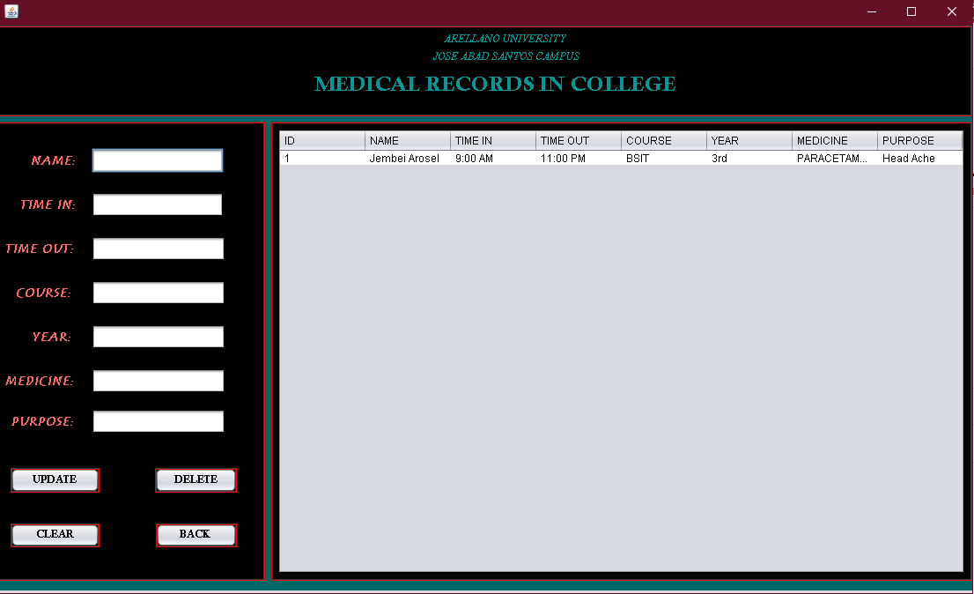

**Delete :**

DefaultTableModel model = (DefaultTableModel) tab.getModel();

int SelectedIndex = tab.getSelectedRow();

int id = Integer.parseInt(model.getValueAt(SelectedIndex, 0).toString());

if (JOptionPane.showConfirmDialog(null, "Are you sure?", "WARNING",

JOptionPane.YES_NO_OPTION) == JOptionPane.YES_OPTION) {

try {

Class.forName("com.mysql.jdbc.Driver");

con = DriverManager.getConnection("jdbc:mysql://localhost/clinic","root","");

pst = con.prepareStatement("delete from college where ID = ?");

pst.setInt(1, id);

pst.executeUpdate();

JOptionPane.showMessageDialog(null,"Record Deleted");

txtname.setText(null);

txtin.setText(null);

txtout.setText(null);

txtpurpose.setText(null);

txtmed.setText(null);

txtcourse.setText(null);

txtyear.setText(null);

txtname.requestFocus();

} catch (ClassNotFoundException ex) {

Logger.getLogger(college2.class.getName()).log(Level.SEVERE, null, ex);

} catch (SQLException ex) {

Logger.getLogger(college2.class.getName()).log(Level.SEVERE, null, ex);

}

}

