13

Designing drawing content
Draw and Impress share a set of graphic editing tools. These tools are partly reproduced in the Drawing tool bar of other applications. Like stand-alone graphic editors as Inkscape, these tools work with vector graphics, which are formats stored mathematically and which therefore can be expanded to any size.
However, you can also import bitmap formats such as .jpeg and .png, which store information as pixels, from editors like GIMP.
Despite their names, Draw and Impress are not meant to be a complete set of tools for editing graphics. Designers have done professional works in Draw, but mainly it is intended for diagrams and simple pictures. Flow charts, architectural layouts, construction plans, organizational charts, circuit diagrams, icons – these are the sorts of documents
that Draw, Impress, and the Drawing tool bar are meant to handle.
You can also import graphics prepared in another application, and do simple layout. However, if you want to draw or edit an image, programs like Inkscape or Krita have more tools.

Learning design principles
Diagrams and layout have fewer limits to their design than a page of text or even a spreadsheet. For this reason, you can work with them better if you know some basics of design.
Whole books are written about design, and perfecting your expertise can be a life-long study. However, the best starting points I have ever seen are the four principles that Robin Williams uses in her books. See Appendix B, “Error: Reference source not found,” page Error: Reference source not found.
Each principle helps to guide readers through the document, but their use remains contextual. In some situations, using more than one principle at once can strengthen the design, but in others they can work against each other. Sometimes, too, one principle may be strong enough that you can ignore other ones.
Williams’ four principles are:
- Alignment: Shows whether elements are or are not connected by their alignment. For example, list items have a common alignment, while the return address is the only part of the letter to
- have a right alignment because it is unconnected to the rest of the letter.
- Contrast: Emphasizes differences between elements on a page by design differences. For example, use a different, larger font for headings than for body text, or a background color for a side bar in a financial report that is different from the background for the body text.
- Proximity: Groups items that are related to each other together. For example, a document’s title and author might appear in the same header or footer. By comparison, word count and the author’s name do not belong in the same header or footer unless you have no other place to put them.
- Repetition: Unifies the document by repeating design elements. For example, if you use a particular shade of blue for the headings, use the same blue as a background for table headers and for a line that separates the header from the text.
These principles can be thought of as the tactics of design. To them, I would add several strategic guidelines. These guidelines are partly a matter of typographic standard practices, and partly a reflection of current design trends that show no signs of disappearing any time soon.
These strategic principles are:
- A simple design is preferable to a complicated one.
- If you don’t have a reason for a design element, delete it. Replace it with the simplest possible alternative. Sometimes, you may not need to replace it at all.
- Layout that calls attention to itself is bad layout. Design enhances documents. It is not an end in itself.
- Modern design favors the asymmetrical rather the balanced design. This strategy directly contradicts most beginners’ instinct, which is to always create a symmetrical design.
There is much more to design than these brief comments. But learn to apply these ideas, and you will be thinking like a designer.
- Example: applying design
To help make Williams’ four principles more concrete, here are four illustrations based on the designing of business cards, showing a card before and after a principle was applied.
The After cards, while not necessarily the best of all possible designs, are at least noticeable improvements over the Before cards.
(Photo credit: Nathan Wilson, “Tagwa”)

Alignment
Before | 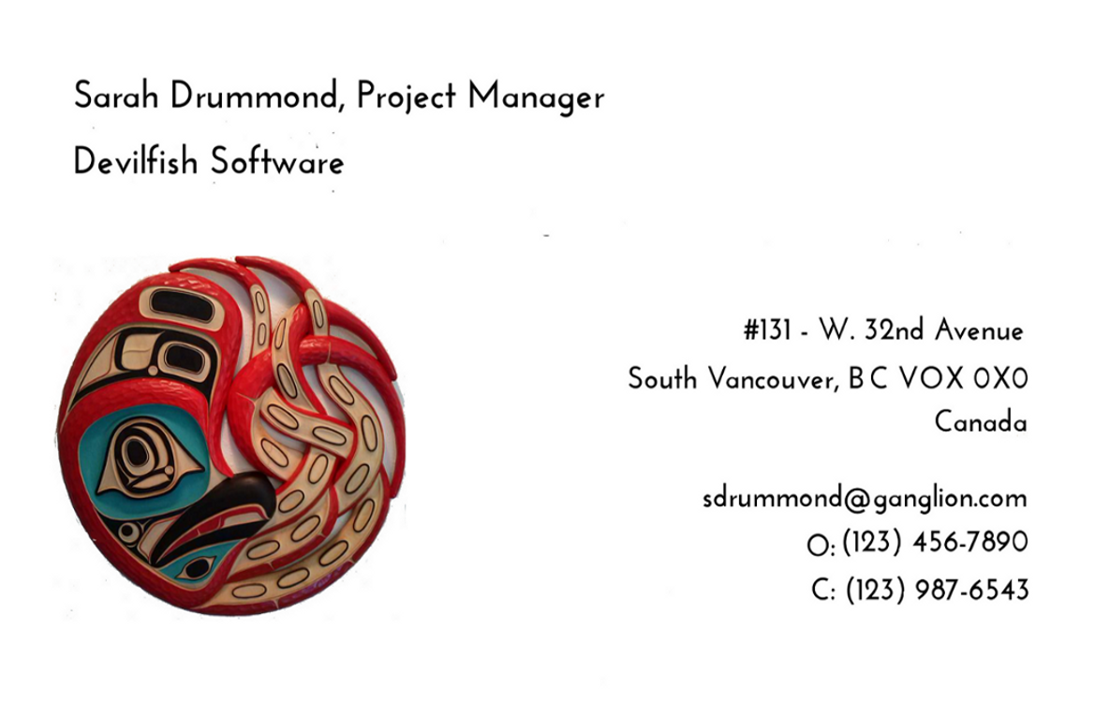
After | 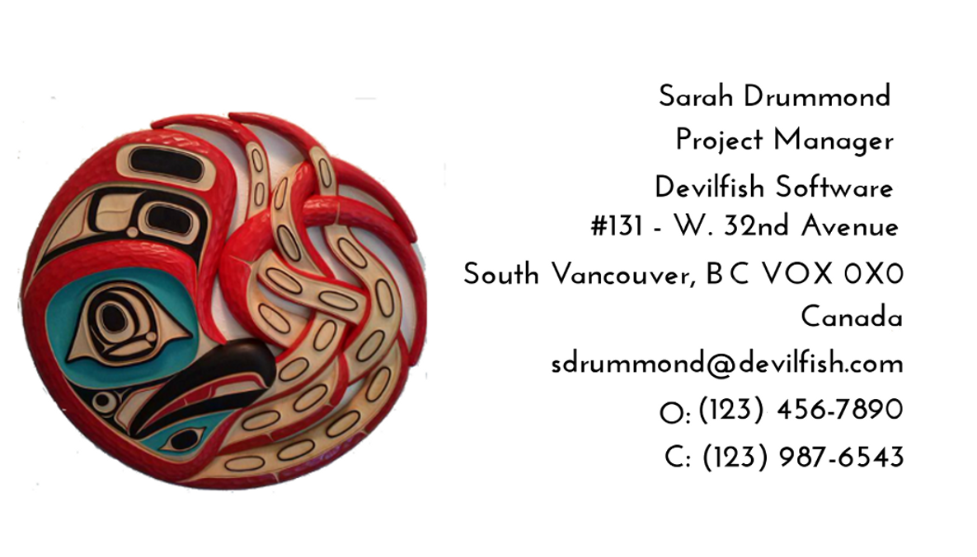
Separating the name and company from the rest of the contact information serves no useful purpose. The design is simpler – and therefore stronger – with all contact information in a single column, and the name and company are still prominent because they are at the top of the column.

Contrast
Before | 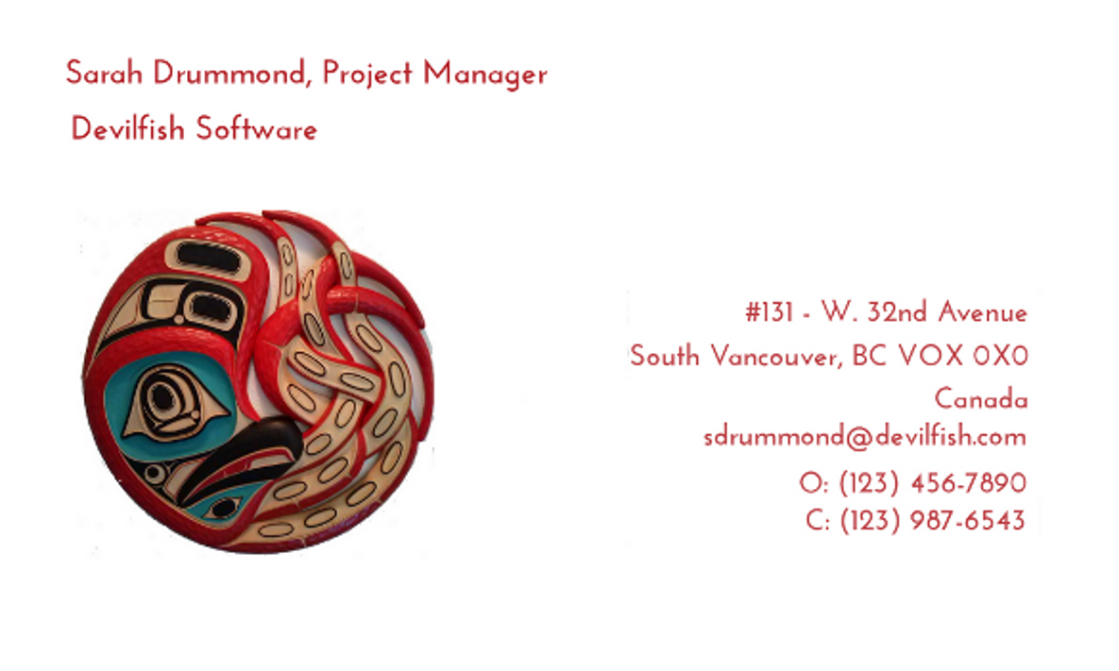
After | 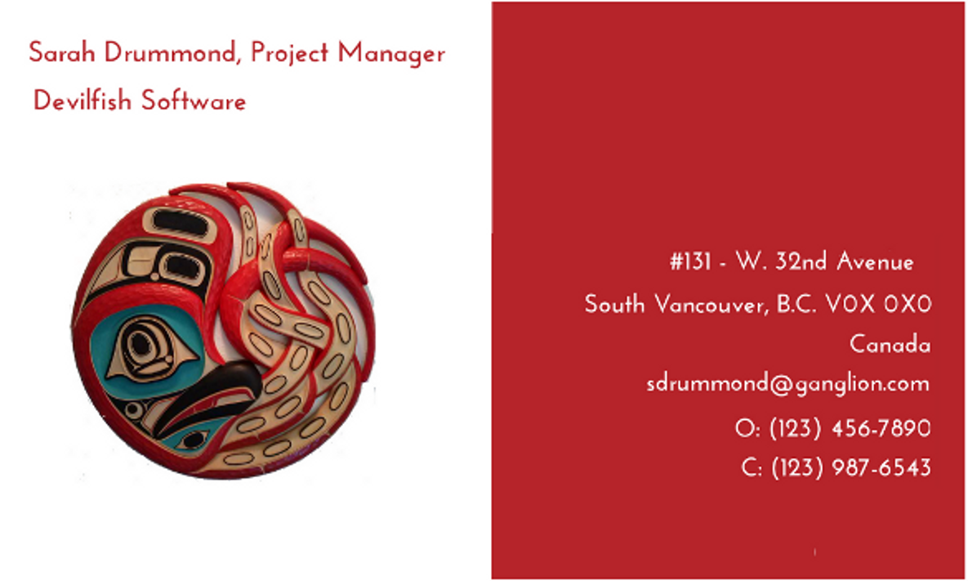
Since the design already splits into two columns with two different types of information, why not make the design more interesting by giving one column a different background color? Using the red color makes sense because it is the dominant color in the octopus panel.
In this case, placing the name and company in one column helps because it provides a top and bottom contrast to accompany the left and right contrast.

Proximity
Before | 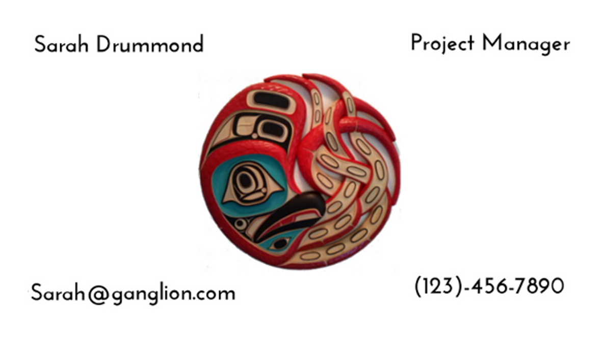
After | 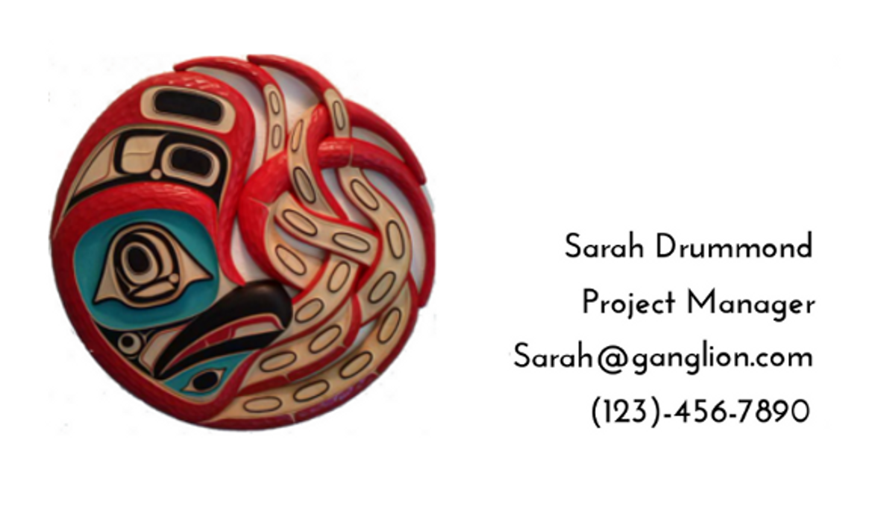
The Before card looks as though the designer thought: “Four pieces of information? Four corners? Cool!” and plunged ahead. But there is no connection between the pieces of information and their positioning, which means that the reader's eyes have no hint about where to start. Instead, eyes tend to fall on the octopus panel in the middle, which is the most visually interesting element, but also the one that contains the least information.
The After card introduces some proximity, placing all the information together, and giving it a common alignment. Probably, I would use another principle to improve the design,
but at least the After card is less cluttered and more easily read.

Repetition
Before | 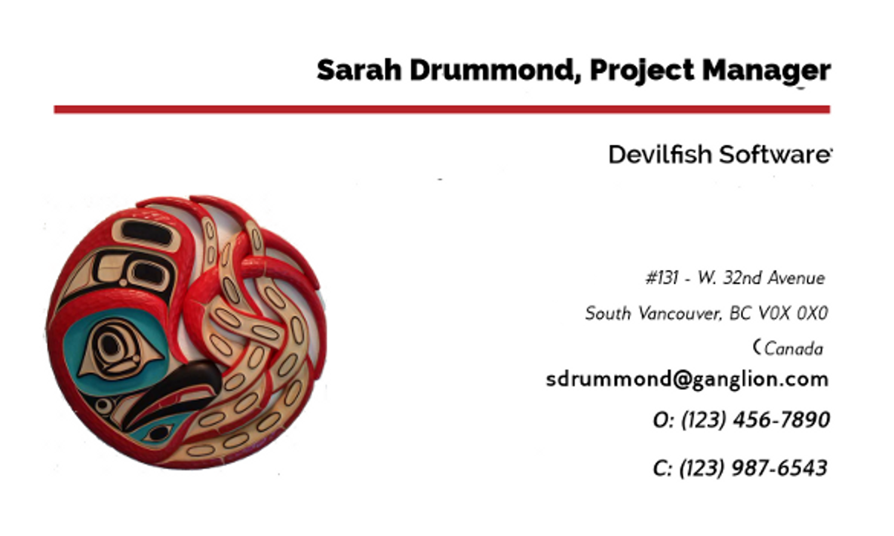
After | 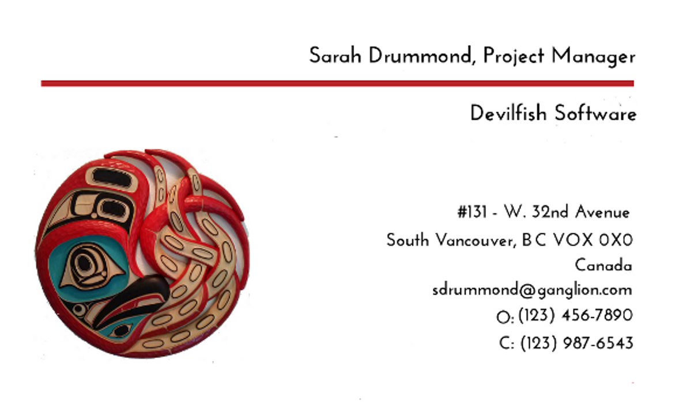
Remember the suggestion to limit the number of fonts? Here, the Before card’s design uses two different fonts and several weights and font sizes. Probably, the idea was to differentiate different types of information, but the encoding is not immediately obvious. Even more importantly, the result is chaotic, even though a right alignment is used consistently throughout.
By contrast, the After card uses the same font and weight throughout, with only two different font sizes. The result is far less confusing to the eye.

Finding content
The Drawing tool bar includes a generous supply of primitives or basic drawing shapes among its icons. They include basic geometric shapes, callouts to annotate diagrams, arrows, and even a library of basic flow chart shapes. By grouping or stacking shapes, you can make more complex shapes as well (see “Stacking shapes into other shapes,” page 20).
Often, though, you need more than the primitives. For instance, while the flow chart library contains most of the basic shapes for creating flow charts, some of the shapes you need may be available from other buttons on the tool bars. Many people, too, will need to do a web search to find a guide to when each shape should be used.
In addition, while Draw and Impress are ideal for creating diagrams, they sometimes lack the necessary libraries for some types of diagrams. Some, such as those for architectural or electrical diagrams, are missing from both the tool bar and the Clip Art Gallery. Instead of developing the libraries for yourself, you can save time by looking for libraries that already exist. Try:
- LibreOffice and Apache OpenOffice extensions (see Appendix A, “Error: Reference source not found,” page Error: Reference source not found).
- The libraries of other free-licensed diagram applications, such as Dia or Calligra Suite’s Flow.
- The OpenClipart site (http://openclipart.org/).
View > Clip Art Gallery (also found in the sidebar as Gallery) is a convenient place to store these libraries.

Producing content
The odds are that if you use Draw much, you will need to produce your own content using the Drawing tool bar. The Drawing tool bar contains mostly basic shapes like rectangles or ovals, or primitives, as designers call them.
- 祕訣
The Drawing tool bar is complete in Draw and Impress only. Writer and Calc versions of the tool bar are missing a few tools such as connectors.
To draw a primitive, select an item from the Drawing tool bar, and then move the cursor to the editing window, clicking and dragging to size the object.
In many cases, an additional tool bar for the shape opens at the top of the editing window for manually editing the shape. However, applying a style instead simplifies revisions.
- 祕訣
If you want a square instead of a rectangle, or a circle instead of an oval, press the Shift key as you drag the primitive.
After you insert an object, you can move and resize it by clicking then dragging it. When you do, a frame with eight handles appears around the object. As you drag an object, it appears in snap lines so that you can position it more exactly in relation to other objects.
Click any other part of the object than the handles, and you can move an object without changing its size and proportions. If you want to resize the object or change its shape, drag it by the handles that appear when you click it.
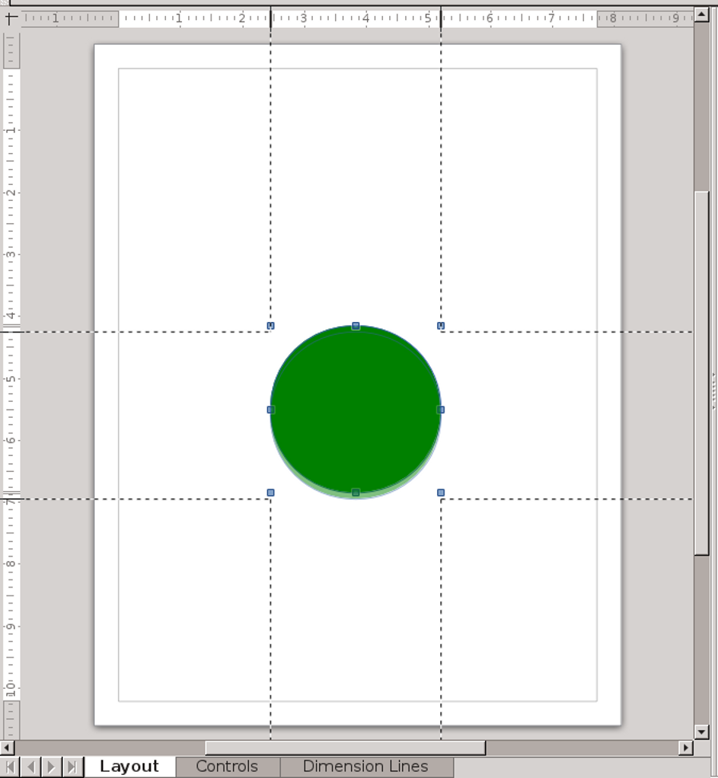
8
A basic shape being moved. The snap lines are useful for exact positioning, even with the grid turned off, because you can see the exact position on the horizontal and vertical rulers.
After you add a primitive, you may need to click the Select button, the first on the left of the tool bar, to restore the drawing tools to their default state. Otherwise, you might not be able to add another shape.
For most primitives, these instructions are all you need to know. However, some primitives require additional notes.

Understanding dimension lines
Dimension lines show the space between two end points on a diagram. The end points are
emphasized by two guides or vertical lines, and a measurement is generally used as well.
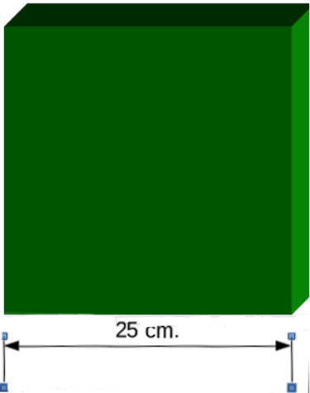
A dimension line for a three-dimensional shape.

Understanding text inside a shape
Before release 4.4, to add text inside a shape required that you draw the shape and the graphic text separately, then position and group them so that the text was overlaying the shape (see below).
However, in 4.4 and above, you can simply select an object and start to type.
Text outside a shape is still added by creating a text box first.

Understanding connectors
Connectors are lines attached to two objects by means of glue points. When you move an object that has a connector, the connectors are modified to keep them attached to the objects at the other end.
Other objects at the other end of the connector remain in place unless you select both objects, which drags the objects and the connectors
between them as though all elements were grouped.
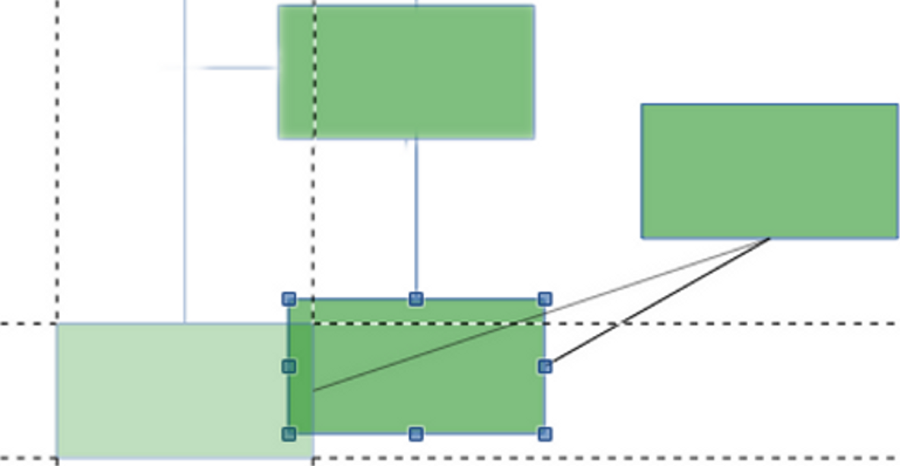
A rectangle attached to two others with connectors. Lines at the center of one side are connectors, while broken lines are the snap lines for positioning the object being moved. The paler rectangle indicates the object’s original position.

Understanding curves
The Curves button is for drawing freeform shapes, usually (but not always) with curved sides. Depending on your selection, a curve can be open, or filled with a color.
When you draw a curve, click once to change directions, and twice to stop drawing. When you are done, selecting the curve reveals the points that you can drag on to adjust the shape.

Understanding freeform lines
A freeform line is one that follows the direction of the cursor as you move it in the editing window.
The Writer and Calc Drawing tool bars have a separate button for freeform lines, but in Draw and Impress, they are the last option when you select the Curves button.
With patience and practice, you can use freeform lines to produce more advanced content. However, while you are learning Draw, you might want to avoid the effort.

Understanding callouts
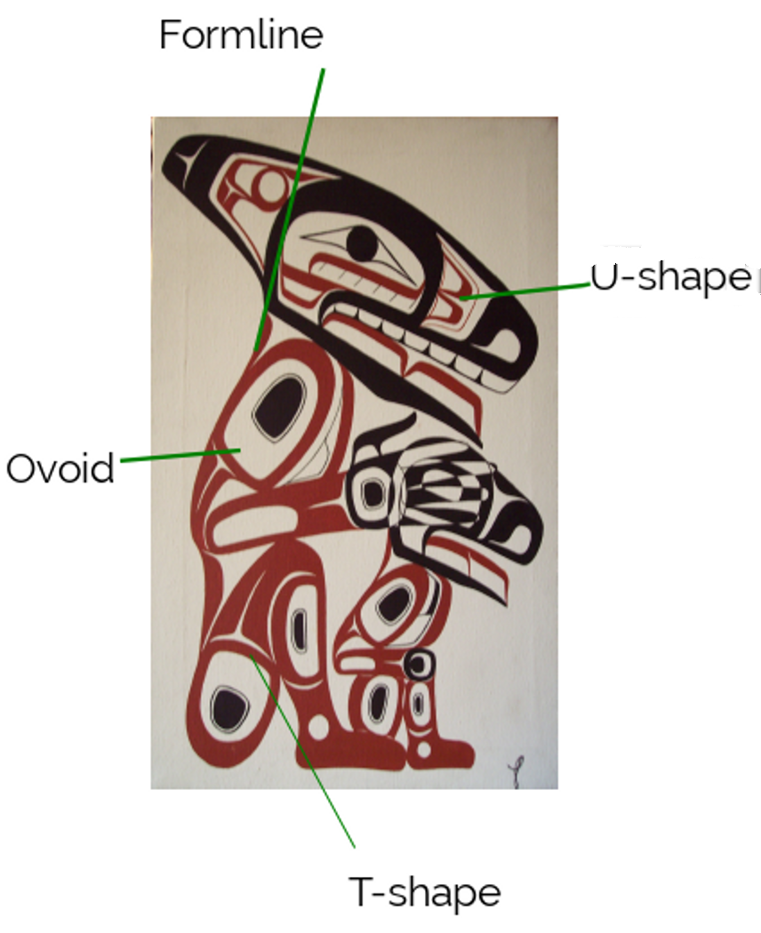
Callouts describing some of the basic shapes in Northwest Coast formline design. In this example, the text blocks have been made borderless. Photo credit: Todd Stephens, “Jorja and I.”

Callouts are used to indicate and explain parts of a diagram. They consist of a line pointing to part of the diagram and a text box, both of which are edited together. The lines act like connectors, changing shape if you drag the text box around.
By default, callouts have borders. However, borders are usually unnecessary. To remove them, right-click the object and select Line > Style > none.

Understanding points
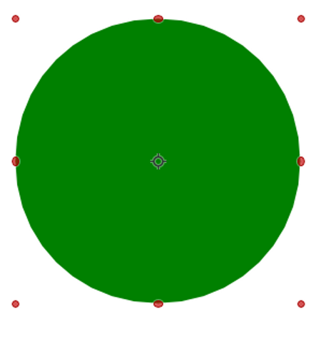
Drag on points to edit a shape.
Points are controls for manipulating a shape. They are synonymous with the frame handles, but they rotate rather than move the shape.
To edit points, select the shape in the editing window, then select the Points button and click the shape so that the handles turn red. Dragging on a handle changes the shape of the primitive.

Understanding the Fontwork Gallery
The Fontwork Gallery is available from the Drawing tool bar. It is midway between manual
formatting and graphic styles. The Fontwork Gallery offers a quick way of formatting graphic text that is not on a flat baseline, but follows a curve or other shape. It is useful mostly for short, highly formatted documents such as a brochure or newsletter.
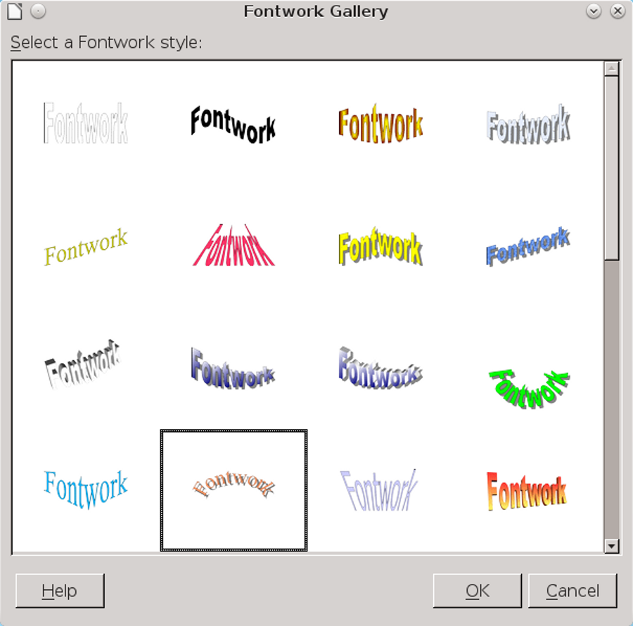
Fontwork is a library of formats for editing graphic text.
The Fontwork Gallery includes forty pre-defined samples. Often, you will not find exactly the sample you need, but if you pick the one closest to it, you can modify it. Sometimes, all you need to modify it will be the standard object tool bar. However, you can also use the Fontwork tool bar that opens to the right of the standard Drawing tool bar that appears
on the bottom of the page when you select the sample in your document.
Begin by replacing the default text with your own. You will probably want to replace the color of the Fill and the Area as well.
The text can be formatted by clicking it, but often you will find making changes easier by using the icons on the Fontwork tool bar:
- Fontwork Shape: Choose the shape of the baseline. The baseline for text is the imaginary line on which the bottom of an “m” or “n” rests upon.
- Tip
If you need an effect not available from the tool bar and are having trouble editing, set the shape to flat to make your changes, then return to the original shape.
- Fontwork Same Letter Heights: Toggles letters to same height or restores original letter heights. Setting letters to the same height is not the same as converting all the letters to upper case, but produces its own distortions.
- Fontwork Alignment: Align the entire sample, or each word.
- Fontwork Character Spacing: Sets the spacing between letters, choosing one of several broad categories ranging from Very Loose to Very Tight, or choose a custom percentage.
- Tilt Up, Down, Left, Right: Angles the sample. This tool is not available in some versions of LibreOffice.
- 注意
Text pasted into a Fontwork sample is displayed unformatted until you finish creating the sample.
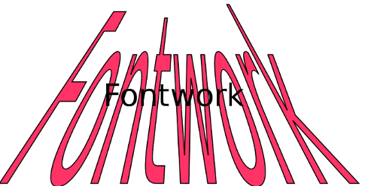
A Fontwork sample ready for the text to be edited,
- 祕訣
You can get quick and interesting effects by using a dingbat set with Fontwork.
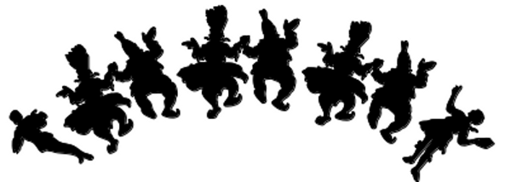
The Knavery dingbat set used with Fontwork.

Understanding 3D objects
Any primitive can be made into a rotatable 3D object by selecting it and then clicking Modify > Convert > To 3D.
You can do some basic editing on 3D objects by clicking on them until the handles turn red, then dragging by a handle.
A set of editing tools for 3D objects is available by selecting 3D Effects from the right-click menu, or by toggling on Extrusions on the Drawing tool bar. You can rotate objects, adjust depth and perspective, and adjust surfaces.
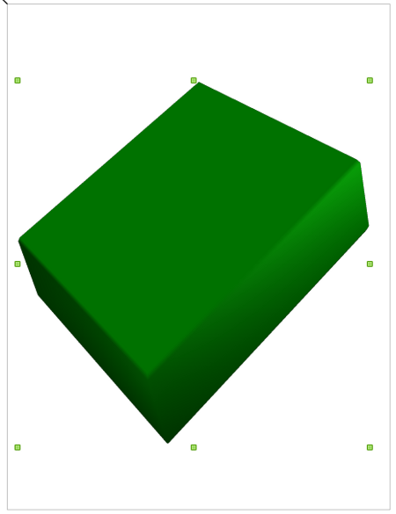
A rotatable 3D rectangle.
- 注意
Like shadows on text frames, 3D objects are easy to overdo. Avoid using 3D shapes unless they result in a diagram that is genuinely easier to read than a 2D one.

Understanding tables
Tables are not on the Drawing tool bar. Instead, use Insert > Table. The tool is similar to the one in Impress, but defaults to gray column headings and
row. To get more options, either take a screen shot of a Writer table, or add the Writer table to the Draw or Impress document using Insert > Object > OLE Object.
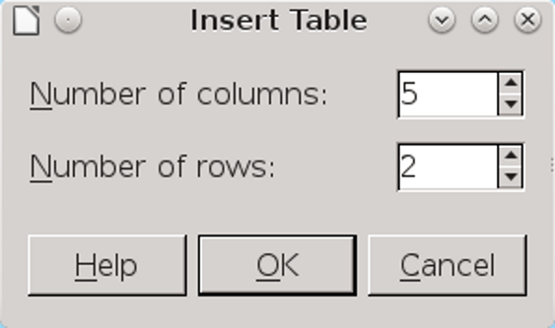
Compared to the table options in Writer, those for Draw and Impress are basic.

Grouping shapes
As you build a diagram or drawing, you often want to keep certain shapes together. In an organization chart, for example, you might want to keep all the positions on the same level together. By keeping them together, you can move them without having to reposition each one individually. In effect, you make a single shape out of originally separate ones.
In other cases, you might build a complex object from several simple ones. You would group them together because it is the complex shape, not its components, with which you work.
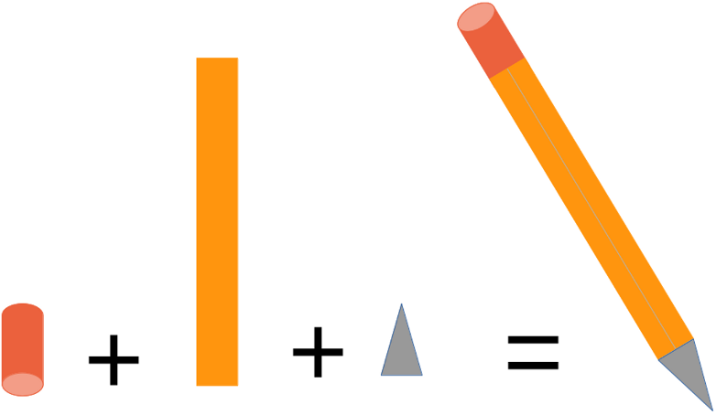
Arranging and grouping a cylinder, rectangle, and triangle produces a stylized pencil, suitable for use as an icon in a document, perhaps for tips.
To group shapes, select them one at a time while pressing the Shift key. With each selection, the frame and handles expand to include the new shape. Then select Group from the Modify menu or the right-click menu from one of the shapes. The option changes to Ungroup so you can undo the group.
- 祕訣
If the diagram is too crowded to select shapes to group, try selecting smaller groups first, then grouping groups. The only drawback to this technique is that ungrouping may become more difficult.
- 祕訣
You can edit an individual shape in a group by selecting Enter Group from the Modify menu or right-click menu.
Grouping shapes is an under-appreciated feature of LibreOffice. Very few people seem to use it, so it is rarely explained in any meaningful way in manuals or online help, which in turn means that fewer people consider using it. Yet, with ingenuity, it can produce results that cannot be created with any other feature.

Stacking shapes into other shapes
You can build complicated shapes by combining basic shapes in different ways. All require careful planning.
Often, the effect you want depends on which shape is on the top or bottom of the stack. Sometimes, two menu selections can give the same result.
- 祕訣
Using the Modify menu to Rotate, Flip, or Convert shapes may help to make primitives more versatile. In particular, converting graphic text to a bitmap may give you more options.
Stacked shapes can be made into a single complex shape in several ways:
- Overlap stacked shapes, then choose Arrange from the main or right-click menu. The shape changes as shapes are sent back or forward in the pile.
Shapes become more visible towards the front, and more hidden towards the bottom, while in
between their visibility depends on the colors and transparencies in the stack.
Once you have the shape you want, group the objects to preserve the more complicated shape.

A custom drop capital “O” shows how shapes can be stacked into more complex ones.
This one consists of:
a) A circle with a thick line and transparent area..
b) An archer dingbat set. stacked on top of the circle.
c) Two sword fighter dingbats. The one on the left is converted into a polygon using the Modify > Convert sub-menu, then flipped horizontally to face the other.

- Create a shape from overlapping objects by selecting Modify > Shapes > Merge. The result is a shape with the outlines of the objects. Overlapping areas disappear, and the area color is the fill of the object at the bottom of the stack.
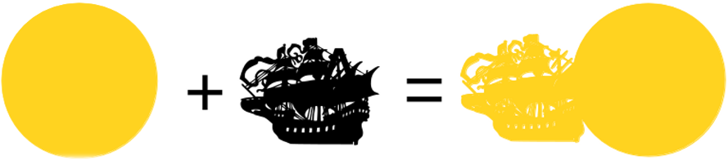
When shapes are merged, a single new shape results that is easier to keep track of.
- Create a shape from overlapping objects by selecting Modify > Shapes > subtract.
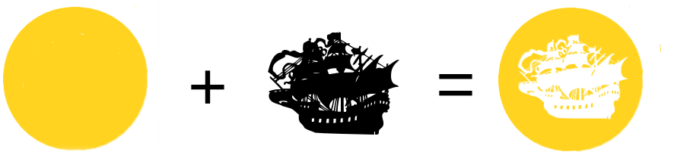
When the circle and a dingbat set are stacked, subtract leaves a cutout showing the color of the paper.
The same effect could be made by changing the dingbat’s color, but a white character on a white background would be easy to lose.
- Create a shape from overlapping objects by selecting Modify > Shapes > Intersect. The top objects and the visible parts of objects lower in the stack disappear, leaving only the parts that overlap.
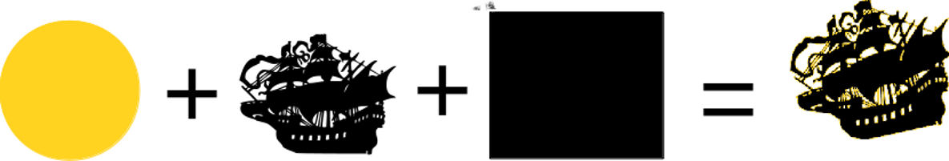
In this example, the circle and the ship are in the middle of the stack, and the rectangle at the bottom overlaps them on all sides. When Intersect is chosen, the visible portion of the rectangle disappears, leaving the objects in the middle merged to form a flaming ship.

Connecting lines and curves
The bottom of the Modify menu arranges items in combinations of general curves, lines, and shapes. Unfortunately, it can be confusing, because menu items are arranged in no particular order, and with few indications of which item is to be used with which shapes.
To connect two lines, select them, then click Modify > Connect. Be careful that they are actually touching, because otherwise LibreOffice draws a connection that may be crooked. To split lines, click Modify > Break.
Connect two curves with Modify > Combine, and split them with Modify > Split.
- 注意
Do not try to use Connect or Combine with closed shapes. If you do, the result is an abstract shape with few practical purposes.

Adding images
Draw, Impress, and the Drawing tool bar treat images as another form of primitive. All standard graphic formats are supported, but Draw is especially useful because of its support of vector graphics – images that are stored as a series of mathematical relationships rather than pixels and are therefore easier to resize.
On the right-click menu, images have several tools that primitives lack:
- Crop Image: Display only part of the image, or resize the image display. The original picture file is not affected in either case.
- Change Image: Replaces the current image with another one.
- Save Image: Copies the image to its own file.
- Compress Image: Reduces the resolution, and therefore the size of the LibreOffice file.
- Edit with External Tool: Opens the image in the system’s default graphics editor.

Designing fills
Object areas can be decorated with different types of fills: colors, gradients, hatchings, and bitmaps. These fills can be used to create an abstract design for custom Impress slides or for filling drawing shapes.
From a Drawing Objects style, you can only use the fills that are already defined for LibreOffice as a whole. However, you can customize styles from Format > Area within Draw. When saved, your custom designs become generally available in LibreOffice.
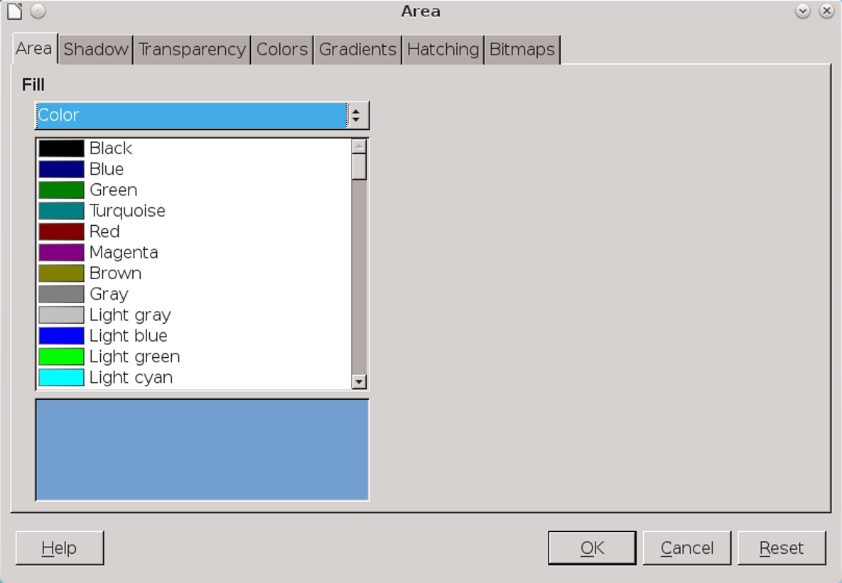
In Format > Area, fills are designed for use throughout LibreOffice.

Designing area colors
The Color tab of Format > Area is a duplicate of the tab at Tools > Options > LibreOffice > Colors. A color added in Format > Area becomes available for use throughout LibreOffice.
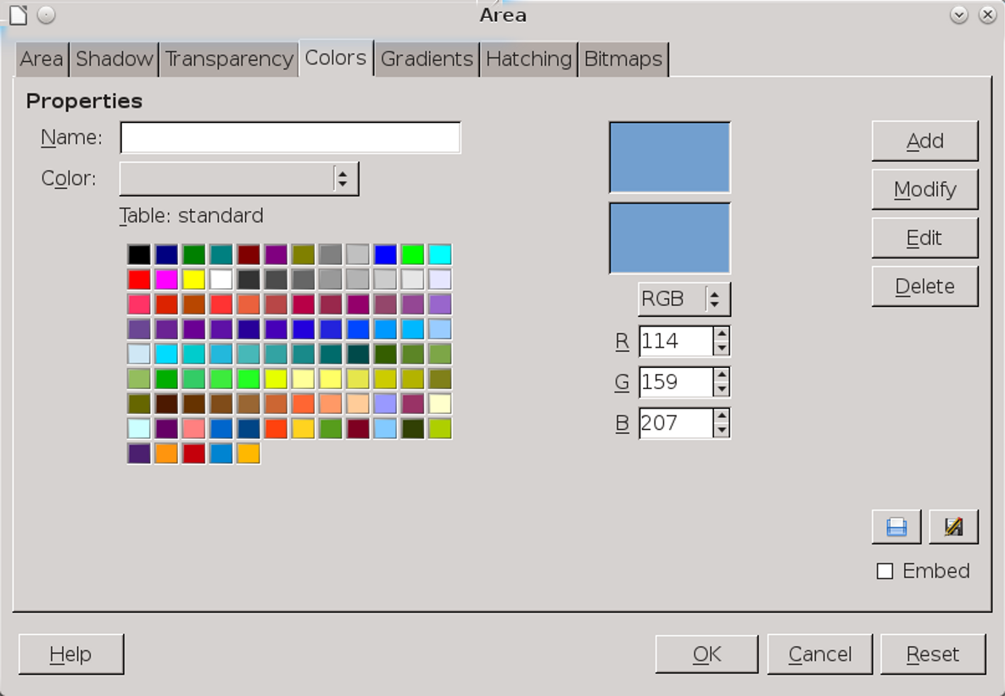
Format > Area > Colors creates new colors with the RGB color model for use throughout LibreOffice.
If you need to add a specific color, sample it in a graphics program to get its RGB definition. For example, in the screen shot above, the blue color indicated has a definition of 114-159-207 on a scale of 256.
- 祕訣
Color definitions are ways of blending a few colors to make the rest. RGB uses red, green, and blue, CMYK cyan, magenta, yellow, and black. The CMYK model is generally considered the most accurate.
The fact that RGB is used online and CMYK for hard copy explains why printing exactly the colors you see online can be challenging. There is no exact
correspondence between the two color models, so results can be different between the screen and paper.
- 祕訣
If a color is important in the document – perhaps because it is a corporate color – give it a suitable name, such as Devilfish Software Red, so you can locate it quickly.
Your custom color fills are stored in the /user/config directory of your personal configuration path in a file with an .soc extension (StarOffice Colors).

Designing area gradients
A gradient is a gradual transition from one color to another. In between the starting color and the ending color are a number of intermediate colors, or increments.
Gradients are a popular choice for presentations and desktop wallpapers on computers. The reason is obvious: with a little experimenting, you can create an original, abstract design that is suitable for almost any subject matter.
Drawing Object styles use only gradients already defined in LibreOffice. You can create a custom gradient from Format > Area > Gradients in the main menu.
LibreOffice gradients can have up to nine settings. At first glance, these settings may seem mathematically complex for such a simple goal.
However, you can ignore all except the colors and still produce an original gradient.
Admittedly, you can create more complex designs with the other fields, but the most productive attitude is to regard the other fields as options you can play with and mix and match, rather than anything with which you have to deal.
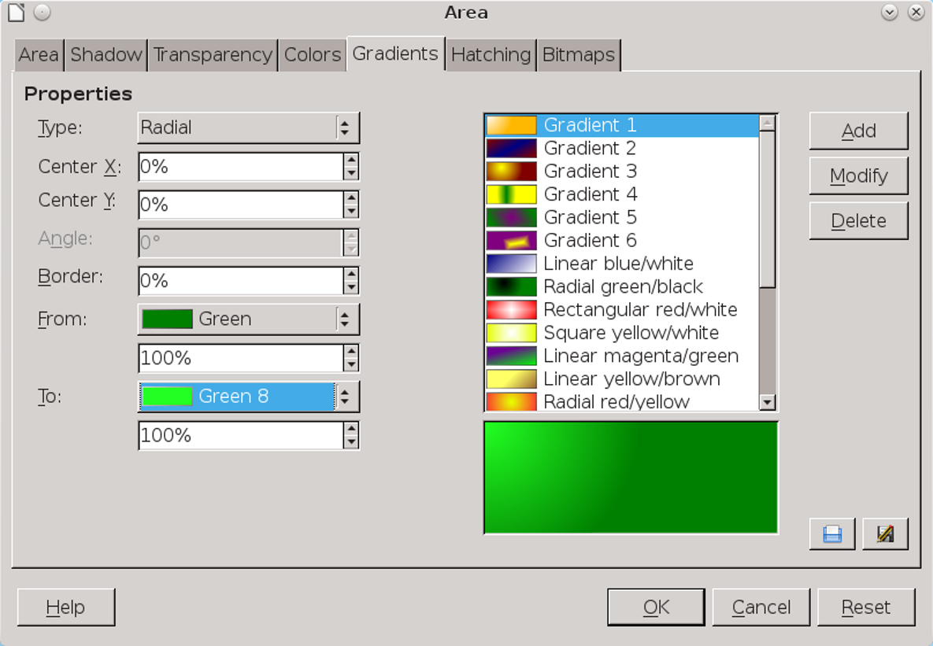
Format > Area > Gradients creates backgrounds in which one color shades into another. The result is often abstract designs suitable for Impress slides, or even desktop wallpapers.
LibreOffice supports several different types of gradient:
- Linear: The gradient is horizontal, starting with the first color at the top and ending with the last color on the bottom.
- Axial: The gradient is horizontal, starting with the first color in the center and ending with the last color at the top and the bottom.
- Radial: The gradient is diagonal, starting with the first color in the lower right and ending with the second in the upper left.
- Ellipsoid: The gradient is diagonal, starting with the first color in the lower right and moving through intermediate colors in curved bands to end with the second color in the upper left.
- Square: The gradient is diagonal, starting with the first color in the lower right and moving through intermediate colors in square sections to end with the second color in the upper left.
- Rectangle: The gradient is diagonal, starting with the first color in the lower right and moving through intermediate colors in rectangular sections to end with the second color in the upper left.
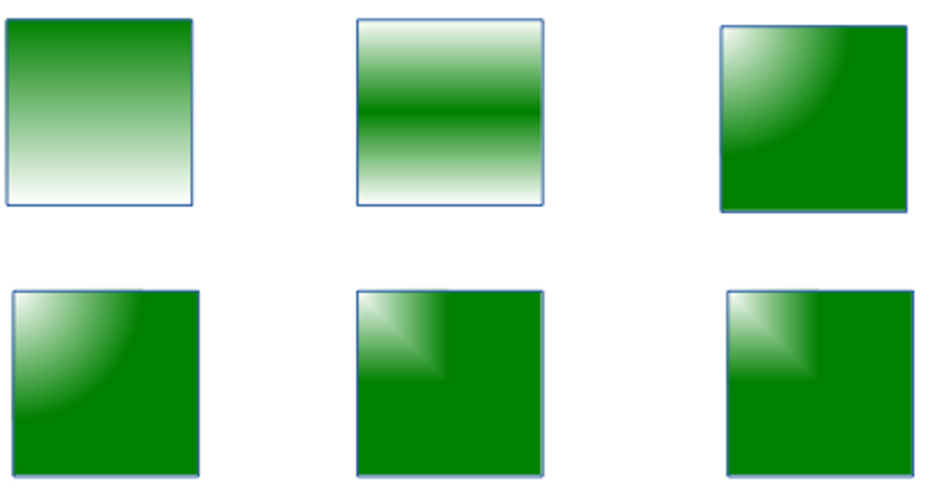
Gradients available in LibreOffice. From top left: Linear, Axis, Radial, Ellipsoid, Square, Rectangle.
- 祕訣
The illustrations above are based on gradients with an angle of 0, and no X or Y offset. If a gradient starts in a different position, it will look slightly different.
All gradients are defined by the colors they begin with (From) and end with (To). Gradients can also have a border, at which the current color partially fades, as well as an angle.
Some, such as Radial gradient, also have an X (horizontal) and Y (vertical) offset from the upper right-hand corner. Use the preview to experiment until you get the positioning that you want.
Your custom gradient fills are stored in the /user/config directory of your personal configuration path in a file with an
. sog extension (StarOffice Gradients).

Designing area hatchings
Hatchings are patterns of vertical, horizontal, and/or diagonal lines. Their usefulness is easy to under-estimate, but they can sometimes be effective fills, especially when printed in black and white.
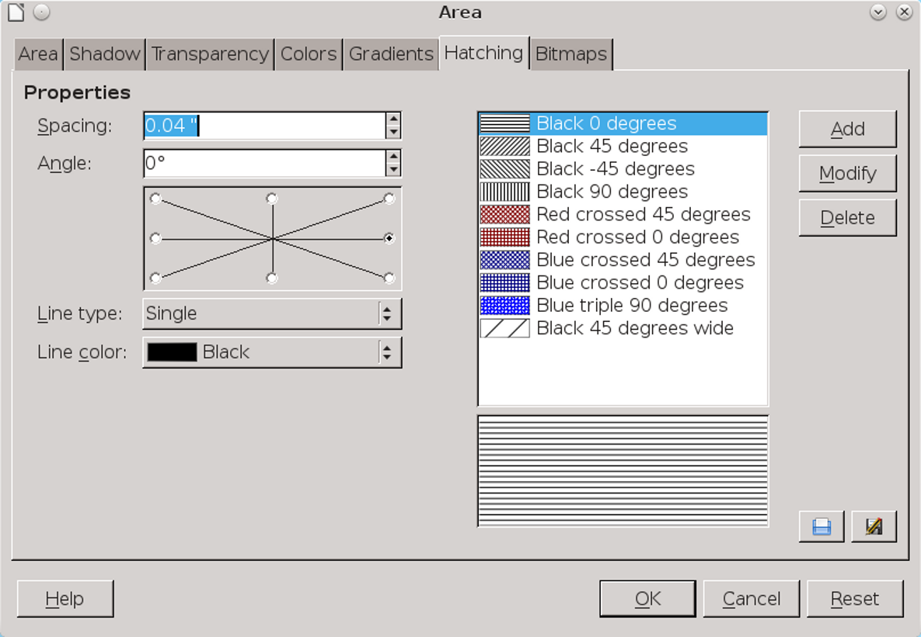
Format > Area > Hatching creates linear hatchings for fills throughout LibreOffice.

Designing area bitmaps
Bitmaps refer in this context to tiles that are used to create a repeating pattern. You can build your own tile, pixel by pixel in the Pattern Editor, or load a fill from another source.
Your custom fills are stored in the /user/config directory of your personal configuration path in a file with an .sob extension (StarOffice Bitmap).
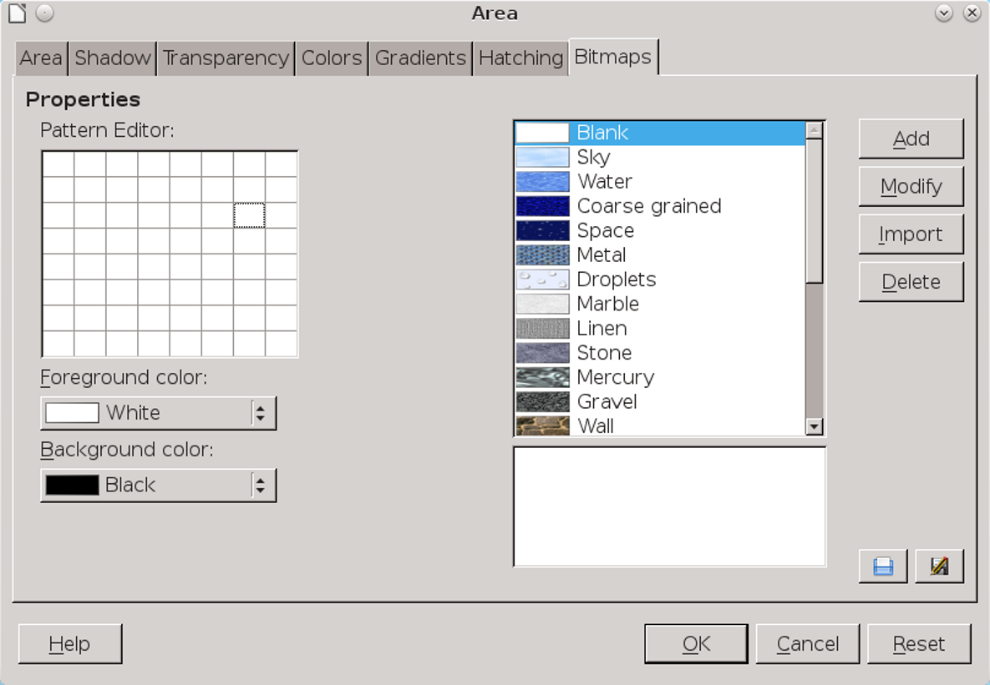
Format > Area > Bitmaps are tiles used for a quick area fill.

Gathering shapes
Draw is limited compared to stand-alone graphic editors like GIMP or Krita. However, as you find or develop shapes to use in a project, you may discover that Draw and the Drawing tool bar are more versatile than you first imagined. Draw’s usefulness, like any graphic editor’s, depends on how familiar you are with it and how much effort you are prepared to make.

