14

繪製物件樣式與圖表
繪製物件樣式（也被稱為影像樣式，或是先前稱為圖形樣式）在 Draw 或 Impress 中定義了繪製物件的特徵。雖然你可以在 Writer 與 Calc 中使用繪圖工具列來繪製物件，但這些功能並未在其他 LibreOffice 應用程式中出現。一般來說，你會在插入形狀後套用它們。
- 注意
在 Draw 與 Impress 中的繪圖工具列有一些 Writer 與 Calc 沒有的圖示。特別是 Draw 與 Impress 的版本中有連接符與箭頭。
還有一點要注意：繪製樣式僅用於格式化。其並不會影響形狀與大小。舉例來說，有一個以帶有陰影的樣式預定義好的物件可以格式化為同時是矩形與除了尺寸以外都一樣的形狀。
本章節將會討論如何使用 LibreOffice 的圖表子系統來設計圖形與圖表。在大多數的 LibreOffice 應用程式中都可以使用，但圖表仍是在整個辦公室套裝軟體中少數幾個僅使用手動格
式化的工具。同樣地，圖表在商業、學術與科學文件中仍有相當重要的地位，且其可自訂程度相當高。

規畫圖形樣式
就像其他的 LibreOffice 應用程式一樣，Draw 包含了預定義的樣式。其中一些用於圖形化的文字，但其它則用於繪圖物件的一般分類，如帶有箭頭的物件。除了尺寸線以外，大多數並非僅適用於特定的形狀、大小或用途。
不過，通常來說建立你自己的樣式較方便，即便你是從修改預定義的樣式開始也一樣。開始的最佳方法就是把圖形分解為其基本元素。然後再為每個元素指派一個圖形樣式。
舉例來說，如果你正在建構一份組織架構圖，你可能會有一個稱為位置框的樣式來指出每一個工作。如果你想要以不同的方式套用此樣式──也許是使用不同顏色的形狀來指出不同的部門或是專案領導人──從組織者分頁使用繼承自與下一欄來建立名字像是位置框 或專案領導人的子樣式。

套用圖形樣式
不像 Writer 中的樣式，圖形樣式可以僅在形狀加入到文件後才套用。插入其中一種你在文件中使用的形狀，然後從樣式與格式視窗中選擇樣式來套用。
一旦你將樣式加入到某一種類型的物件後，你就可以複製並貼上以建立其他相同類型的物件，或是使用 編輯→再製。
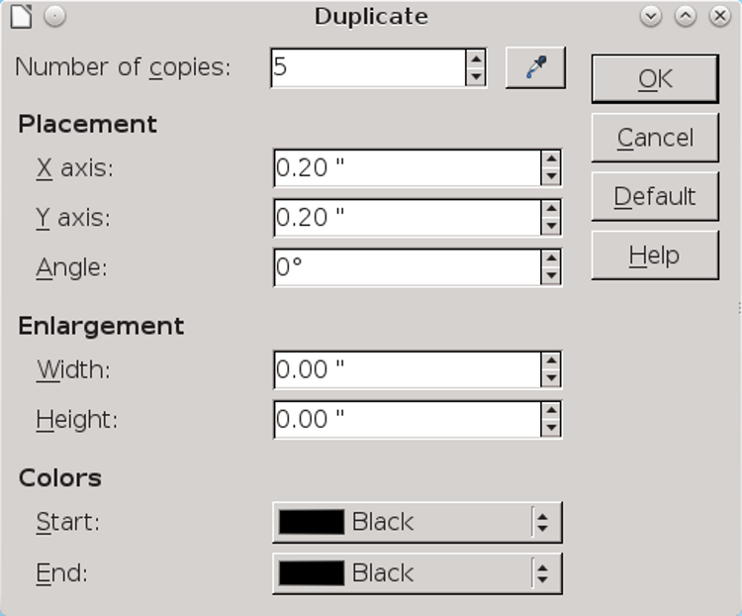
編輯→再製儲存複製並貼上形狀。
除了複製以外，再製視窗可以放大並複製顏色，以及將它們並列，這樣你就可以在你需要的時候製作一份拷貝。在 Draw 或 Impress 中工作時，你可能習慣使用 Ctrl+C 與 Shift+F3 來複製。

格式化繪製
形狀選擇決定每個物件的特色。很多都與其他樣式類似，但在圖表中，它們會變得更重要。
舉例來說，在大多數的 Writer 樣式中，你可能不需要邊框或背景，但在 Draw 中，這樣的特性（稱為 線與區域）變成了重點。
在處理形狀的特徵的時候，你很快就會發現許多可用的設定僅適用於特定的形狀。你可能會選擇忽略其他東西，可能是因為預設值對你的目的來說已經足夠了，又或是因為你的繪圖不會受到設定所影響。舉例來說，若你的繪圖沒有文字，則任何文字設定都與其無關。
- 祕訣
For detailed information about the Alignment, Font, Font Effects, Indents & Spacing, and Tabs tabs, see Chapters 3-5. Details about style features unique to graphic styles follow in this chapter.

Setting line formatting
Lines distinguish the outline of a shape from the area. They are approximately equivalent to Borders in other LibreOffice applications, although the features are not identical.
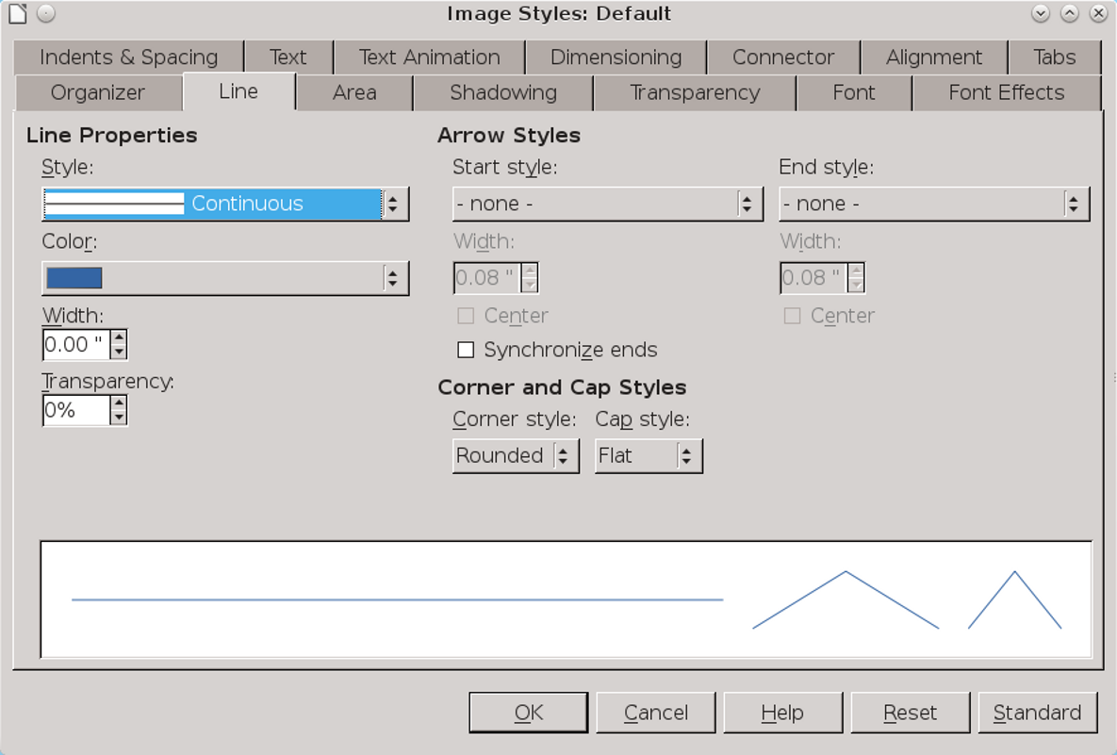
The Line tab is analogous to the Borders tab in the styles for other applications.
If lines are irrelevant to your design, set the Line Style to None, and you only need to be concerned about area formatting.
In addition to choosing the color and thickness of an object’s outline, the Line tab also includes options for arrows and line ends for both ends of a line. By default, arrows and line ends have the same proportions as the line itself, but you can make them thinner or thicker as you choose.
- 祕訣
The Drawing tool bar also has block arrows that you can group with a line.
Customized lines are stored in the /user/config directory of your personal configuration path. The .sod file contains custom line formats, the .soe file custom arrows.

Setting dimension lines
You can modify dimensions lines from the Dimensioning tab of a graphic style. The Line fields let you adjust the dimension line and the guides in relation to each other, although you will probably have little need to change the defaults.
You are more likely to want to change the legend, or measurement, positioning it in one of the ten default position shown in the right column of the Dimensioning tab.
- 祕訣
The AutoVertical check box centers the legend vertically, the AutoHorizontal horizontally. Both must
be turned off if you want to position the legend anywhere except the default central position.
- 祕訣
If unit measurements are displayed, changing the unit may be a convenient way of changing the scale of a drawing. The alternative is to use Tools > Options > LibreOffice Draw > General > Scale > Drawing Scale.
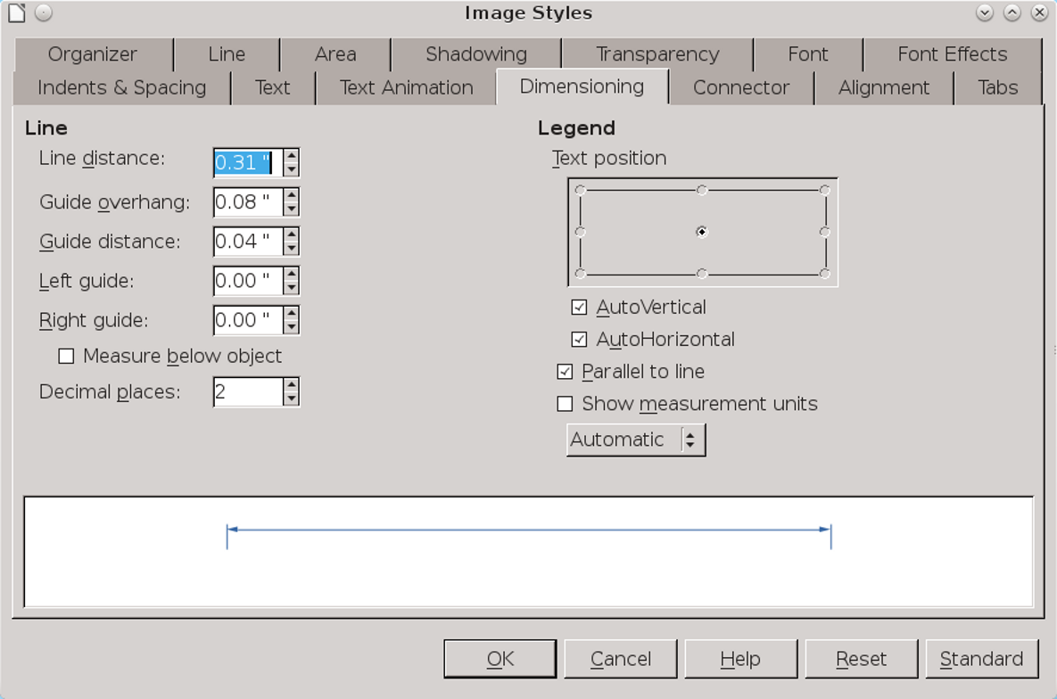
To draw a dimension line, click the Lines and Arrows button on the Drawing tool bar (the ninth from the left), and select Dimension Line from the available tools.

Setting connectors
Connectors join shapes together. When you move an object that has connectors, the connectors are modified to keep them attached to the objects at the other end.
Objects at the other end of the connector remain in place unless you select both objects, which drags the objects and the connectors between them as though all elements were grouped.
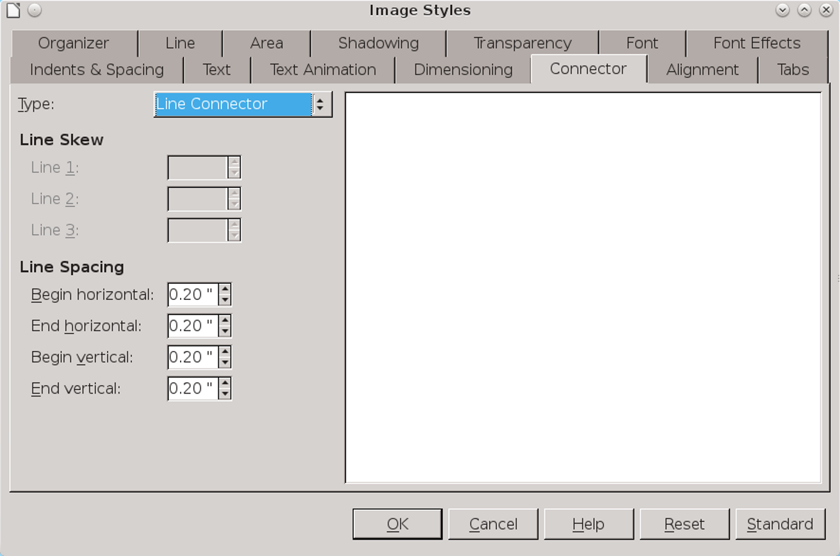
Connectors are lines attached to two objects by means of glue points. They keep objects attached to each other even when one is moved.
To add a connector, click the Connector button on the Drawing tool bar (the eighth from the left). You can choose between four kinds of connector:
- Standard: A connector with horizontal and vertical lines, possibly with one right angle in it. A Standard connector is useful in crowded hierarchical diagrams, in which several objects are subordinate to one above them, such as
- directors below executive officers in a company chart.
- Line: A connector with a small segment at each end for adding a change of direction. Use Line connectors in diagrams that are even more crowded than the ones in which you use Standard connectors.
- Straight: A connector that consists of a single vertical or horizontal line. Straight connectors are by far the easiest ones to use, but you may not always have the space for them. Extend a connector to the center of one side of a shape, and it immediately converts to a Straight connector.
- Curved: A connector with one curved line. Curved connectors are most suitable when you want an informal look to a diagram, perhaps to suggest that the relationships you are illustrating are approximate.
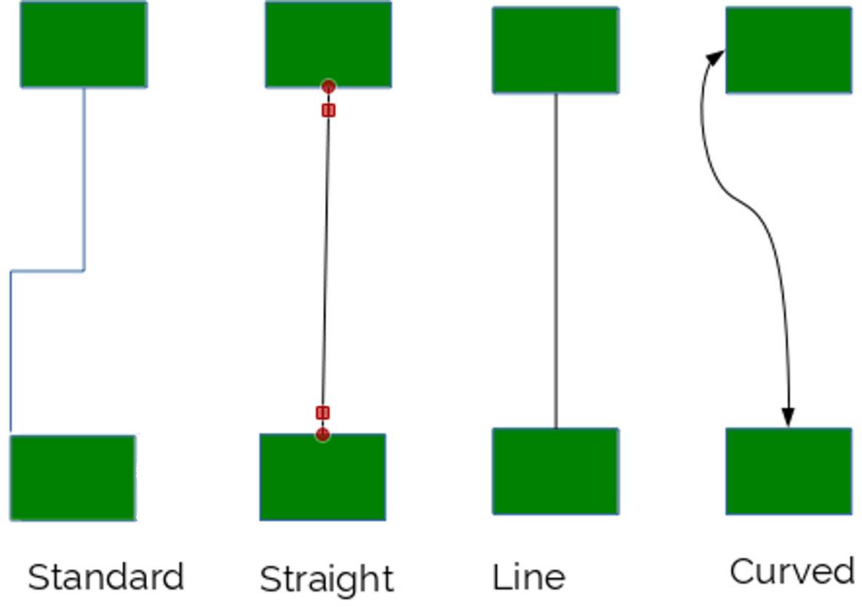
The four types of connectors.
All connectors can end with an arrow or an open or filled circle. You can adjust the shape of a connector by selecting it and dragging on its handle, or by moving one of the objects to which it is attached. You can also select the Glue Point button on the Drawing tool bar.
To adjust a connector, go to the Connector tab of a graphic style. For a Line or Straight connector, you can also adjust the line skew – that is, the length of the line segments included – and the horizontal and vertical space for the line segments.
These settings are especially useful when repositioning has twisted connectors out of shape, or when you are adding the final touches to a diagram and trying to make everything consistent and uncluttered.
Even so, you may sometimes save time by deleting existing connectors and adding new ones.

Setting area options
The area of a drawing object can be formatted with Colors, Gradients, Hatchings, and Bitmaps. You are restricted to the fills already defined in LibreOffice. However, you can use Draw to define custom fills.
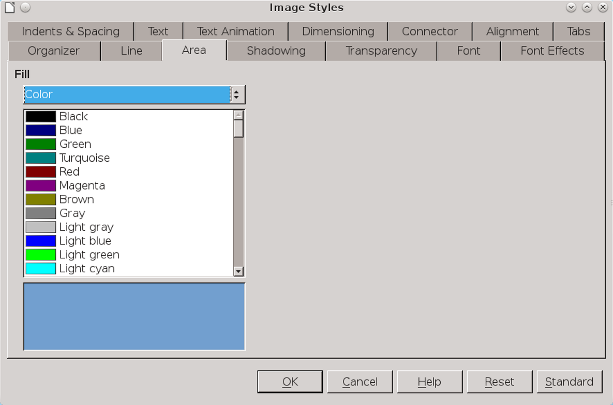
The Area tab for graphic text is roughly equivalent to the Background tab in some other types of styles. Formatting an object's area means choosing a fill for it.

To add a fill, go to Format > Area, and select the tab for the type of fill you want to add. See Chapter 13 for more details.

Setting shadows
Shadowing was popular in the early 1990s in graphic design. It is less common today, but can still be useful in creating a quick illusion of three dimensions.
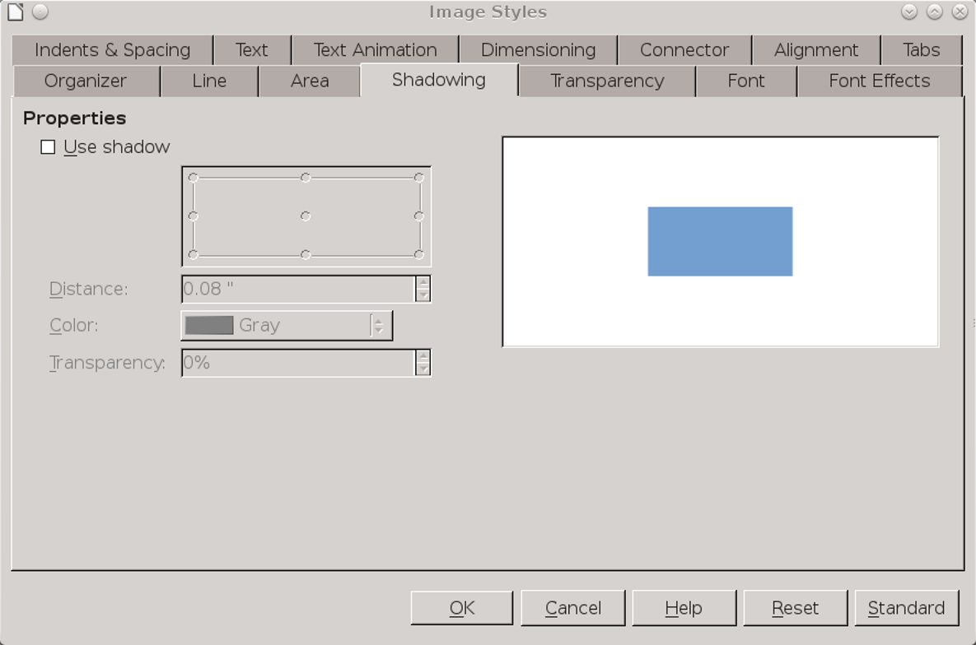
Shadows are easy to over-use, but can create a 3D look.
The Shadowing tab lists settings to help customize a shadow. In many cases, all you need is to check the Use shadow box. However, you can also set the shadow’s farthest distance from the object, the position of the shadow in relation to the object, and the color and transparency of the shadow for a subtler touch. Generally, a shadow’s color should be black or a shade of gray.
- 祕訣
The default position for the shadow is the lower right, assuming a light source in the upper left. If you change the shadow’s position, use the same position for other shadows throughout the document.

Setting transparencies
Transparencies are useful for creating matching shades based on the same color, as well as for creating complex designs with overlapping layers.
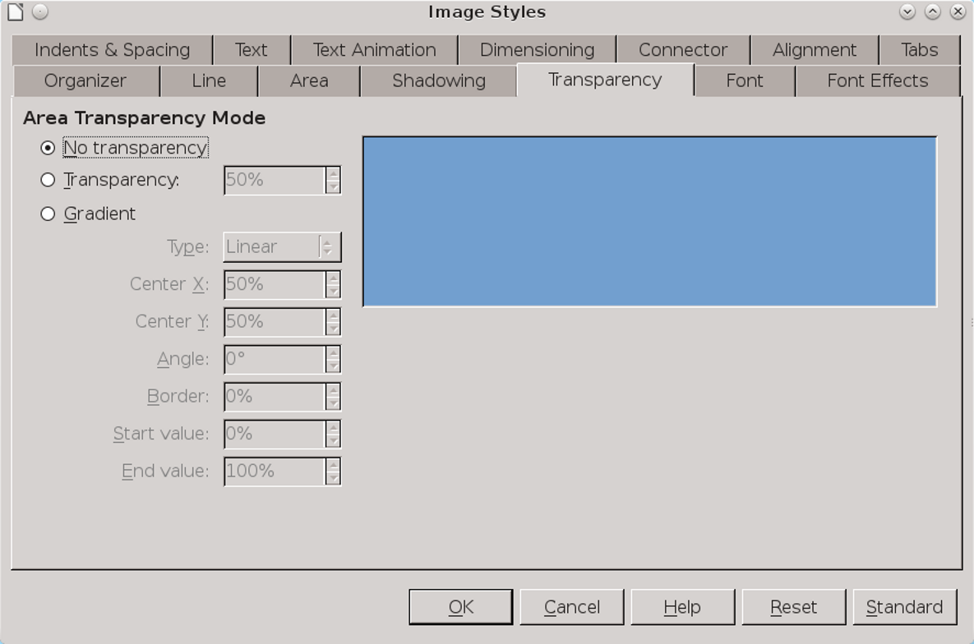
Transparencies expand your range of color.
The Transparency tab expresses transparency as a percentage, with 0 being an unmodified or solid color, and 100% being completely transparent.
The Transparency tab also includes options for creating a gradient, duplicating the options at Format
> Area > Gradient (see above). In terms of graphic styles, the tab’s gradient control allows you to customize gradients, while the Area tab only lets you choose pre-defined gradients.

Setting text characteristics
The characteristics of graphic text are mostly the same as for text documents, with a few minor changes. Regardless of whether you are using regular or graphic text, the typographical conventions remain much the same.
For Tab | See | Notes
Alignment | “Error: Reference source not found,” page Error: Reference source not found. | No options in Draw for last Justified line.
Fonts | “Error: Reference source not found,” page Error: Reference source not found. | Choose fonts at least the size of body text, if not slightly larger for diagrams.  Sans serifs often make for clarity. If possible, use a font used elsewhere in the document.
Font Effects | “Error: Reference source not found,” page Error: Reference source not found. | In most cases, ignore all except Font color.
Indents & Spacing | “Error: Reference source not found,”page Error: Reference source not found. | Use indentations, especially for the first line, instead of tabs.
Tabs | “Error: Reference source not found,” page Error: Reference source not found. | Awkward with graphic text, and not really needed with the right spacing. Consider alternatives, such as tables, especially when the design is frequently changing.

Using text animation
From the Text Animation tab in a graphic style, you can set LibreOffice’s equivalent of the Blink and Marquee HTML tags, either making text blink off and on, or scroll in one of several ways in the text frame.
The tab includes settings for the direction of scrolling, the number of repetitions, and other settings.
However, LibreOffice users should learn from web designers’ experience and avoid text animation in almost every circumstance. Blinking and scrolling are usually the antithesis of everything that a design element is supposed to do – instead of enhancing content, they distract readers’ attention from it. In fact, they have little purpose except to call attention to themselves.
If you must use text animation, be merciful and set it to run only a few times before stopping. Having readers disagree with the opinions you express can be a natural consequence of writing, but annoying readers with your design is simply a poor tactic. Why undermine yourself?
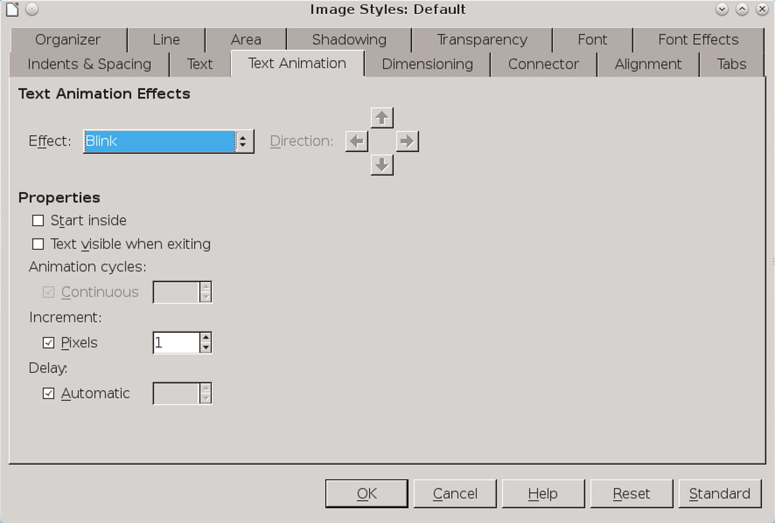
Avoid text animations as obsolete.
- Creating a flow chart
Flow charts appear to have been invented several times between 1850–1930. They are meant to be informal documents, but you can vastly improve their look if you use basic design principles such as repetition and alignment to organize them.
As with any diagram, you can plan a flow chart by placing elements outside the margin of the document until you are ready to use them. However, sketching the design on a piece of paper might be just as easy.
Either way, when you are finished planning, turn on View > Grid > Select Grid and Snap to grid, and follow these steps:
- Decide what basic shapes you need, and create a style for each. In this case, I needed a style for:
- Flow chart objects (Decision, Action, and Start/Finish). I only need one style, because drawing styles are not concerned with shape. I borrowed rounded rectangles from the tool bar’s Rectangle button.
- Text.
- Lines starting with an arrow.
- Lines ending with an arrow.
- Lines starting and ending with an arrow.
Styles should include settings for font effect, lines, area, and possibly transparency.
- Create one each of the basic flow chart elements. Using the grid, size and position each shape and apply the style.
- 祕訣
Expect to have to reposition objects, and possibly resize as well. In either case, you may come to appreciate the advantages of styles.
- Copy and position each flow chart element as needed, making one column for Decisions (diamonds) and another for Actions (large rounded squares). Use the grid to help keep elements horizontally and vertically aligned.
- Add text to each object. In LibreOffice versions prior to 4.4, adding text requires creating text boxes and positioning them inside the flow chart elements, grouping them for convenience. In 4.4 or higher, simply start typing inside each element.
- Add lines with arrows and their captions. Keep the line length and position as regular and as few as possible, unless you are trying for an informal look.
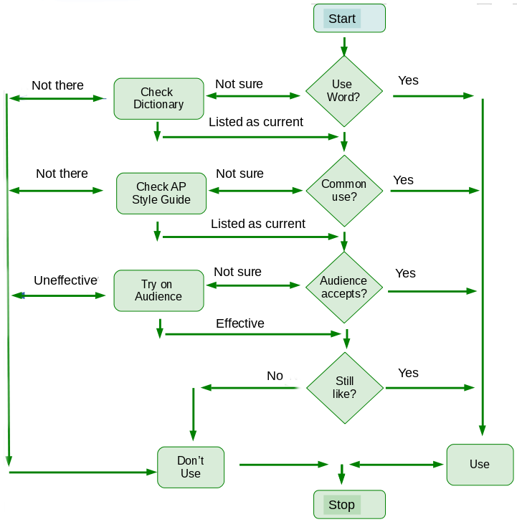
A flow chart for deciding whether to use an idiomatic word.

Adding charts and graphs
A chart or graph is a visual comparison of two or more pieces of data, such as the unemployment rate over time, or the distribution of results by population.
Charts and graphs are created in LibreOffice with the Chart sub-system. You can use charts in Writer by selecting Insert > Object > Chart from the main menu, or in other LibreOffice applications by selecting Insert > Chart.
In Calc, adding a chart opens a wizard that guides you through formatting a chart. Unfortunately, in Writer, Draw, and Impress, you must format manually without styles or much of anything else to help you.
Except in Calc, the Chart sub-system works much like the one for Fontwork. When you select Insert > Chart, LibreOffice adds a default chart to your document – specifically, a 2d bar graph.
The chart uses the default chart colors, which you can adjust in Tools > Options > Charts > Default Colors or by right-clicking on the chart. By changing the colors used in a chart, you can make the chart fit with other decisions about color in the document, or reflect corporate or project branding.
All features in a chart are editable, but LibreOffice supplies no means to save formatting choices. If you want a chart to look similar to another one, you must copy and paste.

Formatting charts
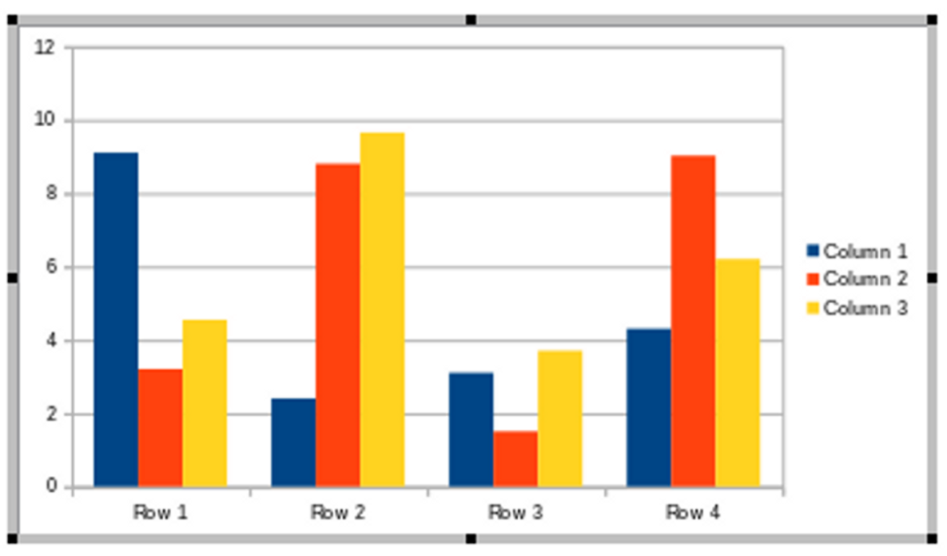
A chart is ready to edit when it has a gray border.
To edit the look and structure of a chart, click twice until the chart is outlined by a thick gray border.
- 祕訣
When the gray border does not show, you can edit the separate elements of the chart, but not the general structure.
The default chart can be repositioned and resized by dragging on its handles. You can insert your own data by selecting Chart Data Table from the right-click menu.
- 祕訣
The default chart includes three Y axis values. However, many charts only require one.

Selecting chart types
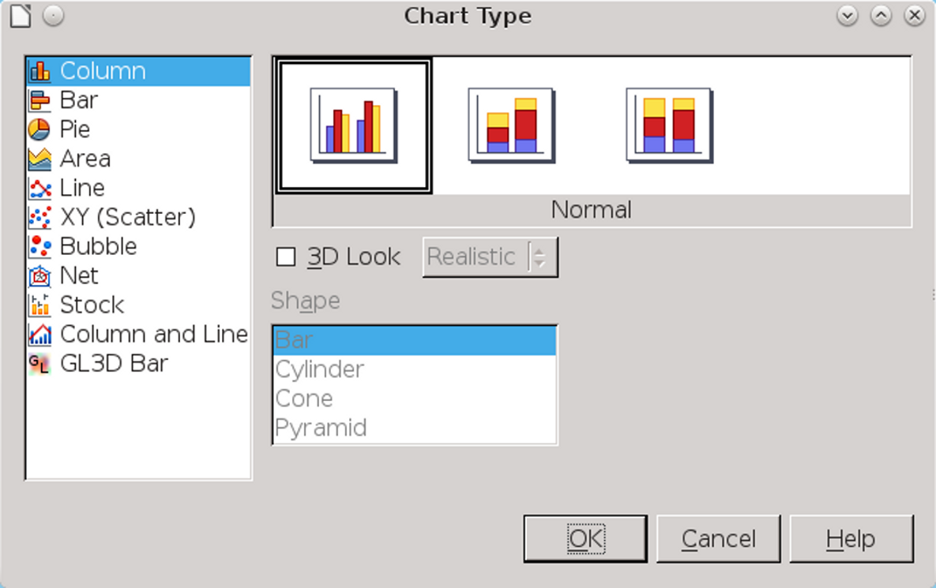
Charts are available in eleven types, many in both 2D and 3D.
You can change the default chart type by selecting Chart Type from the right-click menu, and choosing from the graphs shown.
The available charts are:
- Column: The data displays in vertical columns.
- Bar: The data displays in horizontal columns.
- Pie: Chart data is depicted as wedges in a round shape. This chart type is popular for financial data and business reports.
- Line: A graph of data points. If the data points are meant to show a progression (for instance, over time), then the points are usually connected.
- Area: A line graph with several lines, and the space between lines shaded in with colors.
- XY (Scatter): A type of chart for comparing the results of two or more trials of an experiment.
- Bubble: A graph that displays three dimensions: the X and Y axis and the size of the bubble that depicts the data point. Bubble graphs are a variation of an XY chart.
- Net: A chart in which every X axis has a separate Y axis. As a result, results are not a point or a line, but an enclosed shape. This type of chart can be difficult to read for an audience not accustomed to it.
- Stock: As the name implies, a graph often used to show changes in stock values. It is described technically as a depiction of changes in the values of the X axis.
- Column and Line: A chart that offers both a column and line representation of the same data.
- GL3D Bar: A bar graph that uses OpenGL for rendering three dimensional graphs. This choice only works when your video driver has hardware acceleration, which some Linux installations will not have.
Most of these types of charts have sub-types as well. Often, the differences in the sub-types are
subtle, so you may have to look twice to see the difference. The same is also true for the three dimensional options for most types of graphs, which can have a Simple or Realistic rendering.
Stick with the chart types you understand – if you don’t know the uses of a graph, or are unable to see what is useful about a sub-type, you shouldn’t be using it. The majority of users will probably use the Column, Bar, Pie, or Line formats for comparing data along two axes.

Choosing 2D or 3D
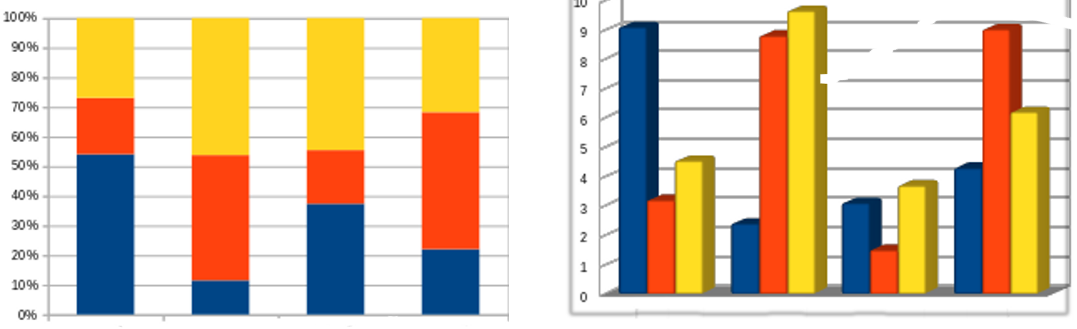
Two-dimensional and three-dimensional charts.
Three-dimensional charts were a new feature in early office suites. For a time, they completely replaced two-dimensional charts, just as justified alignment replaced left alignment, simply because they were new and seemed sophisticated.
However, in the last decade or so, a reaction has set in. Part of the reaction is a fad for two-dimensional icons and widgets on mobile devices, and part is that 3D graphics are no longer a novelty.
Whatever the reason, in many circles today, 3D graphs are seen as a sign of slickness that offers
nothing that a 2D graph does not. An audience of developers may see a 3D chart as proof that style has triumphed over substance, while an audience of marketers might see a 2D chart as a lack of sophistication.

Editing graphs and charts
By clicking on a part of the graph or opening the right-click menu, you can manually edit all of its pieces.
The pieces differ with the type of graph, but may include:
- Legend: The key that describes what the colors refer to.
- Wall: The background.
- Grid: The lines against the wall that make values in the axes easier to read.
- Axes: The horizontal and vertical values.
- Title: The name of the whole graph.
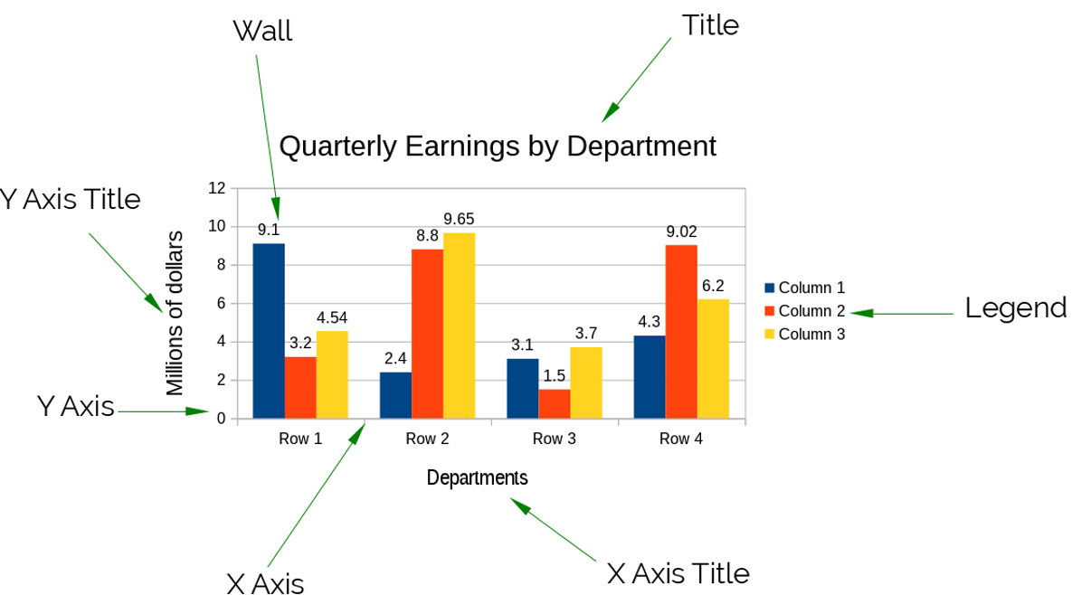
Editable parts of a chart.
Charts has no means of saving designs for later use, so copy and paste instead. If you use charts regularly, consider a template with samples of the charts you are most likely to use.
- Creating a chart
In Calc, creating a chart is easy; adding a chart opens a wizard that lets you work through the stages of formatting.
However, in the rest of LibreOffice, creating a chart can be confusing at first, because the options change with how you click on the chart.
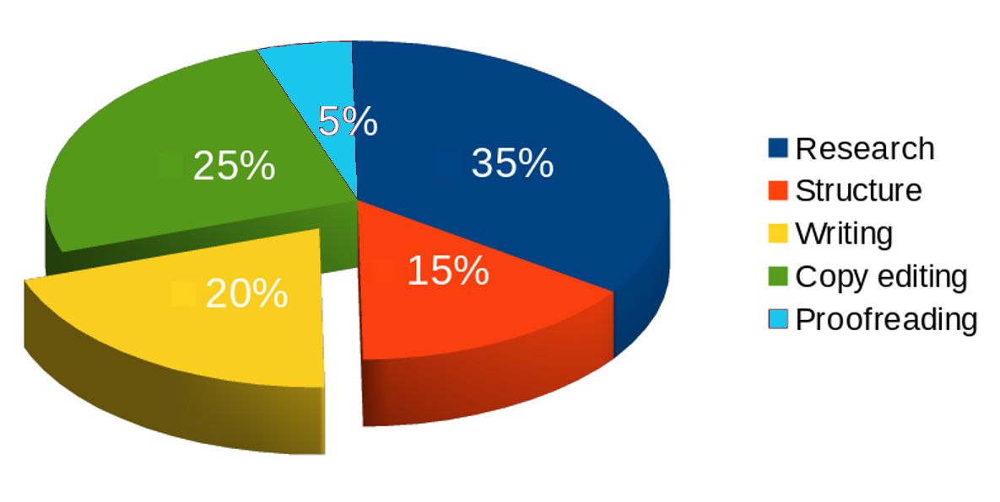
A 3D pie chart. The time spent writing is cut from the rest of the pie in order to emphasize it.
Following these steps should help minimize confusion:
- Either accept the default colors, or change them at Tools > Options > Charts > Default Colors. LibreOffice uses the colors in the order they are listed under Default Colors.
- 注意
If you are printing in black and white, test colors for contrast.
- Select Insert > Chart in Calc, Draw, or Impress, or Insert > Object > Chart in Writer. LibreOffice adds a 2D bar chart.
- Click twice on the chart so that it is surrounded by a gray border, then open the right-click menu to select Chart Type and choose the chart design to use.
- Right-click on the chart when the gray border is visible and select Chart Data Table to enter the data points for the chart.
- With the gray border still visible, click an element to edit. When an element is selected, the right-click menu contains a menu item for formatting it, such as Format Legend.
- Click on the chosen elements or data series to edit their appearance.
- With some chart types, you can select a data series, then right-click to select Arrangement. For example, if you are using a pie chart, you can select a data series and drag it out of the pie.
- Click the chart so that the gray border disappears and the object handles appear. You can drag on the handles to move or resize the chart, or right-click to change features such as alignment, or edit the Line to create a border or Area to change the background.

Separating analysis and creativity
Using styles for diagrams means finding a new way to work. Instead of plunging directly into designing, it requires taking time first to think about what you need.
At first, this new work flow may make you impatient. However, by taking more time to plan before you begin, you will save time if – as seems likely – you modify your design while you work.
Even more importantly, planning styles first helps to separate the analytic aspects of work from the creative ones. If you try to structure as you create, you are trying to think in two different ways at once, which means that you are probably doing both inefficiently. By contrast, starting with styles helps you to separate these two ways of thinking – and, chances are, do each more efficiently.
If you have any doubts of the advantages of this work method, try it several times. Then try creating a complicated diagram manually, or even a chart. Once you are used to the new way of thinking, you are likely to have far fewer false starts than if you design manually – and, probably, wish that Chart was designed for styles, too.

