10

Structured prose: lists and tables
Lists and tables are sometimes called structured prose. The name contrasts them to the relative formlessness of body text.
Structured text is easy to read, but takes up more space than body text. This extra space is no problem online, but can add to the pages and therefore the expense of hard copy.
In most word processors, list options are included in paragraph styles, while table styles are not provided at all. By contrast, Writer treats bulleted and numbered lists as a separate type of style, and tables as a sort of pseudo-style, or at least a gallery of saved formats.
Writer’s separate list styles have several advantages:
- Lists have more formatting choices, which would be harder to offer if all the choices were squeezed into a single tab for paragraph styles.
- The same list style can be used with multiple paragraph styles, avoiding duplication of design work.
- A paragraph’s list style can be changed with a single selection.
Table styles are due to be added to Writer in the future, but for now tables are formatted in a mixture of manual and style-like editing.

Understanding the types of list
With list styles, you can create:
- Bullet lists: Unordered lists whose items start with a bullet, special character, dingbat, or graphic.
- Numbered lists: Ordered lists whose items start with a number, upper or lower case letters, or upper and lower case Roman numerals.
- Outline lists: Hierarchical summaries of an argument or piece of writing, in which each level has its own numbering system.
All these types of list are in common use today, especially online.
However, what most people do not appreciate is that each has its own set of conventions about how they are structured and used – conventions that are rarely taught in schools, and that most people never observe or learn.

Understanding bulleted lists
Bullets are probably descended from midpoints, the all-purpose separator used in medieval European manuscripts. However, midpoints were used to cram as much as possible on each line because parchment and other writing materials were expensive.
By contrast, bullets take up more space. They take full advantage of the cheapness of wood or rag pulp paper compared to vellum for printing.
More recently, of course, the rise of online reading means that space is no longer an issue, so bullet points can be used at will without increasing the expense of publication.
Nobody has documented exactly what happened, but the name suggests that bulleted lists started being used after the invention of guns loaded with balls.
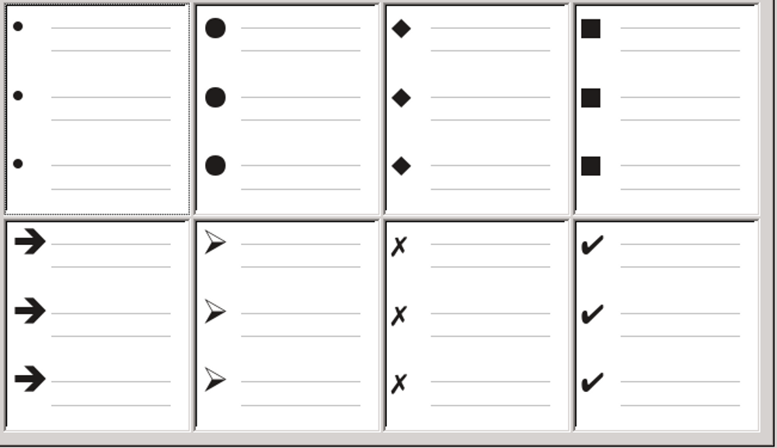
Writer’s pre-defined bullet types.

However, we do know that, by the mid-twentieth century, bulleted lists became popular in technical documents. More recently, slide shows have further spread the use of bullets.

Learning the conventions for bullets
The use of bullet lists follows well-defined rules. Bullet lists:
- Are used only when the order of the points is irrelevant. You might want to arrange points for rhetorical effect, starting with one fairly important point and ending with your strongest point, but readers do not actually need to know one point before another. The HTML tag for bullet lists, <ul> (unordered list), emphasizes this convention.
- Have three points or more. If you have two points, they both stay in the body of the text.
- Are introduced in the last sentence in the body text above them either without any punctuation, or with a colon.
- Consist of points that are all grammatical completions of the last sentence in the paragraph before them. That means that each point has a similar grammatical structure to the others. In this bullet list, for instance, each point starts with a present tense verb.
- May be sentence fragments, but should be consistent with each other. For example, they could be all nouns or participles.
- Start with a bullet on the left margin, then indent for the text. If they are lists within lists, then the bullet has the same indent as the text in the top level list. The extra indentations of raw HTML and Microsoft Word are the exceptions, not the convention.
- Can start with either an upper or lower case letter, so long as the convention is consistent throughout the list and the document.
- End each point with the same punctuation. No punctuation, commas, semi-colons, and periods are all valid choices. What matters is the consistency of list items and of all lists within the document.
- Are generally no more than 6–8 items long. Much longer, and the ease of reading is lost.
- Do not use an “and,” “or,” or any other word to introduce the last point in the list, even though that would be grammatically correct.
- Are sometimes considered too informal to use. When in doubt, avoid them.

Understanding numbered lists
While people number lists all the time, the convention is that numbered lists should only be used when the order of the information matters.
For instance, in a procedure in a technical manual, one step might be impossible – or even dangerous – without doing another one first.
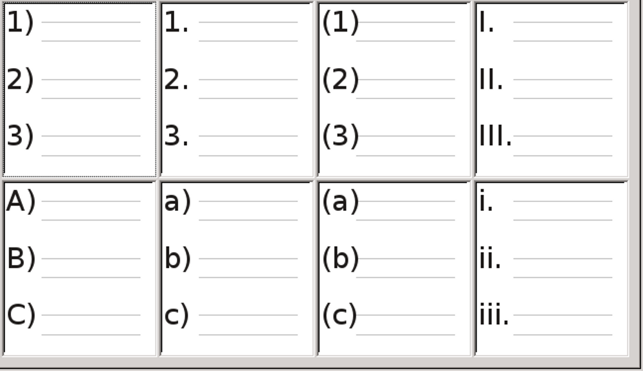
Writer’s pre-defined numbered lists.

Learning the conventions of numbered lists
Numbered lists have fewer conventions than bullet lists, but they do have a few:
- They are used when the order of items is important. If the order is irrelevant, use bullet lists instead.
- Like bullet lists, they are used only for three items or more. Two-step procedures stay in the body of the text.
- They are generally introduced in the body text by a summary of the overall task they describe that ends in a colon. For example, “To install the software update, follow these steps:” or, simply “To install:”
- Each step can have multiple paragraphs, most of them unnumbered, describing what happens when it is performed or the alternatives.
- The steps in a procedure should be less than a dozen (some suggest 6–8, based on the
- maximum number of items the average human can easily remember). Any more are intimidating and harder to remember.
- 祕訣
If each step has multiple paragraphs or you have more than about a dozen steps, you may need to break down the list into smaller lists or else present the points as ordinary body text.

Understanding outline lists
Outline lists summarize the structure of a much longer, typically unwritten document. In finished technical and legal documents, they are used in headings to make the structure obvious, although this use is becoming less common than it was a couple of decades ago.
Writer gives several options for outline lists. List styles create an outline method that uses a single paragraph style. When such a paragraph style is in use, you change the level and the numbering by pressing the Tab key to descend a level, and Shift+Tab to ascend a level. This single style outlining is by far the quickest to apply and learn.
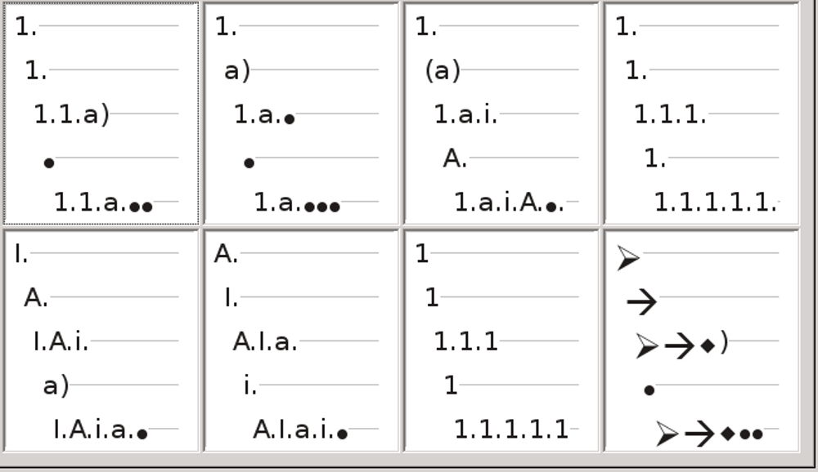
Writer’s pre-defined outline list styles. Remember that bullets imply that the order is unimportant.
The conventions for outline lists are:
- Usually, a different numbering system is used for each level to help distinguish them.
- Levels can be ordered using Arabic numerals, upper and lower case Roman numerals, and upper and lower case letters.
- Upper case Roman numerals are usually reserved for the top level, and upper case letters are used before lower case ones. Another alternative is Arabic numbers followed by lower case letters. However, these rules are not fixed.
- In technical manuals, you used to see multiple levels in a heading (for instance, I.A.2 or 1.1.1). These headings have largely fallen out of practice except in a few specialized cases such as legal documents, for the obvious reason that they are hard to remember. Also, if each heading is indented, as was common in the days of
- typewriters when formatting choices were limited, after two or three levels, almost no space is left for text.
- 祕訣
Practically speaking, you should also restrict the number of levels in an outline to 3 or 4.
This restriction is not a convention so much as the recognition that any more reduces the clarity that is supposed to be the purpose of an outline list.

Naming list styles
LibreOffice uses List 1-5 for default bullet lists, and Numbering 1-5 for numbered lists. However, these names are too limited to remember easily. Instead, add your own styles and give them descriptive names like Arabic Numeral Blue or Lower Case Indented.
- 祕訣
Using the same name for both the list style and the paragraph style with which it is linked can make working with different types of styles much easier. If you use a character style to define the bullet or number, give it the same name, too.
Along with each basic paragraph style, LibreOffice also includes list styles ending in Cont. (Continue), End, and Start. You can use these styles to customize lists.
For example, the Start list style might have extra space above it to separate the list from the body text, and the End list style extra space below it.
The Cont. style is sometimes used for unnumbered paragraphs in a list that have a different format. However, the name suggests using it with a list style with the Numbering field set to None on the Options tab, and (continued) or the equivalent in the Before field.
The text in the Before field will be added automatically whenever you apply the style.
- 祕訣
If the paragraph has no other content than the Before field, you need to type a space before you press the Enter key. Otherwise, the paragraph disappears.
If you decide not to use these styles, you can right-click on each of them in the Styles and Formatting window and hide them. You can go to the Hidden view and unhide them later if you decide you need them after all.
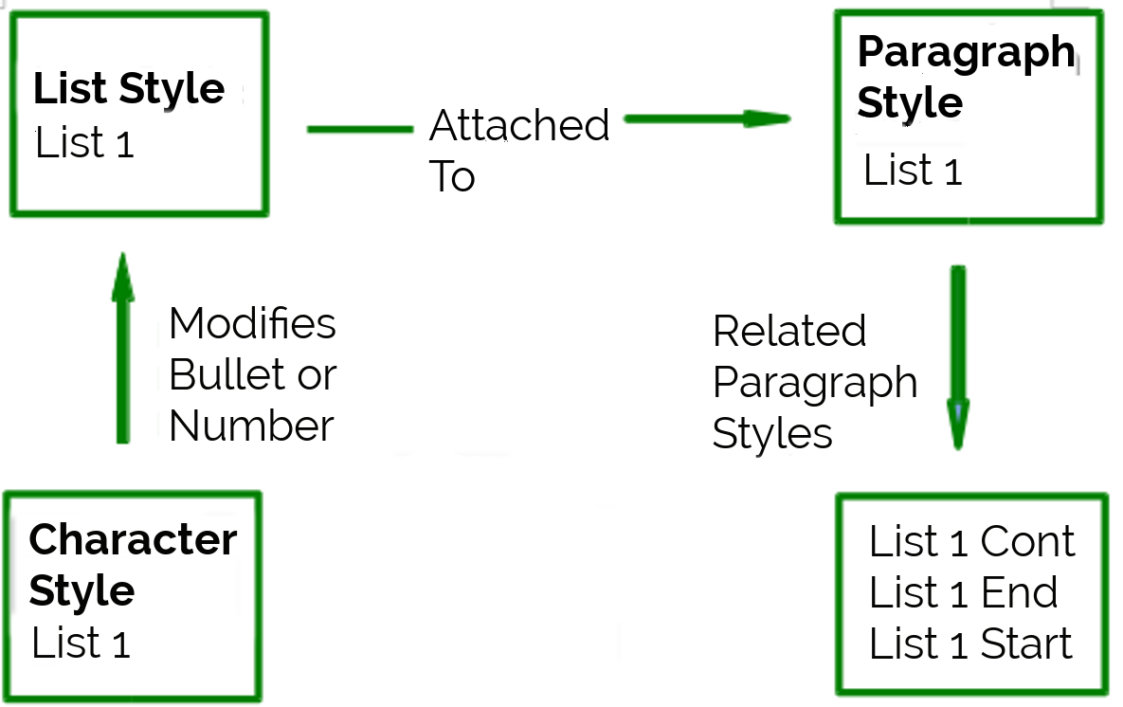
Give related styles similar names and you can locate the ones you need more quickly.

Applying list styles
You can apply a list style just as you would any other style, placing the cursor in a paragraph, and then selecting the list style from the Styles and Formatting window.
However, the most effective approach is to create a paragraph style that is attached to the list style. Go to the Numbering style field on the Outline & Numbering tab for the paragraph style, and select the list style from the drop-down list. This method also has the advantage of requiring fewer mouse clicks to apply the style.
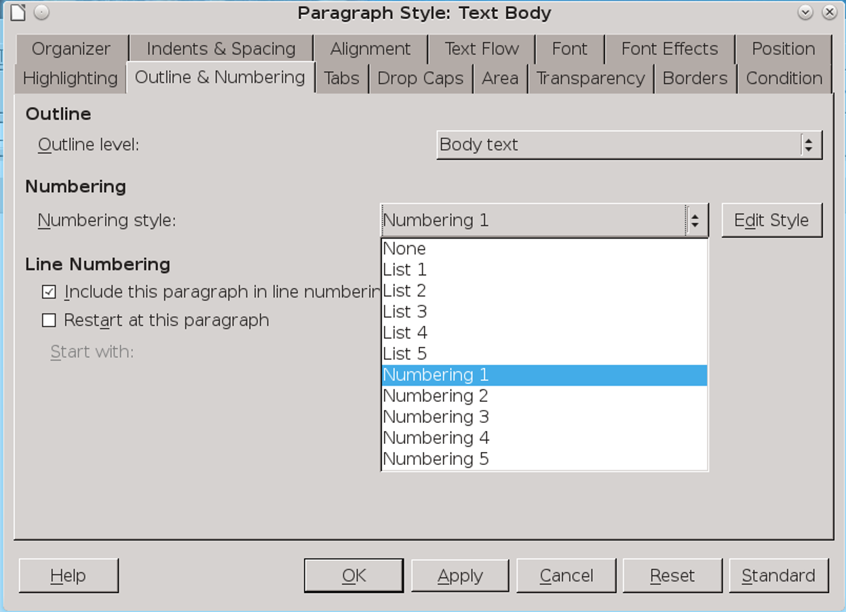
Select Outline & Numbering > Numbering style to select from the drop-down list the list style to associate with a paragraph style.

Formatting list styles
You have two ways of formatting bullets and numbers in list styles.
The quick way is to select a style from the Bullets, Numbering Style, Outline, or Image tabs for a list style. Each of these tabs give a variety of options, although not an exhaustive list.
However, I suggest you avoid using any choices on the Image tab unless you want a retro mid-1990s look.
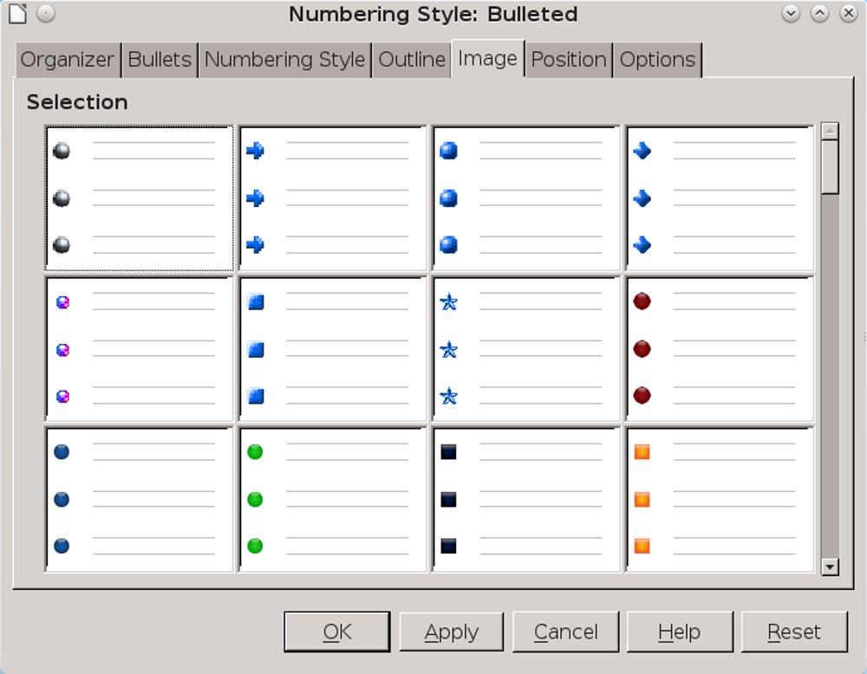
The bullets on the Image tab are too old-fashioned to use.
The second and more practical way is to customize bullets or numbered lists for yourself, using the Options and Position tabs.
Both the Position and Options tabs have ten levels. This setting is mostly useful for creating a single outline numbering style, in which the numbering changes each time you press the Tab key (see “Understanding outline lists,” page 6).
For most bulleted and numbered lists, either set the Level to 1, or leave the Level at the default 1-10.
If your design gets muddled, restart by clicking the Default button on the Position tab or Reset button on the Options tab.

Positioning bullets, numbers, and list items
The Position tab sets up the spacing before bullets or numbers, and between the bullet or number and the text.
When a list style is linked to a paragraph style, editing the fields on the Position tab in the list number dialog results in changes to the Indent > Before text and Indent > First line settings on the Indents & Spacing tab for the paragraph style.
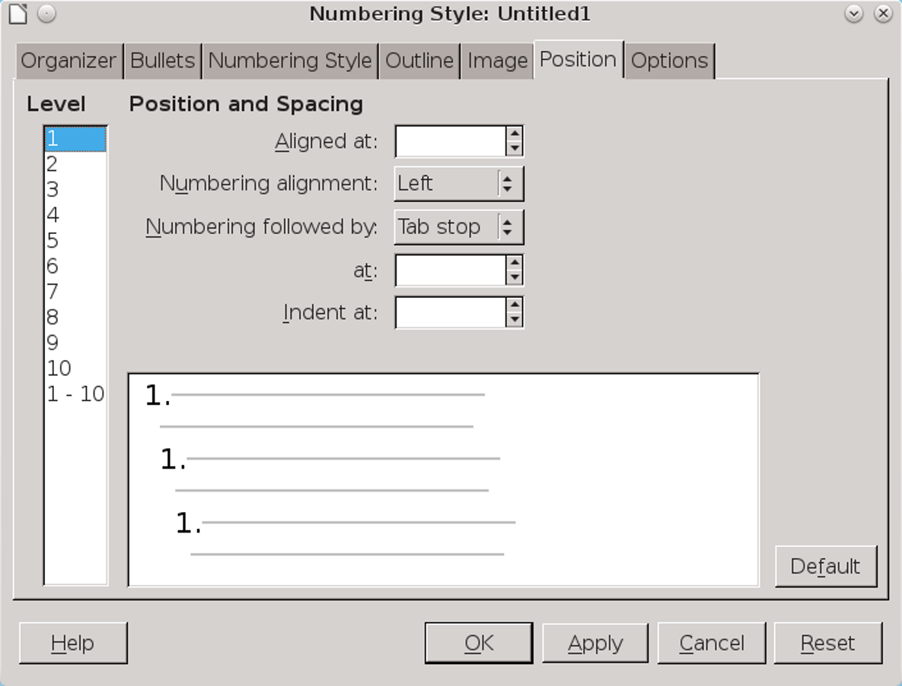
The Position tab is one of two tabs in the list style dialog window for customizing lists.
The reverse is also true. However, to avoid complications, make all the changes on the Position tab for the list style. Not only is that the logical place
to look for changes on the list style, but adjusting the paragraph settings usually involves negative entries for the First Line field, which can complicate editing immensely.

Understanding position fields
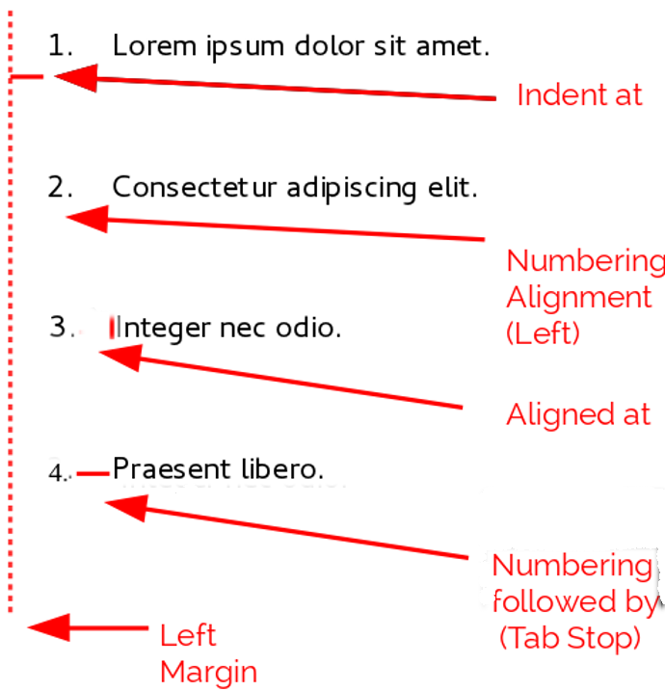
Fields on the Position tab for list styles and what they refer to. In this case, the list is indented from the left margin, which often is not the case.
When you are defining a new list style, the important fields on the Position tab are:
- Aligned at: The vertical position for numbers, measured from the left margin. In most cases, you can leave this field at 0 (at the left margin). However, if you use any Numbering Alignment except Left, numbers set this field to another value.
- Numbering Alignment: How the bullet or number is aligned. Most of the time, you can leave this field
- at the default of Left, but if you are having trouble positioning text, changing the alignment to Center or Right can sometimes solve the problem, especially for lists or levels that require two-digit numbers.
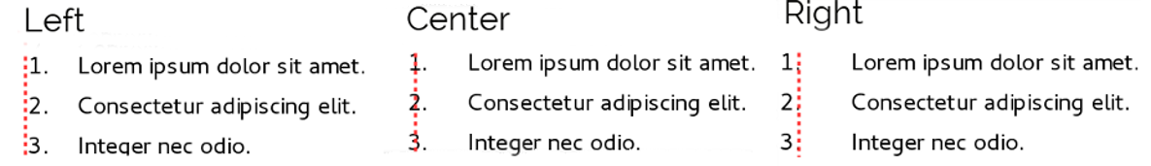
The dotted line is the margin in this example. If the value of the Numbering Alignment is 0, then choosing Center or Right can force the numbers into the left margin.
- Numbering followed by: Sets the space between the number or bullet and the text. Although the choices include space or nothing, the choice that offers the most control is Tab Stop. Set the exact tab in the at field directly below the drop-down list.
- Aligned at: Sets where the numbers or bullets are on the line. In many cases, this setting is 0 points – that is, against the left margin.
- Indent at: Sets the start of the text. This setting should be equal or greater to the tab stop set for Numbering followed by.
- 注意
This setting should not be more than about two line-heights, or else the connection between the bullet or number and the text might be lost.

Formatting ordered (numbered) lists
To create a numbered list, select a numbering style from the Number field on the Options tab. The selections in the drop-down list begin with typical choices for Western European languages: Arabic, upper and lower case letters, and upper and lower case Roman numerals. Scroll down, and options for Bulgarian, Russian, Serbian, and Greek are available.
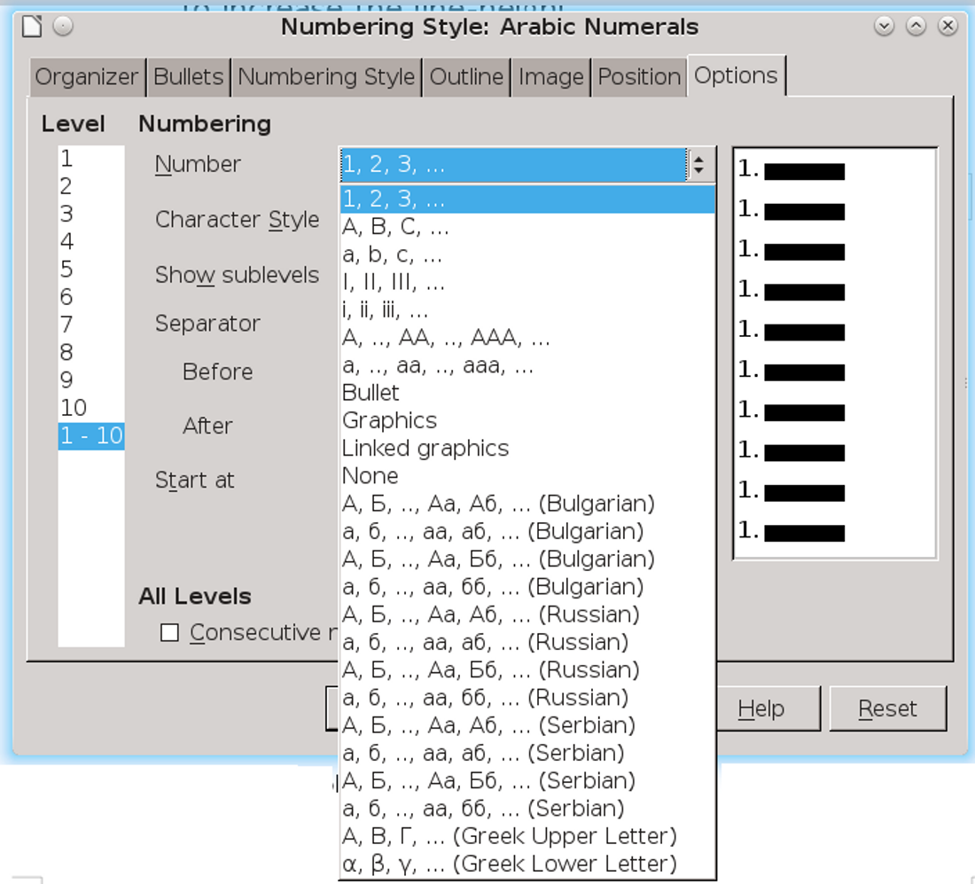
Select a numbering style from the Options tab.

Adding characters before and after numbers
You can set up to 40 characters before or after the actual number using the Before and After fields. These characters are added automatically whenever the list style they are attached to is applied.
Common characters after a number might be a period, a parenthesis, or both. Alternatively, you might put a parenthesis both before or after the number, or text such as Step # in the Before field. In a List Cont. style, you might add (Continued) before.
More elaborately, you might set a paragraph style to start at the top of the page, then attach to it
a list style with text so that the paragraph style will automatically add text.
In a numbered list, you can choose the number of outline levels in the list by adjusting the Show sublevels field. For example, if you decided to show three sublevels, the first use of the third sublevel would be numbered 1.1.1.
- 注意
Using the Before, After, and/or Show sublevels fields means that the settings on the Position tab need to be adjusted so there is enough space between the number and the text.
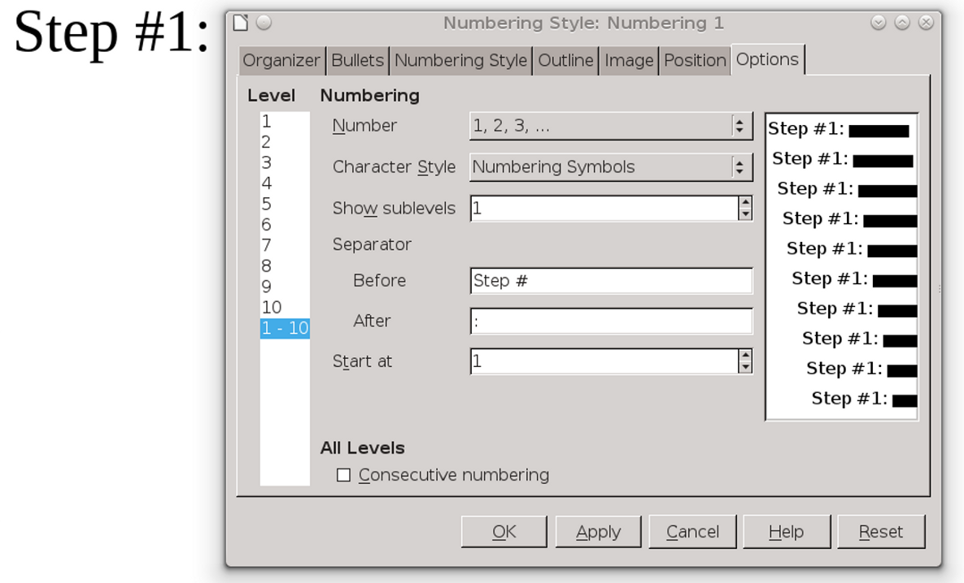
Characters before and after numbers in a list, created using the Before and After fields, increase the versatility of list styles.

Setting the character style
By default, the Character Style field for numbered lists is set to the Numbering Symbol character style, and for bulleted lists to the Bullets character style.
For most purposes, you probably have no reason to change these defaults. Unless modified, these character styles use the same font and font size as the Default Style character style, and apply to both the number and any text in the Before or After fields.
Common modifications include making the numbers or bullets larger, giving them a corporate color, making them bold, or using a condensed version of a font.
- 注意
You may need to change the text indent if you use a larger font, especially for two or three digit numbers. The line height may also need to be increased.

Working with two-digit list numbers
Numbered lists with two digits can displace list items, upsetting your carefully calculated designs by offsetting the text too much.
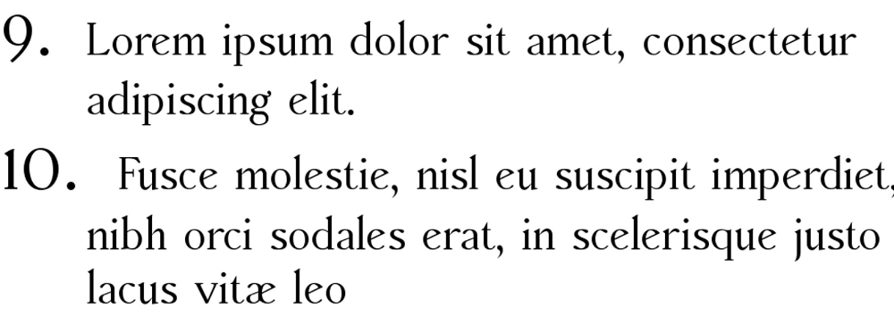
Unless extra spacing is provided, the list items are displaced when the numbering enters two digits.
You have several options to correct this problem:
- Never have a list with more than nine items. Rewrite lists that have more, combining steps or dividing one list into two or more shorter ones. This arrangement may make your instructions the easiest to remember.
- Add extra space between the number and the list item using the Indent at field. Do not add so much space that the association between numbers and list items is lost.
- Adjust the size of the numbers using Options > Character Style.
- Set the Numbering Alignment to Right. Watch that this change does not extend numbers into the left margin.

Restarting a numbered list
The Options tab for a numbering style includes a Start at field. However, notice that this field refers to the first time that the list style is used in a
document. It is not a tool for re-starting the numbering.
To restart the numbering in a list, right-click on a paragraph with a list and select Restart Numbering from the menu.

Reversing number order
People occasionally ask for numbered lists that count down from the starting number, instead of up – presumably for Top 10 lists and other countdowns. Unfortunately, LibreOffice provides no way short of a custom macro for reverse order in lists.
A reverse order list must be entered manually. Since LibreOffice does not recognized reverse order lists, it will not automatically generate numbers.

Designing unordered (bulleted) lists
The default character style for bullets is Bullets. It gives you a standard bullet for the Default style. However, you might want to change the symbol using the Character field. Selecting the Character field opens a dialog window from which you can choose any symbol supported by the current font.
To choose a truly unusual bullet, set the character style to use a dingbat font. However, be careful: too detailed or unusual a dingbat distracts from the contents.
- 注意
When you use an unusual character style for bullets, be sure to include the font used when you share a file.
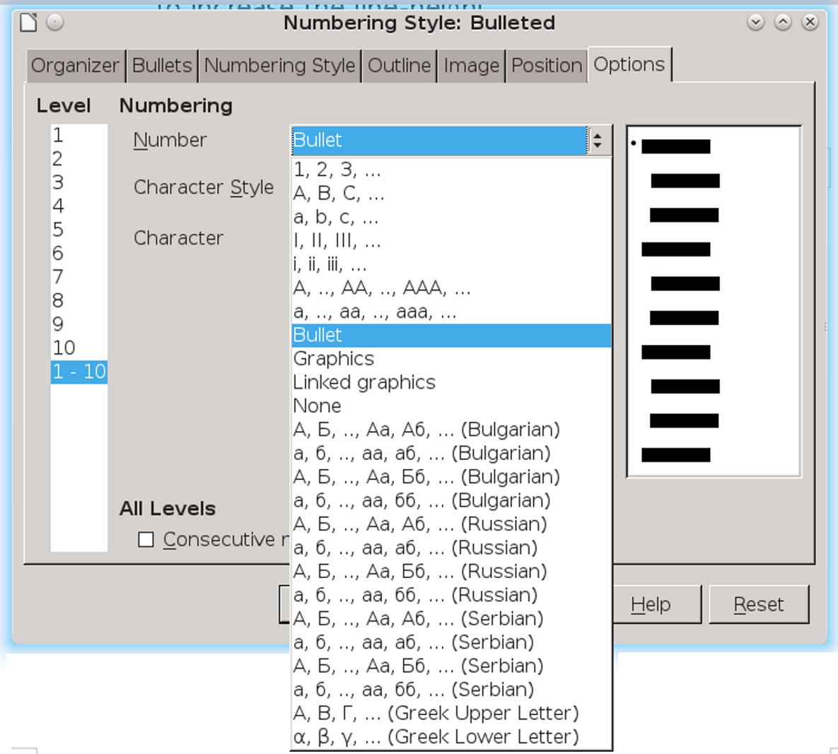
The field name is deceptive: To set up a bullet list, select Options > Number > Bullet in a list style.
If your design includes nested bullets – that is, bullet lists within bullet lists – you might want to create an additional list style with a name like Bullets2.
However, if you do use more than one bullet list style, make sure their designs are compatible. In fact, indenting the nested bullets and nothing more is enough to distinguish them from the top level bullets.
- Example: Making a checklist
Depending on the characters you choose, bulleted list styles can serve as more than unordered lists. For example, a bullet list can be made into a checklist by selecting the font or character used for the bullet.
If you want a checklist to be used with a pen, set up the list style in the usual way, using a character style that uses the OpenSymbol font that ships with LibreOffice, and assign the character U+E00B (a shaded open box) as the bullet (that is two zeros, not lower case “o”s). Print the list, and it is immediately ready for use. Add some corporate branding and letterhead, and the To Do list can be used in business.
If you want to use the list on the computer, create two list styles, one that uses the character U+2752, and one that uses the character U+E531 (a box with a check mark). Create the list using the first style, then tick off an item by applying the second style to it.
Depending on the purpose of the list, you can also create a third list style that uses the character U+E532 (an X mark) to indicate items that were not completed.
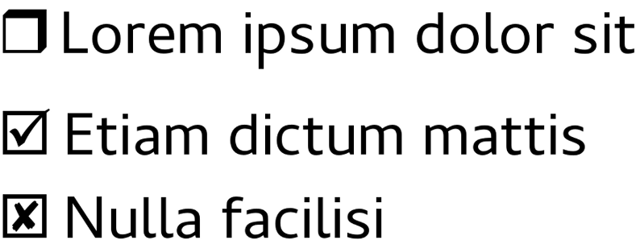
With three list styles, you can create both manual and computer-based checklists. Change the Paragraph style and its associated List style as each task is completed or marked as undone.

Using images as bullets
Using an image instead of a standard bullet is a convenient way to add some originality to your document. However, you are limited by the small size at which most bullets display. Mostly, you need simple images with strong contrast as a substitute bullet. Often, a black and white image will be more effective.
Images used for bullets are also a way to position an image on a page. In particular, they can be used to create tip and warning signs in a technical manual or an informal text.
In either case, select a graphic to use from Position > Number in the dialog window for the List style.
Choosing Graphics embeds the picture within the document file. By contrast, Linked graphics only adds a link to the graphic. See “Error: Reference source not found,” page Error: Reference source not found.
- 注意
If the image is cut off, you need either to adjust the image size, or else change the line spacing to At Least so the top half of the characters in a line is not chopped off..
After you choose Graphics or Linked graphics, the window lists a set of fields for editing the bullet:
- The Select button opens a file manager to select the picture.
- The Width and Height fields set the size at which the picture displays. They do not affect the original picture file.
Remember that too large a height requires changing the paragraph Line spacing setting to At Least so that the letters are not cut off at the top.
- Keep ratio, when selected, ensures that changing either the Width or Height field changes the other proportionally.
- Alignment can usually be ignored, but can help with the spacing between the bullet and the text.
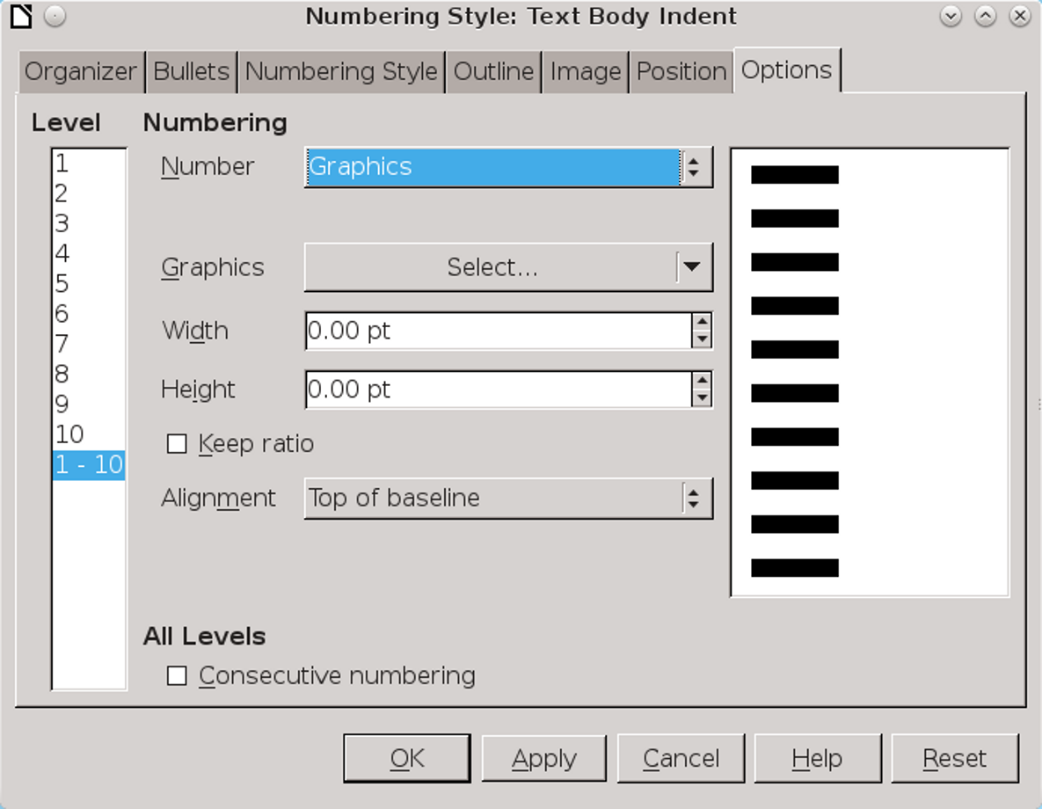
The fields for using a picture as a bullet appear after you have selected Options > Number > Graphics or Linked Graphics.
- Example: Repeating graphics using lists
Graphic bullets are especially useful for reoccurring graphics. For example, in a technical document, you could use a graphic to mark a note, caution, or warning, as this book does.
To use bullets for repeated graphics:
- Create the style, setting it up to use the graphic (see “Positioning bullets, numbers, and list items,” page 11).
- Create a paragraph style to link the list style to. If you want a logo at the top of every page, create an automatic page break on the paragraph style's Text Flow tab.
- Apply the paragraph style as needed.
- Type the text to accompany the graphic. You must enter at least one character or a space, or else the graphic disappears when you press the Enter key, leaving the indent but no bullet.

Setting up and designing tables
Tables began to be used in the eighteenth or nineteenth century, when scientists first appreciated their ease of reading and how they could suggest new relations between data.
Charles Babbage, who designed (but never built) the first computer, was especially fascinated with tables, especially for mathematical purposes, publishing his own tables of logarithms early in his career. Part of the intended purpose of his never-built Analytical Engine was to use and generate tables more efficiently.
LibreOffice does not have currently have styles for tables. For now, the next best thing is to to use Table > AutoFormat.
- 祕訣
You do not need to have the same number of rows and columns as in the table from which you made the
AutoFormat. AutoFormat does its best to apply the format despite differences.

Planning tables
As you design a template, decide what table formats the document will have.
The most common are:
- Plain: Uses borders, with the thinnest possible lines.
- No borders or background: This style is ideal for comparisons in point forms. It needs a reasonable amount of white space to replace the borders.
- Shaded: Uses a background for alternate rows in place of borders. The different colors help readers follow information horizontally within the table.
- 祕訣
Keep the spacing around tables consistent. Most times, you will want to use the entire space between the horizontal margins. Watch, too, for extra space added by paragraphs above and below the table.
- Place sample tables of the appropriate widths in Table > AutoFormat (see “Using AutoFormats,” page 35).
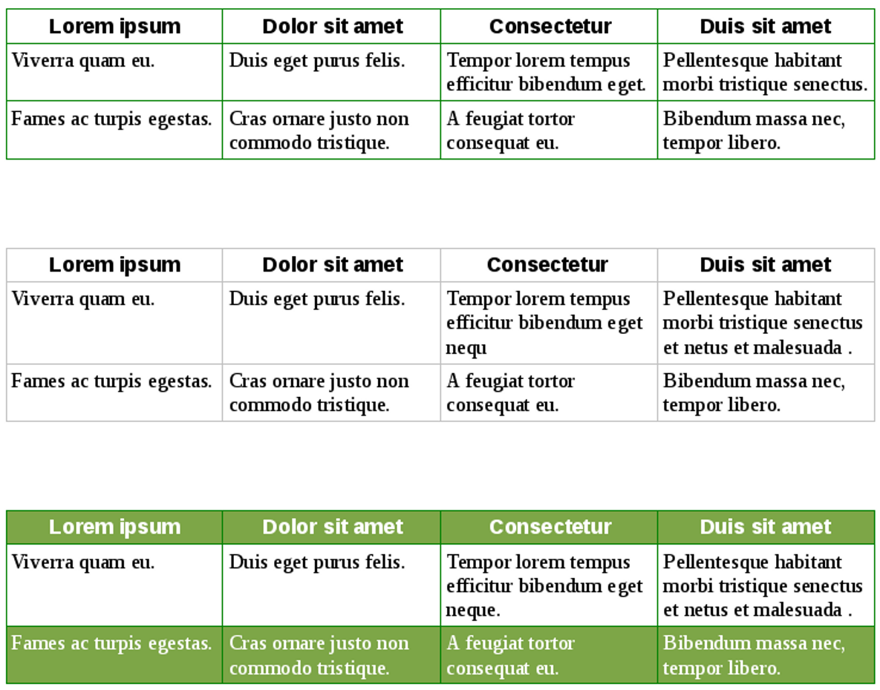
Basic table designs. When designing a template, choose a few designs and stay with them, rather than designing each table as the need arises.
The three shown here are classical designs that should serve as basic patterns for most purposes, and are compatible if two or more are used together. As you can see, modern typography favors simple designs. They may go out of fashion, but they will always remain functional.
For convenience, the boundaries of the borderless table in the middle are shown within Writer, but do not print.
To see how a borderless table looks when printed, view it from File > Print Preview.
- 祕訣
LibreOffice usually offers a choice of tables with different backgrounds for row headings and ordinary
rows. However, modern convention favors minimizing the use of backgrounds.

Designing tables
The goal of tables is to present information efficiently. Cluttered or over-designed tables work against that goal. If you are working in a Western European language like English, these rules should ensure that your tables serve their function properly:
- Headings should be horizontal or at the most slightly angled, but never vertical. Vertical headings may save space, but they reduce readability, which is the main point of having a table.
- Fonts should be the same size as body text, although they may be in a different font or weight. Making them smaller saves space at the cost of readability and convenience.
- Cell borders, shading for alternate rows, and other elaborate design elements should be minimized.
- Remember to use white space to help with the design, especially when setting the distance from a cell’s borders and its contents. A cramped table defeats the purpose of using a table in the first place.
- 祕訣
In particular, leave space at the bottom of table cells. Select all the cells in the table, and select Table > Spacing > Below. Two line heights will often be ideal.

Adding a table
To create a new table:
- Select Table > Insert Table or press Ctrl+ F12. The Insert Table dialog window opens.
- Either name the table so you can find it in the Navigator, or else accept the default name. The default name is Table, followed by a number. The number indicates the order in which the table was added, not the table's order from the start of the file.
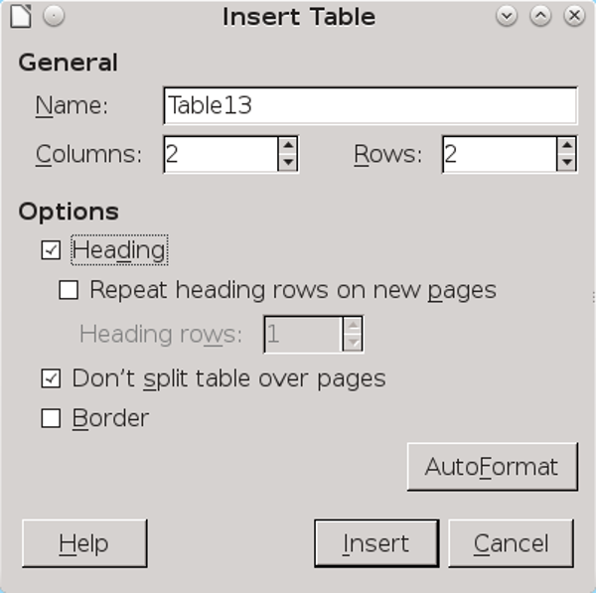
The Insert Table dialog window includes the most commonly used table options, so you do not have to format after the table is inserted.

- Select from the common options listed:
- Heading: Defines one or more rows as a Table Heading row at the top of the table. Once Heading is selected, you also have the option of Repeat heading rows on new pages, and of selecting the number of heading rows in the fields below.
- Don't split table over pages: Prevents tables from printing on two or more pages unless the table is so long that is impossible. This setting keeps information together, but can also create problems with page breaks unless tables are always given their own page.
- Border: Adds a default border around all cells and table edges consisting of a solid line, black in color and .05 points thick. You can adjust this setting on a table’s Border tab.
- Optionally, click the AutoFormat button to choose an already-defined format.
- 祕訣
Note the options you choose in the first table and, so far as possible, use them in every other one. Consider saving the table as an AutoFormat. See “Creating AutoFormats,” page 36.
- 祕訣
If you want the same options most of the time, you can set some of them in Tools > Options > LibreOffice Writer > Table.

Editing table parts
When you right-click in a table and select Table Properties from the right-click menu, you can edit all parts of the table that are currently selected. If the cursor is simply in the table, you edit the entire table.
A more exact way to edit is to use the Cell, Row, and Column sub-menus on the right-click menu. From these sub-menus, you can select, insert, or delete parts of a table, as well as adjusting their width or height.
In the Cell sub-menu, you can split a single selected cell, or merge two or more selected cells, altering the general table design for your specific purposes. For example, you might want a table heading to straddle more than one column.
To delete an entire table, place the mouse cursor anywhere in the table and either click Table > Delete > Table from the main menu or select the table as well as the space before and after the table and press the Delete key. Using the menu is generally easier.

Adjusting table spacing
By default, tables occupy the entire width of a line. If you ever need to know the exact space between margins, you can right-click on Table Properties and read the Width field on the Table tab to get the information.
To adjust a table’s overall width, select from the right-click menu Table > Table > Width. Alternatively, if
you prefer, you can adjust the Alignment and Spacing options.
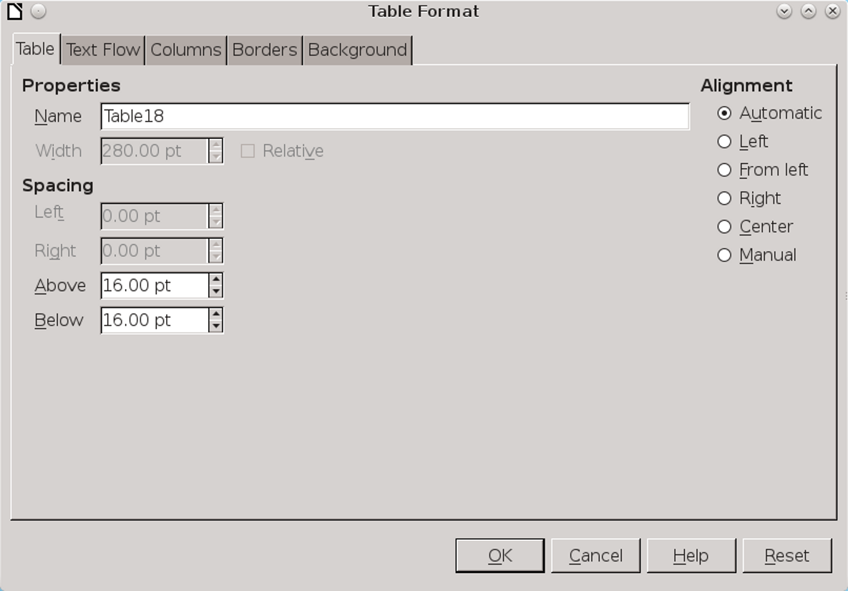
The Table tab of the Table Format dialog window has fields for positioning a table horizontally and vertically.
The available options depend on your choice of alignments:
- Automatic: The table fills the entire line width.
- Left: The left side of the table aligns with the page’s left margin. You can use Spacing > Right to indent the right side of the table.
- From Left: The table shifts by the amount in the Spacing > Left field. This option may shift the table into the right margin, where part of it may be unprintable.
- Right: The right side of the table aligns with the page’s right margin. You can use Spacing > Left to indent the left side of the table.
- Center: The table aligns with the center of the line. If the table’s width equals the full length of the line, this setting has no visible effect.
- Manual: Use the Spacing fields to adjust the table on its left and right.
If the table is surrounded by text, place a table closer to the paragraph above it than the one below it to show their relation.
Similarly, if the next paragraph style is a caption, position the caption closer to the table than the next paragraph.
To adjust the vertical spacing before and after tables, right-click on any part of the table and select Table Properties > Table > Spacing > Above and Below.
By default, content is aligned to the top of cells on the Text Flow tab. You can also align it to the center or the bottom, although in practice there is rarely a reason for doing so.

Adjusting column spacing
You can redistribute horizontal space among the existing columns by using the cursor to drag at cell borders. This method may seem inexact, but with both vertical and horizontal rulers in the editing window, it can actually be as exact as any choice.
Alternatively, select Table Properties > Columns from the right-click menu and balancing the Column Width fields.

Adjusting row spacing
You can redistribute vertical space between the existing rows by using the cursor to drag at cell borders or selecting Row > Height from the right-click menu.

Setting text flow options
Positioning a table in hard copy can be difficult, because you frequently get uneven page breaks. Sometimes, rearranging rows can improve the break, but often you need to manually intervene with one of the available tools, most of which are listed in the Text Flow tab of the Table Format dialog window.
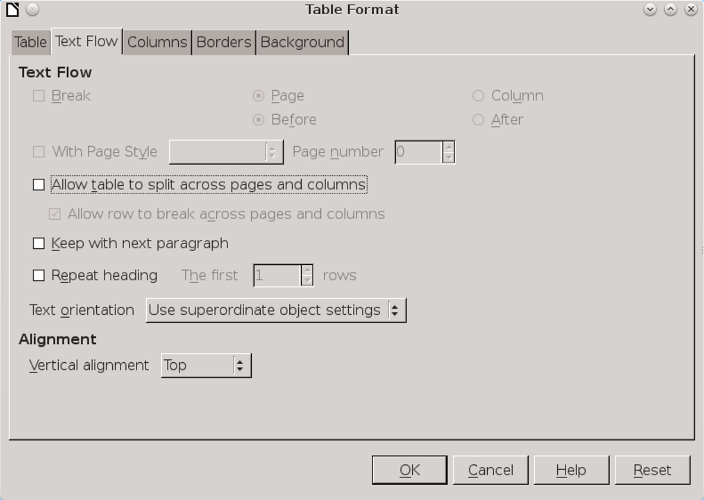
The Text Flow tab of the Table Format dialog window contains options for how a table displays on the page.
- Repeat Heading: Repeats the top row(s) of a table on each page if the table continues on another page. Usually, you need only the first row when it serves as a table heading. Repeating multiple rows will usually only be needed when you have complicated headings that take up more than a single row.
- Allow table to split across pages and columns: A multi-page table tends to defeat the purpose of making information easily read. However, a table that does not split often makes for uneven page breaks.
- Allow row to split across pages and columns: This option has the same trade-off as allowing the entire table to split, but to a lesser extent.
- Keep with next paragraph: Since a table usually requires an introduction, this setting should only be needed occasionally. However, it is available if it will be useful for captions if you prefer not to place captions in a frame.
- Repeat Heading: Repeats the top row(s) of a table on each page if the table continues on another page. Usually, you need only the first row when it serves as a table heading. Repeating multiple rows will usually only be needed when you have complicated headings that take up more than a single row.
- Convert: Table > Convert in the main menu converts text to a table, or a table to text. Converting text to a table requires markers to mark columns and rows, and is rarely worth the effort. However, converting a table to text saves time when you decide to change the presentation of information or are working with data that uses tabs to create columns.

Adding spreadsheet behaviors
Writer’s tables have limited capacity to act as a spreadsheet:
- Number format: Available from the right-click menu, Number format opens a dialog window where you can set how numbers are interpreted and
- presented. For example, if you set the format to Date, you could choose from such formats as YYYY-MM-DD or DD-MM-YY.
- Number recognition: Selected from the Table menu. Identifies input specifically as numbers and right aligns it.
- Adding formulas: Selected from Table > Formula in the main menu, this option opens a tool bar for inserting a couple of dozen common spreadsheet formulas.
The Formula bar allows basic spreadsheet functions to be used in Writer tables.
- Alignment: Available from Tools > Options > LibreOffice Writer > Table > Input in Tables, Alignment places numbers in the lower right corner of a cell, as in a spreadsheet.
- 祕訣
If you need a more complex spreadsheet, create one as a separate file, then embed it using Insert > Object > OLE Object.

Adding captions
If the sentence which introduces a table is clear enough, a caption may be redundant.
However, if a table needs a caption, or you want to refer to the table by a number, right-click and
select Caption from the right-click menu. If you always want a caption, set up AutoCaption for tables in Tools > Options > LibreOffice Writer > Table > AutoCaption.
- 祕訣
Adding a caption to the table adds a frame around the table and the caption.
If you are having trouble with frames staying in place, add a row with no borders to the bottom of the table and place the caption there.

Using AutoFormats
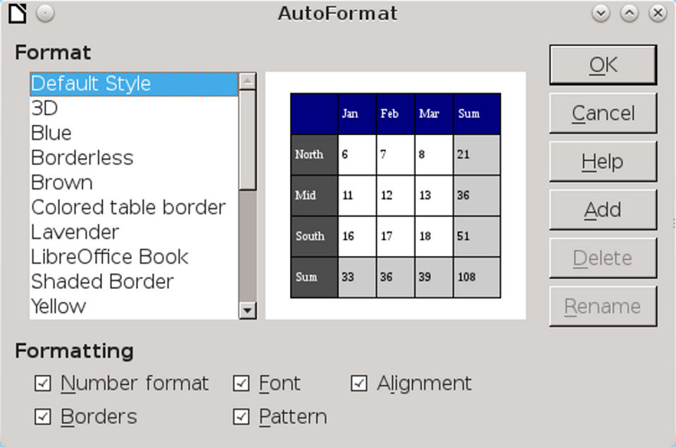
Table AutoFormats are a partial substitute for styles, but the pre-defined formats include many obsolete designs.
AutoFormats are the closest that Writer gets to table styles. As with styles, AutoFormats can be either pre-defined or customized. Unlike styles, AutoFormats cannot be edited, except for being
renamed. If you want to use the same name as an existing AutoFormat, you must delete the existing AutoFormat first.
Like many galleries in Writer, table AutoFormats include many styles that were popular in the mid-1990s, but have fallen out of fashion since. Think twice before using multi-colored AutoFormats, or the gray 3D AutoFormat.
Follow the same restrictions when creating customized AutoFormats. You might want to use corporate or project colors for borders or a colored header, but usually nothing more.
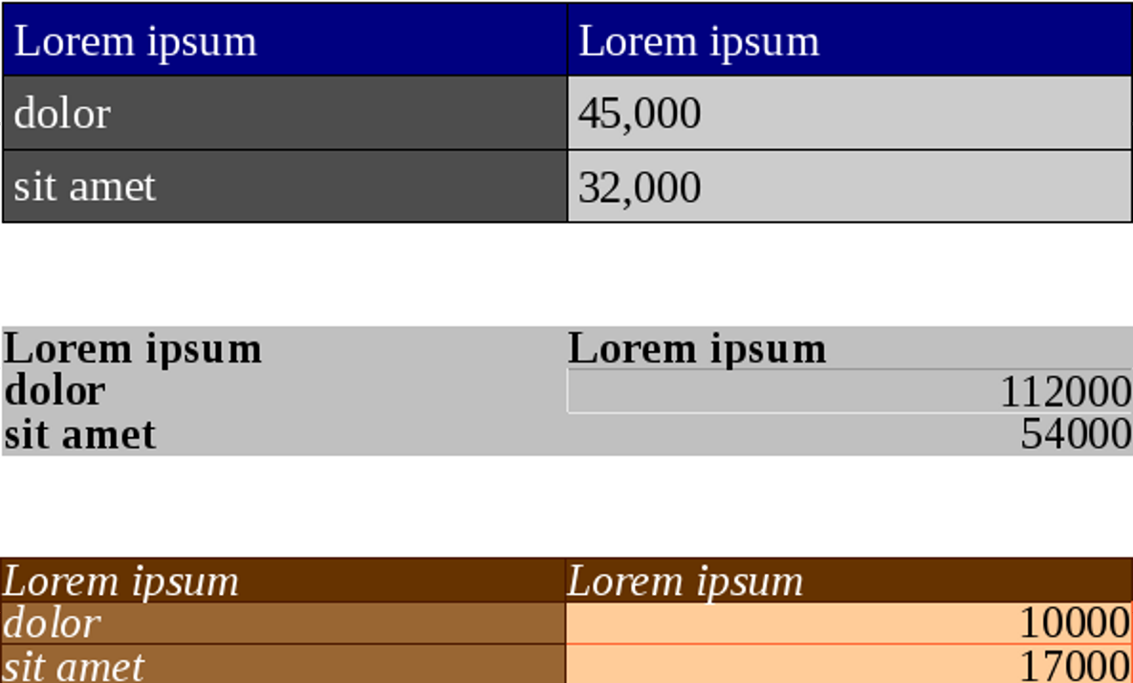
Obsolete table formats are found throughout LibreOffice. By modern standards, they are ugly and over-elaborate.

Creating AutoFormats
Creating an AutoFormat is similar to creating a new paragraph style from a selection:
Manually format a table as you choose, then, with the cursor anywhere in the table:
- Click the formatting options you want to store in the AutoFormat from the list at the bottom of the AutoFormat dialog window.
- Click the Add button. Note that in some versions of LibreOffice, once you click the button, you can no longer select formats.
- Name the new AutoFormat. Until you close the dialog window, the new AutoFormat displays at the top of the window’s list.
- 祕訣
In addition to the formatting listed in the window, you also save font selection and spacing options.
- 祕訣
As an alternative to AutoFormats, in some versions of LibreOffice you can save a table in Edit > Autotext.
- 注意
You can delete any AutoFormats one at a time, including pre-defined AutoFormats. Deleted AutoFormats are deleted not just from the current document, but from Writer and all documents.

Using tables as workarounds
In many ways, Writer’s tables are simpler versions of frames. The major differences are that you cannot wrap text around tables, and text cannot flow from cell to cell like it can from frame to frame.
However, as detailed in Chapter 8, Writer’s frames are often unstable, shifting objects without warning. When frames fail you, a table may be the solution you need. For example, tables can successfully anchor text in headers and frames, as well as keeping pictures and other objects in their positions.
In such cases, a table gives you more limited options than a frame or another formatting feature such as tab stops. However, if your main goal is to keep text or objects where you place them, tables do appear to be more reliable than frames.

New aspects of literacy
The use of lists and tables is no more than a few hundred years old. For much of this time, they were used by only a minority of scientists and engineers.
Now, however, both lists and tables have become commonplace in online documents. Neither is taught at any level of education, but how and when to use lists and tables is rapidly becoming part of the knowledge that defines basic literacy. Learn the conventional ways of using them, and you can be sure of presenting your thoughts in the best
possible light, both inside LibreOffice and at the podium.

11

Styled features and long doc

