15

Spreadsheet design
Spreadsheets are the electronic descendants of accounting ledgers. Yet although accounting ledgers are traditionally almost as regular in their formatting as text documents, the idea of styles has never caught on in spreadsheets as strongly as in word processors. There are several probable reasons for this difference:
- Spreadsheets’ forty year history is hardly enough time for design conventions to develop and become accepted.
- Spreadsheets are valued more for their functional computing power than their formatting.
- Spreadsheets are not frequently revised.
- Spreadsheets often grow as needed, because they are mostly used online. It is no accident that one of the two types of styles in Calc is concerned
- with ways of squeezing the spreadsheet on to a printed page – a special use case that is of no relevance to many users.
- Calc styles are given only two sample defaults, making it harder for users to imagine how they might be used.
Don’t mistake me – styles remain useful in Calc, especially for spreadsheets that are in constant use and maintained over long periods of time. Cell styles in particular are essential building blocks for a well-organized, self-automating spreadsheet.
Still, spreadsheets have less established forms than text documents. However, you may still want to apply the basic principles of design to your spreadsheet designs. See “Learning design principles,” page 378.

Planning spreadsheets
Spreadsheets have a way of growing with no direction, but the more advanced planning you do, the more easily you will be able to find your data as you need it.
As with text documents, begin by designing a default spreadsheet template with corporate or personal branding colors and fonts. Then, using the default template as a basis, branch out and develop additional templates for the kinds of spreadsheets you use regularly.
A Calc spreadsheet includes one sheet by default. Begin with the first sheet, then add other
sheets as necessary, right-clicking on the tabs to rename them to help navigation.
- 祕訣
You can change the default number of sheets in Tools > Options > LibreOffice Calc > Defaults.
For example, if you are a computer programmer, you might start with a general list of potential employers, then eventually add another sheet specifically for high-tech employees.
Similarly, if you are regularly manipulating data, you will find that the pivot tables you create are added by default to a new sheet. You can change the location of pivot tables from Data > Pivot Table > Create > Pivot Table Layout > Destination.

Building lists and data collections
Most spreadsheets, you will find, are either a text-based list or a data collection. Spreadsheets are usually not categorized in this way, but the distinction is useful when you are designing one.
A list spreadsheet could be as simple as a To Do list. It might include when each task should be completed, or be a project management plan that includes the stages of the project, who is assigned to each task, and the dependencies that must be completed before another task can start. This kind of spreadsheet is often overlooked, but it is one of the more commonly used types.
A data collection is what most people usually think a spreadsheet is. It is a collection of information together with calculations that help to analyze the data.
Such a collection could be as basic as a personal monthly account that lists income and expenses, or as complex as a collection of raw data whose average or future growth is projected. Occasionally, you see a data collection arranged to serve as a tutorial.
- 祕訣
If a data collection has more than a few hundred entries, you may decide to switch the information to a database.
Admittedly, current versions of Calc can contain over a million rows, and 1024 columns. However, even with modern computer memory, a database remains a more efficient way of storing, retrieving, and manipulating data. The tradeoff is that a database can require expert knowledge to make the most of it.
With both types of spreadsheet, you should generally organize by column. Not only is that the convention, but, if you plan on printing, columns are more trouble to position on the page than rows.
As you plan:
- Decide which sheets require what kind of design. For example, a sheet containing raw data needs a design that is straightforward and perhaps a single page, while a sheet containing analysis
- may require several sheets and not only headers, but also longer notes to guide users.
- Group related information on the same sheet.
- Leave space for labels – that is, cells that describe each data array. Labels assist users, and are often recognized automatically by Calc.
- Use borders, backgrounds, and empty cells to set apart one data array from another.
- Follow the basic principles of design described in Chapter 13 – formatting related types of information the same way and in the same order, and positioning them close together.
For instance, if you are recording monthly sales figures, the text of cells that display the sales figures should have the same format. Cells for totals might be a different color, and should always be placed close to the sales figures they tally.
Always, your main concern should be to make different categories of information easily distinguishable, structuring so that information is easy to absorb.
Do not worry about abstract aesthetics. Not everybody is equipped to admire the design of a text document, but very few have ever considered admiring the design of a spreadsheet. Unlike text documents, spreadsheets remain extremely practical.
- 祕訣
Unless you can visualize the format clearly, start the design by sketching out its approximate layout on a piece of paper. The more complex a spreadsheet is, and the longer the spreadsheet is likely to be used, the more important planning becomes.

Designing spreadsheet lists
A list usually consists of cells formatted for text, not numbers. Basically, a spreadsheet list is a more powerful version of a table in a text document: its structure is meant to make information easier to scan, and to help users see relations between items that would be harder to see if the document consisted only of text.
For a list, assign individual colors to either the tasks or the people assigned them. To create sub-lists, set off cells from the rest of the sheet by blank cells, borders, or backgrounds. Make the colors as different as possible to make the sheet readable at a glance.
You might also want a sign-off column, either for initials or a signature, or perhaps a check mark borrowed from a dingbat font.
Lists are likely to make little use of functions. When they do, their functions are apt to be simple ones from the Mathematical and Statistical categories, such as SUM or AVERAGE.
- Exercise: A trip-planning list
Don’t under-estimate list spreadsheets. Even without functions, they can still be useful, and they are probably the most common type of spreadsheet used
Take, for example, this simple trip planner:
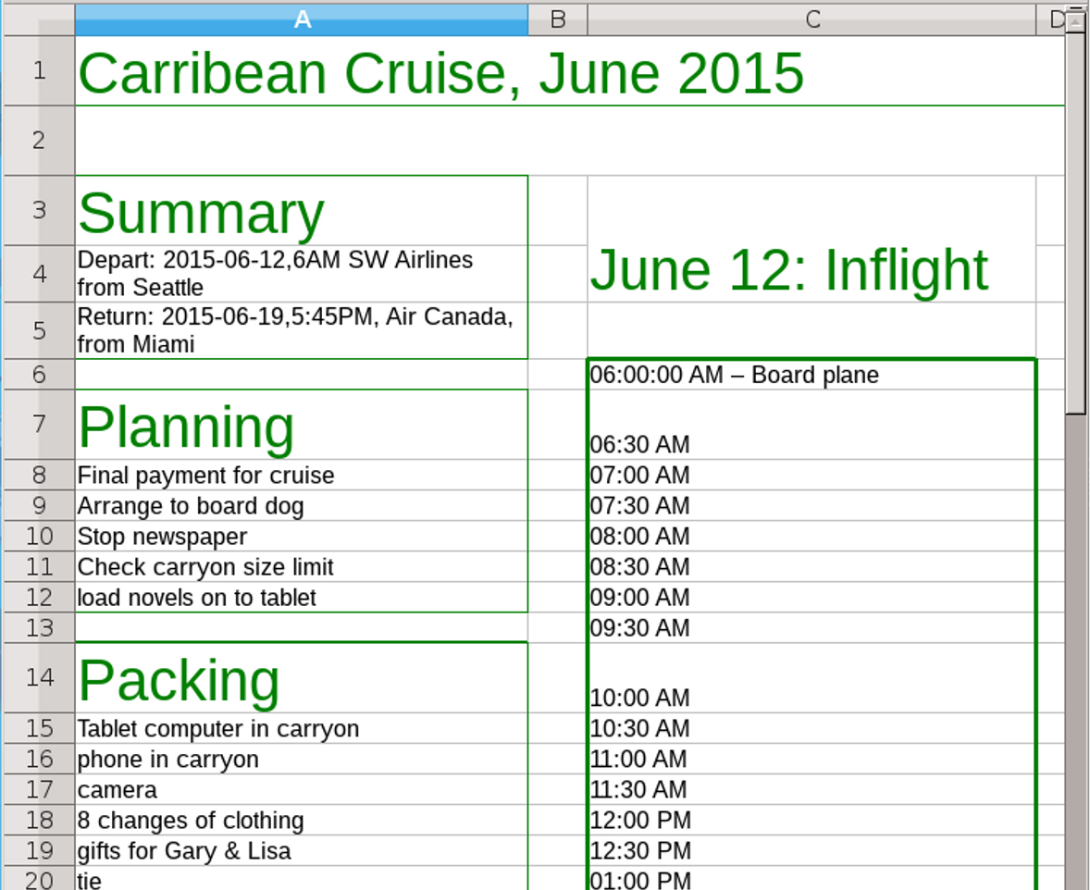
A list spreadsheet for planning a trip. Sub-lists are separated by blank cells, borders, and title, and each day of the trip is broken down into half-hour sections. Large and colored headings help to organize information as well.
To create this trip planner:
- Format the Default and Heading 1 cell styles. Make the Heading 1 style’s Font Size and Font Color different from the Default style’s.
- Merge the cells in row 1, and enter a total, using the Heading 1 cell style.
- Using empty rows and columns as separators, create ranges of rows for Summary, Planning, and Packing, increasing row and column dimensions as necessary. Use the Heading 1 cell style for headers, and the cell’s collective Border tab to put a box around each clump of information. Consider adding backgrounds, and new styles based on Default to go with them.
- To the right of the first column, add a summary for each day of the trip, and a more detailed itinerary below. Copy and paste as needed.
The resulting spreadsheet can be filled out on the computer, or on separate pages for planning and each day.
You may have to customize the resulting template for each trip, but the result will still be quicker than starting from scratch. Much of the Planning and Packing sections can be reused, while recycling the calendar only requires a change of dates.

Designing data collections
Calc includes over 455 different functions for manipulating data, and more functions are available as extensions. Many functions are deliberately
compatible with Microsoft Excel, so that Calc spreadsheets can be easily shared.
In addition to functions, plan for column headings, totals, and the results of the functions you will need. Format the cells for raw data and those for manipulations of the data differently.
Functions for data collections vary widely. Each has its own set of input variables, some entered manually and others that can be entered by dragging with the mouse on selected cells.
You can enter variables manually from the Formula bar at the bottom of the tool bars, or with Insert > Function List. However, the easiest way to add a function is to use the Insert > Function dialog window, which opens a wizard for building functions and previews answers and errors.
The window is also useful for browsing functions to discover the ones you need. You can choose a category to browse, or press a key to jump to a category starting with that letter.
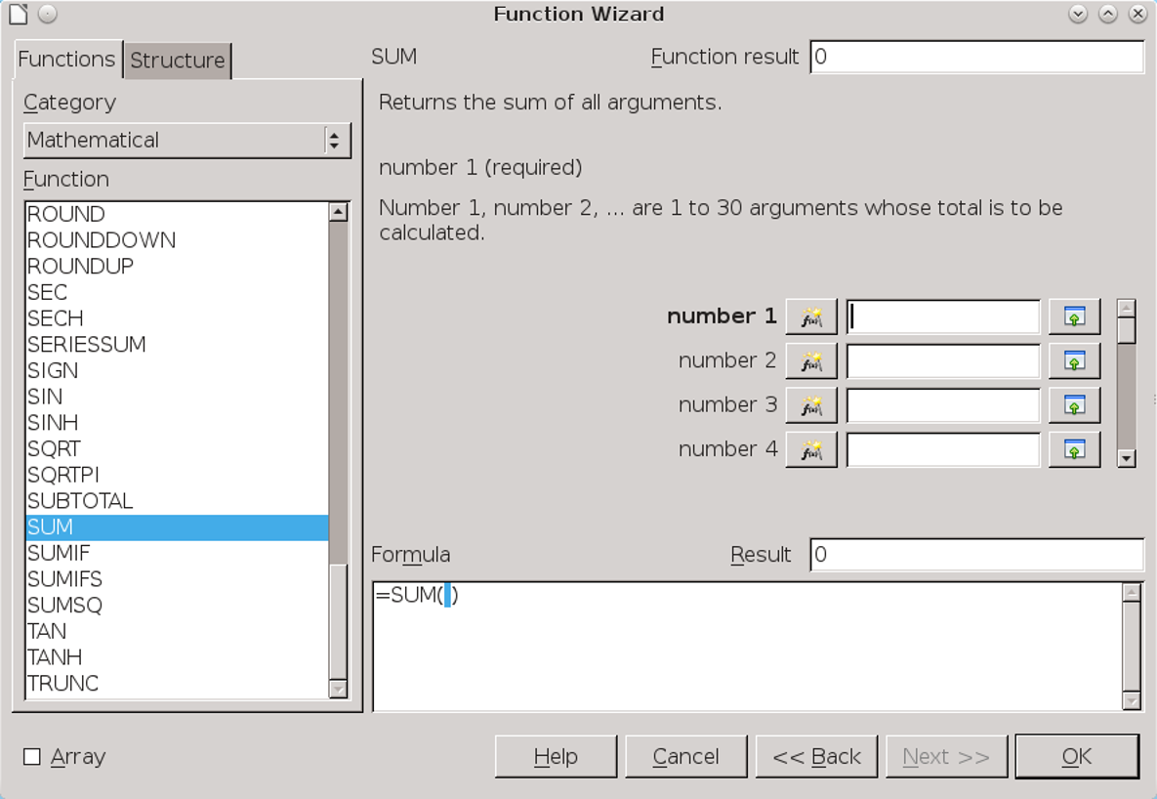
The Function Wizard (Insert > Function) is the easiest way to construct a formula.
- Exercise: Creating a mark book
A common misconception is that you need to be a mathematical wizard to take advantage of spreadsheet functions. In fact, functions can have simple everyday uses.
As an example of an everyday use for a spreadsheet, here are the steps to create a teacher’s mark book, starting with the basic setup:
- Format the Default cell style. In addition, create Total, Heading 1, Heading 2, and Value styles. Use Font Size and Font Color to distinguish them from the Default style.
- Merge columns A-G in row 1, and use Heading 1 to enter the course name.
- Set column A to a width of 12 centimeters, and column H to 1 centimeter. Column H will be used as a spacer.
- Use Heading 2 to name columns A-G. Starting from column A, the headings will be: Student, Essay 1, Midterm, Essay 2, Exam, Total, and Grade.
- Use the Value style to format the row below the headings to enter the value of each assignment. Make the total out of 100 so that it is a percentage.
- For convenience, enter the grading scale in column I. It is already set apart by the thin column H, but you can use the borders and/or background to further set it apart.
- Format the Total and Grade columns with the Value cell style.
- Leave enough rows for the number of students, then use the Exam column below the list of students for the labels of any statistics you want to set. The Total column will contain the actual statistics. A row separates the figures from the raw data in the sample, but you could use other formatting to set them apart. In the sample, I have used Average, Median, Max, and Min.
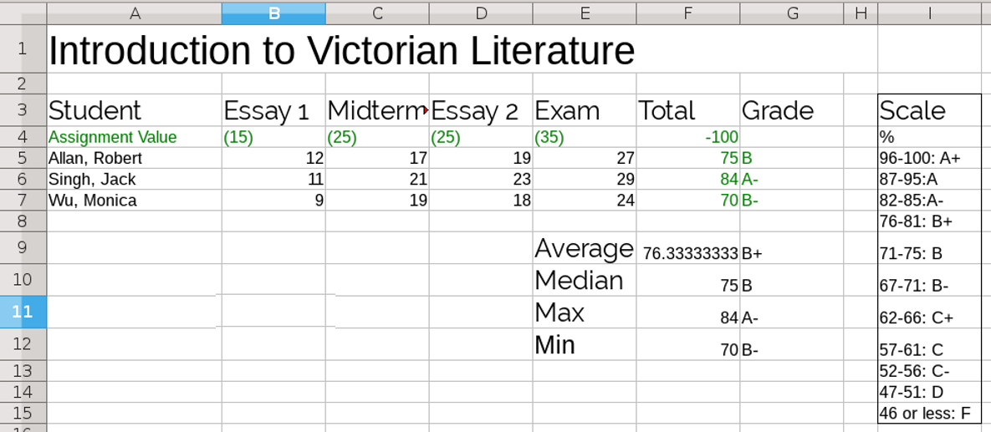
An excerpt from a data collection spreadsheet – specifically, a mark book for teachers.
- Adding data and functions
When the basic layout is finished, enter the marks and functions:
- Enter all the marks for each student.
- In the Total column for the student at the top of the list, add the function =SUM(Input Range). In the sample, the function is =SUM(B5:E5).
- Drag on the lower right corner of the cell in the first student’s Total column until you reach the end of the list. This step copies the function to each row and automatically updates each copy of the function so it works on its row.
- Use the scale to assign the grade for each student (there is probably some way to convert the percentage automatically, but it is not immediately obvious).
- Enter the function for each statistic. Use whatever functions you choose, but the sample uses:
- The average mark: =AVERAGE(Input Range).
- The mark midway between the high and the low: =MEDIAN(Input Range).
- The highest mark: =MAX(Input Range).
- The lowest mark: =MIN(Input Range).
In each case, the input range is the contents of the Total. column.
- In the next column, add the grades beside each statistic.
Delete the marks and the student names, and you can save the spreadsheet as a template.

Adding spreadsheet tools
Discussion about spreadsheets usually centers on functions.
That emphasis is natural enough, but, as you plan, consider the available tools as well. Often, they can be as important to your purposes as the functions themselves.
Tools are scattered through the main menu, but most are located in the Tools and Data menus. If, like many people, you are unfamiliar with them, taking a look at their purposes can help you plan your spreadsheets.
Some tools – Detective, Goal Seek, Multiple Operators, Pivot Tables, and Solver – are for use as you work with a spreadsheet. For that reason, they are not detailed here. By contrast, the ones here can be added to the spreadsheet as you design, either because they
make using a sheet easier or because they need space allocated to them on a sheet.

Hiding and showing the display cells
Each row and column heading includes options to Hide or Show. Changing these options can temporarily reduce complexity when you scan or study data, or select the data to print to hard copy.
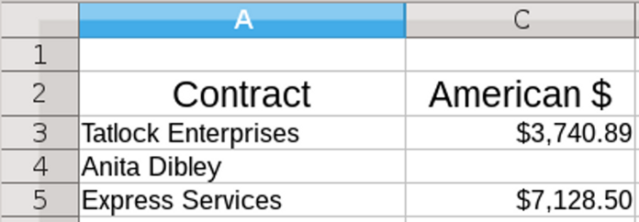
A hidden column – in this case, Column B, which is for contracts paid in Canadian dollars. You can still tell that the Anita Dibley contract is in Canadian dollars, because its listing under American dollar is blank.

Grouping and outlining cells
As an alternative to hiding individual cells, you can select Data > Group and Outline > Group to hide multiple cells. This feature clumps rows and columns together. Creating a group adds a tree structure to show the group by expanding the tree, or hide it by collapsing the tree.
- 祕訣
Groups can be nested within groups.
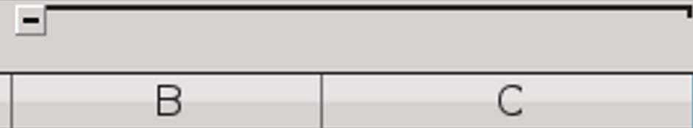
Here, Columns B and C are grouped, allowing them to be hidden or revealed together. The control for expanding and hiding are in the top margin on the left.

Filtering data
Data > Filter changes the data displayed in a selection of cells. Filtering does not delete the data in the selected cell – only which cells are displayed.
By filtering, you can focus on data more carefully by hiding information not immediately needed, or prepared different versions of a spreadsheet for printing or presenting to different audiences.
Calc includes three types of filter. The standard and advanced filters can be useful, but the most convenient filter for everyday use – especially in lists – is often AutoFilter.
Adding an AutoFilter requires a cell at the top of a range of cells, where it adds a permanent drop-down list for filtering. This cell can contain a heading, or, if you prefer, remain blank so that the control in the lower right corner is more obvious.
AutoFilters have several advantages:
- They are always on the sheet, next to the data they filter.
- Alone among filters, they can show empty and non-empty cells.
- The menu includes buttons for hiding and unhiding cells.
- You can create a standard filter from them.
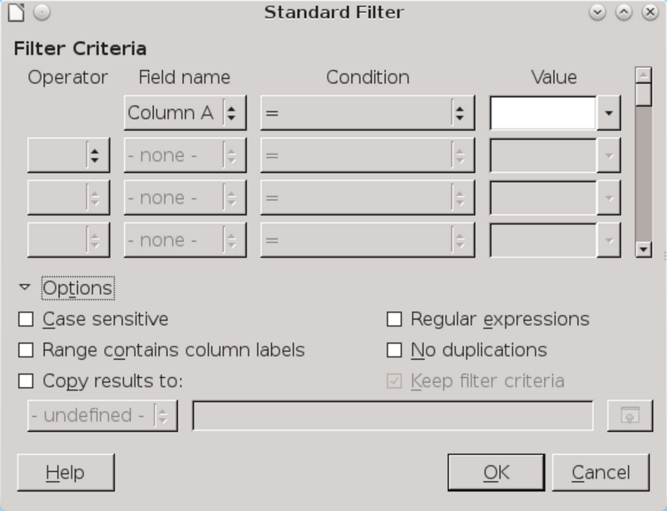
Tool > Filters > Standard Filter sets the Columns and conditions with which to filter information.

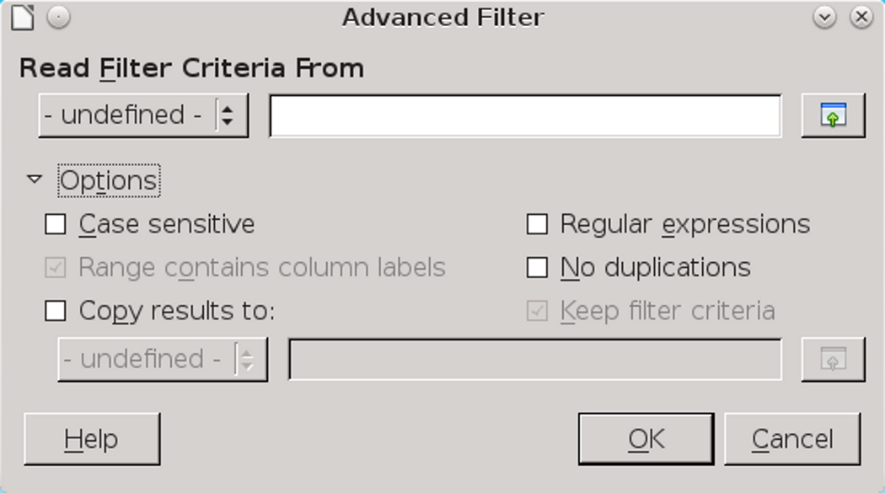
Tool > Filters > Advanced Filter reads filters from the spreadsheet. Otherwise, its options are similar to those of a standard filter.
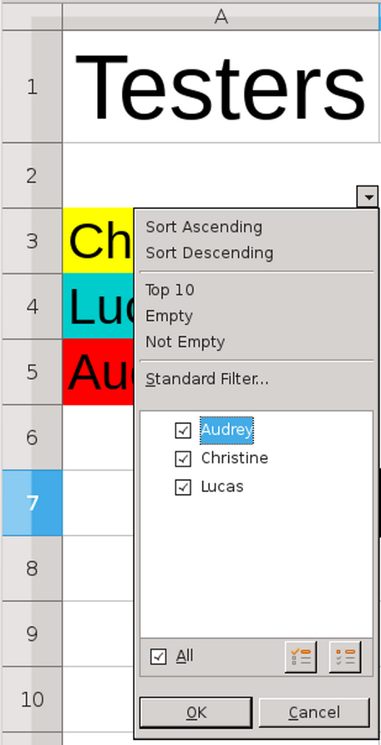
Data > Filter > Autofilter adds a convenient drop-down list for sorting a range of cells.

Creating subtotals
SUBTOTAL is actually a function listed under the Mathematical category of functions. However, because of its usefulness, the function has a graphical interface accessible from Data > Subtotal.
To work, SUBTOTAL requires a data array – that is, a selected range of cells with a label. When applied, it adds labels for subtotals and totals.
Using the Subtotals window, you can select data arrays, then choose a statistical function to apply to them. You select where the labels for totals appear from the Group by drop-down list.
Typically, the labels appear in the column to the left of the data array, with the totals below the data array. You may need to add a column to your data to hold the totals unless you have planned for them.
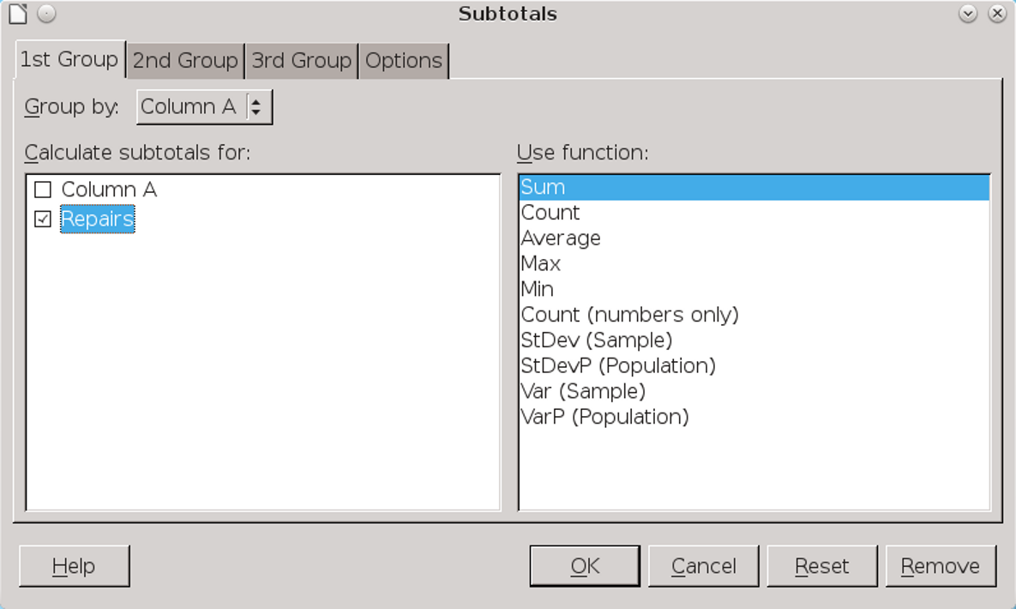
Data > Subtotal adds totals to a data array. However, it needs to be set up in the correct position.

For efficiency, you can choose up to three groups of data arrays to which to apply a function. When you click the OK button in the window, Calc adds subtotals and grand totals to the selected arrays.
- 祕訣
Edit the labels for totals by modifying the Result and Result2 cell styles so that they stand out and readers can go directly to them.
You can also arrange the subtotals according to choices made on the window’s Options tab, including ascending and descending order or using one of the pre-defined custom sorts defined in Tools > Options for Calc.
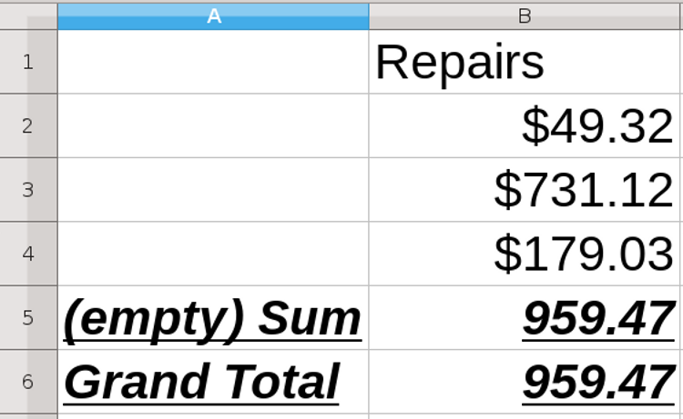
Data > Subtotal performs a function upon a data array, and adds labels for the totals.

Defining cell content and adding help
Validity defines the type of contents that can be entered in a cell. Basically, it is a form of online help,
either to aid your memory, or to assist others who are using the same spreadsheet.
You create your own messages. Imagine what you might need to know if you are using the spreadsheet six months from now, and provide as much detail as possible in the message. Point form or short phrases may be cryptic to your future self and other readers, so test your messages on somebody else.
Be as concise as possible, and revise your messages carefully. Remember, though, that too much detail is more useful than too little.
Contents for Validity can include:
- The range and type of contents that can be entered (on the Criteria tab).
- The purpose of the cell contents.
- The proper formatting of contents.
- An explanation of the content rules you decide upon for the cell.
- A definition of invalid content, whether it will be accepted, and how to correct it (on the Error Alert tab).
- A macro that starts when invalid content is entered.
Unless otherwise stated, most of this information can be entered on the Input Help tab.
- 祕訣
A validity rule is part of a cell’s content. Selecting Format or Delete All from the Delete Contents window removes it.
To copy a validity rule along with the rest of the cell’s content, use Edit > Paste Special > Paste Formats or Paste All.
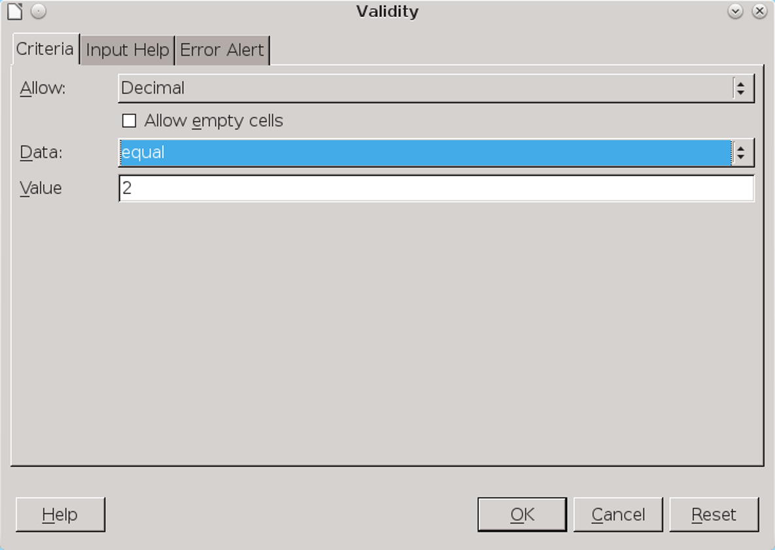
Data > Validity is a form of online help.

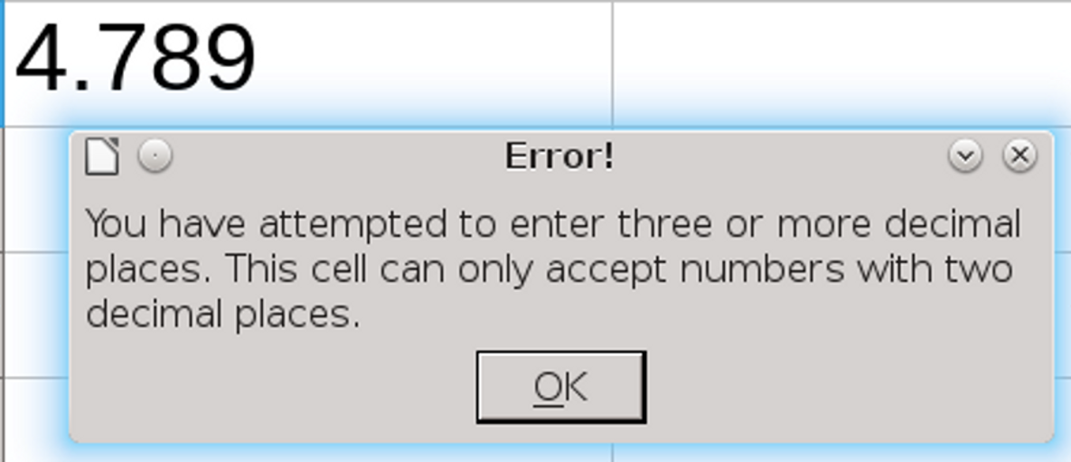
You create your own Validity error messages. At the very least, explain in the first sentence what is wrong and in the second what needs to be corrected.

Creating pivot tables
A pivot table is a rearrangement of an existing range of data to give new insight.
At its most complicated, a pivot table can be used to analyze raw scientific data, showing the correlations between different fields. However, it can also be used in simpler cases, such as sales figures.
To create a pivot table:
- Select the range of data on the spreadsheet, including the headings.
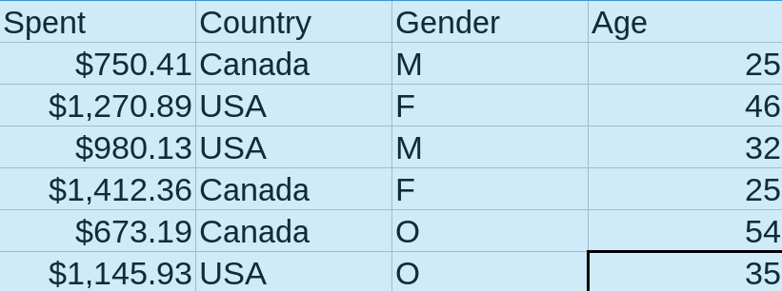
A data range showing tourism expenditure, according to nationality, gender, and age, selected to create a pivot table.

- 祕訣
You can use a database as the source for a pivot table.
Select from the main menu Data > Pivot Table > Create, then select Data Source registered in LibreOffice from the Source dialog, then make a selection from the Select Data Source dialog.
- Click Data > Pivot Table > Create. The Pivot Table Layout window opens. The headings in the original data are listed in the Available Fields pane. They can be added to any of the other panes, but not all combinations will be relevant or make sense. Experiment to find the best arrangement.
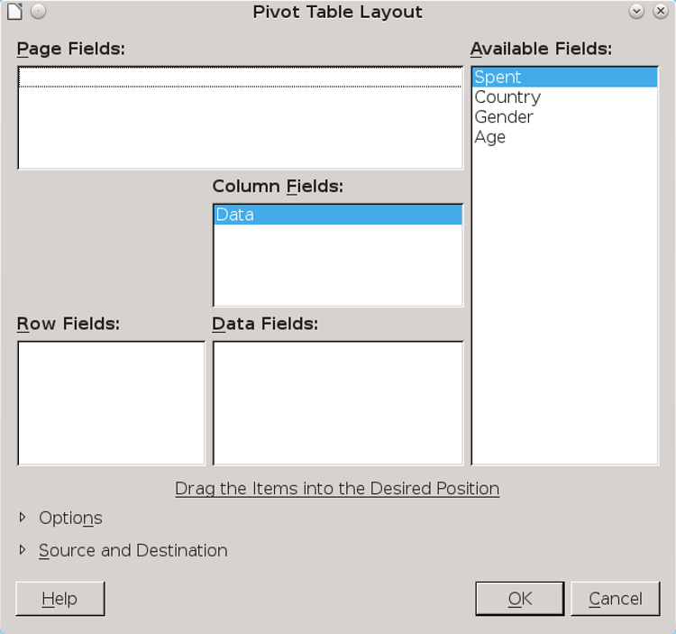
15
The layout window for a pivot table.
- Drag the available fields to the other panes to change their relationships. You do not need to use all the available fields. Choices are:
- Page Fields: Creates a drop-down list to filter what the Pivot table displays.
- Column Fields: Creates columns from an available field.
- Row Fields: Creates rows from an available field.
- Data Fields: Information to manipulate in the pivot table.
You need at least one column or row field, plus at least one data field. Page fields are optional.
- 注意
Visualizing the results of a pivot table takes practice. You may need to experiment to get the results you want.
- Click the Options arrow to select any other layout options. Total columns and Total rows are selected by default.
- If necessary, click the Source and Destination arrow to make any modifications. For example, by default, a new pivot table opens in a new sheet called something like $'Pivot Table_Sheet1_1'.$A$1, which would create a new sheet and place the first cell of the pivot table in the first cell of the new sheet. However, you might give the destination a more meaningful name, or place the pivot table on the same sheet as the source data.
- Click the OK button to create the pivot table. The pivot table appears in the destination entered by default or edited by you.
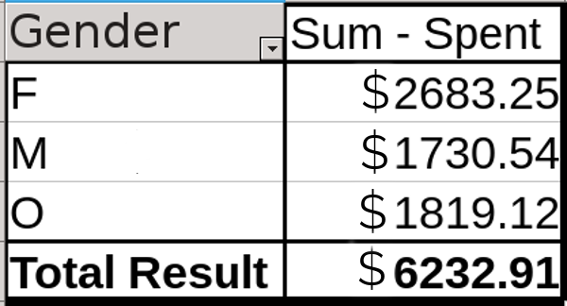
A pivot table that takes the source data and rearranges its information to show tourist spending by gender. Here, those tourists who identify as female are shown to spend the most money when traveling.
- 祕訣
Pivot tables are uneditable, and do not refresh automatically. Click Data > Pivot Table > Refresh to update pivot tables with the latest data or to correct a mistake.

Deciding on the styles
Calc offers only a couple of sample cell and page styles. However, you can create other styles. An analysis of your purposes can help you decide what styles to create. For instance, consider a separate cell style for:
- Column headings.
- Sub-totals and/or totals.
- A different cell color for each task or person in a list.
- Each cell of a different category on the Numbers tab for cell styles.
- Cells to be hidden when printing.
Page styles set how sheets are printed. They define page dimensions, format headers, footers, and margins, and how wide sheets are printed on multiple pages. Often, you may need only one style, selecting colors for branding or purposes and choosing the tactic for printing hard copy. At other times, pages may be color coded by purpose or customer, or include a sheet used as a title page.

Applying spreadsheet styles
To apply cell styles, you can select:
- Individual cells or a range of cells.
- One or more columns.
- One or more rows.
- An entire sheet (select the cell above row 1 and to the left of column A).
When the cells are selected, click the style in the Styles and Formatting window in the side bar.
To apply a page style, you technically need only to place the cursor anywhere on a sheet. However, to avoid printing blank pages, place the cursor in the last cell that has content, then click the style in the
Styles and Formatting window. All cells above and to the left of the selected cell are formatted using the style.
- 祕訣
Page styles are not visible in the editing window. You can view them from File > Page Preview.

Setting up cell styles
Cell styles are the spreadsheet equivalents of paragraph styles in text documents. In other words, they are basic units for format and content.
The resemblance is so close that over half the tabs on cell styles are nearly identical to those on paragraph styles. You can read more about paragraph styles in Chapters 4–7.

Selecting fonts for spreadsheets
Choose fonts and font effects by the same criteria as you would for text documents. Most spreadsheets should follow the suggestions for online documents in “Other considerations for fonts,” page 83.
A common fault in spreadsheets is to choose a small font size. However, a font size that prevents easy reading goes against the main purposes of putting information in a spreadsheet in the first place.
Generally, you should also avoid old style figures in favor of lining figures (the ones you are
used to seeing). Old style figures, each with their own baselines, can be easier to read in text documents, but modern readers are likely to find them harder to read in rows of figures.
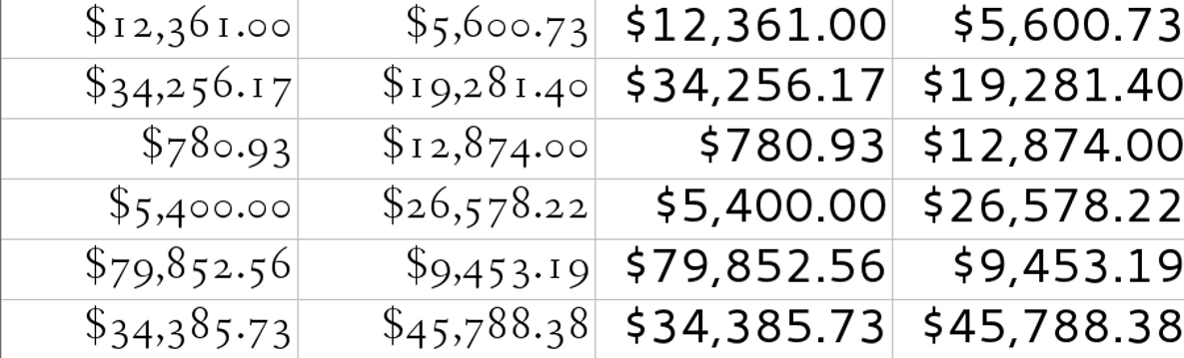
Left: Old style figures. Right: Lining figures. Old style figures look more polished in text, but are harder to read than lining figures in a spreadsheet or table.

Selecting borders
Borders in spreadsheets help to mark data arrays as separate from other figures on the sheet. However, blank cells or backgrounds can be used instead. Similarly, thicker than normal borders can set off totals or statistics from raw data.
You rarely see spreadsheets using any color except black for ordinary purposes, regardless of whether the sheet is used online or printed to hard copy. Other colors can be easily confused with the colored lines that Calc uses for display purposes but does not print.

Selecting backgrounds
Unlike text documents, spreadsheets use backgrounds freely for purposes such as classifying tasks or who does them in a list. Sometimes, they
distinguish calculations and formula results in a data collection.
Go wild – if the background makes a useful distinction, no one will care if it is gaudy.
However, make sure that backgrounds contrast with foregrounds, so that cell contents can be easily read.

Setting how numbers are handled
By default, cells are set to contain any sort of information. Alphabetical characters are assumed to be text, aligned to the left, and numbers are assumed to be ordinary numbers, aligned to the right for convenience when reading.
Other formats, such as dates or currency, must be specifically set from the Numbers tab.
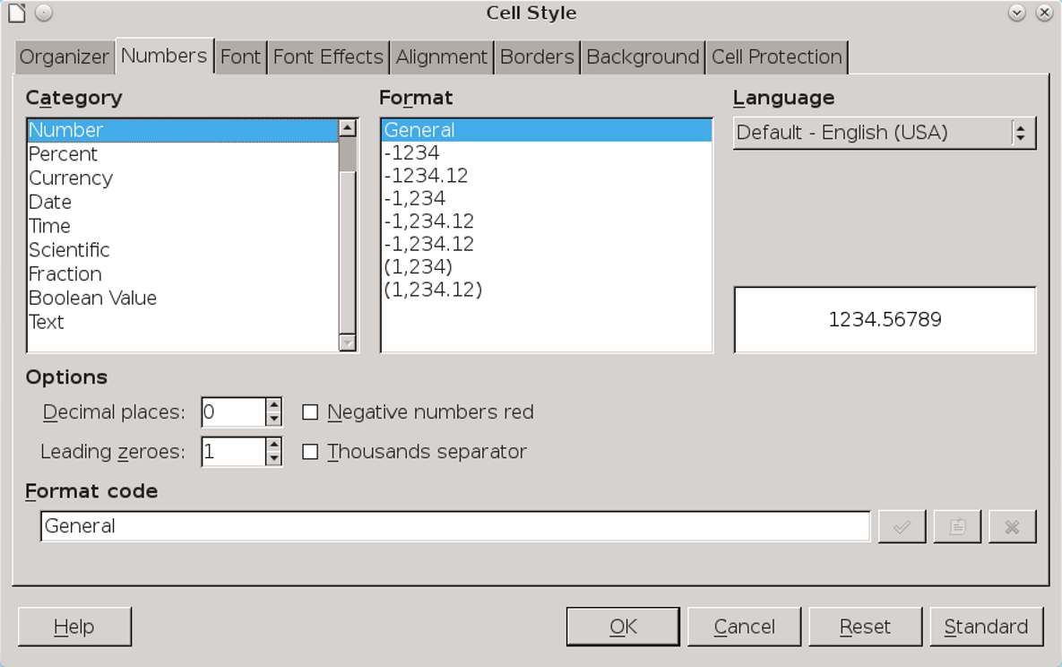
The Numbers tab sets how cells treat numbers (and text, too). The available default formats depend on the locale to which LibreOffice is set.

When you select another format, the behavior of the cell becomes fixed. For instance, selecting Text means that numbers are treated as text characters, which might be handy in a list of numerical addresses that you did not want aligned to the right. Similarly, selecting Date means that today’s date is always presented in the format you select. Currency and other symbols are added automatically, depending on the format.
The available formats depends on the category. However, note that:
- Formats are often available with and without decimal places. If you choose a format without sufficient decimal places, your spreadsheet may read inaccurately when you use formulas.
- The default Date format for US English is MM/DD/YY. For instance, 01/31/15 is January 31, 2015. However, this format means that whether the month or the date comes first is unclear for days 1-12 of any month.
To avoid ambiguity, use the format YYYY-MM-DD, which is becoming increasingly common as an international standard.
- Most time formats assume a 24 hour clock, unless they end with PM.
You should also keep in mind the general options that may or may not apply to a particular number format option:
- Make sure you set the number of decimal places that you need. Otherwise, Calc rounds up or
- down, which may display imprecise results for formulas.
- Leading zeros set the digital places to the left of the decimal point. The default is 1, which means that you need to change it to 2 if you want to display 01 rather than 1.
- Negative numbers are red. This is a traditional setting for accounting, but make sure that your cell backgrounds and font color do not conflict with it.
- Thousands separator: Whether a character will be used to separate numbers larger than a thousand for easier reading.
The separator used depends on the locale. In English locales, the separator is usually a comma (for instance, 1,000), but in German it is a period (1.000) and in France a space (1 000).

Setting alignment
The Alignment tab has the options you might expect: Left, Center, Right, and Justified, all of them referring to how a line is positioned in a cell. However, the alignment options also include Filled, which repeats contents so that the entire cell is filled, and Distributed, a close relative of Justified that distributes contents evenly across the cell. It also contains the equivalents for vertical alignment.
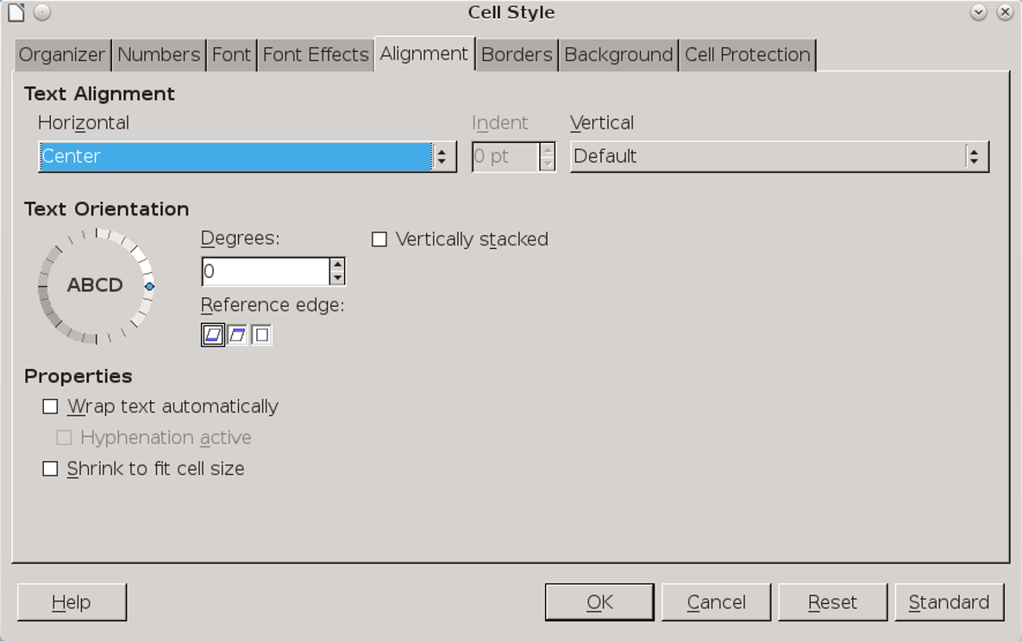
The Alignment tab also sets hyphenation and page wrap inside cells.
These options are useful if you care about the look of your spreadsheet. However, in practice, most people are focused on the information rather than the design, and tend to leave the defaults unchanged. In practice, most users are interested in the other options on the tab.

Rotating text
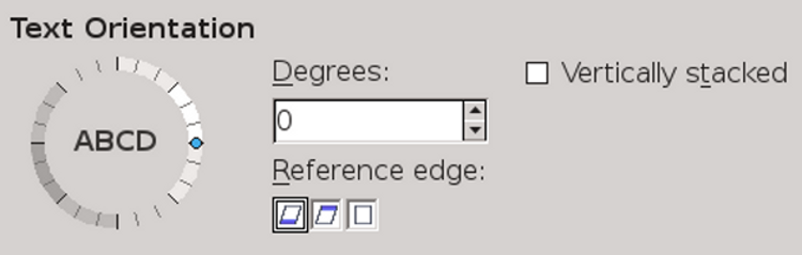
The Alignment tab includes settings for displaying text inside cells.

Confusingly, settings for how text displays are on the Alignment tab for cell styles.
Text Orientation is useful largely for headings. By angling headings, you can often squeeze the entire text into a column that would otherwise be too small for it.
You can adjust text with the dial counter, or more precisely by entering an angle in the Degrees field.
Rotate text as little as possible, turning the Text orientation dial counter-clockwise, so the text starts at its lowest point. More than a 45-degree angle should generally be avoided, and even more so Vertically Stacked, which displays text vertically, character by character. Rotating text may allow more to be squeezed in, but often at the cost of reduced readability.
You can adjust rotated text by selecting its Reference Edge – that is, where the text starts. Text Extension From Lower Cell Border gives you the most space, and is usually a reasonable default. At times, Text Extension Inside Cell may be reasonable, since it confines text to within the cell border, although it can quickly become too small to read easily.

Rotating text. From left to right: a 45-degree angle, a 90-degree angle, and vertically stacked.

Adding hyphenation and text wrap
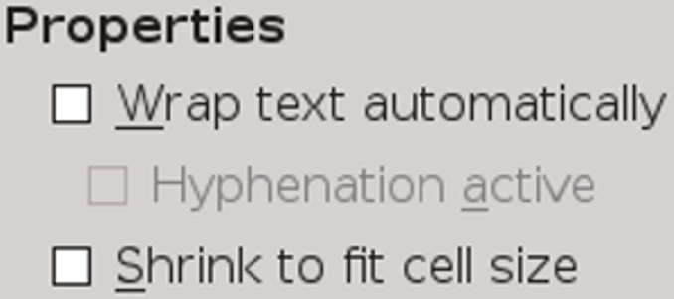
Like text orientation, hyphenation and text wrap settings are found on the Alignment tab.
When spreadsheets first became popular, most users were satisfied with text appearing in a single line, extending into the next cell.
This presentation is known in LibreOffice as text extension. It is still the default way to display cell contents, and die-hards insist that it is the only way.
- 祕訣
Text extension is used regardless of whether text is rotated or not.
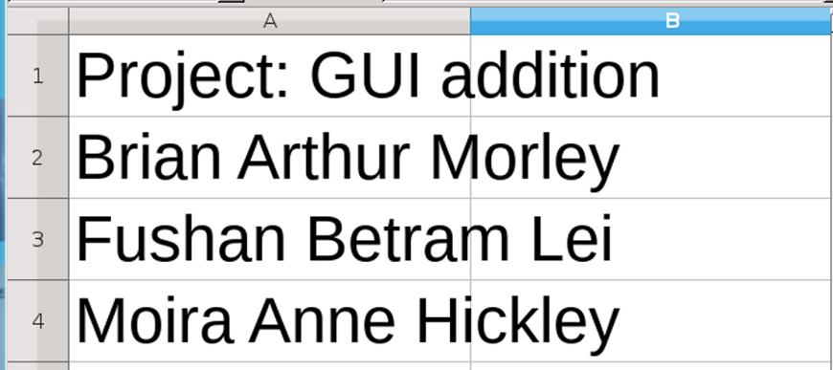
Text extension overlaps text into other cells as necessary.
However, the Alignment tab provides alternatives that many people today prefer.
The first is Shrink to fit cell size. This option is useful largely for contents that almost but not quite fits into a cell. However, be careful: even with a zoom, it can result in text that is too small for easy reading.
A more readable solution is Wrap text automatically. This option makes text in a cell act like text in a Writer document, making it easier to read at the cost of changing the dimensions of the cell, which may not be practical if the cell needs to align with other cells.
Wrapped text can also cause unusual breaks in words. Generally, if a cell is set to use text, you should check Hyphenation active as well to make the text more readable.
Together, these two choices make cell content visible at a glance. They work best online, where cell width is not an issue, and you can use as much space as you want.
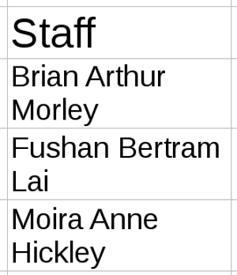
Text wrap presents spreadsheet text in a more conventional format than text extension, displaying contents without spilling over into another cell.

Setting cell protection
Cell protection either protects cells from editing or causes Calc to skip over flagged cells when printing or performing other operations.
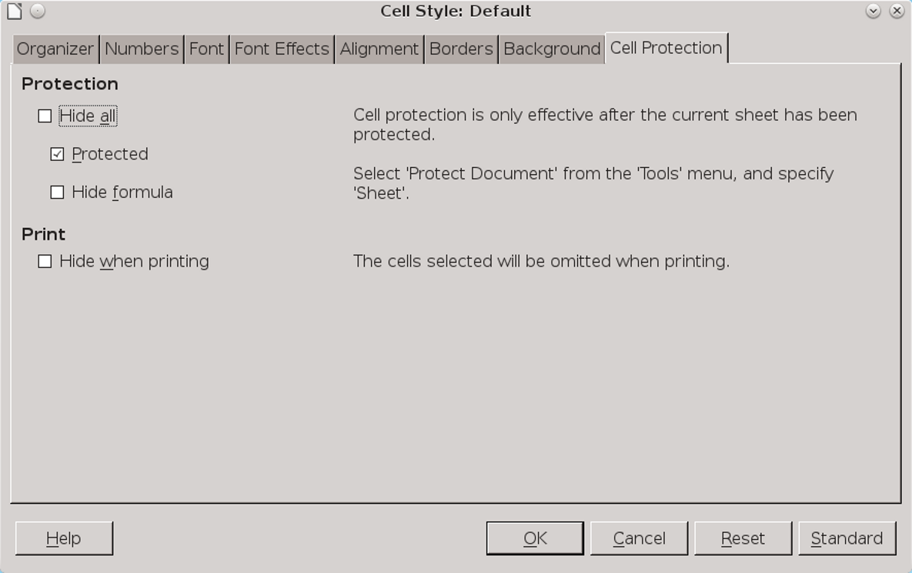
The Cell protection tab helps to control editing.
The Cell Protection tab offers four options:
- Hide all: Formatted cells are protected from editing, any formula in them is hidden, and the cells are not printed.
- Protected: Formatted cells cannot be edited.
- Hide formula: Any function in a formatted cell is invisible.
- Hide when printing: The contents of formatted cells are not printed. You should only make this choice when you know that you will always be printing the spreadsheet in the same way.
- 注意
Cell protection is not activated unless you elect either Sheet or Document from Tools > Protect Document.
Selecting either item a second time turns off all protection features.
- 注意
Cell protection is useful mostly against accidental changes. For example, the spreadsheet might be used by clerks who need to enter data into specific cells, but who should not change anything else.
If you are seriously concerned about preventing other users from editing your spreadsheet, password protect the document, and/or limit the permissions on the file.

Setting conditional formatting for cells
Conditional formatting in Calc automatically changes the appearance of selected cells. The automatic format can be the application of a cell style, or of an indicator that visually presents data in much the same way as a graph or a chart.
Conditonal formatting is an extension of sparklines, which are small, undetailed graphs popularized by the information designer Edward Tufte. You can create a sparkline by shrinking a chart and removing the legends. However, conditonal formatting gives other graphical representations of data as well.
To use Calc’s conditional formatting, select the cells to work with, then click Format > Conditional Formatting > Condition, and select an item from the sub-menu. All types of conditional formatting can be configured from Condition. Color Scale and Data Bar are
shortcuts to options available under Condition. If necessary, you can edit the range of cells affected at the bottom of the Conditions window.
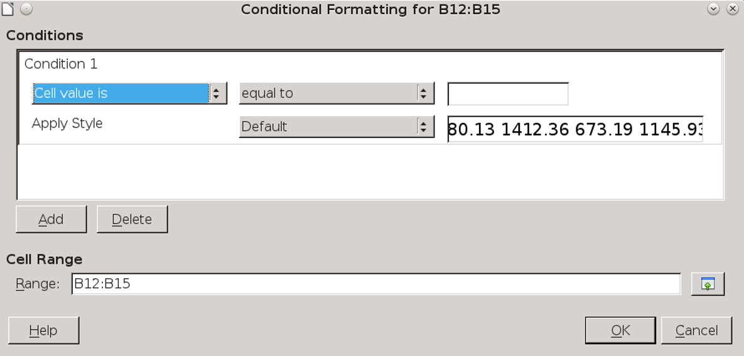
Format > Conditional Formatting > Condition > Condition.
The Conditions area has three fields. From left to right, they are:
- The general condition.
- The filter to refine the condition.
- The numerical value that must be present to activate the conditional formatting.
By changing the general condition, you can set the following types of conditional formatting:
- Cell value is: Applies the selected cell style when the numerical value is met. This type is useful for emphasizing target values in a range of cells. It cannot be used for cells formatted for text.
- Formula is: Applies the selected cell style to cells in which the designated formula is used. The
- formula is typically one that viewers of the sheet wish to find easily.
- Date is: Applies the selected cell style to cells in which the designated filter is used, from Today to Last Week. This type is especially useful for locating recent information.
- All Cells > Color Scale (2 entries). Creates a gradient of two colors. The fields refer not to formulas, but to target values. The color scale is especially useful for showing high and low values in a range of cells at a quick glance.
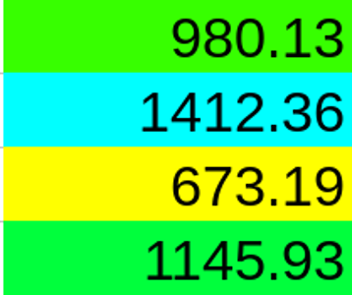
A color scale, with yellow indicating the lowest value and cyan the highest. Mid-ranged values are different shades of green.
- All Cells > Color scale (3 entries): Like a color scale for two entries, except that a third target value is added, often a midpoint using the value Percent.
- All Cells > Data Bar: A gradient that creates a graph-like representation, typically showing how far above or below a cell value is of a designated norm.
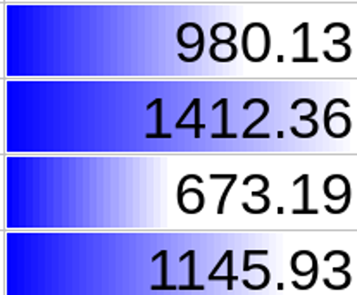
A data bar in which high values are indicated by more blue,
- All Cells > Icon Set: Adds a set of icons to summarize the contents of cells. For example, traffic icons or emoticons might designate if results were above, below, or equal to projections.
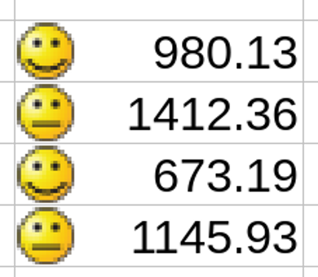
An icon set annotates results. Here, emoticons indicate that two results were neutral, and two results better than neutral.
Once you have set conditional formatting, you can select Manage from the sub-menu to see a summary and edit the selections.
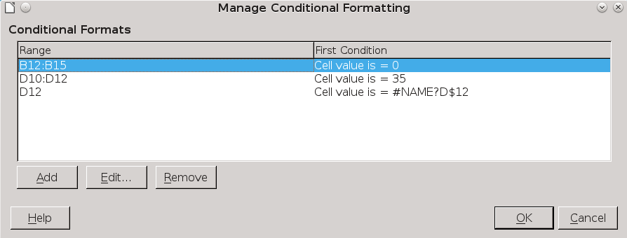
Click Manage in the Conditional sub-menu to add, edit, or remove conditional formatting.
- 祕訣
If conditional formatting does not work, check that Tools > Cell Contents > AutoCalculate is selected. It should be on by default.

Using page styles
Page styles tend to be used less in spreadsheets than in text documents because spreadsheets are mostly online documents. Often, spreadsheets are made with no thought of them conforming to any printed page size.
Moreover, if you plan to print to hard copy, you may want to pay more attention to typographical standards than you would if a sheet is used entirely online. Users tend to apply the standards of text documents to any printed page, and what is acceptable online may not be on paper.
In addition, you may need to worry about how the sheet will look when printed. Often, colors that contrast well look too similar when reduced to black and white.
Conversely, if you are printing in color, a contrast that works well online may look distractingly garish on paper, because the color models for printers and monitors are different.
To help cope with such considerations, Calc page styles have many of the same options as Writer documents, giving you the versatility you need for printing well-formatted sheets. Borders, backgrounds, headers, and footers can all be designed with the same considerations as pages in a text document, although if the printed spreadsheet is meant for informal use, you might omit headers and footers. For more detailed information, see “Planning page styles,” page 199.

Printing sheets
Online, the dimensions of a spreadsheet have few restrictions. However, translating a spreadsheet from online to hard copy is frequently an onerous task, full of false starts as you try different solutions.
One way to make printing easier is to keep careful track of column widths to make sure that they fit comfortably on a page. For instance, allowing for margins of 2.5 centimeters on portrait-oriented, letter-sized paper, columns should have a combined width of no more than about 17 centimeters.
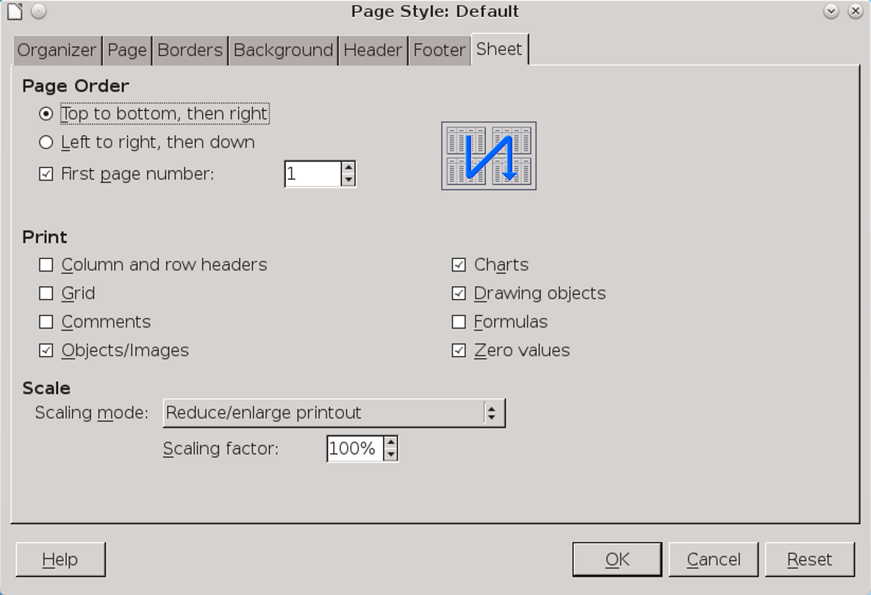
The Sheet tab has options for printing to hard copy.
Unfortunately, this practice would limit you to no more than half a dozen columns, which is often impractical. Sometimes, you can hide some columns or print only selected columns, but not always. In many cases, page styles are the only alternatives.
Most of the options for spreadsheet pages are similar to the page styles for text documents (see Chapter 8). However, the Sheet tab has options that deserve a closer look.

Scaling spreadsheets
The scaling options on the Sheet tab should be your starting point with page styles. It may even be your only point.
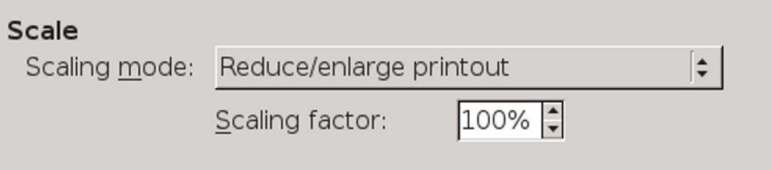
The Sheet tab includes options for fitting a spreadsheet on a printed page.
Begin by experimenting with the Reduce/Enlarge printout, entering either a percentage of the original size, or Fit print range(s) to width/height or Fit print range(s) on number of pages.
However, for all of these solutions, you are limited to no more than about one-third reduction in size if you are interested in readability. Anything more, and the contents will be less than 8 points high, and hard to read. At 300dpi or less, the result may not be printable, either.
For many spreadsheets, the most practical solution is to select from Page order, choosing Top to bottom, then right or Left to right, then down. These selections can be confusing, but the diagrams beside the selection may keep things clear.
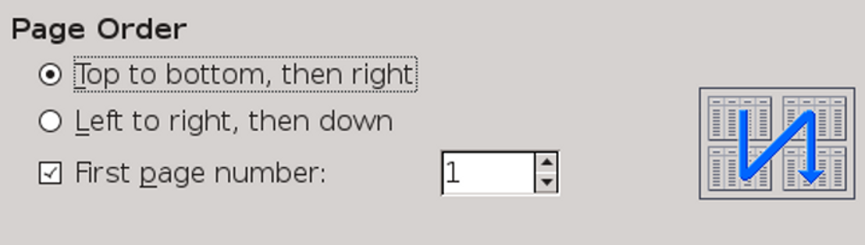
The page order options on the Sheet tab help to squeeze a spreadsheet onto a page.
If you continue to have problems, you might be able turn off the printing of elements such as comments or charts to save space.
- 注意
Whatever combination of solutions you decide to use, plan and test in advance. Don't rely on printing a spreadsheet five minutes before you need it unless you have done so before and know how to get the results you want. You are likely to need several tries to print satisfactorily.
In the end, you may even want to tape pages together to reproduce the spreadsheet more accurately in hard copy.

Other options
The Sheet tab’s Print pane includes selection boxes for what is printed. Most of these options are of limited use, except perhaps for comments on unfinished drafts or trial attempts at printing – after all, if the spreadsheet doesn’t need objects, why add them?
The two possible exceptions are Column and row headers (the alphabetical identifiers for columns and numerical ones for rows) and Grid (the cell borders). Printing them is only a matter of turning options on, but people have strong feelings about the choice.
Many users – especially inexperienced ones – feel that a spreadsheet requires borders for each cell and the row and column headers, and that a spreadsheet simply isn’t a spreadsheet without one.
Others argue that such things distract from the contents. Sometimes, too – for instance, when you
import into Writer – you may want the cells to look like a table rather than a sheet.
How you format printed spreadsheets may be a matter of personal preference or corporate style sheet. Or perhaps you have a practical reason for certain choices. For example, if you are writing a how-to about using a spreadsheet, you may want to use snippets of spreadsheets that look like an online spreadsheet. No firm conventions exist, except for one: once you have chosen the formatting, use it consistently.
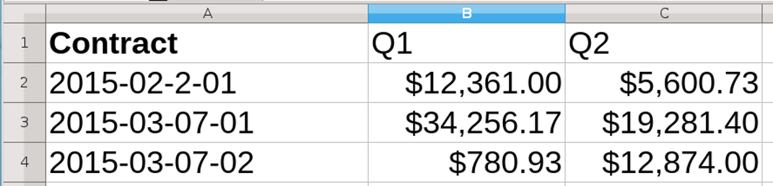
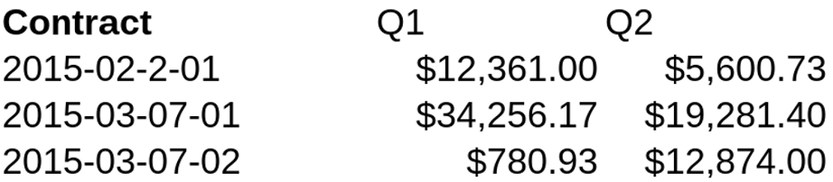
Printing with (above) and without (below) cell borders and row and column headings.
You may especially want spreadsheets to look like tables when you use Calc to create a tutorial because, when you already have a collection of pictures and charts on the sheet, the grid may do nothing except add to the clutter. Like printing in general, whether you print the grid or the header may be an exercise in trial and error.

Formatting spreadsheets automatically
When you want to format only part of a sheet, you can use Format > Autoformat. However, many of these pre-defined styles look dated, such as the 3D ones.
Instead use the Add button to apply your own formatting. You may find AutoFormat more useful than using page styles for creating a general look.
- 祕訣
You can apply an AutoFormat to an entire sheet by clicking the cell above the row 1 header and to the left of the column A header.
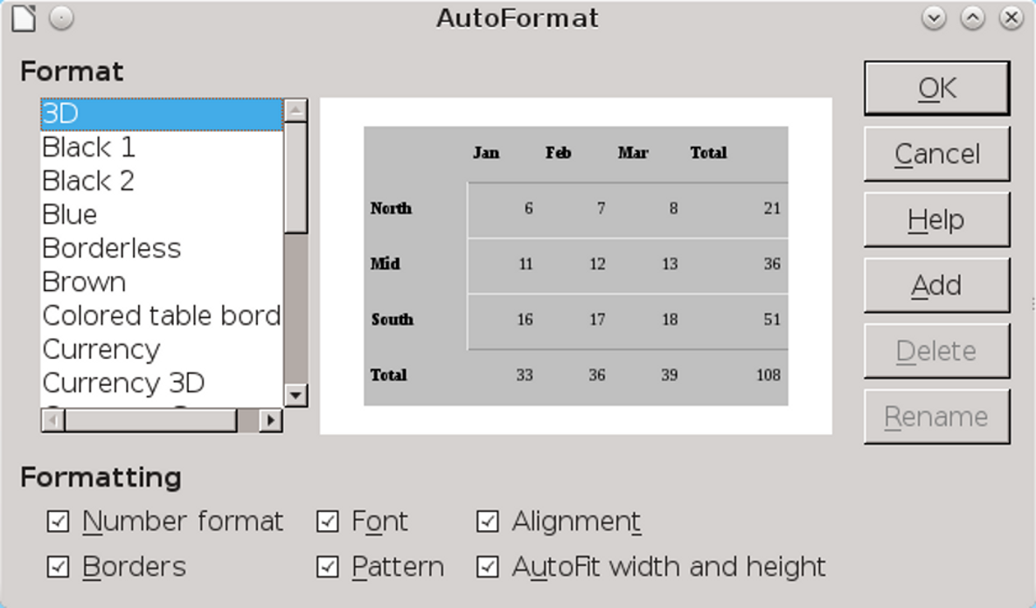
AutoFormats are an alternative to page styles for formatting some aspects of a spreadsheet.

Adding other elements
Spreadsheets are primarily lists or ledgers. However, you can also add other elements, such as pictures, charts, and formulas, especially when you are turning a spreadsheet into a tutorial.
Unfortunately, just as with frames in text documents, additional elements in Calc do not always stay where you place them. Even worse, nobody has found a workaround for the problem in Calc.
The best advice is to follow the precautions suggested in Chapter 10 for Writer frames. If you still have problems, consider not adding any other elements. They are almost always enhancements rather than necessities on a spreadsheet.

Working with conventions
Spreadsheet conventions differ greatly from those of text documents. Some of these conventions are expectations, worth noting because they are how others will judge your work.
Other conventions, however, are what have been found to work – usually, when reading a spreadsheet online.
However, despite the differences from text documents, spreadsheets still benefit from the use of styles. You may not use the page styles regularly, but, like all styles in LibreOffice, the cell styles will make revising your spreadsheets and using them
over long periods of time much easier than manual formatting.

