5

Spacing on all sides
Paragraph styles are the most frequently used type of style in LibreOffice. However, they interact so closely with character styles that talking about one without the other is impossible – they even share several of the same tabs in their dialog windows.
Paragraph styles define the general formatting for any text-heavy document, while character styles provide brief variations. For short bursts of text – for example, a title, URL, or bullet point – character styles provide exceptions that give paragraph styles the flexibility they lack by themselves.
Chapter 3 ventured into some of the basics of paragraph and character settings while discussing fonts and how to find the ideal line spacing. This chapter completes the discussion of basic paragraph formatting, (including a more detailed discussion of
line spacing), covering the options for vertical and horizontal spacing.
The next two chapters discuss special features and potential problems and advanced features.
- 祕訣
Many of the tabs in character and paragraph style dialog windows reappear in the other LibreOffice applications. To minimize repetition, later chapters refer back to this chapter and the two following it.

Preparing to design
- Choose your fonts and ideal line spacing.
- Have a calculator and a list of multiples of the line spacing ready so you can check basic measurements.
- Set the default measure to points in Tools > Options > LibreOffice Writer > General > Settings > Measurement Unit. You can reset the default unit to centimeters or inches when you are done, but points are the most commonly used unit of measurement for general typography.
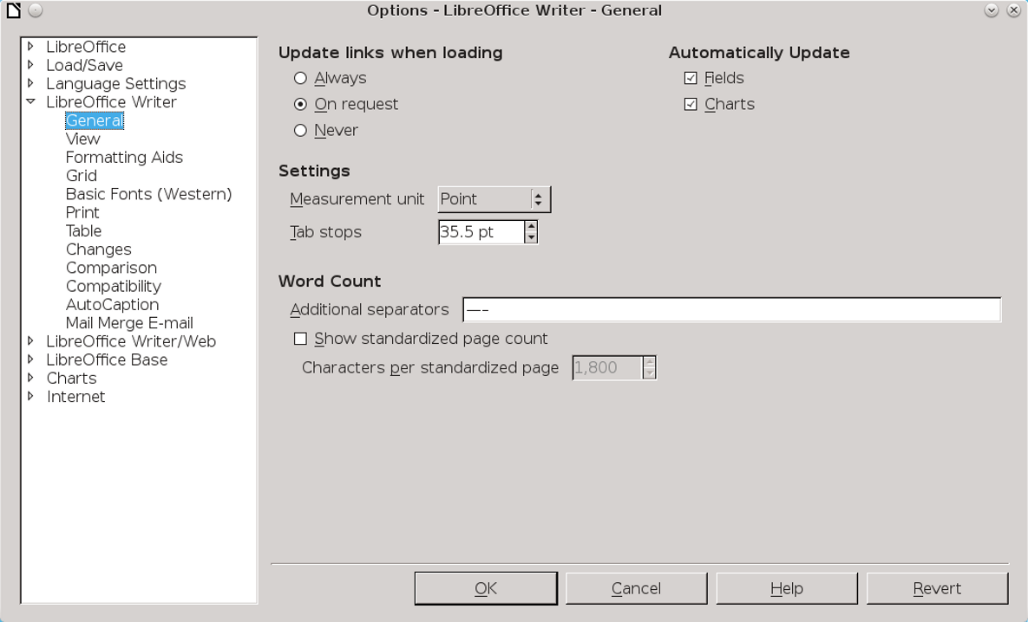
0
Before you design, set the Measurement Unit to points.
- Set the zoom to 100% so you can judge the page color. Print or zoom in or out periodically so you can get a different perspective.
- In the status bar at the bottom of the editing window, set LibreOffice to display multiple pages, selecting the third button from the left. Unless you are struggling with a small monitor, a two-page spread helps you see the effect of your design choices.
Displaying multiple pages shows how the document will look when printed or else viewed on a wide screen monitor in a two-page spread.

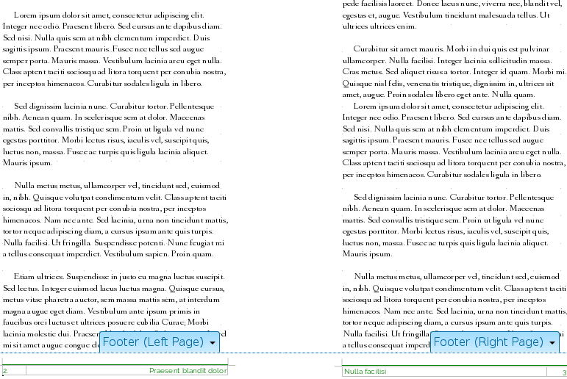
A multi-page display gives a design overview. Here, it confirms that footers are mirrored as intended.

- Open a second file where you can experiment and use dummy text to test formats.
- While you design, use manual formatting. Creating styles at this point is just an extra step until you have finished experimenting. When you have decided on the formatting choices, you can always drag a selected passage to the Styles and Formatting window to create a style from it.
- Use this chapter’s headings as a checklist so you cover all the basic formatting.
- 注意
As you work, you may find that some of the settings you have already chosen require changing – even the magic number.
Rather than resisting the change, accept it as a natural part of the design process. The goal is to develop the best design you can, not to cling to a pointless consistency.

Planning text styles
You can save time while designing by working whenever possible with Writer’s pre-defined styles. Later, as you write, you will find that some features, such as Insert > Fields > Other Document > Chapter > Chapter name field, depend on the pre-defined paragraph styles being in the document.
The pre-defined character and paragraph styles should cover most of your needs, but you can add other styles as needed..
Then go through the list of pre-defined styles and decide which ones you do not need. For example, paragraph styles Heading 5–10 are far more headings than anyone can manage. Perhaps, too, you have no use for paragraph styles like List 1 Cont., List 1 End, and List 1 Start, and they will only clutter up the Styles and Formatting window. For each unnecessary style, select Hide from the right-click menu. Should you decide that you need a hidden
style after all, you can go to the Hidden Styles view and select Show instead.
All these tasks are a lot of work. But you will also find that there are many styles in which you can keep the default settings.
For instance, line spacing may be unimportant in headings, since headings are often less than a single line in length.
Similarly, in a simple document, an automatic first line indent may completely remove the need to set tab stops. The fact that many defaults can be used unchanged or entirely ignored greatly reduces the amount of designing necessary to complete a template.

Setting vertical line spacing
Writer’s Line spacing field is on the Indents and Spacing tab of each paragraph style. It used to accept entries of 1/10 of a point (1/720 of an inch), but, since LibreOffice 4.2, the field rounds entries to the nearest point (1/72) or an inch.
This rounding produces adequate results, but not always optimal ones. Believe it or not, 1/10 of a point can make a large visual difference.
- 祕訣
Apache OpenOffice still allows entries of 1/10 points.
If you used your choice of fonts to determine the magic number, then you have already adjusted
this option using the Fixed setting in the Line spacing field. Fixed remains by far the best setting, because it is the only option that gives an exact measurement.
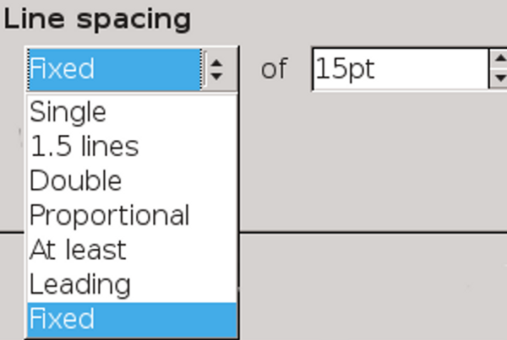
Line spacing options for paragraphs.
Fixed also has the advantage that documents will be register-true, regardless of whether the Register-true setting is turned on. In other words, lines will be in the same horizontal position on all pages, especially if the document uses only one font.
In addition, should you print on both sides of a page, the lines will overlap in most places, preventing the shadow of the other page showing through thin paper.
However, one problem with paragraph styles with larger font sizes, such as headings, is that they can have the tops or bottoms of letters cut off when Fixed is used. This problem can be solved by setting the Line spacing field using the At Least option while keeping the line height unchanged.
Cut-off characters are a sign that the Fixed line spacing needs to be either adjusted or replaced by At Least.

The other options for line spacing are different ways of expressing line spacing. Except for quick, one-off documents, avoid the Single, 1.5 lines, and Double options. These options use Writer’s standard defaults for line spacing, and are optimal for any given font only by luck.
The least useful option is Proportional, in which line-spacing is expressed as a percentage of the automatically determined single space, and not an exact figure. In other words, this option places you two removes from the actual figure for line spacing.
Another vague option is Leading. “Leading” is a term from the days of manual typesetting, when scraps of lead or anything else around the print shop were used to increase line spacing. “Leading” came to refer to the entire line spacing. However, LibreOffice uses the word to refer to only the extra space beyond the font size. For example, in LibreOffice, a paragraph set to 12/15 would be set with Leading at 3 points.

Line spacing at small font sizes
You can sometimes find fonts specially designed to be readable at sizes below 10 points. More often, small font sizes need extra line spacing to make them readable.
Unfortunately, LibreOffice, like most word processors, treats line spacing for small font sizes the same as line spacing for any other size. As a rule, select Fixed to give small font sizes the extra line spacing they need.
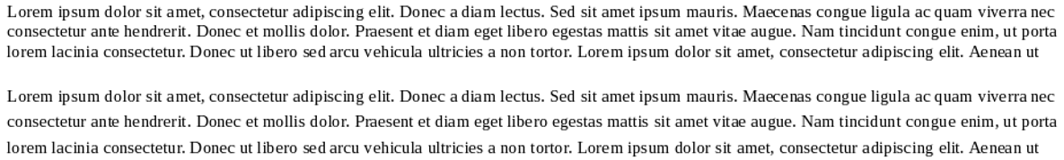

Above: 8 point Liberation Serif with automatic single spacing. Below: 8/12 Liberation Serif. Font sizes of less than 10 points almost always require extra line-spacing for readability.

Spacing between paragraphs
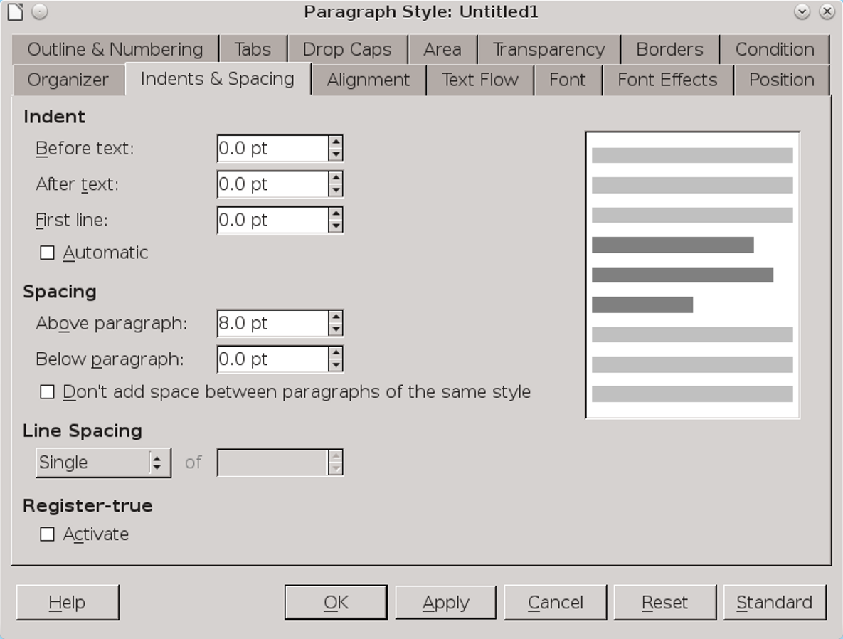
The Indents & Spacing tab, with the Above paragraph and Below paragraph fields listed under Spacing.
Vertical spacing is set on the Indents and Spacing tab in the Spacing > Above Paragraph and Spacing > Below Paragraph.
Vertical spacing is also used to increase the effectiveness of headings. The rule is simple: Put a heading closer to the content it summarizes, and the relation between the heading and the content becomes clear at a glance.
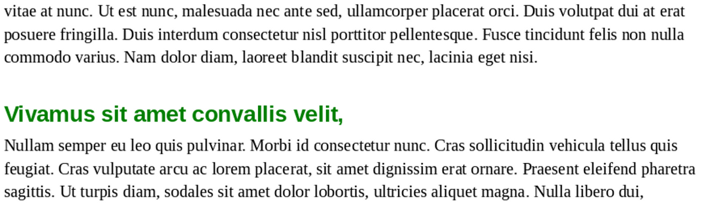
Putting less space between headings and the passage they introduce helps the eye to associate them.
Extra spacing between paragraphs is one of the ways to indicate the start of a new paragraph (the other is an indentation of the first line). Usually, extra spacing is used in technical documents, but the only rule is not to use both at the same time.
- 祕訣
The heading's font size, and the space above and below it, should total a multiple of the line spacing. In this way, heading paragraph styles matches the line spacing every few lines.
Use the same formula if spacing between body text paragraphs is used instead of a first line indentation.
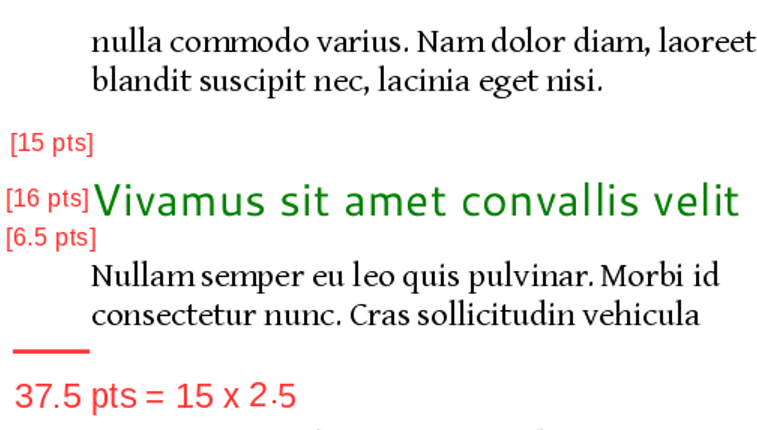
In this example, the line spacing is set to 15 points. Together, the spacing before the heading and after it plus the font size for the heading should equal a multiple of 15 or of 7.5 (half the line height).

Removing unexpected space.
The combined effect of Before and After settings for two subsequent paragraph styles can cause unexpectedly large spaces between paragraphs.
Minimize this problem by using only the Before Paragraph field and leaving the After Paragraph field set to zero for most paragraph styles.
In the case of pictures, you may want to vary the spacing to avoid extra large gaps.
Sometimes, the conflict may be between an image and a paragraph style. When that happens, modify the space below the image so that it matches the convention you have set and leave the paragraph style settings alone. After all, spacing
around an image or any other object is manually set already.

Avoiding widows and orphans
Standard typography tries to avoid a single line at the bottom of a page – a widow – or a single line at the top of a page – an orphan.
- 祕訣
You can distinguish widows from orphans by remembering that an orphan is left behind while a widow goes forward by herself.
Of course, avoiding widows and orphans is not always possible. Some paragraphs are a single line long. Tools > Autocorrect does have an option to combine short paragraphs, but that is not always suitable to the sense of the passage.
Other paragraphs have a number of lines that do not fit Writer’s settings. For example, if you have set last and first paragraphs on a page to each have two lines, something has to give when a three-line paragraph straddles two pages.
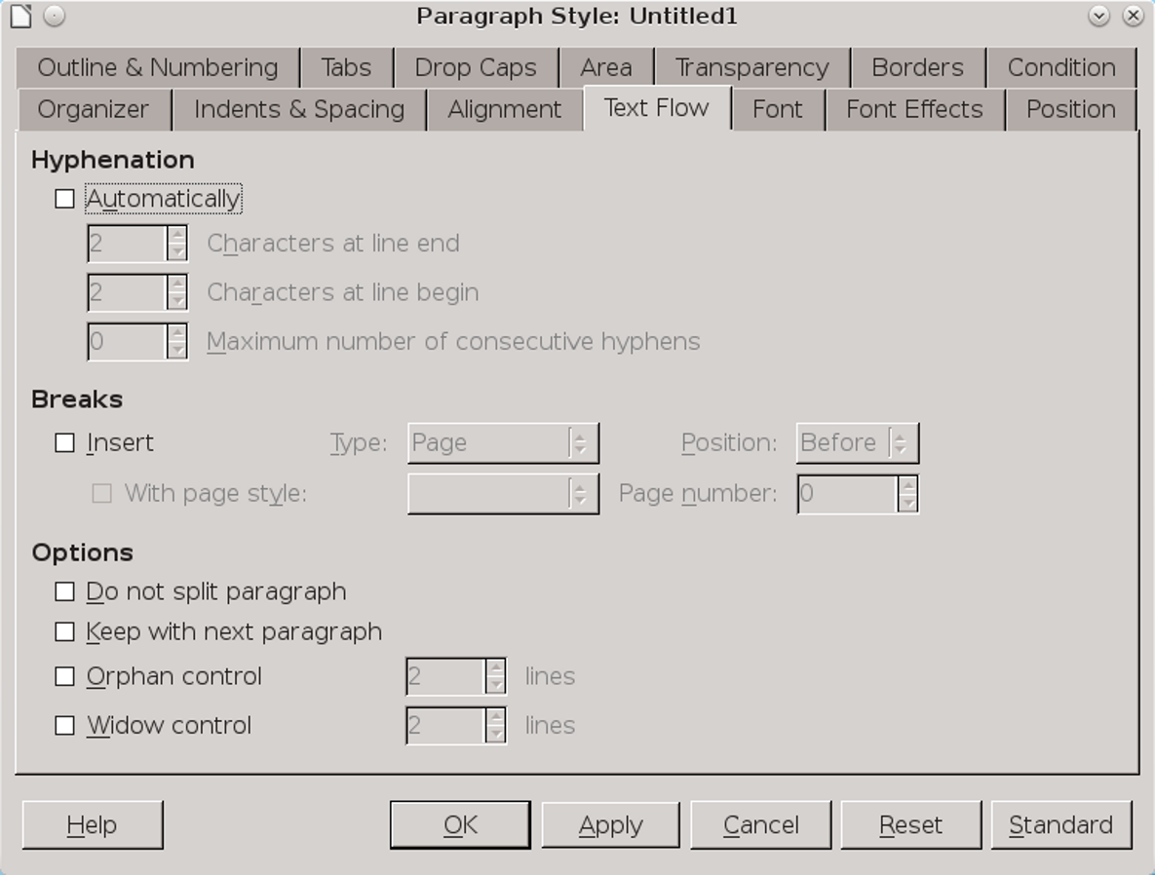
The Text Flow tab, with Orphan control and Widow control under Options.
The Text Flow tab of a paragraph style includes four options for avoiding both.
The main tools for avoiding widows and orphans are Widow control and Orphan control. For Text Body and related styles, you should activate both, accepting the default of keeping two lines together, or three at the most. You do not need these settings for heading paragraphs, or in a case in which all paragraphs are short – in either case, the controls will have nothing to adjust.
As an alternative, keep Widow control and Orphan control unselected and select instead Do Not Split Paragraph. This setting may keep important information together and therefore easier to read,
but can result in page breaks well before the bottom of the page.
For headings, you may prefer Keep with next paragraph. When headings are meant to introduce the body text below them, having the heading and body text on separate pages makes no sense. However, this setting, too, may result in poorly positioned page breaks, so use it sparingly.

Spacing between paragraphs
Vertical spacing is set on the Indents and Spacing tab in the Spacing > Above Paragraph and Spacing > Below Paragraph fields.
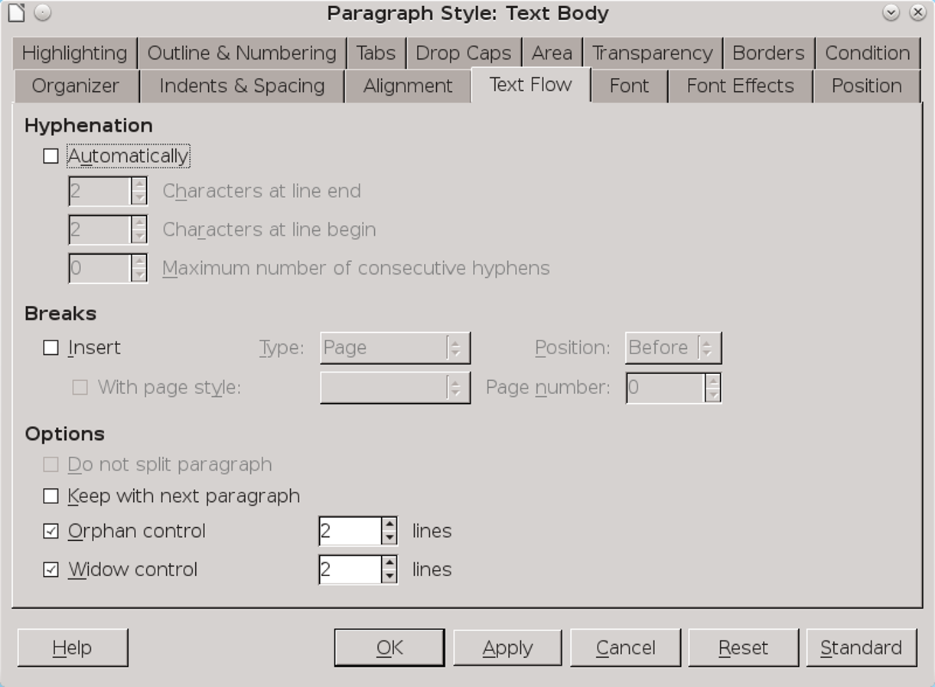
The Indents & Spacing tab, with the Above paragraph and Below paragraph fields listed under Spacing.

Vertical spacing is also used to increase the effectiveness of headings. The rule is simple: Put a heading closer to the content it summarizes, and the relation between the heading and the content becomes clear at a glance.
Extra spacing between paragraphs is one of the ways to indicate the start of a new paragraph (the other is an indentation of the first line). Usually, extra spacing is used in technical documents instead of first-line indentation, but the only firm rule is not to use both at the same time.
Putting less space between headings and the passage they introduce helps the eye to associate them.
- 祕訣
The heading's font size, and the space above and below it, should total a multiple of the line spacing.
Use the same formula if spacing between body text paragraphs is used instead of a first-line indentation.
- 注意
The combined effect of Before and After settings for two subsequent paragraph styles can cause unexpectedly large spaces between paragraphs.
Minimize this problem by using only the Before Paragraph field and leaving the After Paragraph field set to zero for most paragraph styles.

Selecting an alignment
On the Alignment tab of a paragraph style, you have four choices for horizontal positioning: Left, Right, Centered, and Justified.
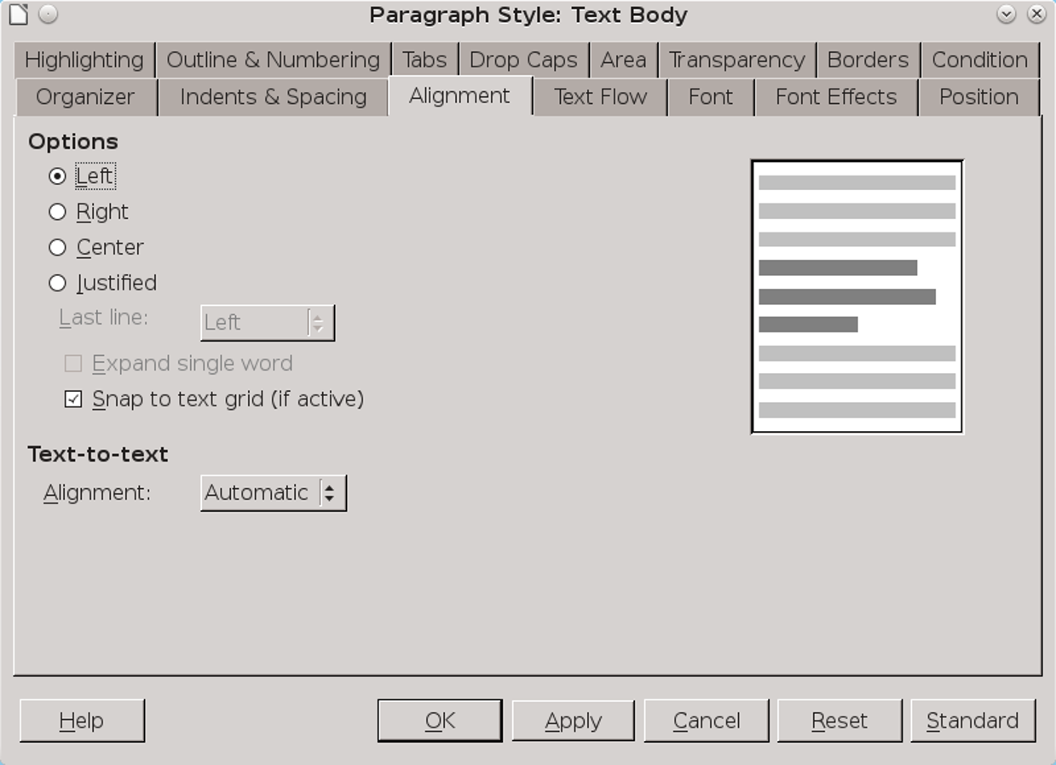
The Alignment tab, with the Options at the top of the window.

Right is rarely used except in short, highly-formatted documents such as ads or diagrams, while Centered is generally reserved for titles and sub-titles. For most paragraph styles, your choice is likely to be Left or Justified.
Whatever your choice of alignment, if you are using hyphenated styles, run Tools > Language > Hyphenation as a last step before publishing. This selection repairs any sub-optimal choices Writer might have made on the fly.

Using a Justified alignment
Many users prefer a Justified alignment, in which all lines start at the same position on the left and end at the same position on the right. Because commercial publications often use Justified, users often believe it looks more professional.
The preference may also be a reminder of the earliest days of word processing, the first time that a Justified alignment became practical. The vast majority of typewriters, of course, could only use a Left alignment.
The trouble is, a Justified alignment often requires more work. Too often, it results in irregular spacing between characters or words that looks far worse than Left alignment ever could. You almost always need to tinker to find the best distribution of characters and words on a line.
Generally, too, the shorter the line, the harder you have to work to make Justified work. As a rule, lines of less than 40 characters are too much effort
to be worth justifying. A Left alignment can still cause problems, but they are often less severe, especially in columns or tables.
The easiest way to tell if a paragraph style can easily use Justified is to set it up with dummy text and count the number of lines that end in a hyphen and the blotches of irregular white space.
The more of these problems that appear, the more you need to change the hyphenation, the font, the font size, and/or the column width in the hope of a better fit. You can even go to the Position tab to expand or condense character spacing.
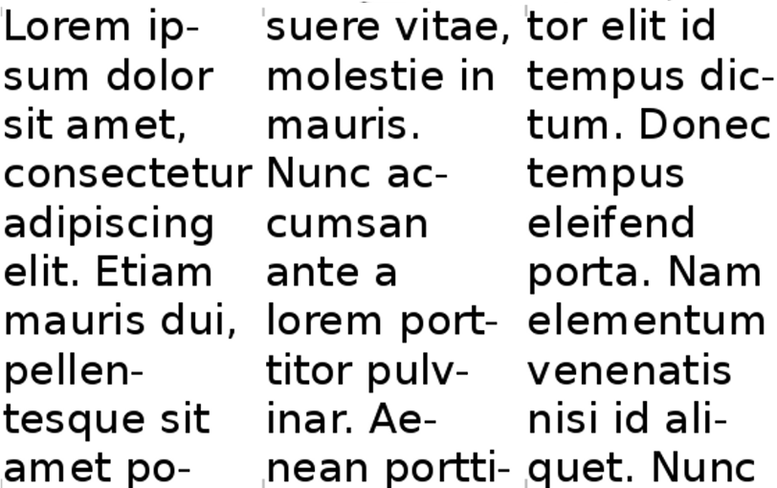
An example of the wrong alignment for the line length. The middle column has three hyphenated lines, while hyphenation causes awkward breaks throughout. Even worse, several lines are single words. Some lines even have more than one fault.

Setting the last line of justified text
The last line of justified text is only a complete line by luck. Almost always, it is an incomplete line.
LibreOffice offers several choices of how to handle this approach. Frankly, though, you have to
wonder why. All but one leave large gaps between words or letters that anyone who cares about the design of their documents should find unacceptable.
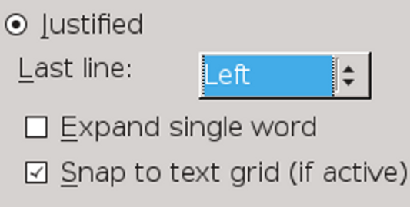
The Last line options for justified text on the Alignment tab. The other options in the drop-down list are Centered and Justified.

- 祕訣
Snap to Text Grid (If Active) uses the non-printing grid set in Tools > Options > LibreOffice Writer > Grid for positioning. Apache OpenOffice lacks this option.
The only consistently aesthetic choice is to set the Last line field to Left. This selection is the only one that eliminates the impossible situation of trying to justify a line of text that is too short and has ugly gaps in it.
The other options – Justified, Centered, Expand single word, and Left – all look awkward. The only reason to use any of them is to provide a sample of why they are unacceptable.
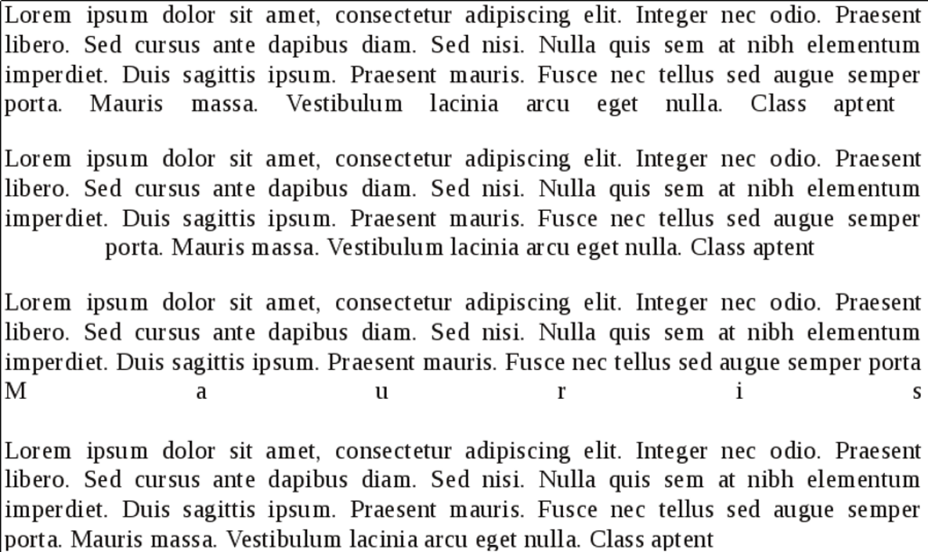
The justification of the last line. From top to bottom: Justified, Centered, Expand Single Word, and Left.
You may be able to improve the look of Justified by selecting Snap to Text Grid (If Active) and adjusting the grid set in Tools > Options > LibreOffice Writer > Grid. However, getting an acceptable look is likely to take a lot of trial and error.

Using a Left alignment
When a paragraph has a Left alignment, all lines start at the same position on the left, but can end anywhere on the right. For this reason, a Left alignment is sometimes referred to as “ragged right.” This is the default choice in Writer, probably because it is reasonably acceptable without tweaking, especially if lines are not hyphenated or are over about 40 characters long.
Generally, the shorter the line, the harder you have to work to make Justified look decent. That means that Left can be a better choice in columns or tables.

Setting hyphenation
Hyphenation options are set on the Text Flow tab. Whether to hyphenate is one of the most important design decisions you will make when designing a document.
Hyphenation is a contentious issue in digital design. Most word processors hyphenate as you type, and while they make adjustments as the line lengths change, their on-the-fly solutions are not always optional. Short lines are especially hard to hyphenate well automatically.
These difficulties are one reason that many designers prefer a Left alignment or ragged right margin. A Left alignment does not always produce the best possible use of the line, but its shortcomings are rarely as severe as those with a Justified alignment.
Another choice is to turn off hyphenation completely, which is probably why the Text Flow tab does not check the Automatically hyphenation box by default.
Other designers, more determined or more patient, try to improve hyphenation by adjusting the settings on the Text Flow tab. The number of letters at the end and start of the line should be 1–4. The typographical convention is not to allow more than two lines in a row to end with a hyphen.
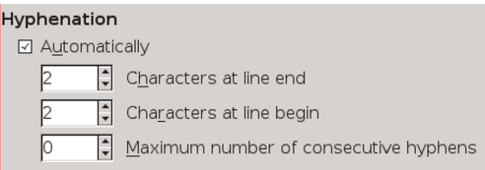
Detail of the Text Flow tab, showing the hyphenation controls.
The Characters at line end and Characters at line begin fields can sometimes be manipulated to improve hyphenation by playing one off against the other. Working by itself, the Maximum number of consecutive hyphens field can also make a difference.
In many documents, only Text Body and perhaps another handful of paragraph styles are used at such length that hyphenation can improve how they fall on the page. Headings, which are rarely more than a few words long and almost never more than two lines, generally do not need to be hyphenated at all. If anything, headings are easier to scan if not hyphenated.
You may want to change the hyphenation by adjusting:
- The Hyphenation settings on the Text Flow tab.
- The font weight or size.
- The choice of fonts.
- The settings for Tools > Options > Language Settings > Writing Aids > Options > Minimal number of characters for hyphenation. These settings are over-ridden by any formatting in the document itself.
- The Scale width and Spacing fields on the Position tab to expand or condense character spacing. Frankly, these fields are a last desperate measure.
In addition, if you do hyphenate, the line divisions can be improved by running Tools > Language > Hyphenation as a final touch on the document.
This tool not only works interactively, giving you more control, but also generally does a better job than the on-the-fly hyphenation, if run when the document is complete.
- 祕訣
For extra fine-tuning, go through a document when it is complete, and hand-hyphenate by positioning the cursor between syllables and pressing Ctrl+ -. This key combination creates a conditional hyphen that only comes into play when it is in the hyphenation zone near the right margin.

Setting horizontal spacing
By default, paragraphs run from the left margin to the right margin – or, at least, to a region just before the right margin that LibreOffice must reach before starting a new line, with or without hyphenation.
However, on the Indents and Spacing tab, you can indent a paragraph on the left by entering a value in the Before Text field, or on the right by entering a value in the After Text field.
Common uses for an indent include:
- The start of a new paragraph.
- A quotation of over three lines or 100 words. Typically, such long quotations are indented one line-space on the left and right. No quotation marks are used, since the indentation is enough to mark is a quotation.
- The space between a bullet or number and an item in a list. This space is set using the Indent at field on the Position tab for a list style.
- Notes, tips, or warning paragraph styles.
- Paragraph styles intended for single style outline numbering.
- Cases in which headers and footers are wider than body text.

Controlling the number of indents
Some paragraph styles that begin with an indentation are unavoidable in a text document. However, too many different indentations clutter the design, so indentations should be kept to a minimum. No need, for example, exists to have a bulleted or numbered list indented more than the Text Body style. Instead, the indentation for a long quotation can be the same as the first line indentation, as well as the position where the text starts in a list item after a bullet or number.
- 祕訣
Horizontal line spacing can also be a help in readability. Regardless of font or page size, typographic convention suggests that a line of body text should be 50–75 characters long for readability – or, to put things another way, two to three lower case alphabets long in a single-column layout.
In tables or multi-column layouts, the length should generally be 30–50 characters, regardless of alignment. Anything less risks cluttering the column with hyphens, single-word lines, and/or vast stretches of white space.
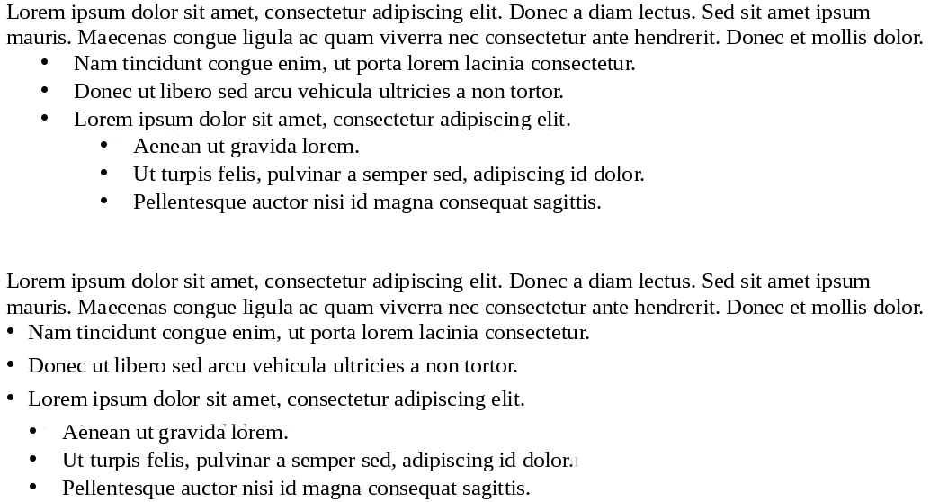
An example of why indents should be as few as possible. Starting at the left margin, the top passage has five indentations, and looks cluttered. The bottom passage looks less cluttered because it reduces the number of indentations to three.

Setting first line indentation
A first-line indent is one of the two ways to indicate a new paragraph. The other way is to add extra space between paragraphs.
Usually, a first line indent is used for more formal or literary works, while an extra space may be for technical manuals, but the rule is not absolute. The only firm convention is that you should use one or the other, but not both at the same time
Most people set an indent of 30–36 points – no doubt a legacy of typewriters, on which setting indentations precisely was difficult. However, that is excessive.
Unless a font is extremely small, the first line indent usually needs to be no more than the line spacing, and you might even manage with half a line-space, depending on the font size.
If you set the First line field to Automatic, you can largely ignore tabs, except for features like tables of contents that rely upon them for some features.
The first line indent is set in the First line field of the Indent section of the Indents & Spacing tab. You can use it either by pressing the Tab key or by selecting the Automatic box.

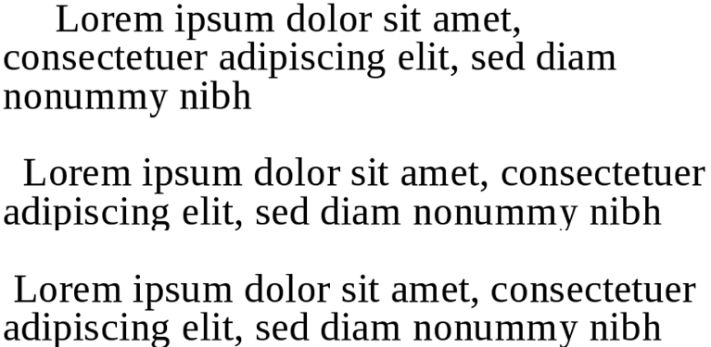
First line indentation. 36 points (top) can leave too much white space to the left, while half a line-space (bottom) can be hard to distinguish. Usually, a full line-space (middle) avoids both extremes.

- Example: Designing a letter template
If you have been reading chapter by chapter, at this point you may want a sense of what goes into a template.
You can customize a letter template from File > Wizards > Letter that uses frames to position different elements of the letter. As an alternative, here are the steps in building a letter template with styles.
The example ignores page settings, since they have not been covered yet. You can add margins and headers after you have read about page styles.
Choosing fonts
This template uses two fonts: One for the body of the letter, and one for information like addresses and the salutation – the equivalents of headers in other documents.
After some experimentation, I opted for two free-licensed fonts from the Arkandis Digital Foundry. Baskervald ADF Std. imitates the classic Eighteenth Century font Baskerville and is used for body text. Gillius ADF No.2, which imitates Gill Sans, is used for heading text (that is, anything not part of the body text).
If you download and install these two fonts on your system, you can build the template by following the description below.
Creating the basic font palette
To prepare Gillius ADF No.2, apply these settings to the Heading paragraph style:
- Since this font is only for short lines, ignore elements such as first line indentation or widow and orphan control, which will not be used.
- Set the font size to 14 points for greater legibility on the Font tab, and set the line space to 18 points. Experiments with page color show that anything less makes the color of the font too dark on the page.
To prepare Baskervald ADF Std, apply these settings to the Text Body style:
- Select the Automatically box for hyphenation, Orphan control, and Widow control on the Text Flow tab.
- Set the font size to 15 on the Font tab. Baskervald's characters use more white space than most fonts, and therefore appear much smaller than the actual size.
- Set the Line spacing to Fixed > 18 points on the Indents & Spacing tab. This setting gives Baskervald a color close to that of Gillius, which makes for a uniform look on the page.
Check these settings by printing samples of at least three lines for both fonts. All other styles will be based on the settings for these two, with variations for individual needs.
Setting up other styles
The best way to set up other styles is to start at the top of the document and note the styles that are needed:
- Use the pre-existing Addressee style for the return address. Change the Inherit from field on the Organizer tab from Addressee to Header, and change the alignment to Right on the Alignment tab.
- 注意
You may need to re-start LibreOffice for the changes to take effect. This problem may happen with any pre-existing style.
- Below the return address is the Date style, which is followed by white space, then the Address. Create both as new styles linked to the Header style.
Then make the following changes to the Date style:
- Set the Next style field on the Organizer tab to Address.
- Change the alignment to Right on the Alignment tab.
- On the Indents and Spacing tab, set Spacing > Above paragraph to 54 points, and Spacing > Below to 126 points. Notice that these are multiples of the fixed line spacing of 18 points being used for Header and its subordinate style.
- 祕訣
If you are using any page size other than Letter, increase Spacing > Below to a multiple of 18.
- From the menu, select Insert > Fields > Other > Document > Date. Select a format from the Format pane, then click the
- Insert button. Now, every time you select the Date style, the current date will be automatically added.
- The Address style is unmodified from the Header style. However, it is worth creating so you remember what style to use. Besides, you might eventually decide to modify it.
- The next style is the Salutation. On the Indents & Spacing tab, set Spacing > Above Paragraph to 36 points (2 lines), and Spacing > Below paragraph to 18 (1 line). Then, on the Organizer tab, set the Next Style field to Text Body.
- The Text Body style is already created. However, it needs a First line indent setting on the Indents & Spacing tab. Set it to 18 points, the same as the line spacing.
- Create a Signature style with the following settings:
- On the Alignment tab, set the alignment to Center.
- On the Indents and Spacing tab, set Spacing > Above Paragraph to 18 points (1 line),
- On the Indents and Spacing tab, set Spacing > Below Paragraph to 95 points (5 lines). Leave more space below if you have a large signature.
Creating character styles
The only character styles likely to be needed with this template are those for Emphasis (italics) and Strong Emphasis (Bold). Base both on the Body Text (Baskervald ADF Std, 15 point).
Other points
Following these steps results in a useful, well-designed template. Formatting consists of six changes of paragraph styles, two of which are automatically changed when I press the Enter key. Instead of worrying about formatting, I can concentrate on what I am saying.
However, you may prefer to organize the paragraph styles differently than I have done, and make other adjustments beyond the basics given here.
Building a template is a matter of trial and error, and you are unlikely to remember everything – or get all design elements perfect – after a single session.
For instance, after using the template for a few letters, I realized that the default margins created a somewhat narrow look. Changing the left and right margin to 72 points (a multiple of the line spacing for the Text Body) improved the layout immensely.
Similarly, when I realized the template worked best for short letters, I added a page with a footer containing the page number for longer letters.
I could also have added a few touches, such as creating and attaching a list style to the Salutation paragraph style that automatically added “Dear” when I applied the paragraph style.

The text style basics
The settings discussed in this chapter are the ones you are likely to use in every document. The next two chapters explore special cases and advanced settings that you may want to use now and then.

6

文字工具與陷阱
第5章討論所有文檔幾乎都使用的設定。本章是關於較不常用的字元及段落設定。一個單一文檔可能用到到好幾個這樣的功能，但很少全部都用到。
某些功能只有有限或特殊的用途。然而，其他的功能使用前則應該小心的考慮。
某些功能是Writer首次發行時(約二三十年前)合理的設計元素，現在不僅已經過時，而且從未成為最佳的排版慣例。
還有一些功能隱晦或難以使用。這種情形通常可以選用其他方式達到相同的結果。
There is even a feature or two that LibreOffice technically supports but implements so poorly that you will get more satisfying results if you use another piece of software instead.5

Spacing on all sides
Paragraph styles are the most frequently used type of style in LibreOffice. However, they interact so closely with character styles that talking about one without the other is impossible – they even share several of the same tabs in their dialog windows.
Paragraph styles define the general formatting for any text-heavy document, while character styles provide brief variations. For short bursts of text – for example, a title, URL, or bullet point – character styles provide exceptions that give paragraph styles the flexibility they lack by themselves.
Chapter 3 ventured into some of the basics of paragraph and character settings while discussing fonts and how to find the ideal line spacing. This chapter completes the discussion of basic paragraph formatting, (including a more detailed discussion of line spacing), covering the options for vertical and horizontal spacing.
The next two chapters discuss special features and potential problems and advanced features.
- 祕訣
Many of the tabs in character and paragraph style dialog windows reappear in the other LibreOffice applications. To minimize repetition, later chapters refer back to this chapter and the two following it.

Preparing to design
- Choose your fonts and ideal line spacing.
- Have a calculator and a list of multiples of the line spacing ready so you can check basic measurements.
- Set the default measure to points in Tools > Options > LibreOffice Writer > General > Settings > Measurement Unit. You can reset the default unit to centimeters or inches when you are done, but points are the most commonly used unit of measurement for general typography.
0
Before you design, set the Measurement Unit to points.
- Set the zoom to 100% so you can judge the page color. Print or zoom in or out periodically so you can get a different perspective.
- In the status bar at the bottom of the editing window, set LibreOffice to display multiple pages,
- selecting the third button from the left. Unless you are struggling with a small monitor, a two-page spread helps you see the effect of your design choices.
Displaying multiple pages shows how the document will look when printed or else viewed on a wide screen monitor in a two-page spread.

A multi-page display gives a design overview. Here, it confirms that footers are mirrored as intended.

- Open a second file where you can experiment and use dummy text to test formats.
- While you design, use manual formatting. Creating styles at this point is just an extra step until you have finished experimenting. When you have decided on the formatting choices, you can always drag a selected passage to the Styles and Formatting window to create a style from it.
- Use this chapter’s headings as a checklist so you cover all the basic formatting.
- 注意
As you work, you may find that some of the settings you have already chosen require changing – even the magic number.
Rather than resisting the change, accept it as a natural part of the design process. The goal is to develop the best design you can, not to cling to a pointless consistency.

Planning text styles
You can save time while designing by working whenever possible with Writer’s pre-defined styles. Later, as you write, you will find that some features, such as Insert > Fields > Other Document > Chapter > Chapter name field, depend on the pre-defined paragraph styles being in the document.
The pre-defined character and paragraph styles should cover most of your needs, but you can add other styles as needed..
Then go through the list of pre-defined styles and decide which ones you do not need. For example, paragraph styles Heading 5–10 are far more headings than anyone can manage. Perhaps, too, you have no use for paragraph styles like List 1 Cont., List 1 End, and List 1 Start, and they will only clutter up the Styles and Formatting window. For each unnecessary style, select Hide from the right-click menu. Should you decide that you need a hidden
style after all, you can go to the Hidden Styles view and select Show instead.
All these tasks are a lot of work. But you will also find that there are many styles in which you can keep the default settings.
For instance, line spacing may be unimportant in headings, since headings are often less than a single line in length.
Similarly, in a simple document, an automatic first line indent may completely remove the need to set tab stops. The fact that many defaults can be used unchanged or entirely ignored greatly reduces the amount of designing necessary to complete a template.

Setting vertical line spacing
Writer’s Line spacing field is on the Indents and Spacing tab of each paragraph style. It used to accept entries of 1/10 of a point (1/720 of an inch), but, since LibreOffice 4.2, the field rounds entries to the nearest point (1/72) or an inch.
This rounding produces adequate results, but not always optimal ones. Believe it or not, 1/10 of a point can make a large visual difference.
- 祕訣
Apache OpenOffice still allows entries of 1/10 points.
If you used your choice of fonts to determine the magic number, then you have already adjusted
this option using the Fixed setting in the Line spacing field. Fixed remains by far the best setting, because it is the only option that gives an exact measurement.
Line spacing options for paragraphs.
Fixed also has the advantage that documents will be register-true, regardless of whether the Register-true setting is turned on. In other words, lines will be in the same horizontal position on all pages, especially if the document uses only one font.
In addition, should you print on both sides of a page, the lines will overlap in most places, preventing the shadow of the other page showing through thin paper.
However, one problem with paragraph styles with larger font sizes, such as headings, is that they can have the tops or bottoms of letters cut off when Fixed is used. This problem can be solved by setting the Line spacing field using the At Least option while keeping the line height unchanged.
Cut-off characters are a sign that the Fixed line spacing needs to be either adjusted or replaced by At Least.

The other options for line spacing are different ways of expressing line spacing. Except for quick, one-off documents, avoid the Single, 1.5 lines, and Double options. These options use Writer’s standard defaults for line spacing, and are optimal for any given font only by luck.
The least useful option is Proportional, in which line-spacing is expressed as a percentage of the automatically determined single space, and not an exact figure. In other words, this option places you two removes from the actual figure for line spacing.
Another vague option is Leading. “Leading” is a term from the days of manual typesetting, when scraps of lead or anything else around the print shop were used to increase line spacing. “Leading” came to refer to the entire line spacing. However, LibreOffice uses the word to refer to only the extra space beyond the font size. For example, in LibreOffice, a paragraph set to 12/15 would be set with Leading at 3 points.

Line spacing at small font sizes
You can sometimes find fonts specially designed to be readable at sizes below 10 points. More often, small font sizes need extra line spacing to make them readable.
Unfortunately, LibreOffice, like most word processors, treats line spacing for small font sizes the same as line spacing for any other size. As a rule, select Fixed to give small font sizes the extra line spacing they need.
Above: 8 point Liberation Serif with automatic single spacing. Below: 8/12 Liberation Serif. Font sizes of less than 10 points almost always require extra line-spacing for readability.

Spacing between paragraphs
The Indents & Spacing tab, with the Above paragraph and Below paragraph fields listed under Spacing.
Vertical spacing is set on the Indents and Spacing tab in the Spacing > Above Paragraph and Spacing > Below Paragraph.
Vertical spacing is also used to increase the effectiveness of headings. The rule is simple: Put a heading closer to the content it summarizes, and the relation between the heading and the content becomes clear at a glance.
Putting less space between headings and the passage they introduce helps the eye to associate them.
Extra spacing between paragraphs is one of the ways to indicate the start of a new paragraph (the other is an indentation of the first line). Usually, extra spacing is used in technical documents, but the only rule is not to use both at the same time.
- 祕訣
The heading's font size, and the space above and below it, should total a multiple of the line spacing. In this way, heading paragraph styles matches the line spacing every few lines.
Use the same formula if spacing between body text paragraphs is used instead of a first line indentation.
In this example, the line spacing is set to 15 points. Together, the spacing before the heading and after it plus the font size for the heading should equal a multiple of 15 or of 7.5 (half the line height).

Removing unexpected space.
The combined effect of Before and After settings for two subsequent paragraph styles can cause unexpectedly large spaces between paragraphs.
Minimize this problem by using only the Before Paragraph field and leaving the After Paragraph field set to zero for most paragraph styles.
In the case of pictures, you may want to vary the spacing to avoid extra large gaps.
Sometimes, the conflict may be between an image and a paragraph style. When that happens, modify the space below the image so that it matches the convention you have set and leave the paragraph style settings alone. After all, spacing
around an image or any other object is manually set already.

Avoiding widows and orphans
Standard typography tries to avoid a single line at the bottom of a page – a widow – or a single line at the top of a page – an orphan.
- 祕訣
You can distinguish widows from orphans by remembering that an orphan is left behind while a widow goes forward by herself.
Of course, avoiding widows and orphans is not always possible. Some paragraphs are a single line long. Tools > Autocorrect does have an option to combine short paragraphs, but that is not always suitable to the sense of the passage.
Other paragraphs have a number of lines that do not fit Writer’s settings. For example, if you have set last and first paragraphs on a page to each have two lines, something has to give when a three-line paragraph straddles two pages.
The Text Flow tab, with Orphan control and Widow control under Options.
The Text Flow tab of a paragraph style includes four options for avoiding both.
The main tools for avoiding widows and orphans are Widow control and Orphan control. For Text Body and related styles, you should activate both, accepting the default of keeping two lines together, or three at the most. You do not need these settings for heading paragraphs, or in a case in which all paragraphs are short – in either case, the controls will have nothing to adjust.
As an alternative, keep Widow control and Orphan control unselected and select instead Do Not Split Paragraph. This setting may keep important information together and therefore easier to read,
but can result in page breaks well before the bottom of the page.
For headings, you may prefer Keep with next paragraph. When headings are meant to introduce the body text below them, having the heading and body text on separate pages makes no sense. However, this setting, too, may result in poorly positioned page breaks, so use it sparingly.

Spacing between paragraphs
Vertical spacing is set on the Indents and Spacing tab in the Spacing > Above Paragraph and Spacing > Below Paragraph fields.
The Indents & Spacing tab, with the Above paragraph and Below paragraph fields listed under Spacing.

Vertical spacing is also used to increase the effectiveness of headings. The rule is simple: Put a heading closer to the content it summarizes, and the relation between the heading and the content becomes clear at a glance.
Extra spacing between paragraphs is one of the ways to indicate the start of a new paragraph (the other is an indentation of the first line). Usually, extra spacing is used in technical documents instead of first-line indentation, but the only firm rule is not to use both at the same time.
Putting less space between headings and the passage they introduce helps the eye to associate them.
- 祕訣
The heading's font size, and the space above and below it, should total a multiple of the line spacing.
Use the same formula if spacing between body text paragraphs is used instead of a first-line indentation.
- 注意
The combined effect of Before and After settings for two subsequent paragraph styles can cause unexpectedly large spaces between paragraphs.
Minimize this problem by using only the Before Paragraph field and leaving the After Paragraph field set to zero for most paragraph styles.

Selecting an alignment
On the Alignment tab of a paragraph style, you have four choices for horizontal positioning: Left, Right, Centered, and Justified.
The Alignment tab, with the Options at the top of the window.

Right is rarely used except in short, highly-formatted documents such as ads or diagrams, while Centered is generally reserved for titles and sub-titles. For most paragraph styles, your choice is likely to be Left or Justified.
Whatever your choice of alignment, if you are using hyphenated styles, run Tools > Language > Hyphenation as a last step before publishing. This selection repairs any sub-optimal choices Writer might have made on the fly.

Using a Justified alignment
Many users prefer a Justified alignment, in which all lines start at the same position on the left and end at the same position on the right. Because commercial publications often use Justified, users often believe it looks more professional.
The preference may also be a reminder of the earliest days of word processing, the first time that a Justified alignment became practical. The vast majority of typewriters, of course, could only use a Left alignment.
The trouble is, a Justified alignment often requires more work. Too often, it results in irregular spacing between characters or words that looks far worse than Left alignment ever could. You almost always need to tinker to find the best distribution of characters and words on a line.
Generally, too, the shorter the line, the harder you have to work to make Justified work. As a rule, lines of less than 40 characters are too much effort
to be worth justifying. A Left alignment can still cause problems, but they are often less severe, especially in columns or tables.
The easiest way to tell if a paragraph style can easily use Justified is to set it up with dummy text and count the number of lines that end in a hyphen and the blotches of irregular white space.
The more of these problems that appear, the more you need to change the hyphenation, the font, the font size, and/or the column width in the hope of a better fit. You can even go to the Position tab to expand or condense character spacing.
An example of the wrong alignment for the line length. The middle column has three hyphenated lines, while hyphenation causes awkward breaks throughout. Even worse, several lines are single words. Some lines even have more than one fault.

Setting the last line of justified text
The last line of justified text is only a complete line by luck. Almost always, it is an incomplete line.
LibreOffice offers several choices of how to handle this approach. Frankly, though, you have to
wonder why. All but one leave large gaps between words or letters that anyone who cares about the design of their documents should find unacceptable.
The Last line options for justified text on the Alignment tab. The other options in the drop-down list are Centered and Justified.

- 祕訣
Snap to Text Grid (If Active) uses the non-printing grid set in Tools > Options > LibreOffice Writer > Grid for positioning. Apache OpenOffice lacks this option.
The only consistently aesthetic choice is to set the Last line field to Left. This selection is the only one that eliminates the impossible situation of trying to justify a line of text that is too short and has ugly gaps in it.
The other options – Justified, Centered, Expand single word, and Left – all look awkward. The only reason to use any of them is to provide a sample of why they are unacceptable.
The justification of the last line. From top to bottom: Justified, Centered, Expand Single Word, and Left.
You may be able to improve the look of Justified by selecting Snap to Text Grid (If Active) and adjusting the grid set in Tools > Options > LibreOffice Writer > Grid. However, getting an acceptable look is likely to take a lot of trial and error.

Using a Left alignment
When a paragraph has a Left alignment, all lines start at the same position on the left, but can end anywhere on the right. For this reason, a Left alignment is sometimes referred to as “ragged right.” This is the default choice in Writer, probably because it is reasonably acceptable without tweaking, especially if lines are not hyphenated or are over about 40 characters long.
Generally, the shorter the line, the harder you have to work to make Justified look decent. That means that Left can be a better choice in columns or tables.

Setting hyphenation
Hyphenation options are set on the Text Flow tab. Whether to hyphenate is one of the most important design decisions you will make when designing a document.
Hyphenation is a contentious issue in digital design. Most word processors hyphenate as you type, and while they make adjustments as the line lengths change, their on-the-fly solutions are not always optional. Short lines are especially hard to hyphenate well automatically.
These difficulties are one reason that many designers prefer a Left alignment or ragged right margin. A Left alignment does not always produce the best possible use of the line, but its shortcomings are rarely as severe as those with a Justified alignment.
Another choice is to turn off hyphenation completely, which is probably why the Text Flow tab does not check the Automatically hyphenation box by default.
Other designers, more determined or more patient, try to improve hyphenation by adjusting the settings on the Text Flow tab. The number of letters at the end and start of the line should be 1–4. The typographical convention is not to allow more than two lines in a row to end with a hyphen.
Detail of the Text Flow tab, showing the hyphenation controls.
The Characters at line end and Characters at line begin fields can sometimes be manipulated to improve hyphenation by playing one off against the other. Working by itself, the Maximum number of consecutive hyphens field can also make a difference.
In many documents, only Text Body and perhaps another handful of paragraph styles are used at such length that hyphenation can improve how they fall on the page. Headings, which are rarely more than a few words long and almost never more than two lines, generally do not need to be hyphenated at all. If anything, headings are easier to scan if not hyphenated.
You may want to change the hyphenation by adjusting:
- The Hyphenation settings on the Text Flow tab.
- The font weight or size.
- The choice of fonts.
- The settings for Tools > Options > Language Settings > Writing Aids > Options > Minimal number of characters for hyphenation. These settings are over-ridden by any formatting in the document itself.
- The Scale width and Spacing fields on the Position tab to expand or condense character spacing. Frankly, these fields are a last desperate measure.
In addition, if you do hyphenate, the line divisions can be improved by running Tools > Language > Hyphenation as a final touch on the document.
This tool not only works interactively, giving you more control, but also generally does a better job than the on-the-fly hyphenation, if run when the document is complete.
- 祕訣
For extra fine-tuning, go through a document when it is complete, and hand-hyphenate by positioning the cursor between syllables and pressing Ctrl+ -. This key combination creates a conditional hyphen that only comes into play when it is in the hyphenation zone near the right margin.

Setting horizontal spacing
By default, paragraphs run from the left margin to the right margin – or, at least, to a region just before the right margin that LibreOffice must reach before starting a new line, with or without hyphenation.
However, on the Indents and Spacing tab, you can indent a paragraph on the left by entering a value in the Before Text field, or on the right by entering a value in the After Text field.
Common uses for an indent include:
- The start of a new paragraph.
- A quotation of over three lines or 100 words. Typically, such long quotations are indented one line-space on the left and right. No quotation marks are used, since the indentation is enough to mark is a quotation.
- The space between a bullet or number and an item in a list. This space is set using the Indent at field on the Position tab for a list style.
- Notes, tips, or warning paragraph styles.
- Paragraph styles intended for single style outline numbering.
- Cases in which headers and footers are wider than body text.

Controlling the number of indents
Some paragraph styles that begin with an indentation are unavoidable in a text document. However, too many different indentations clutter the design, so indentations should be kept to a minimum. No need, for example, exists to have a bulleted or numbered list indented more than the Text Body style. Instead, the indentation for a long quotation can be the same as the first line indentation, as well as the position where the text starts in a list item after a bullet or number.
- 祕訣
Horizontal line spacing can also be a help in readability. Regardless of font or page size, typographic convention suggests that a line of body text should be 50–75 characters long for readability – or, to put things another way, two to three lower case alphabets long in a single-column layout.
In tables or multi-column layouts, the length should generally be 30–50 characters, regardless of alignment. Anything less risks cluttering the column with hyphens, single-word lines, and/or vast stretches of white space.
An example of why indents should be as few as possible. Starting at the left margin, the top passage has five indentations, and looks cluttered. The bottom passage looks less cluttered because it reduces the number of indentations to three.

Setting first line indentation
A first-line indent is one of the two ways to indicate a new paragraph. The other way is to add extra space between paragraphs.
Usually, a first line indent is used for more formal or literary works, while an extra space may be for technical manuals, but the rule is not absolute. The only firm convention is that you should use one or the other, but not both at the same time
Most people set an indent of 30–36 points – no doubt a legacy of typewriters, on which setting indentations precisely was difficult. However, that is excessive.
Unless a font is extremely small, the first line indent usually needs to be no more than the line spacing, and you might even manage with half a line-space, depending on the font size.
If you set the First line field to Automatic, you can largely ignore tabs, except for features like tables of contents that rely upon them for some features.
The first line indent is set in the First line field of the Indent section of the Indents & Spacing tab. You can use it either by pressing the Tab key or by selecting the Automatic box.

First line indentation. 36 points (top) can leave too much white space to the left, while half a line-space (bottom) can be hard to distinguish. Usually, a full line-space (middle) avoids both extremes.

- Example: Designing a letter template
If you have been reading chapter by chapter, at this point you may want a sense of what goes into a template.
You can customize a letter template from File > Wizards > Letter that uses frames to position different elements of the letter. As an alternative, here are the steps in building a letter template with styles.
The example ignores page settings, since they have not been covered yet. You can add margins and headers after you have read about page styles.
Choosing fonts
This template uses two fonts: One for the body of the letter, and one for information like addresses and the salutation – the equivalents of headers in other documents.
After some experimentation, I opted for two free-licensed fonts from the Arkandis Digital Foundry. Baskervald ADF Std. imitates the classic Eighteenth Century font Baskerville and is used for body text. Gillius ADF No.2, which imitates Gill Sans, is used for heading text (that is, anything not part of the body text).
If you download and install these two fonts on your system, you can build the template by following the description below.
Creating the basic font palette
To prepare Gillius ADF No.2, apply these settings to the Heading paragraph style:
- Since this font is only for short lines, ignore elements such as first line indentation or widow and orphan control, which will not be used.
- Set the font size to 14 points for greater legibility on the Font tab, and set the line space to 18 points. Experiments with page color show that anything less makes the color of the font too dark on the page.
To prepare Baskervald ADF Std, apply these settings to the Text Body style:
- Select the Automatically box for hyphenation, Orphan control, and Widow control on the Text Flow tab.
- Set the font size to 15 on the Font tab. Baskervald's characters use more white space than most fonts, and therefore appear much smaller than the actual size.
- Set the Line spacing to Fixed > 18 points on the Indents & Spacing tab. This setting gives Baskervald a color close to that of Gillius, which makes for a uniform look on the page.
Check these settings by printing samples of at least three lines for both fonts. All other styles will be based on the settings for these two, with variations for individual needs.
Setting up other styles
The best way to set up other styles is to start at the top of the document and note the styles that are needed:
- Use the pre-existing Addressee style for the return address. Change the Inherit from field on the Organizer tab from Addressee to Header, and change the alignment to Right on the Alignment tab.
- 注意
You may need to re-start LibreOffice for the changes to take effect. This problem may happen with any pre-existing style.
- Below the return address is the Date style, which is followed by white space, then the Address. Create both as new styles linked to the Header style.
Then make the following changes to the Date style:
- Set the Next style field on the Organizer tab to Address.
- Change the alignment to Right on the Alignment tab.
- On the Indents and Spacing tab, set Spacing > Above paragraph to 54 points, and Spacing > Below to 126 points. Notice that these are multiples of the fixed line spacing of 18 points being used for Header and its subordinate style.
- 祕訣
If you are using any page size other than Letter, increase Spacing > Below to a multiple of 18.
- From the menu, select Insert > Fields > Other > Document > Date. Select a format from the Format pane, then click the Insert button. Now, every time you select the Date style, the current date will be automatically added.
- The Address style is unmodified from the Header style. However, it is worth creating so you remember what style to use. Besides, you might eventually decide to modify it.
- The next style is the Salutation. On the Indents & Spacing tab, set Spacing > Above Paragraph to 36 points (2 lines), and Spacing > Below paragraph to 18 (1 line). Then, on the Organizer tab, set the Next Style field to Text Body.
- The Text Body style is already created. However, it needs a First line indent setting on the Indents & Spacing tab. Set it to 18 points, the same as the line spacing.
- Create a Signature style with the following settings:
- On the Alignment tab, set the alignment to Center.
- On the Indents and Spacing tab, set Spacing > Above Paragraph to 18 points (1 line),
- On the Indents and Spacing tab, set Spacing > Below Paragraph to 95 points (5 lines). Leave more space below if you have a large signature.
Creating character styles
The only character styles likely to be needed with this template are those for Emphasis (italics) and Strong Emphasis (Bold). Base both on the Body Text (Baskervald ADF Std, 15 point).
Other points
Following these steps results in a useful, well-designed template. Formatting consists of six changes of paragraph styles, two of which are automatically changed when I press the Enter key. Instead of worrying about formatting, I can concentrate on what I am saying.
However, you may prefer to organize the paragraph styles differently than I have done, and make other adjustments beyond the basics given here.
Building a template is a matter of trial and error, and you are unlikely to remember everything – or get all design elements perfect – after a single session.
For instance, after using the template for a few letters, I realized that the default margins created a somewhat narrow look. Changing the left and right margin to 72 points (a multiple of the line spacing for the Text Body) improved the layout immensely.
Similarly, when I realized the template worked best for short letters, I added a page with a footer containing the page number for longer letters.
I could also have added a few touches, such as creating and attaching a list style to the Salutation paragraph style that automatically added “Dear” when I applied the paragraph style.

The text style basics
The settings discussed in this chapter are the ones you are likely to use in every document. The next two chapters explore special cases and advanced settings that you may want to use now and then.

