7

Positioning and automating text
This chapter concludes the ongoing discussion about character and paragraph styles by talking about their advanced features. It explains the relationship between paragraph and list styles, how to position characters more precisely, and several specific ways to automate your work flows using text styles.
The automating features are easy to overlook, but they can be as important as features that affect the look of a document.
For example, a conditional style allows you to format the same style differently depending on its context, or set a paragraph style so that it always starts a new page. Although casual users may never be aware of such features, those who write as part
of their work will soon become well aware of the time these feature save.
You will rarely use these features all the time, nor all of them at once. However, knowing what is available can help you to design your documents more intelligently and to work more efficiently when you write.
For example, the font effect Hide sounds minor. Yet in one unimportant-looking toggle switch, Hide provides an elegant solution for one of the most difficult tasks for professional documenters – maintaining multiple versions of the same document in a single file.

Fine-tuning characters
Like most word processors or layout software, LibreOffice does much of the housekeeping for design.
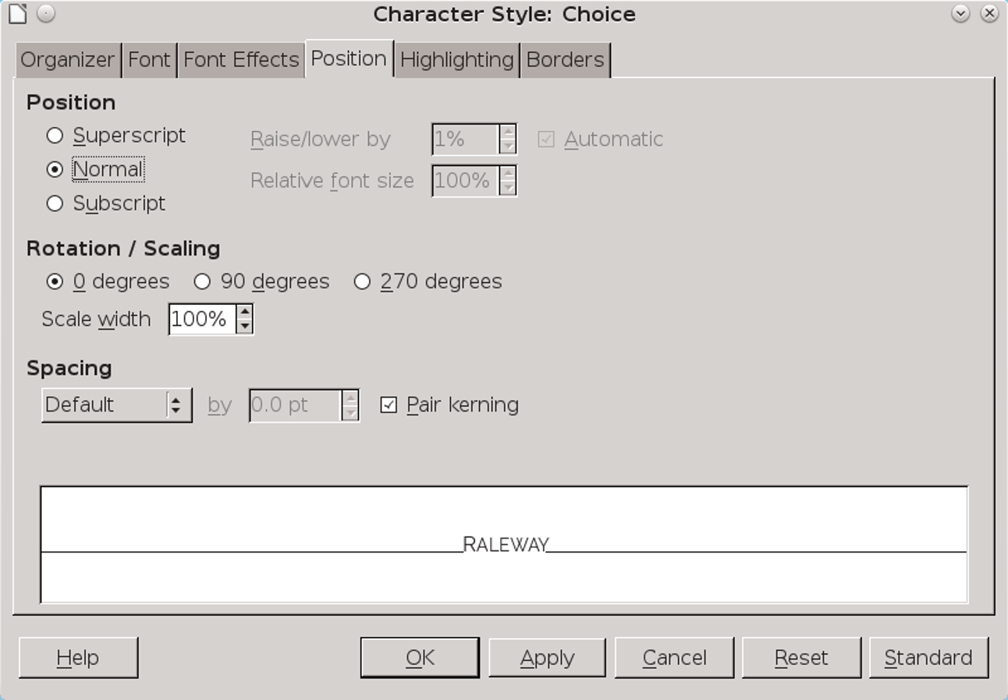
Unique to character styles, the Position tab is the main spot for adjusting individual characters.
For example, without consulting users, Writer examines font files to display characters properly. It also detects whether a font family includes italics or bold weights, and decides the size and placement of footnote numbers.
Most users are happy to let LibreOffice make these decisions. However, the software’s decisions are not always ideal, so at times you might want to tweak the spacing between characters or reposition footnote numbers.
LibreOffice includes the tools you need for such tweaking. Many are on the Position tab for character styles, although others are scattered throughout the character and paragraph style dialogs.

Positioning superscript and subscript
The Position tab of a character style gives you several advanced options for adjusting superscript characters (above others on the same line) and subscript characters (below others on the same line). Another alternative for superscript characters is to adjust the vertical alignment of text on the same line (see “Aligning different-sized text on one line,” page 5).
These adjustments are relatively common, because, depending on the font, LibreOffice’s default superscript and subscript characters can sometimes be too too small for easy reading.
To understand superscript and subscript characters, you have to remember that all letters sit on an imaginary baseline. Many characters have what is called an x-height – the height of a letter x, but also of an m or r, as well as the bowl of a lower case b or p.
Still others like y have descenders, or lines that are lower than the baseline, while letters like k have ascenders, or lines that rise above the x-height. However, all characters are positioned relative to the baseline. The exact positions are part of the font’s design and are stored in its files. There is no reason, though, why you should not modify the intended design if you care to make the effort.
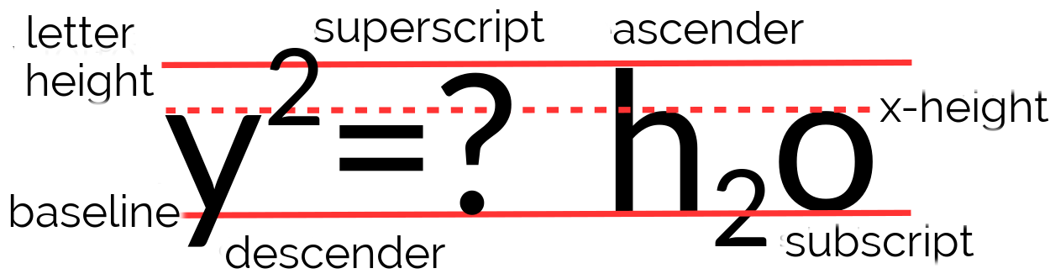
Superscript and subscript characters. The superscript “2” on the left is higher than the ascenders or the question mark, and throws off the look of the line.
By contrast, the subscript “2” on the right is as low as the bottom of the descender on the “y,” which gives a more consistent look to the line (Font: Lato).
Superscript characters, such as mathematical components or footnote numbers, are usually positioned somewhere between the x-height and the height of the ascenders.
Similarly, subscript characters, such as those in chemical equations, usually sit between the baseline and the low point of descenders.
The size of superscript and subscript characters is a trade off between being large and easily readable and being uncluttered but harder to read. To many users, LibreOffice’s defaults are too small.
When adjusting both position and size, be prepared for several trials and errors before getting the best results, with the adjustments getting smaller as you move closer to the ideal.
To direct your experiments, consider these points:
- The exact size will vary with the font’s white space, but 40–60% of the body text should be the usual range.
- If a font’s characters use a lot of white space, so that they look small compared to fonts of the same size, increase its size.
- Unless the x-height is exceptionally large, using it for the bottom of superscript characters often makes for a consistent design. However, using this guide with a large x-height is likely to make the superscript characters too small.
- Avoid old style characters for superscript and subscript. Their lack of a common baseline means either an eye-disturbing clutter or a time-consuming positioning of each numeral separately.
- Aligning superscript characters with the top of ascenders and subscript characters with the bottom of descenders has the advantage of being symmetrical while giving you a visible target.
- 注意
The fields for lowering or raising superscript or subscript characters read all input as percentages, rounded to the nearest number. You cannot use points in them.
- 注意
The Position tab for characters and paragraph styles is specifically for blocks of text. To create formulas, open File > New > Formula or use the Math application.

Aligning different-sized text on one line
The Text-to-text option on the Alignment tab vertically aligns text of different sizes on the same line. It can be used with a brochure or poster than an essay, but its main use is probably to create superscript or subscript characters without the fuss of using the Position tab (see “Positioning superscript and subscript,” page 3).
The setting can align font sizes by the Top, Middle, or Bottom of the letters, or the default Base Line. In each case, the largest characters remain on the baseline, while other characters are raised or lowered in relation to them. For example, if you select Bottom, then the smaller characters are positioned at the bottom of the largest characters’ descenders (the lines below the base line). Similarly, with Top selected, the smaller characters are positioned at the top of the largest characters’ ascenders (the lines above the x-height).
However, mostly you can leave the setting on Automatic, which defaults so that all different font sizes are aligned by the base line. In other words, you can usually safely ignore the setting.
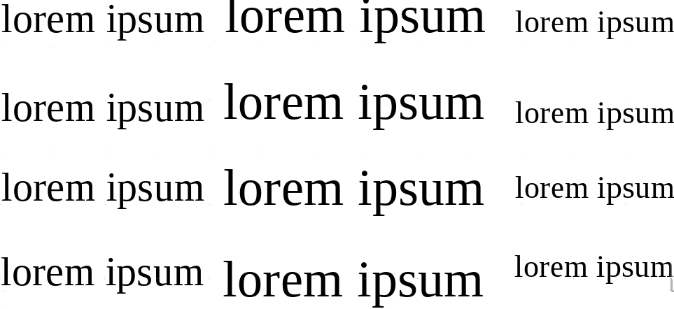
From top to bottom: The Text-to-text field on the Alignment tab set to Automatic (Base Line), Bottom, Middle, and Top.

Rotating text
The Position tab for character style includes settings for rotating text 90 (right angle to the baseline and above) and 270 degrees (right angle to the baseline and below). These settings are mostly useful in a table heading, but both interfere with readability and should not be used if any alternative exists.
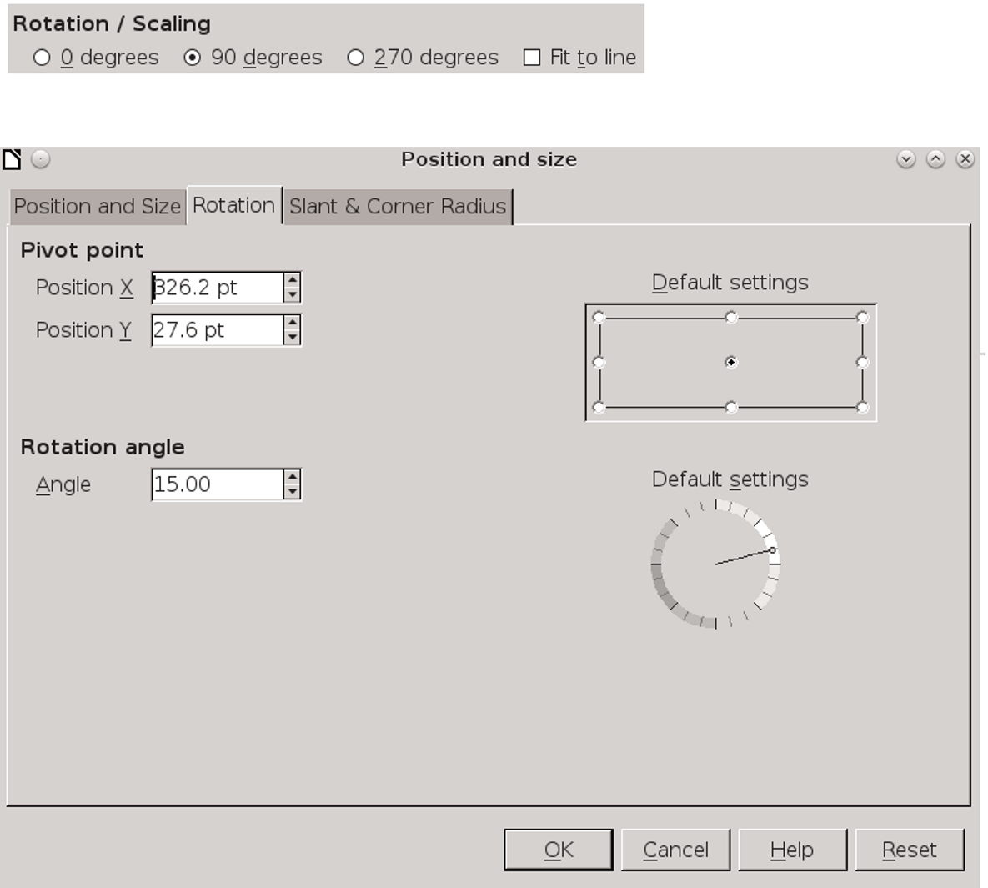
Above: Controls for rotating a character style on the Position tab. Below: Controls for rotating graphic text on a sample’s right-click menu. Graphic text is text created with the Drawing toolbar, and is treated as a drawing object rather than as text.
The rotation tools may be useful in brochure and ad designs, but they are very basic. You will have more precision than these settings offer if you use graphical text – text treated as a drawing object – and then right-click and select Position and size > Rotation instead.

Adjusting font width
The width of characters is interpreted by LibreOffice’s reading of each font’s file. However, you
can adjust it using the Scale width field on the Position tab. This feature is especially useful when you have no condensed or expanded version in a font family.
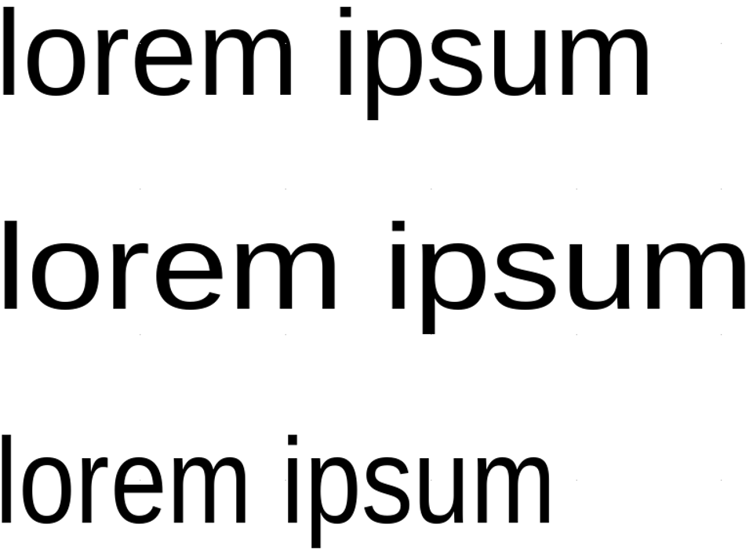
From top to bottom: 100%, 115%, and 85% character width. Greater increases or decreases tend to look clumsy with most fonts, especially at smaller sizes. Font: Maven Pro.
In pre-digital typesetting, changing the width of a font would also include changing the design of many of the individual characters to keep the proportions in the shape of the letter. These adjustments do not happen with most digital fonts, and rarely to the same degree. Consequently, you can do little to change the width of some fonts without producing a disordered mess.
However, most fonts can stand 1–15% adjustments less or more than the default 100% without deteriorating too badly. These adjustments can help improve the page color of the body text.

Adjusting character combinations (kerning)
Kerning is the spacing between characters. Professional printers sometimes adjust kerning to improve the appearance of awkward combinations of letters. Combinations such as “Va,” “ll,” and “ff” can be improved in most fonts, and individual fonts may benefit from the adjustment of other combinations as well.

Changing the spacing between characters using the Spacing field on the Position tab.
Left: Reducing the space between characters improves the spacing.
Middle: Creating your own ligature by moving characters together.
Right: Sometimes, kerning means increasing the space between characters for easier reading. Font: Maven Pro.
Kerning has always been a concern in typography, but digital typography makes it more important than ever. Unlike in manual type, digital fonts usually do not have different spacing when the font size changes. Instead, the spacing is intended for a standard size.
Consequently, if you greatly decrease or increase font size, the kerning may be off. What is intended for 12 points may not work for 8 or 48 points.
Moreover, LibreOffice’s general kerning tends to be very loose, and you can often improve on it if you are willing to make the effort and make small changes.
If you choose to handle your own kerning, create character styles with adjusted spacing. You may manage with only a single kerning character style for all your needs, but if you are really attentive to detail, you might decide on individual kerning character styles for different letter combinations – it all depends on your patience, the font you use, and your perfectionism.
However, you may want to change the spacing, either to improve legibility or for a short string of characters in a more graphical document, such as a brochure, by adjusting the Spacing field on the Position tab.
If you are manually adjusting justified lines, you might also want to make micro changes here and there.
No matter what your interest, you will want to select the Pair kerning box beside the field.
- 祕訣
Whether you worry about kerning depends on how much of a perfectionist not only you, but the font’s designer, happens to be.
Often, you can reduce the amount of kerning by carefully choosing a font after looking at letter combinations that often need kerning. Gentium, for
instance, is tightly kerned and even uses ligatures automatically.
By contrast, early versions of Cantarell had a reputation – since outgrown – for being poorly kerned, which made manual kerning much more difficult.

Manufacturing small capitals
Small capitals are designed to improve the look of two or more capital letters in a row. Although they have to be applied in individual cases, small caps are especially useful in improving the readability of text full of abbreviations.
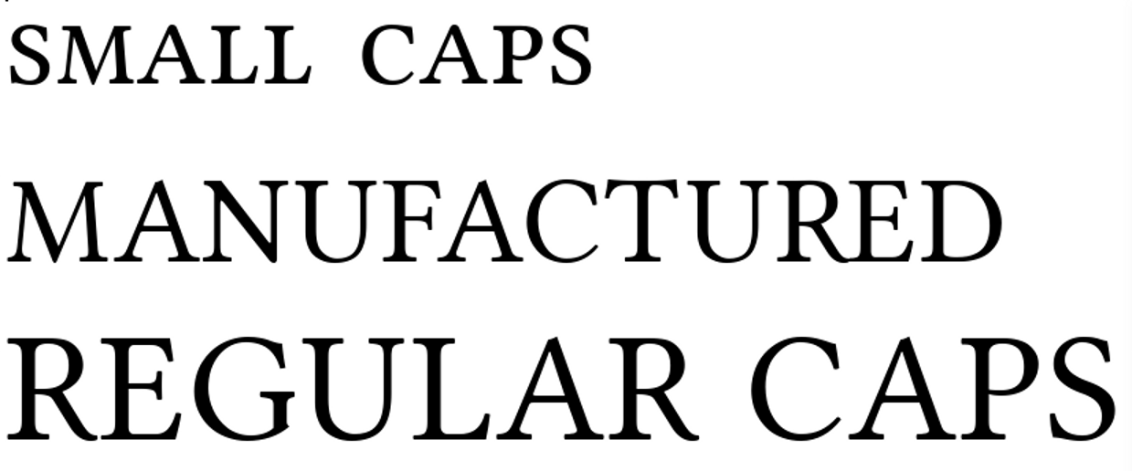
From top to bottom: genuine small caps, manufactured small caps, and regular caps. If you compare the “A” in the genuine small caps with the other samples, you can see that small caps are not just a matter of size – the proportions of letters are also changed. Font: Linux Libertine G.
When a font does not include its own set of small caps, LibreOffice creates an imitation of them, usually making them smaller than ordinary capitals. However, these imitations are rarely more than adequate, because true small capitals are
distinguished not just by size, but by an entire redesign of characters.
Still, not every font comes with small capitals, leaving you sometimes with no choice except to try making your own.

Making your own small caps
If a font lacks small capitals, LibreOffice manufactures some. However, you might want to see if you can improve on what LibreOffice offers. If so, follow these steps to manufacture small caps for yourself:
- Use the regular capitals for your experiments. Starting from manufactured capitals mean that you are inheriting all sorts of assumptions that are hard to pin down.
- Start with a character style that is several points smaller than the paragraph font with which it will be used. Experiment until you find a suitable size.
- Use the Scale width field on the Position tab to make the characters slightly wider than those of the paragraph style it will accompany. Do not increase the width by more than a few percent, or it may look grotesque.
- Increasing the width may have upset the spacing between characters, so experiment with the Spacing field on the Position tab. Because the small cap character style has a smaller font size, you probably will want to increase the spacing anyway to increase legibility.
When you have finished your tweaks, compare your effort to LibreOffice’s manufactured small caps, and choose the best one to use.

Making line spacing consistent
Even advanced users puzzle over the Register-true setting on the Indents & Spacing tab. It’s a large mystery for a simple setting. The Register-true feature makes lines consistent across the pages – or as near as possible if different-sized fonts are used.
When Register-true is selected, the lines of text in columns, mirrored pages, or on both sides of a page are spaced identically.
The setting improves the looks of both single and multi-column documents, and prevents shadows of the other side being from interfering with reading.
Usually, the spacing is that of the Text Body font.
- 祕訣
Setting Register-true for more than one paragraph style can negates the setting. Use the setting only for the paragraph style used most often – usually, Text Body – and related styles – for example, Text Body Indent – that use the same line spacing.
Instead of using Register-true for Headings, make the font size, the space above, and the space below equal a multiple of the line spacing. That way, the Headings will rarely be out of sync for any length of time.
You can improve the effectiveness of the setting for pages printed on both sides by choosing a heavier weight of paper – which you probably want anyway if a document is important enough that you are concerned about line spacing.
There is no reason not to select this setting, but setting Line spacing to Fixed on the Indents & Spacing tab will produce much the same effect.
- 祕訣
Page styles also have a Register-true setting, which allows you to set the line spacing by page, selecting the paragraph style to use. Choose the paragraph or the page Register-true setting, rather than using both.
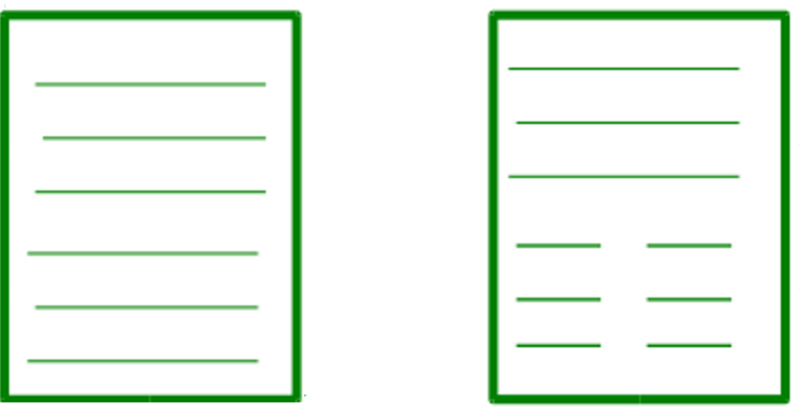
The Register-true feature on the Indents & Spacing tab makes lines consistent across the pages – or as near as possible if different-sized fonts are used.

Automating with styles
People think of typography mostly in terms of format – that is, the choices of fonts and spacing.
However, digital typography is also about making a document easier to construct and maintain.
These concerns do not matter if you are writing a document that will be sent, read, and discarded in a matter of minutes. In fact, any attempt to implement them in a short-lived document is a waste of effort.
However, many other documents have longer life spans. For example, a technical manual may be revised a dozen times or more in its life cycle. In such circumstances, any formatting that gives you one less thing to think about is welcome.
This section introduces two features of paragraph styles that make documents easier to construct: using conditional styles, and setting page breaks by style.
In exchange for some extra setup, both features keep your hands on the keyboard as you work, allowing you to focus on content instead of distracting you with formatting issues.

Configuring conditional styles
A conditional style is an alternative way of using paragraph styles. Normally, you define a style, then set the Next Style field on the Organizer tab.
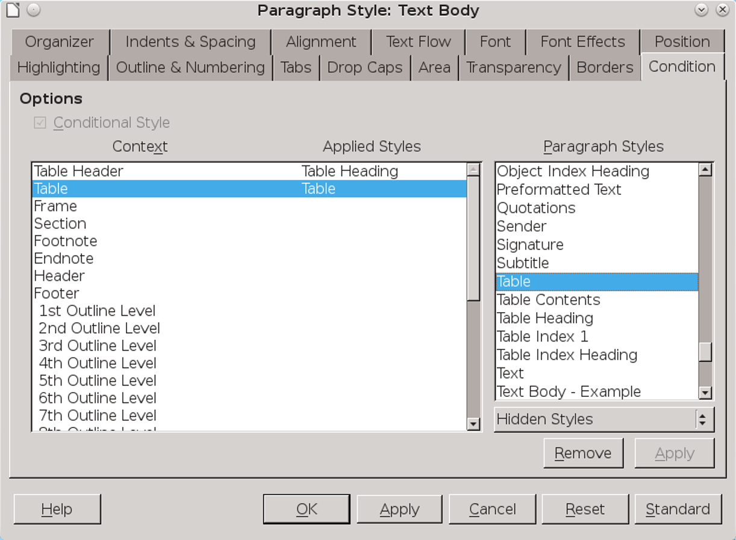
The Condition tab sets up one paragraph style to use the formatting of other styles in different contexts.
However, with a conditional style, you define the paragraph’s format in each context, such as in a table or a footer. When the cursor moves to a new context, the style’s format changes automatically.
- 注意
Don't confuse a conditional paragraph style with a Conditional text field available from Insert > Fields. All that the two have in common is that each changes when their context changes.
Conditional styles are different enough from the normal use of styles that they puzzle many users, who scrupulously avoid them. However, they are
easier to use than you might imagine. Each contextual format is defined by another paragraph style, then connected to the conditional style on the Condition tab.
Conditional styles do have limitations:
- You cannot make any pre-defined paragraph styles conditional except Text Body. In fact, pre-defined paragraph styles display no Condition tab, although new (custom) paragraph styles created from them do.
- If you want a custom style to be conditional, you must set up at least one condition before you click the OK or Accept button when you close the style dialog window for the first time. Otherwise, the next time you open the style’s dialog window, the Condition tab is no longer available.
- A conditional style is limited to thirty pre-defined contexts. You might be able to think of at least two dozen more contexts that might be useful, but you cannot create custom contexts.
Still, even with these limitations, conditional styles can be useful, especially if the document structure is not too complex.

Defining conditional styles
Conditional styles are an answer to those who claim that styles are too difficult to remember. With conditional styles, you only need to remember the name of a single paragraph style per document or template, yet format quickly in different ways.
Admittedly, the available contexts are limited, but they may still be enough for many purposes. You might think of conditional styles as equivalent to single-style outlining – an advanced trick that can be useful and free you from thinking about formatting.
To create a conditional style:
- Examine a Condition tab and make a note of the contexts you want to use. You cannot create new contexts.
- Create or format a paragraph style for each context you plan to use. The only pre-defined style that you can use as a conditional style is Text Body, but you can create a new style from any pre-defined one.
- Create a new paragraph style and go to the Condition tab. Under Options, select the Conditional Style box.
- 祕訣
To minimize confusion, name the style Conditional Text or something like Single Style so you can identify it.
Otherwise, as you work, you might wonder why the formatting has changed but the style listed on the tool bar hasn't.
- Highlight a context on the Condition tab.
- In the Paragraph Styles pane on the Condition tab, select the paragraph style that you want to apply in the highlighted context. Click twice, and the selected style is listed under Applied Styles on the right side of the Context pane.
- Repeat Step 4–5 as often as needed.
- 注意
If you want to use conditions with a custom style, you must set at least one before you close the dialog window. If you do not set at least one condition, the tab will be unavailable the next time you open the style’s dialog window.
So long as you have set at least one condition, you can add and delete conditions later.
- Click the OK or Apply button when all the contexts you plan to use are associated with a paragraph style.

Setting page breaks by style
The application of a particular paragraph style often coincides with the start of a new page.
For example, new chapters may always start with a paragraph style called Chapter Number or Title, while a style called Diagram Title might begin a new page to ensure plenty of space for a diagram.
This feature is set up in the Break section of the Text Flow tab for a paragraph style.

Automating page breaks
To set up automatic page breaks:
- Open the dialog window for the paragraph style that will coincide with the start of a new page.
- Select Text Flow tab > Breaks > Insert.
- Set the Type to Page.
- If the Position is Before, you can select the With Page Style box, and choose the new page’s style from the drop-down list.
- When you select a page style to follow the break, you can also re-set the Page Number. For example, you might have a page style for an introduction numbered in lower case Roman numerals, and ordinary pages that use Arabic numerals.
- If you want the page number to continue sequentially from the previous page, leave the Page number field set to 0.
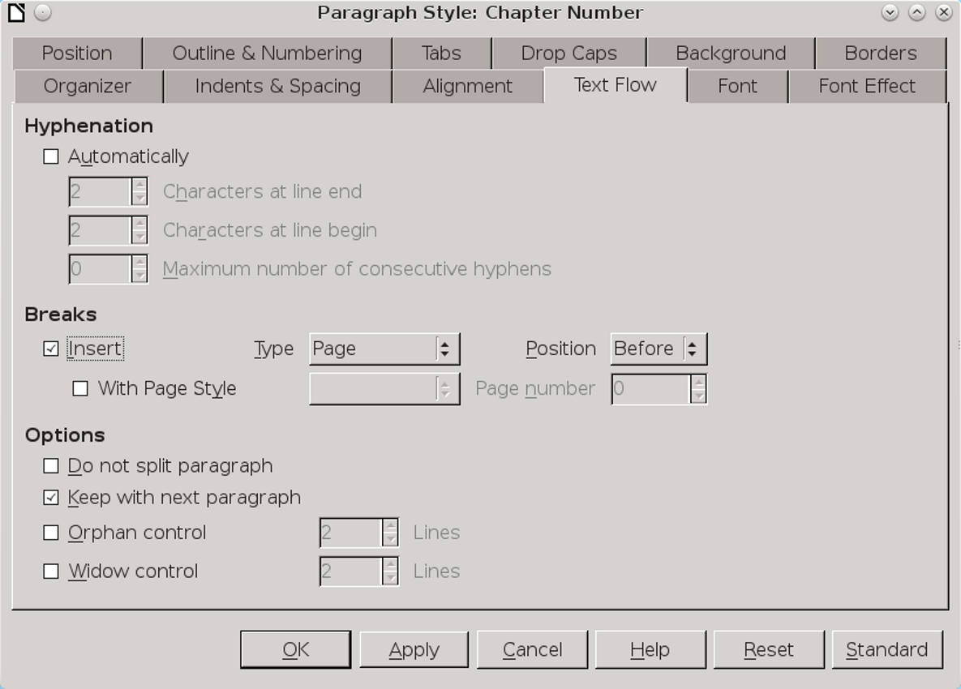
Automate page breaks in the Breaks section of the Text Flow tab by associating them with a paragraph style. This setting is used mostly to start new chapters in a long document or a master document.
Other common uses include starting a page reserved for an image that occupies an entire page, or inserting a landscape page in an otherwise portrait-oriented document.

- 注意
The Type of break also includes the option of Column. This selection may be useful in a multi-column section or a newsletter. However, it can be awkward and confusing. In many cases, you are likely to have less trouble with items shifting if you create a table instead.

Single-sourcing by hiding text
Multiple versions of documents that differ only in some details are common in business or academia. For instance, you might want one version of a handout for students, and another version for teachers that adds teaching goals and suggestions for use. Or, you might have one version of a software manual for users and another for system administrators.
The only trouble is that maintaining multiple versions of a document is difficult. Placing each version in its own file complicates keeping all the versions in sync. Forget just once to update all versions, and correcting the mistake can cost you several painstaking hours.
Yet in most word processors, maintaining all versions in a single file complicates printing, forcing you to create a duplicate copy first, and then to delete all the parts not needed for the version you are printing and hope that you don’t make a mistake.
LibreOffice’s solution to this dilemma is to create a single file in which selected words, paragraphs, or sections are hidden or revealed as needed. The tools include styles and fields. All the tools for hidden elements work with two versions of the text, but sections and some fields do not work with three or more versions.
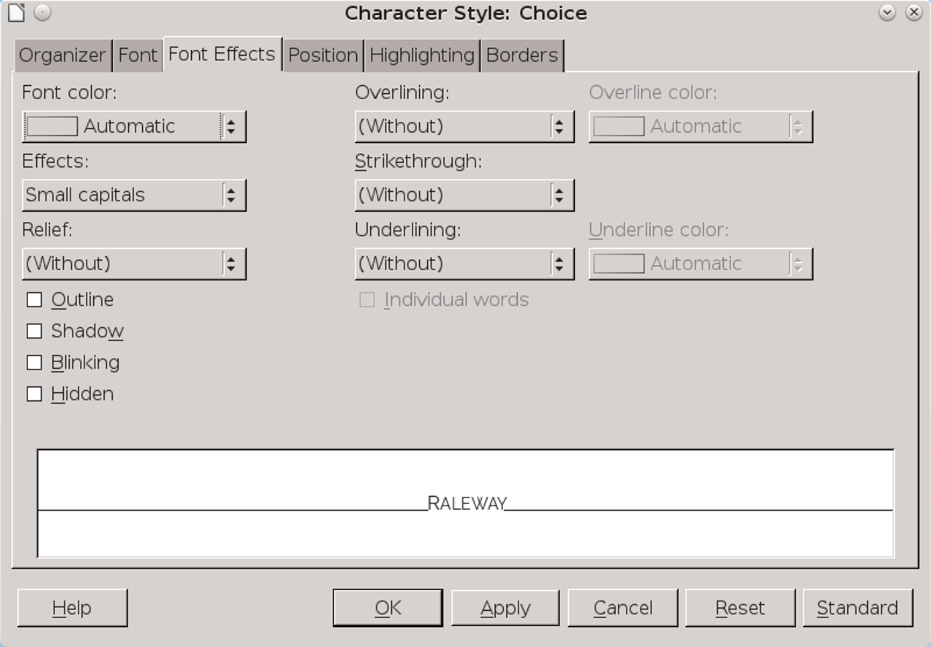
Maintaining two copies of the same document in a single file is as easy as toggling on or off the Hidden box at the bottom left of the Font Effects tab.
Using hidden text is faster than manual formatting and reduces the chances of making mistakes. It also eliminates the need to print from copies, which with careless hands or tired brains can lead to the accidental over-writing of the original file.

Choosing a tactic for hiding/showing text
Features for hiding and showing text can be used in two ways.
If two versions of the document share common text, enter one using ordinary paragraph styles and create unique paragraph styles for the other that
can be hidden and shown as needed. This method works with both styles and with sections and fields, but can be hard to organize.

One way to structure single-sourcing is to have one set of styles, sections, or fields that are always visible and another set for each additional version that can be turned on and off.
The alternative is to create a special set of paragraph styles for each version of the document, turning them on and off as needed.
In this structure, each version could be distinct, and single-sourcing mainly a method of keeping related material together. Alternatively, each version could be mixed and matched. For example, if you were preparing user, developer, and admin guides for a piece of software, the published guide for administrators might require showing both the user and admin material, while the guide for developers might include both the admin and developer material. You might also create multiple bodies of content found in more than one version, although that might become too complex to work with. All these possibilities can be used by setting up multiple variables for fields (see “Hiding text using fields,” page 18), one for each version, but are least confusing when working with styles only.
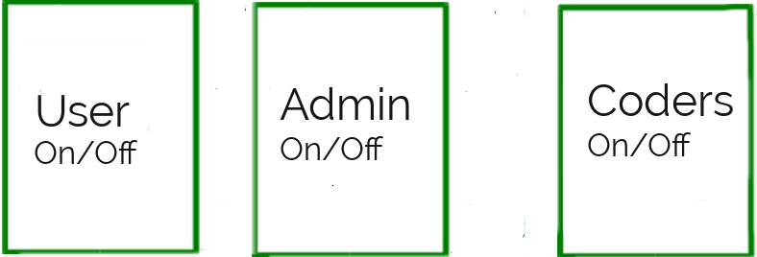
Another way to single source is to have separate sets of styles, fields, and sections for each version of the document, turning each on and off as needed
No matter how you work, single-sourcing can be confusing, so choose the name of styles and fields to help keep everything straight. You can even give each paragraph style a different font color to make it quickly recognizable. Each style’s font color can be replaced quickly by using Edit > Find & Replace. If you are printing in black and white and use dark enough colors, you may not even need to change the colors when you print.

Hiding text using styles
To hide or reveal text, you can toggle the Hidden box on a style’s Font Effect tab. You can either choose part of the document to hide to produce one alternative version, or else create a different set of paragraph styles for each version.
Whatever method you choose:
- Create one set of character and paragraph styles for text that appears in all versions of the document.
- Create the common styles needed for each version of the text. For example, in a student quiz
- with an answer key, you might have one set of styles with names like User – Text Body and Teacher – Text Body. These styles are formatted exactly the same as the common styles, and hidden as needed.
- 祕訣
You may not need to copy all the common styles for each version of the file. For example, in a quiz, the teacher's version might only need a single paragraph style called Answer Key.
- On the Font Effect tab, toggle Hidden as needed before printing. Notice that spacing above or below a paragraph is hidden along with the text. By contrast, you need to select the space after a string of hidden characters.
- After you print a version from a single-source file, de-select Hidden so the complete file is visible the next time you open it.

Hiding text using fields
An alternate but more time-consuming way of single-sourcing is to place each passage in its own field. You can either toggle one version of the document, or else create a separate variable with a unique value for each version of the document. Usually, this second method is practical only for relatively short documents.
When you single-source, the Functions tab of the Fields dialog contains several useful tools: Hidden text, Hidden Paragraph, and Conditional text. Other types of fields exist, but, except for Set Variable, are not relevant to single-sourcing.
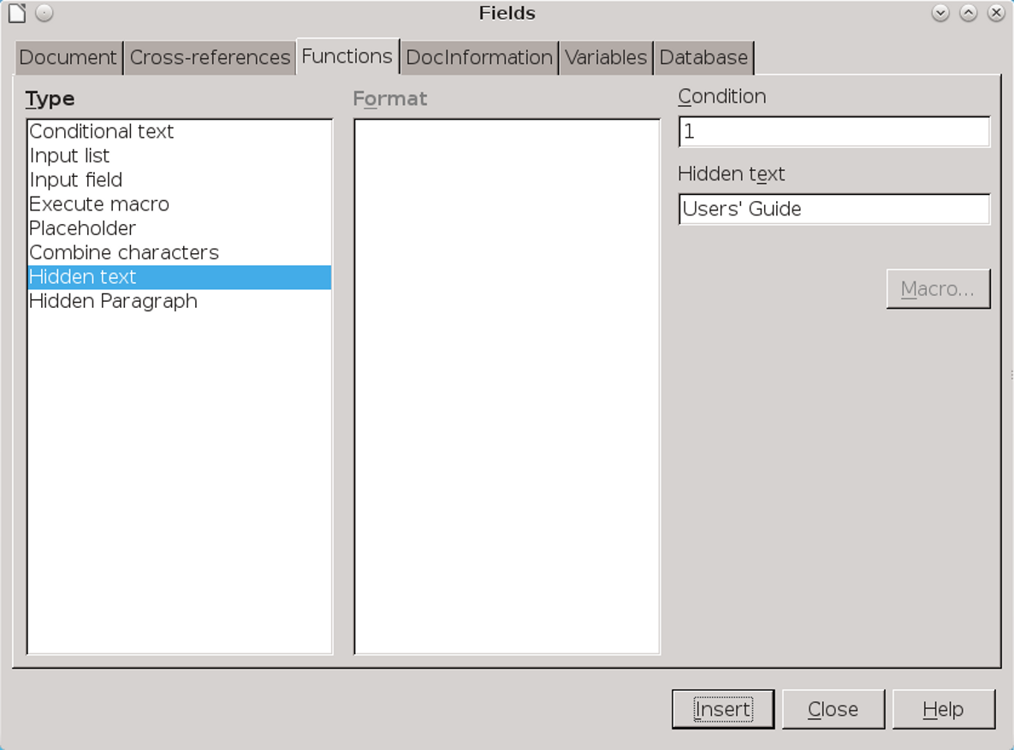
The Hidden text field window.
For very limited uses, such as changing the title or the contents of a header or footer, you can use Input Lists, which contains interchangeable items. However, input lists are impractical in a longer document, because each has to be changed separately.
The Hidden option in a character or paragraph style is the stylistic equivalent of some of the fields in Insert > Fields > Other > Function > Type, such as Hidden text and Hidden Paragraph.
- 注意
Make sure that View > Field Shadings and View > Hidden Paragraphs are turned on when you use these fields. Otherwise, you will be lucky to find the hidden text or paragraphs.
The fields used for single-sourcing use an off or on condition for hiding and unhiding. A condition is merely a state of a document – or, if you prefer, a version with different content.
For instance, when a condition is set to 0, then the content in the fields is hidden, creating one version of the file. When a condition is set to 1, then the content is shown, creating a second version. Alternatively, the condition that turns one version of a document on could be the name of the version, such as User Guide. This arrangement is no different than checking or unchecking the Hidden box in a style.
- 祕訣
A Hidden Text field can be awkward, because the field for entering it makes only a limited amount of text visible at one time. Hiding a section may be a simpler tactic to use.
Alternatively, in a Conditional text field, a simple expression is set up using the Condition, Then, and Else fields on the right side of the window. For instance, if the condition is 1, then the text that appears in the document is whatever is entered in the Then field,
such as User's Guide. However, change the condition to anything else, and the text in the document becomes whatever is entered in the Else field, such as System Administrator's Guide.
This arrangement is almost as handy as the Hidden box in a style. In effect, the Condition field becomes a password to limit who can change the condition.
The main disadvantage of this method is that each condition needs to be changed separately, while using the Hidden Font effect means toggling a single box.
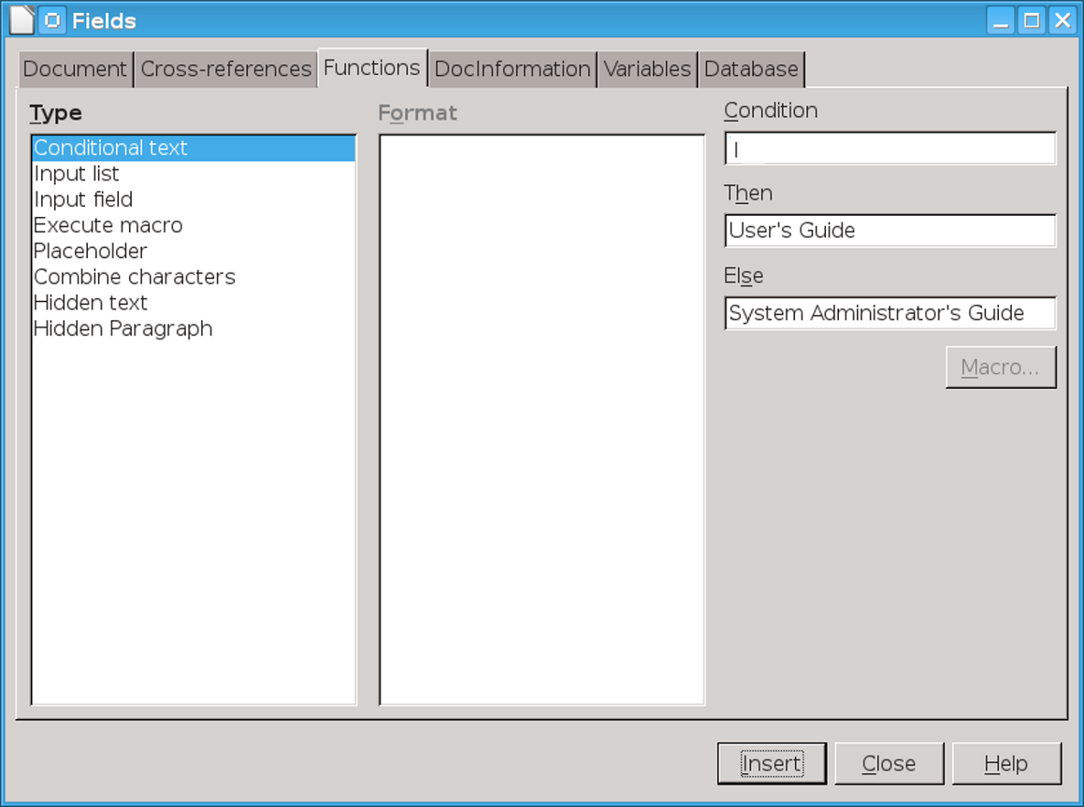
Do not confuse a Conditional Text field with a Conditional paragraph style. A Conditional Text field is similar to the Hidden check box on a paragraph style’s Font Effects tab.

Hiding with sections
When documents have large areas to hide or show, you may prefer using sections.
Sections are areas that have properties that are different from the main body of text. These properties may be formatting, or content that is password-protected from editing.
You can also add a link to insert a separate file in the current document. Such links can be another sort of single-sourcing, allowing content used in several documents to be maintained in one place.
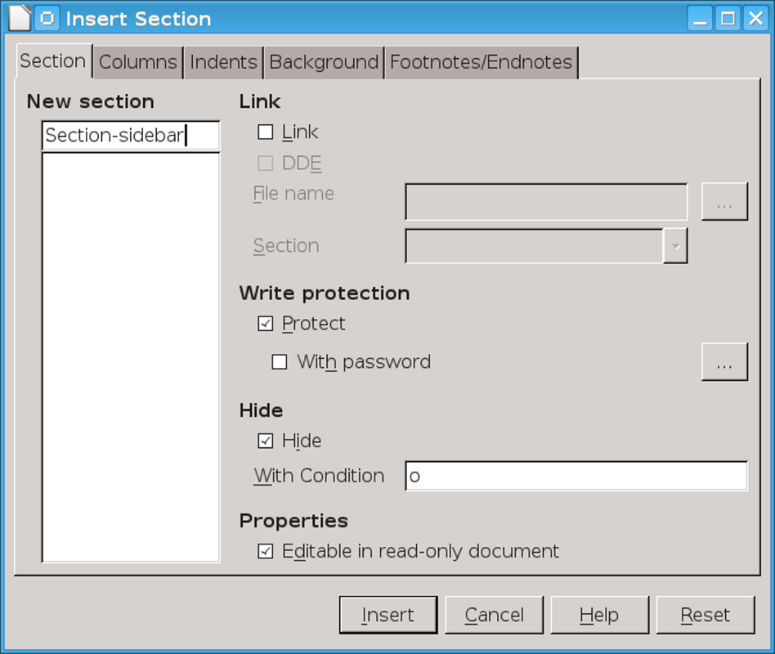
Insert > Section can hide or reveal large sections of text.

Automating the use of fields and sections
Field windows stay open after you insert a field, allowing you to move to the next position for a field in the document. Section windows do not, although
you can use the Navigator to jump from one section to the next as you edit.
However, changing the conditions for each field or section individually eats up time. If the same field appears more than once, you can copy and paste or use Edit > AutoText so that you can add information with a couple of keystrokes, instead of making changes manually.
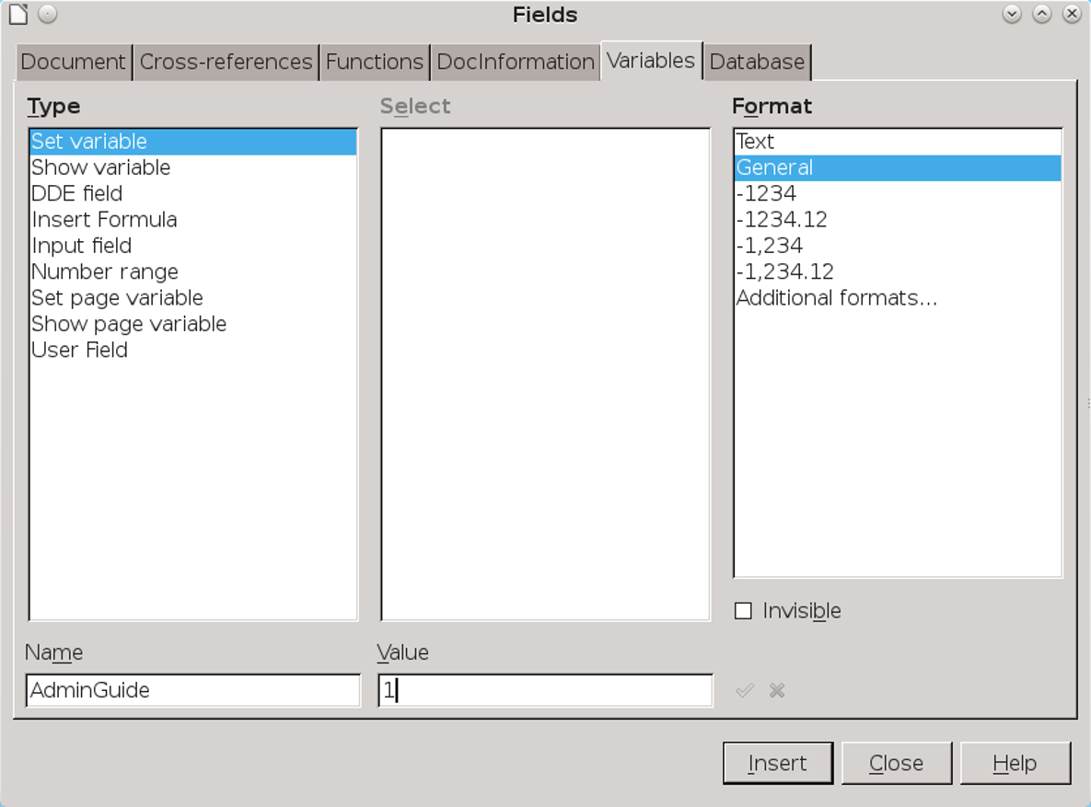
A variable can be a master control for turning all fields with the same condition on or off.
Better yet, you can set a general variable that toggles all fields at the same time:
- Place the cursor at the start or end of the document, or anywhere else that is easy to locate.
- Click Insert > Fields > More Fields > Variables > Set Variable.
- Set the Format. You can leave it as General, or specifically as Text or a number format.
- At the bottom of the window, give the variable a name. The name can indicate one of the document versions, or be something like MasterSwitch.
- Enter a value. It can be text, or simply 0 or 1, but make sure that it uses the format entered.
- Click the Invisible box so that the variable cannot be seen in the document. Then click the Insert button.
- 注意
Locating the variable can be difficult, so you should place it in some easy to find place. You might choose to leave it visible while you work.
- In all the Conditional Text, Hidden Text, and Hidden Paragraph fields, as well as Sections, set the condition to the variable name, followed by the value in quotation marks. For example: MasterSwitch “0” or AdminGuide”1”.
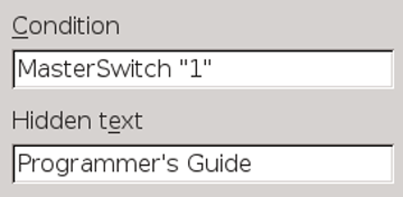
A Hidden Text field set up to work with a variable called MasterSwitch. The value of the variable follows its name.

Now you can show or hide all the fields in the document by changing only the variable, much as you would with a style.
If you have more than two versions of the document, you can create other variables to toggle each one off and on.
However, make sure that the values are different for each, and that each is placed where you can easily find them. The easiest way to find the values is to use Edit > Track Changes > Manage Changes, especially when the document is complete and the only changes you are marking are hiding or showing different versions.

Using sections
Sections are yet another way to hide or unhide text. They can be used more easily than fields for long passages, but are less versatile than a paragraph style.
Sections work in much the same way as fields:
- Place the cursor where you want an empty section, or else highlight existing text. Then select Insert > Section. The Insert Section dialog window opens.
- Give the section a unique name that reflects its contents, and if desired protect it with a password.
- Click the Hide box, and/0r set the With Condition field to 1. Either is necessary, but not both. When you close the dialog window, the section and the
- space above and below it are no longer visible in the document.
- 祕訣
A section set to hide is visible until you remove the mouse cursor from it.
- When you want to edit the section, click Format > Sections. The dialog window lists the document’s sections, with an open or closed lock beside each name to indicate whether it is hidden. Sections can be formatted without unlocking them, but must be unlocked to edit the text.

The limits to LibreOffice text design
If you read the last few chapters in sequence, you should start to understand why Writer can best be described as an intermediate desktop publisher. Using Writer, you can follow basic typographic principles and easily design complicated documents.
However, a few advanced features can be added only by tweaking a few settings in character and paragraph styles. Others cannot be set up in styles at all.
Probably the greatest lack is the easy insertion of non-standard characters, such as diagonal fractions or, in English locales, accented characters. The only way to mitigate this limitation is by
choosing an international keyboard locale that includes accented characters and international currencies.
Even then, resources like small caps, old style figures, and ligatures – redrawings of groups of characters to make them easier to read – cannot be used automatically. Sometimes, these features are available in separate font families, but, in other cases, you might want to use features like macros, AutoText, and AutoCorrect to create libraries in your default template. The difficulty, of course, is remembering how to access such libraries.

Using the Typographic toolbar
SIL International, a maker of free fonts, also offers support for Graphite, a system which automatically uses small caps, old style figures, and ligatures where they are appropriate. However, a font has to be Graphite-aware before you can take advantage of the support – and, so far, only a handful of fonts are, such as Linux Libertine G and Linux Biolinum G.
If your fonts are Graphite-aware, consider installing the Typographic tool bar extension. This extension adds a tool bar to the LibreOffice window from which you can quickly add advanced typographical features manually. The help will also give you formulas that you can add to the end of the Family field on the Font tabs of character and paragraph styles that will automatically enable advanced features.
However, if these choices seem too fussy, stay with what you can do with standard character and paragraph styles. Modern typography tends to ignore these advanced features, so you might not even miss them.
Besides, while the arrangement of individual characters and paragraphs is a major part of typography, it is not the only part, as the next chapters will show.

