8

Styling the page
Page styles are one of Writer’s distinguishing features. Most word processors have character and paragraph styles, but having page styles elevates Writer to an intermediate desktop publisher, giving it immense flexibility.
Page styles matter because the design of pages is central to typography. Entire books have been written on the topic, many of them full of abstruse theories reinforced by complicated diagrams that often seem abstract from the practical issue of composition. In fact, until the rise of digital typography, the page was generally the main unit of composition.
Fortunately, however, you do not need to believe in obscure theories, much less follow them, in order to design a page.
The only drawback to page styles is that most users are unaccustomed to thinking in terms of pages. Why, many ask, should page numbers or footers and headers be associated with pages? Other word processors certainly do not make the same association. In fact, they frequently offer no sense at all of what the page looks like.
However, when you think, the page is really the most logical place for such features. It is other word processors that treat these features illogically.
Over the years, LibreOffice has added tools to make manual formatting of pages easier. For instance, while you still have to add new page styles to create new headers or footers, you can now apply them from the Insert menu.
Yet despite these efforts, the basic logic of associating such features with pages remains strong despite its unfamiliarity. Learn to accept it, and possibilities open up that are not available in manual formatting – not the least of which are increased ease of use.

Understanding layout conventions
Page design is based on the two-page spread of left and right pages, because that is what you see when reading a book unless you are on the first or, sometimes, the final page.
While your document may be intended to be read online, a two-page spread is still a reasonable
view to refer to regularly, because it means that you are less likely to miss any design problems.
Even more importantly, with wide screen monitors having become universal, a two-page spread is the most economical display of a document.
You can get a spread view by selecting Book View from the zoom controls at the bottom right of the editing window.
Traditionally, a document’s first page is a right page, modified to make clear that it is the start. Open any book and you immediately see why: On the left is the cover or binding, which leaves the first page to fall on the right.
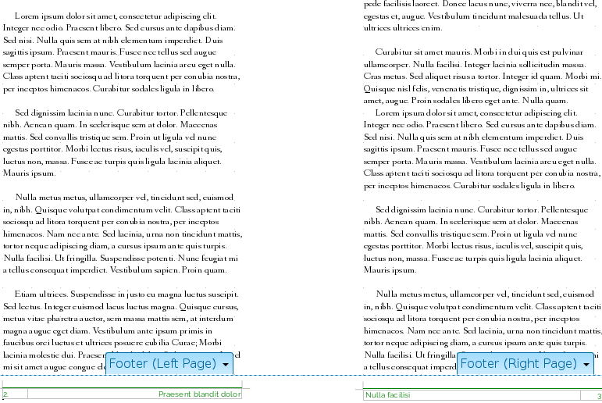
A two-page spread in the zoom shows a document as readers will experience it in hard copy.
This tradition also means that right pages are usually odd numbered, and left pages even numbered. Master documents automatically add blank pages so that chapters will start with a right page.

Applying page styles
In theory, you can change the style of the page at any time by placing the cursor on a page and making a selection from the Styles and Formatting window. However, this practice can cause other pages in the document to change their style – not all the time, but often enough that the method is unreliable.
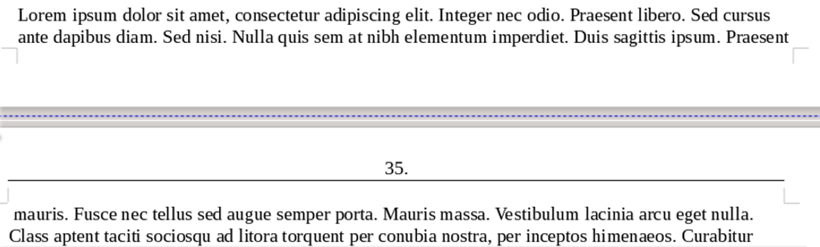
A page break is marked in the editing window by a purple dotted line.
The only times this approach works reliably is when manual or automatic pages clearly mark the start and the end of a page.

Automating the next style
You do not want to be continually inserting a page break and selecting a page style as you work. As a result, the Next Style field on the Organizer tab is even more important for page styles than for paragraph styles.
The most basic pattern is defined for you: a left page is followed by a right page, and a right page by a left page. If you use a First Page style, its Next style field defaults to Left Page.
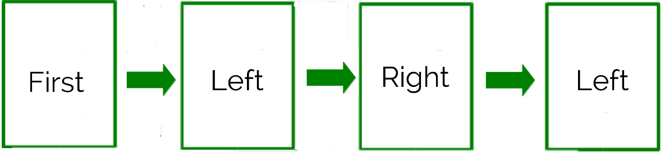
The default page succession. Usually, you can leave the default.
- 祕訣
The Next Style field over-rides the Page Layout field on the Page tab. For example, if a page is set to Left Only, the Next Style field allows you to use it as right page.
In some LibreOffice versions, a conflicting next style and page layout may cause layout problems, so make the two fields consistent.
Keep this default arrangement, and you should only have to think about setting page styles when you do something unusual, such as adding a landscape page to an otherwise portrait-oriented document. In these unusual circumstances, select Insert > Manual Break > Page Break and select the appropriate page style.
In other non-standard cases, you might create a paragraph style that is set on the Text Flow tab to start a new page with a particular style. See “Error: Reference source not found,” page Error: Reference source not found.

Planning page styles
The default page designs are either for a specific dimension, such as Envelope and Landscape, or for a specific purpose, such as Endnote or Index.
You might also considering adding page styles for:
- Tables of contents.
- Front matter such as copyright notices and acknowledgments.
- Alphabetic index. If the entries are short, it can save space by being multi-columned.
- End notes in a scholarly work.
- A title page with the title and author’s name. A title page is often centered, and in a larger font size than the body text.
- An epigraph, or short quote at the start of the document. Usually, an epigraph is indented vertically and horizontally. It may use an italic or script font.
- Poems, especially in a mixture of verse and prose.
- Dramatic scripts. Scripts have a very definite format, which you can find online.
- Legal documents that require a strict format.
- A page for a single page, chart, or diagram that may or may not be landscape-oriented.
For some documents, especially short ones, the Default Style is all you need.
However, the most basic page styles for any purpose are the Left Page, Right Page, and First Page. They are the ones that will be models for most of the other page styles.

Designing left and right pages
Unless you are using only the Default Style, page design almost always begins with the Left Page and Right Page. They are most often mirror images of each other, part of a two-page spread.
You might choose to design only one of these styles for an online document, although many readers on tablets or wide screen monitors prefer a two-page spread online these days. You should also consider a spread if the online document is ever likely to be printed out. Unbalanced headers or footers may distract readers from the text with a clumsy design.

Designing the first page
The first page refers not to a title page, but the page on which a document or its first chapter begins. A first page is customarily a modified right page. It should be different enough that it is immediately obvious as the start of a new part of the document.
- 祕訣
Designers sometimes pride themselves on a minimum of indicators, but better to use more indicators than are strictly necessary than have readers miss that you are starting a new chapter.
Sometimes, the main indicator of a first page may be a different header or footer from the rest of the pages – or perhaps the only ones. Usually, however, the indicators are more obvious:
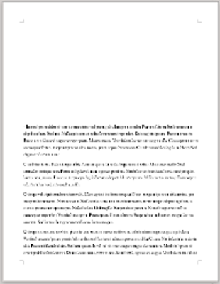  A top margin that is 76–230 points taller than the top margin on a normal right page. |  | 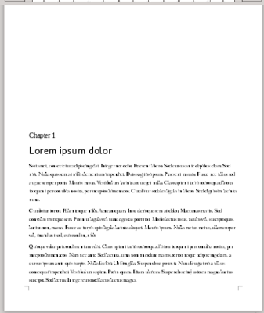  A chapter title and/or number. The titles may be in one or two styles.
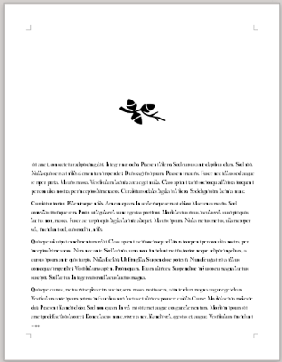  An image or a dingbat, either above the text or in a text frame at the start of the first paragraph. |  | 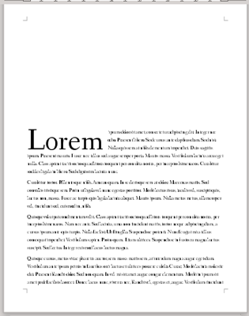  A drop capital of a single letter or a string of characters. This indicator is common in fiction. See “Error: Reference source not found,” page Error: Reference source not found.
Common tactics for indicating a first page. If headers are a different color from body text, you can also use the header color for the background color.

Setting the paper format
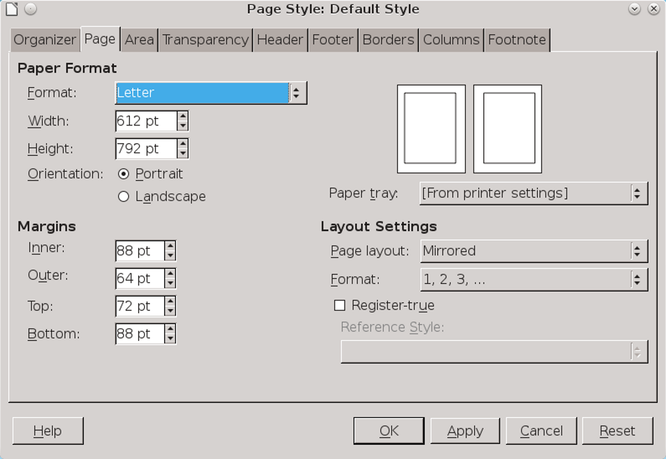
The Page tab for page styles.
Paper formats are set on the Page tab for a style.
The default page size is usually determined by your locale, and should be changed as necessary for your needs or printer. Throughout much of the world, the standard size is A4, but in North America, the standard size is Letter.
Regardless of the page size, the standard orientation is portrait (taller than wide). The alternative is landscape (wider than tall).
- 祕訣
To define your own page dimensions, start with any page size, and manually change the width and height. The Format field changes automatically to User.
Most printers will print non-standard page dimensions on whatever size they support. Some printers may not print non-standard dimensions at all from LibreOffice, but will support printing if you first export the document to PDF, especially if they support PostScript format.
All page formats assume a single sheet of paper. However, printing multiple pages to a sheet is more economical if you are using a large commercial printer. You can set up multiple page sheet printing through File > Print, or else by using text frames instead of pages.
All multiple sheets will of course need to be cut or folded later. LibreOffice does not support crop marks, but you can still cut pages down to size by making careful measurements.
For instance, single sheet brochures are often printed duplex (double-sided) with connected frames on one side for pages two and three, and frames on the other side for pages one and four.
If you are publishing online, neither paper size nor orientation matters unless the document might be printed to PDF or converted to an ebook format.
- Example: A4/Letter combined template
A4 is a standard page size in most of the world, and Letter in the United States and Canada. They are also close in size: A4 has a width of 595 points and a height of 842 points, while Letter has a width of 612 points, and a height of 792 points.
If you have an international audience, a template that you can print on both sizes becomes a form of single-sourcing.
To create a combined A4/Letter template:
- Create a user-defined page format with a width of 595 points, and a height 792 points. These are the smallest measurements of the two formats. To display, all contents must fall within this area.
- Decide on the left and right (or inner and outer) margins as though designing for the A4 format, the narrower of the two formats.
- Decide on the top and bottom margins as though designing for Letter format, the smaller in height of the two formats.
The result is not completely satisfactory for either size. However, with this template, you can print from the same file to both sizes, rather than maintaining two files with the same content.

Setting layout settings
Layout Settings on the Page tab set the basic formats for a page. The Page Layout setting offers four choices:
- Mirrored: The page style is used for both left and right pages.
- 祕訣
When you choose Mirrored, the margin fields on the Page tab also change from Left and Right to Inner and
Outer, with the Inner margin the one closest to the center of a two-page spread.
In a traditional hard copy book, the inner margin may have extra space so that the book can be bound. Be careful that enough space is allotted so that the binding does not become so tight that it obscures characters on the inner side of the page or requires readers to bend the binding to view the complete text.
In a mirrored layout, the Inner margin will be on the right side of left pages, but the left side of right pages.
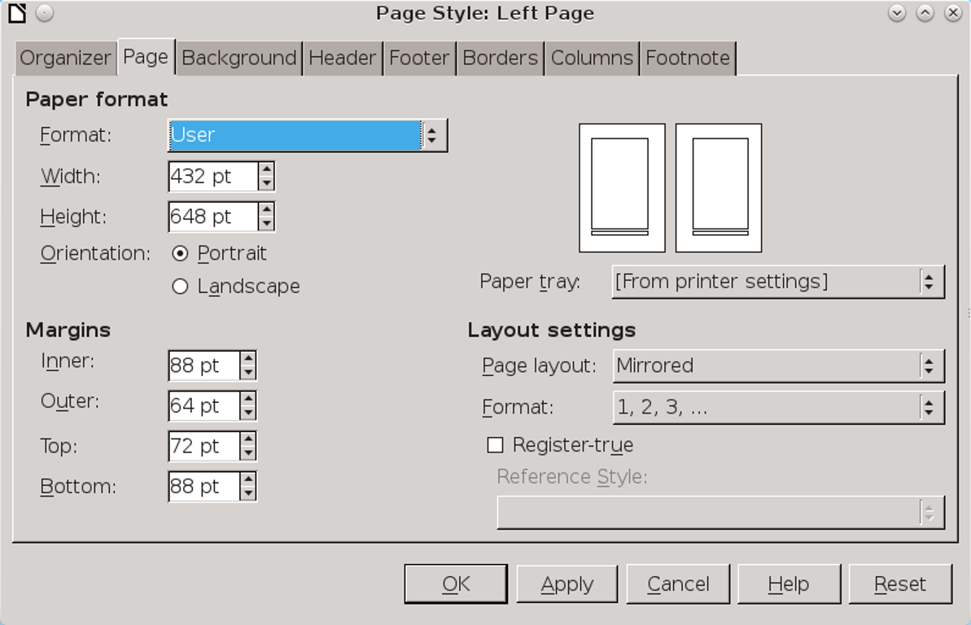
Layout settings are on the bottom right of the Page tab.
- Right and Left: The page style is used for both right and left pages.
- Only Right or Only Left: The page style is used only for right pages or only for left pages.
- 注意
The Page Layout field may be over-ridden by the Next style field on the Organizer tab. Ordinarily, this over-ride would mean that you could ignore the Page Layout field.
However, in some versions of LibreOffice, some combinations may cause blank pages or other formatting problems. For this reason, you should make sure that no conflicts exist, such as a Next style field that forces a page style set to Left only to appear on a right page. Otherwise, a page style created in one version of LibreOffice may not display as you intended in another version.

Setting margins
Margins are set on the Page tab of a page style. All margins have three purposes:
- To let readers hold hard copy without hiding some of the text with their fingers.
- To provide space for readers to add comments in the case of essays, proposals, and printed drafts.
- To frame the document unobtrusively so that readers can focus on its content.
The third is by far the most important. Unlike the other two, it applies to all documents, no matter what their medium.
- 注意
None of these purposes should ever be ignored in favor of the time-honored student efforts to fit text into a certain number of pages.
These efforts are not only obvious, but usually distract from the text by being too broad or too narrow.
- 注意
The default settings for all margins in Writer is 57 points (about 3/4 inches or 2 centimeters). For almost all cases, this is at best a minimum for a margin that fulfills any of its functions.

Choosing margin proportions
Theories about ideal margins often are based on everything from how reams of paper were folded to make books in the Middle Ages to analogies of musical scales, with accompanying diagrams that look capable of summoning demons.
One popular theory holds that the ideal margin settings are based on the Golden Section, a set of proportions first fully described by Euclid that are said to be naturally pleasing to the human eye.
Applying the Golden Section to page margins means that, starting from the outer margin moving to the top, then the inner and the bottom margins, the proportions of the margins should be 2:3:4:6. You could also start from the inner margin, but the
result is often a narrow margin that may binding reduces even more
This ratio means that, using a basic unit of 20 points, the inner margin would be 40 points, the top 60 points, the outer 80 points, and the bottom 120 points.
These proportions do produce a pleasing page, but publishers sometimes regard them as wasteful, especially with the large bottom margin.
To be truthful, the only time that you are likely to see the Golden Section used to format pages is in poetry and in small print runs of prose, in which printers are willing to charge more in return for a well-designed page.
In the end, the Golden Section is a prestige ideal rather than a practical one – and one that not everyone believes is worth the effort of applying its elaborate theory. If you decide to use it, choose a thick, quality paper and a simple but elegant font for the body text of the document. Anything less seems out of place.
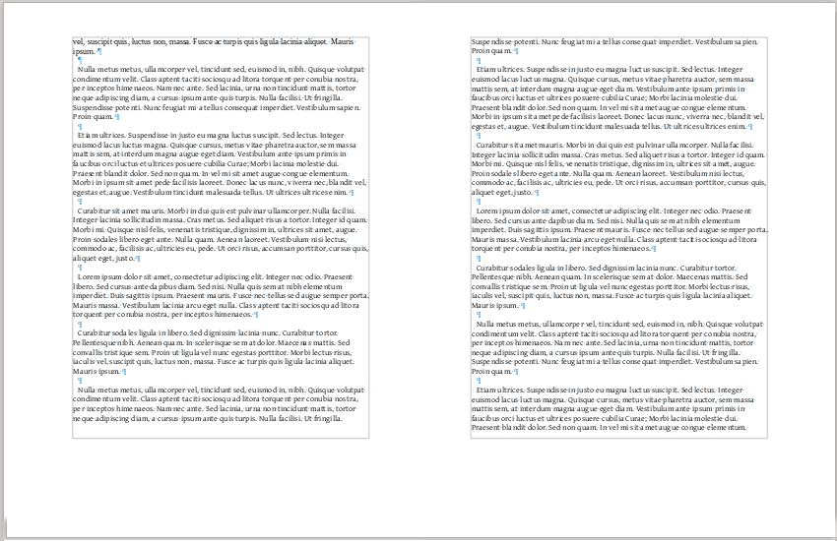
A view of non-printing characters showing margins set using the Golden Section.
A more flexible set of rules can be distilled from the majority of theories and layouts:
- Make the top margin greater than the inner margin.
- Make the outer margin equal or greater to the inner margin. For printed documents, the outer margin should be wide enough so that the pages or book can be conveniently held.
- Make the bottom margin taller than the top margin.
All margins should be multiples of the line spacing.
You can find other page margins that are successful, but these guidelines reflect the most common margins. Just as importantly, they are flexible enough that, unlike the Golden Section, you can use them without adding to the printing cost by increasing the number of pages.

Considering binding and trimming
If your document is going to be printed and bound, the inner margin requires extra space for the binding. This space will make the two-page spread look lopsided on your monitor, but prevents words disappearing into the gutter (the center of a spread, where the edges of the pages are bound) in the finished product.
The exact space needed for binding varies with the type of binding, and the fittings chosen. For example, a spiral bound book can use spiral coils of different sizes.
You should consult your printer, but in most cases you will probably need at least 20–45 points extra on the inner margin for the binding, and possibly more.
- 祕訣
If you are unsure what binding you will use, too wide an inner margin is easier to adjust than too narrow a one.
- 注意
Depending on the printer used, you may also need extra space on the other margins for trimming. Consult your publisher and printer as necessary.

Designing headers and footers
Headers and footers are spaces at the top and bottom of the page that contain document information. In Writer, their spacing is in addition to the margin; they do not fill part of the margin.
Unlike in Microsoft Word, in Writer, headers and footers are classified as part of a page style. Even when you manually format from Insert > Header or Footer, your selection is based on the pre-defined page styles.
Headers and footers often appear together, but using just one is just as common. Decide what information you want to display on the page, and how it will be divided up, and you may find that just one will do. Typically, each header or footer has up to three pieces of information.
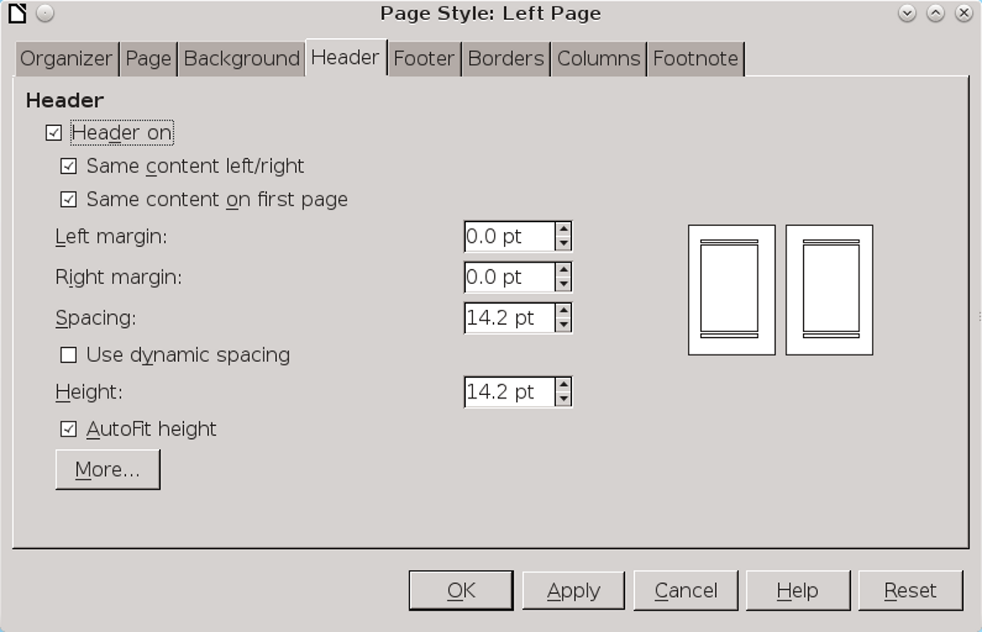
The Header and Footer tabs for a Page style have identical features.
If you do choose both, an obvious arrangement is to reserve one for just the page number, which is the most used information likely to be in a header or footer.
- 注意
You can use a single footer, then unselect the check boxes Same content left/right and Same content on first page rather than designing each page style separately.
However, do not use both approaches together. The result can be unresolvable formatting conflicts.

Turning on headers and footers
To add a header or footer, go to the Header or Footer tab for a page style and select the On box on the top left.
The immediate result is a single line for text in the top or bottom margin. The text area is immediately visible in Apache OpenOffice, but in LibreOffice you need to click anywhere in the margin for the minimal guides to be visible. Although you can add additional lines, more than one line gives a sloppy look that you should avoid in any published document.

Choosing tabs or tables
Many users simply use tab stops to add information, using a right tab for information that ends at the right margin. However, this arrangement can require constant readjustment as you revise, especially if you use fields or alter font sizes, making it more trouble that it’s worth.
A more robust solution is to add a single-row table with invisible cell borders and as many columns as you need. This technique means fewer spontaneous changes than with tabs, and, therefore, less work. You will especially appreciate the convenience of tables if your document is likely to last several years and through several versions of LibreOffice.

Formatting headers and footers
Below the box for turning on a header or footer are the basic formatting options:
- Left margin and Right margin: The margins for the header and footer are in addition to the page margins. Usually, these can be set to zero, since headers and footers are rarely indented more than the body text.
- 祕訣
You cannot enter a negative number to make a header or footer extend into the left or right margin.
Should you ever want this arrangement, you would have to give your paragraph styles indents on the left and right, so that they use a shorter line than the header or footer.
- Spacing: The distance between the header and footer and the main text frame. This field should be a multiple of the line height. If the distance is wide enough, you may not need a line or any other sort of divider to separate the header or footer from the body text.
- Height: The line height of the footer. Often, this will be the line height of the body text. If you are using the footer or header to include a recurring image, then the Height will need to be at least the height of the image.

Adjusting the border and background
The Border/Background tab for headers and footers is full of settings that need to be used cautiously.
To start with, unless you are looking for a retro-1990s look or deliberately practicing bad typography, ignore the settings for adding a shadow to the footer or header.
The same is often true for the Background, except for the most delicate difference in shading between the page and the header and the footer, or if the only point of the header or footer is to add a graphic in the same place on every page. Consider using a transparency to make the background more subtle than a solid color.
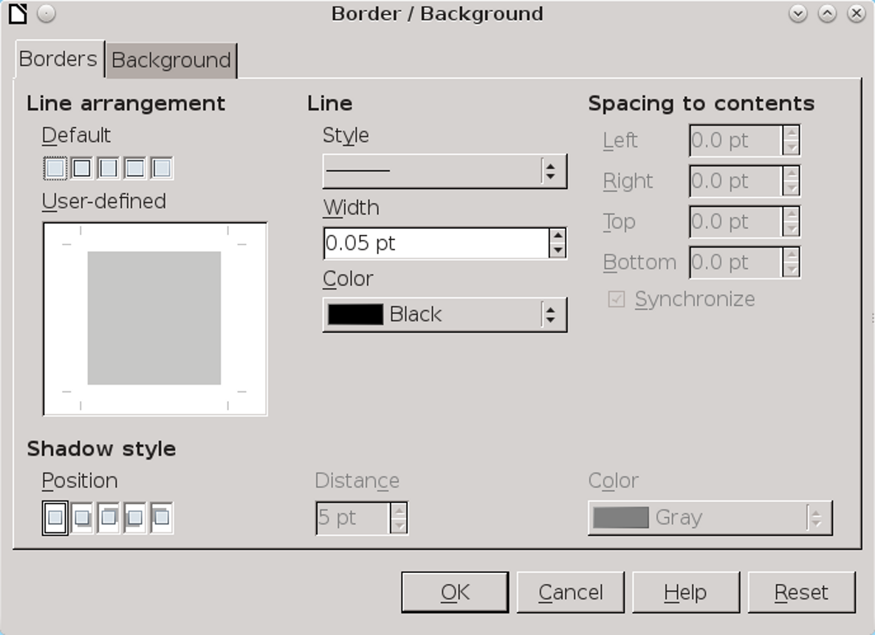
Click the More button on a Header or Footer tab to reach the Border/Background tab.
Most of the time, you can also forget anything more than a single line between the header and the footer and the page’s main text frame – and even that line should be set to the thinnest setting possible, although you might choose to color it.
In fact, you might manage without even a thin line if the space to the body text is large enough and the font used in the header or footer is different from the body text.
The most useful settings on the tab are for Spacing to Contents, and even they are only necessary if your use of borders makes the header or footer look cramped.

Adding header and footer paragraph styles
At this point, you may want to revisit your paragraph styles for headers and footers. You have Header Left, Header Right, Footer Left, and Footer Right by default. However, you might want to create Header Center Left and Header Center Right as well. Or, if you are using tabs instead of tables, consider character styles of the same names.
No matter how you arrange headers and footers, their information should have a similar font size to the body text. The page number, perhaps, can be larger. Making the text smaller than the body text only reduces the usefulness of headers and footers.

Adding content to headers and footers
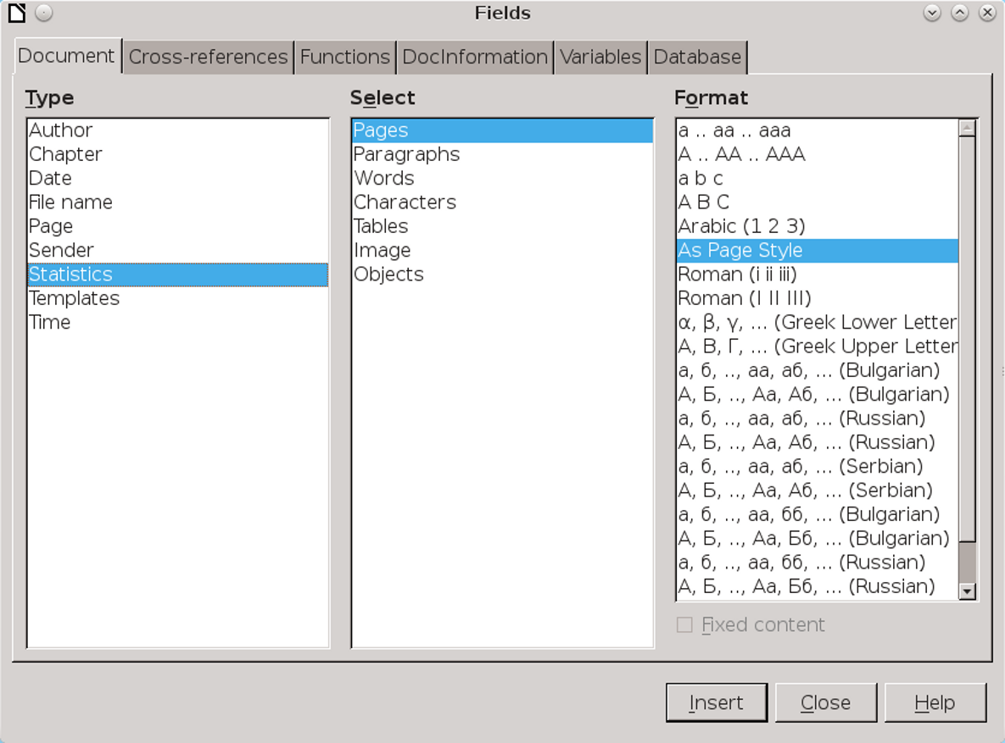
Fields are a common source of header and footer contents.

The contents for headers and footers generally include static information such as the document name, chapter name, and writer’s name. Other possible contents includes the fields available in Insert > Fields.
While you are writing, you might want to use temporary contents, especially fields from Insert > Fields > Document, such as the word count or template. As you finish the document, you can delete or replace these temporary fields.
Other content is available at Insert > Fields > Other. Most of the fields you might consider using are on the Document tab and the DocInformation tab.
The table below suggests likely fields.
General | Development | Internal
Author | File Name | Created
Title | Revision | Modified
Chapter | Template | Sender
Page | Statistic > Words | Last Printed
Title | Page Count | Modified
Fields for headers and footers. Many fields have the advantage of updating automatically, or of taking information directly from your personal information or from File > Properties.
- 祕訣
You may want to change header and footer content as a document is being prepared.
When you create the document, you might want to include word count and author in the headers or footers.
However, before you publish, you probably want to delete these fields, and replace them with ones for the chapter title.

Using running headers and footers
Running headers (or footers) constantly change according to the latest instance of a particular paragraph style. In this way, they provide a guide for readers scanning to locate a passage.
For example, you could have a header for left pages that repeats the text of the previous Heading 1 paragraph style. If Heading 1 was used only for the chapter title, then the header would always include the chapter title. You could then have a right page that repeats Heading 2 texts to help readers see where they are in the chapter.
Running headers or footers can be set up using any paragraph style set as an outline level. By default, that means using heading styles. See “Adding header and footer paragraph styles,” page 1.
- 注意
If more than one paragraph style is assigned to the same outline level, you may have unexpected results.
To set up a running header or footer:
- Set up a paragraph style on the Text Flow tab so that it starts a new page. The default is Heading 1, but Title or a custom style called Chapter Number is less confusing.
- From Tools > Outline Numbering > Numbering, assign the paragraph style you are using to an outline level if you have not already done so..
- Place the mouse cursor in the position for the page number.
- Select Insert > Fields > Document > More > Chapter > Chapter Number. Then click the Insert button.
- Repeat steps 3 and 4 for every page style in the document that includes page numbering.

Making vertical headers and footers
Headers and footers are generally horizontal. However, you may find that on landscape pages (ones wider than they are tall) that the length of headings and footers makes for difficult reading.
You might also choose vertical headers and footers on portrait pages (ones taller than they are wide) to give a novel effect.
The disadvantage of vertical headers and footers is that page styles do not automatically repeat them on every instance of a page style, the way they do horizontal ones. Instead, you have to recreate them on each instance, or copy and paste
them. These choices tends to restrict them to shorter documents.
To create vertical headers and footers:
- Add the landscape page if it is not already in use.
- Create the text for the header or footer, using the appropriate paragraph style and adding fields. Position it about halfway down the landscape page.
- 祕訣
If you are working in a document that already has portrait pages, you can copy and paste a header or footer on another page.
- Select the line that will become a header or footer and select Character > Format > Position > Rotation/Scaling > 90 degrees or 270 degrees. 90 degrees positions the text so that it begins at the bottom and moves up, while 270 degrees positions the text so that it begins at the top and moves down.
- 注意
Tabs, borders, shadows, and other formatting other than the paragraph style will be stripped when you click the OK button.
- Select the now-vertical line and click Insert > Frame to place it in a frame.
- Position the frame outside the inner or outer margin, where it will act as a header or footer. If you are working in an existing document, check another page style to see how far the header or footer is positioned from the main text body in other page styles. Turn on the grid to help you position the frame.
- Size the frame so it occupies the full space between the top and bottom margins. To be exact, you can subtract the top and bottom margins from the page height to get the exact size that the frame should be. However, at a high enough zoom, the text boundaries may be enough to guide you.
- Right-click on the frame and select Frame from the right-click menu to add any borders or shadows, or to turn them off.
- Repeat as needed.

Setting page numbers
Insert > Fields includes Page Number in its sub-menu. Selecting from the sub-menu, you can insert a page number based on the setting for the current page style set from the Page > Layout Settings > Format field. You can then align the page number by editing its paragraph style.
The sub-menu also includes a Page Count field, so by typing one or two characters, you can quickly have “2 of 3” or “2/3.”
However, to gain full control of page numbering, you need to go to Insert > Fields > More Fields > Document > Page. There, you can override the page style’s setting with another numbering format chosen from the pane on the right. For instance, you might want to start with an introduction numbered in Roman numerals, then continue with the body of the text numbered in Arabic numerals.
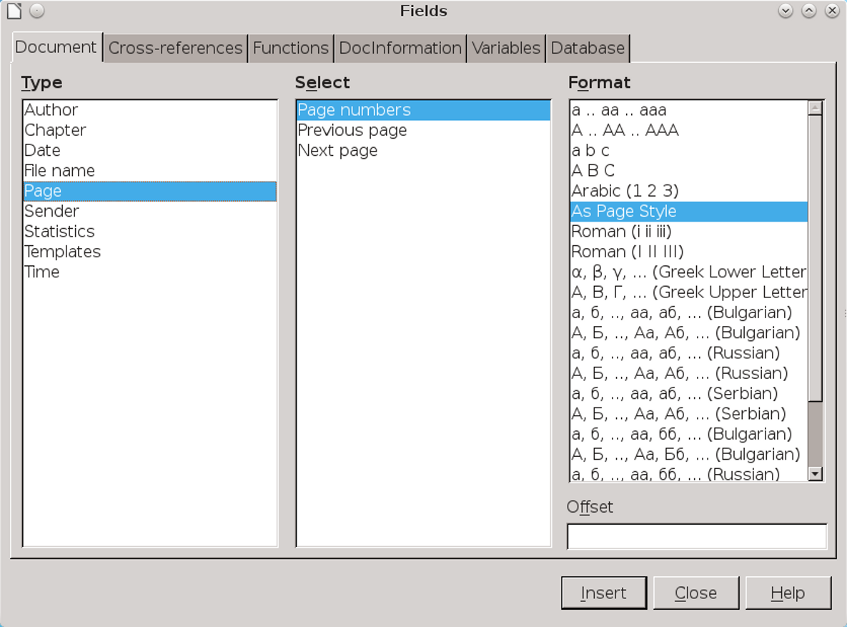
For a complete set of options, set page numbers from Insert > Fields > More Fields > Document > Page.
You also have the option of adding an offset – of subtracting or adding pages from the actual page count. An offset is most commonly used when a document has a number of pages that are either unnumbered or use a different numbering system, such as front matter or an introduction.

Adding chapter numbers to page numbers
Technical documentation or any other material that is frequently revised sometimes restarts the numbering with every chapter. Under this system, for example, the third page of chapter 5 would have the page number 5–3.
This style may be used so that, when revisions are published, users can replace only a chapter instead of the whole document – an arrangement especially useful with ring binders.

Setting page number formats
Layout Settings > format sets the page numbering format for the page style. However, just as the Page Layout field may be over-ridden by the Next style field on the Organizer tab, so the format field is over-ridden by the settings you choose for Insert > Field > Page Number field.
Depending on the version of LibreOffice, this over-ride may cause formatting problems, so make everything consistent.

Adding chapters in page numbering
To include the chapter in the page numbering:
- Set up a paragraph style on the Text Flow tab so that it starts a new page. The default is Heading 1, but Title or a custom style called Chapter Number is less confusing.
- If necessary, from Tools > Outline Numbering > Numbering, assign the style you are using to Level 1.
- In the After field, add a separator, such as a hyphen.
- Place the cursor in the position for the page number.
- Select Insert > Fields > Document > More Fields > Chapter > Chapter number. Then click the Insert button.
- Select Insert > Fields > More Fields > Document > Page > Page Numbers (or simply Insert > Fields > Page Number) to add the page number.
- Follow steps 3 and 5 for every page style in the document that includes chapter-page numbering.

Restarting page numbers
The most common scenario in which page numbering restarts is when a document begins with an introduction – usually numbered in lower case Roman numerals, then continues with the rest of the text – usually numbered in Arabic numerals.
To restart the page count:
- Create Introduction Start, Introduction Left and Introduction Right page styles, modeled on the main default pages. On each of these custom styles, set Page > Layout Settings > Format to lower case Roman numerals.
- Immediately before the page on which the page count restarts and the main body of the text begins, select Insert > Manual Break.
- Select Page Break for the Type.
- Select the page style to use after the break. Probably, you will want to use First Page.
- Select Change page number, and set the number to Restart at. Negative numbers are not allowed.

Setting up multiple page columns
Multiple columns are useful for newsletters, and for printing indexes or other tables whose entries rarely require an entire line. Without multiple columns, many indexes and tables would occupy far more pages than necessary.
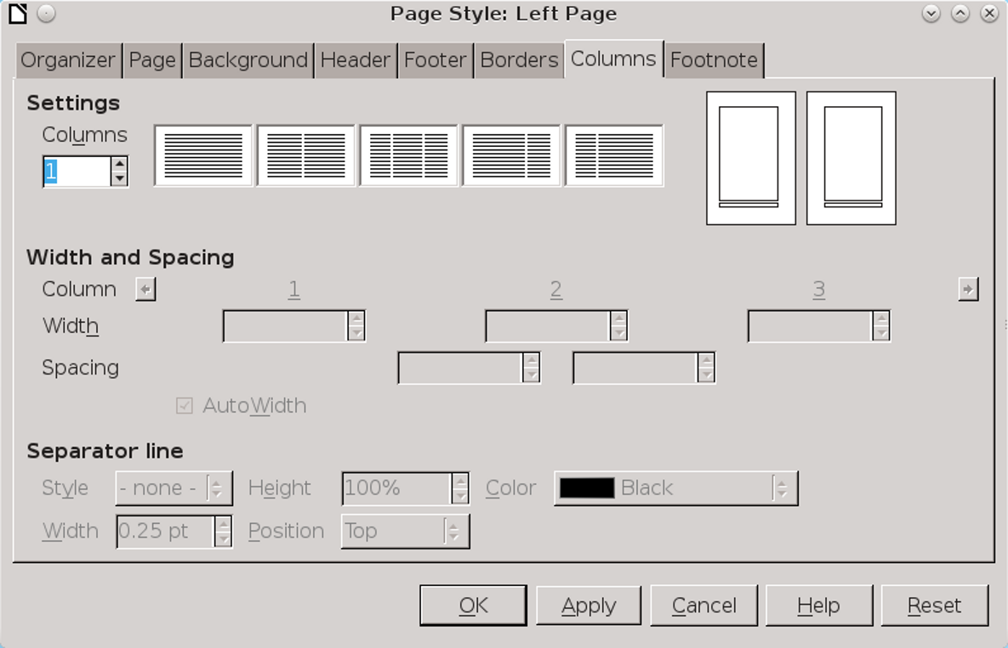
The Columns tab contains several tools for setting up multiple-column layouts.
On the most commonly used formats – A4 or Letter sized paper with a portrait orientation – you probably have room for a maximum of 4–5 columns, unless some of them are extremely narrow.
- 注意
Too many columns may result in poor hyphenation and problems with alignment. See “Error: Reference source not found,” page Error: Reference source not found.
Fortunately, this is exactly what the Column tab assumes. You can add more columns, but the tools assume no more than 4–5.
You can set the number of columns by entering an exact number plus a layout under Settings. In most cases, all columns are given the same width.
If you prefer, you can set each column width separately using Width & Spacing. At all times, the total with of all columns must equal the total available. Among other possible confusions, this arrangement means that you must reduce the free space in one column before you add space to another column.
Below the Width & Spacing is Spacing, which sets the spacing between columns. The greater the spacing, the easier the text will be to read.
Use a Separator line only if the Spacing is extremely tight and relying on white space alone would make reading difficult. In effect, adding a line between columns is an acknowledgment that your design does not work, but you have some overwhelming reason not to correct it.

Combining single- and multiple-column layouts
Writer is designed with uniform pages in mind. As a result, you cannot create a page style with more than one column format.
If you need such a layout, begin with a single-column design, then add a multiple-column section. Unfortunately, you will need to add the section on each instance of the page style.
Another option is to add manual frames and set up the text flow you want. See “Error: Reference source not found,” page Error: Reference source not found.

Setting up footnotes
Footnotes are positioned automatically by LibreOffice – usually with acceptable results, although occasionally the only solution is to convert them to endnotes instead. However, you can control much of the footnote layout by the settings on a page style’s Footnote tab.
The most important setting is the height for the footnote area. You can set a specific Maximum footnote height, or Not larger than page area – which means that no footnote can be larger than a page long. Usually, this is not a problem, since a footnote longer than a page is probably important enough to be moved to in the main text or an appendix.
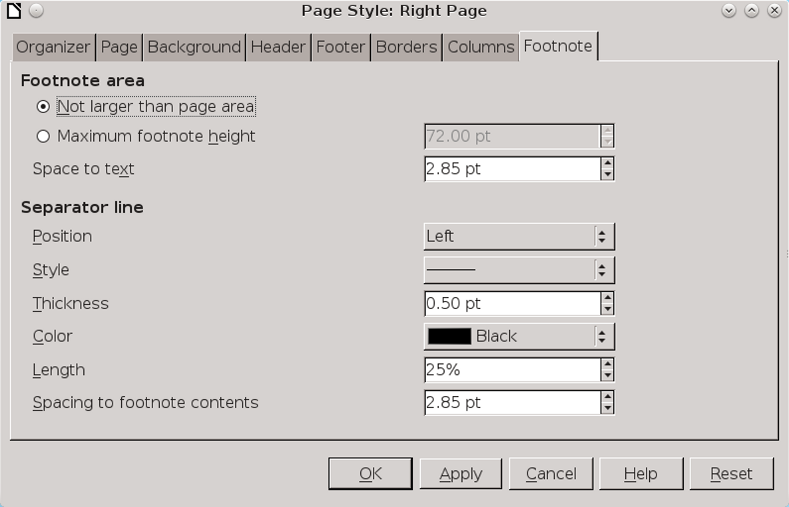
If your document has no footnotes, ignore the Footnote tab.
Typically, you will want at least two lines’ spacing as Space to text, and at least one line between the Separator line and the Spacing to footnote contents.
A separator should be as thin and as short as possible. With proper spacing, it may not be needed at all. However, be careful that the separators for the footer and footnote do not result in two solid adjacent lines.

Setting the page background
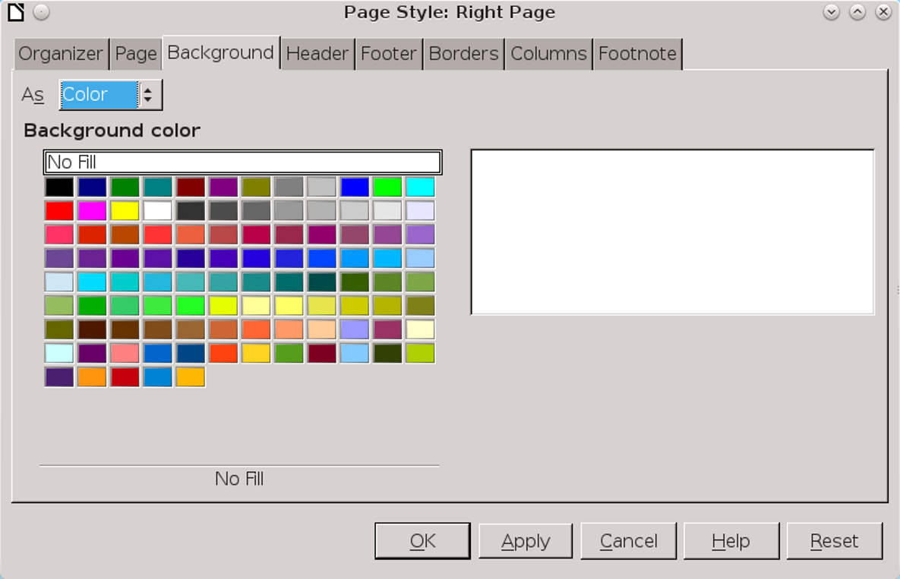
The Background tab is available for page styles, but is often unnecessary.
Backgrounds are useful either to mark part of the document as different or for short works like brochures. If you can’t give a reason for a special background, then you can be confident that it is not really needed.
The trouble is that page backgrounds are seriously limited in functionality. For one thing, they cover only the space inside the margins. You can set all the margins to zero, but you will need a printer capable of bleeds (the technical name for printing to the edge of the paper). On most home printers, you will still have about a centimeter or so around the edge of the page where you cannot print. This non-
printing area severely limits the usefulness of adding a background.
For another, in a printed document, changing the background from the default white can mean slower printing and wasted ink. A more efficient solution is to print on colored paper, although you might have trouble matching batches of the paper exactly.
If you go ahead despite these limitations, the basic principle remain the same as for paragraphs or any other unit of design that can use a background. See “Error: Reference source not found,” page Error: Reference source not found.
- 祕訣
A color or graphic background usually does not need a border unless some point along its edge blends into the paper color.
When that happens, use the minimal border that serves its purpose – and never add a shadow, except for a retro look.

Using recurring images
The greatest weakness of LibreOffice page styles is that they have only limited ability to include a recurring image such as a logo each time a style is used. In fact, there are only four work-arounds, three of which are less than ideal:
- Place the recurring image in a header or footer. On a first page, you might even be able to
- position the image more or less the way you want it by extending the height of the header or footer. Often, however, the usefulness of this option is limited.
- Associate the graphic with a list style. You will still need to apply the list style at each position, and you are very limited in how you can position the graphic. See “Error: Reference source not found,” page Error: Reference source not found.
- Add a graphic background. Make all of the background the same color as other pages, and position the graphic where you want it to appear. The graphic will have no text wrap, so you will have to design carefully so that no text comes near it.
- Anchor the image in the header or footer, but place the image outside the header or footer, setting the anchor to As Paragraph or As Character. You can then position the image anywhere on the page, and it will be repeated each time the page style is used. This tactic is usually the most effective.

Moving in the new dimension
Immigrants from other word processors sometimes overlook page styles. However, page styles are the means of adding everyday features such as page numbers and headers and footers.
Just as importantly, they help you design in large blocks, such as the page or the two-page
spread. This ability gives you a perspective that most word processors entirely lack. You might want to use sections for slightly smaller blocks, but once you are comfortable with page styles, you will probably find few uses for sections unless you want to password-protect part of your document.
Take the time to understand page styles, and you will find that Writer really comes into its own.

