6

文字工具與陷阱
第5章討論所有文檔幾乎都使用的設定。本章是關於較不常用的字元及段落設定。一個單一 文檔可能用到到好幾個這樣的功能，但很少全部都用到。
某些功能只有有限或特殊的用途。然而，其他的功能 使用前則應該小心的考慮。
某些功能是Writer首次發行時(約二三十年前)合理的設計元素，現在不僅已經過時，而且從未成為最佳的排版慣例。
還有一些功能隱晦或難以使用。這種情形通常可以選用其他方式達到相同的結果。
甚至有一兩個功能是技術上來說LibreOffice支援但實作不佳，以致改用別的軟體會得到較滿意的結果。
我很想避免討論這類功能，但警告值得一提。此外, 這類功能可能 有比想像中更實用的功能。如果有人知道用法，我願意瞭解。
當然，如果你覺得我貶抑的功能有其用處，儘管忽略我的警告，採用你覺得最好的方式。排版實務可以提供建議，卻不應該
當成盲目遵從的習慣。最終，能讓文字更可讀、更易瀏覽或更易維護的都是合理的方法。

邊框設定
邊框是圍繞物件四邊的線條。所有LibreOffice模組在樣式設定都包含相同的邊框頁籤。在Draw和Impress中，類似的功能稱為線條。
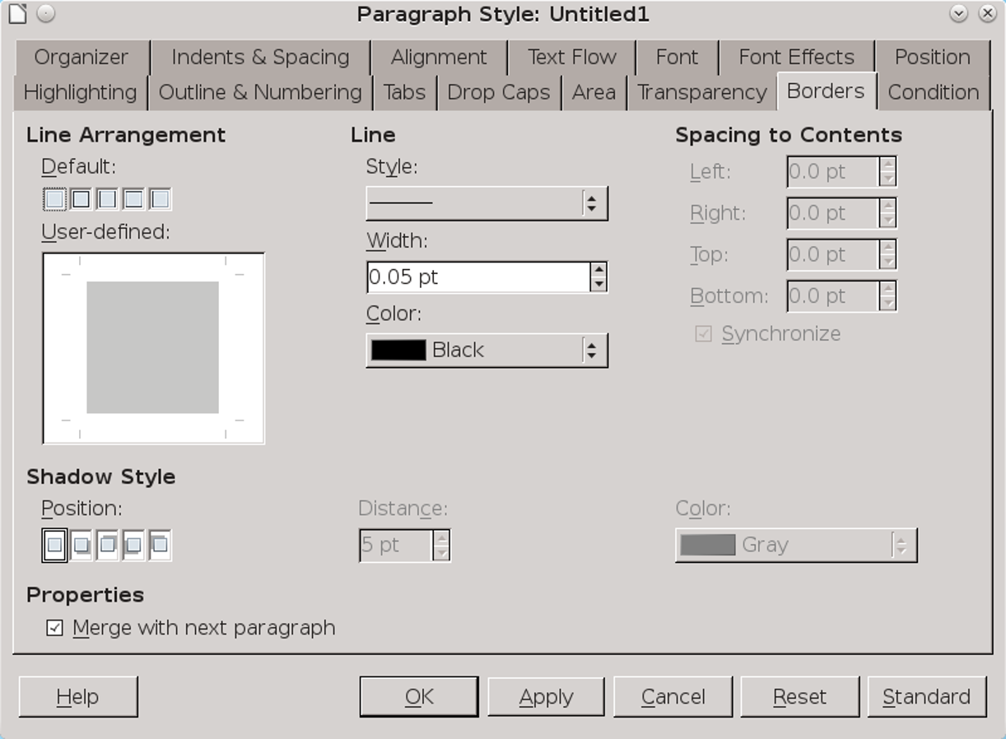
LibreOffice中類似的 邊框 頁籤。

加入邊框
設定邊框的方式:
- 在線條安排，使用預先設置集或使用者定義圖示 選取繪製框線的邊界。
預先設置集圖示可以單鍵選用預先設定好的線條安排，一次設定全部的邊界。使用使用者定義圖示，可以個別設定每個邊界。
- 設定線條樣式、寬度和顏色. 在多數情形，儘可能選擇最細、最簡單的樣式。你可能須要選取較粗的線條，以便較低階的印表機偵測。
- 設定每邊離內容的邊距寬鬆的間距增加可讀性，避免難以辨識的外觀。
當 同步勾選時，你可以同時填入左右邊或 上下邊的內容。
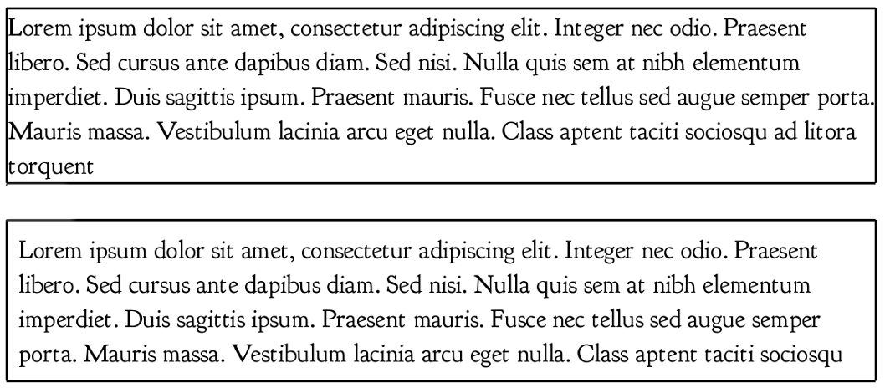
下: 邊框 > 離內容的邊距 設為 0點。下: 設定為5點。額外的空白增加可讀性並且避免擠向邊框。
- 祕訣
有時，邊框會在你設定為沒有邊框的時候出現。一旦發生而你並不需要邊框時，將線條配置 設定為空白，並選擇 線條 > 樣式 > 無。
- 如果你要邊框陰影，選擇陰影樣式的 位置、距離 (離內容的間距)及顏色。
- 注意
陰影有助於區分圖形與背景。然而如果無法說明使用陰影的原因，應該不要使用。陰影在1990年中期太過度使用，以致於今日看起來顯得老式。
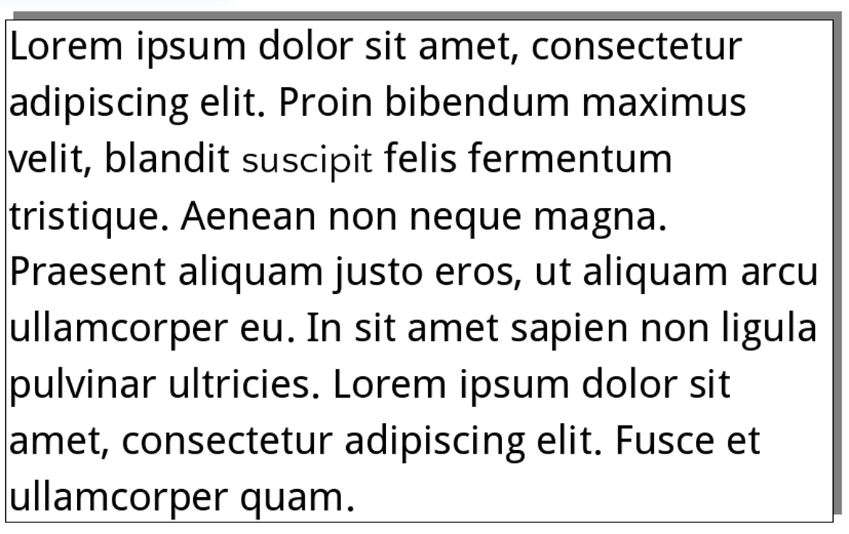
使用邊框和陰影的段落。只在有理由使用時設定陰影。僅因為能夠呈現陰影就使用陰影的日子已經過去很久了

在字元及段落樣式中使用邊框。
許多設計初學者不喜歡空白。對他們來說，空白就是浪費空間。結果他們傾向用邊框包住所有的東西。. 這樣的誘惑幾乎應該總是 被避免。
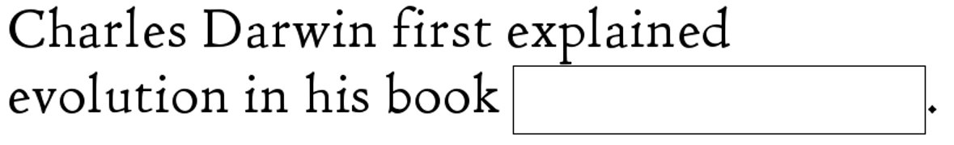
在文件和簡報投影片中，邊框的用途是有限的。最明顯的 用途是製作回答試題答案的空白或新聞報紙的側邊。
字元樣式中的邊框可以作為答題填空用。

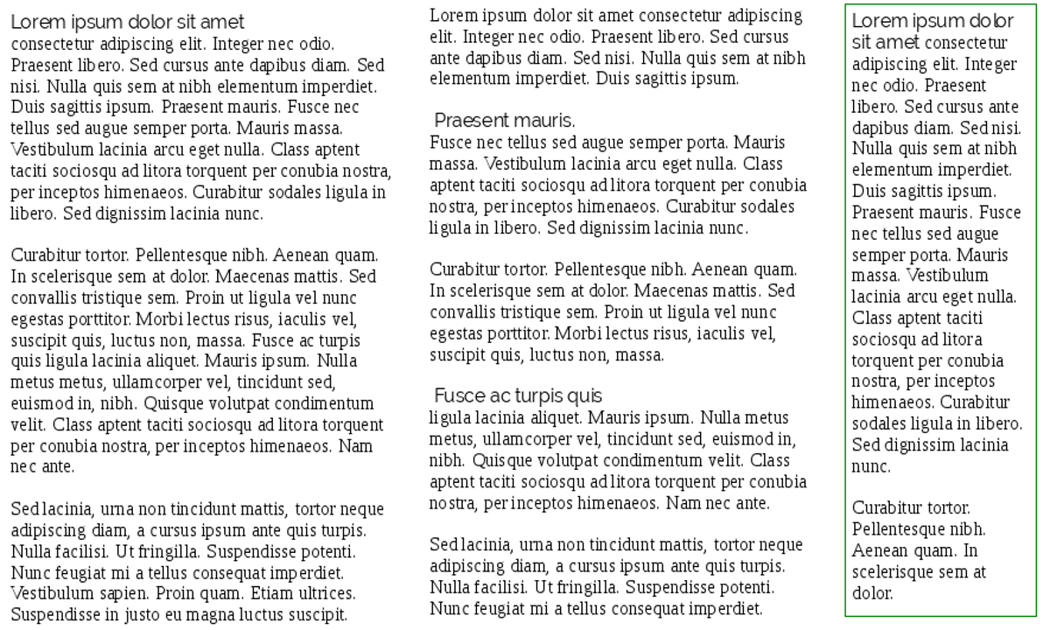
段落樣式中的邊框可以用於建立側邊當其他內容沒有設定邊框時，在小篇幅離題討論內容的周圍設定邊框，可以強調內容並非正常文字流的一部分。字型: Liberation Serif.
然而，經常來說，邊框只是另一個多餘的雜物。充足的空間，也可以達到與邊框相同的效果，且看起來較不 侷限。因為訊框有更多選項可以使用，有時是更好的選擇。
無論你如何加入邊框，將線條寬度設為最小並使用較寬裕的離內容的間距設定。和內容擠在一起的邊框只令人混淆。

色彩標明及設定背景
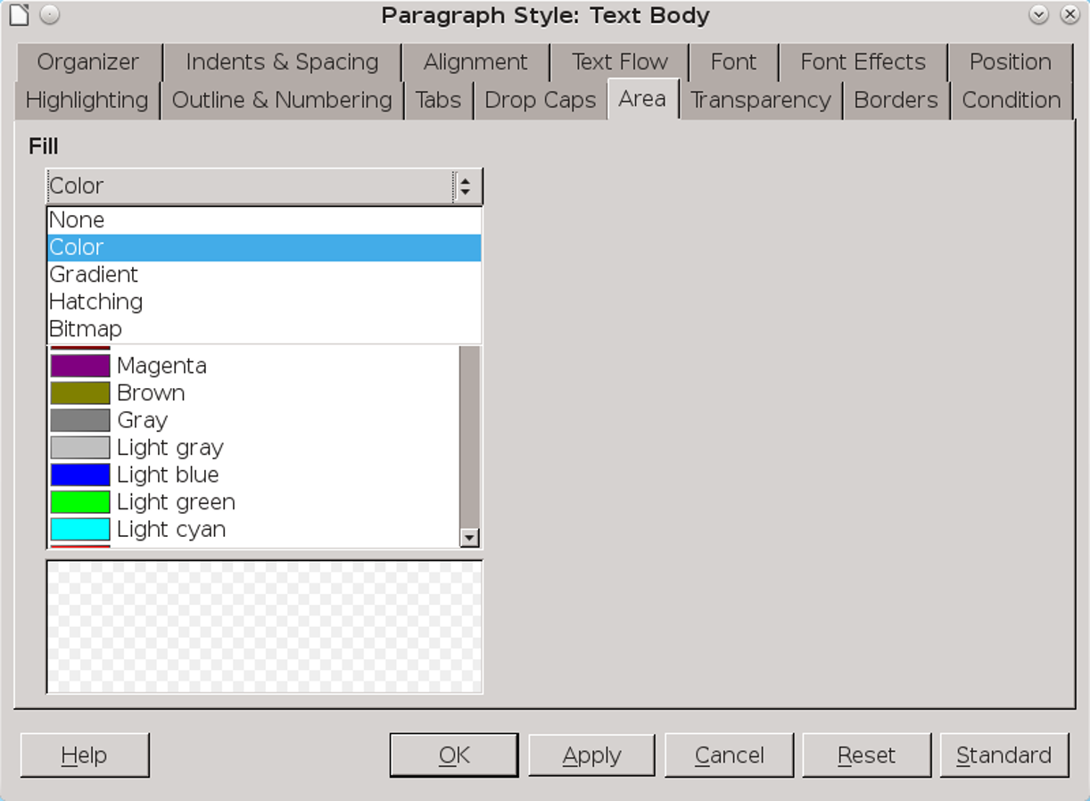
就像邊框頁籤，背景/區塊頁籤可以在整個LibreOffice找到，有時僅允許顏色。
色彩標明可以在字元樣式中找到，在非正式文件中強調段落最有用。背景或區塊在段落樣式中，基本上與色彩標明是相同的功能，除了色彩標明僅允許顏色，而背景或區塊可以是漸層、樣式或位元圖。
- 祕訣
使用區塊及透明頁籤，可以讓段落有自己的浮水印。See “Error: Reference source not found,” page Error: Reference source not found.
如果你選擇使用有色背景，確認你想要的顏色是LibreOffice定義的顏色。否則，到工具 > 選項 > LibreOffice >
顏色 增加到自訂的顏色，，或者調整 透明頁籤 (見 “設定透明度,” 頁 1).
相似的，在你加入圖形背景之前，先在GIMP之類的圖形編輯軟體準備顏色的維度和透明度設定。.

背景的基本規則：文字和背景之間應形成對比。
對所有的背景/區域而言，基本規則是：結合淺色文字及深色背景，深色文字及淺色背景。缺乏強烈對比，你的文件 失去可讀性淺色背景上的深色文字對許多人來說最容易閱讀，因為最常使用。
同時小心，不要使用太多顏色的背景。經常的結果是難讀的內容。
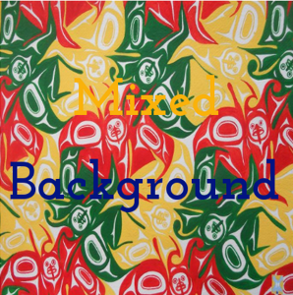
多數的前景色在多色的背景中遺失。
- 祕訣
加入背景時，考慮是否需要檢查黑白及彩色列印的對比。兩種列印模式並不一定相同。

在字元及段落樣式中使用背景
如同 邊界，背景在字元及段落樣式中用處有限。使用幾種背景顏色不同的字元樣式，可能有助寫筆記或者在傳單中強調重點，但多數以文字為主的文件採用單純的白色背景。
大多時候，使用訊框或套用頁面樣式的背景色提供更多選擇及控制。

設定透明度
「透明」頁籤源於圖形樣式，在Writer 4.4版中被加入 to 段落樣式設定中
The tab adds transparency when a selection is made on the Background/Area tab. 0% is no transparency, 100% complete transparency.
From the Transparency tab, you can:
- Create a transparency to add quickly (if approximately) another color without formally defining a color in Tools > Options > LibreOffice > Colors.
- Edit the transparency of a background/area to improve the contrast between the foreground and background.
- Create a background gradient using degrees of transparency. A gradient makes a transition between two colors. (See “Error: Reference source not found,” page Error: Reference source not found.)
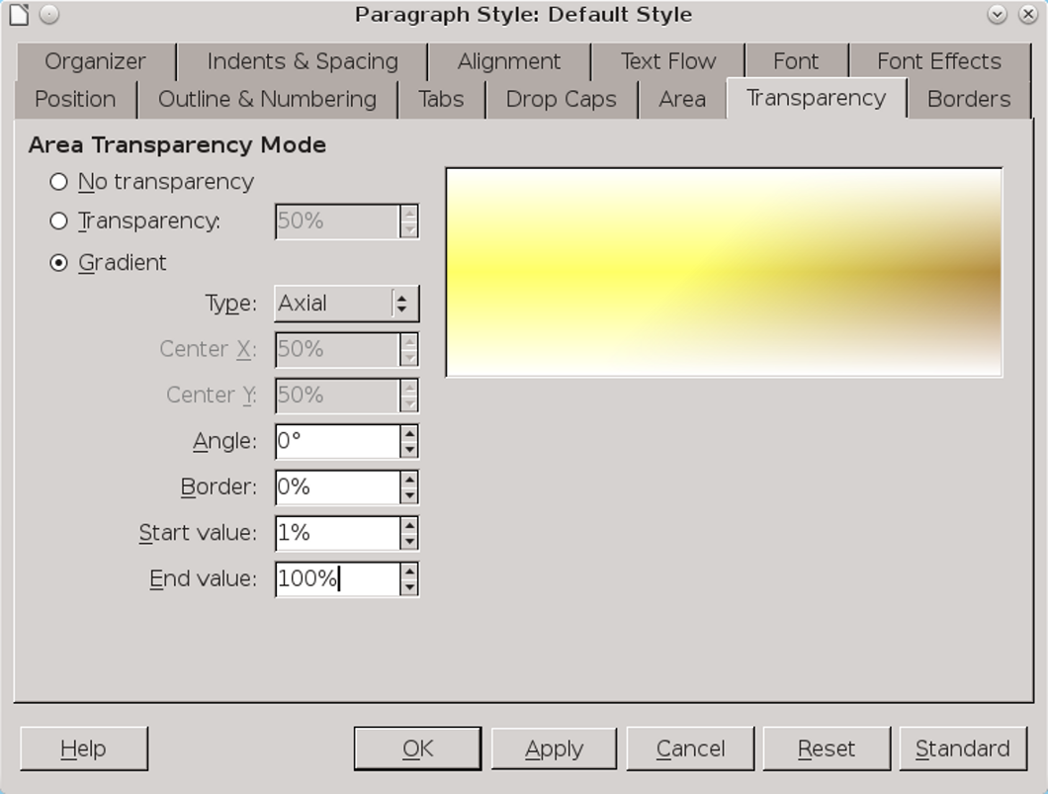
The Transparency tab works with the Area tab. Here, the controls to define a gradient are shown.

Setting tab stops
Tabs are set positions on a line. The place where a tab begins is called the tab position or tab stop.
Usually, tab stops should be multiples of the line-spacing, and kept to the minimum necessary. Much of the time, the standard typewriter tab stops of half or one inch will be far more than you need.
Tabs are sometimes used to create columns of text, but a table is usually a better option. If you use an automatic first line indent, in many cases the only reasons to use tab stops are from habit or because LibreOffice uses them in an advanced feature such as tables of contents.
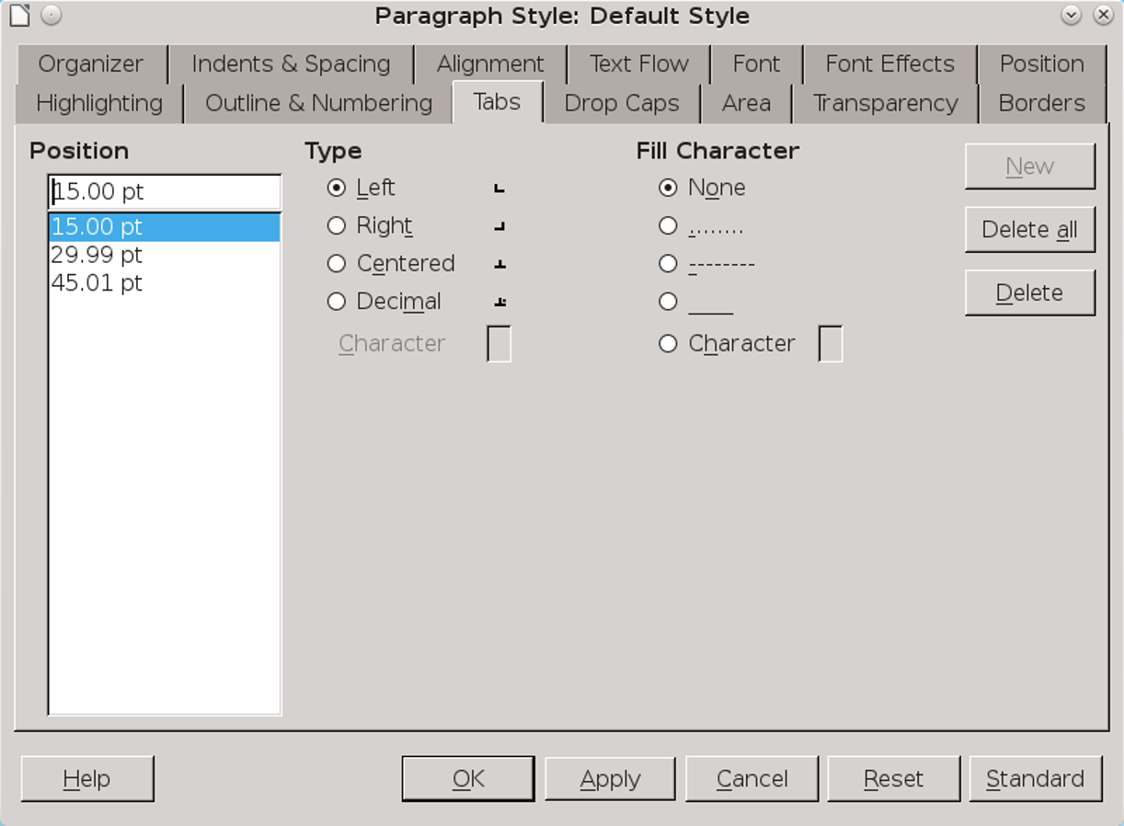
Use of tabs can be greatly minimized. When you do use tabs, make each a multiple of the line spacing.
The types of tabs are:
- Left: Places the left edge of the text column at the tab position, extending the text to the right. In most cases, this will be the most commonly used type, and often the only one.
- Right: Places the right edge of the text at the tab, extending the text to the left. The most common use of this type is to position a column of text against the right margin.
- Centered: Places the center of the text at the tab position, extending it on both the left and the right. Often, this type can be replaced by setting the general alignment of the line to Centered.
- Decimal: Places the decimal at the tab position, and whole numbers and text to its left. You can set the decimal character according to the language locale. For instance, the decimal character is a period in most English locales.
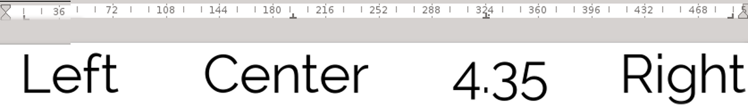
The four types of tab positions differ in where text appears in relation to the tab stop in the ruler.
The trouble with all the types of tabs is that they can be an unstable way of positioning characters. The smallest formatting change can sometimes throw them out of position.

有效使用定位點(Tab)
即使你儘少使用定位點，你也無法避免LibreOffice內建的使用。舉例來說， LibreOffice使用定位點定位文字相對於清單樣式中的項目符號及編號的位置， 及作為設定目錄的選項或選擇性樣式的設定
否則，請考慮使用定位點的需求，或以其他方案取代。使用訊框或無邊框的表格通常是更穩定的選擇。
When using tabs, do: | When using tabs, do not:
- Set them in the Default paragraph styles, or at the very least, as high up the hierarchical tree as possible. Otherwise, you will have to set tabs separately for each paragraph style. | - Use them to indicate the start of new paragraphs. Instead, create a First Line Indent and check the Automatic box on the Indents and Spacing tab.
- Make the tab positions multiples of the line spacing. | - Use them to position characters in a text frame, such as a header or footer. Instead, use a table with invisible borders and carefully adjusted column widths.
- Set the tab positions as late as possible in your designing. Otherwise, changes in features such as font or font size may force you to re-set them. | - Use fill characters in the blank spaces between tab positions. See “Error: Reference source not found,” page Error: Reference source not found.
The Dos and Don’ts of using tab stops.

Setting up drop capitals
Drop capitals are enlarged letters that mark the start of a new chapter or section. The Drop Caps tab for a paragraph style automates the process of creating a text frame and setting the text flow around it.
Drop caps are more common in fiction than non-fiction, and in magazines than in an academic essay. They create an informality that is more at home in a novel than in most types of non-fiction. The exception are the highly decorated capitals found in illuminated manuscripts from the Middle Ages.
Before creating drop caps, consider what other indicators of a new chapter you have in your design. If your first page style starts lower down than the rest of your pages, or if the start is marked by a recurring design or by numbers, then drop caps may be more than you need.
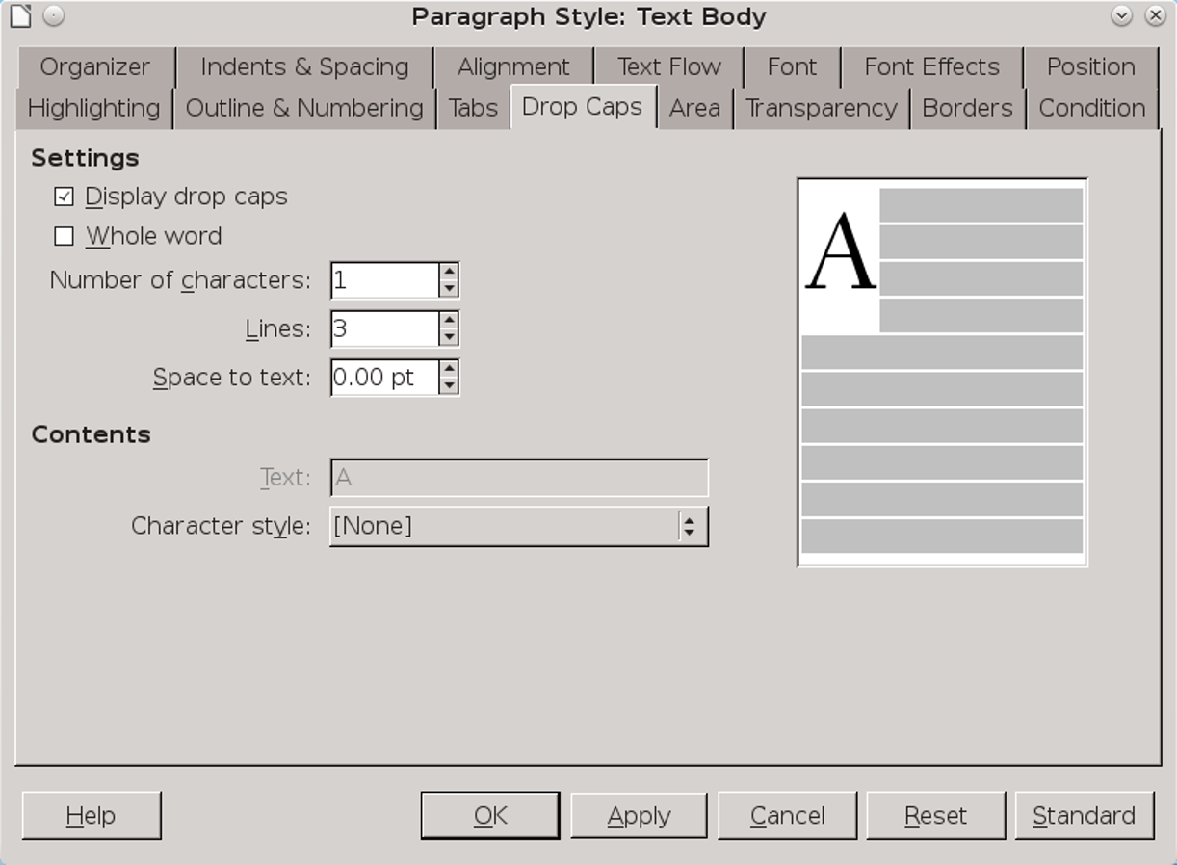
The Drop Caps tab.

Creating drop caps:
To set up drop caps:
- Choose the font for the drop caps. It can be the same font as for body text – perhaps in a different weight – a decorative font, or even a character from a dingbat set.
- Use the Drop Caps character style to define the font.
- Create a Drop Caps paragraph style. Most likely, it will be the child of Text Body, differing only in having settings for Drop Caps.
- On the Drop Caps tab of the paragraph style, under Settings, select Display drop caps. This selection enables others on the tab, as well as the preview to the right.
- Under Character style, select Drop Caps.
- Select either Number of characters or Whole word to set the length of the drop cap. You can use up to 9 characters.
- 祕訣
第一行設定不同的字重視非常常見的排版選擇。如果你想要嘗試，忽略 首字放大頁籤，另建一個首行樣式。
- 設定height of your drop cap in terms of the number of lines.
- Set the Space to text. Unless the drop cap is extremely large, the magic number is probably too much, so try half of it first.
- 注意
Contents > Text is permanently grayed-out on the Drop Caps tab. According to the online help, the field is supposed to give the text to use instead of a single letter.
However, the Whole word and Number of Character fields substitute adequately for it.
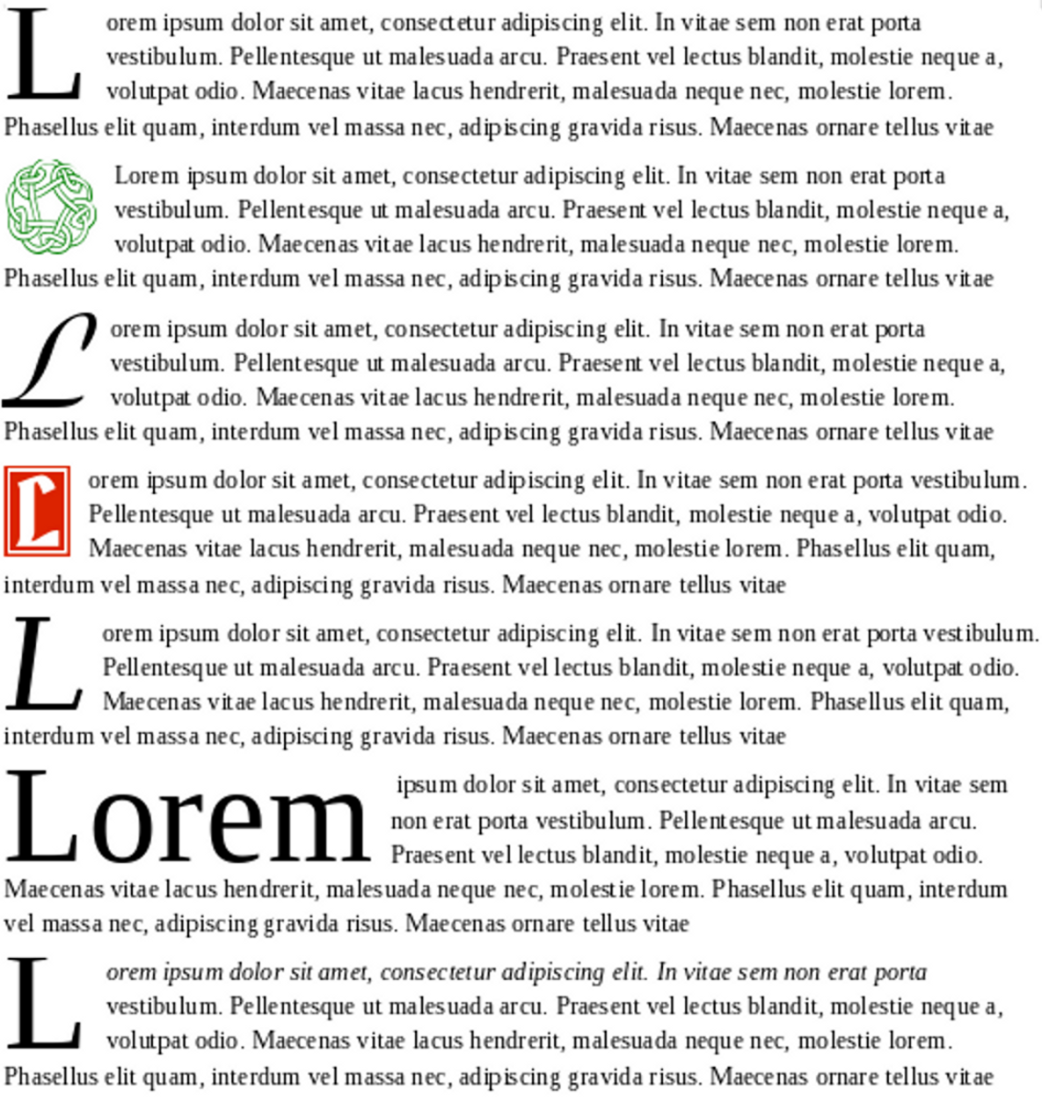
A selection of drop capitals. The last sample uses a character style to place the first line in italics.

Outlining and making lists
Lists have enough features that they are a separate type of style in Writer. However, as you might guess from the existence of the Outline & Numbering tab, paragraph styles are essential to lists and outlining.
Specifically, on the Outline & Numbering tab, you can:
- Associate list styles with paragraph styles so that they can be applied automatically. The same list style can be associated with multiple paragraph styles.
- Create an outline using a single paragraph style.
- Add a paragraph style to the default outline styles. Being included in the outline styles means that a paragraph using that style is listed in the Navigator, and used automatically in features like tables of contents.
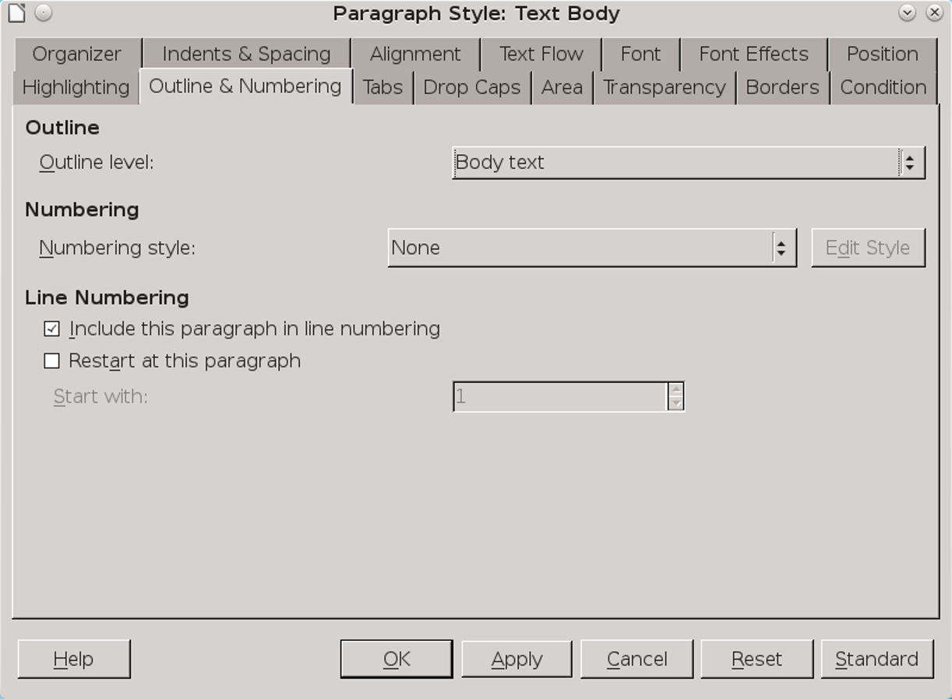
Associate a list style with a paragraph style in the Numbering section on a paragraph style’s Outline & Numbering tab.

Automating lists
An unordered list is another name for a bullet list, and an ordered list is another name for a numbered list.
Set up an ordered or unordered list in the dialog for list styles (see “Error: Reference source not found,” page Error: Reference source not found). Then associate it with a paragraph style from the paragraph’s Outline & Numbering tab in the Numbering style field.

Restarting paragraph numbering
You do not need to create a separate list style for each numbered list in a document.
To restart the numbering in any numbered list, select Restart Numbering from a paragraph’s right-click menu.
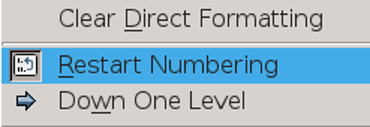
Restart the numbering in a list from the right-click menu.
- 注意
The Restart at this paragraph field on the Outline & Numbering tab is for line numbering, not paragraph numbering.

Nesting lists
A nested list – a list within a list – is most common in an online text, where space is unimportant and structured text like lists and tables improve readability.
To nest a list, you have two choices. The first is to create a list style, and set up two or more list levels with different formatting choices on the Position and Options tabs. The advantage of list levels is that each level can be formatted separately, but all the levels remain connected. You can switch to the next level below by pressing the Tab key, or to the one above by pressing Shift+Tab.
The preview pane can help you set up each list level, and the customized list style is associated with a paragraph style for use.
To switch to a lower list level while using the associated paragraph style, press the Tab key before entering content; to switch to a higher list level, press Shift+Tab.
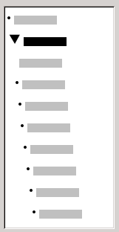
The Preview pane for a bulleted list style with two list levels. The other list levels have not been customized, so they default to the same bullet as the top level.
The second choice is to create two separate list styles, then associate each list style with a separate paragraph style.
Neither choice has any advantage over the other, since you are still dealing with the same options. However, in both cases, each nested list is typically indented more than the list level above it. Typically, too, each list level will use a different bullet style or numbering system.
Style names like Bulleted and Bulleted 2 or Nested will help to remind you of the relation between the two paragraph styles. For convenience, use the
same names for both the Paragraph and List styles, since they cannot be mixed up.
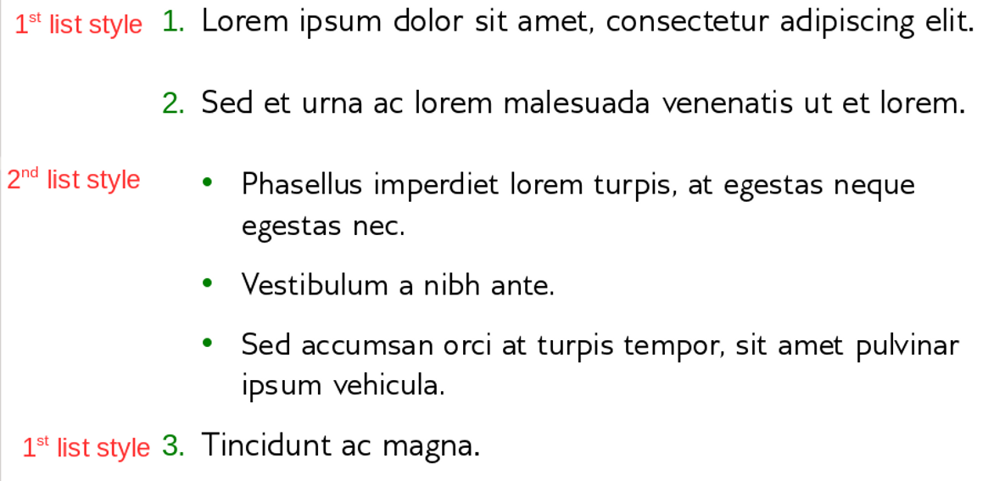
Nested lists created using two separate list styles.

Outlining with paragraph styles
LibreOffice has several ways to outline using paragraph styles. With Tools > Outline Numbering, you can choose a numbering style for each paragraph style, making it part of the Outline Levels (see “Outlining and making lists,” page 1). Alternatively, you can ignore Tools > Outline Numbering, and associate each Heading style with a separate list style using the Styles and Formatting window.
An even easier form of outlining is to create a single list style for outlining. If you want to, you can manually set up the different levels on the list style’s Options tab. However, you can get much the same result by selecting a pre-defined pattern from the list style’s Outline tab instead.
To use the paragraph style, press Enter + Tab to add a sub-level paragraph. The sub-level paragraph automatically uses the numbering pattern of the list style. To raise the level of a paragraph style, press Enter + Tab + Shift.
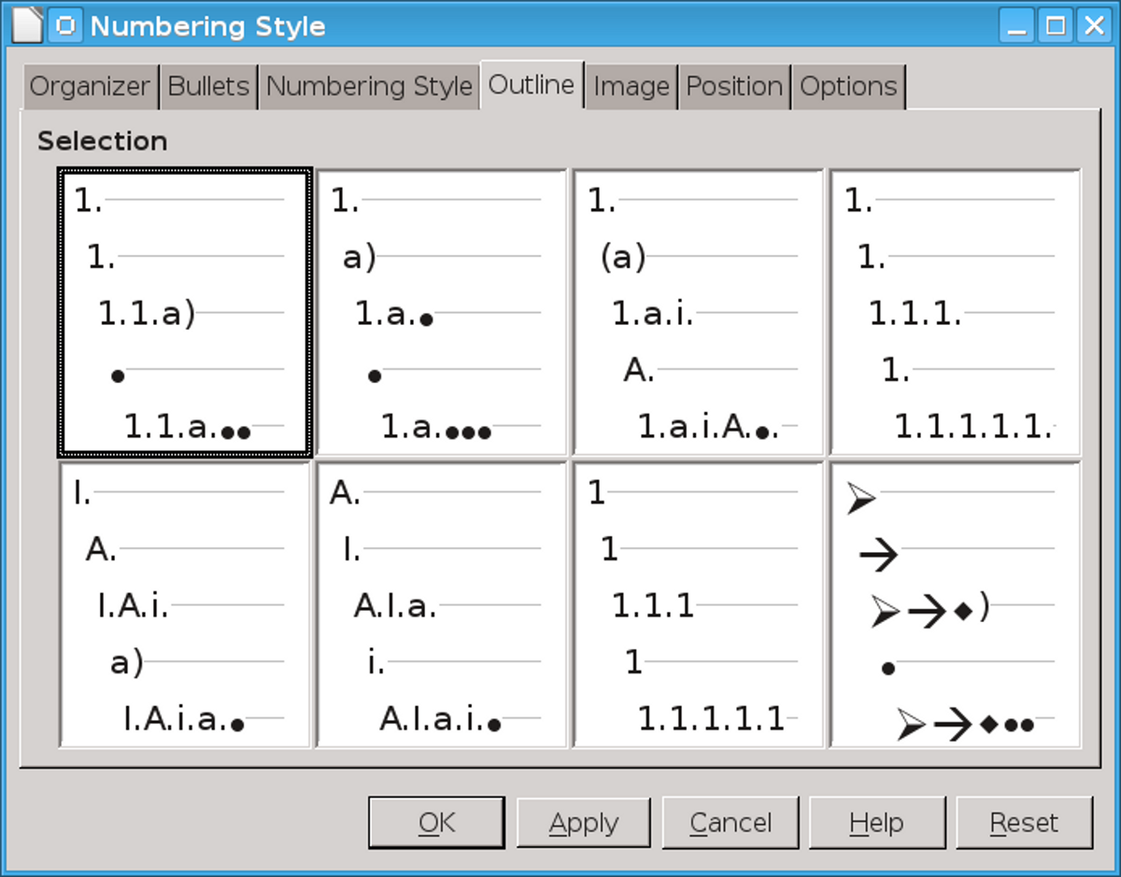
The pre-defined formatting for outlines in the list styles window. An outline is typically a way of planning a document that readers never see, so often whether the pre-defined format is exactly what you prefer won’t matter.

Creating outlines with a single paragraph style
To set up a single paragraph style for outlining:
- Create a list style and associate it with one of the pre-defined formats on the Outline tab.
- Select or make a paragraph style for outlining. You cannot use the Heading 1-10 styles. Presumably, this restriction prevents confusion between a single paragraph style outline and the registered outline levels.
- On the Organizer tab of the paragraph style, set the style to use itself as the Next style.
- Assign the list style to the paragraph style using the Numbering field on the paragraph style’s Outline & Numbering tab.

Adding paragraph styles to outline levels
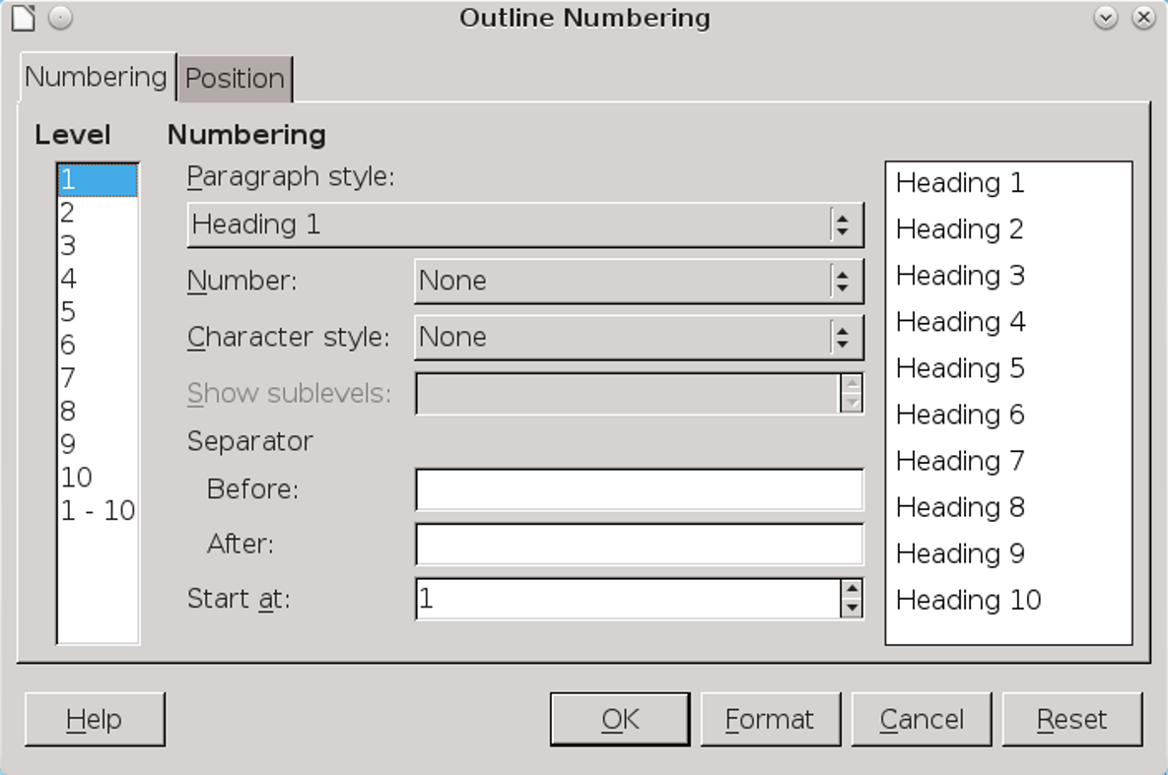
Outline Levels default to Heading paragraph styles. You can add other paragraph styles using the Outline Level field on their Outline & Numbering tabs.

- 祕訣
In the drop-down list for the Outline Level field on the Outline & Numbering tab, all paragraph styles not assigned to an outline level are identified as Body Text. This designation has nothing to do with the Text Body paragraph style.
Outline levels are a concept used throughout LibreOffice to automate advanced features. For example, outline levels determine which paragraph styles are displayed by default in the Navigator under Headings, and in a table of contents .
By default, outline levels are mapped to the Heading 1-10 paragraph styles. Outline Level 1 is mapped to Heading 1, and so on.
You can change these mappings, or add another paragraph style to an outline level in the Outline level field on the Outline & Numbering tab.
- 祕訣
You can assign more than one paragraph style to an outline level, but only one paragraph style displays in Tools > Outline Numbering.

Skipping a paragraph in a list
In many lists, each paragraph is a list item and is therefore numbered. However, you sometimes need to break up a list with an unnumbered or unbulleted paragraph that gives more detail about a list item. Without such a paragraph, a list item may turn into
a long paragraph, reducing the readability that is the whole point of using a list.
To create a style for such paragraphs, you can use the paragraph style with a list to create a linked paragraph that is mostly formatted identically. The exceptions are on the Outline & Numbering tab, on which:
- Outline Level is set to Body Text.
- Numbering Style is set to None.
- This paragraph in line numbering is unchecked.
If you have only a few horizontal indents, this style may be usable with multiple lists.
Body Text Indent is a pre-defined paragraph style that you can use for this purpose.
- 祕訣
如果要在段落編號(像詩)，使用工具 > 行編號。
這個工具比段落樣式中的格式更完善，可以選擇字元樣式及編號相對文字的位置。

使用多種語言s
LibreOffice支援超過110種語言以及許多區域設定。區域設定是語言的變形，有獨特的語彙和拼字。
舉例來說，在英國英語區域設定中，鄰居正確的拼法是“neighbours,” 而在美國英語中，是“neighbors.” 完整的區域設定是由獨立的拼字、連字符及同義字字典所構成。
許多使用者只使用所下載的LibreOffice提供的預設語言。然而，你有兩個選擇可以增加更多語言及區域設定的支援。
The most common way to add support for additional languages is to select them from the drop-down list at Tools > Options > Language Settings > Writing Aids > User-defined dictionaries > New.
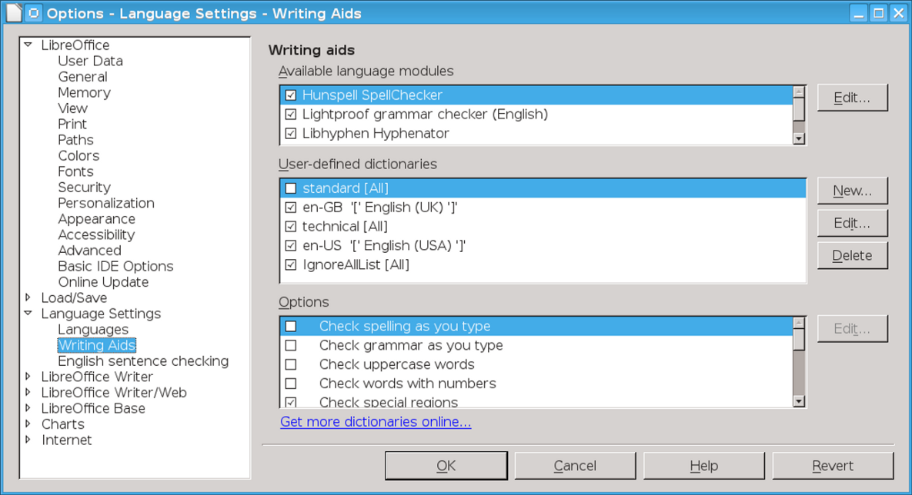
Use the general language settings to load as many languages and locales as you want.
In addition, the extension site also has packages for several languages, including Ancient Greek, Finnish, and Basque.
You can update extensions with Tools > Extension Manager > new, which is an advantage when the dictionaries are still being developed and changing rapidly.

Setting up other language features
Adding dictionary locales may be only the first step in using another language. You may need to:
- Select a system keyboard layout for the language. An international English keyboard is adequate for most Western European languages. Without a suitable keyboard layout, you have to rely on Insert > Special character for accents and umlauts.
- Install a font for a language. A Greek style is of limited use if your installation of LibreOffice has no Greek font installed.
- Adjust the settings for East Asian or Bi-Directional Languages at Tools > Options > Language Settings > Languages > Enhanced language support.
- Create multiple styles with similar names in a multi-language document. For example, you might have paragraph styles called Text Body – English and Text Body – French.
- Disable Tools > AutoCorrect Options in a multi-language document. If you don’t use Autocorrect, uncheck the Enable word completion and Collect words boxes at Tools > AutoCorrect Options > Word completion.
- Set URLs or snippets of code to none in the Language field to spare yourself extra queries while spell checking.

Creating a block quote style
All forms of academic quotation have a special format for long quotations – that is, quotations that fill more than three lines or are longer than about 100 words.
Quotations that meet this criteria are presented in a block so that they are easier to read. The assumption is that a long quote would not be used unless it was important. Readers may wonder if the emphasis is misplaced if a block quotation is not especially relevant.
Typically, the paragraph style for a block quote is the child of the body text style. The standard format for a block quotation is:
- Do not use quotation marks, unless someone is quoted directly or speaking.
- Use the same font and font size as for the body text. Making the font size smaller only makes the block harder to read.
- Use an equal indentation on the left and right sides of the paragraph, based on the line spacing. Usually, 40–50 points on each side will be about right, the exact width depending on the font size.
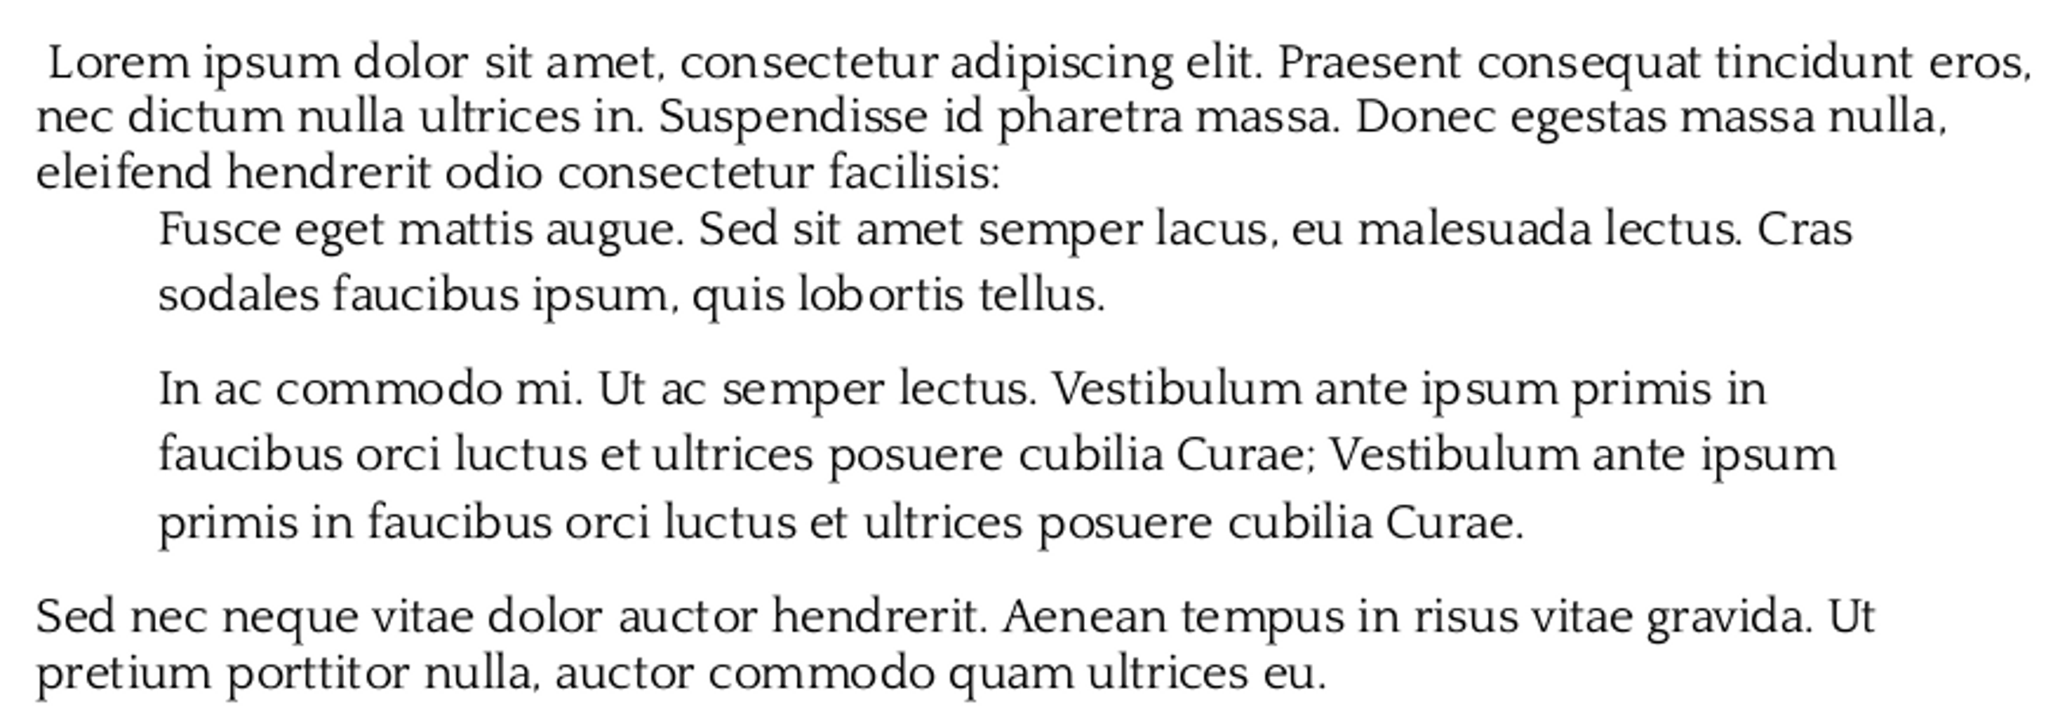
The standard layout for a block quotation. The extra indentation is used instead of quotation marks.
- Indicate new paragraphs by either a first line indent or else an extra space between
- paragraphs. The indicator is not necessarily the same as the one used in the rest of the body text.
Writer includes a Quotations paragraph style by default, although you might prefer a custom style with a name like Block Quotation for greater clarity.

Preparing styles for HTML
HTML has never been well integrated into LibreOffice Writer.
On the one hand, Writer includes View > Web Layout so you can have an approximation of how an HTML page looks, but the view is not always reliable. It also includes View > HTML Source so you can see the code with which you are working.
On the other hand, you cannot save files as HTML in the template manager.
To add to the confusion, HTML is treated in a very individualist way. While LibreOffice uses File > Document Properties to create a thorough collection of meta-tags, it also converts all graphics to .jpegs, with no provision for doing otherwise.
An even greater limitation is that only a limited number of character and paragraph styles are converted directly into HTML tags. Other styles, as well as fields, are converted to .css classes.
These peculiarities mean that HTML files exported from LibreOffice preserve as much of the formatting as possible.
Unfortunately, they also mean that LibreOffice does not produce clean HTML – that is, files with only HTML tags that are easy to use in other applications.
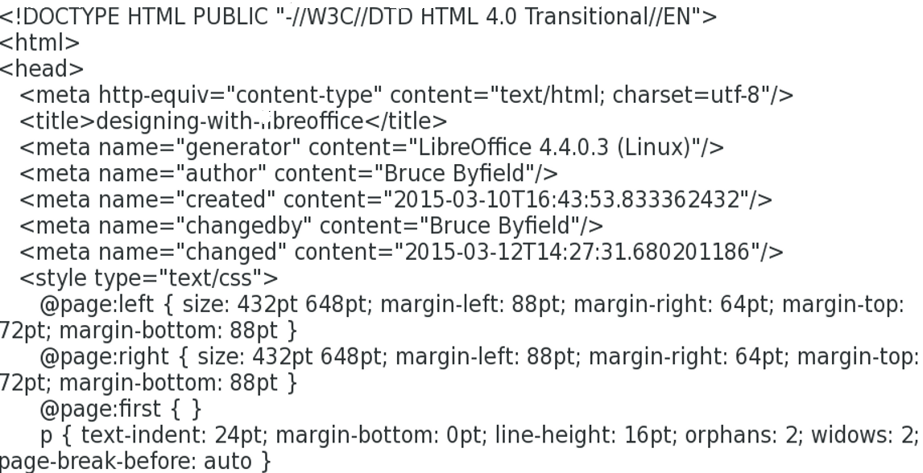
Looking at the source code for HTML generated by LibreOffice shows how cluttered it can be.
Unless you are prepared to write your own style sheet, or clean up HTML files exported from LibreOffice either manually or through a program like HTML Tidy, LibreOffice’s exported HTML requires great effort while offering results that are usually mediocre at best.
You could, of course, create a series of macros for HTML tags, then save files as plain text, renaming them in a file manager. However, at that point, using a dedicated HTML editor is less trouble.
The only times that using LibreOffice’s HTML output is advisable are when the output is only going to be used by itself and has a short life.
Problems with cluttered HTML are often compounded when the output files are used, or
when someone uses a file without knowing its limitations.
Paragraph style | HTML tags | Comments
Heading 1-6 | <h1> - <h6> | Notice that only 6 headings are available, while Writer has 10.
List Contents | <p> | Converts to the default paragraph tag. Use with list styles.
List Headings | <dl>, <dd> | Creates a definition list <dl> or adds the heading <dd>.
Preformatted text | <pre> | Appears in the web browser in a monospaced font (such as Courier).
Quotations | <blockquote> | Indents the text on both margins.
Sender | <address>
Table Contents | <p> | Converts to the default paragraph tag.
Table Heading | <p> | Converts to the default paragraph tag.
Text body | <p> | The default HTML tag for contents.
How Paragraph styles are mapped to HTML tags.
Character style | HTML tags | Comments
Definition | <dfn> | Displays default font.
Emphasis | <em> | Displays as an italic font.
Endnote characters | References style sheet. | Defaults to default font.
範例 | <samp> | Defaults to monospaced font.
Footnote characters | References style sheet. | Uses default font.
How Character styles are mapped to HTML tags.

Minimizing HTML problems
LibreOffice HTML code is generally best avoided. However, if you do decide to use it, follow these steps to minimize problems:
- Select File > New > HTML Document.
- Press F11 to open the Styles and Formatting window. Notice that the All and HTML views are identical.
- Select View > Web Layout. This selection displays the file as a web page instead of a printed page.
- Customize only by making changes to the pre-defined paragraph and character styles listed in the table above.
- 祕訣
If you want clean code, avoid using additional styles, using any character or paragraph style that requires a style sheet, or using multiple page, frame, or list styles.
In other words, design as though you are using the plainest possible HTML.
- Save the document by selecting File > Save as and selecting HTML Document Template (.ott) as the format or file type. Notice that you cannot save an HTML document using Templates > Save As Template. If you try, you receive no error message, but nothing is saved. Instead, save the file as an HTML Document Template in a directory specifically set aside for that purpose.
- If you want clean HTML output, do one (or both) of the following: Manually remove unnecessary tags or run the file through a tool such as HTML Tidy. In Linux, many major distributions have HTML Tidy in their repositories.
- Open the file in at least one major browser such as Chrome, Firefox, or Internet Explorer to see whether any display problems exist.
To use the template, navigate to the directory in which the template was saved.
- 祕訣
如果這些指令過於複雜，避免使用Writer產生HTML輸出。所有平台都有許多比Writer更容易使用的網頁工具。

Moving beyond practical text
If you are reading this book from beginning to end, at this point all the features of character and paragraph styles that you might want to use regularly have been covered.
在結束文字樣式的主題之前，第6章討論一些進階的功能，這些功能在設計中並非絕對必要，但可以自動化你的設計並讓模板的設計更有效率。

