Danske Bank – Pokemon assignment

# RabbitMQ topics:

// Exchanges/topics

public const string TYPESEXCHANGE = "types";

public const string LEGENDARYEXCHANGE = "legendary";

public const string BASEEXCHANGE = "base";

public const string HEADERSEXCHANGE = "headers";

public const string BATTLEEXCHANGE = "battle";

# RabbitMQ queues:

// Queues

public const string TYPESEARCH = "typeSearch";

public const string TYPESSEARCH = "typesSearch";

public const string LEGENDARYLIST = "legendaryList";

public const string NAMESEARCH = "containsSearch";

public const string HEADERSLIST = "headersList";

public const string HEADERSSEARCH = "headersSearch";

public const string BATTLE = "battle";

# Endpoints:

Endpoints can be seen using swagger. Start the project and go to “/swagger” to see it.

List of endpoints:

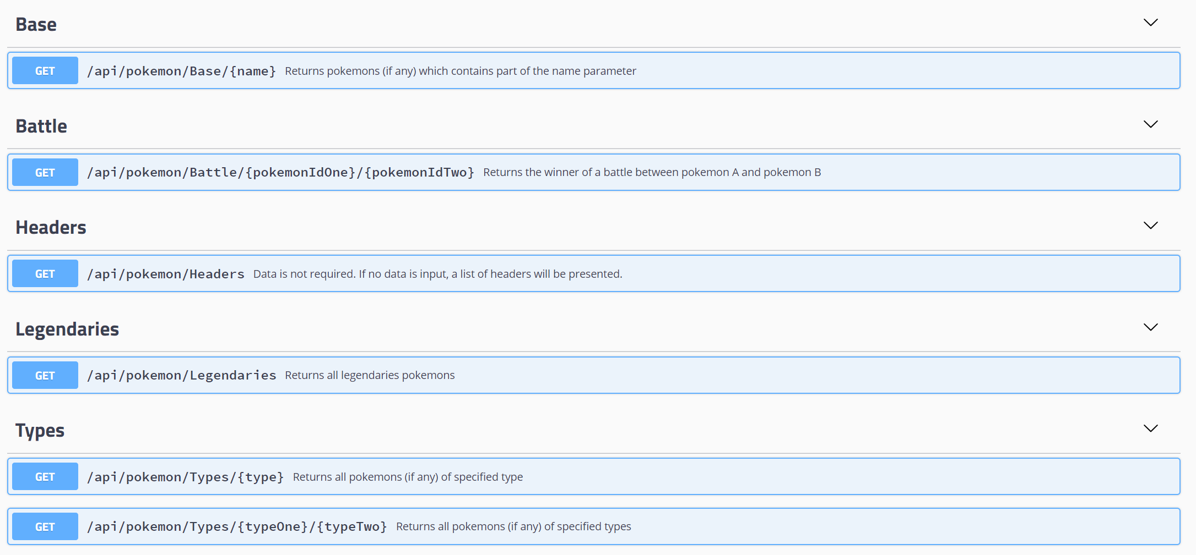

# Battle system logic:

The battle system is in the BattleHandler.cs file.

The HandleBattle accepts two pokemons (pA, pB).

We first check if both exists, as we might have 2 ids that does not exist in the db.

If they exist, we set the starting pokemon to the one with the highest speed.

We then loop (for loop while i < 8), and call the HandleRound method, which simply does a check for which one is the starting pokemon, and then let that attack first.

If the other pokemon is not dead after this attack, it will attack back.

Then the round is over, and we do the HandleRound again.

If one of the pokemons dies before all 8 rounds, we break out of the for loop, and return who is the winner:

$"{pokemonA.Name} is the winner."

or

$"{pokemonB.Name} is the winner."