**Chapter I**

**Introduction**

**Background of the study**

The introduction of computer-mediated communications has brought about new forms of asynchronous discussion, which makes up a significant and very important component in distant interaction. The internet and computer networks have given a platform for online communication and interaction amongst people. Over the years, many other types of discussion groups have emerged; these are spaces where people may write, read, and share articles, messages, software, and other types of information.

Many schools are adopting online communication and discussions, which is an effective way during this time, and one of these is Sultan Kudarat State University, which uses social media pages, specifically Facebook, to post announcements, events, or topics of interest where students can respond through comments, which leads to a discussion with other students and teachers. However, consistency is sometimes difficult in this space. Interaction with others can be unmanageable because so many pages associated with the school are created to deliver a piece of information to the students. If a student wanted to share information with other students or professors, they could only do so by posting it on social media sites in the hopes that others would see it. Nowadays, Physical interaction of teachers, students, and other staff in school will no longer be allowed and online communication will play a significant role. Although we have these social media sites that specialize in user interaction, none of this provides a space like a school environment where students and teachers can have interaction with a discussion about certain topics and school matters.

With this, the proponents propose a Internet-Based Discussion Forum for Sultan Kudarat State University using Progressive Web App Technology will bring people together with shared interests and mindsets. The use of an online discussion forum system has grown in popularity as a useful tool for engaging students outside of the classroom. The system is an online student-centered space platform that allows students to create discussion posts, add comments to discussion threads, interact with and get feedback from other students and instructors, and accordingly create a deeper understanding of the subject matter being discussed. The system makes use of Progressive Web Application (PWA) technology, which makes the web application installable on both iOS and Android devices as well as desktop PCs, allowing users to access it with only one tap. The system’s push notifications functionality is one of its benefits, allowing users to receive timely updates. As a result, no user will miss any important forum announcements or discussions.

**General Objectives**

Generally, this study aimed to design, develop and evaluate the study entitled “Internet-Based Discussion Forum for Sultan Kudarat State University using Progressive Web App Technology”.

**Specific Objectives**

1. Allow users to access the app using web browsers or through installation on any of the given platforms.

1.1 Desktop

1.2 Android

1.3 IOS

1. Provide a student module to perform the following :
   1. Manage account
   2. Create, update and delete a post
   3. Attach files to a discussion post
   4. Filter the publicity of the post
   5. Comment to a discussion post
   6. Report a post
2. Provide a teacher module to perform the following:
   1. Manage account
   2. Create, update and delete a post
   3. Attach files to a discussion post
   4. Filter the publicity of the post
   5. Comment to a discussion post
   6. Report a post
   7. Create, update and delete announcements and events
3. Provide an office administrator module to perform the following:
   1. Manage account
   2. Create, update and delete announcements and events
   3. Attach files to a discussion post
   4. Create, update and delete a discussion post
   5. Comment to a discussion post
   6. Filter the publicity of the post
4. Provide a system administrator module to perform the following:
   1. Manage account
   2. Create, update and delete announcements and events
   3. Manage users
   4. Manage discussion
   5. Allowed to review discussion post that has been reported
5. Allows the user to receive live notification for new discussion posts, new announcements, new events.
6. Generate reports such as :

7.1 Number of posts per campus

7.2 Number of posts per day and months

1. Evaluate the system in terms of :

8.1 Functionality

8.2 Acceptability

8.3 Accessibility

**Significance of the Study**

The following is the significance of the study.

**Office administrators** – They will be able to create announcements and events regarding their office transactions and will be delivered to the students easily.

**Teachers** – The teachers will be able to send information and announcements to students in a much easy way.

**Students** – The system will be the main source of information coming from the different departments and teachers of all campuses of SKSU. It will be a huge help for the students to be updated all the time. The system will help the students to boost their confidence in socializing with others, sharing their thoughts, and start a discussion forum.

**Future researchers** – This capstone project will be a test and a challenge for the researchers, as they will be putting their programming, system analysis and design, database administration, web development, and mobile development skills to the test.

**Scope and Limitation**

**Scope**

This research is limited to Sultan Kudarat State University campuses. This study is intended for the development of an Internet-Based Discussion Forum for Sultan Kudarat State University using Progressive Web App Technology. All office admins, students, and teachers are covered by the system. It covers the most recent evolution of the forum, which is the online approach rather than the traditional face-to-face method. It also describes the web application's key features as well as the users. On the office administrators module, they can manage accounts, manage announcements and events, manage a discussion post, attach a file to the discussion, comment to the discussion post and filter the publicity of the post. On the system administrator's module side they can review a reported post, manage users, manage discussions, and manage announcements and events. On the teacher’s module, they can report a post, comment, and attach a file to the discussion, filter the publicity of the post, as well the management of accounts, post, announcements, and events. On the student’s module, they can only manage accounts, manage a discussion post, report, comment and filter the publicity of the post, and attach a file to the post. The management of announcements and events is not part of the student module.

The system will also generate reports such as the number of posts per campus, number of posts per day, and months and allows the user to receive live notifications for new announcements, events, and discussion posts.

**Limitations**

Live conferencing, private chatting, account registration, and office inquiries are not done online, thus the delimitation.

**Operational Definition of Terms**

**PWA** – “A Progressive Web Application (PWA) is a website that provides all of the features of an app. PWAs allow you to create a version of your website or e-commerce business that is faster, more dependable, and more engaging. PWAs can perform almost everything that native apps can, including working offline, accessing your camera and microphone, and using GPS”.

**Forum** – “a place, meeting, or means for exchanging thoughts and viewpoints on a specific topic”.

**System** – “A complete installation that includes peripherals such as a hard disk drive, monitor, and printer, all of which are designed to work together. Online It is activated and ready for operation, capable of communicating with or being controlled by a computer”.

**Internet** – “It is a networked system that uses the TCP/IP protocol to connect computers all over the world”.

**Asynchronous discussion** – “Asynchronous discussion allows students to read and respond “out-of-time.” Given the latitude participants have in their reaction time, this type of online conversation, as seen in a college literacy course, produces a text of dialogue that has the potential to be reflective”.

**Discussion** – “Talking or writing about anything, especially to solve a problem or answer a question”.

**Mediated communication** – “is a term that describes communication that takes place through the use of information and communication technology, as opposed to face-to-face contact.”.

**Technology** – “**Technology is the application of scientific knowledge to the practical goals of human life, or, as it is sometimes called, the manipulation and transformation of the human environment**”.

**Chapter II**

**REVIEW OF RELATED LITERATURE**

In this chapter, the literature and studies are carefully selected. This literature and studies help the researcher to have evidence and proof to their study. Also, this chapter discusses the relevance of the study.

Online discussion forums are a type of traditional learning that encourages dialogue, reflection, knowledge development, and self-evaluation. Online discussion forums have been increasingly accepted as tools for online learning due to their potential benefits. “Students' critical thinking and problem-solving skills, decision-making capacity, and writing communication skills may all benefit from online chats, as well as their ability to organize and evaluate information”. (Zalpaska, Falnegin, & Rudd, 2004)

Forums are online discussion areas where you can post and read messages from other users with similar interests, usually in an organized thread layout. Many Web sites today also build communities around their site by offering discussion forums where users can post messages, reply and discuss specific topics or simply introduce themselves to other forum members. These online communication spaces are frequently called online forums, discussion forums, or just forums. The forum itself is an application that “holds” discussions and user-generated content that is contributed by the community of forum members. Most forums will have moderators, sometimes called mods for short, who are users that have access to remove unrelated posts, rude comments, spam messages posted to the forum, or even remove unruly users themselves. They can lock threads from further discussion and generally oversee that the forum runs smoothly for all participants. (Beal, 2008)

The idea for Web-based discussion forums stemmed from newsgroups that used the Usenet system. Developed in 1979, Usenet operated as a bulletin board system and was supported by UNIX machines. As technology advanced, discussion forums were developed to operate on the Web, rather than on a UNIX-based system. Along with newsgroups, discussion forums also were like Internet chat. Both discussion forum and chat technologies allowed Web surfers to communicate online. Discussion forums used asynchronous communication, however, which differed from chat in that it allowed its users to post and respond to messages from any computer at any time, rather than requiring all chatters to be logged on simultaneously. (Cashel, 2001)

Combining an online discussion forum with a case study method, which is a standard pedagogical methodology used in many business schools, is thought to be a successful method for getting students to connect theory to practice. As a result, several academics have begun to use online discussion forums to teach utilizing the case approach. While the learning objectives of online and face-to-face case discussions are essentially the same, there is little research on the pedagogy and assessment of the online case method in business and accounting education. (Rollag, 2010)

The benefits of using online discussion forums and peer-to-peer learning for enhancing student learning are well known. Other than in fully online courses, their adoption in traditional learning environments complementing face-to-face teaching is increasing and has now become a common educational strategy in higher education. Interest in using online discussion forums as an indicator of students’ performance is increasing. Online discussion forums are expected to enable flexible and independent learning and knowledge construction and develop critical thinking skills. There are, however, some problems such as lack of learners’ focus and inadequate reflection, students not responding to the ideas of others, and surface-level discussions. Though there are many advantages of its use, students' use of the online discussion forums in the context of their study and the characteristics of an effective online discussion environment that facilitate effective learning need to be investigated. (Seethamraju & Hwang, 2014)

However, the impact of these hybrid learning models, which mix traditional classroom case study pedagogy with asynchronous media such as online discussion forums, on learning outcomes and processes, remains unknown. With the recent widespread deployment of course management systems (CMS) and learning management systems (LMS) by academic institutions, further studies to offer insights into the current and future directions of this field are necessary. (M. Loncar, N. E. Barrett, & Liu, 2014)

Using your discussion board as a forum for a debate has two potential benefits. It creates an atmosphere for a lively and engaging discussion. It also gives you, the instructor, the opportunity to guide students in how to respectfully and intelligently engage in a debate a skill that sometimes seems to be dwindling in today’s political and societal atmosphere. If using a discussion board as a debate forum, you have the option of assigning students to debate from a particular viewpoint or you can allow them to debate from their view. Either way, it’s helpful to have a rubric or guidelines set up to guide students toward respectful, well-developed responses. Expect that you or an assigned student will play the moderator. (Castaneda & Rentz, 2020)

In collaborative group discussions, learners learn to listen attentively to each other and value the efforts of shared knowledge and input. Online discussion technology also helps learners respond to questions, participate, and offer peer feedback to support the sharing of new information. Successful discussion groups include learners who are actively engaged in accountable and responsible talk. Accountable talk between learners emphasizes logical connections and allows learners to draw reasonable conclusions to new information. Learning through collaborative online discussion groups is reciprocal and the most direct way for instructors to assess learning online. (Higley, 2018)

Information technology alone does not contribute to student success raising the question of the educational motive and the related impact. In the context of discussion boards, we identified content knowledge, written communication skills, organization and structure, and group collaboration as desirable learning outcomes. According to SLT, setting these objectives before the learning process ensures that they manifest in the cognitive model. Additionally, fulfilling these objectives should be incentivized with marks to ensure sufficient motivation within the education setting. Chen, Lambert, and Guidry (2010) conclude that student engagement is highly relevant for learning with web-based technologies. To that end, system usage led to higher engagement that in turn resulted in higher desirable learning outcomes including the use of higher-order thinking, reflective learning, and integrative learning in their studies. As a result, it seems that the individual’s attitude towards group work as well as the related group work engagement influences the motivation for the reciprocal interaction required for the cognitive learning process. (Delaney, Kummer, & Singh, 2018)

In general education classes, instructors strive to engage students and develop critical thinking abilities regardless of discipline. A recent study of the benefits of online conversation (also known as computer-mediated communication) found that it encourages active learning and improves student outcomes. Students demonstrate higher levels of critical thinking in online discussions when teachers use excellent questioning and moderating skills, according to researchers. Stephenn DeLoach and Steven Greenlaw (2005) identified ‘‘critical thinking spillovers’’ that are not present in traditional classroom discussions and writing homework. Students' arguments tend to improve in reaction to the quality of the comments they receive from their classmates, according to the researchers. Similarly, researchers discovered that after reading notes written by other students and the instructor, students who started classes with lower grade-point averages obtained improved grades. (Williams & Lahman, 2011)

The fundamental difficulty in asynchronous discussion forums is a lack of engagement by most students and the dominance of a small group of students. Grading can be a viable technique to encourage involvement because assessment is the currency that students deal in. Given that the present generation of students has a lot of online and social media expertise, previous internet experience (or lack thereof) may no longer be a concern. As a result, rating pupils for their contributions can be used to encourage their participation and, learning. The fear of losing marks, as a result, may limit their engagement to some level; nevertheless, grading may inspire students to participate in the conversation with thought and preparation. Students may be fearful of displaying their lack of knowledge, which could be used against them if they open up too much. An effective learning environment and assessment must be carefully planned to avoid unintentionally diminishing learning motivation. (Harlen & Deakin-Crick, 2003)

Comtella Discussions (Comtella-D) [3] is an online community for discussing the social, ethical, legal, and managerial issues associated with information technology and biotechnology. Moreover, it represents a mechanism for motivating participation in interest-based online communities, which engages non-contributing members by modeling and visualizing the asymmetrical relations formed when reading, evaluating, or commenting other community member's contributions. Indeed, it was used to support the coursework related to a 4th year undergraduate class on Ethics and IT taught in the spring of 2006 at the University of Saskatchewan. Access to content is restricted to registered members. Members are relatively anonymous because they are identified just by their alias. The purpose of using Comtella-D in the class was sharing and discussing information (Internet publications, popular magazine, paper, respectively) related to the course topics. The students had to share at least one link to an online paper related to the weekly topic and summarize the paper in a way that it stimulates discussion. As a part of their coursework, the students also had to reply/discuss two of their colleagues' postings each week. In parallel with the students of the Ethics and IT class, (4th year Computer Science students), the Comtella-D system was used in a class on Ethics and Technology offered by the Philosophy department. These students used the system only as an additional resource, recommended by the instructor. The system was not related to their coursework, and it was used entirely voluntary. (Abel, et al., 2010)

**Conceptual framework**

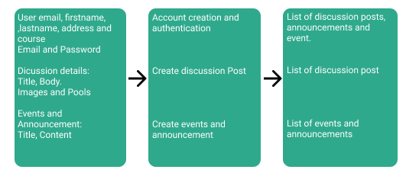

Figure 1. **Conceptual Framework of the study**

The conceptual framework of the study is shown in figure 1. As illustrated, we can now easily figure out the process of the system.

**Chapter III**

**Methodology**

System Methodology involves dividing software development work into distinct stages and coming up with tasks or activities aimed at achieving better planning and time management. It is considered a trivial part of the systems development life cycle.

**Project Development Description**

**Tools and equipment**

The table below is the tools and equipment to be used in the study.

Tools and Equipment Used in the Study

**Table 1. Hardware**

|  |  |
| --- | --- |
| **Description** | **Specification** |
| PC   * RAM(memory) * Processor * ROM (Storage) | * 8GB * Intel core i5 * 512GB (SSD) |
| Network Peripherals Needed   * Fiber | * PLDT 100Mbps |

Table 1. Showed the tabular representation of the hardware materials used in the project development.

**Table 2. Software**

|  |  |
| --- | --- |
| **Description** | **Specification** |
| IDE | Visual Studio Code |
| Dependency Manager | Composer, Node JS |

Table 2. Showed the tabular representation of the Software materials used in the project development.

Table 3. Bill of Supplies and Materials

|  |  |  |  |  |
| --- | --- | --- | --- | --- |
| Item No. | Qty | Unit | Item Description | Estimated Price |
|  | Hardware Cost | | |
| 1 | 1 | Unit | Specifications:   * Processor - Intel Core i5 * RAM - 8GB * SSD- 512GB | 49,999.00 |
|  | Software Cost | | |
| 2 | 1 | Pkg | Windows 10 Operating System (Licensed) | 4,000.00 |
| 3 | 1 | Lot | Web hosting | 65,000.00 |
| 4 | 1 | Service | Pusher | 2,450 * 12 = 29,400 |
|  | Manpower cost | | |
| 4 | 1 | Person | System analyst | 10,000 * 12 = 120,000.00 |
| 5 | 1 | Person | Programmer | 9,500 * 12 = 1140,000.00 |
|  | Maintenance and Other Operating Expenses | | |  |
| 6 | 3 | Person | Project Deployment and Maintenance | 15,000 * 12 = 180,000.00 |

Table 3. shows the bills of supplies and materials used in building Internet-Based Discussion Forum

### Project Duration

Figure 2. Project Duration

Figure 2. Shows the development time frame in processing the Internet-Based Discussion Forum

## 

## **Software Development Methodology**

Testing

Maintenance

Installation

Coding

Design

Feasibility of study

Requirements collection

Figure 3. System Development Life Cycle

The Waterfall approach is one of the most popular models in Software engineering, it was the very first SDLC Model to be used. The approach taken was to treat the whole process of modeling software in sequential order, the outcome or output of the previous step would serve as the input for the next step. This would enable software developers to separate these steps into distinct stages, with each phase having different requirements and activities. The illustration bellows shows a representation of the stages found in the Waterfall Model.

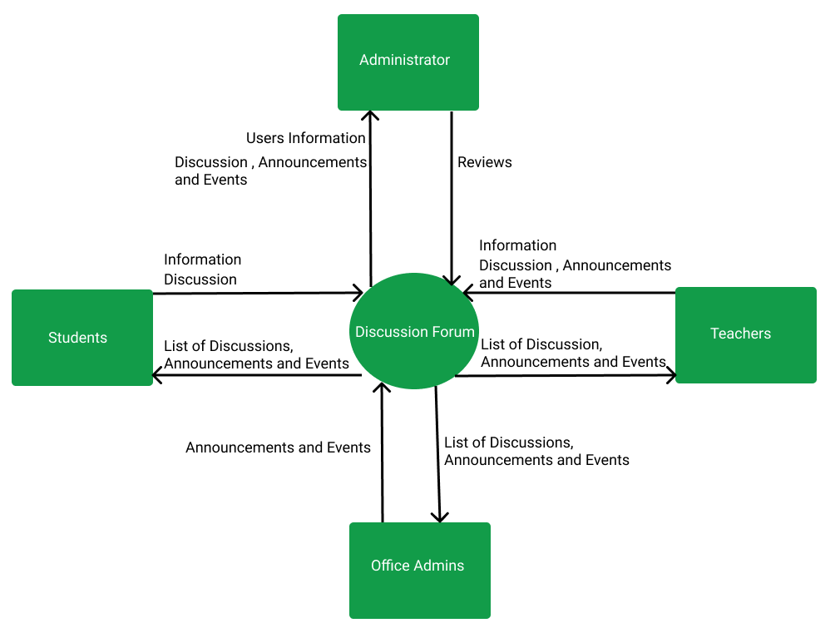**Context Diagram**

Figure 4. Context Diagram of the System

Figure 4. Shows the context diagram of the system. The students will only be able to log in if they have an institutional account provided as well as the teacher but optional for the office administrator. All of the discussions, announcements, and events can be visible to users. The student, teachers, and office admins can create discussions and only the teachers and office admin can create announcements and events. The System administrator can manage the users, discussions, announcements, and events.**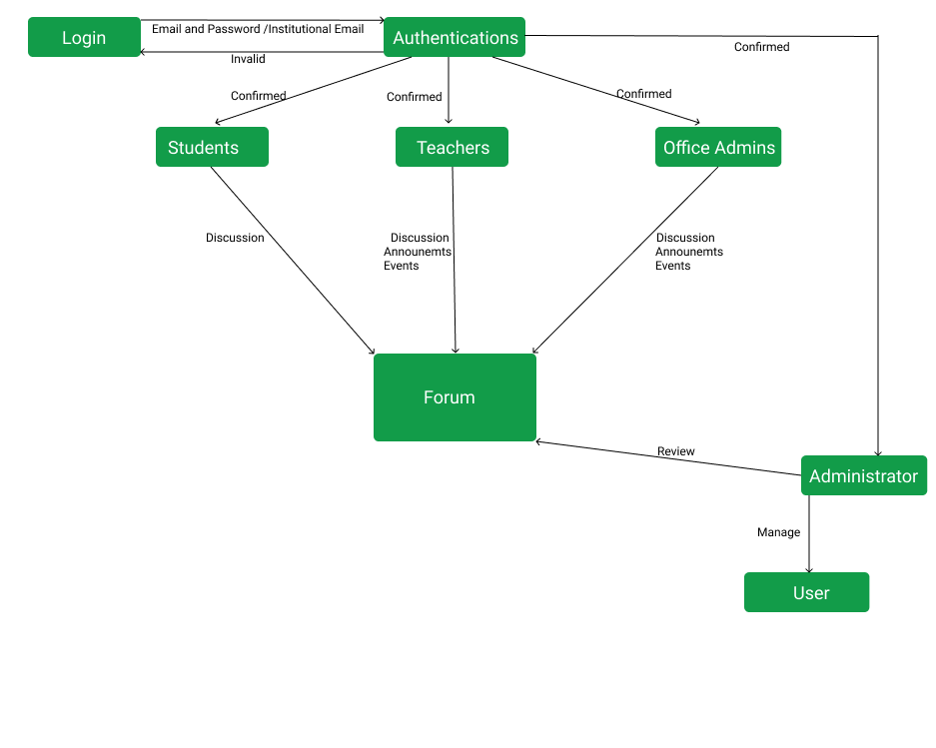Data Flow Diagram**

Figure 5. Data Flow Diagram of the System

Figure 5. Shows how the system will be used by the end-users.

### Entity Relationship Diagram

### 

Figure 6. Entity-Relationship Diagram

Figure 6. Shows the Entity-Relationship Diagram of the Internet-Based Discussion Forum for Sultan Kudarat State University using Progressive Web App Technology.

### Database Structure

Figure 7. Database Structure used in the System

Figure 7. shows the database structure used in the Internet-Based Discussion Forum for Sultan Kudarat State University using Progressive Web App Technology.