**Chapter I**

**Introduction**

**Background of the study**

The introduction of computer-mediated communications has brought about new forms of asynchronous discussion, which makes up a significant and very important component in distant interaction. The internet and computer networks have given a platform for online communication and interaction amongst people. Over the years, many other types of discussion groups have emerged; these are spaces where people may write their thoughts, read messages, share news, communicate each other, and other types of information.

Many schools are adopting online communication and discussions, which is an effective way during this time, and one of these is Sultan Kudarat State University, which uses social media pages, specifically Facebook, to post announcements, events, or topics of interest where students can respond through comments, which leads to a discussion with other students and teachers. However, consistency is sometimes difficult in this space. Interaction with others can be unmanageable because so many pages associated with the school are created to deliver a piece of information to the students. If a student wanted to share information with other students or professors, they could only do so by posting it on social media sites in the hopes that others would see it. Nowadays, Physical interaction of teachers, students, and other staff in school will no longer be allowed and online communication will play a significant role. Although we have these social media sites that specialize in user interaction, none of this provides a space like a school environment where students and teachers can have interaction with a discussion about certain topics and school matters.

With this, the proponents propose a Internet-Based Discussion Forum for Sultan Kudarat State University using Progressive Web App Technology will bring people together with shared interests and mindsets. The use of an online discussion forum system has grown in popularity as a useful tool for engaging students outside of the classroom. The system is an online student-centered space platform that allows students to create discussion posts, add comments to discussion threads, interact with and get feedback from other students and instructors, and accordingly create a deeper understanding of the subject matter being discussed. The system allows the web application to be installed on both iOS and Android devices, as well as desktop computers, and to be accessed with a single tap. Because it uses Progressive Web Application technology (PWA). The system’s push notifications functionality is one of its benefits, allowing users to receive timely updates. As a result, no user will miss any important forum announcements or discussions.

**General Objectives**

Generally, this study aimed to design, develop and evaluate the study entitled “Internet-Based Discussion Forum for Sultan Kudarat State University using Progressive Web App Technology”.

**Specific Objectives**

1. Allow users to access the app using web browsers or through installation on any of the given platforms.

1.1 Desktop

1.2 Android

1.3 IOS

1. Provide a student module to perform the following :
   1. Manage account
   2. Create, update and delete a post
   3. Attach files to a discussion post
   4. Filter the publicity of the post
   5. Comment to a discussion post
   6. Report a post
2. Provide a teacher module to perform the following:
   1. Manage account
   2. Create, update and delete a post
   3. Attach files to a discussion post
   4. Filter the publicity of the post
   5. Comment to a discussion post
   6. Report a post
   7. Create, update and delete announcements and events
3. Provide an office administrator module to perform the following:
   1. Manage account
   2. Create, update and delete announcements and events
   3. Attach files to a discussion post
   4. Create, update and delete a discussion post
   5. Comment to a discussion post
   6. Filter the publicity of the post
4. Provide a system administrator module to perform the following:
   1. Manage account
   2. Create, update and delete announcements and events
   3. Manage users
   4. Manage discussion
   5. Allowed to review discussion post that has been reported
5. Allows the user to receive live notification for new discussion posts, new announcements, new events.
6. Generate reports such as :

7.1 Number of posts per campus

7.2 Number of posts per day and months

1. Evaluate the system in terms of :

8.1 Functionality

8.2 Acceptability

8.3 Accessibility

**Significance of the Study**

The following is the significance of the study.

**Office administrators** – They will be able to create announcements and events regarding their office transactions and will be delivered to the students easily.

**Teachers** – The teachers will be able to send information and announcements to students in a much easy way.

**Students** – The system will be the main source of information coming from the different departments and teachers of all campuses of SKSU. It will be a huge help for the students to be updated all the time. The system will help the students to boost their confidence in socializing with others, sharing their thoughts, and start a discussion forum.

**Future researchers** – This capstone project will be a test and a challenge for the researchers, as they will be putting their programming, system analysis and design, database administration, web development, and mobile development skills to the test.

**Scope and Limitation**

**Scope**

This research is limited to Sultan Kudarat State University campuses. This study is intended for the development of an Internet-Based Discussion Forum for Sultan Kudarat State University using Progressive Web App Technology. All office admins, students, and teachers are covered by the system. It covers the most recent evolution of the forum, which is the online approach rather than the traditional face-to-face method. It also describes the web application's key features as well as the users. On the office administrators module, they can manage accounts, manage announcements and events, manage a discussion post, attach a file to the discussion, comment to the discussion post and filter the publicity of the post. On the system administrator's module side they can review a reported post, manage users, manage discussions, and manage announcements and events. On the teacher’s module, they can report a post, comment, and attach a file to the discussion, filter the publicity of the post, as well the management of accounts, post, announcements, and events. On the student’s module, they can only manage accounts, manage a discussion post, report, comment and filter the publicity of the post, and attach a file to the post. The management of announcements and events is not part of the student module.

The system will also generate reports such as the number of posts per campus, number of posts per day, and months and allows the user to receive live notifications for new announcements, events, and discussion posts.

**Limitations**

The limitations of the system and functions that are not done online is Live conferencing, private chatting, account registration, and office inquiries.

**Operational Definition of Terms**

**PWA** – “A Progressive Web Application (PWA) is a website that provides all of the features of an app. PWAs allow you to create a version of your website or e-commerce business that is faster, more dependable, and more engaging. PWAs can perform almost everything that native apps can, including working offline, accessing your camera and microphone, and using GPS”.

**Forum** – “a place, meeting, or means for exchanging thoughts and viewpoints on a specific topic”.

**System** – “A complete installation that includes peripherals such as a hard disk drive, monitor, and printer, all of which are designed to work together. Online It is activated and ready for operation, capable of communicating with or being controlled by a computer”.

**Internet** – “It is a networked system that uses the TCP/IP protocol to connect computers all over the world”.

**Asynchronous discussion** – “Asynchronous discussion allows students to read and respond “out-of-time.” Given the latitude participants have in their reaction time, this type of online conversation, as seen in a college literacy course, produces a text of dialogue that has the potential to be reflective”.

**Discussion** – “Talking or writing about anything, especially to solve a problem or answer a question”.

**Mediated communication** – “is a term that describes communication that takes place through the use of information and communication technology, as opposed to face-to-face contact.”.

**Technology** – “Technology is the application of scientific knowledge to the practical goals of human life, or, as it is sometimes called, the manipulation and transformation of the human environment”.

**Chapter II**

**REVIEW OF RELATED LITERATURE**

Technologies have played a significant role in the education field in the last decade.

Traditional learning is encouraged through online discussion forums, which promote self-evaluation, knowledge development, and reflection. Because of their potential benefits, online discussion forums are becoming more widely accepted as tools for online learning. "Online chats may benefit students' critical thinking and problem-solving abilities, decision-making capacity, and writing communication skills, as well as their ability to organize and evaluate information. (Zalpaska, Falnegin, & Rudd, 2004)

Forums are online discussion places where you can read messages and create a post from other users who share your interests, typically in the form of an organized thread layout. Many websites today create communities around their sites by providing discussion forums where users can post messages, respond to and discuss specific topics, or simply introduce themselves to other forum members. These online communication spaces are commonly referred to as online forums, discussion forums, or simply forums. The forum is a community-created application that "holds" discussions and user-generated content. Most forums will have moderators, also known as mods for short, who have the ability to remove unrelated posts, rude comments, spam messages, and even unruly users themselves. They have the ability to close threads and generally ensure that the forum runs smoothly for all participants. (Beal, 2008)

The concept of Web-based discussion forums arose from Usenet newsgroups. Usenet was created in 1979 as a bulletin board system and was supported by UNIX machines. As technology improved, discussion forums were designed to run on the Web rather than on a UNIX-based system. Discussion forums, like newsgroups, were similar to Internet chat. Web surfers could communicate online using both discussion forums and chat technologies. Discussion forums, on the other hand, used asynchronous communication, which differed from chat in that it allowed users to post and respond to messages from any computer at any time, as opposed to requiring all chatters to be logged on at the same time. (Cashel, 2001)

Blending an internet discussion platform with a case study approach, which is a conventional teaching and learning methodology used in several business schools, is considered to be an effective method for getting students to interact theories into practice. As an outcome, several academics have begun to teach using the case method through online discussion forums. While the learning goals of online and face-to-face case conversations are similar, there has been little research on the teaching methods and evaluation of the online case study approach in business and accounting education.(Rollag, 2010)

The advantages of using discussion boards forums and peer-to-peer learning to improve student learning are well understood. Aside from fully online courses, their use in traditional learning environments to supplement face-to-face instruction is growing and has now become a common educational strategy in higher education. The use of online discussion forums as a performance indicator for students is becoming more popular. Online discussion forums are designed to stimulate flexible and self-directed learning and knowledge construction, as well as the development of critical thinking skills. However, there are some issues, such as learners' lack of focus and insufficient reflection, students' failure to respond to the ideas of others, and surface-level discussions. Despite the many benefits of its use, research into students' use of online discussion forums in the context of their studies, as well as the characteristics of an effective online discussion area that facilitate effective learning, is needed. (Seethamraju & Hwang, 2014)

The effect of these hybrid learning methods, which combine traditional classroom case study technique with asynchronous media like online discussion forums, on academic results and processes, however, is unknown. With the new widespread adoption of course management systems (CMS) and learning management systems (LMS) by academic institutions, more research is needed to provide insights into the field's current and future developments. (M. Loncar, N. E. Barrett, & Liu, 2014)

There are two potential advantages to using your discussion board as a forum for a debate. It sets the stage for a lively and engaging discussion. It also allows you, the instructor, to guide students in how to respectfully and intelligently engage in a debate, a skill that appears to be dwindling in today's political and societal environment. When using a discussion board as a debate forum, you can assign students to debate from a specific viewpoint or allow them to debate from their own. In either case, having a rubric or guidelines in place to guide students toward respectful, well-developed responses is beneficial. You or a student assigned to you will most likely serve as moderator. (Castaneda & Rentz, 2020)

Learners in collaborative group discussions learn to listen carefully to one another and value the efforts of shared knowledge and input. Online discussion technology also assists learners in responding to questions, participating in discussions, and providing peer feedback to support the sharing of new information. Learners who actively engage in accountable and responsible conversation make up successful discussion groups. Accountable conversation among students emphasizes logical connections and allows students to draw reasonable conclusions from new information. Learning through collaborative online discussion groups is the most direct and reciprocal way for instructors to assess web - based learning. (Higley, 2018)

The question of the educational motive and its impact is raised when information technology alone does not contribute to student success. We recognized content knowledge, writing skills, organization and structure, and cooperative learning as good educational outcomes in the context of discussion boards. Setting these objectives prior to the learning process, according to SLT, ensures that they manifest in the cognitive model. Furthermore, meeting these objectives should be incentivized with grades to ensure adequate motivation within the educational setting. According to Chen, Lambert, and Guidry (2010), student engagement is extremely important for learning with web-based technologies. To that end, system use resulted in greater engagement, which resulted in more desirable learning outcomes, such as the use of higher-order thinking, reflective learning, and integrative learning in their studies. As an outcome, it appears that an individual's attitude toward group work, as well as participation in related teamwork, affects motivation for the two - way interaction required for the intellectual process of learning.(Delaney, Kummer, & Singh, 2018)

Regardless of discipline, instructors aim to engage students and develop critical thinking skills in general education classes. According to a recent study of the benefits of online discussion (also known as computer-mediated communication), it promotes active learning and increases student performance. According to researchers, when teachers use excellent questioning and moderating skills in online discussions, students demonstrate higher levels of critical thinking. "Critical thinking spillovers," according to Stephenn DeLoach and Steven Greenlaw (2005), are absent from conventional class discussion and writing schoolwork. According to the researchers, students' arguments tend to improve in response to the quality of comments they receive from their classmates. Correspondingly, researchers found that the students who began classes with lower grade-point averages improved their grades after reading notes written by other students and the instructor. (Williams & Lahman, 2011)

The core issue in asynchronous discussion forums is a lack of participation by most learners and the dominance of a bunch of students. Because assessment is the currency that students deal in, grading can be a viable technique for encouraging participation. Given that today's students have extensive online and social media experience, prior internet experience may no longer be a concern. As a result, rating students based on their contributions can be used to encourage participation and learning. As a result, students' engagement may be limited to some extent; however, grading may inspire students to participate in the conversation with thought and preparation. Students may be afraid of revealing their lack of knowledge, which could be used against them if they reveal too much. To avoid unintentionally decreasing learning motivation, an effective learning environment and assessment must be carefully planned. (Harlen & Deakin-Crick, 2003)

Comtella Discussions (Comtella-D) is an online community for discussing the social, ethical, legal, and managerial issues associated with information technology and biotechnology. Moreover, it represents a mechanism for motivating participation in interest-based online communities, which engages non-contributing members by modelling and visualizing the asymmetrical relations formed when reading, evaluating, or commenting other community member's contributions. Indeed, it was used to support the coursework related to a 4th year undergraduate class on Ethics and IT taught in the spring of 2006 at the University of Saskatchewan. Access to content is restricted to registered members. Members are relatively anonymous because they are identified just by their alias. The purpose of using Comtella-D in the class was sharing and discussing information (Internet publications, popular magazine, paper, respectively) related to the course topics. The students had to share at least one link to an online paper related to the weekly topic and summarize the paper in a way that it stimulates discussion. As a part of their coursework, the students also had to reply/discuss two of their colleagues' postings each week. In parallel with the students of the Ethics and IT class, (4th year Computer Science students), the Comtella-D system was used in a class on Ethics and Technology offered by the Philosophy department. These students used the system only as an additional resource, recommended by the instructor. The system was not related to their coursework, and it was used entirely voluntary. (Abel, et al., 2010)

**Conceptual framework**

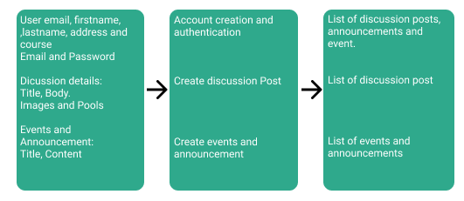

Figure 1. **Conceptual Framework of the study**

The conceptual framework of the study is shown in figure 1. As illustrated, we can now easily figure out the process of the system.

**Chapter III**

**Methodology**

System Methodology entails segmenting software development work into distinct stages and devising tasks or activities to improve planning and time management. It is regarded as a minor aspect of the systems development process.

**Project Development Description**

**Tools and equipment**

The table below is the tools and equipment to be used in the study.

**Tools and Equipment Used in the Study**

**Table 1. Hardware**

|  |  |
| --- | --- |
| **Description** | **Specification** |
| PC   * RAM(memory) * Processor * ROM (Storage) | * 8GB * Intel core i5 * 512GB (SSD) |
| Network Peripherals Needed   * Fiber | * PLDT 100Mbps |

Table 1. Showed the tabular representation of the hardware materials used in the project development.

**Table 2. Software**

|  |  |
| --- | --- |
| **Description** | **Specification** |
| IDE | Visual Studio Code |
| Dependency Manager | Composer, Node JS |

Table 2. Showed the tabular representation of the Software materials used in the project development.

**Table 3. Bill of Supplies and Materials**

|  |  |  |  |  |
| --- | --- | --- | --- | --- |
| Item No. | Qty | Unit | Item Description | Estimated Price |
|  | Hardware Cost | | |
| 1 | 1 | Unit | Specifications:   * Processor - Intel Core i5 * RAM - 8GB * SSD- 512GB | 49,999.00 |
|  | Software Cost | | |
| 2 | 1 | Pkg | Windows 10 Operating System (Licensed) | 4,000.00 |
| 3 | 1 | Lot | Web hosting | 65,000.00 |
| 4 | 1 | Service | Pusher | 2,450 * 12 = 29,400 |
|  | Manpower cost | | |
| 4 | 1 | Person | System analyst | 10,000 * 12 = 120,000.00 |
| 5 | 1 | Person | Programmer | 9,500 * 12 = 1140,000.00 |
|  | Maintenance and Other Operating Expenses | | |  |
| 6 | 3 | Person | Project Deployment and Maintenance | 15,000 * 12 = 180,000.00 |

Table 3. shows the bills of supplies and materials used in building Internet-Based Discussion Forum

### Project Duration

**Figure 2. Project Duration**

Figure 2. Shows the development time frame in processing the Internet-Based Discussion Forum

## 

## **Software Development Methodology**

## 

Requirements collection

Feasibility of study

Design

Coding

Testing

Installation

Maintenance

**Figure 3. System Development Life Cycle**

The Waterfall method is one of the most widely used models in software engineering, and it was the first SDLC model being used. The strategy employed was to treat the entire modelling software process in sequential order, with the previous step's outcome or output serving as the input for another step. This would allow software developers to divide these steps into distinct stages, each with its own set of requirements and activities. The following illustration depicts the stages located in the Waterfall Model.

**Context Diagram** 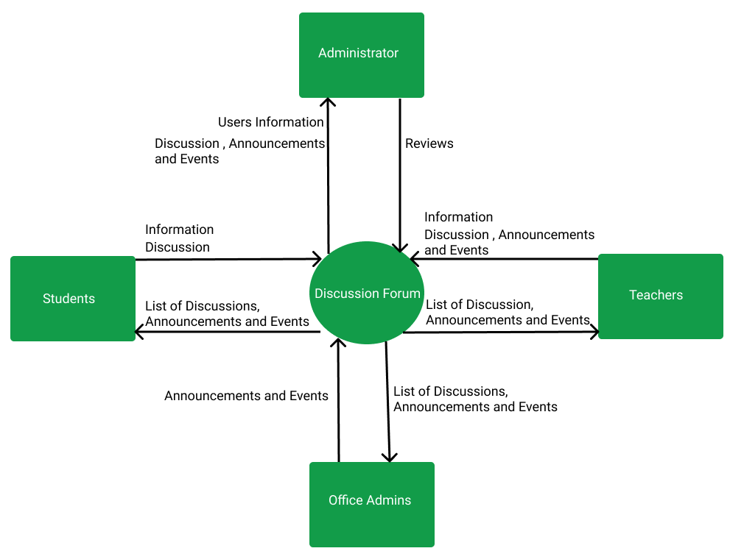

**Figure 4. Context Diagram of the System**

Figure 4. Displays the system's context diagram. Students will only be able to log in if they have an institutional account, which will be provided by the teacher and is optional for the office administrator. Users can see all of the discussions, announcements, and events. Discussions can be created by students, teachers, and office administrators, but only teachers and office administrators can create announcements and events. Users, discussions, announcements, and events can all be managed by the system administrator.**Data Flow Diagram** 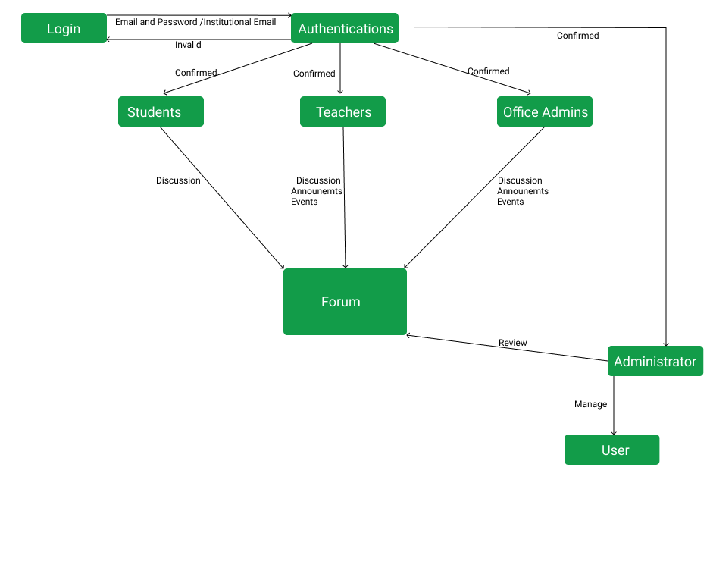

**Figure 5. Data Flow Diagram of the System**

Figure 5. This diagram depicts how end users will interact with the system.

### Entity Relationship Diagram

### 

**Figure 6. Entity-Relationship Diagram**

Figure 6. Shows the Entity-Relationship Diagram of the Internet-Based Discussion Forum for Sultan Kudarat State University using Progressive Web App Technology.

### Database Structure

**Figure 7. Database Structure used in the System**

Figure 7. Shows the database structure used in the Internet-Based Discussion Forum for Sultan Kudarat State University using Progressive Web App Technology.

Use the "Insert Citation" button to add citations to this document