***Sprint 1 (Allow users to access the app using web browsers or through installation on Desktop, Android, and iOS)***

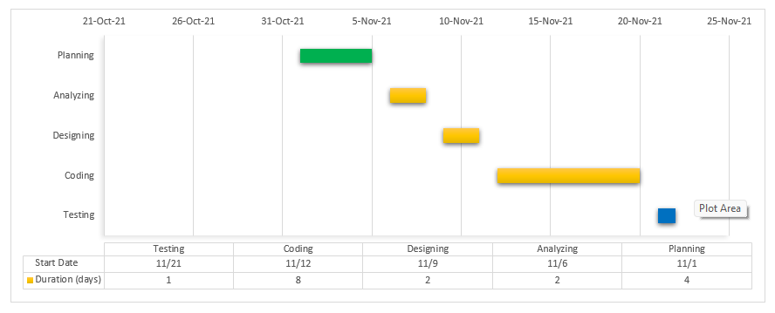

***Sprint 2 (Provide a student module)***

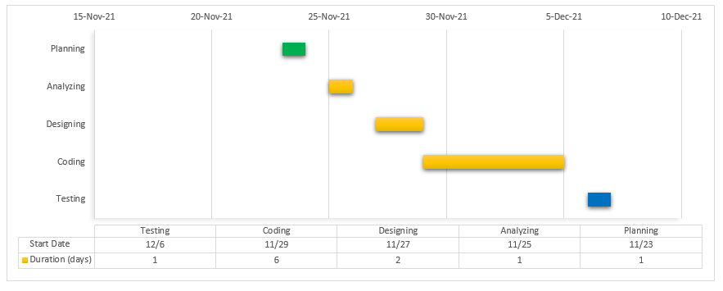

***Sprint 3 (Provide a teacher module)***

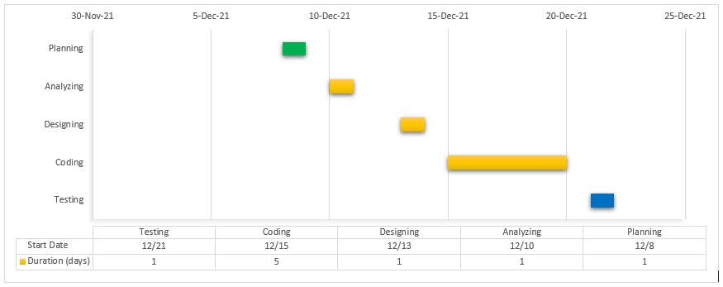

***Sprint 4 (Provide an office administrator module)***

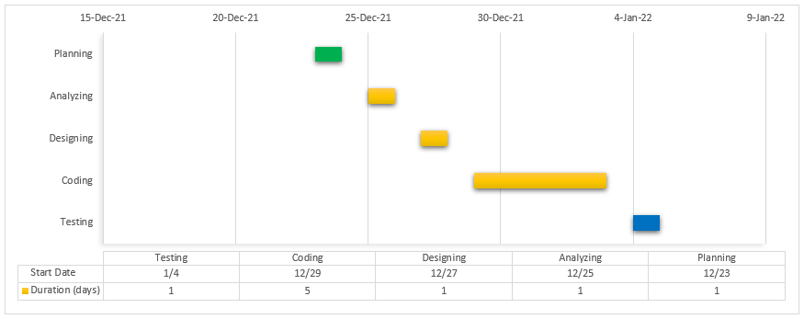

***Sprint 5 (Provide system administrator module)***

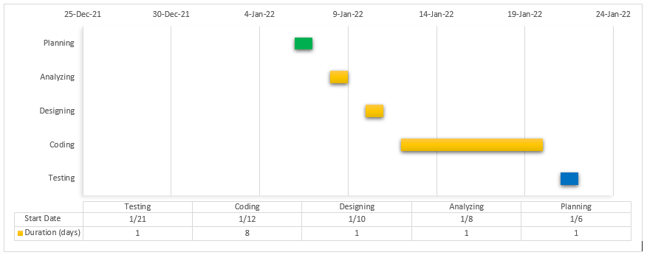

***Sprint 6******(Allows the user to receive live notifications for new announcements, new events)***

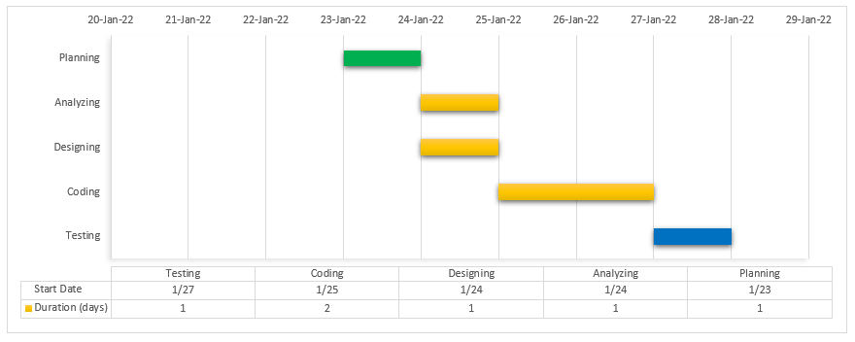

**Figure 2**. Gantt Chart of the study

Figure 2 shows the timeline, tasks, and duration of the project and the expected completion date.