## **Software Development Methodology**

Agile Software Development Methodology was developed to ensure the satisfaction of the requirements for the development of a discussion forum. It was a methodology construction to make sure that the requirements, planning, development and implementation, testing of the system follow a logical approach and technical ways.

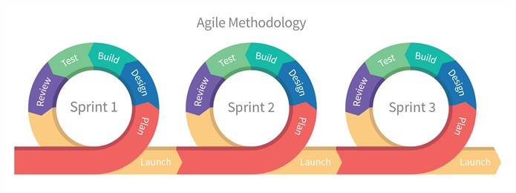

**Figure 3. Agile Software Development Methodology**

The researcher started by determining and examining the problem in the existing online platform that is open for discussion that can be used by the students. They found out that providing features that focus on the school interaction process is important in building a student-centered space discussion forum. The researchers created a project title, formulated project objectives, scope, and project schedules of the project.

The researchers also identify the probable problems that will arise in the development of the study entitled Internet-Based Discussion Forum for Sultan Kudarat State University using Progressive Web App Technology.

***Sprint 1 (Allow users to access the app using web browsers or through installation on Desktop, Android, and iOS)***

In allowing users to access the app using browsers or through installation, aside from accessing the app using browsers, the app can also be installed on the desktop, android, and iOS. The researcher designed and built the app to be capable of installation and run to their devices like a native app.

The researchers further came up with the design output of the study using the Progressive Web App feature of google chrome browser that makes web application installable in any platform using JavaScript programming language and configuration file (manifest.json) on how the app will behave in every variety of the devices.

The researchers performed testing on every platform to ensure that the app can be installed as the researcher expected it to be. They examined the process functionality, acceptability, and accuracy to determine if it truly fits the application requirements. The researchers put the app through its paces and performed training sessions with students.

***Sprint 2 (Provide a student module)***

In providing a student module, the student can create a post and be able to attach a file on it and view announcements and events. The researchers design the app with prototypes for every action that the user may take.

The researchers consider the performance of the app in the long run so they came up with the idea of using Google Drive as a file system for the app through Google Drive API. Google Drive API allows the app to store all assets and files in google drive instead of saving them on the server.

The researchers performed testing from both the application side and Google Drive side to see if there is any issue in storing the file. They ensure that there are no bugs or errors in the process and any legal issues such as the Same-Origin Policy from every HTTP request to Google Drive. They examined the process functionality, acceptability, and accuracy to determine if it truly fits the application requirements. The researchers put the app through its paces and performed training sessions with students.

***Sprint 3* *(Provide a teacher module)***

In providing a teacher module, the teacher can create a post and be able to attach a file on it, and view announcements and events. The teacher can also create their announcements and events. The researchers design the app with prototypes for every action that the user may take.

The researchers consider the performance of the app in the long run so they came up with the idea of using Google Drive as a file system for the app through Google Drive API. Google Drive API allows the app to store all assets and files in google drive instead of saving them on the server.

The researchers performed testing from both the application side and Google Drive side to see if there is any issue in storing the file. They ensure that there are no bugs or errors in the process and any legal issues such as the Same-Origin Policy from every HTTP request to Google Drive. They examined the process functionality, acceptability, and accuracy to determine if it truly fits the application requirements. The researchers put the app through its paces and performed training sessions with students.

***Sprint 4* *(Provide an office administrator module)***

In providing an office administrator module, the office administrator can create a post and be able to attach a file on it, and view announcements and events. The office administrator can also create their announcements and events. The researchers design the app with prototypes for every action that the user may take.

The researchers consider the performance of the app in the long run so they came up with the idea of using Google Drive as a file system for the app through Google Drive API. Google Drive API allows the app to store all assets and files in google drive instead of saving them on the server.

The researchers performed testing from both the application side and Google Drive side to see if there is any issue in storing the file. They ensure that there are no bugs or errors in the process and any legal issues such as the Same-Origin Policy from every HTTP request to Google Drive. They examined the process functionality, acceptability, and accuracy to determine if it truly fits the application requirements. The researchers put the app through its paces and performed training sessions with students.

***Sprint 5 (Provide a system administrator module)***

In providing a system administrator module, the system administrator may review all reported posts by the user. The researcher understands and anticipates there might be some posts the will contain inappropriate content. They planned and design the app that the system administrator can delete a post that is reported.

The researcher creates a report option for every post for the users so the system administrator can review it and delete it if necessary. This process is possible by sending database queries to update the status of the post to “reported”. The researcher follows the analyzed data and prototypes they created to execute this process without compromising the freedom of speech of the users.

The researcher performed a series of tests to examine for functionality, acceptability, and accuracy to determine if it truly fits the application requirements. The researchers put the app through its paces and performed training sessions with students.

***Sprint 6*** ***(Allows the user to receive live notifications for new announcements, new events.)***

Inallowing the user to receive live notifications for new announcements, new events. The researcher planned to use web sockets service, and create prototypes to gain an image of what they wanted to create.

The researcher built the application with Pusher to enable live transmitting of data for every user to allow live notifications. Laravel has a feature called Laravel Echo that will allow the app to send and listen to an event from the pusher that will trigger data fetching from the database.

The researcher performed a series of testing to examine for functionality, acceptability, and accuracy to determine if it truly fits the application requirements. The researchers put the app through its paces and performed training sessions with students.