Regular Lattice. Hexagonal Symmetry

Each one with 6 neighbors.

Connected by vectors $c_{i}≡c_{ia}, i=1,2,3,4,5,6 a=1,2 \left(spatial dimentions \left(x,y\right)\right)$

$$c_{i}=c_{i1}+c_{i2}=c_{ix}+c_{iy}=c_{i}\hat{x}+c_{i}\hat{y}$$

Each lattice site can have up to 6 particles.

Each particle has mass $m=1$.

Each particle can move only along one of the 6 directions

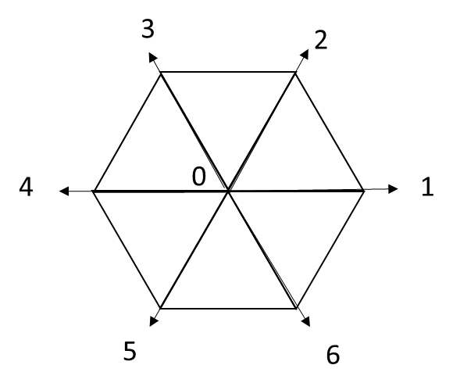

Each time cycle $\left(Δt=1\right)$ the particles hop to the nearest neighbor ONLY via a discreet vector ***cia***. Longer jumps can’t happen, which means the particles have the same energy. No 2 particles can move along the same vector (exclusion principle).

How do I determine which particle goes where? (Guess: particle 1 goes down1, etc. If particle 1 is 0, it doesn’t go. Maybe?)

Use a single digit integer per site (short) for number of particles. No. Now they say 6 bits. Makes more sense.

No need to store direction. That is indicated by the particles *i* index.

Occupation number is $n_{i}\left(x,t\right)=0, 1$. I guess there are 6 of these per site.? Yes. Makes sense. ***x*** is the site. *i* is both the index of the particle and the direction it’s about to go. So

This will produce 6N occupation numbers (where N is the number of lattice sites).

This creates a “Boolean Field” which is just the collection of the 6N Booleans indicating the presence of a particle in a slot at a site, the slot dictating where it will move at the next time step.

The *a* parameter could be the *x, y* coordinate of the location of the cell. Maybe. Might not be right.

Looks like both. X is the x,y position, and i=1,2 is the direction of the speed of the particle.

Evolution

Free-streaming—particle transfers from site to site according to discrete speeds *cia*.

I.E. The *ith* occupation number at location ***x*** + ***cia*** at a subsequent time step is the same as the occupation number at location x at the time before it. Therefore

$$Δ_{i}n_{i}=n_{i}\left(x+c_{ia},t+1\right)-n_{i}\left(x,t\right)$$

Transcript of Boltzmann free-streaming operator. $D_{t}≡∂_{t}+v_{a}∂_{a}$

The change in the *ith* occupation number is the *ith* occupation number at ***x*** + ***cia*** at a subsequent time step minus the *ith* occupation number at ***x*** at the current time.

Collisions

When at a site, the particles interact and re-shuffle their momenta along with conservation of energy and momenta. Since the speeds all have the same magnitude (c=1) and mass (m=1) they all have the same energy.

Conserve particle number

Conserve total momentum

Collision operator: Change from $n_{i} to n_{i}^{'}$

$$n_{i}^{'}-n_{i}≡C_{i}\left(\underline{n}\right), \underline{n}≡\left[n_{1},n_{2},n_{3},n_{4},n_{5},n_{6}\right\rangle$$

Phase space can be depicted by

$$\underline{s}=\left[s_{1},s_{2},s_{3},s_{4},s_{5},s_{6}\right\rangle e.g. \underline{s}=\left[100100\right\rangle and \underline{s'}=\left[010010\right\rangle$$

Doing it that way, we can define a transition matrix, where each element identifies an allowed collision (1) and disallowed collision (2).

Unfortunately, a single input into the transformation can have more than one output (2 in this case). So we define a probability. We will say equal probability.

$$P\left(\underline{s},\underline{n}\right)=\prod_{i=1}^{b}{n_{i}^{s_{i}}{\overline{n}}_{i}^{{\overline{s}}_{i}}}=\prod_{i=1}^{b}{n_{i}^{s_{i}}{\left(1-n_{i}\right)}^{\left(1-s_{i}\right)}}$$

E.G

$$P\left(\underline{s},\underline{n}\right)=n_{1}^{s_{1}}{\left(1-n_{1}\right)}^{1-s_{1}}n_{2}^{s_{2}}{\left(1-n_{2}\right)}^{1-s_{2}}…n_{6}^{s_{6}}{\left(1-n_{6}\right)}^{1-s_{6}}$$

For instance

$$P\left(|100100⟩,|100100⟩\right)=1^{1}{\left(1-1\right)}^{1-1}0^{0}{\left(1-0\right)}^{1-0}…1^{1}{\left(1-1\right)}^{1-1}…{\left(1-0\right)}^{1-0}$$

$$P\left(\left|100100\right\rangle ,\left|100100\right\rangle \right)=\left(1^{1}0^{0}\right)\left(0^{0}1^{1}\right)\left(0^{0}1^{1}\right)\left(1^{1}0^{0}\right)\left(0^{0}1^{1}\right)\left(0^{0}1^{1}\right)$$

$$P\left(\left|100100\right\rangle ,\left|100100\right\rangle \right)=\left(1\right)\left(1\right)\left(1\right)\left(1\right)\left(1\right)\left(1\right)=1$$

Here’s the matrix

$$A\left(\underline{s},{\underline{s}}^{'}\right)=1 \left(allowed\right), 0 (forbidden)$$

$$A=\left[\begin{matrix} & s_{1}^{'} & s_{2}^{'} & s_{3}^{'} & s_{4}^{'} & s_{5}^{'} & s_{6}^{'} \\ s_{1} & 0 & 0 & 0 & 1 & 0 & 0 \\ s_{2} & 0 & 0 & 0 & 0 & 1 & 0 \\ s_{3} & 0 & 0 & 0 & 0 & 0 & 1 \\ s_{4} & 1 & 0 & 0 & 0 & 0 & 0 \\ s_{5} & 0 & 1 & 0 & 0 & 0 & 0 \\ s_{6} & 0 & 0 & 1 & 0 & 0 & 0\end{matrix}\right]$$

$$\left[\begin{matrix}0 & 0 & 0 & 0 & 0 & 0 \\ 1 & 0 & 0 & 0 & 0 & 0 \\ 0 & 0 & 0 & 0 & 0 & 0 \\ 0 & 0 & 0 & 1 & 0 & 0 \\ 0 & 0 & 0 & 0 & 0 & 0 \\ 0 & 0 & 0 & 0 & 0 & 0\end{matrix}\right]\left[\begin{matrix}1 \\ 0 \\ 0 \\ 1 \\ 0 \\ 0\end{matrix}\right]=\left[\begin{matrix}0 \\ 1 \\ 0 \\ 0 \\ 1 \\ 0\end{matrix}\right]$$