Project Charter

# Project Name

Earth System Models from Flux Tower Data

Prepared by:

The Skyentists

# Date:

9/19/19

# Project Description & Problem

## 1.1 Background

This project involves creating a new calibration process for a climate change model that deals with different plant types and soil moisture. The model gets its test data from eddy flux towers located across the globe, as well as other scientific data. This improved calibration process will allow the user to tweak the model’s inputs and graph outputs to more accurately reflect the tower data. The sponsor of this project is the Numerical Terradynamic Simulation Group (NTSG), a group that researches tech development in certain Earth satellite data. The sponsor’s mission statement is "our primary mission is to develop capabilities to quantitatively describe the structure and function of ecosystems from regional to global scales using emerging technologies in satellite remote sensing, computational modeling and biophysical theory."

## 1.2 Problem

This project will solve a problem dealing with the current calibration process of this model data, as the current method does not allow for a visual comparison of the model output to the real-life data. In addition to solving this problem, the software will allow the user to edit the parameters of the model during this visualization. The improved calibration will help further the ecological understanding of climate change effects on plants and soil moisture. A challenge of creating the software will be fully understanding the entire workflow, as it requires understanding of complex ecological and meteorological concepts. NTSG, the sponsor’s organization, will benefit by streamlining the workflow and having an easily changeable code-base to improve model calibration for others to learn and continue to grow.

## 1.3 Desired Impact

With a cleaner calibration process of the climate change model, more accurate datasets will be created to make research with this data more reliable to accurately reflect real-life data. On a local scale, this new process will allow Arthur and other employees at NTSG to improve their workflow by being able to visually compare the model output to real life data. The impact that this improved calibration process will provide has the potential to be far-reaching on a global scale, such as the potential to allow scientists to better predict the effects of climate change on soil moisture and plant life. The understanding that this program will help provide will allow ecologists to be better prepared to face the consequences of climate change in the future.

# Stakeholders

|  |  |
| --- | --- |
| ***STAKEHOLDER*** | ***Need/Problem Solved by Project*** |
| *The Client* | *The client is the main individual, or primary stakeholder, that will be using this software. Currently, the client uses the previously described calibration process at NTSG. The project will improve the job experience by being able to visually compare the model output to actual data and edit the model parameters.* |
| *NTSG Employees* | *NTSG employees, the secondary stakeholders or potential primary stakeholders, will indirectly and directly use this software. The program will improve user experience, by providing a GUI to perform the calibration process. Employees will also have to view and compare the output of the model to the real-life data, which will be calibrated correctly with help of the program.* |
| *NTSG* | *NTSG will benefit from this program, because the new calibration process will improve the workflow by improving model data by packaging and improving the outputs. This company is a NASA-funded company so the data will be used by other NASA-funded companies and researchers.* |
| *Other Scientists* | *Other scientists will be dealing with the output of the model. This data can be used by more complicated models that scientists develop. This will further improve the understanding of climate change on soil moisture and plant life which will allow for the prediction of ecological effects.* |
| *Professor Reimer* | *Professor Reimer will be the grader of the project and not a user. She provides the structure of the entire program and overall guidance for our team. She will see an improvement in the knowledge of the team in both computer science and ecology areas.* |
| *Team members* | *We, as a team, will further the ability to problem solve by creating software in an area that we are not accustomed to working in. We will gain more understanding on how to communicate with clients and one another which we help us in our career. Experience in beginning to develop a program from the ground up will be useful in our careers as software developers.* |

# Measurable Organizational Value (MOV)

The Software shall improve the operational functions of NTSG by performing the climate simulations at least 20% faster and with 30% or more less memory than the previous method while having a modular design all by the end of May 2020.

# Project Scope

All work within the scope of the project:

* Read in real-world data on plant growth and change
* Read in a model that simulates plant growth and change
* Show how the model currently predicts plant growth and change
* Update model behavior based on data
* Show the results of changing the model to better match the data
* Output a table of results that are used to run the model after calibration
* Calculate how well the model predicts part of the real-world data that was not used in calibration

All work outside the scope of the project:

* Create new data
* Create new models
* Create new calibration algorithms
* Edit existing MATLAB code to be more functional

# Project Schedule

Include a printout of your TeamGantt chart showing major milestones for the semester.

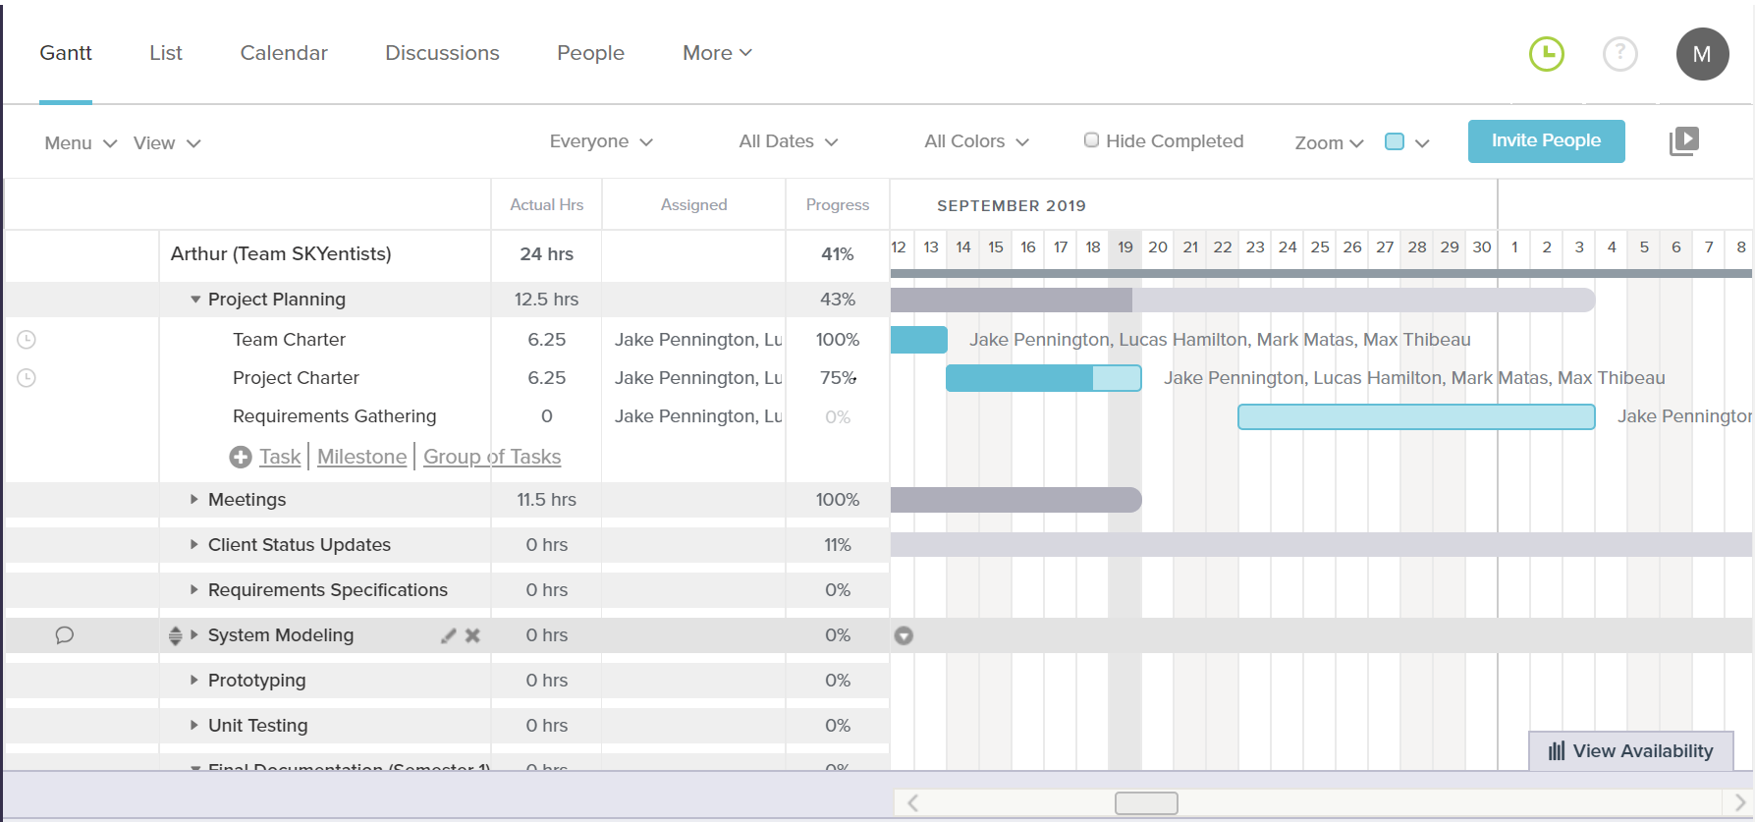

# Resources, Assumptions and Risks

Most of the Resources that will be provided for this project will be provided by Arthur Endsley, which involve a finished version of a requirement/information documents that we will receive soon (we already received a rough draft of it on 9/16/19), matlab code that will be used to compare our future program against (received on 9/18/19), and inputs and data sets for calibration that are already provided on the NTSG website. Other resources (computers with certain specifications, workspace, basic tools) will either be provided personally or by the University of Montana within use by students of the University. More information on additional resources we may need will be more apparent later during the design process.

The Assumptions of the project will include:

That Arthur Endsley will be available for contact so the team may be informed of certain information when requested, discuss concerns in certain aspects of the project that may surface, or for requesting specific resources that cannot be obtained personally or by the University.\

That each team member will be available to work on their portion of the project each week and show up to regularly scheduled meetings, unless in emergency situations or situations discussed before the meetings are taking place.

The risks of the project will include:

The team not finishing the project in time, which would cause either Arthur Endsley to have to continue using his version of the calibration software and the company continuing to go without a clean modular system of software to use for their other projects, or for Arthur to find another team to finish the project in our place, which could result in possible loss of credit on project. Could also be damaging to the reputation of the SKYientists.

Our implementation not being faster and cleaner than what has already been provided, which could result in the same as not finishing the project in time.

Hardware failure which could result in loss of work done on the machine it is happening too and may result in the team member not being able to work on the project as efficiently.

The possible creation of Inaccurate data that could result in the hinderance of scientific progress.

The constrains of the project:

Hardware constraints: The project must be able to run on a Linux or MAC operating system. Should be able to run on Arthur’s computer.

Software constraints: Must use Python 3.xx with only libraries that are non-left and open source, with version control using GIT. Cannot emulate the matlab code we have been provided by Arthur.

Resource constraints: We can only use data that is provided to use by the NTSG website or by Arthur Endsley for the use in our software.

Outstanding issues:

There are currently no outstanding issues as of 09/19/18.

# Acceptance and Approval

Team names, signatures, and dates of approval, including the client.

The Skyentists

Mark Matas



Lucas Hamilton



Jake Pennington

Max Thibeau



Arthur Endsley (Client)