# Team Charter

*“A team charter is a document that is developed in a group setting that clarifies team direction while establishing boundaries. It is developed early during the forming of the team. The charter should be developed in a group session to encourage understanding and buy-in.*

*The team charter has two purposes. First, it serves as a source for the team members to illustrate the focus and direction of the team. Second, it educates others (for example the organizational leaders and other work groups), illustrating the direction of the team.”*

<https://www.lce.com/Team-Charters-What-are-they-and-whats-their-purpose-1219.html>

Prepared by: The Skyentists

Date: 09/06/19

# SKYentists

We are the SKYentists, a driven software development team determined to deliver a quality product.

# Goals

Our goal as a team is to work as a cohesive unit to build a project that we can take pride in. We’ll learn how to take advantage of each other’s strengths and make up for our weaknesses. Our goal is also to ensure that the client feels well-respected and is an integral part of the project. Another goal of our team is to expand our knowledge in areas that we do not fully understand and incorporate this into the project or further in our careers.

# Members

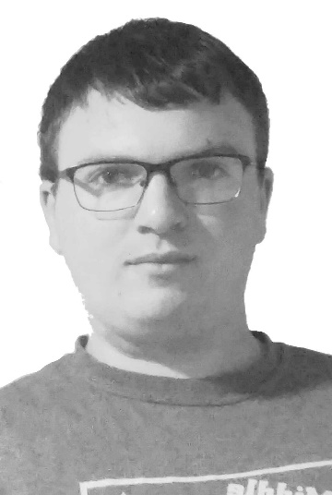Jake Pennington, 1-406-459-5710,

[jake.pennington@umontana.edu](mailto:jake.pennington@umontana.edu#_blank)

Jake grew up in the small town of Elliston, Montana where he enjoyed mathematics and technology. He discovered his passion for programming at the age of 14 and has continued that lifestyle to this very day. Jake attended the University of Montana where he was awarded a B.A. in Mathematics. He is currently a graduate student at UM working on an M.A. in Mathematics while also completing a B.S. in Computer Science. He has worked for Dr. Oliver Serang where he tested and debugged software, optimized parameters, and developed algorithms for bioinformatics.

Jake has a lot of experience in object-oriented programming, but also has a healthy exposure to functional and component-based models. He can do it all, but especially enjoys back-end development, algorithm design, and technical advising. His responsibilities for this project will likely include programming the back-end, ensuring code meets functional and non-functional requirements, providing adequate documentation and testing for the codebase, and ensuring license compatibility will all external libraries.

Max Thibeau, 1-406-214-1680,

[max.thibeau@umontana.edu](mailto:max.thibeau@umontana.edu)

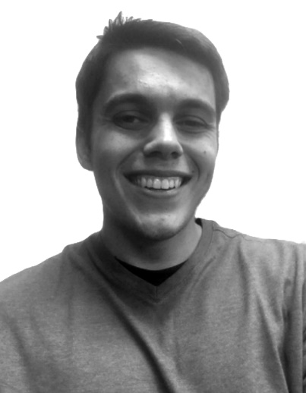

Max Thibeau was born and raised right here in Missoula, Montana. Max always enjoyed solving puzzles, and naturally found programming to be a good outlet for problem solving. Max has gone through most of the CS program and has had some valuable work experience under Dr. Oliver Serang. He’s currently helping the lab develop an expectation maximization algorithm for solving protein inference problems. This is part of an in house Python protein inference library he helped write that’s heavily Object Oriented. The foundation of this library is a programming language Max wrote that generates CPP code for Evergreen Forest, a graphical models solver.

Given this experience, Max is willing to help with anything but will be most interested in being the team architect for the project. Getting a grand scope of the entire process from start to finish and making objects to abstract as much of the process as possible would be his goal. If the interface portion of the process is finished, Max would also be interested in learning the process of satellite calibration with ground truth data to see if there’s some way to automate the process.

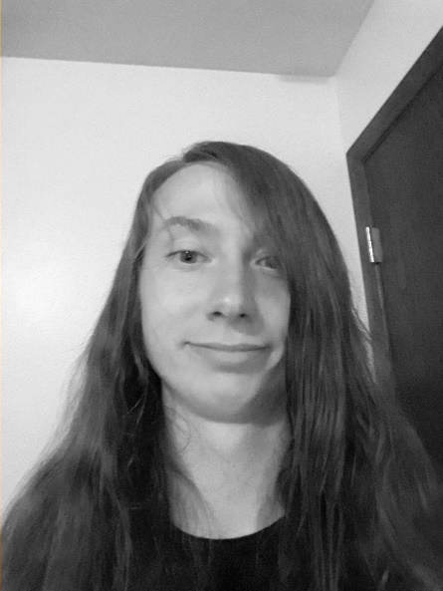Lucas Hamilton, 1-406-290-4426, [lucas1.hamilton@umconnect.umt.edu](mailto:lucas1.hamilton@umconnect.umt.edu)

Lucas Hamilton was originally from Newbury, Massachusetts, where he would later be raised in Reed Point, Montana. Lucas initially developed in interest in Computer Science during high school where he participated in the Code Montana program and really enjoyed the problem-solving portion of the program. Due to this initial spark, Lucas would go on to achieve the majority of his experience through his course work with the University of Montana. The classes Lucas had taken gave him experience in JavaScript, Java, HTML/CSS, Python, C/C++, MySQL, Oracle SQL, and R.

Lucas’s Primary Role would mostly consist of helping with the software development of the project, with a close secondary role as the Data Analyst if needed. Data analyst would be his second role due to his experience in Data Visualization, a course he took at the University of Montana. Lucas will, however, also help with any role that needs to be filled. Lucas will also help fix problems that may occur in other roles. The main goal that Lucas wants to get out of this project would be to learn more about how the development cycle works and to gain experience for the working world.

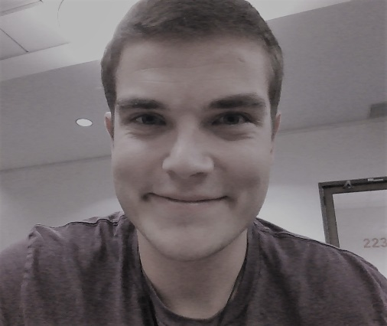Mark Matas, 1-480-318-0106,

[mark.matas@umontana.edu](mailto:mark.matas@umontana.edu)

Mark Matas, both an Illinois and Arizona native, has been around Missoula, Montana for about six years now due to having family in town. Mark has a B.S. in Biology with a minor in Mathematics and currently is in his last year of earning his B.S. in Computer Science. He gained a lot of useful skills in his time at the University of Montana, from not knowing how to program to becoming proficient in software development. Mark has programming experience in Python, C/C++, Java, JavaScript, Ruby/Ruby on Rails, and SQL. He has worked the past two summers as an Implementation Consultant for Fast Enterprises and has been working for Dr. Rob Smith on campus for three years.

Mark has always enjoyed a creative outlet, from hiking up mountains to drawing cartoons to problem-solving during programming and gaming. Mark has been elected the project manager for the SKYentists, so he is willing to do what needs to be done to deliver a working, well-documented program based on client requirements to ensure the upmost satisfaction. He is interested in how the process of satellite calibration works, as well as seeing how his Biology degree will help make informed decisions about the project.

# Values & Ethics

The following of ethics is of upmost importance to the team to have the ability to determine the justifiable decisions and behaviors that affect the team and client interactions. The values will help the team with these decisions by informing the thoughts, words, and actions to guide how the team will act towards each other and in meetings.

* Avoid harm: do not hurt anyone, do not make the client or Yolanda angry
* Open Communication: always be professional, let other members know if you are going to absent/late, members should communicate when progress is made and when they need help
* Shared Responsibility: share the workload evenly, hold one another accountable for an even load, if one member fails then we all fail
* Initiative: take charge and have the want to complete the project
* Punctuality: keep things moving, show up on time when needed, arrive prepared
* Attendance: always show up and communicate when not able to attend

# Rules & Expectations

The following list includes the rules of the team to achieve high quality standards and ensure the completion of the project. Expectations are also included so that the team members and client know what to do and how to perform in order to create successful software.

* Meetings: set up by Mark in Gantt and communicated with the team members, everyone needs to be there unless they communicate to everyone their absence, everyone’s opinion will be heard in meetings, one team member will always be a designated notetaker
* Client: team leader provides weekly status updates to the client while CC’ing other members of the group, always speak and write and act professionally when communicating with the client, value the client’s free time
* Team Decision: every team member’s opinion will be heard and valued, use cost benefit analyses and value identification to frame our opinions to arrive at a majority decision (unanimous decision preferred)
* Communication: open and professional in meetings or email, member communication can also be done through casual texting
* Documents: created and reviewed by the group, edited by everyone, submitted by one team member, all updates shared through email with every team member, Max will maintain the team binder

# Schedule

* Class Meeting Times: Monday and Wednesday at 3-4:20 in SS 362
* Weekly Team Meetings: held on Fridays at 3-4 to talk about the work done during the week and sending the weekly status update to the client.
* Hours will be logged into Gantt by the team leader
* Potential for more meetings not at this set time
* Class Client Meeting Dates: 9/16, 10/7, 10/28, and 11/25 (all on Mondays)
* First Scheduled Client Meeting: 9/16 during regular scheduled class time
* Client Availability: Flexible schedule, works on UM campus
* Member Availability
* Mark: Tuesday-Friday any time after 3, Saturday-Monday open availability
* Jake: Monday and Wednesday after 4, Thursday 12:30-3, Friday after 3, Saturday-Sunday open availability
* Max: Monday-Friday 1-5, Saturday-Sunday open availability
* Lucas: Monday and Wednesday 11-3, Tuesday after 3, Thursday after 1, Friday-Sunday open availability
* Progress Reports: Weeks of 9/23, 10/14, and 11/18

# Conflict Resolution Plan

Having a conflict resolution plan in place is important because conflict can make it hard for people to think clearly about an issue. Having a predetermined series of steps to follow makes it easy to take personal bias out of a conflict and look at the issues objectively.

While it would be nice to claim there is no possibility of conflict, this simply does not represent reality. Anytime a group is working on a project, people are bound to have different ideas about how to do things. Most of the time the group can reach an agreement about how to move forward but there are times when resolving these issues is not so simple and conflict can arise. Because conflict, to some degree, is all but inevitable; it is prudent to have measures in place to resolve such conflict. Our process for technical/developmental conflict resolution is described below:

Conflict Resolution Plan (for both technical and development conflicts):

1. Only the members in conflict will meet
   * Both sides give a cost benefit analysis of their side
   * Both sides discuss the values their stance holds
   * If no unanimous opinion is reached move to next step
2. Meet as a team
   * Both sides give a cost benefit analysis of their side
   * Both sides discuss the values their stance holds
   * Everyone discusses the issue at hand
   * A vote is held, the majority wins
   * If the vote ties move on to the next step
3. Bring conflict to Yolanda
   * Both sides will present their cost benefit analysis and values
   * Yolanda will give feedback to the team
   * The team votes once more, majority wins
   * If no majority is made Yolanda resolves conflict with absolute authority

# Execution and Acknowledgement

The team members hereby indicate by their signatures below that they have read and agree with the specifications of this charter.

Name & date: _______________________ __9/11/19__

Name & date: _______________________ __9/11/19__



Name & date: _______________________ __9/11/19__

Name & date: _______________________ __9/11/19__

Client Name & date: ______________________ ___________