Low-fidelity

Prototypes

Prepared by: The Skyentists  
Due Date: 10/24/19

## Overview

UI prototypes take the user through the process of using software without fully implementing the software. UI prototypes consist of rough drafts of the software and have a limited degree of interaction. This is critical to developing an effective UI as it is the most cost and time efficient way to get feedback from users. Developing software is expensive, and it’s even more expensive to re-implement a finished product because the old one had a poor user interface.

‘

There are several different types of prototypes. The first type of prototype implemented in the software development process is a low fidelity prototype. Low fidelity prototypes are typically hand drawn sketches of the software process. These have the advantages of being low cost and easy to edit.

Low fidelity prototypes have a limited degree of interaction, which is why they serve as a benchmark for the other main UI prototype: the high fidelity prototype. High fidelity prototypes are realistic depictions of a program with a high degree of interactivity. High fidelity prototypes lets the user give feedback on all parts of the software, especially edge cases. Users can give more meaningful feedback as well, as they can interact with the prototype as if it were the software. All of these benefits do come at a higher cost than the low fidelity prototype.

Medium level prototypes are a blend between low and high fidelity prototypes. They are more interactive and expensive than low level prototypes, but not nearly as in depth and costly as high fidelity prototypes.

## Low-Fidelity Prototypes

The high priority functional requirements that are shown by the screenshots below are as followed:

1. Calculate dominant Plant Functional Type (PFT) for each tower site
2. Read in 4 input datasets (L4C (Level 4 Carbon) reference dataset, L4C meteorological input dataset, Flux Tower Fluxes dataset, IGBP FAO (Our empirical one) Soil Organic Carbon Inventory dataset) for calibration
3. Compile the L4C meteorological inputs and flux tower data into a table
4. Allow the user to choose one of the nine PFTs
5. Guide the user through removing outliers in average annual GPP (Gross Primary Production i.e. plants absorbing CO2) and RECO (Ecosystem Respiration Net CO2 output by plants and soil) calculations
6. Allow user to choose which parameters to use when optimizing GPP and RECO
7. Calculate linear ramp functions given current BPLUT (Biome Properties LookUp Table: All the data we have for a single plant type)
8. Allow user to specify number of Numerical Spin-Up iterations and then review results
9. Compute comprehensive validation and fit statistics: graph flux tower data against model-estimated data
10. Output updated BLPUT, 4 SOC (Soil Organic Carbon: CO2 emitted by soil) stock-size maps, and SMRZ (Soil Moisture Root Zone: amount of moisture plants roots can absorb) minimum and maximum for 2000-2018
11. Calculate flux tower weights (some tower sites are in the same 9km section)

Intro Page

This page shows the first screen of the calibration process. Upon clicking the “Begin Calibration” button, the process of calibrating the SMAP L4C algorithm will start.

Configuration File Page

This page displays the name of the configuration file that the user will select. The configuration file consists of the current BPLUT table, list of flux towers sites to include and exclude, file path to the previously used Nature Run dataset, file paths for the HDF5 inputs, and the file path for the output file. The ‘Next’ button will allow the reading in of the four input datasets (High priority #2) and the compiling of the meteorological inputs and flux tower data into a single table (High priority #3).

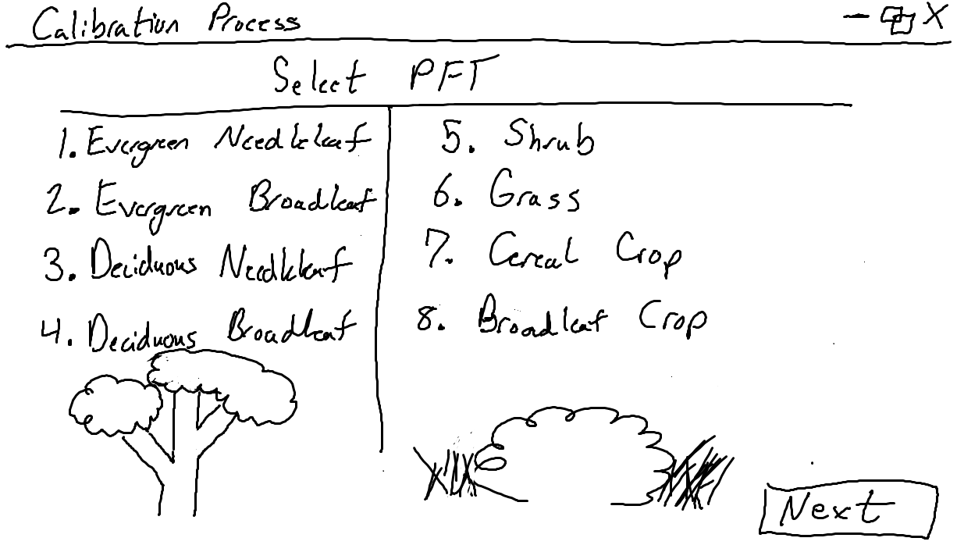

PFT Selection Page

This page lets the user choose 1 of 8 plant functional types (PFTs, high Priority #4). This PFT selection will determine the following ramp function calculations and optimization, as each one will have its own subset of tower data (High priority #1). The selected PFT will be highlighted and the ‘Next’ button will be enabled.

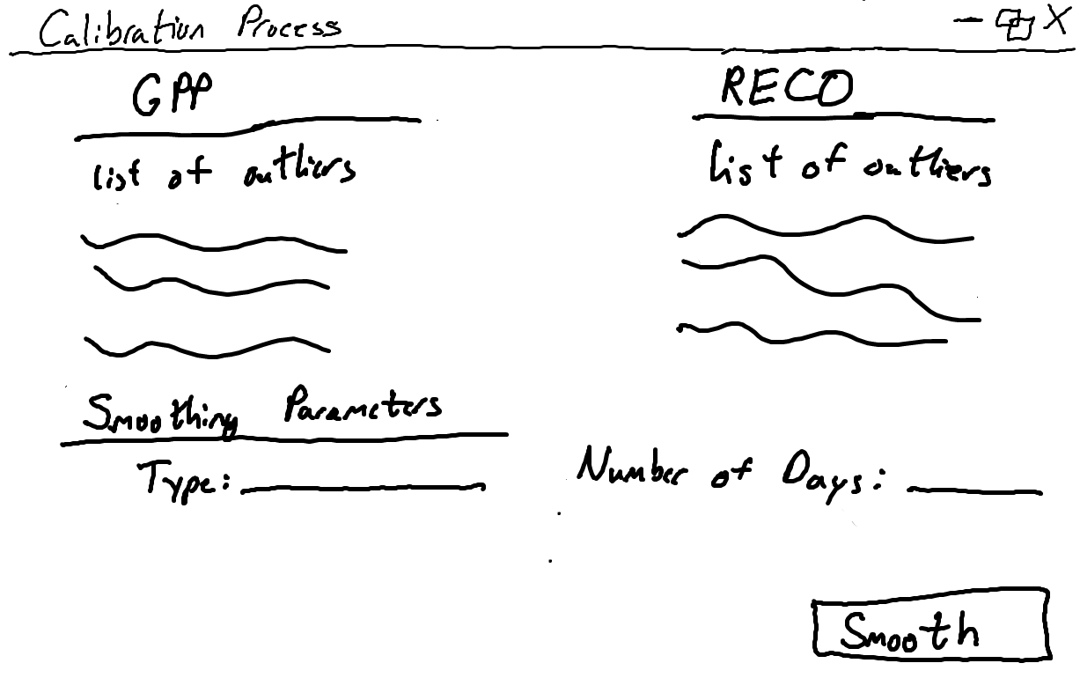

Selecting Outliers Page

This page allows the user to choose outliers in the average annual GPP and RECO that can be removed (High priority #5). The user will also be able to choose the type of smoother to use, such as SciPy’s filtfilt() implementation, and specify the day range of the dataset. Clicking the ‘Smooth’ button will begin the smoothing function.

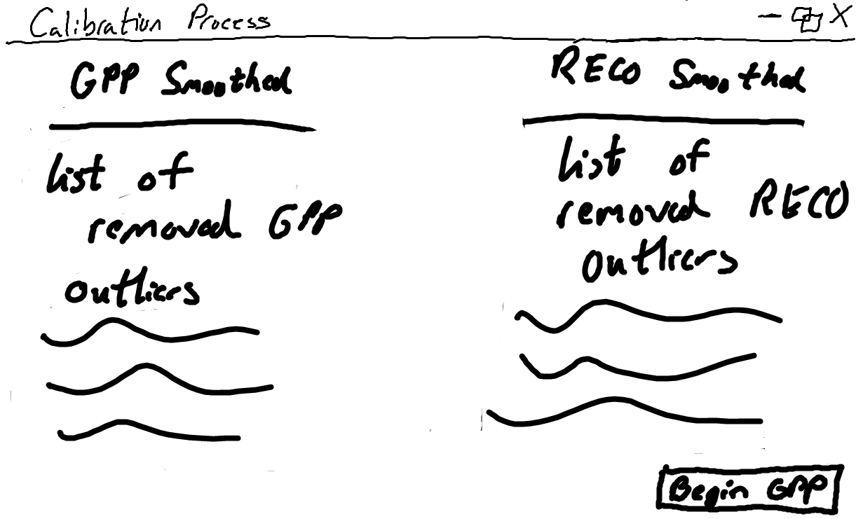

Removed Outliers Page

This page reports the selected outliers that are removed from the subset of data for the selected PFT due to the smoothing function. Clicking ‘Begin GPP’ will start the optimization function.

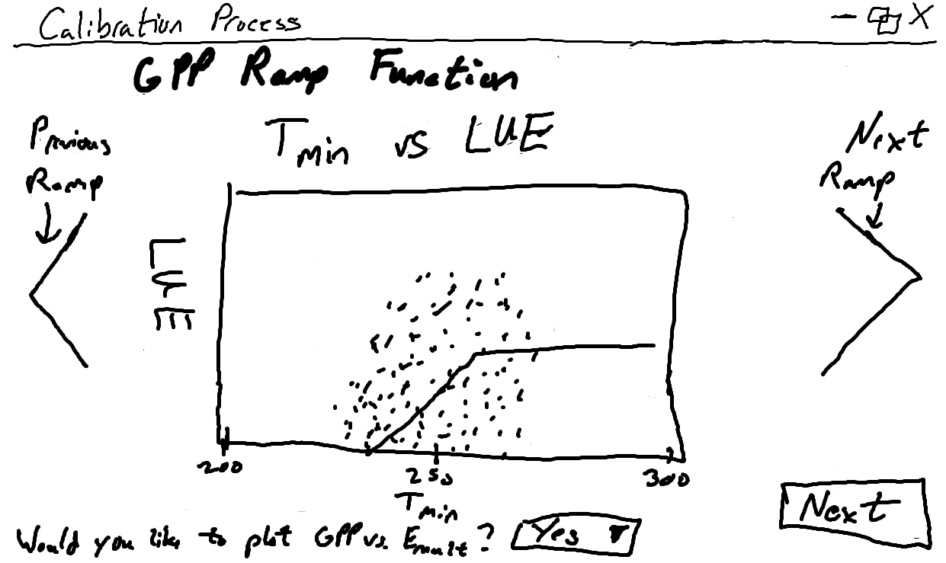

GPP Ramp Function Page

This page displays the plots of the current GPP ramp functions using the current BPLUT table (High priority #7), a part of the configuration file that includes data on the selected PFT. The option to display the GPP vs Emult graph is presented to the user with a dropdown for Yes or No, showing the below page with Yes selected when clicking the ‘Next’ button.

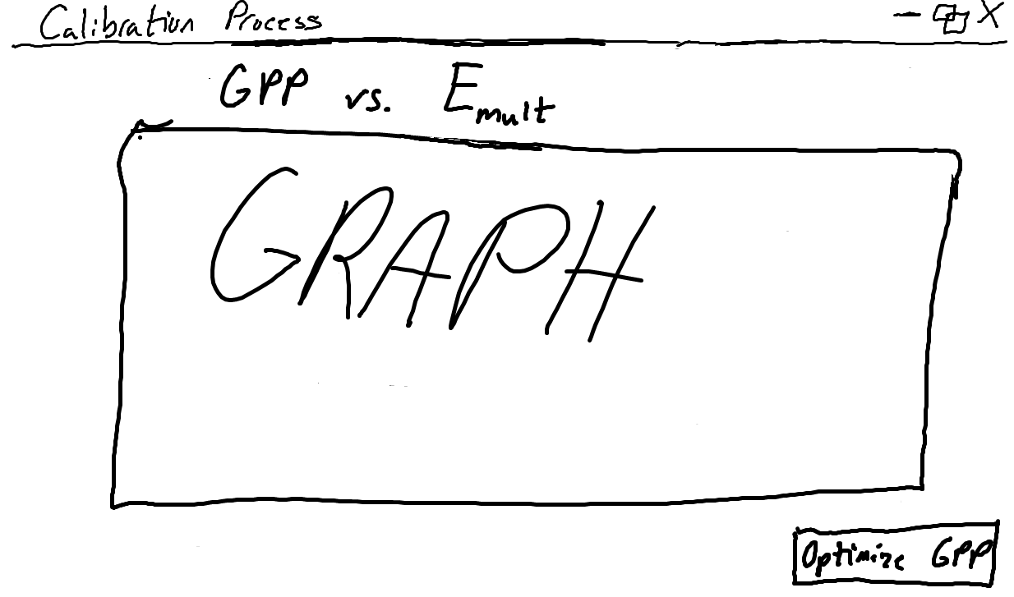

GPP vs Emult Graph Page

This page displays the graph of GPP vs. Emult which is an optional graph that the user may or may not wish to view. Clicking the ‘Optimize GPP’ button will start the optimization of GPP parameters.

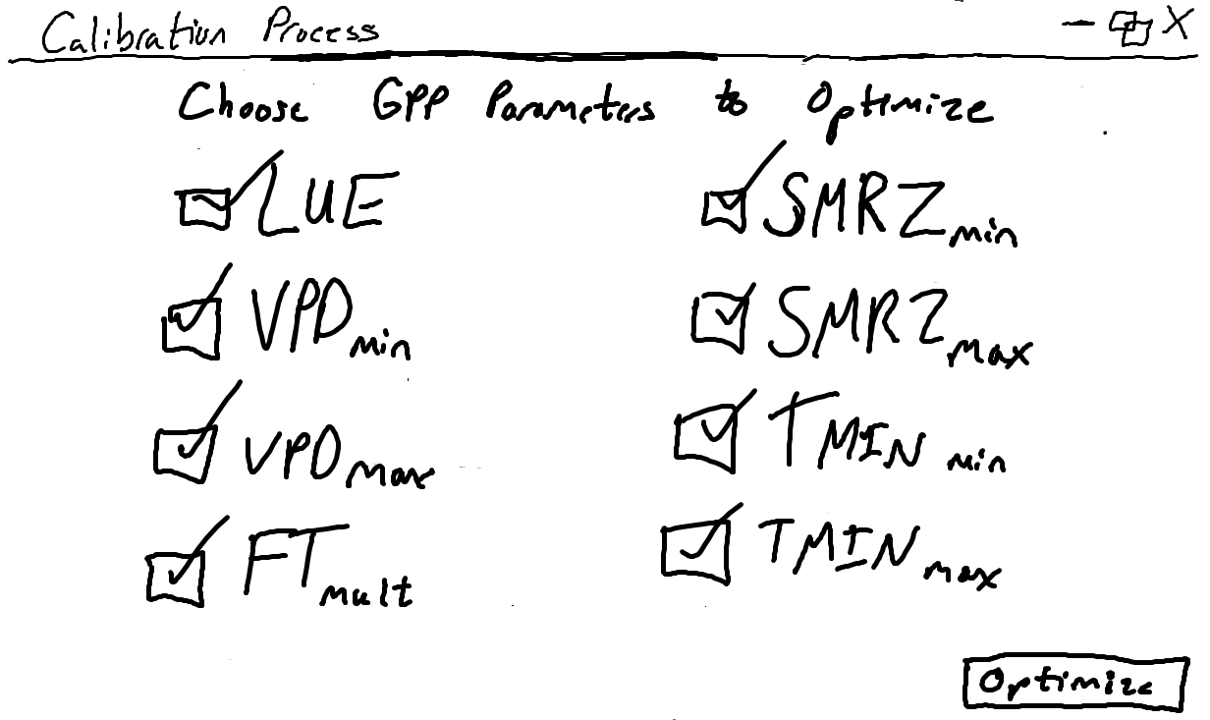

GPP Parameters Page

This page allows the user to choose which of the eight GPP parameters will be optimized (High priority #6). All eight of these parameters will automatically be checked as a default for the optimization process, but can be unchecked to be excluded. The ‘Optimize’ button begins the GPP optimization process.

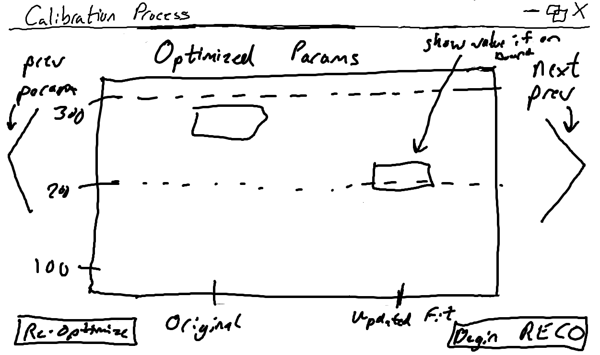

GPP Differences Page

This page displays both the original and updated fit for each optimized parameter. The value of the updated fit will be reported if it falls on or above/below the upper or lower bound. The updated fit is stored and updated in the BPLUT table. There is an option to run the GPP optimization again by clicking ‘Re-Optimize’ button. Clicking ‘Begin RECO’ will begin the RECO optimization function.

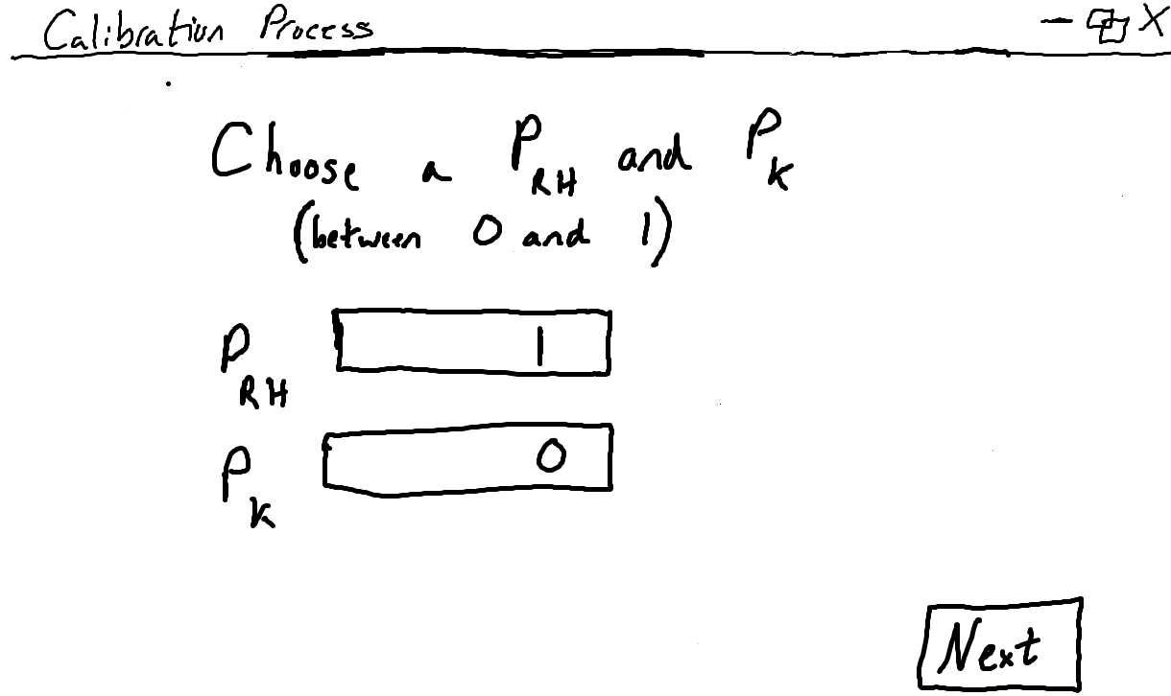

RECO Hyperparameters Page

This page lets the user determine the value, between 0 and 1, of PRH (percentile of RH/Kmult to use in initializing SOC pools) and PK (percentile to use as minimum threshold for acceptable Kmult values). These hyperparameters will be used to calculate Cbar, which is vital to the RECO calculation. Clicking ‘Next’ displays the ramp functions for RECO.

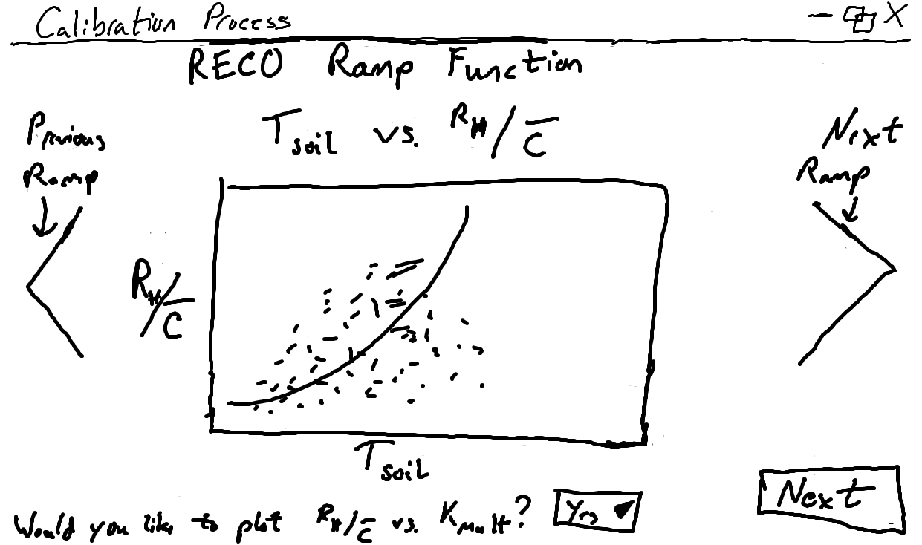

RECO Ramp Function Page

This page displays the plots of the of the current RECO ramp functions, similar to the GPP ramp functions (High priority #7). The user can view two other RECO ramp functions by selecting the arrows on either side of the graph. There is an option to display the graph of RH/Cbar vs Kmult, similar to the GPP vs Emult graph for GPP and showing a page similar to the GPP vs Emult Page with Yes selected when clicking the ‘Next’ button.

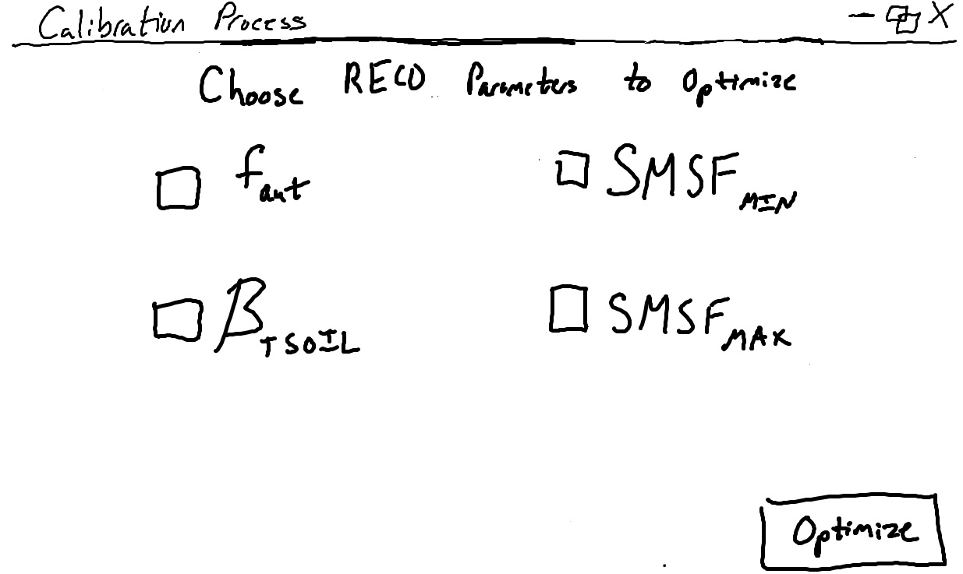

RECO Parameter Page

Much like the GPP Parameter Page, this page allows the user to choose which of the four RECO parameters will be optimized (High priority #6). These four parameters are included as a default but can be unchecked to be excluded. The ‘Optimize’ button begins the RECO optimization process.

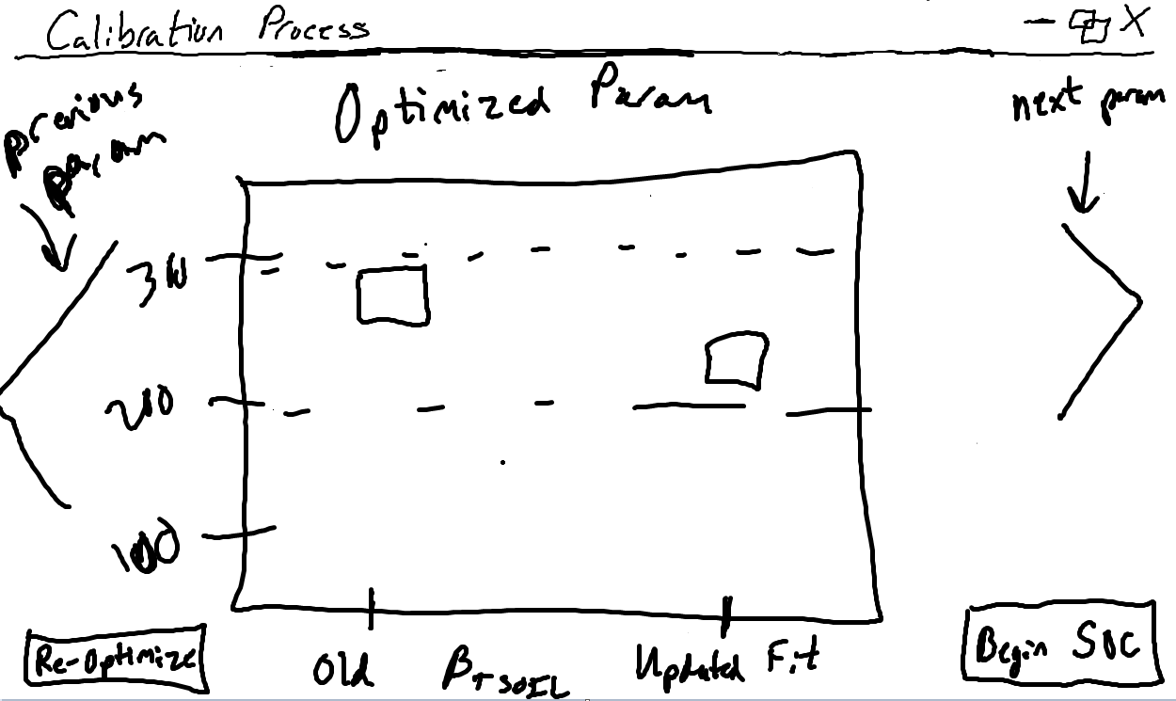

RECO Differences Page

This page displays both the original and updated fit for each optimized parameter, like the GPP Differences page. The value of the updated fit will be reported if it falls on/above/below the upper or lower bound. The updated fit for the optimized RECO parameter is stored and updated in the BPLUT table. There is an option to run the RECO optimization again by clicking ‘Re-Optimize’ button. Clicking ‘Begin SOC’ will begin the final steps to the calibration process.

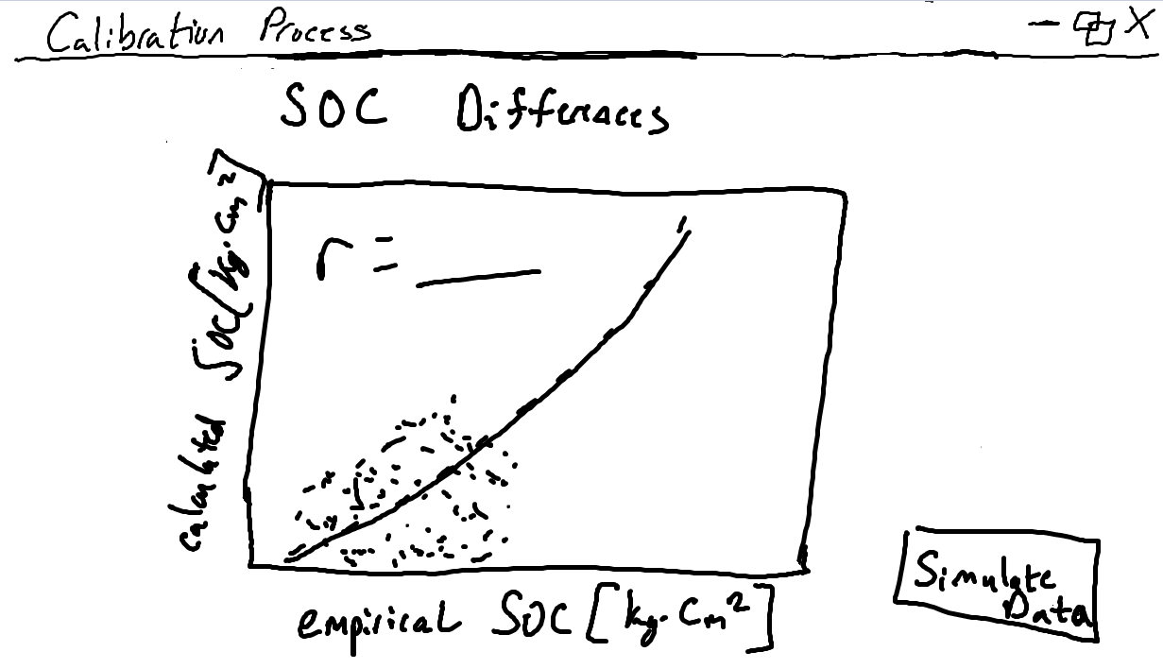

SOC Differences Page

This page displays a plot of the empirical SOC calculated from the ground-truth flux tower data against the model-estimated, or calculated, SOC. The SOC is calculated using the optimized GPP and RECO parameters (High priority #9). The ‘Simulate Data’ button pops up the following window.

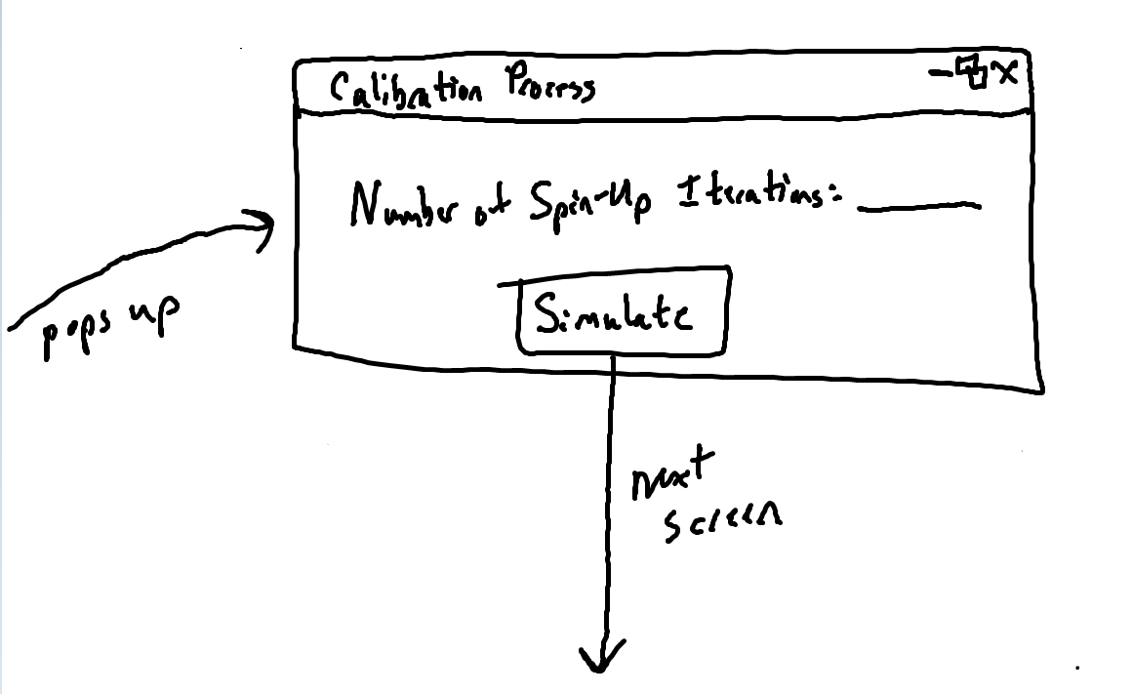

Iteration Pop-Up

This pop-up window allows the user to choose the number of numerical spin-up iterations that the model will be doing (High priority #8). The ‘Simulate’ button will begin the simulation iterations.

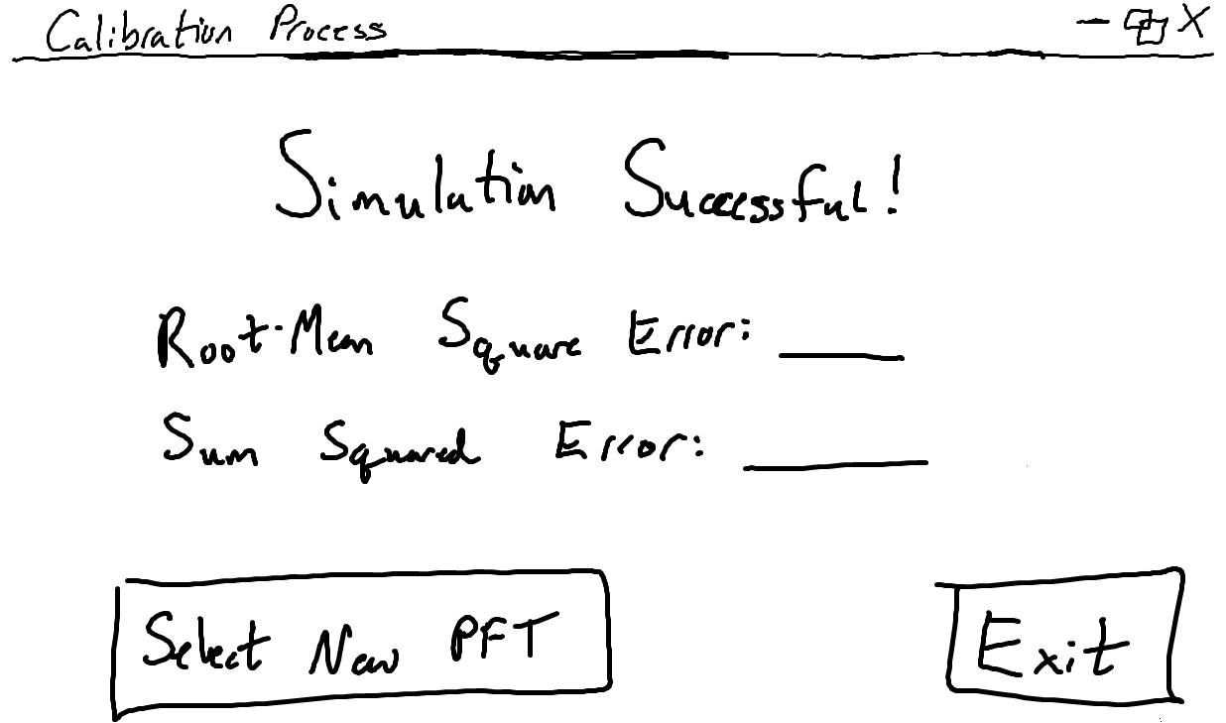

Ending Page

This page lets the user know that the simulation has run successfully. The root-mean square and sum squared errors are reported to the user for the selected PFT, which is updated to the output. The output of this calibration process, by clicking ‘Exit’, contains the updated BPLUT table, the four SOC stock-size maps, SMRZmin and SMRZmax from 2000-2018 which is also termed the Nature Run (High priority #10). The user can return to the Select PFT Page to continue the calibration process for another PFT by clicking the ‘Select New PFT’ button.

## In-class presentation

The following list contains the notes and feedback that the team received for this original low-fidelity prototype during the in-class presentation on Wed. Oct 23, 2019:

* Change the re-smoothing type from a string input to a drop-down menu option in the Selecting Outliers Page
* Only accept HDF5 file type for input, and throw error when not, on the Configuration File Page
* For GPP and RECO Parameter Pages, say “upper bound” and “lower bound” instead of “max” and “min”
* Display definitions and what the value is being calculated with/for when clicking on any term
* Make back buttons (so the program does not feel strictly linear)
* Create a ‘Choose/Select All’ button for both Parameter Pages and potentially a ‘Clear All’ to then select one (one needs to be selected to proceed)
* Create a progress bar, since the calibration process may take a couple hours to run

## Execution and Acknowledgement

The team members hereby indicate by their signatures below that they have read and agree with the specifications of this document.



