**ISE Entrance Submission – Golf Yardage Calculator – Mark Mannion**

**Please find all code and images relating to my submission in the following GitHub Repository –** [**https://github.com/markmannion/MarkMannion_ISE**](https://github.com/markmannion/MarkMannion_ISE)

**Introduction**

My entrance submission for the Immersive Software Engineering Programme 2025 entry is a personal passion project that I created which makes it easier for people to play better golf.

One of the main parts of improving your golf game is knowing what club to hit relative to the distance you have left on a hole. This enables you to hit better shots. Oftentimes the yardage that you have left into the green is a flat yardage without taking the slope of the hole, the wind speed or the temperature into account. In my project my main aim was to create a quick and easy to use tool to bring all of these variables into the equation and make the task of gauging distance on the course a much simpler one.

**Intitial Research**

I conducted my own research as well as using secondary sources during this project. To measure slope on the two courses at Fota Island Golf Club, I used a laser rangefinder (accurate to 0.5m over 1000m) to measure the slope of each of the holes on the courses from four set yardages: 200/150/100/50 yards. Through this data collection I found up to a 10 yard increase/decrease in yardage depending on slope.

I then investigated the effect temperature has on the flight of the golf ball. According to my research the standard carry distance for each golf club is when the temperature is at approximately 24 degrees celscius. For every increase/decrease of 5.5/6 degrees celscius from that temperature, the carry distance increases/decreases by 2 yards.

The final variable which I investigated was wind which has a massive impact on the carry distance of the golf ball. I found that for every 10 mph of tail wind/head wind the ball will carry 10 yards farther or shorter.

**Creating the Programme**

After gathering all of the data I required, I created my Python Yardage. I started by creating user inputted variables for the temperature, wind speed, hole and yardage. I then created If/Elif statements for the wind and temperature. Also, I created four functions based on different length yardages - 200/150/100/50 yards. Finally, the programme suggests which club you should hit depending on the set clubs and corresponding distances that are in the programme. For example if you hit your 9 iron 160 yards and your 8 iron 170 yards the programme will recommend which club you should hit for the final adjusted yardage.

Functions from the first python script


However, this code was inefficient and far too long so I replaced my If/Elif statements and functions with dictionaries. These dictionaries held my slope, temperature and wind information. I then created variables which determined which club to suggest. This was much more efficient and concise/compact.

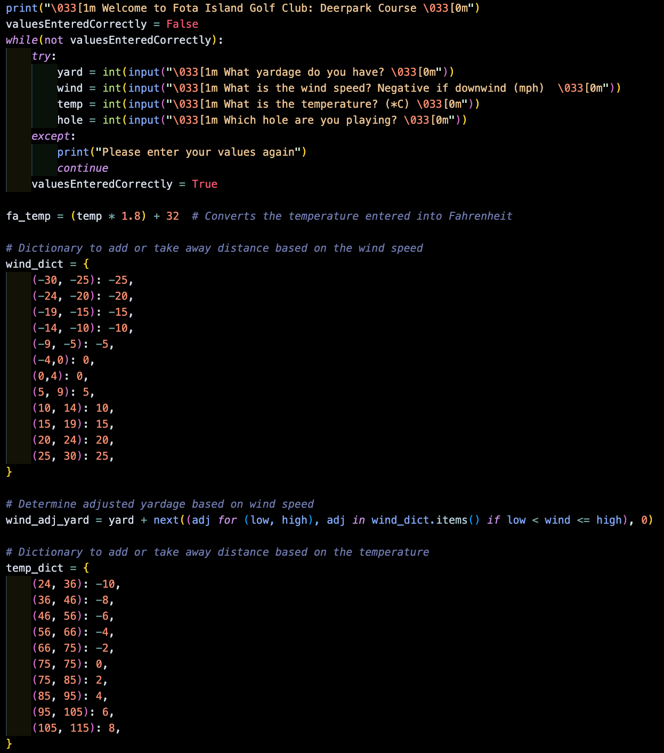

Upon creating these python scripts I decided to create an application using this yardage calculator. To do this I decided to use Flask for Python. This enabled me to insert my Python Flask App into whichever development interface I liked. I initially went with React Native as my interface of choice for app development, however this didn’t satisfy my own needs. To fix this issue I changed my interface to Flutter which uses the Dart language. Before beginning on the programming I created some prototypes on Jotform to give myself a design to work towards.

Firstly, I integrated my Flask app into my Flutter app by running both on a local network. This enabled me to use my Flask app as the backend to run the calculations. I then created multiple classes for my various pages.

After creating these classes I created a light and a dark theme for the app to suit user’s own preferences. These colour themes also affected the images in the app which changed to blend in with the current theme.

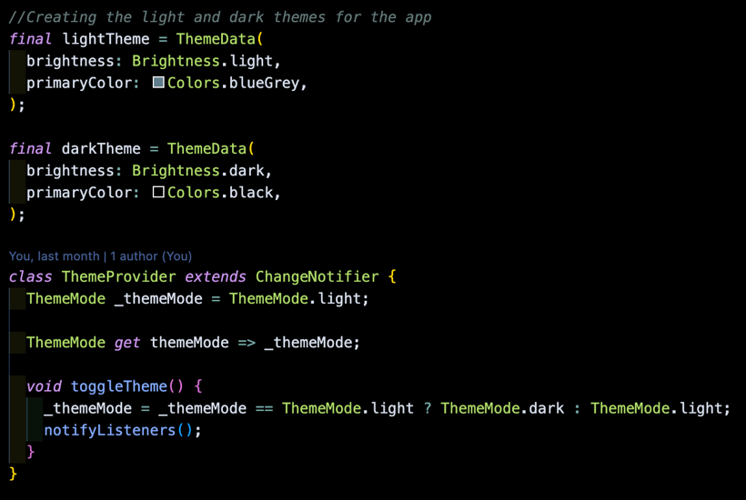

Finally, I improved the layout and design of the homepage to improve the user experience. This was done by improving text and interactive feature positioning.

**Conclusion**

Overall I really enjoyed this project and learning how to use new languages. This was my first experience building an app, using Flask and also programming in Dart.

I showed this app to my friends and they found it really interesting and intuitive to use. They also helped provide feedback to improve the user design and experience.

I could also adapt and introduce a few things if I were to continue on with this project. I could introduce another page where the users would be able to set their own clubs and corresponding yardages. I would also integrate multilingual support for global use and I could also introduce a method for users to add their own home golf course through the app by adding in their own slope values and then their yardage would be determined via GPS functionality. The app could have commerical potential.

[**https://github.com/markmannion/MarkMannion_ISE**](https://github.com/markmannion/MarkMannion_ISE)

**Finished Application**

**References:**

<https://www.sciencedirect.com/science/article/pii/S1877705812017213>

<https://mygolfspy.com/labs/hot-versus-cold-golf-balls/>

<https://seedgolf.com/blogs/news/how-does-cold-weather-effect-golf-ball-performance>

<https://www.andrewricegolf.com/andrew-rice-golf/2023/4/what-effect-does-temperature-have>

<https://www.golfmonthly.com/tips/golf-swing/how-to-calculate-distance-in-the-wind-108215>

<https://www.andrewricegolf.com/andrew-rice-golf/tag/wind+formula>

<https://www.paulhurrion.com/tuition/blowin-in-the-wind/>

<https://www.scottsdalegolf.co.uk/blog/60-second-technique-tips/into-the-wind-vs-down-wind-the-effect-on-your-ball>

<https://www.golfwrx.com/318416/how-the-wind-affects-your-golf-ball/>

<https://www.sciencedirect.com/science/article/pii/S187770581100991X>

<https://journals.sagepub.com/doi/abs/10.1177/1754337118812618>

<https://www.f22labs.com/blogs/how-to-implement-dark-mode-in-your-flutter-app/>