LITTLE LAND OF LIMERICKS

Jerome Teelucksingh

For Emma and Eliana

Table of contents

I

- Outside the Asylum
- Spring
- The fragile
- On the verge of a miracle
- Circus Day
- For labourers in Fiji
- Disease, viruses and germs
- The witches
- The islands go for a holiday
- A confused American
- Below the surface
- Clash on Jupiter
- Torn Apart
- The lost school days

II

- Little Land of limericks
- Return to the Little Land of Limericks

III

- Closer to our Lord
- Wearer of the crown
- He has the power
- Baby Jesus
- The Ark
- Risen Saviour
- You are part of our lives
- He is always there
- Keep the fires
- We shall sing
- Clap your hands
- The baby is born
- Rejoice in the Blessed
- The Crown
- The Hated
- Warning for the world
- The Coming

1

Outside the Asylum

They say there once lived a confused president,
who ensured money was badly spent.
It was debatable that he ignored equality, education and health care;
felt it was better for the American elite to prosper as we live in fear.
So lots of money continued to be put aside
for guns, planes and tanks to conquer far and wide.

She was a highly educated prime minister who eloquently spoke
of creating a better life and social security.
She boasted of big dreams but it was a grandiose joke
as nobody wanted to work and misunderstood civic duty.
Her fellow politicians shamelessly praised her gall
as the hungry wolves quietly waited for her downfall.

Some advocates wanted to carry a weapon or gun
they cited laws, held rallies and clamoured for freedom.
Then the shooting began, some prayed, cursed and others were on the run;
the dead were soon forgotten and nobody challenged the kingdom.
A few shouted but weapons continued in colourful school bags.
Some felt human lives were less precious than their country’s flags.

The regal statesmen stood silent and allowed the wasteful war
they fought for land and a useless boundary.
Fighters and fanatics proudly proclaimed a holy war
whilst the grieving accepted the hollow victory.
Nobody questioned their beloved prophet and the fight
or the bloodthirsty and blighted who felt it was alright.
Another monument and statue that was expensive and useless
as children died from illness and starvation.
The African leaders continued constructing fancy architecture
as big bellied children flaunted their malnutrition.
Blue collar Latin American workers shrugged and complained of stress.

Drugged damsels dined and the corrupt plotted
whilst the suicidal man stood with his rope ready and knotted.
A king and queen drank and ate the best then heaped scorn
on their pitiful peoples. Another sickly baby is born
but only the parents display empathy.
The resources are not for you but for the beloved European royalty.

Smugglers and human traffickers fund political parties
whilst cowardly activists and the pious turn a blind eye.
Medical researchers plead for any scraps of support
but their wails are ignored as another injured daughter dies;
another reluctant son shipped abroad to patrol a fort
as his parent anticipates bad news and never-ending lie.

Oily, old tankers once left footprints of oil
and carcasses of crustaceans for many miles.
Fires sweep across California and Australia
leaving carcasses of creatures and fauna.
Predators wait to rape and defile the soil;
the legislators pay lip-service and cavort with coke.
An Asian suffers a stroke and recuperates in a sauna
whilst depressed Canadians flash silly smiles.
The well-fed prisoner lives in comfort behind bars
whilst the scarred victim copes with scars
and untreated trauma.
Ignorant insurance companies query claims for a helpless grandma
An abused boy was insulted, ignored and dubbed a bloke;
he was diagnosed as abnormal and flawed.
He soon sought revenge and struck,
the media felt it was good luck.
They gleefully reported on the heinous crime
and this is how they spent their valuable time.

The girls lack a proper school and a street child awaits a meal.
A Cuban grocery remains bare as patriots beg;
and far away a Pakistani teenager needs a prosthetic leg.
Boys in the projects wait for their leader to make a deal
Monsoon rains in India cause havoc destroying livestock and peas;
onlookers perfumed with arrogance,
sip afternoon teas and eat desserts of moral decadence.

2

Spring

The colorful leaves form mats near trunks and roots;
puffy clouds float past the icy mountains.
Eagles and hawks search for food among the grassy plains.

Mother Nature watches over the forest animals
as happy trees sprout new clothes and begin another new page.
A groundhog and sleepy bears search the multicolored foliage

The fishes begin their journeys upstream,
and the geysers spout steam.
The children happily play games whilst parents put away winter boots.

3

The fragile

The sun still asleep
and the morn is brimming with peace and gratitude.
A mother weeps with joy
as she feels her legacy emerging.
It is a moment of pain and beatitude.

The chaos of the delivery room
masks the solace of trained hands and minds calm.
To bring order to chaos, moving organs and ensuring happy faces.
Another day in the hospital’s war zone
to make flowers bloom.

4

On the verge of a miracle

Another day of futile searching,
another night of ceaseless praying.
Unanswered calls, silent cursing and shouting
as another sister in the ICU goes cold.

Another month of unanswered prayers,
another year of queries and darkness.
Fathers at the bedside demand justice as
sons never regain consciousness.

The faith of a mother is tested
as a daughter loses the difficult fight.
A brother breathes his last
as his family reflects on their happy past.

5

Circus Day

Posters on walls and fences soon to become alive,
old and new eyes anticipating the trains with the animals;
as they follow the long lines that traverse the town.

The carriages of exotic beasts no longer dreams, clumsily pass toxic mouths,
excited eyes wait and watch as the lined poles begin to grow and become entwined.
Moving ropes, wood like stents and arms cause the tents to arise.

Those big bears growl and eager ears follow the clamour
as they join the long lines to enter the big tent and hear the ringmaster’s song.
Eyes of awe marvel at the chimpanzee, aerialist and the swinging trapeze.

He cracks his whip and the ship of eyes follows his every move,
teenagers are seduced as the bold acrobats begins their feat.
Barnum enjoys the ambience of the awed audience who are dumb.

Sideshow attractions are more of distractions for those planning to escape with the circus;
the bearded lady and fattest man smile as they entertain for the viewers refined and plain.
An armless midget and the Elephant Man make no fuss over the reckless heckles.

Dubbed freaks of nature they enjoy the attention and travels across the nation.
They absorb the menagerie and the unusual exhibits. It seems unreal and a lie.
A monkey on a tricycle performs as a juggler on a unicycle wows those eyes of unbelief.

6

For labourers in Fiji

The cunning arkati tricks his victims to the desolate depot,
these women, children, Brahmins and untouchables would later eat from the same pot.
Duped to believe the grand voyage is to a land of milk and honey;
all empty promises and lies of earning lots of money.

The first wave boarded the Leonidas and soon realized it was too late to reject the offer,
wicked sardars and worthless overseers with whips in Nausori made them suffer.
Off to humble homesteads in Malolo which were mocked by whites
they built schools, mosques, mandirs and in Lovulovu observed the festival of lights.

During girmit they sold in the markets, toiled on the sugar plantation,
reared cows and sadhus became shopkeepers whilst learning to ration.
Struggling with sickness, defying diseases, these barefoot jahaji bhais passed through the same gate to labour on the Valnunu Tea Estate.

Some from Labasa recited the Koran whilst others in Lautoka read the Gita and Ramayana;
some fasted during Ramadhana whilst others in Nukulau helped build the tazia.
On evenings they spoke of life in Kanpur and Calcutta
of family members in Bombay and the longing to return to Mother India.

7

Disease, viruses and germs

From our comfortable seats we again view the implosion
as never-ending fears turn to a stark reality.
The vengeance is not complete as some are some are allowed to live again.
Shriveled victims in body bags lack a requiem;
hotels become hospitals and morgues as we candidly choose our victims.
There is little reprieve as fiction becomes fact
and failure hunts your medicine and spirituality.

Busy battalions bolster the sick;
memes and mockery have long stopped in America, Italy and Spain.
Weeping willows watch the empty windows.
The enemy is everywhere as cobwebs from the corner
wait for another unsuspecting victim.

I’ve been waiting for you…when life’s dependency cord is severed.
You treasure your tyrannical protectors
of the same blood and you remain isolated.
You are suddenly wary of contagious movements and your idols fail the brood.

Leaders have created idols of followers to walk
but now they cannot trust their followers.
Not even you can be trusted amidst the confusion and chaos
that reigns over this land of cheap talk.

Mesmerized lashes fluttered but refuse to open
Your riddled thoughts cannot be understood
mass graves mean no rituals and pitiful goodbyes.
Nothing can be trusted, no animal, steel or wood.

This lyrical and fantasy world has come to a halt and the grass begins to grow.
Knowledge once accessible to the nation
now swimming in a morass of misinformation.
The citizenry emerge from a vague blackness of uncertainty.

Practical signs are ignored as nightmares continue,
We weep for the dying and the gnash teeth for the unborn.
The clothed cranium and nostrils cannot run from the flu;
so why try to change your destiny with death?

Walls emblazoned with grime and graffiti
now scrubbed clean and deodorized.
The cluttered lives of lesser gods now display compassion
but the sick ignore their rantings and contamination.

Fighting the unseen enemy that we produced,
We search our inner self for comfort and ignore the finery.
They speak a blunt language that irritates
and harvest sadness and scars for those they seduced.

They say the Earth can breathe again
Whilst you gasp for breath and writhe in pain.
Then the soul goes wandering and your offspring now lack an objective as they too
struggle against the changing force.

The deterioration and decline of civilization is expected
Flesh of liars and bones of the truthful are a farce
as the equalizers claim their bounty.
It cannot be eradicated.

Melodramatic and miserable mortals say we here a century ago,
And claim it was predicted even longer.
They perform on their blood-stained stage and then age
all unworthy shrubs who claim to be spiritual and stronger.

Their gusty ambitions to find a cure are only temporary,
as they perish from polluted land, sea and air that are now cursed.
They are famished and cannot perform their final act,
yet hope to be redeemed and blessed.

It’s neither a game of chance nor planned
Your cleansers and medicine are futile.
Your feeble lives and smiles are ignored.
You cannot overcome our monstrous challenges.

All that you build and construct will collapse
All that is evil, mundane and sacred we will attack.
We left Pandora’s Box and will not rest
until a victor is declared and then we will make another pact.

8

The witches

With ears of rings so large, she shook as with electric charge.
The bent figures stirred the pot and cursed.
They issued warnings to take heed of a haunting joker atop a mourning hyena,
who is chanting dirges whilst the humbled peasant is humiliated.
They cast dastardly spells on tribal folks
whilst cracking goat skulls and mixing yolks.

Their evil hearts spin webs of confusion on ancestors
and offer drinks from murky goblets;
whilst spinning lies among wanderers, they fear only dark angels.
Loners with the forsaken, the nights are spent brewing troubled minds
as they are powered by hate to make meek mortals mourn.

They do not yearn for freedom and when you cross their paths
all victories and any reign will be eclipsed as they taketh away
even the happiness of the harlot.
Your longings are replaced by a millstone of madness which you once forgot.

Your survival will depend on other worldly forces
as a reptilian head awaken caustic memories and send them to
your unsuspecting predecessors.
Through sly slits they mix pungent potions for pregnant princesses
and bottled for hypnotized followers to see the nonexistent.

Hooded heads stir and chant.
A pinch of dragon’s vomit, a bat’s wing and a baboon’s brain,
thrown by hideous hands to destroy foreign lands.
Marked and miserly they adjust the cauldron
and forecast the destruction and gloom.

Ebbing shadows of the moon hide the sorcery and her hood,
as she plots the downfall of a scheming soul.
Their rooms are filled with jars of flora and floating fauna
skulls with clotted blood and the carcass of an aborted hyena.

Are you alive? The apparition mutters an appellation
And they sprinkle snuff on their sacrifice and scamper away.
Afraid of their power the earth shakes and
the ordeal ends as flanks of fire are now embers.

She cracks the fragile neck and pours the blood
over the frothing fawn who awaits his doom.
Carefully chanting as mystic music envelops the room.
The pure are purged and fear to be terminated.

Frostbite faces are filled with fear,
and crowds stare at the eccentric and friendless
bruised souls are afraid of help from these wicked tongues
that emit troubled tirades against the glassy-eyed epileptics.

Ravens on the rafters stare at the ranting women
who whisper names and call forth strange gods.
From the depths of the unknown they bring damaged damsels
Soulless soldiers to wage wars against royalty and nobles.

Vendors seeking vengeance against guilty guilds
pay for venom to be directed against the defiled.
Then the demons arise and drown the swimming and afloat
wreaking worries on the wealthy.

9

Below the surface

There below the hazy surface of Pluto an unseen battle continues
as mysterious organisms now loose.
They breathe carbon monoxide and emit infrared radiation.
One who is stoned and the other is tailed and carries a rope with a noose.
Chasms on the furrowed brow of the space explorer reflect pools of futility
as he stares into infinity.

The greenish waters are soiled with alien skulls like a strange Divine Comedy,
slithering creatures crack the dome and greedily consume the negligent and unguarded.
Light fades and a mind dulls.
The hearts of glory within spaceships cannot be seen through the window pane
and alien life forms with their frothing mouths devour the
unsuspecting astronauts whose last breath is filled with nitrogen and methane.

Righteous mortals lie broken on chaotic paths.
On the surface, they patrol like spouting whales,
as chameleon creatures with hydra heads and disjointed bones
crush the asteroids searching for food.

10

Clash on Jupiter

The dusty rings of Jupiter hide the menacing monsters,
who breathe hydrogen and helium.
Telescopes cannot see what lurks beneath.
The survivors of the intergalactic wars roam the moons of Io, Europa, Ganymede and Callisto.
A comet crashes into the surface.
The alien furtively approaches the entrance of the ship,
as panicking humans reach for weapons.

Curious headless inhabitants of Neptune and Uranus receive the transmissions
and arrive on Jupiter.
They seek peace and understanding,
but the earthlings are fumbling.
A chance of peace is dissipated as the bomb explodes and their lives are vaporized.

11

The islands go for a holiday

Far away in the Caribbean were some large, small and tiny islands
that had hotels, coconut trees and happy women and men.
Their coasts had soft, white and brown sands.
Each morning the sun would awake the animals, fishes and a sleepy hen.

One day Jamaica felt restless and bored
and decided to go for a holiday abroad.
She decided on Austria, told the Blue Mountains to get their passport
and began packing ten big suitcases.
Next day she combed her palm branches and headed for the airport.
On her way, she stopped to buy a beef patty and tie her shoelaces.

Then Barbados heard that her neighbour went for a holiday
and he decided to also take a trip far away.
Barbados said goodbye to the flying fishes and finally decided to go to France.
That night he packed his hat, toothbrush, comb, shirt and pants;
he checked his money, made a list and decided to fly first class
and when he realized it was late, he rushed outside with his boarding pass.

Then in December, Dominica felt bored and told the rainforest
he was going abroad to build a snowman and look for a treasure chest.
It was stressful to pack so Dominica first relaxed in the hot, volcanic spas
then closed the Morne Trois National Park.
He packed all the villages in seventeen cars
then booked a return flight to New York to stay by a cousin in Central Park.

The two stepsisters, Haiti and Dominican Republic, also longed to go for a holiday,
And after checking the map of Europe and USA decided on a big trip.
They found cheap flights to Canada, Mexico and Norway
but finally decided on a one week holiday in the Town of Islip.

Cuba, the elderly grandfather, wanted to hike on the mountains with a knapsack
but it was expensive and he did not have enough money.
The travel agency felt sorry and said they would accept sugar that tasted like honey.
Cuba took twenty bags of sugar and received a ticket for a ride on a turtle’s back.

The brothers, Martinique and Guadeloupe, were also excited to be on a trip.
They quickly bought sleds, gloves, snow shoes and headed for Athabasca.
Both boys took extra money for food, snacks and tips,
and after decided to go on the cruise to Alaska.

Then the thin triplets, Aruba, Curacao and Bonaire
felt the need to travel to Iran, Iraq and Arabia.
They packed their big brown bags, found their cosmetics and combed their hair;
they hoped also to visit Italy and Tunisia.

Puerto Rico decided on a different holiday adventure in a hot air balloon.
He wanted to visit uncles and aunts in Afghanistan, Greece and England,
but the balloon could not move because there was too much weight.
So he removed a chair, bed, refrigerator, television, radio and gate.
Then the load was lighter so balloon began to finally rise.
When he saw the vast ocean it was a real surprise.

Anguilla decided to travel on the back of a very large tortoise,
but there was no more room for Bermuda who began to sneeze.
So Bermuda paid money to a travelling porpoise.
St. Vincent saw the islands leaving and felt it was time to bid goodbye
So she packed her briefcase, purse and at the airport began to sigh.
She knew she would miss the warm sun and cool afternoon breeze.

Bahamas and her brood heard of the holidays of their nearby islands
and they decided to check for flights for somewhere cold.
They decided on a short trip to the Netherlands.
It was a long flight and they lost their luggage but they were bold.

Antigua and Barbuda, two cousins, felt a bit lonely
so they booked hotels in Pakistan, Italy and Spain.
They closed their hotels chased away tourists and hugged their family.
At the airport in Europe, they collected their luggage and took a train.

Hawaii and her family wanted to visit Australia
After two weeks of seeing kangaroos down under,
They decided to visit Taiwan, New Zealand and Malaysia,
They never felt alone and were reunited with their stepbrother.

Faraway, there was Madagascar
who heard about the islands who went for a holiday.
So he bid farewell to Africa and took a submarine and then a car
and visited Argentina, Brazil, Uruguay and Malay.

Montserrat wanted to see Honduras and where gladiators battled in Rome,
So he closed his shops and sadly left home.
Two aunts, Turks and Caicos enjoyed hiking on terrain that was rough.
They wanted to visit Guatemala and Belize to see pyramids and ancient stuff.
They told St. Martin who was relaxing under a coconut tree and getting a tan
and she decided to visit lands that were conquered by Genghis Khan.

Tasmania wanted to swim in the Caribbean Sea
but decided to visit a library in Singapore to read about the Cherokee.
He boarded a ship that headed that could only sail on the horizon
Soon he changed his mind and visited the Amazon.

St. Kitts and Nevis were sad because they had passports that were expired.
After waiting two days in a line they felt hungry and tired.
They eventually decided to visit Germany to see a zoo
and returned to the Caribbean with a flu.

12
A confused American

See us on the streets walking with heat,
we want to walk away from racism, but you keep pulling us back.
We loot to feed the starving and greedy, and know you will still shoot.
I regret staying quiet when they spat on the Irish and Italians.

We are not protesting the police brutality,
we march against the past and continued injustices.
We shout for the deaf authorities to remember who got the power.
I regret staying quiet when the First Nations had their lands stolen.

We chant fancy slogans for deaf politics and to scare the privileged elites;
don’t be afraid…these threats are like ashes that will harm nobody.
You raped and lynched our ancestors…now you are afraid of us?
We cannot wait longer, we cannot stay quiet.
I regret minding my own business when the Asians were targeted after the Harbor was bombed and Vietnam exploded.

Angry marchers got matches and if you push us
then the fire will be unstoppable.
You call us arsonists but you burnt the bridges of peace;
you call us rioters but we learnt it from you in 1776.
I regret staying quiet when my Middle Eastern friends were mocked.

Where is the peace and love your hippie generation preached?
You quote laws and amendments but ignore the Emancipation Proclamation.
You call us domestic terrorists but stay dumb after school shootings.
I regret staying quiet when they came for the Communists.

Our ancestors built this land, now we run the liquor stores and casinos.
The ghosts of the brave are with us…who is on your side?
I’m safer chained on plantations and beaten in prisons.
I regret laughing at the Latin Americans.
I’ve been abused and seen power misused…I cannot call America
my home.

13
Torn apart

The Buddhas of Bamiyan go tumbling down
as Afghanistan takes a beauty sleep and the rest of us remain dumb.
The fears of the primitive Taliban are worse than their foreign made bullets.
Kabul mourns for the innocent then feast on dumplings;
the rockets respect the embassy borders and Hindus flee the hateful tide.
Peace evaporates in the slums and cities,
a hungry man awaits his okra and eggplants,
oblivious to the nearby gunfire on another bleak day.
A boy begs for afghanis whilst fires consume both homes and plants.
Intelligent girls adjust their hijabs and run away from the Sharia law imposed by lunatics.
The jihad becomes the norm as suicide bombers take their last ride.
The evening’s sun bids goodbye to another chaotic day,
polluted seas bring ships to save the innocent from fanatics.

14

The lost school days

On moribund Mondays we were mutilated by whips,
on twisted Tuesdays we battled empty-headed bullies.
Then came worthless Wednesdays when wasted teachers mocked us
and continued to taunt us on Thursdays as we learned in terror.
We became frustrated on Fridays and realized the foolish had won the battle.
On sick Saturdays we suffered in silence
and on Sundays we waited in fear for tomorrow.
We dreaded classrooms that reminded us of scars
and one morn we eventually left the dreaded gate
with a certificate and minds filled with scorn and hate.

15

Little Land of limericks
I wanted to visit the faraway land of limericks
filled with talking animals, insects, fishes, vegetables but no ticks.
So one day I set sail on a large boat
that was named Goat.
As I approached an oil-rig,
a purple fish in my boat jumped into the sea and performed a jig.
In a nearby boat was a purple dolphin that had recently been in the media,

and was studying a fat encyclopedia
as he hoped to find a cure for bulimia.
The dolphin’s father was close to hysteria
because he was standing on sleeping eel
but in deep sleep, he did not feel.
Well and soon awoke and asked for an orange to peel.
Whilst enjoying the fruit, he said “For years looked for heel
because I wanted to pray but no knees to kneel.
He boasted of teeth harder than steel.
In underwater gear stood strange skunk
with purple stripes on back resembling a punk.
Told me “I wanted to be a monk.
but too small for the big bunk.
His dreams surely would’ve been sunk
as he secretly admitted was always drunk.
Chained to the skunk’s foot was a tree trunk


that was penance for exams he might flunk.
On the skunk’s striped back was a yellow snail,
boasting she could move faster than any hammer and nail.
Braving sun, snow and gale,
the snail told us of a plan that would never fail.
The plan was a journey around the world without eating kale.
It was to be done at her speed, so she left a good job delivering mail
to raise money for brother’s bail.
But one year later, her brother was stepped on in jail.

After sailing away, I soon met Dusty a water loving dinosaur
who admitted life was a bore.

As everyone thought his family was buried under the ocean floor.
People even felt Dusty was imaginary as a centaur.
Dusty was greedy and after eating was always asking for more.
He wished for friends and family to adore
especially his antics galore.
But soon preferred free life without a chore
he had neat raft built from a door
which he stole from grocer’s store.
This made the grocer really sore
even though the grocer said the door was rotten to the core.

Then I saw a large floating sponge with a dancing cobra
that had a tie and costly tiara
After performance, the cobra expected loud hurrah
but only obtained a nod from Berk the brown zebra



who managed an underwater farm that grew talking pears.
On Mondays, the pears would sob with orange tears
because they feared being eaten by hungry polar bears.

On high tree, sole cherry never merry
as often mistaken for simple berry.
Who hated to travel on any ferry
but when ripe became wary.
Hidden underground was healthy carrot
frightened of being forgotten, and that he might rot.

Wanted to play in the sun so hot
but afraid of healthy, hungry parrot.


Growing on long vine was one grape
wishing it tasted as tape.
The grape longed to fly with a mask and red cape


but sadly couldn’t remember his mum
and wondered if she was numb or playing dumb.
The grape was ashamed of his father who was the city’s biggest bum.
Stupid persons would stop and ask green lime
if he could tell time.
The lime would stare at them and chime
sometimes rehearsed his hobby-the mime.


After six weeks the lime became old, turned yellow and fell beside the cabbage
which had curled leaves and this was proof of its old age.
Lime traveled abroad with little luggage
to ensure trips in fast carriage.
Hoped to star in a movie or act on any famous stage,
and soon caught attention of famous producers who lived on the sea.
One of the producers was a swimming flea
who spoke without glee.
The flea was searching for his lost car-key.
Nearby had large waves which affected a boat with a rowing rat
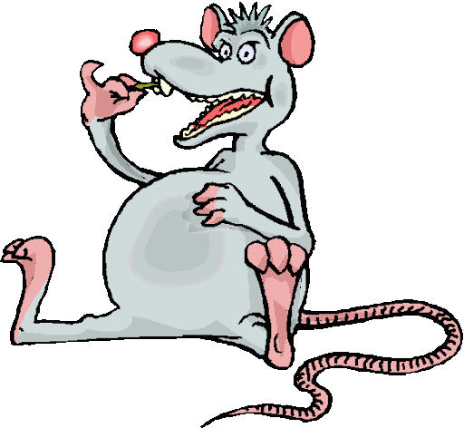
who was fat and trying to escape from man who wanted to be fat.
The rat became fat because every night he ate a piece of an old cricket bat
and made a few holes in a blue hat.
Behind the bat, on a log was a cat and snake
fighting over crumbs of stale cake.


Cat said, “I am without teeth real or fake.”
The snake said, “You cannot make.”
Close to log was a drowning lizard
hungrily watched by a blue buzzard.
Said the lizard, “If it wasn’t for this excess lard
I would be able to swim better than any drunkard.”
The lizard reached the shore and found seated on broken chair
eating porridge was a brown bear.

In jolly mood talked without fear
of family walking on road near.
The bear said, “If wasn’t for this fur or hair,
would probably be a bare bear.”
Then his mood changed, and he said to the lizard with a sneer
“You wanted my hide so dear
or with flames came to make home disappear?”

With grudge offered a glass of beer
when the lizard politely refused, he received a cold stare.
The bear shouted “leave and never return here!”
On leaving, he heard laughter of monkey
who was mocking a tiny donkey.

The reason being, the cruel monkey would kick him and flee
and never share a drink of cold tea.
On a high pole, stood a dirty stag
who was feeling upset and needed an airplane bag.
His money had vanished and now only owned a rag
which he used to dry his hands and everyone would stare
and some screamed for the stag to hear.
The screams were loud and his small ears unable to bear.
The monkey was suddenly jolted when an electrical wire touched him that was near,
he opened his eyes to see his mother’s face so dear.
She laughed and began to jeer.

There seated on two rocks was a sad tortoise
who related without surprise
that he also wanted to be a porpoise,
but unable to bear aquatic noise.


The tortoise always had strange ploys
and above her flew a young eagle.
On landing realized it was a flying beagle
escaping after committing act illegal.
The beagle quickly left when he saw police albatross
who was extremely cross
because the flying beagle had stolen his dental floss
and now on teeth began to grow moss.
The albatross caught the beagle who was planning to poach.
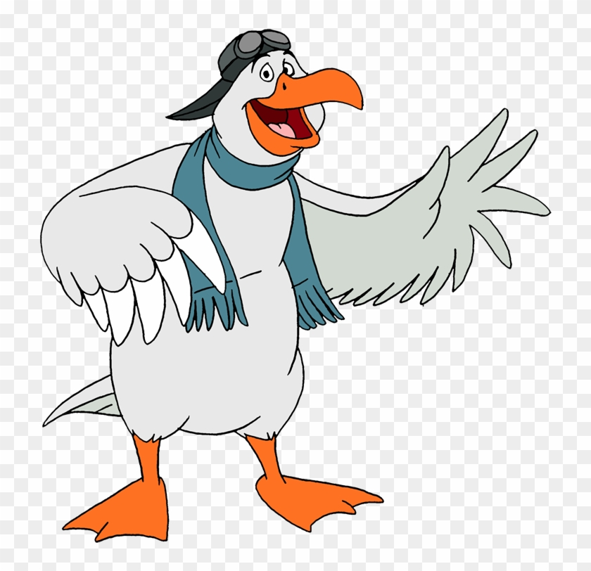
The beagle said, “Life is never safe, almost hit by speeding coach
whilst trying to race against a cockroach.”
The albatross never went to work because he did not want to encroach.
Also near the albatross was a talking bear
who explained due to hidden snare
she cleaned her fangs with care.
The bear looked at the beagle and said “I know the albatross. You have nothing to fear.”


The fantastic boat trip to the Land of Limericks ended when a fox
fell in an old, dirty box.



16

Return to the Little Land of Limericks

I decided to return to the Land of Limericks to see or feel
if it was false or real.
I met Tony the Pony who had an orange tail often had humorous dreams
each one better than the last.
Part of nature for this polka dot pony and luck it seems,
that each of his dreams filled with nonsense, fun and characters odd and fast.

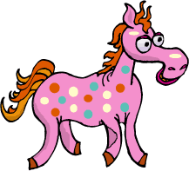
Dreaming whilst hungry,
begging for more with kindred.
Rolling on the ground, laughing till he began to cry.
Tony decided to relate one story among a hundred
because big sister did not want to try.
“Please stop that useless crowing,”
sighed Tony’s mother, “Make that face dry
stop wasting tears or you’ll stop growing.”
She said, “Go read a book today,
then able to have an intelligent talk.
Before your hair’s gray
don’t sleep but take a walk.”
So Tony went for a walk and met a rude mule.
He asked, “Can I sit on the stool?”
Suddenly mule lost his cool
and Tony replied “Go ahead, look like a fool.”
Quickly left and soon met Wooish who has part worm and part fish.
Wooish begged, “Please remove me from this hook,
and don’t make me a dish
take a look, that young fisherman is a crook.”
The young fisherman was short and heavy as lead
and under hot sun, he looked very sad.
He said, “Used to love to dance on my head
but after it pains extremely bad.”

Fisherman belched and suddenly became tall and an old man
who regularly refused fruits when it was time to eat.
He said, “Everything is too sweet.”
He ate too much dessert and became terribly sick.
Worried friends brought disguised fruits in big basket
but he discovered fruits were sweet and realized it was a trick.
He now quietly lies in small casket.
At the fisherman’s funeral was Polly a yellow pig
who was plump and lost a hip and now has two hips.
She wore a red and blue wig
and was searching for her yellow lips.


Tony met a sly alligator known as Ali who spent life on the river banks.
Ali loved to take a bath or shower whenever he stepped on the ground.
Not once did Ali say thanks
to delicious food he found.
And among the waters muddy
emerged a sad looking hippopotamus.
Said the hippo to Ali, “I’ve lost my invisible buddy.”

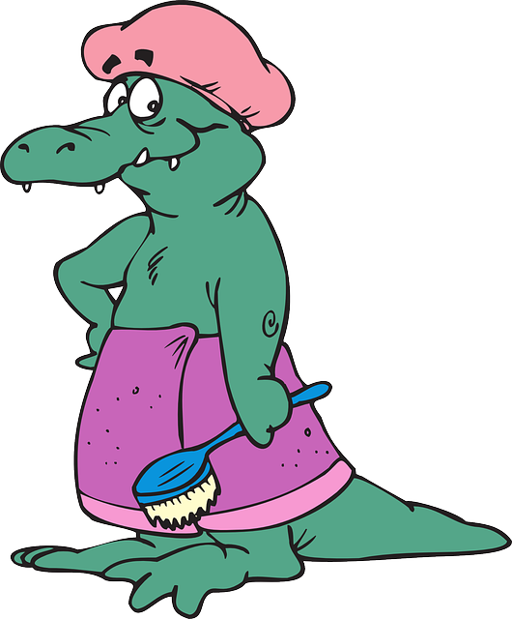

Tony decided to leave as everything was ridiculous.
High in sky, hungry eagle with sharp eyes
spotted a blackbird sitting on the hippo and eating a snack.
The bird was quiet among the buzzing flies.
The eagle suddenly swooped down and snatched blackbird from hippo’s back.
Close to the riverbank, Water told Fire,
“Because you lost beloved daughter
I’ll look, but remember I’m not for hire.”
Said grateful Fire to Water,
“Please do, especially next year
because you’ll be everywhere
and surely would find my dear
until then, good news hope to hear.”



Under a red mushroom was a green spider called Saul
who wanted to spin a web in community hall.
Frightened owner saw Saul and began to bawl
and the commotion caused poor Saul to fall.
Saul was soon greedily eaten by a silly purple snake
who lived alone in old tool shed.

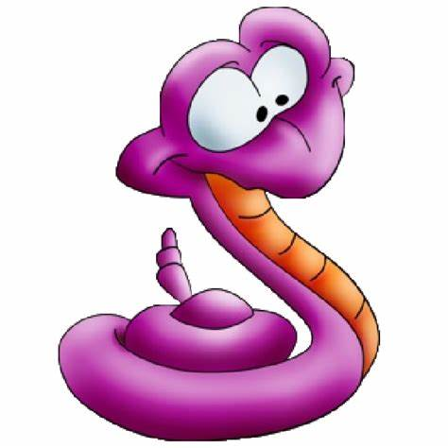
The snake had mistakenly eaten a rake
and only realized mistake after they were wed.
At wedding reception the silly snake ate a mouse named Brent.
The snake and the rake found an empty house in Kent
but soon left due to high rent.
They finally decided to live in a tent.
The snake tried to eat a sailor’s goat
but goat escaped into sea but could not float.

Nearby two brothers were fishing and hoped to visit Troy.
One cleverly devised a secret ploy
to obtain a child’s toy.
Their old mother was from Norse
she had a big-eyed horse known as Henry who felt he was a boss.
He was an extraordinary horse
who ate coloured paper at his reading course.
After graduating Henry decided to return home where he met Harry the hog.
Harry was fat as a log, always hungry and did not like to jog.
“Jog twenty miles a day to lose weight” advised Belinda the pink and brown bug.
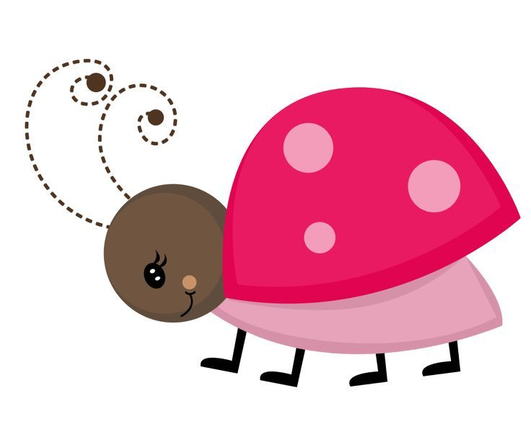
Then hungry Henry hugged the bug and soon became thin as a rug.
Harry then met Sally the sheep.
He told her, “Teach me how to leap
among high rocks and creep.
I’m terribly afraid of slopes so steep.”
Sally fled and Harry returned home to find his favorite seat
contained a small man with five feet
who claimed to perform many a circus feat.
The small man began counting to twenty then ate a sugary treat.
He advised, “Try to find a good wife
for when gladness turns to madness
and when home is full of strife
she would able to overcome any sadness.”

The small man left and met King Tim the blue telephone who lost his ring.
But Tim did not feel blue
because doctors said it would return if he did not sing.


By morning King Tim was as good as new.
Suddenly King Tim scratched his head and removed Edward the blue louse.
Said the louse, “If it’s okay with you
I would like to use your head to build a house
or you could drop me off at the zoo.”
The louse was kicked out and soon met jolly Santa Claus
with endless names on lists long.
Santa said each name without a pause.
Santa’s features were correctly described in festive song.
At his side, was a tired Easter Bunny with basket very large
filled with broken eggs that were once delicious.
The bunny fed Larry the lobster and his children without charge
and they gobbled food as if carnivorous.

Larry headed for fridge with food
then ate chocolate cake in oven that tasted good.
He continued to eat until he was green and overfed,
then with stomach filled and still weary mind
became drowsy watching television.
Soon without knowing, Larry was dreaming of food fine.
He soon awoke and found himself seated in talking boat
that was stationary in large moat.

The talking boat felt she was a goat
and said, “I am a goat and thus cannot stay afloat.”
Afraid of sinking, Larry and the talking boat swam for land;
finally they reached large beach with castles of sand.
The castles had angry faces and couldn’t understand
why tides wouldn’t allow them to stand.
The castles nodded in agreement when they saw Waldo the yellow whale
relaxing on shore after swimming exams which everyone usually fail.
Waldo sadly recalled, “Trained to swim in a pail
but on sea, could only find Cyril a large crab.”
Cyril complained of heavy scab
a broken back and legs of lazy flab.
Cyril soon caught by hungry man with quick grab.

Soon aroma of cooked crab attracted Oreo the orange octopus
who wanted to partake without a fuss.
Before eating, complained of long ride in crowded bus
then boasted that personally knew Christopher Columbus.
During meal came Sumintra the silver shark
who was invited to dine and with delight began to bark.
After eating in the dark
she began singing tunes as if ate a lark.
Looking for resting place Sumintra met a herd of elephants
with sad faces because they had just trampled some ants.
On bended knees, the elephants prayed to forgive miscreants
and they swore loudly never to eat plants.

Sumintra quietly left and kicked a seashell.
The yellow seashell was known as Shiva and he soon awoke and had a sad tale to tell.
Shiva said, “My friends and family stolen to sell,
but I was left with empty feeling and never well.
Yesterday I tried to flee
by climbing a coconut tree.”

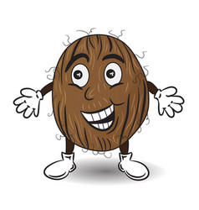

Tony met Carl the Coconut who told him of a boring life without glee.
Carl said, “People come and take a nut, thinking it’s free.”
Sally and Carl argued about need for a coconut vault.
They were soon joined by a block of talkative salt
who complained that fishes never would halt
at traffics lights which turned red and he once collided with a small shrimp
who now swims with limp.
The shrimp secretly wished to grow big as a blimp
to prevent him from being eaten by a greedy imp.

Carl bid everyone farewell and began searching for sunken treasure
which was overlooked by divers during their leisure.
He soon found it and the value was difficult to measure
and the excitement created extra pressure.
Nearby stood a group of cute coral
who complained of work dismal.
To their left was Gustavo the Seaweed
who talked of friends and swam with speed.
Gustavo advised but nobody would heed
because the corals felt their ideas were only useful for Richard the Reed.
Richard stumbled across a large underwater farm,
and was careful not to mistakenly harm
residents of beauty and charm.
There were some swimming bees in a swarm
who stung Gustavo till his body was numb.

Nearby was Gretta, a blonde possum from Greece, who was eating a plum
and wanted to prove she wasn’t dumb.
She began to give advice about dangers of an imaginary bomb.
After the words of wisdom she began munching on a fig
which grew on a tree that was bushy and big.
She began chatting with an oil-rig
but it jumped away and began a jig.
Gretta met Darling the Dolphin who had been in the media
after eating a radio and an encyclopedia
whilst trying to find cure for bulimia.
Darling’s father was close to hysteria
after standing near a sleeping eccentric eel.
Darling never slept because she did not want to miss a meal.
Every morning she would ask for an orange to peel,
and after eating the fruit would say “For years I felt like a heel
since I wanted to pray but had no knees to kneel.”
Darling also boasted of false teeth made of rubber and steel.

A few houses away was Sorry the Skunk
who was perfumed with pink and green stripes and looked like a punk.
Sorry told Darling, “I wanted to be a monk
but too small for their big bunk.”
His dreams surely would’ve been sunk
as he was always drunk.
To prevent any escape, his foot was chained to a tree trunk.
This was penance for swimming exams he planned to flunk.
On Sorry’s striped back was Samantha the Snail
boasting she could move faster than a growing toenail.
Samantha left them and braved sun, snow and gale
to reach venue of swimming exams which she eagerly wanted to fail.
Samantha felt the journey around the world must be made without oil
so didn’t drive van she used for delivering mail.
Samantha found time to raise money for brother’s bail
who was regularly stepped on in jail.
On the trip she met Dave a Dinosaur
who admitted life was a bore
because all his family and friends were buried deep under Earth’s floor.

Dave soon met Carol the Centaur
who was short, greedy and at dinner was always wanting more.
Carol wished for friends and a family to adore
since she performed antics galore.
She preferred free life without a chore
and had neat raft built from broken kitchen door
that she had stolen from grocer’s store.
The grocer became very sore
and said Carol was rotten to the core.
Carol’s best friend was sly Cindy the Cobra
who wore a dress and blue tiara.
After her performances, expected loud hurrah
but only obtained nod from zesty Zorro the Zebra.
His favourite dish was three plums and two pears.
One day Cindy received loud cheers
from two lost, hungry polar bears
who would cry plastic tears.
On a high tree, was Jerry the blue cherry who was never merry
because he was often mistaken for Beharry the Berry.
The cherry had amazing energy and loved to travel on the ferry
but when ripe became slow and weary.

Hidden underground was Cleaver the Carrot
who was frightened she might rot.
The carrot wanted to play in the sun that was very hot,
but was afraid of being eaten by a hungry parrot.
Nearby on a long vine was Ginger the Grape
who wanted to be a carpenter and wished the vine was a measuring tape.
She longed to fly with a red cape
like Captain Underpants to visit her sick mum
and step-brother who was a bit dumb
and speckled father who was a bum.
On the vine were other fruits including lazy Lucinda the Lime.
Persons would ask if she could tell time.
She would stare at them and chime
and often acted as if she was a mime.
One day Lucinda fell near to Carlos the Cabbage
whose curled leaves was proof of his old age.
They soon married and decided to travel with little luggage
and hired a fast carriage.
Carlos hoped to act on a famous stage,
but did not interest anyone in the sea
except Francine the Flea.
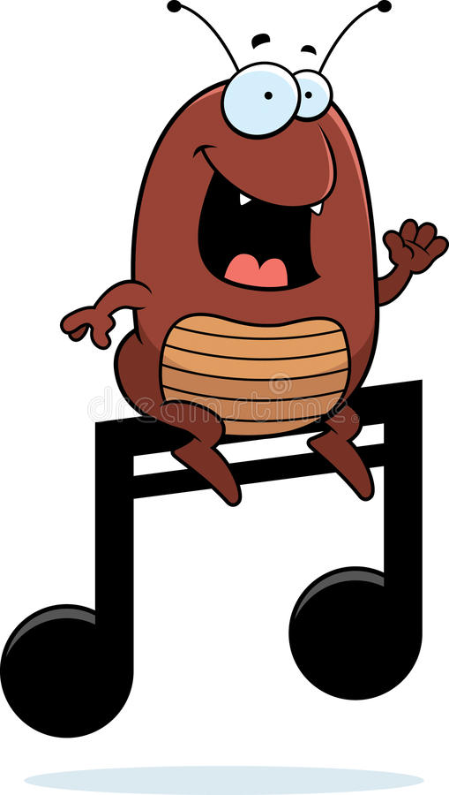

Francine was a singer once sang with glee,
“After I find my lost car-key
will talk to a famous agent who lives on a boat with a rat,
but the agent is a glob of talking fat.”
Francine found Rowburta the Rat who ate piece of her prized cricket bat
and made three holes in her nice hat.
The rat ignored her and began to fight with Soong the Snake.
They were fighting over crumbs of stale chocolate cake
and then Soong from Japan said, “You win because I have arms that are fake.”
So Rowburta grabbed the cake but was worried when he felt earthquake.

The rat and snake heard splashing and soon found a drowning lizard
who was closely watched by Bernardine the Buzzard.
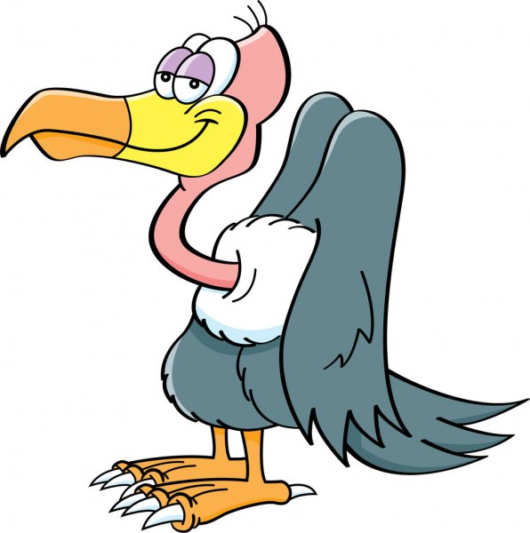

Bernardine had a orange and yellow beak and said, “I enjoy eating lard
and able to swim better if I had a gizzard.”
The lizard finally reached the shore and found seated on his broken chair
eating porridge was brown Banerjee the Bear.



Banerjee had a pillow and blanket and talked without fear.
He pointed to a family walking near,
“If wasn’t for this fur or hair,
would probably be a cold bear.”
Then his mood changed, and with sneer
asked “You want my hide so dear
or did you come to make my home disappear?”
With a grudge Banerjee offered the lizard a square glass of beer
and when lizard refused, he received a cold stare.
Banerjee became angry and shouted, “Leave and never return here!”
The lizard left and then heard loud laughter of green and red monkeys.
who were laughing at polka dot donkeys.
Every week the donkeys would kick them and flee.
The polka dot donkeys headed for the sea
after monkeys warned, “This island is owned by a gorilla
who eats donkeys for dinner and lives in a villa.”
And, the gorilla once acted in the King Kong movie thriller.

Nearby seated on rock high was Tobbie the Tortoise
who related without surprise,
that he was once a rectangular porpoise.
Tobbie decided to change because unable to bear aquatic noise.
Above the tortoise was Ernest the Eagle
who was seeking his sister the famous flying beagle.
He wanted to hide after committing act illegal.
Ernest took a flute and played tune sounding regal
but quickly stopped when he saw Abracadabra the Albatross
who had long toe nails and was extremely cross.

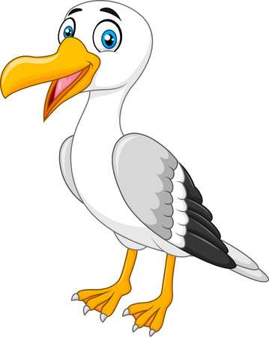
The albatross had stolen five boxes of dental floss
because his teeth had slime and moss.
Abracadabra quickly left only to encounter a surfing cattle
who played with a rattle.
The cattle began to noisily prattle
of brave stories and recent heroic battle
which he fought in Seattle.
As cattle left, along came fat Christopher the Cockroach
who warned, “Life is never safe, almost got hit by speeding coach.”
He was rehearsing for surfing contest and wanted to win a brooch.
Neighbours complained whenever his surfing seemed to encroach.

Christopher arrived on a small island and met Hammy the Hare.
Hammy explained due to a hidden snare
had to grow fangs which she cleaned with care.
Christopher raised his wings and said “You have nothing to fear.”
On the opposite end of island was funny Ferdinand the Fox
who lived in old, dirty box.
Around his neck he had forty clocks
which was to prevent him from getting smallpox.
Near an apple tree lived a professor with many comic books
who was reading on ways to frighten crooks.
“Stop reading books” shouted two rooks
who were soon eaten by the hungry professor who often people into brooks.
The professor and his wife owned three pet hyenas
and a cage with two golden mynahs.
The professor hated fancy diners
but enjoyed bad food from airliners.
He once rode on a camel with three humps
and had three eyebrows, two noses and facial bumps.
The camel said he liked the bumps which reminded him of mumps
and only drank water from green pumps.
The camel hated porridge because it had too many lumps.

The neighbor of the professor was a short dragon
who drank only from an expensive flagon.
The dragon would explain confusing scientific jargon
to a thirsty cousin living in a coconut tree in Saigon
who owned a mule, two monkey and a smiling penguin.
The penguin claimed to have invented the garbage-bin
and always talked of lost kin.



who lived faraway in Antarctica and never committed a sin.
The penguin always wanted to know
if anyone happened to see any snow.
Whenever someone told him no
he would happily began to sew.
Not far behind was Elina the Egret
who wanted to be a famous poet.
But she only composed poems for her sister’s dead pet.
One day whilst singing in musical duet
Elina touched an electrical outlet
and now lives in sad regret
because while singing she would soon forget.
She only composed songs while nibbling on a cotton net.

Elina took a trip in a very long car
hoping to see places afar.
It was driven by a two-headed green monster
who would regularly swallow a chocolate bar
which was kept on the front seat in a big jar.
The jar also held insects at war
which were obtained from near and far.
In the trunk of the car was a fallen star
resting on a golden bar.
The green monster sometimes did not look at the road
because he felt dizzy as if in strange abode.
Elina soon met Tommy a Toad
carrying a heavy load.


He blocked the busy road
and began to blabber in unexplainable mode
that he had rights according to the city code.
Elina left him and then stopped at a shop
found a telephone and dialed a cop.
Soon the police car came along and almost did not stop
because inside the car was a rubber cop
who did not use a gun but had a large mop.
The cop almost blew his top
when learnt that his entire crop
of corn was ruined by rain and his sales would eventually flop.
Then the shy large mop began to hop,
it hopped away because it was afraid of the approaching pedestrian
who was running as if a great equestrian.
The mop said, “My father is an electrician
who wanted me to become a musician.”
Before Elina could ask what the mop meant
the shy mop ran away with his head bent
and this resulted in a serious accident.

Elina met Troy the Truck who one day slammed into a parked tricycle,
that lost a wheel and it is now a cheap bicycle.
From the nearby crowd, emerged a crying man with cracked monocle,
claiming to be victim’s uncle.
But after adjusting his cracked monocle
realized mistake and quickly left carrying a rusty sickle.
Troy sighed with relief and bought a popsicle.
Troy was no ordinary truck,
he was a troublemaker who walked and quacked like a duck
and began crying about bad-luck.
The troublesome truck left but fell in tar and was stuck.
Then who should come along but Ben the Hen who charged one buck
to help but the truck could not pay to become unstuck.
Troy said he was a poor person from faraway land of Yuck
who could only drive, bounce and knock.
Ben then decided payment would be a hockey puck.
Ben began telling Troy a tale of a friendly scorpion who could blow a horn,
“He was a harmless Capricorn
more harmless than a broken crayon.”
Then Ben became excited and began to jump
but quickly stopped after fatal bump
as a result of tripping on a tree stump.
His head now had a sore lump
and he resembled small camel with an extra large hump.

Lester the Lion who was a friend of Tony, was afraid of an ugly kitty.
But the kitty felt pity,
and advised Lester to be more witty.
People traveled far and wide to small city
to comfort and sympathize with kitty.
But laughing at kitty, was a small mouse
who looked as if flattened by a house.
The mouse smelled as if bathed in spoilt souse,
and people without any grouse
admitted he was an extremely ugly mouse.
Observing the mouse was Gary the Goat who was a generous gossip
who boasted of places he visited on a weekly imaginary trip.
Describing in detail his favorite food was boiled turnip,
which he ate until his clothes would rip.
He had a long whip
to punish waiters who would not serve him a boiled turnip.
One day after eating a turnip his lower lip
began to grow and grow till it was past his hip.
Soon Gary could move only if he decided to flip
otherwise he would trip.
Gary finally met Tony the Pony who had orange tail and wanted to skip
and would often stop to give a helpful quip.
Gary said, “Your mouth needs a zip.”
Tony felt sad because it was his dream and suddenly tears began to drip
and he soon was thirsty and needed a sip.
The polka dot pony drank until his stomach was big and felt it was about to rip
and he looked like a large cruise ship.
He began to bawl and was heard by all on harbour’s tip.
There in front was a grand castle
built especially to withstand battle
and a bridge resting on fragile mantle.
The castle had an appearance gentle
and anyone would want to settle,
even though engineers said building was brittle.
On leaving castle, Tony entered a garden with tall, smiling tower.
It slowly became lower
and Tony appeared to cower.
He sought advice from a sleeping flower
who said, “Do not cower or be sour
enter quickly because you have the power.”
The flower soon fell asleep on seeing a rain shower.

Tony ran from the wet garden
entered the castle and remained hidden.
He did not expect a maiden
or royalty in this castle laden
with dust and cobweb and smelling like an animal’s den.
Greeted by Jacqueline the court jester
who immediately began to pester
Tony for money and a cooked oyster.
Frightened by the jester, Tony ran to a potter
whose father was a professional fire tester.
The room felt hotter
so continued inwards and found there paintings nice.
Soon observed that all were portraits of rice
in all styles, cooked, raw and some looking like delicious lice.
Some appeared so real that two were eaten by mice,
who after played dice.
There was even a painting of rice frozen in ice,
some baked as rice bread and seemed so real that Tony begged for a slice.
A final picture had a large jug filled with cooked rice
Tony left and entered room with talking bed
which began to complain that under-fed.
It ate pillows, ponies and lead.
Tony had a look of dread
and quickly fled.

Finally reached large hall of king and queen
but now Tony wasn’t very keen
to be heard and seen.
The king was a hot pepper and the queen a red bean.
Both seated on thrones tall and lean
surrounded by mud figures who would constantly preen.
At the side was a princess who was a weird teen
and despite missing a few teeth
she was always eager to greet.
Her fingers were on her feet
and eating was a bizarre feat.
When there was unbearable heat
she would dress in her best clothes then roll along a dusty street
and still appear clean and neat.
The royal family also had a small giant
with huge hands and growing on top his head was a cactus plant.
He often walked slowly so the cactus would not slant.
Before he had the plant he would play truant
run in circles then begin to pant.
He felt these actions were brilliant
and for one week would be jubilant.
The duty of the small giant was to guard cobwebs and dust considered rare.
This he did with extreme care
and strangers would receive a cold stare.
Any suspicious person would be watched with fear.
If anyone came close to the cobweb or dust, the giant would make them aware.
Bobo the Bear was from the land of Nowhere
and once mistook the cobweb for fine jewel.
Nobody knew that Bobo was under an evil spell,
and anyone touching him would turn into a bell.
This strange tale Tony and others tell
to visitors with faces full of gel.

Leaving the royal family, Tony spotted a cellphone
and began to dial but it was dead as stone.
Then the cellphone told him about the sale of a cheap throne.
Said the cellphone, “Take a loan
buy the throne which emits a low drone.”
Tony bought the throne but it would pout and loudly moan
when anyone sat on it, so Tony thought he wasted a loan.
Tony was bored and went to the land of Marmelades
where there were only waiters and maids.
They were neatly dressed with hair in braids
as punishment for low grades.
Each had shovels and spades
which were used for eating and displayed in parades.
Some waiters spent days cleaning a large sword
whilst others would be painting a board.
Any splinters given to maids who loved to hoard.
After twenty years of cleaning and painting they became bored.
They wanted a change and decided to strike,
but were afraid to tell boss whose name was Mike,
because they feared he might do something they would not like.
So instead of striking they decided to buy him a green bike
which he would ride in flooded dyke.
This frightened a huge pike
and interrupted the swimming of a tyke.
Tony decided to tell Mike to join him on a hike
and Mike decided to do this wearing shoes with only one spike.
Mike carried Tony and the pike along a flat road
and Tony carried a heavy load.
But Mike was unhappy and threatened to explode.
Tony soon bellowed
and the pike sweetly crowed.
There was grass in the middle of the road
and Tony threatened to have it mowed.
Eventually, the boat trip ended and I saw a river that never flowed.

17

Closer to our Lord
Lord bring me closer to you, bring us closer to you,
Help us God keep my mind focused on your goodness.

Come into our minds, come into our minds
Make us holy, make us holy.
I sing praises to you, we sing praises to you.

Help us, keep us on the path of love
Come as the dove, keep us on the path of love.

Lord, purify our hearts, purify my heart.
Cleanse me of evil, cleanse us of evil till our hearts are pure.
Heal our weaknesses, heal our pain.

Come into our minds, come into our minds
Make us holy, make us holy.
I sing praises to you, we sing praises to you.

18
Wearer of the crown
The Garden of Gethsemene was his sanctuary,
He prayed for guidance and his followers’ safety.
God watched over his Son in solitude,
Future generations will praise and forever be in gratitude.
Divine Jesus was betrayed, whipped and humiliated
He painfully endured mockery, abuse and hatred.
Dragging a heavy cross through the jeering crowds, he accepted the Holy Grail.
Gentle Jesus now bloody, his bare feet and caring hands now nailed

For hours Christ hung from the old, wooden cross
His friends and family mourned the great loss.
Soldiers gambled for my Lord’s clothes and fed him wine vinegar,
The forgiving Christ suffered from thirst and hunger.
And forgave them of their acts of indecency
As they fulfilled the prophecy.

It was there amidst rain and dark clouds on the deserted hill,
My Saviour looked to the heavens ready to fulfil his Father’s will.
The two forsaken sinners died with the Son of God and his mother cried,
Gentle Jesus was taken down, washed and buried.
The crown of thorns on a weary head that often did not rest,
Our sins now washed away and our lives forever blessed.

19

He has the power
My Lord has the power
Oh, yes, He got the power
He got the power to fight Satan
He got the power over angels
Our Jesus is powerful and wonderful.

Oh, yes he got the power to drive away demons
He got the power to make the blind see
My Lord has the power to let the lame walk
And make the dumb talk
Our Jesus is powerful, powerful and wonderful.

My Jesus defied the Devil for forty days in the desert
My Lord has the power to change water to wine
And heal the paralyzed
Our Jesus is powerful, powerful, powerful and wonderful.

My Jesus raised the dead, he easily cured the sick and dying
Your Lord got the power to walk on water and calm storms
My Jesus healed skin diseases and the bleeding.
My Jesus was never afraid of any laws, rulers or rabbis.
Our Jesus is powerful, wonderful, wonderful, wonderful.

He’s so amazing and wise
My Jesus gives hope to the hopeless
He makes us soulful
He fed crowds with a few loaves and fishes
Our Jesus is powerful, wonderful, wonderful, wonderful.

20

Baby Jesus

Baby Jesus lies asleep in the manger
Baby Jesus loves all the babies in the world
Jesus loves the laughing and crying babies

Baby Jesus sleeping in a crib of hay
among the horses who begin to softly neigh
He watches over all babies in the world.

Gentle Jesus will comfort sick babies till they sleep,
and keep safe the orphan babies during those frightening times.
Baby Jesus watches over all babies in the world.

Baby Jesus will protect children in the light and darkness
He will comfort the sick babies and hug the sad babies
Baby Jesus will make all babies smile and be happy.

21
The Ark

Many years ago there was a man known as Noah with a vision.
God spoke to Noah and told him to begin building an ark.
This was Noah’s mission and his family’s vision.

The ark was huge and built for various animals.
Pairs of giraffes, elephants, cows, pigs, birds and even snails
all entered the ark.

Noah and his family along with insects, birds and animals waited and waited
then the rains came down.
It rained and rained for many days.

Some persons outside the ark shouted
for Noah to open the ark.
But nobody heard and the ark floated away.

22

Risen Saviour

He briefly went to meet His Father, Lord of Earth and Heaven
and returned to see the faithful.
No one expected to see again the man who hung from the cross
and defied the Pharisees and teachers of the Law.

For some, the empty cross reflected a battle lost,
as one man died for the sins of this world.
No one expected to hear about a stone being rolled away
and an empty tomb.

His sermons, advice and parables no longer heard,
but his messages of love and forgiveness will be forever told.
No one expected our Saviour to return again
to bring light into lives and ease heavy hearts filled with pain.

That early morning will always be remembered
when Christ returned to prove doubters wrong.
No one expected God’s Messiah to defy death
and return with a glorious promise of everlasting life.

23
You are part of our lives

Holy Spirit enter our lives, free us from evil and hate.
Holy Spirit we are ready to accept change and glorify your name.
Guide us, guide us today and tomorrow.
Guide us on a path of goodness.

Holy Spirit fill our lives with your holiness
Uplift the poor, sick and lonely.
Holy Spirit guide us through the heavenly door and gate.
Protect our families and loved ones.

Holy Spirit enter our lives, free us from darkness
Fill our lives with goodness.
Breathe into us and let us shine with brightness
Support our frail bodies in these earthly vessels
So we can give thanks with grateful souls.

Bring redemption and salvation for our destiny.
Give us strength to overcome evil and wickedness
We honour you and praise your name
We adore your grace and holiness.

24

He is always there

Jesus helps the poor.
Yes, He will never forsake those in need.
He will harm neither flower nor weed.
Yes, Jesus is among the poor and will heal the baby’s broken arm or sore.
My God is a good God who watches over rich and poor creations,
He knows each ghetto and tears on a little girl’s cheek
and can hear the hunger of the unclean boys in a slum.
Yes, Jesus knows the beggar’s daily frustrations,
He is in the slums and always provides silent comfort to the poor and weak,
He watches over the unemployed mother who is worried and glum,
and knows that soon all the poor who aimlessly roam
will live a life of comfort and peace in His heavenly home.

25
Keep the fires

Can you feel the fire?
It’s burning inside you, it’s burning inside me.
Lord keep the fire burning. Lord never let this fire stop.
The fire from the burning bush has spread to every town and village
it’s burning the wicked and destroying the evil.
It’s an unstoppable fire
burning in my soul, burning in your soul.

O Lord cleanse my soul
wash away my sins, wash away our sins.
Let the fire burn away doubts and selfishness. Let it burn and never expire.
Anoint us with holy oil.
Keep me burning with the holy fire
Let my faith overflow and spirituality boil
till my time is ready to enter your kingdom.

26
We shall sing

We shall sing your praises to the highest
We shall shout your greatness.
Our voices will be heard from the lowest to the highest.

Come and join hands as we confess
Accept us so we can proclaim your goodness.
Let us exalt your divinity.

Let us embrace your beauty,
We shall sing till we are weary
We shall sing till every soul is merry.

27
Clap your hands

Clap your hands if you are part of the beauty of this world,
clap your hands if you are a follower of Jesus.
Clap your hands for being a praying soul
clap your hands for Jesus to enter your life.

Clap your hands if you help others,
clap your hands if you are a follower of Jesus.
Clap your hands if your friends are true and loyal.
Clap your hands to ask for salvation.

Clap, clap, clap those hands till Jesus enters your heart,
clap your hands if you are a follower of Jesus.
Clap those hands to tell others He is here,
clap your hands as we greet His arrival.

28
The baby is born
A bright star in the dark sky, followed by three wise men
it is the sign of the arrival of the Christ child.
The crowded inn and a lowly stable was all part of the plan.
A special manger with the animals was the designated place
for the holy birth of our messiah.

Wise men with costly gifts travel far to greet the sleepy newborn,
braving cold winds and strange peoples.
They kneel before the quiet baby, giving thanks and praise
for the miraculous birth of our holy messiah.

Mary and Joseph stand in awe, witnessing the gift to humanity.
They know not the greatness to come of their precious baby.
Many are still unaware of this holy birth of our great messiah.

29
Rejoice in the Blessed

We praise Him who opened the rock for water
and shielded the orphan son and motherless daughter.
We will not forget our Saviour
Whose wondrous works never end.
Sing praises to the One who rebuked the Red Sea.
God speaks and His holiness is awesome.
Blessed is His presence.

Praise the Lord!
Rejoice!
Only You, O God can help us.

Behold our Lord.
Blessed are You, O Lord. O God, the Lord keep us safe
as the lily of the valleys.

30
The Crown

Praise the One who once walked among us,
Give thanks to Jesus.
He protects the widow and the fatherless;
His crown they made of thorns and mocked Him.

A King of Earth and Heaven,
Give thanks to our King,
Our King for His boundless grace,
He protects the unborn
He suffered for us.
Yet they treated Him with scorn.

31
The Hated
You persecuted the needy, poor and orphans;
the sinner remains an abomination.
Storing grain for friends, the greedy do not gain.
Nobody fully knows the wrath of God,
Sin that smells like saffron and tastes like honeycomb.
You dream of eating pomegranates among fountains of living water.

32
Warning for the world

They no longer tremble at the Lord’s presence,
as their poor cry for honey and milk,
They are ignored by those adorned in clothes of silk.
Like the children of Egypt they seek God’s blessing.

Today’s leaders rule worse than the hated Pharaoh,
they are like the vipers who bite the innocent.
Cries from the Valley of Gibeon once ignored
still persist as their descendants mourn and lament.
You praise everyday idols and trivialize the God of Jacob.

The righteous wait on Mount Zion for a sign
they cannot be scattered again.
They have also waited on Mount Perazim
Lying tongues and deceitful hearts;
kindle fires of love and knead dough of gratitude.
They resist the false prophets,
the pride of Judah shows no remorse for those who entertain
modern day harlots.

The God of Israel look on the evil,
they will be cut by swords and burnt by future fires.
The evil reject the word of God;
they dwell in rebellious houses.
The God of hosts will send another plague.

The evil that smells of incense. False divinations emanate from
false prophets.
But our God is merciful.

33
The Coming
The God of Israel does not care for your slaughtered animals,
and petty sacrifices.
If your heart is filled with revenge and lust then your pleadings are useless;
If your singing and rejoicing sounds as melodious as David’s Song of Praise, if your mind is stained then all this will be hollow and meaningless.
You cried for His help
just as the Israelites cried out to the flawless Lord.

Have mercy on those who deny the Lord our God,
lament for those who expect God to avenge their wrongs.
We do not know the Most High who
ensures the lamp of Israel will continue to burn.

Those before us, used the finest cedars
their priests with decorated vestments awoke the sleeping spirit with their trumpets
and observed the various feasts of the Lord.
They recited from the Book of the Law but ignored basic laws of humanity.
You too will suffer from a similar fate
as you claim a place in heaven.

