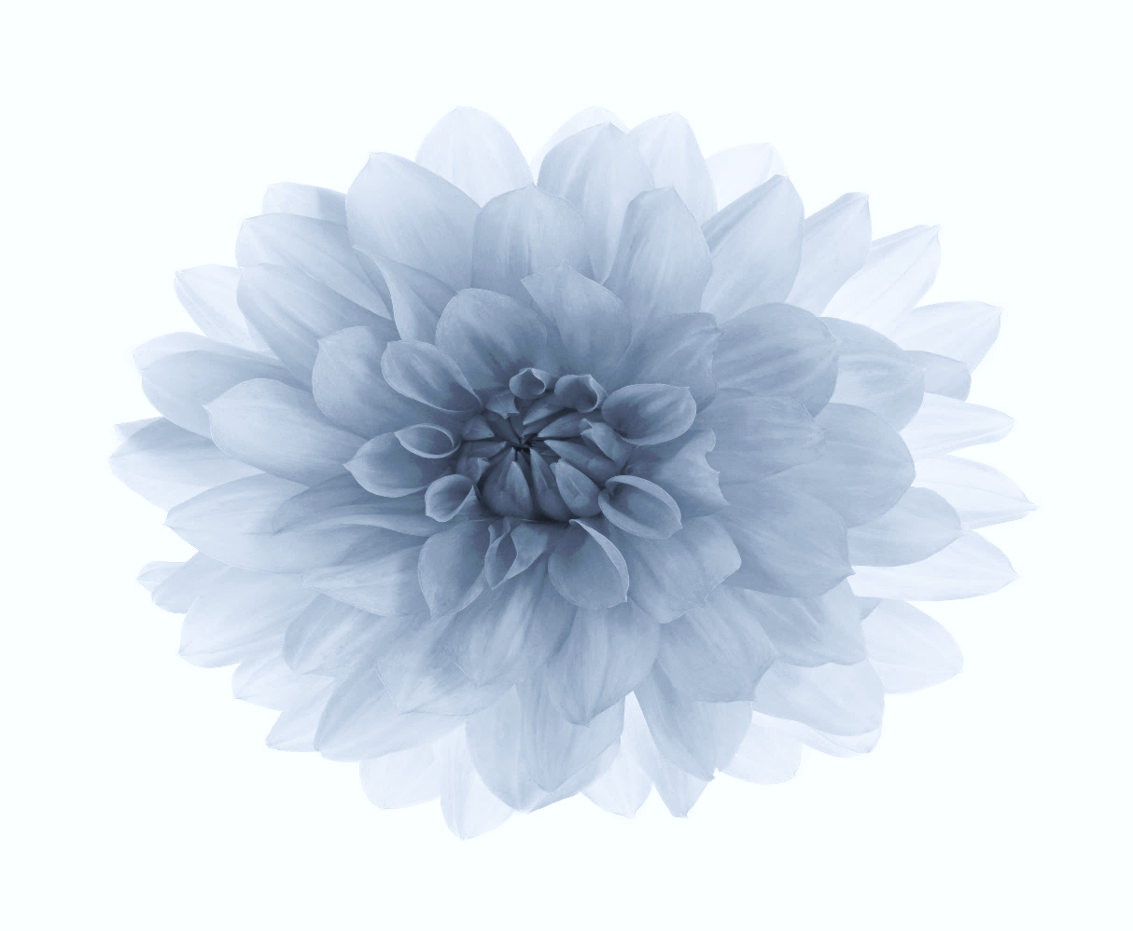

Love Came By
With Lacquered Flowers
By B. Christie

Copyright© 2023
Cover art by postermywall.com
Cover design by Brenda Christie
Images by stock image
Edited by Brenda Christie

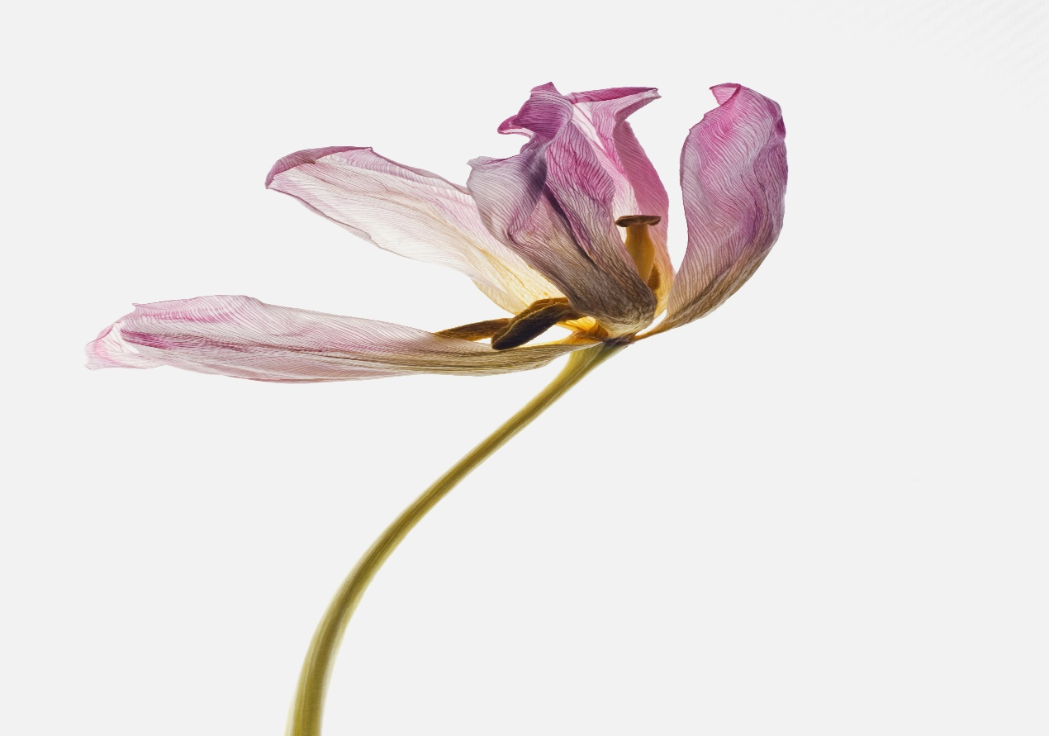
There is no other language more meaningful than love.
And there is no other language more harmful than hate.
I hope you find love overall.

Table of contents

Broken Secrets………………… 5-26
Watering Her Heart…………27-48
Growing Apart…………………49-70
Plucking Dead Flowers………71-92
Feelings We Yearn For……93-114

Broken Secrets
5-26
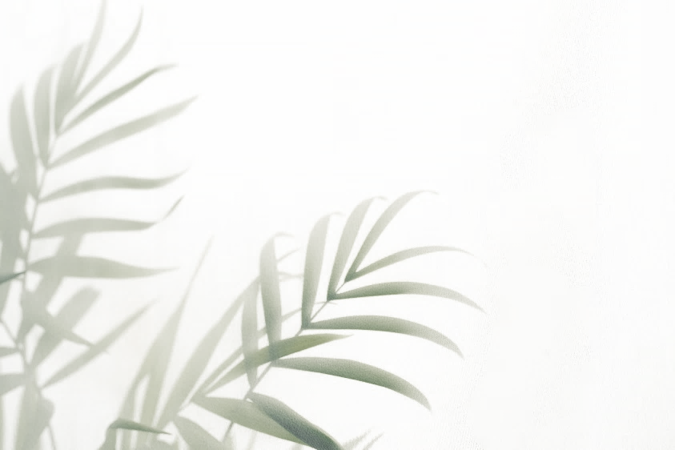

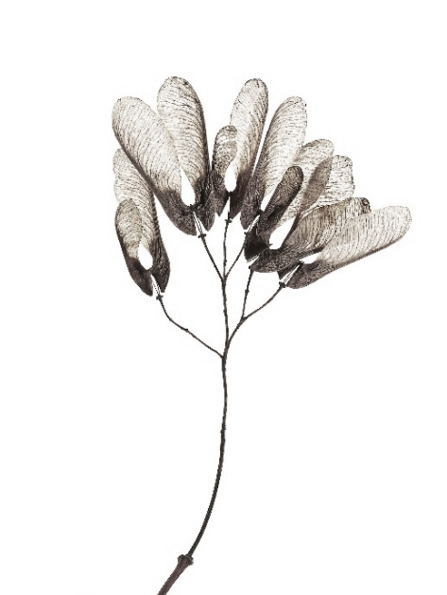
It started, as far back, as I can
remember, with her tender voice,
soothing to the ear.
She reassured me,
that I would
make it out of
the most difficult
times because
her gentle spirit
and hardboiled heart,
always cracked open with love nearby.

Her roots were unshakable.

There were times, when
I wanted to escape
from reality.
Fear burled,
into the core.
I panicked,
when I felt unsafe.
Her love,
was safe.
Her love was real,
but she couldn’t
protect me from life.

Roots
don’t always hold
families together.
Especially, when
the weak roots
are dirt
poor,
growing
on the
other side
of the
fence.
Stuck
in a
grave of
sprouting
forgottenness.

My father was the weak link.
He held all his confidence in
sexual desires
for other women.
Breaking apart
the structure
of our family
and my mother’s
trust in him.

Trust in men.

A woman’s body,
should be her own.
In many circumstances
a man still controls,
a woman’s needs.
My mother suppressed
her feelings for many
years after she was raped,
and pregnant with a
child she did not keep,
but they met in later years,
before my mother died.

Love can find,
its way back from heartache.

I was determined early on
to pick out the broken pieces
from my hearts chamber,
and made a glass home,
inside myself.
Everyone not welcome in
my home tried
to shatter my self-worth’s value.
The clear vision
my family looked
out of, was
unbreakable.

I held onto them.

Bullies walked,
around the perimeter of our house.
They’d knock on the door,
I never opened it.
In the school, and outside
the school is where they
lived to hunt you down,
and beat you until
you quit school.
Panic attacks
became an unwanted
friend, that thrived,
inside, until I started
running down the street
and away from myself.

I didn’t allow my feet to touch the ground.

Her hands were strong enough,
to hold the both of us,
but someone else had to pay.
“I am sorry,
I demanded
so much,
but I had no control,
over fear.”

I couldn’t let her go.

Looking through
an opaque window
was the only way,
I could escape clearly.
From this haunting
vision I had
slowly recovered from
to build strength
with humor.

Laughter was a happy place.

Roots can tie,
miracles together
when we think
no one else
cares.

And some can untie the knot, of true love.

Doors have closed heavily,
in heartache.
I learned to open a few windows,
exposing light to vibrate in the roots,
I planted in me.

The sun, shines full, where shadows, devour.

I loved a few.
Left many.
Never, did love
feel, what I needed
it to feel.
Friendship
was a loss found,
everywhere I went.

Why am I,
drawing on the
dark side of you?
When all the chalk confetti
begins to fall,
with uncertainty in me.
Shyness hangs onto anxieties
loss for words.
Escaping from reality,
with its mouth wide
opened for when death brings life.

There is something to be
said, about the dispirited,
men of the world without fathers.
They depend on secure women,
to guide them from the bed, then out into living,
with the sun shining on everything they do.
Women have held many clouds over their heads,
without being held in sunshine themselves.

Love is a garden.
Dotted with flowers.
Connecting the roots to
one another in which
we breathe and circulate,
in a circle of life.
Filled with our hearts.
Growing stronger for
each other’s feelings
of inseparableness.

Some will leave us warm.
Some will leave us cold.
Some will find their way.
Some will be lost.
Somewhere searching to be found.
Some things we will know.
Some things we will never understand.
Some will never know,
how deeply they have touched us,
to the inner core.
Somewhere, someone
is coming back from a dark place,
hidden in the stars of their past,
searching for the lost heart of their smile. . .
to give love. . .
between it all.

Maybe I’ll stay.
Maybe I’ll go.
I have wept for animals.
But never for you.
My mind has packed its
bags a thousand times.
I have stared at the
the luggage until I
have gone blind.
No airport in sight
on my flight today.

Everyone has left me hanging,
like a madman in the mouth of a serpent.
Blankness. . . glaring at me all day. . .
in hopes of catching fire in the
coldest hearts I have ever felt.

The world waits,
for you to light up
a new voice.
And ease the burden,
placed under the moonlit
star’s talking to the
skies dreams.
There are signs,
everywhere you go.
Signs, changing the
way you look at things,
in many directions.
Maybe, it’s not worth
the wait for time to
come back to you,
anymore, but now,
has nowhere to hide.

Here we go –
All alone.
People crying every day.
Breaking apart in love bit by bit.
People we don’t see, too familiar in our eyes,
we strain.
You look at me and I start to fly away.
No one’s ever touched me, in miracles this way.
Love was a smile you had given and opened,
from the start.
Caring for the things we believe in, to talk about.
Walk with me,
Stand out and hold my shaky- hand.
I think I am falling in love with you.
The winds are sailing around,
the world inside my heart.
I wish you everything.
On the stars tonight.
I wish you knew, how I wanted you.
I wish you knew, the love I have for you,
was, taking care of you, me, and us.

I break at dawn.
I break in desperation.
I break promises.
I break ends,
I cannot mend,
to keep or toss.
I suffer greatly,
from people not
knowing how to love
me with feelings of forever.
And sometimes,
we never heal,
in life, but death
finds peace.

Watering Her Heart
27-48
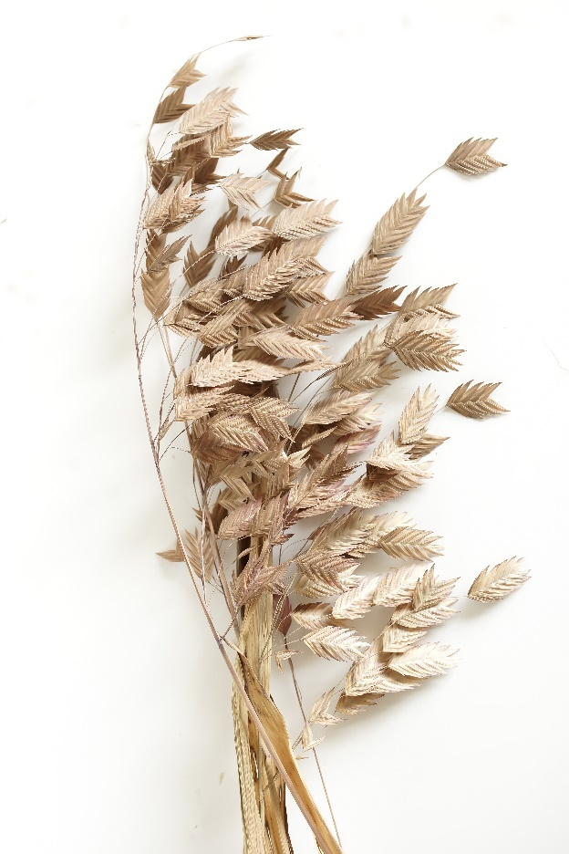

I crawled deep into your
emotions and you fell,
deep from my tears.
There is a hush that,
looms in the dark night.
A place we spent with meaning,
now turned downwards,
towards whatever happens - happens.
Take me as I am, a lost soul, coming,
back from a never-ending story.
Pursuing one another, until
there’s nothing left of the other.
Tell me I am worth something,
to someone’s paradise translation.

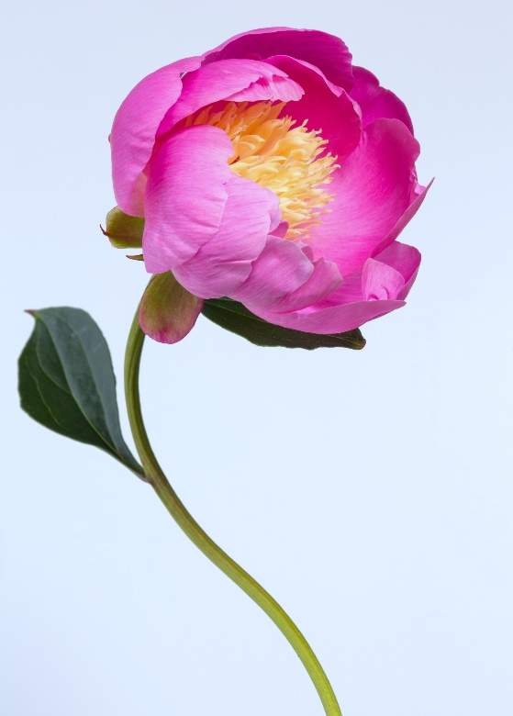

Breathe faith deep,
into sonorous lungs
suppressed in love.
Seed hope into
sprouting light
nestled along blue
hearted skies.
Wave courage high
above weaved willow wings
nudged between the spineless night.
Lift strength, not fear, to carry
you through the heavy void
weighing you down.

High winds,
torrent rain.

No sunshine
for you.

Love, matted in storms.

I bled, electrical for you.

I cradled your heart
in my fascicled womb
and pushed out words,
with meaning
into grey matter,
absorbing trenched
chaotic clouds.

It’s time to move from
this empty space I
clutter myself with.
They say a home is either,
your castle or your prison.
All I want is to find,
the person living inside.

Breathless flowers
on earth’s rotating hours.
Decaying frosty thorns
succumb to human sorrows.
Lavender pink swells
in the charcoaled sky.
Oxygen lacks in
their desolated smile.
Open their airways across the
meters homeland, inched in miles.
River flows in spirits youth, sipping,
teardrops in their graveyards cup.
The forest carpet stripped, once green,
anchored to mother’s frail seams,
swimming beneath the darkened sea.
Tripod armed in macrobiotic war.
Twisted in sheets of fire sliced with
slithering dreams, spread across
with sunflower seeds of hope,
hung on every war-torn door.

I prayed for
thankfulness
for what I have.
I ached for the pain to
find a new home,
beyond the unseeable.
The hopeful ride
has stopped suddenly.
The night is awake without a
warm breath to love bottomless,
inside my dreaming wholeness.
The fog has lifted my eyes, to
see a clearer view of meaning.
I longed to disappear forever,
in the stars of the outermost
possibilities found in the
innermost of happiness
just for me. . .
this one time.

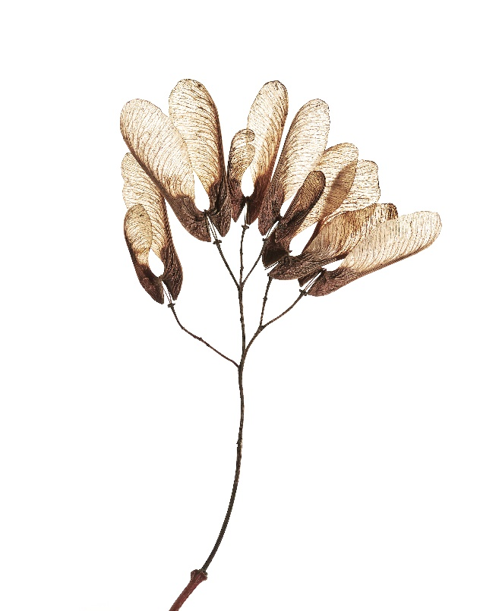

Caught in
tangled strings,
unwinding in knotted breaths.
Filtered out in a hazy lens.
Lost to a gaze behind an origami tree.
I began to melt down,
with visions she left behind.
I watched her play the bellow
accordion with her voice in hymn.
Captured memories, escaped the haunted keys,
where she woke inside her movable dreams.
I fell hard, with her love for me, to never say goodbye.

Caved-in minds,
minted on sandblasted walls.
Carnations bloom in death’s hand,
as life dithers in
triggered dreams.
Pieced together.
Scattered apart.
Humming shifts,
the unseen to
be seen, unheard.
Hyperventilating
until agony releases
demons, effortlessly.
To be in another
world, normalized,
by misery’s God.

I remember when a poem painted
the sky, without Pantone colors hurting the eyes.
I see your smile in the last breath I take when the
night dove sings me to sleep and wakes me up in
a blanket of clouds covered in the warmth of the sun.
Oh. . . my weeping eyes remind me how it felt to be with you.
The way I gasped in winter longing for spring flowers, as I ached,
for you in a time when love was real and everlasting through
undeniable happiness held in the moments of silence,
pinned against the ethereal glow surrounded by a million,
stars rising from the lacquered pearls of aching secrets.

I see a blurry ghost through
the limbs of boney trees.
A buzzing fly takes hold inside of me.
I can’t let go; I lose control.
Alone, I hush like purring spiders,
attached to stillborn leaves.
A ravished storm before the calm
strikes back a haunting escape.
I smell the roses deeply within
my pearled garden, stemmed
between the stars of heartbreak.
I leave a stone to remind myself,
I was never loved the same way, by anyone.
Unflinching darkness, watch over the
night for the breathless fall,
rakes forever, over me, inside.
Restlessly.

Because I love you

If you are ever sad.
I’ll make you laugh,
out loud.
I’ll tuck your
tears in my heart
and tickle them until
the stillness breaks
apart from the pain.
I’ll lace up your ache,
and run in every,
damn marathon race.
I’ll do whatever it takes,
to put a smile back on your face.

She was born to love,
in ocean depth.
Between the columns of the clouds,
and psychedelic marmalade skies.
Edging storms off chiseled cliffs
to reach the wind-pinched colors,
rouged in hollow cheeks and
pierced blue eyes, guiding
the bright particulars
back, with a compass
pointed to the stars,
in her blushing
sighs.

Sometimes, we are the
light in our own darkness.
A hollow branch, waiting for
a flowered garden to
grow from its dead trees,
plucking its own leaves
to bloom within itself.
And sometimes, we
are the light, healing
our inner wounds,
protecting tomorrows
promise to love,
more than this.

She is a budding,
wallflower poetess,
watching you sprout in
ways to grow through,
one another.

A Cinderella love story,
meeting her prince charming,
dazzling her once upon a time ago,
in her mysterious poetic lyrics.

A mother and a wife
losing her mind,
choosing words to keep
her sane, and to be a
better person for herself.

A dreamer, who comes alive,
in rainbows, coloring the nightmare,
skies, with cotton-shaped clouds,
raining sweet dreams of
fire, burning in the mouth,
of the lonely dragon, sleeping,
in a beautiful glass castle.

She can control her lover,
with one word to write the
perfect romance novel in
her poetic heart.

And she can clean up,
everyone’s mess,
with one thought.

She can bring awareness,
and healing through
the eyes, and ears of the
suffering souls around
the world.

But she doesn’t have,
the magic powers. . . if
you don’t believe in her.

She is saffron,
lavendered in gardens,
flowered in the spiced sky.

Planted with angelic
seeds; springing
wild wings of herbs and
luscious berries
lusting after happiness.

She is young and beautiful,
a strong bird, sang out loud.

A heart she believes in,
to welcome freedom in
all her dreams.

Inside her voice, she rises to
stain new ideas on the
faces without hate.

Love is the only place,
she will ever live,
to keep the old ways
out and the new ways in.

We leave behind,
moldavite stones
on her grave,
to remind ourselves
of a powerful,
loving spirit
that she was.

She moved,
us to tears before
she closed her eyes,
and passed forward
in the ever after.

We walked clumsily,
together,
parting the clouds,
seeking a way to
lift a smile,
in the rain.

Glad to have known,
her in all the right
places.

I fanned the ash,
of flames,
fallen chaotically,
on the banks
in my head.
Built an idea,
in the middle
of June.
Untangled a
tale of stability.
Withered
lessons in
mortality.
I wore his
faith on
bitten skin,
and tumbled,
in weeds with
asymmetrical
sculpted beliefs.
Here I rest. . .
face unknown.

Things are only things.
They don’t mean a thing,
to me anymore.
I have too many things
to do, but things get
in the way of doing
the things that make me
feel better.
The one thing I
need more than anything,
is love, and let the whole
damn thing clutter.
Because in the end,
that is the only
thing that will
ever, and forever
matter, logically.

Tonight, she will wait,
surrounded by the blood-
moon, and her sky.
Her gentle spirit. . .
A wildflower weaved,
into a garden of budding
stars strung together,
with long strands
of love. . .
falling for her
earthy smile.
She is a garden keeper,
blooming in all of me.

I wished for too many,
overdue wishes.
I wish I was your
lover in a trembling
love poem.
Seduce me with
words I can never say.
I wish, you,
wished, that you
wanted me,
to be your
everything.
Inside of you.
I’d endlessly
run away and
stay forever alive,
in blown out
wishes, trying
to come true,
with a magic candle
burning up and
disappearing in you.

Growing Apart

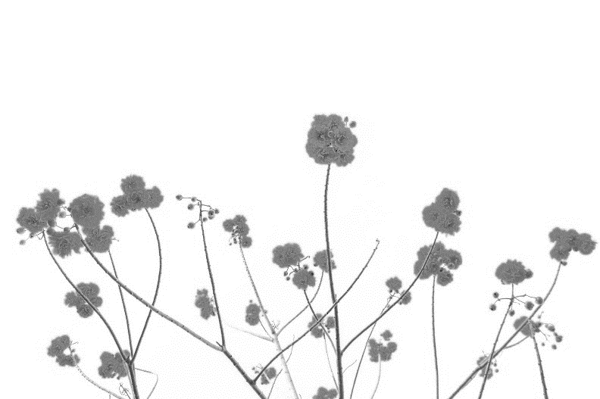
49- 70

The screaming lung.
Jared in youth.
Letting go of
strings attached,
to tomorrows reach
for a roomy sky
to fill this space,
to feel this numb,
to fill this love,
fallen weak, it’s been
asleep, and
here I stand,
with palms in hand,
catching stars,
blind in spots.
Wishing you.
Wishing us.
To see who we truly
are, without
the weight that pulls
us from here.
This dirt that muds
in your palms,
is not yours to give.

Allow yourself room.
To bring yourself
closer to you.
We all need space to
find ourselves within.

I will never look,
for another “I do”
or another,
“I don’t”
I hurt myself by
hurting you.
I also thought I
needed you to
be loved by me.
I was wrong to think.
You were the right one.
I was searching for happiness.
While happiness was unwilling
inside all this turmoil debris.
And that is why I must,
carry on without you.
I need to cope with something,
more than what you thought I was.
Remember me today,
as a loving someone,
not as a hurt stranger
in someone’s yesterday.

Love doesn’t rhyme,
with sugar, spice, thyme
and everything nice all the time.
Sometimes, it
gets mean and
crashes into worlds,
spinning out far into
the solar systems
orbiting heart.
You never know,
what true love can do,
what true love can be,
until it is cut short in
someone’s memories.
Pushing you away
telling you, love
springs forward above
all, it makes things grow
gently, but autumn
came too fast, and
winter left us cold.
In an ideal world, some will wait,
for a cosmic universe to burn out
together in space, uncontrollably hot.

Let go. . .
It can’t hurt you,
anymore.

Let it be. . .
what it is.

Emotional uncertainty,
can be scary.
It’s okay to panic,
when you are afraid of
unknown feelings
related to fear.
You can
take control of anxiety
by pushing yourself forward
and patting yourself on the back
for not leaving yourself behind.

Cherry sea born sky, drifts,
on moonbeam velvet.
Glazed with honey,
and lovesick magic.
Sultry sounds. . .
Silent nights.
Electric snuggles,
move towards her
body’s strength,
through dark
chapels of
deep light.
In another world,
she lives for a day.
To be her everyday,
happily, ever-tiredly
after moments, untouched.

You are no different from
all that separate you to believe.
You are not the same.
Fear hides in places.
No one is expecting it to be.
The anxious wait
until there is nothing
left to wait for.
You are not lesser,
than the greater
things that remain.
To be your equal.

I keep calling out,
to the ones who don’t
answer. I keep telling,
myself that one day
I will find the answers.
In closeness within,
to begin again,
without them.

Ageless possibilities
stay forever young.
Never give up on
your desires, wanting more.
Then anything else.

There
will be,
times when
you are left,
alone in your life
and the only friend
you have is a glimpse of
hope afraid to tell you what,
you need to hear, but hope will,
tell you anyways, to take control of your life.
Before anyone else controls the stars over your heart.

Heavy storms are like devils.
They come in,
all shapes and sizes.
They can wear you out. . .
On your way home. . .
On your way in...
On your way back. . .
On the way to your destination
that you cannot escape from.

And sometimes,
the heavy dark places
stay with you,
until light lifts
the stairwell on the
suns flaring lyrical
strings attached to the pearl wings,
worn by the goddesses, walking barefoot,
with healing sounds sewn to their soles.

Maybe you should
look the other way.
It’s not going to be pretty,
and she’s not heading
back anytime soon.
That love trip took all
the life she had left,
it’s not what she was hoping for.
This is not her joy . . .
This is not her idea of living.
This is not the woman,
she wants you to ever know.
Anger is the only,
thing she has left.
Everyone is tired.
All night, she stays up,
it won’t let her sleep, until
it’s done with the same impossible
endings, beginning again, without
an explanation.

I have climbed as high as
I can go, to keep every
promise safe from the
hell running out of time,
in the humming hours of grief.
I lost everything, with everything,
coming apart, at the seams,
until I stitched the torn veil of love,
to the fabric of grace, and hemmed
it up, with the truth, setting me free.

Hold me tight, before I lose my mind.
You are a fox caught in a wild place.
So rare it’s easy to find.
I will never want to leave you
alone, without being my only
kind of kindness.
Run by my love,
and I will run with your heart.
I need to feel you tremble
on my trembling blades,
etched on everything coming
undone, to something coming,
together as one.
And somehow you. . .
And somehow me. . ..
Stay different, by
coming out the same.

I delivered love to you.
No regrets.
I held you for a moment.
You lit the fire,
burning out,
controlling our desires.
Your kiss,
was an obsession,
I never replaced.

The mystical places we loved,
were in the moments,
our bodies
left secret
confessions with sins
winged to sermons,
preaching on the wicked side of the pew.
On the amiss side of me.
And most definitely, you.

Crushing heart’s
stepping back,
making dreams.
Fading memories,
forever goodbyes.
Wilted romance,
shaky stillness.
Overwhelming
endings,
start again.

Sprawled on a hardwood floor.
We were love birds,
groomed in
steamy sexuality,
but eventually
our claws dug deep
into the places, tides
could not wash away,
the ache, filling
back in
our heart’s scars,
of chance.

My spirit was bedridden.
My breath, was barely enough
to stay awake.
You had become a poison,
I drank to flush out these
toxic lungs from another world.
But now, I anchor the loss beneath
brighter nights and embrace
a love unfolding possibilities.
Stretched inside a little cloud,
holding on to letting go and
reaching for endless beginnings.

No longer will you have to prove to him,
that the universe does not evolve
around his spinning ego.
You are,
a delicate flower growing
in the center of a garden
to be admired by all who
are in love with your heart.

You are not weak.
You are strong, because you
will never again. . . carry his heavy.

Plucking Dead Flowers
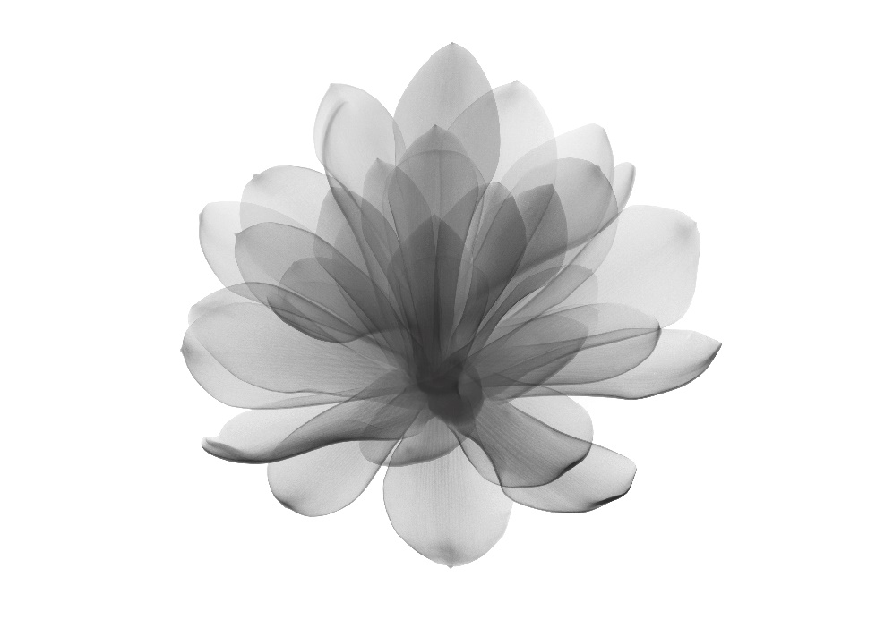
71-92

His dark moon
rides the tides,
like a tsunami
drowning out the
reckless charm
before he leaves
her damaged body
in his explosive path
to nowhere fast.
But she will play dead,
and learn how to love on her own,
by catching fire in wild storms.
Wishing upon, falling stars.
Chasing her nightlight dreams.

He waited in the night,
to hide his dark side,
like a serial killer
lurks in a church,
behind unscented
candle pillars.
He was a wolf,
on the hunt, preying upon the
grounds she worried out.
Her body escaped,
through his dead eyes.
No one heard her voice,
because no one cared
if she stayed alive.
Her heart desired
everything broken.
She wore a happy -go lucky,
silly smiley face,
trusting everyone until
she became a cold case,
filed inside his evil mind.
Keeping him like he is, she
will find, a monster that hides.

No longer will,
I watch an eyeful,
without losing sight
of my own view.

No matter what, people have
become incapable of understanding,
the suffering of other species and it’s
incredibly painful to know,
they are not going to
see it any differently.

Time slips from
mangled fingers,
as she sleeps in
darkness, edged in
her treasured eyes.
Ghosts whisper her
name with dead mans
hands of hate and glory.
Sweet dreams my beauty,
serenade the unreturned
light to the bones and
teeth, hidden beneath,
loves surface, pushing
away, something incomplete.

There are people who self
destruct under pressure
And then. . .
There are those,
who wear an indestructible smile,
to make everyone’s day.

And if that one
thing never happened. . .
You’d still be,
here with me.

Never did I think,
it would feel like this.
It feels like. . . Never.

I am a lost sparrow.
Rushed in the valley.
Caught in the net of the storm.
Bathed in the river of power.
Warmed in the fields of sunflowers sorrow.
Where we were conceived in the eyes of God,
now shattered in shards of heartless concrete
glass, we call home. Soaring from tree to tree
to break free. The sky is crying over the
flock tonight, hovered with angels.
Winged wide on their knees.
Searching for answers
weaved in a scattered
nest, under the moons
broken crest. I would
fly high above, to find a
way back to you from
all this lightless light
we cannot
see.

And maybe when you
stop hurting yourself.
You will finally feel,
love comes trickling,
down in places you
have always wanted to go.

I hope you find a heart.
That will never forget you.

I hope the heart will lift the heavy
and never
weigh you down.

I hope with all my heart.
Someone like you is always loved.

Cross my heart,
and pray, they never let you go, too far away.

Explosive weapons,
die in her wilting hands.
She begins to fight the battle.
With a missile of faith aimed
towards the cartridge encased
in her shielded heart, still
holding onto the
grenades
holy
hand.

Broken in-divided pieces.
Split-apart whole.
Dreaming in a pyramid
with a spear stuck to the core.
She waits.
For more
than a
pharaoh’s
tomb, riddled,
with puzzles,
trapped in lies and
fossilized doom.

And when the clouds lift from
her pale skin, she will slow down,
the rhythm, and thrust into a mode,
taking control over fear.
Her cape-like powers will instill a force,
not to be recon with at any time
demands are made on her domain.
Confidence shifts her mind to think,
straight out of the brewing revolution,
before time runs out of visions sight.

You gave everything,
you had, to make a
difference in other
people’s lives.
It wasn’t your fault.
They didn’t love you.
You must accept this.
Some people, are
not your friends.
They are not worthy,
of your suffering.

Tonight,
she will wait.
Surrounded by the
blue moon and her sky.
Her heart. . .
A wildflower,
weaved in a
garden of burgeoning stars.
Strung together with
long strands of love. . .
falling for her,
earthy smile.

She kissed the fields good night,
threshing the bleached sky.

And the clouds began to
wave rivers, in blackwood,
boxed in with her ashes.

She refused to be born,
unloved to anyone.

An individual spirit,
gifted from the breath,
of water.

Cleansed in agony, against
eroded rock and climb.

Look into her eyes,
if you see, forever her worth.

Open your mouth wide,
take her in, and fill up,
her heart with love.

Even when, you’re
alone, with your biggest fears,
with a handful of reasons,
entwined, in your soul.
You must not lose sight of
yourself in the first and only place
you are looking for.
Find the strength and hold onto love.
Above all the struggles gathered
in your knotted heart, you will survive.
Inseparably, bounded, in togetherness.

You are not alone.

With
all
this
love,
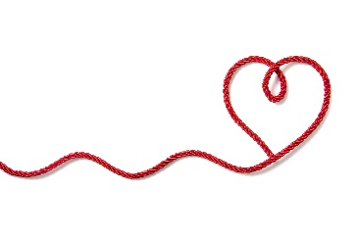
flowing
through
the heart
center
of
your

Your heart.
A safe place to fall.
Hold me there.

Maybe, love becomes a little lazy.
It never seems to find its way
back to the same place it started from.
And it hurts when it’s not around.
Perhaps the feelings of
laziness cannot find the
love standing right in front.
Where it’s always been.
Waiting for you, with ambition.

You have more to give than you’ll ever know.
There are various ways to love yourself.
When you think you are not
whom you wish you could be.
Accept who you’ll never be.
And see yourself as far away,
as possible, from someone else’s dream.
The day you stand on your own.
Is the day you stand to find your
own way back to self-respect.
You are a home, not a prison.

Feelings We Yearn For
93-114

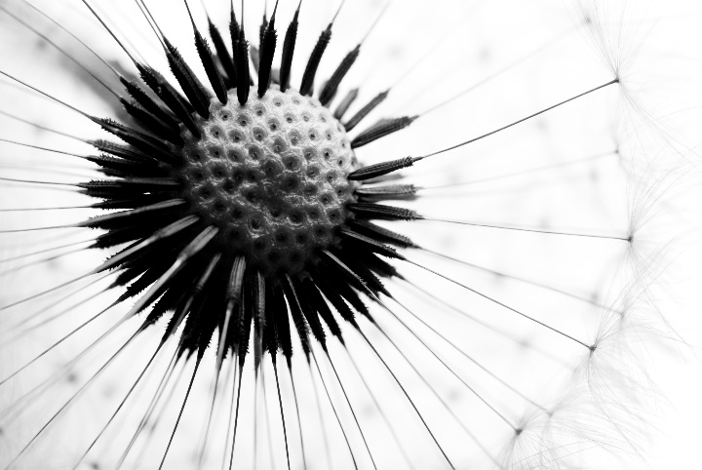

When the day is dark.
And there is no light to be found.
And I feel abandoned.
There is a place I go.
To find the light within.
The light I seek.
Is in, my love to write.
I feel a tenderness.
I feel safe.
So, when I’m sad,
happy, lost,
or found.
The love, of words,
takes refuge, and
holds me in a space,
of meaning, to write.
For all, I adopt.
To never replace.

It’s now,
you want to gaze,
at the moment.
The path,
winding,
wandering aimlessly a few miles,
before the land devours the thin
horned moon, lurking behind me.
But now, has no place,
to keep you in my eyes.
I’m smitten by my own view.
Lighting up the quiver, of endless stars.

It was a bird that taught her,
to free herself and fly.
She soared across the unreachable sun,
setting in the limpid skies.
Freed herself to fly so high,
and made love to all she was inside.
But one day,
she drifted,
without her wings attached.
It was he, who broke her heart in half.
He never kissed her soft cheek.
She longed to be touched.
He said, “I don’t love, the
things I don’t ache to touch.”
She said, “Love, is a compass,
it will align itself again,
and navigate through this,
unraveling moment.
He tore out her heart,
but she stitched it back,
together with courage
sewn to her heart’s wings.
And flew away,
stronger, than ever before.

This is where I departed.
Without him, there will be better days.
I placed his black coat onto the backseat,
with his scarf, next to
mine, in the front seat,
on top of the razors, I just bought.
“The razors, I wanted to
cut his throat with.”
And then, drove endlessly, guilty,
of loving the wrong man, twice my age.

Thin and new.
Half faced,
bright and bare.

A bloated ruby,
over seasoned.

Gripping souls,
in rosy wonder.

Golden hearts,
faint small and full.

In the slender distance. . .
A cold star,
falls pure.

In between, day and night.
I filled my thoughts with you.
As my heart faded with the sun.
I felt hope, lifting the stars,
and pushing my lucid dreams
up onto the moons rocks
and lunar glow.
But I simply fell back,
to earth’s reality
without knowing,
love was gone before I woke -
in another galaxy.
Far, far away, from all I once was.

A rose petal pinned,
deep in love’s creeping darkness.
Handcuffed to the thorns,
shadowing scorns.
She was his soul’s obsession.
Left to wilt on a picnic table.
On a cool fullish day.
Where she gave up a warm sweater,
for a cold shoulder.
A breath too late,
with the wrong mate.
Life chances come apart.
Some will get nothing
back in return. But
she moved, in her own way,
back into loves threads
worn without him.
Wearing nothing at all,
but her true layered fibers.

In the southern sphere.

A hollow night,
sparks light.

Skimmed in
a milky glare.

Smooth, angular,
bending towards
inner wants.

A soft whisper,
sunned,
in perennial full.

Intensely
unprohibited.

Freckled,
intoxicating,
and sinister.

I was a shy girl.
In school, I passed out,
whenever a teacher called
me up to their desk.
Not paying attention was never,
my intention to fail.
I couldn’t comprehend the
words I was taught.
Things were always backward.
The teacher told my mom,
I was special needs,
and wanted to place,
me in a school for slow
learners.
My mother’s love, went nose
to nose with a few teachers.
Whenever she walked
into the classroom, they
felt just a little nervous.
I don’t allow anyone,
to box me in and define me.
Because everyone learns
differently. And different can
bring beauty to the mundane.
Love, teaches us, to see, past ourselves.

The tragic widow.
Spun her struggles in a web.
No one knew if she was alive or dead.
She hid behind a decrepit white shed.
And listened to the leaves,
rustling through the coursing
wind, while she breathed in with ease.
She leaned back and
held herself up onto an old
rusty shovel, between the
fence and all she had, inside her head.
She asked herself,
“Why do others think,
I am either,
too little,
too much,
or not enough?”
And then a tear swelled in
her eyes, but she sucked it up,
pushed it aside,
and then she spun
around and ate,
her poisoned dinner,
with one swallow of fate.

There is someone.
There is something.
Everyone is looking.
No one’s coming.
Who else will you ever love?
You, they, them, anyone.
Has love faltered in trust?
Truth so falsely accused.
You have seen me,
like no one else has.
A mere image,
alongside a stream,
on a
lonely mountain,
dark night storm, passing
through, your soul’s absence.

She loves her time,
with all things,
briefly held.

Picking up lazy things.
Returning them to
cold and fruitless places.

Bending, exhausted.
Every. . . day,
over every. . . one’s,
every. . . thing.

Spinning in the light
of the yellow moon’s,
blooming star,
shining bright on
hanging leaves,
trembling in the night.

Returning her, to the
sky, to the river, to
the trees, to the ever
lasting sunset, growing
dimmer in her eyes believe.

This is where it ends.
The beginning was fully measured.
Until green envy grew empty between us.
Where hurt holds us.
And sweet bitter love lingers.
No longer are we sold on lies.
As servants to our truth.

You are,
azure sultry endless skies.
Permeated with citrusy,
fragrances, scented,
with love flowers.
Blooming,
in pearly grey
April showers.
You are sun, moon, and stars,
embracing dandelion hearts.
You are happy dreams.
Laughing, dancing,
on every path,
fairy tales smile.

Finding your way back, to everything closer to you.

What a beautiful way to say
thank you, by saying I love you,
in the places I missed
you in.
The places we hid.
The places we were scared of.
The places we cried.
The places we revealed ourselves.
The places we were calm.
The places we laughed.
The places were everything, we had known.
The places in between all our sobered dreams.
There is no one, I’d rather have, to come back to, than you.
A beautiful reminder, love came by.

No one is going to,
tell you life is easy.
Because it’s not.
It might seem easier,
for other people because
you might be struggling with yours.
And we all know life is not fair.
Take a woman’s struggles for instance.
Many women in society have been in jail,
for standing up for their rights and speaking
up for freedom of speech. Not only were,
they sent to prison they were killed.
We must continue to stand together.
And become one voice,
for all women.

We were tragedy under a midnight sky.
You pressed your lips on the divine.
Shattered our hearts into a million,
pieces, with star-shaped tears.
Left me waiting for more.
We came untied like a
hundred balloons,
deflating in our eyes.
Drifting alone,
towards, the
fracture of
no repair.
Left to
fill us,
up,
with
out
LOVE
in the air.

As if you didn’t feel it,
but it was there.
In the moments haunting you.
You will make the innermost shape of light.
Because you need to feel the hands,
that have grown to hold you.
You need to feel the eyes,
once upon you, that have truly seen you.
You need to sift through the memories,
that you will leave behind.
You need to tell yourself.
You are strong and brave.
And you need to feel alive,
with courage, to go on.
You need to reach into your heart,
and inspire yourself.
For you, alone, need to feel,
the love, right where you are.

The good son.
Lead with the
growl in your tears.
Peek into the
hearts that see you,
and come back in.

It’s a journey,
away from a rush.
You need not hurry,
through darkness.

There will always
be a spark snagged,
onto a scarf,
snuggled on a worn
heart, that loves you.

Travel wise.
Travel far.

Depart in light, my
precious dark knight.
You are my only
home, I ever loved.

In a noisy filtered world.

I no longer hide.

I choose to be me,
rapt and vacant.

Possible over impossible.

Wanting nothing,
needing more.

In these places, I survive.

I thought love was someone,
else’s idea of beauty.
A beauty I did not own.

I stared at an image.
And despised her reflection.

I was afraid to love her.
Afraid to stand up for her.

If I could do it over again.
I would tell that shy little girl:

“I got your back.”
“You’re not stupid, no one’s stupid.”

You deserve the freedom, to be happy.
No one should ever miss out on love and joy.

I missed out on so much, thinking I wasn’t enough.
I was more than enough, and now I know better.
“I got my own back, bitches!”

Thoughts

Thank you for reading ‘love came by with lacquered flowers.’
I hope you enjoyed reading this compilation of poems on love, heartbreak, and hope.

I remind myself every day when I write that my words are worthy of being read.

Of all things, writing is exceptionally challenging for me,
like piecing together, a jigsaw puzzle, that is incredibly rewarding when completed.
Follow me on Instagram @b_christie_1242

About the Author
Brenda Christie has been writing for most of her life.
Enjoys reading true stories and poetry books.
Loves a chocolate Frosty on a cold winter day.
Is a true movie buff.
Listens to the best of 80’s music.
And writes her heart out at 2:00 a.m.

Blurb:
Brenda Christie’s poems depict the emotional highs and lows of life.
Love Came By With Lacquered Flowers, is a collection of poems on
love, heartache, and hope.

In life, everything changes quickly. Some run away. Those that hang on and stay.
And then, some give their all, to make it back to you.
I gave everything I had, to grow stronger with self-love, from each poem that spilled out from me.

There is no other language more meaningful than love.
And there is no other language more harmful than hate.
I hope, between it all - love came by with lacquered flowers.

