Project Documentation
Quick Tweet --- Developed by Team NULL

In this project, we have developed four main activities. Each one of them is implemented in one file.

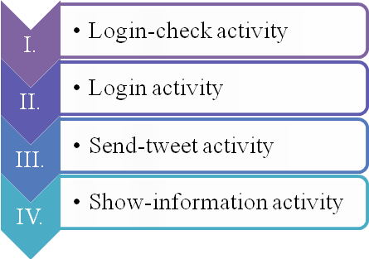

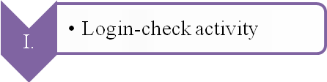
Login-check activity is implemented in class “public class MainActivity extends ActionBarActivity.” It determines whether the user has logged in and sends the user to different activities based on that. And there is no layout for this activity.
In this class, there are three methods.
Method “protected void onCreate(Bundle savedInstanceState)” registers the user with twitter using the key and secret. It sets up a new twitter instance, edits the sharedpreference and sets up a boolean value called loggedin, the value of which will be determined by the value in sharedpreference.
Method “public boolean onCreateOptionsMenu(Menu menu)” inflates the menu and adds items to the action bar if it is present.
Method “public boolean onOptionsItemSelected(MenuItem item)” handles action bar item clicked here. The action bar will automatically handle clicks on the Home/Up button, so long as you specify a parent activity in AndroidManifest.xml.

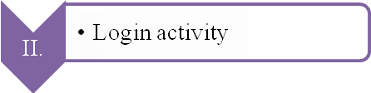
Login activity is implemented in “public class Main3Activity extends ActionBarActivity.” We have the plugin Fabric installed in Android Studio so that we have the Twitter App installed in the program. There is a layout that prompts the user to log in. If the user has logged in, this activity prints out a message saying that the user has logged in.
There is a method “protected void onActivityResult” and it makes sure that the loginButton hears the result from any activity that it triggered.
There is a method “public boolean onCreateOptionsMenu(Menu menu)” and it inflates the menu, adds items to the action bar if it is present.
There is a method “public boolean onOptionsItemSelected(MenuItem item)” and it handles action bar item clicks here.

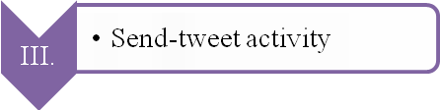
This activity is the core of out app. It is implemented in “public class Main2Activity extends ActionBarActivity.” It sends out the tweet. There is a layout for sending tweet screen. It allows the user to input the desired Tweet content in the textbox. Then, by hitting the “SEND TWEET” button, the text input would be sent through Twitter API to the server and be displayed on the user’s timeline. The sending tweet screen would be closed after a tweet is successfully sent, allowing the user to switch to other apps.
The method “private void addDrawerItems()” defines the options in the drawer, and what happens if options in the drawer menu is taped. If About this App is taped, it shows the app information screen. If logout is taped, it sets the loggedin value to “false” and prints out the logout message.

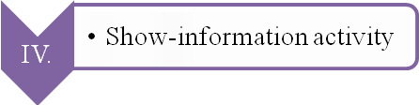
This activity is implemented in “public class Main4Activity extends ActionBarActivity.” It displays the app information.

