3/24/2020

Mark Nasr

8078377

Hydrology VR Report

Requirements

* The application shall run in VR for android devices
* The application shall allow users to select precipitation as an input
* The application shall allow users to select forest cover as an input
* The application shall allow users to switch between pollutants
* The application shall allow users to switch between subbasins
* The application shall allow users to show individual subbasins as well as all the subbasins
* The application shall allow users to zoom-in with the VR camera
* The application shall display forecasted pollutant levels
* The application shall display terrain covering the South Nation Watershed.

Architecture

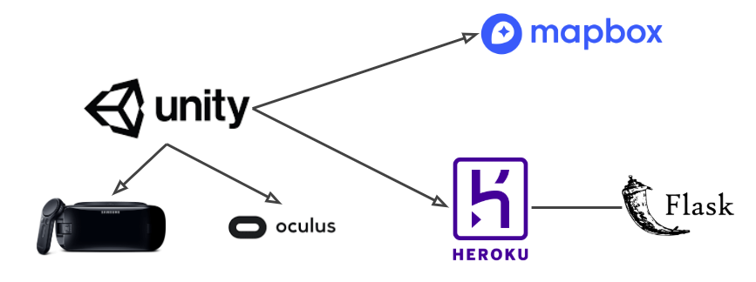

Unity is used to run and render the application. Oculus API is implemented in Unity to run and build the application for Gear VR devices.

Mapbox API is implemented in Unity to render and create an accurate watershed terrain in Unity.

A Heroku server is used to run the Flask code that predicts and calculates the pollutant values.

Challenges

* Lack of documentation for implementing GearVR with Unity
* Creating UI for the application that can work with GearVR
* Creating an accurate terrain of the South Nation Watershed.
* Having the pollutant values update automatically without causing a performance issue on mobile devices

Resolutions

* Carefully looking at GearVR examples and Youtube videos to implement the VR API with Unity
* Looking at UI for VR examples and experimenting with multiple assets and UI objects
* Implementing Mapbox with Unity to accurately render the terrain
* Experimenting with Invoke to find the most optimal time to update the values

Future work items

* Support different watersheds and additional user-defined characteristics
* Look at deployment of the application in more remote countries
* Add dam and flooding rendering
* Show population density