## Customize the UI (replace Image)

--- Mark,2020/8/10

For example, if you want to replace the logo image, just replace the 0.Logo.bmp(in the DWIN_SET) as your own. And then following the step to generate and upload the ICL file.

1.Run DgusToolV7.616.exe;

2.Setting-->DGUS；

3.Select the ICL Tool-->Select Directory-->select the image directory e.g.DWIN_SET；

4.Generate ICL--> Save as and replace the older “32.icl”

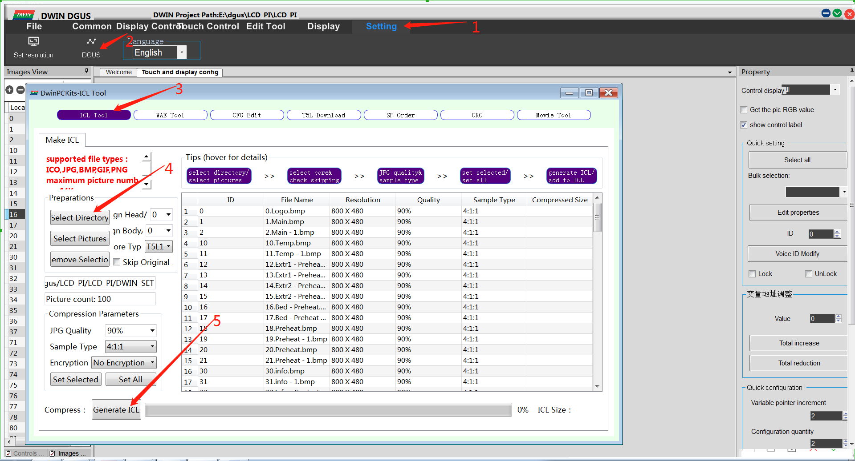

5.Uploade screen Image to screen

Step 1：Format the TF card and copy files run windows command system as administrator, then enter：

format g:/fs:fat32/a:4096/q

Note: g is the drive letter of your TF card ，and the card size must be 1-16G.

Step 2：Copy the folder DWIN_SET which contained your newest 32.icl to TF card;

Step3: Insert the TF card into the card socket (back side of the screen) ,and then power on the screen. Wait for the blue screen and appear on the first line of the screen “SD Card Process... END !” it’s may take 1-2minutes. Turn off the power and unplug out the TF card, re-power the screen Wait for the boot screen.

