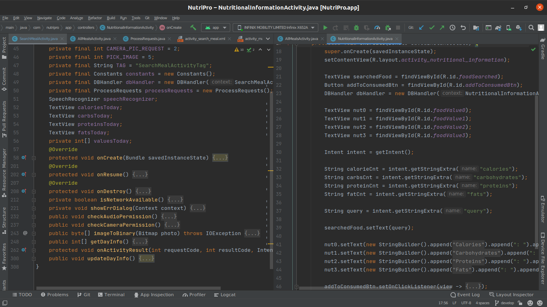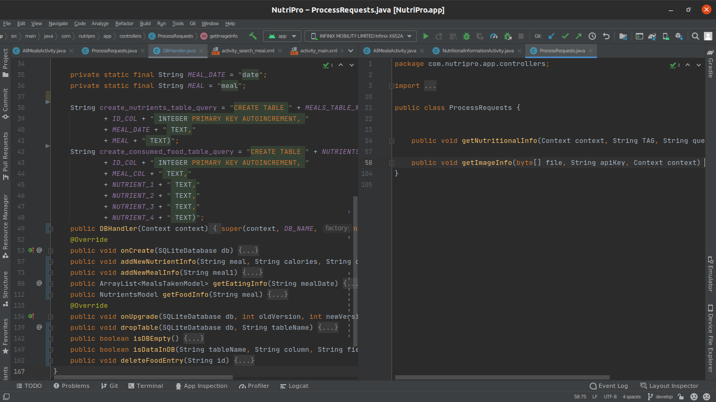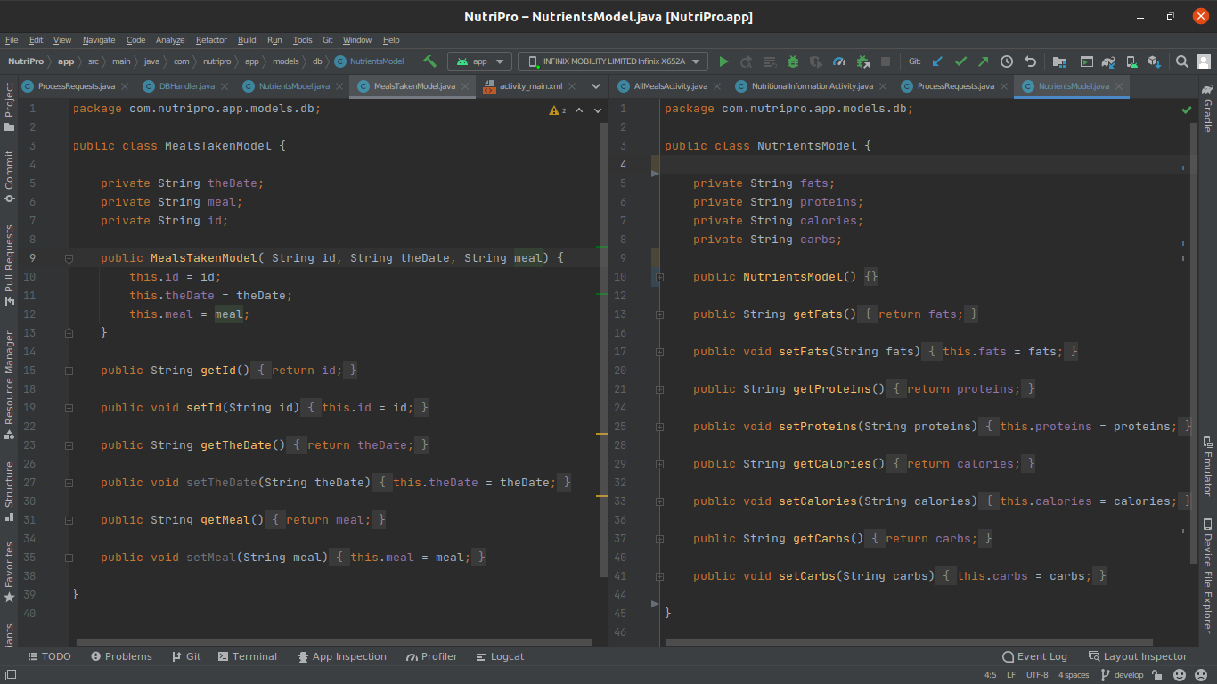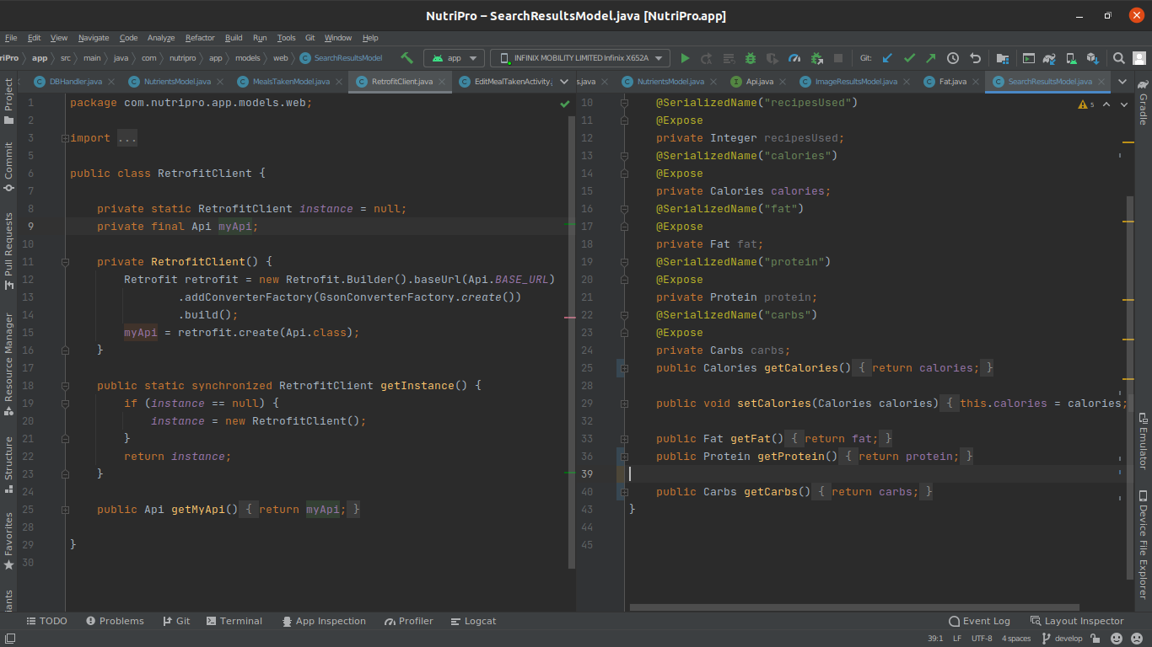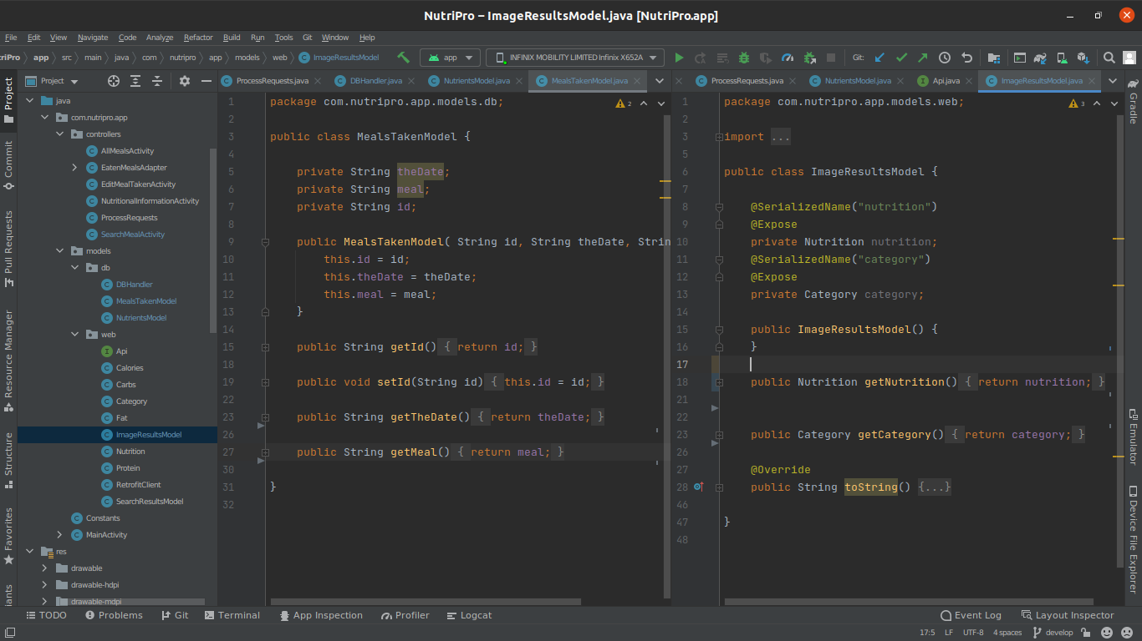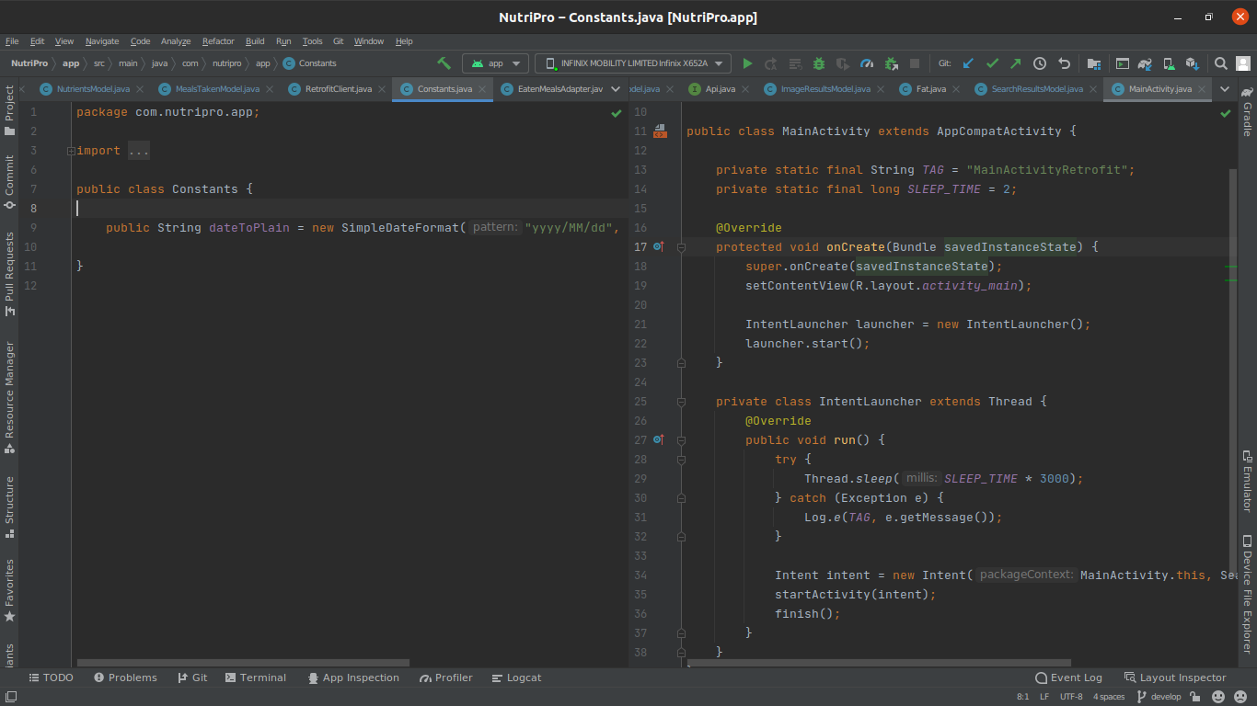

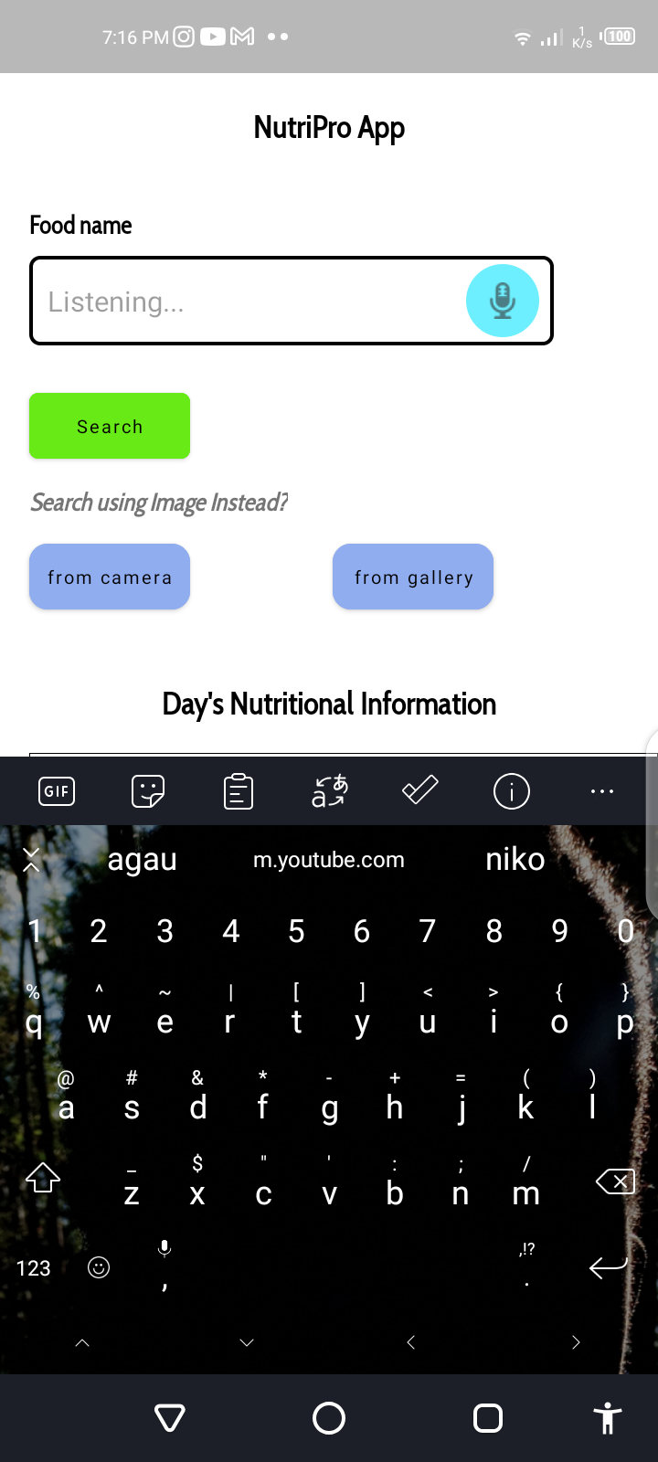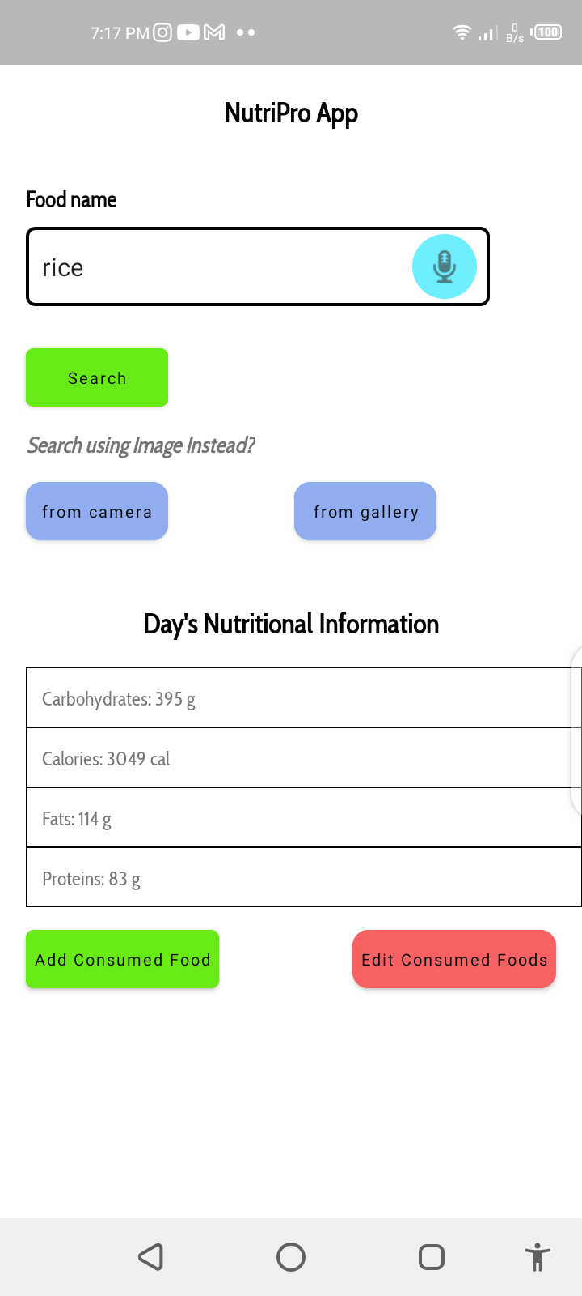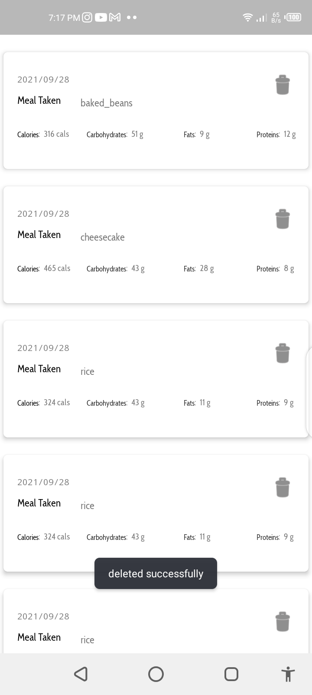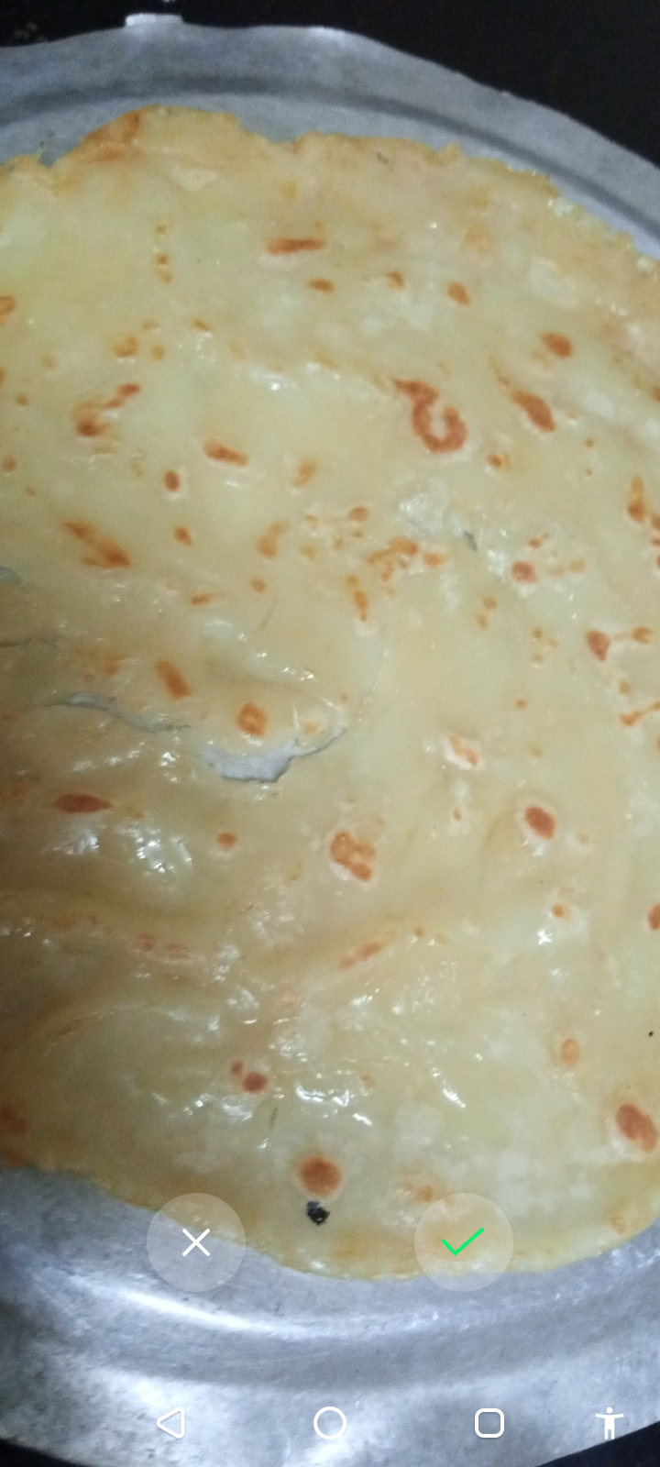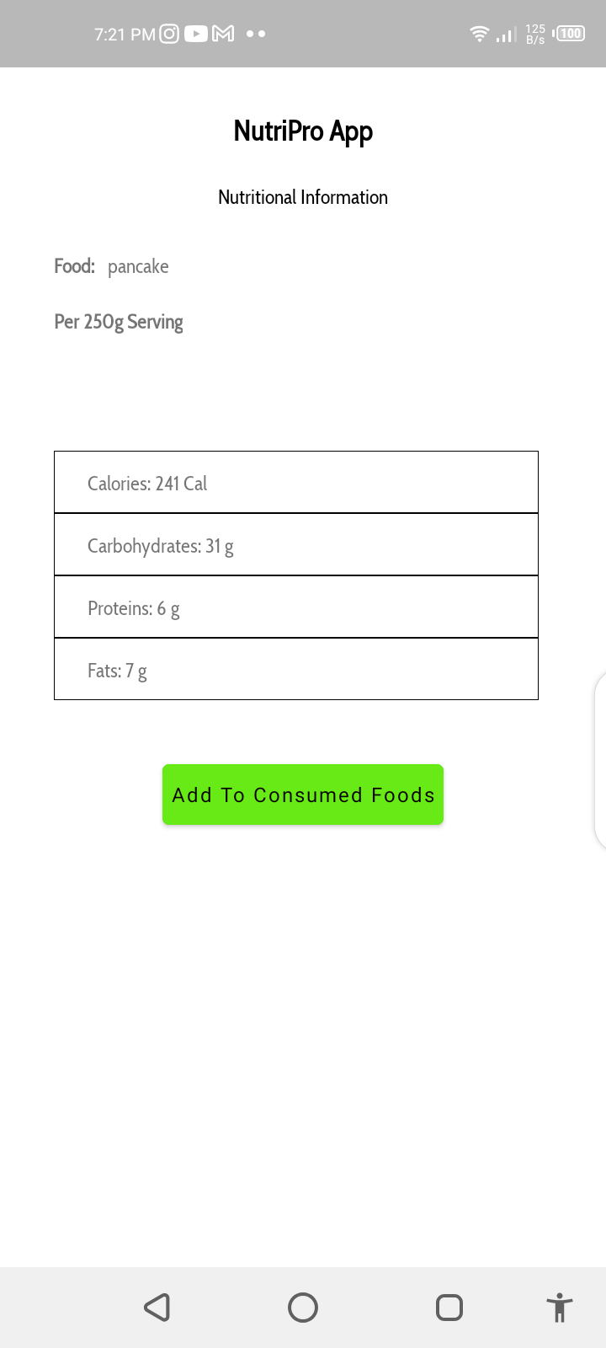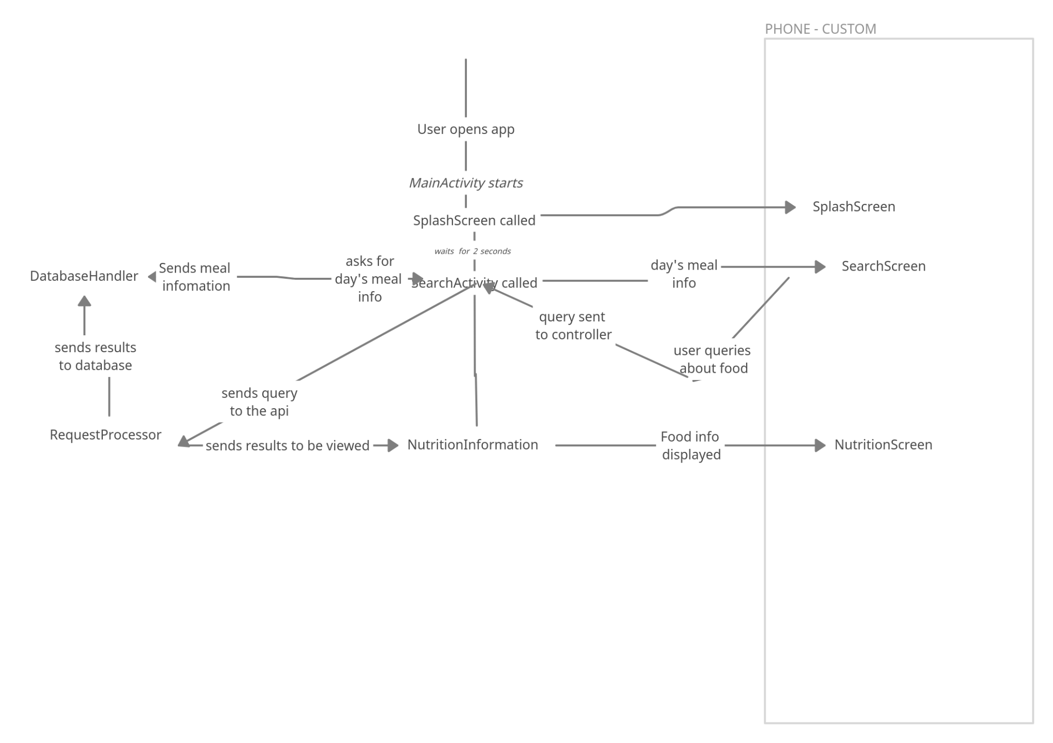To run the application:

I. ensure you have Android Studio installed on your personal computer.

II. get a spoonacular API key by creating an account with them at <https://spoonacular.com/food-api/console#Profile> .

Steps:

1. Open Android Studio on your computer.
2. Select the “open project” option. A pop up screen will appear.
3. Choose the project directory and click “open”.
4. Navigate to /app/src/main/res/values/secrets.xml and paste your spoonacular api key at the “spoonacular_api_key” string resource.
5. Your app is ready to be run. Press shift+f10 to run it.

**Known Issues**

1. The app does not accurately detect the food captured in the picture. This however does not mean that it is bad in food identification. David Urbansky researched on which AI was better at identifying food and classified spoonacular as the third best model with 90 percent accuracy.

**References**

1. **David Urbansky’s https://ddsky.medium.com/comparison-of-7-image-classification-apis-for-food-pictures-1d61b7293285**