Title: Maize WhatsApp for Business Content
Content Author: KALRO
Edited by: Mercy Corps Agrifin
Audience: Farmers
Year: 2021
NOTE: You must adapt this content to suit your needs & to match your user journey.
The menu structure will change from time to time based on implementation.
For any queries or clarification, please reach out to info@sproutopencontent.com
Terms & conditions apply.

WhatsApp for Business Content Starts here:
Welcome to Sprout Learning! 🌱 Sprout Learning is a free service for farmers to learn helpful information on managing crops, livestock & accessing financial services. Today we will learn all about maize farming.
Maize (Zea mays)
Local names in Kenya (Mahindi, Oduma, Bando, Madumwa)
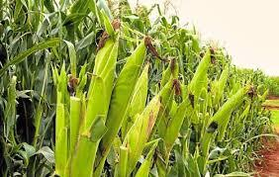
Maize 🌽 is an important cereal crop. It is a staple food for most rural populations. It is used as a human food, animal feed, production of beverages and also making bio-fuel. Maize is a versatile crop with a wide genetic base and a large number of varieties growing across a range of agro-ecological zones and soil types.
Would you like to learn more?
Reply
1 for maize pre-planting lessons
2 for planting lessons
3 for weed & pest management
4 for disease management
5 for harvesting & storage lessons

User prompt 1- pre-planting lessons
Chatbot:
Before planting maize, select a site away from shade to allow for sufficient sunshine and it should be at least 10 meters away from the road to prevent dust and vehicle fumes.

Seeds for planting maize 🌽 should be obtained from reliable 👍 sources. Farmer-saved seeds are alternatives where certified seeds aren’t available. If using farmer-saved seeds, select seed grains situated at the middle of the cob and discard grains at the base and the tip of the cob.

👍 Maize requires deep, well drained, fertile loam soils with good water holding capacity. The optimal temperatures 🌡️ should be 25-30 ºC . Rainfall of 400 – 1200 mm p.a
To prepare the land;
✔️ To plough, use chisel ploughs, hoes or ox-drawn tools
✔️ Slash and plant using the appropriate tools. Contour farming is recommended.
✔️ Don’t over-till the land in order to reduce cost and to conserve the soil water and nutrients
✔️ Add manure & fertilizer in the right amounts

User response 2 Planting
Chatbot:
✔️ Plant at the onset of rains e.g. 4 continuous days of sufficient rain.
✔️ Plant at a spacing of 75cm x 25 or 30cm, 1 seed per hole 5 cm deep. Plant along the contours or across the slope.
✔️ Plant certified maize varieties tolerant to striga weed
✔️ Establish on-farm water harvesting capability and water storage capacity, ditches, mulch.
For watering;
👉 Maize is mostly watered by rain 🌧️ and irrigated if necessary, by adopting more efficient micro-irrigation methods such as the drip method.
👉 Irrigate the fields early in the morning, late in the evening or at night but never during full sunshine.

User prompt 3 Weed & Pest Management
Chatbot:
👍 1st weeding is done 3-4 weeks after germination and 2nd weeding done just before topdressing.
The 1st topdressing is applied when the maize crop is knee high at 30-45 cm high

To control pests;
👍 Practice field cleanliness and store hygiene
👍 Plant and harvest early
👍 Practice crop rotation
👍 Rat traps
👍Use of appropriate insecticides as recommended by experts

Maize pests include;
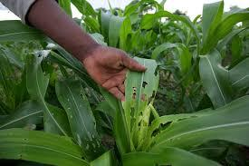
Fall Armyworm
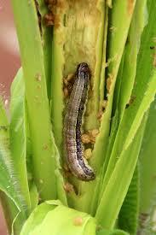
Armyworm
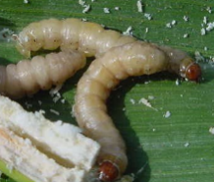
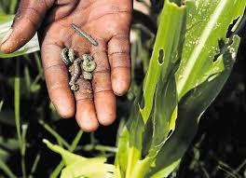
Termites
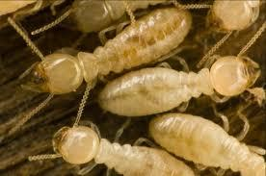
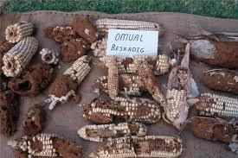
Leaf miner
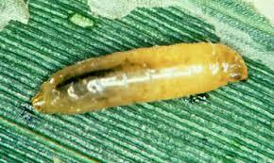
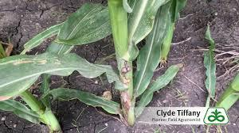
Rodents (rats and mice)
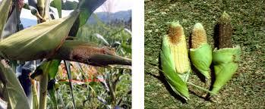
Weevils
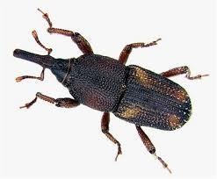
Larger grain borer
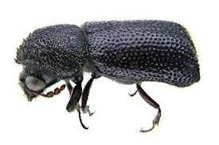
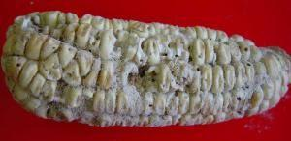

User prompt 4 Disease Management
Chatbot:
Diseases that affect maize include;
Head smut (Sphacelotheca reiliana), Smut (Ustilago maydis), Maize lethal necrosis disease (MLND), Maize streak virus; Northern leaf blight, Common rust, Grey leaf spot

To control diseases on your maize farm;
👍 Use certified clean seeds that are disease resistant
👍 Practice crop rotation
👍 Ensure field hygiene
👍 Use appropriate fungicides as recommended by experts

Head smut
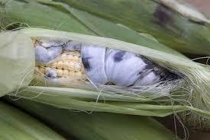
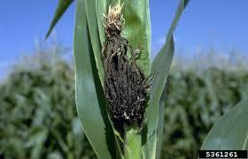
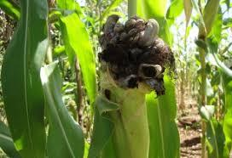
Maize lethal necrosis disease (MLND)
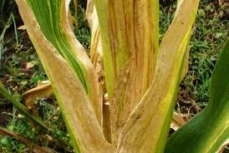
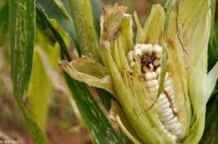
Northern leaf blight
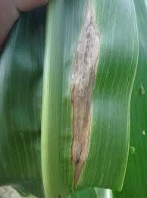
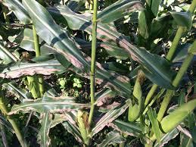

Common rust
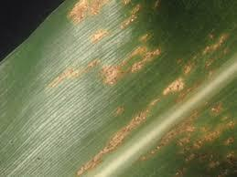
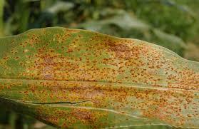
Maize streak virus
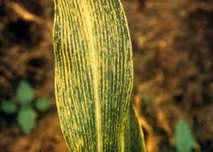
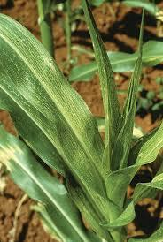
User prompt 5- Harvesting & Storage
Chatbot:
✔️ Maize matures 4 to 9 months after planting depending on the variety.
✔️ Harvest by cutting and stalking to enhance drying and prevent pathogen infestation.
✔️ Transport maize from the field to the place of shelling using clean transport equipment
✔️Winnow to remove dust and chaff

👉 Control weevils, grain borers and fungal infections like aflatoxin by drying the maize to 13-14% moisture content.
👉 Accessible methods of determining or estimating moisture content can be used. Ask your local professional
👉 Sort the maize to remove damaged, discolored and infected grains, store in airtight bags or metallic silos to minimize use of pesticides

