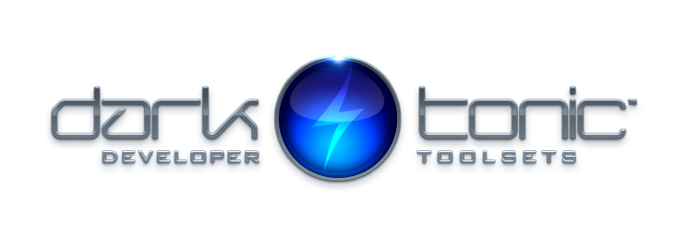

MASTER AUDIO PLUGIN - By Dark Tonic, Inc. (c) 2012-2017

Table of Contents
1. Solutions! Master Audio solves the following problems | 1
2. Summary | 2

This plugin was written to be the be-all end-all for video game audio management! We are always open to hearing your ideas for improvements, suggestions and problems. Email us any time at support@darktonic.com. Our support forums are online at: http://darktonic.freeforums.net as well.
For tutorial / demo videos click here.
Make sure to check out the multiple example scenes in the Assets/Plugins/DarkTonic/MasterAudio/ExampleScenes folder!
The Master Audio online help website can be found here: http://www.dtdevtools.com/docs/masteraudio/TOC.htm
The entire Master Audio API documentation can be found here: http://www.dtdevtools.com/API/masteraudio/index.html

1. Solutions! Master Audio solves the following problems (and tons more)
- Too many instances of the same audio clip playing simultaneously or near-simultaneously. For example, if an enemy has a death scream sound, you may kill 30 of them with a single blow. 30 audio clips playing simultaneously is not only unnecessary but it drags the CPU down, especially on mobile devices. Master Audio lets you specify the maximum number of each sound that can be playing at a single time.
- The ability to randomize a certain sound to play from a pool of weighted variation sounds. This goes hand in hand with setting up the maximum number of each sound that can be played. All X sounds in a group can be the same, or variations. You have complete control over that. You can specify that Variation X plays 3 times as often as Variation Y for example.
- Having to write code to trigger each sound. Master Audio eliminates the need for this in most cases by letting you specify sounds to play when certain events occur, including uGUI (Unity 4.6 UI), NGUI, Pool Manager and Custom Events you can define and fire from various Unity (and Master Audio) events. No coding is needed to do this in most cases.
- Not being able to play sounds when the Audio Source is attached to a game object that is being despawned or destroyed. What happens normally is that you hear a brief blip of the sound and then when the game object is gone, the sound abruptly stops. Master Audio keeps all its Audio Sources in a central location separate from your prefabs so that this doesn't happen.
- Loading an audio clip from a Resource File, playing it, and then unloading it from memory so you don't have the memory taken up until the whole time. All with no coding!
- Setting up multi-language Audio which automatically plays sounds in the user's language!
- Being able to stop all currently playing instances of a certain sound. Since Master Audio knows where all its Audio Sources are at all times, it can trivially do this.
- Adjusting the volume of categories of sound effects with a slider. Since Unity (pre-V5) does not have anything natively, we have included the concept of a pro mixer with Buses.
- Music ducking. You can configure Master Audio to have the music "duck" (get quieter and ramp back up slowly) for whichever sound(s) you like with no coding needed. The amount of ducking is also configurable.
- Music crossfading. You can set up multiple music Playlists that picks tracks that can shuffle, crossfade and auto advance. You can have any number of Playlist Controllers, each playing a Playlist and with crossfading, and they can optionally synchronize with each other.
- Not being able to play music during a scene change. Simple to do with Master Audio!

2. Summary
Make sure to check out our other top-notch plugins such as Core GameKit at http://www.darktonic.com/p/developer.html. Thank you!
-All at Dark Tonic
Sample music provided by Alchemy Studios.

