Url workerja: https://cloudflare-worker-api.marko-busnja123.workers.dev/
Url repo: https://github.com/markobusnja123/cloudflare-worker-api

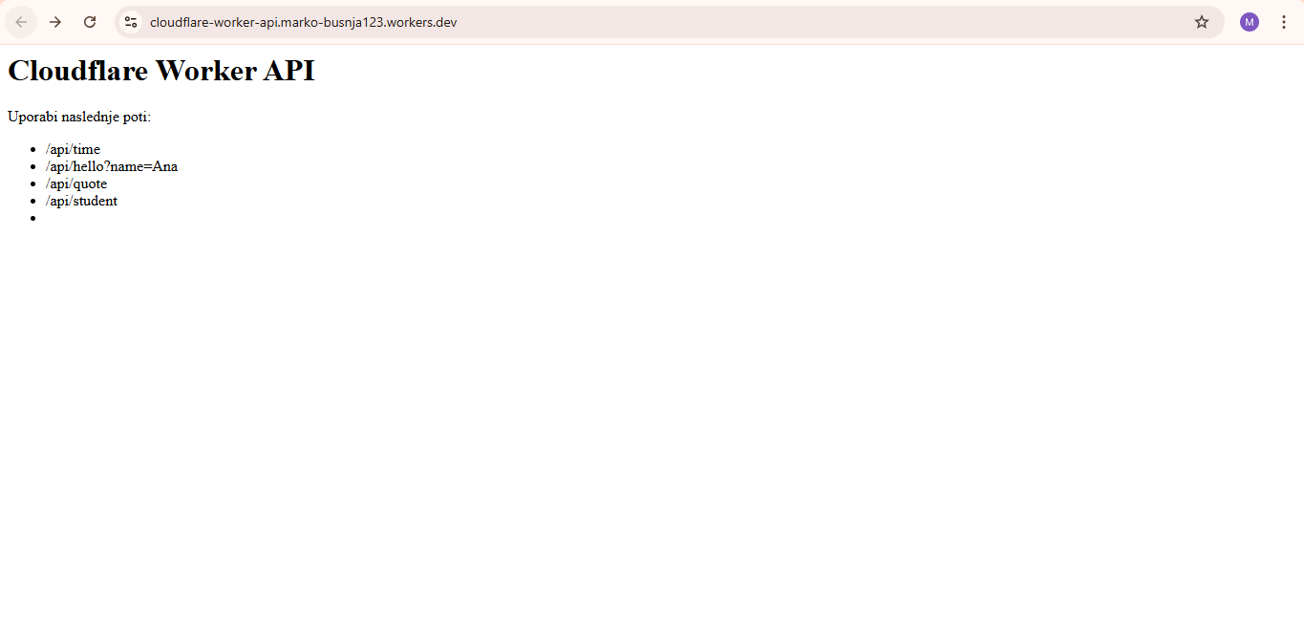
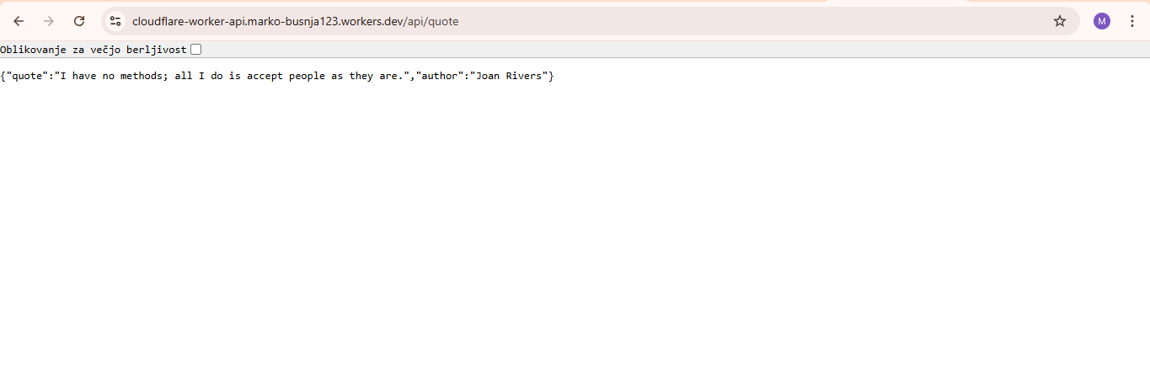

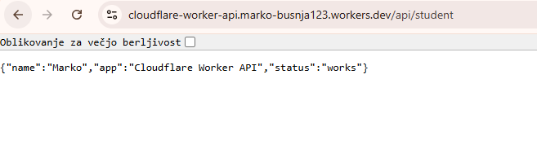
Spremembe: dodal sem na koncu nov IF stavek, ki preveri če je v urlju pot: /api/student in izpiše ime: Marko, kratko sporočilo in status.
#
if (url.pathname === "/api/student") {
return Response.json({
name: "Marko",
app: "Cloudflare Worker API",
status: "works"
})
}
#

